**Comments 1**

* I am very upset and surprise about your services
* I was very flexible in approving the phase 1 & 2 without completing the full requirements, anyway you break out the trust on you, its up to you, now you are saying, you are not a data entry, first you should provide the basics of the site,
* I cannot give the same comments repeatedly, during video call we have discussed many comments and requirements, you never incorporated.
* Still the country shows Bangladesh in many places, and category description, I have already changed 1 or 2.
* I have given you the all sri lanka cities and divisions and not updated
* I am not bother about money, if not success I am cancelled the project, accordingly feedback given to you.
* I am still unable to post an ad, then how users can do the same, ad posting page is full messy, you have not followed any of my comments,

**Home page**

* Gogoads.lk logo – size to increase



* All Ads fonts size/ alignment to be reviewed
* Language – two tabs not dropdown



* General typo/ spelling – to be reviewed
* GogoadsThe - space



* **Logo to change - Transparent**

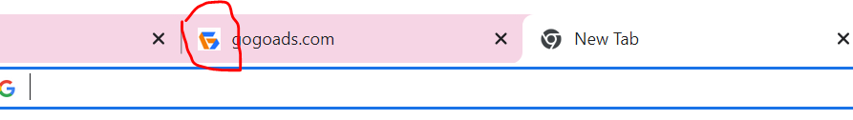

* **Post Free Ad – tab need at below position**



* **Icon to provide for following icons**

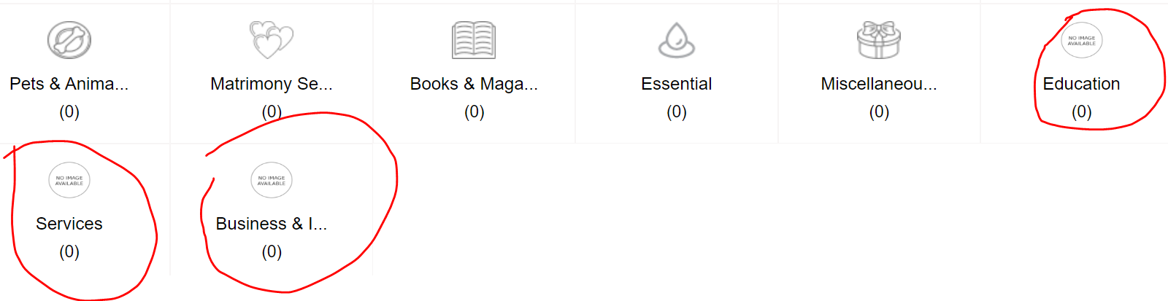

**There is no section to manage all footer pages/ link**

* Quick link
* How to sell fast
* Social media

**~~Popular Categories~~, need all the categories to display, please change as “Browse items by category”**

* Now 16 nos, to arrange in 3 rows, you have provided a limited main category,
* Color icons
* Ad Banners
* Google analytics – not updated
* Google AdSense - code provide not updated
* Not shown – 3 ads on each page
* Sitemap – to complete/ update/ proper organise
* Quick link – not updated all information has been provided

**Ad Posting**

* Admin panel doesn’t have enough details to monitor, user name, status of post (draft, posted or review, expiry date)

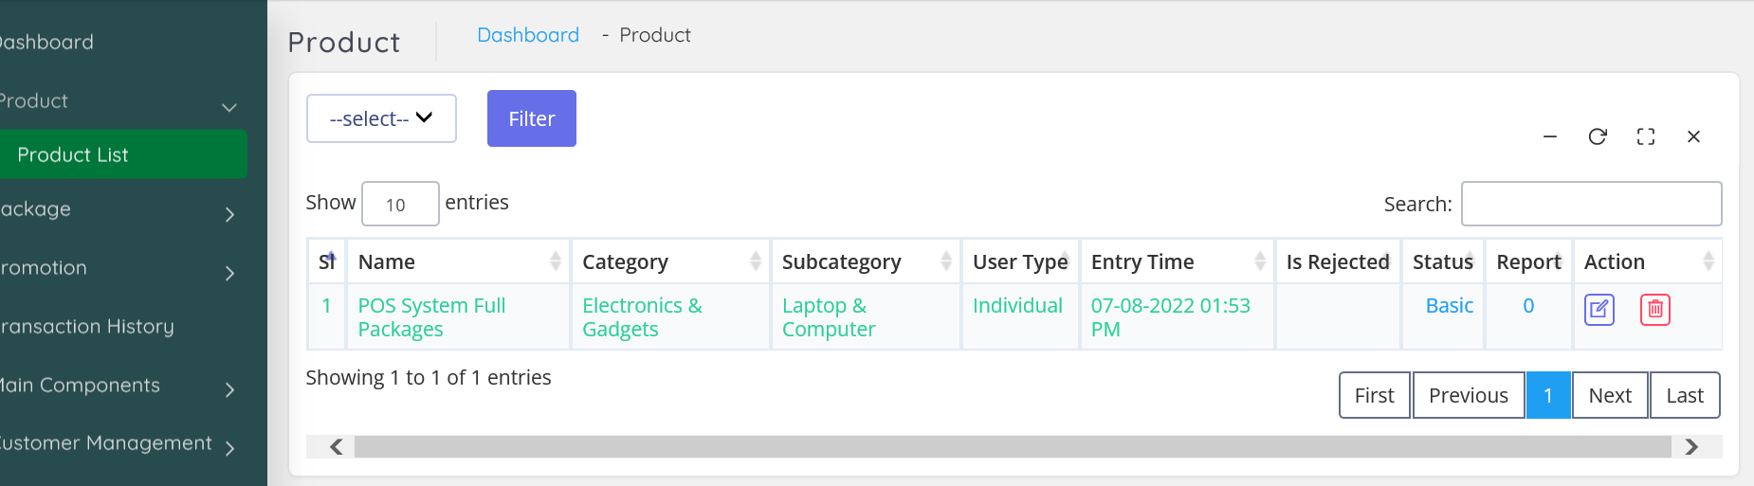

* Admin not receiving a notification after user posting an ad.
* Admin to review and approve the posts.
* There is no email communication system with user, this is agreed scope
* Provision for images to increase at least 6-8 images to be (size and resolution be defined properly)
* Paid customer a proper invoice management to be provided (currently available is very very low quality) no information provided is in sufficient (we will lose user creditability)
* User will be able save the posts and start later time for any reason.
* User home page to be changed as discussed in the first video call and agreed.
* Can’t select area no result found

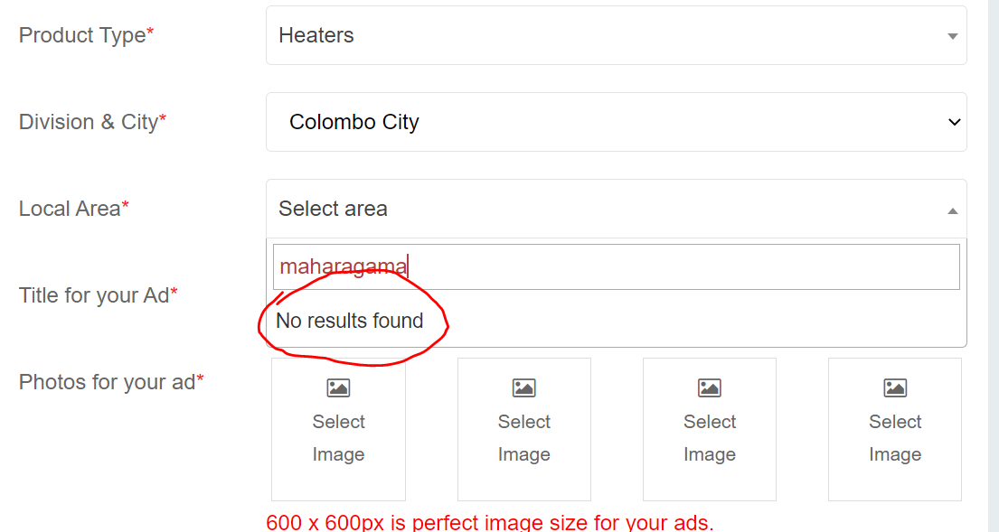

* Number of images minimum 6 to 8
* Image size to be properly defined

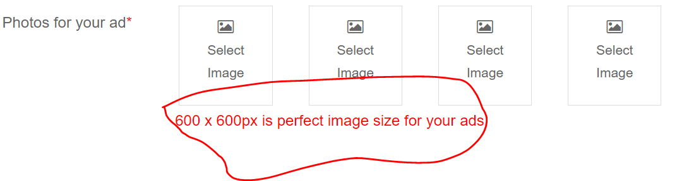

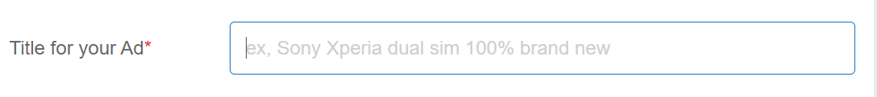

**Cities**

* Cities limited to 20 to be expandable to 25
* I have entered area more than 20 but display only 10, there are some issue in

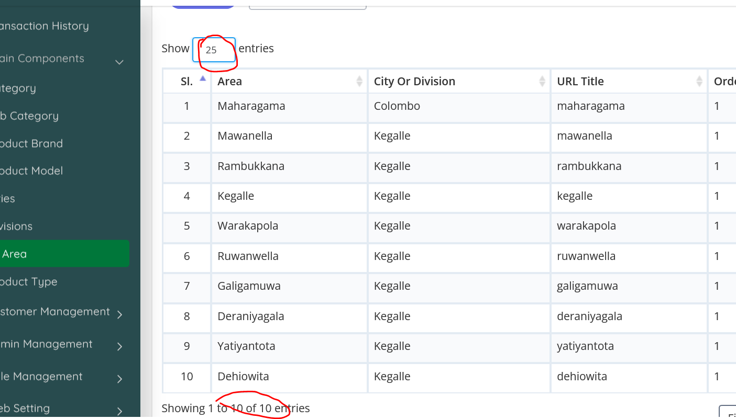

**Creating Brand**

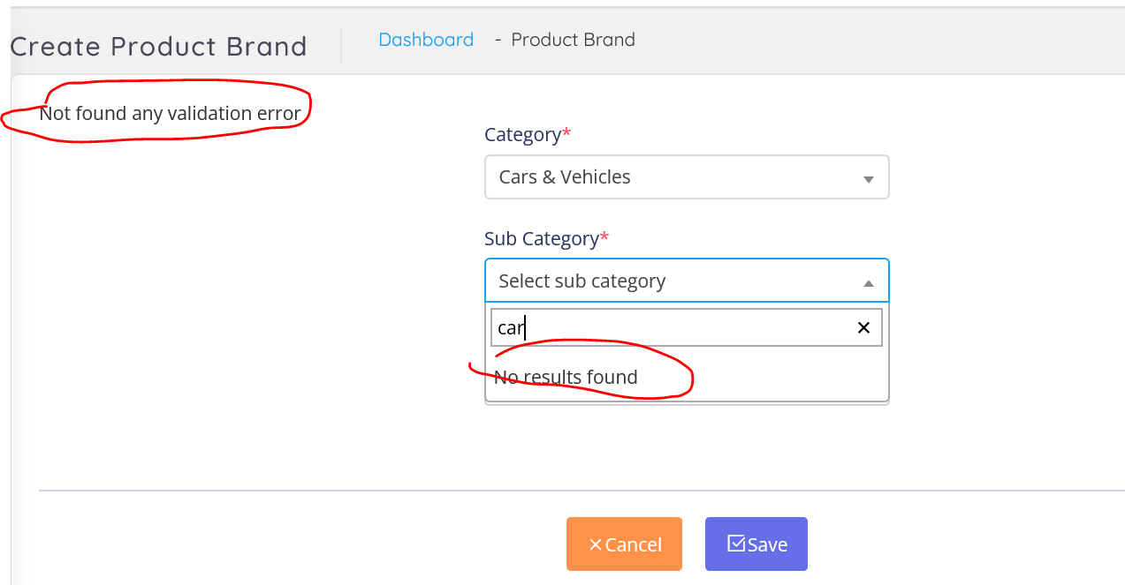

**Main Categories**

1. Property
2. Jobs & Work Overseas
3. ~~Mobiles~~
4. Home Appliances
5. Cars & Vehicles
6. Electronics
7. Fashion & Beauty
8. Pets & Animals
9. Matrimony Services
10. Books & Magazines
11. Essential
12. Miscellaneous
13. Electronics
14. Business & Industry
15. Services
16. Hobby, Sport & Kids
17. Education
18. **Property -subcategories**

* Land
* Houses For Sale
* House Rentals
* Apartment Rentals
* Room & Annex Rentals
* Commercial Property Rentals
* Holiday & Short-Term Rental
* Apartments For Sale
* Commercial Properties For Sale

1. **Home Appliances**

* Furniture
* Kitchen items
* Other Home Items
* Building Material & Tools
* Garden
* Home Decor
* Bathroom & Sanitary ware
* Refrigerators & Freezers (0)
* Living Room Furniture (0)
* Kitchen & Dining Furniture (0)
* Bedroom Furniture (0)
* Office & Shop Furniture (0)
* Children's Furniture (0)
* ACs & Home Electronics (0)
* Household Items (0)
* Home Textiles & Decoration (0)

1. **Electronics**

* Mobile Phones
* Computer Accessories
* Computers & Tablets
* Mobile Phone Accessories
* Electronic Home Appliances
* Audio & MP3
* Other Electronics
* Air Conditions & Electrical fittings
* Cameras & Camcorders
* TVs
* Video Games & Consoles
* TV & Video Accessories

1. **Cars & Vehicles**

* Auto Parts & Accessories
* Motorbikes
* Bicycles
* Cars
* Three Wheelers
* Auto Services
* Lorries & Trucks
* Rentals
* Vans
* Heavy Duty
* Tractors
* Buses
* Boats & Water Transport

1. **Business & Industry**

* Industry Tools & Machinery
* Solar & Generators
* Office Equipment, Supplies & Stationery
* Other Business Services
* Raw Materials & Wholesale Lots
* Healthcare, Medical Equipment & Supplies
* Licences & Titles

1. **Pets and Animals**

* Pets
* Animal Accessories
* Farm Animals
* Veterinary Services
* Pet Food
* Other Animals

1. **Services**

* Trade Services
* Domestic Services
* Other Services
* Events & Entertainment
* Health & Wellbeing
* Travel & Tourism

1. **Hobby, Sport & Kids**

* Musical Instruments
* Sports & Fitness
* Art & Collectibles
* Children's Items
* Other Hobby, Sport & Kids Items
* Music, Books & Movies
* Sports Supplements
* Travel, Events & Tickets

1. **Fashion & Beauty**

* Clothing
* Beauty Products
* Watches
* Jewellery
* Shoes & Footwear
* Bags & Luggage
* Sunglasses & Opticians
* Other Fashion Accessories
* Other Personal Items

1. **Education**

* Tuition
* Other Education
* Textbooks
* Vocational Institutes
* Higher Education

1. **Essentials**

* Gas
* Grocery
* Healthcare
* Fruits & Vegetables
* Household
* Other Essentials
* Baby Products
* Meat & Seafood

1. **Agriculture**

* Crops, Seeds & Plants
* Other Agriculture
* Farming Tools & Machinery

1. **Work Overseas**

* Overseas Jobs
* Study & Work Abroad

Districts and Cities

1. **Colombo**

Maharagama

Nugegoda

Dehiwala

Piliyandala

Colombo 3

Kottawa

Homagama

Kaduwela

Colombo 6

Boralesgamuwa

Battaramulla

Malabe

Moratuwa

Athurugiriya

Rajagiriya

Colombo 5

Talawatugoda

Pannipitiya

Wellampitiya

Padukka

Colombo

Meegoda

Colombo 4

Colombo 11

Colombo 10

Mount Lavinia

Kotte

Colombo 9

Ratmalana

Nawala

Colombo 14

Angoda

Kolonnawa

Colombo

Godagama

Kesbewa

Hanwella

Colombo 2

Kohuwala

Colombo 13

Avissawella

Colombo 12

Colombo 7

Colombo 1

1. **Gampaha**

Gampaha City

Negombo

Kiribathgoda

Wattala

Kadawatha

Ja-Ela

Kelaniya

Delgoda

Nittambuwa

Minuwangoda

Katunayake

Ragama

Seeduwa

Kandana

Ganemulla

Veyangoda

Divulapitiya

Mirigama

1. **Kandy**

Kandy City

Gampola

Katugastota

Peradeniya

Akurana

Pilimatalawa

Gelioya

Digana

Kundasale

Nawalapitiya

Galagedara

Wattegama

Madawala Bazaar

Ampitiya

Kadugannawa

Menikhinna

1. **[Kalutara](https://ikman.lk/en/ads/kalutara)**

Horana

Kalutara City

Panadura

Wadduwa

Matugam

Bandaragama

Alutgama

Beruwala

Ingiriya

1. **[Kurunegala](https://ikman.lk/en/ads/kurunegala)**

Kurunegala City

Kuliyapitiya

Narammala

Wariyapola

Polgahawela

Ibbagamuwa

Pannala

Mawathagama

Nikaweratiya

Alawwa

Hettipola

Giriulla

Galgamuwa

Bingiriya

1. **Galle**

Galle City

Ambalangoda

Bentota

Elpitiya

Baddegama

Hikkaduwa

Karapitiya

Ahangama

Batapola

1. **Ratnapura**

Ratnapura City

Embilipitiya

Balangoda

Pelmadulla

Eheliyagoda

Kuruwita

1. **Matara**

Matara City

Dikwella

Akuressa

Weligama

Hakmana

Deniyaya

Kamburupitiya

Kekanadurra

Kamburugamuwa

Gandara

1. **Puttalam**

Puttalam City

Chilaw

Wennappuwa

Nattandiya

Dankotuwa

Marawila

Anamaduwa

1. **Anuradhapura**

Anuradhapura City

Kekirawa

Medawachchiya

Tambuttegama

Eppawala

Mihintale

Habarana

Galnewa

Nochchiyagama

Galenbindunuwewa

Talawa

1. **Kegalle**

Kegalle City

Mawanella

Warakapola

Ruwanwella

Rambukkana

Galigamuwa

Deraniyagala

Yatiyantota

Dehiowita

Kitulgala

1. **Jaffna**

Jaffna City

Nallur

Chavakachcheri

1. **Hambantota**

Tangalla

Beliatta

Hambantota City

Ambalantota

Tissamaharama

1. **Ampara**

Akkarepattu (983)

Ampara City (926)

Kalmunai (702)

Sainthamaruthu (310)

1. **Badulla**

Badulla City

Bandarawela

Mahiyanganaya

Welimada

Haputale

Passara

Hali Ela

Diyatalawa

Ella

1. **Batticaloa**

Batticaloa City

1. **Matale**

Matale City

Dambulla

Galewela

Ukuwela

Rattota

Pallepola

Palapathwela

Yatawatta

Sigiriya

1. **Trincomalee**

Trincomalee City

Kinniya

1. **Polonnaruwa**

Polonnaruwa City

Kaduruwela

Hingurakgoda

Medirigiriya

1. **Monaragala**

Monaragala City

Wellawaya

Bibile

Buttala

Kataragama

1. **Nuwara Eliya**

Nuwara Eliya City

Hatton

Ginigathhena

Madulla

1. **Vavuniya**

Vavuniya City

1. **Kilinochchi**

Kilinochchi City

1. **Mannar**

Mannar City

1. **Mullativu**

Mullativu City