**Requirements**

1. Privacy policy is not updating from admin panel
2. Ads posting a type select radio button color change 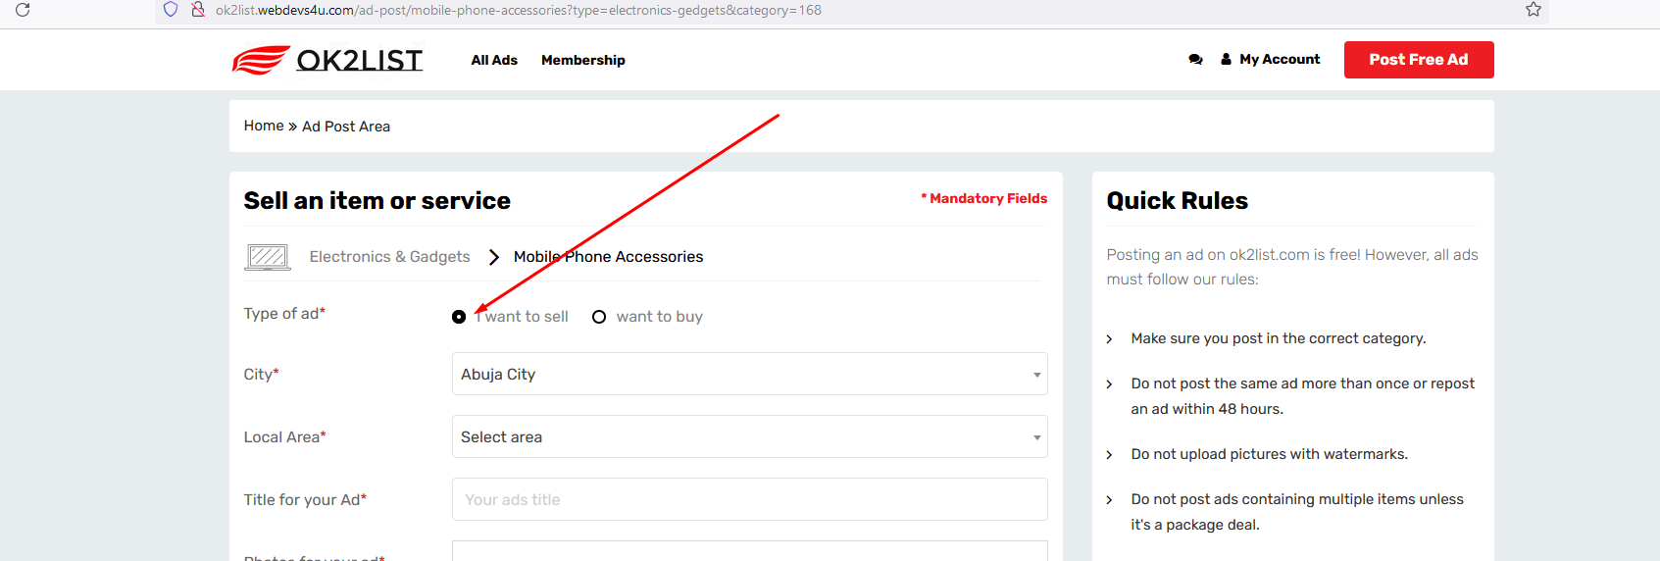
3. Static data & color need to changeGraphical user interface, application, website, Teams

   Description automatically generated
4. Color need to change Graphical user interface, text, application, email

   Description automatically generated
5. It is not selected Graphical user interface, application

   Description automatically generated
6. All ads are going under doorstep delivery & edit mode a selected thakse na
7. Read button asbe minimum 400 word pore Graphical user interface, application, Teams

   Description automatically generated
8. Select city Graphical user interface, chart, line chart

   Description automatically generated
9. Section move to 