1. Seller own shop page linkGraphical user interface, text, email, website

   Description automatically generated
2. Ads Graphical user interface, text, application, email, website

   Description automatically generated
3. Language issue check
4. Related icons 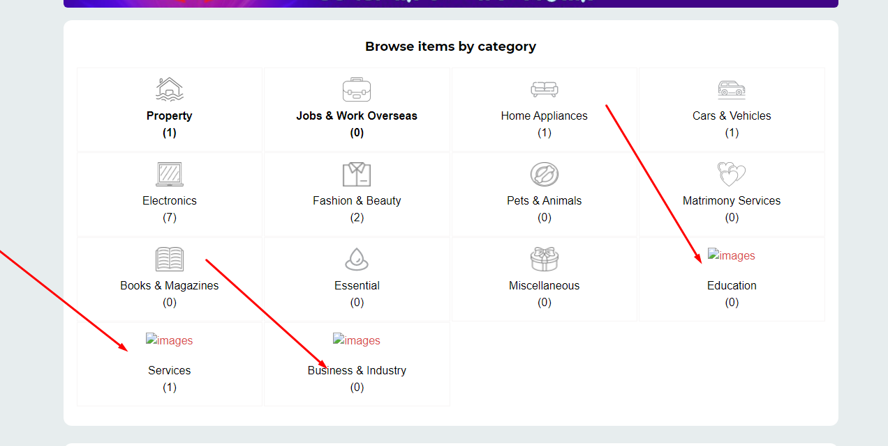
5. Admin panel a demo image update Graphical user interface, text, application, email

   Description automatically generated
6. Need to do dynamic Graphical user interface, text, application

   Description automatically generated
7. Footer section dynamic Graphical user interface, application

   Description automatically generated
8. Copyright dynamic Graphical user interface, website

   Description automatically generated with medium confidence
9. All category akhane asbe 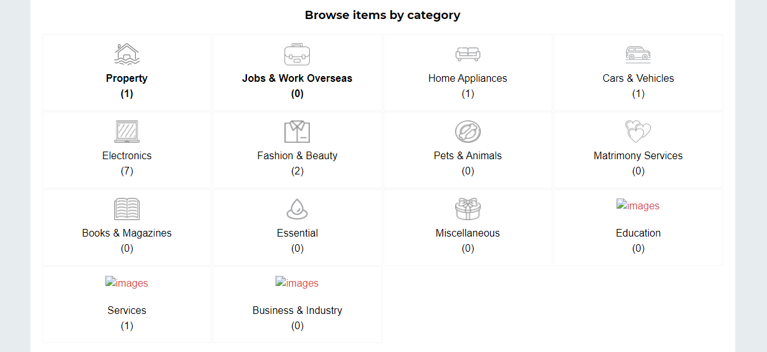
10. There is no email communication system with user, this is agreed scope.
11. Views, telephone, like chat Graphical user interface

    Description automatically generated

**13 December, 2022**

1. Product cart design Graphical user interface, application

   Description automatically generated
2. User dashboard design
3. Container width
4. User dashboard menu as like adlisting
5. Overview menu 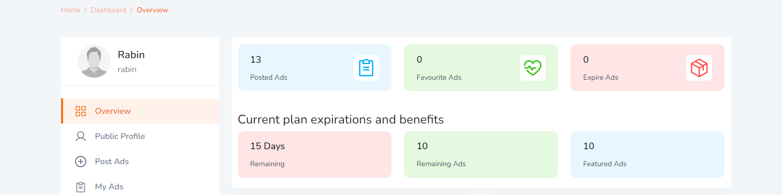
6. Ads alignment Graphical user interface

   Description automatically generated with medium confidence