**Panhandlehub.org**

**Classified Website**

Reference design: <https://www.ukclassifieds.co.uk/>

Functionalities: <https://www.craigslist.org/>

Paid Ads as like: 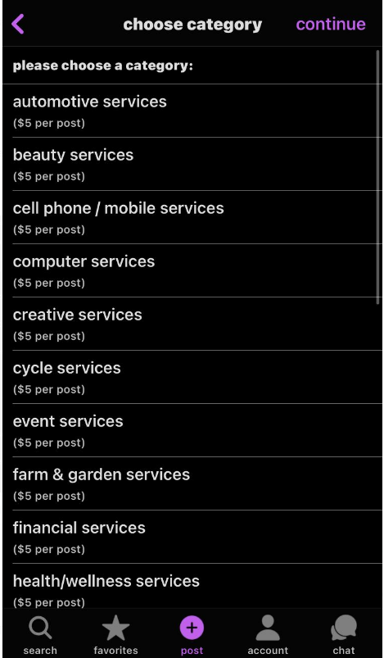

**13 March, 2023**

1. Related items static 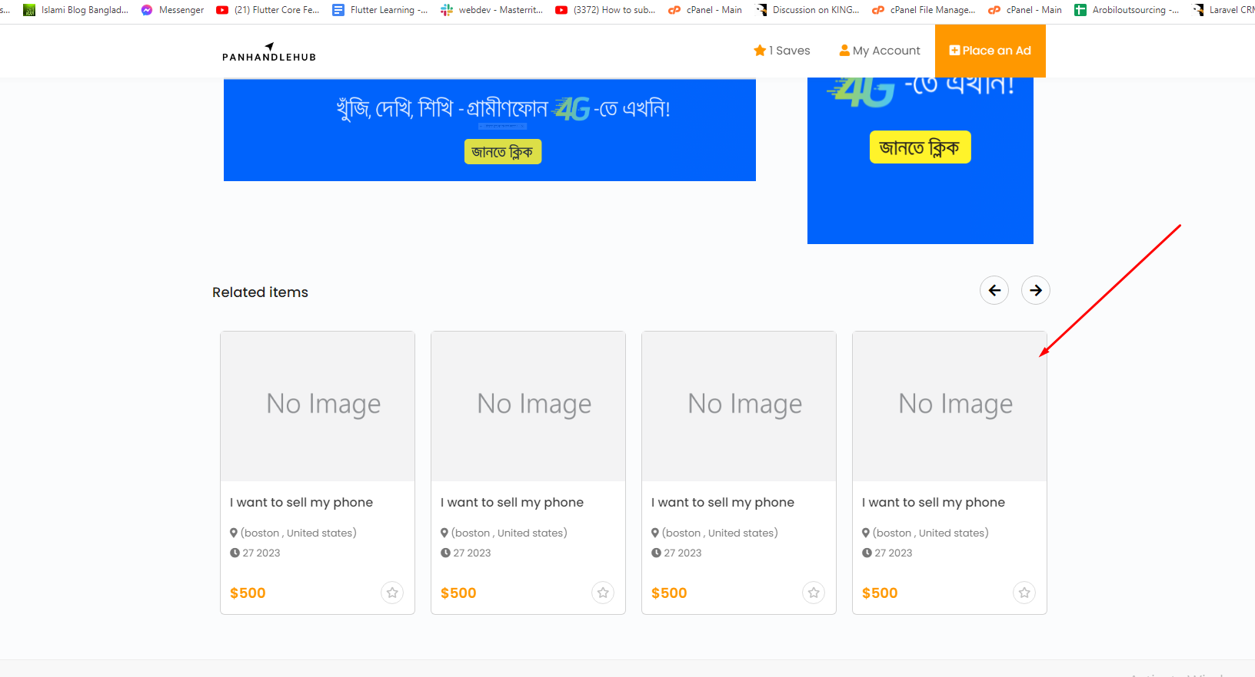
2. Has not link 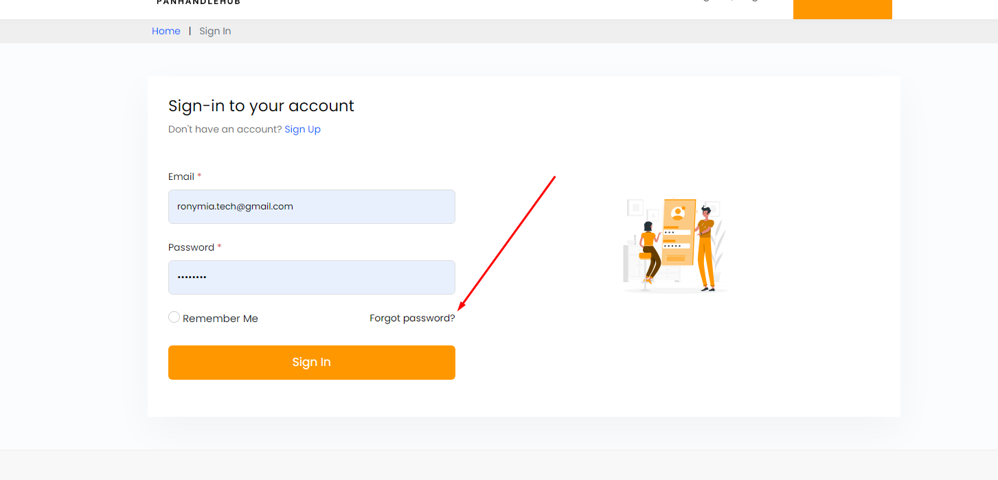
3. Message need to give in center & password less option ta thakbe na, post korar jonno first login required Graphical user interface

   Description automatically generated
4. New user dia registration korar por existing user ar transaction list, kindly check properly 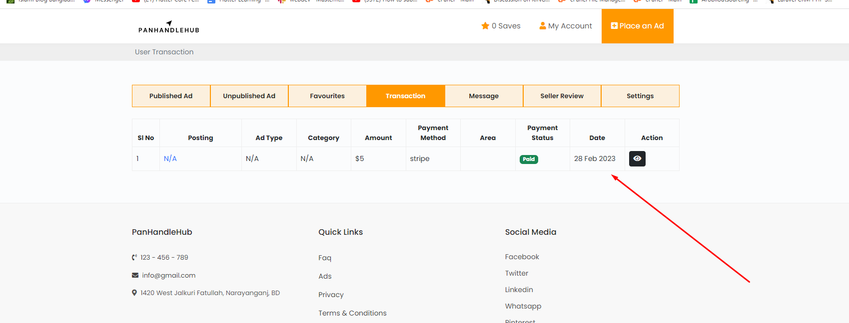
5. Mozila te kaj kore na Graphical user interface

   Description automatically generated
6. Review system 
7. Registration ar somoy je username use hosse ota hobe Graphical user interface, application, email

   Description automatically generated
8. Unseen message hole count asbe akhane and header a chat icon hobe Graphical user interface, application

   Description automatically generated
9. Error message tab 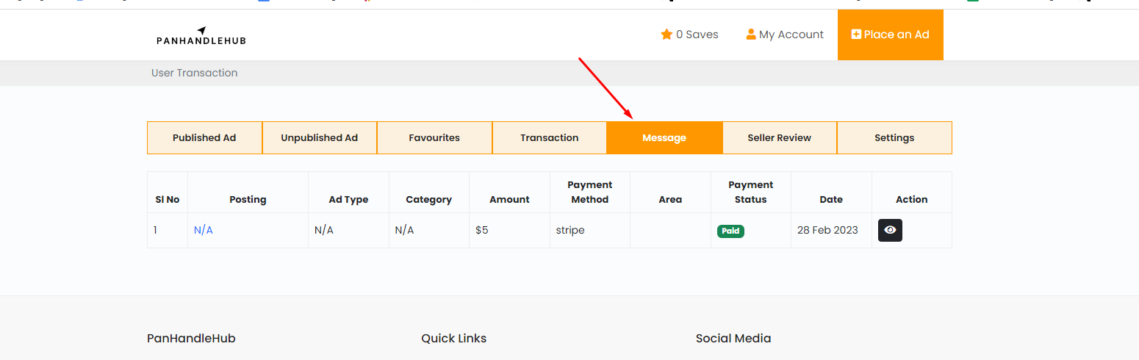Graphical user interface, text, application

   Description automatically generated