[DRAFTING NOTE: This is a draft for the deponent. The measurements were made with the formguard software from the affidavit as filed and the portal originals. The deponent must check every finding against the annexed images before swearing. The figures quoted in the findings were read from the annexed images in preparing this draft, and paragraph 15 states that the deponent read them, so the deponent must confirm each reading. Matters in square brackets are for the deponent to complete.]
REPUBLIC OF KENYA
IN THE SUPREME COURT OF KENYA AT NAIROBI
PRESIDENTIAL ELECTION PETITION NO. E005 OF 2022 (as consolidated with Petition Nos. E001, E002, E003, E004, E007 and E008 of 2022)
RAILA AMOLO ODINGA … 1st Petitioner; MARTHA WANGARI KARUA … 2nd Petitioner
VERSUS
INDEPENDENT ELECTORAL AND BOUNDARIES COMMISSION … 1st Respondent; WANYONYI WAFULA CHEBUKATI … 2nd Respondent; BOYA MOLU … 3rd Respondent; PROF. ABDI YAKUB GULIYE … 4th Respondent; JULIANA WHONGE CHERERA … 5th Respondent; JUSTUS NYANG'AYA … 6th Respondent; FRANCIS WANDERI … 7th Respondent; IRENE MASIT … 8th Respondent; WILLIAM SAMOEI RUTO … 9th Respondent
AFFIDAVIT OF [DEPONENT NAME] ON THE FORENSIC EXAMINATION OF THE FORMS 34A ANNEXED TO THE AFFIDAVIT OF ARNOLD OCHIENG OGINGA SWORN ON 19TH AUGUST 2022
I, [DEPONENT NAME], of [ADDRESS] in the Republic of Kenya, do hereby make oath and state as follows:
1. THAT I am [PROFESSION AND QUALIFICATIONS: forensic document or digital image examiner; years in practice; training; previous testimony], and I am competent to swear this affidavit.
2. THAT I was instructed by [INSTRUCTING PARTY] to examine the Forms 34A annexed to the affidavit of Arnold Ochieng Oginga sworn at Nairobi on 19th August 2022, and to state whether they agree with the Forms 34A that the 1st Respondent published on its public portal.
3. THAT my duty is to this Honourable Court. Where a statement below is my opinion rather than a measurement, I say so.
MATERIALS EXAMINED
4. THAT I examined the affidavit of Arnold Ochieng Oginga in the form in which it was filed, being a PDF file of 132 pages and 51,053,652 bytes with the SHA-256 hash value a6886ef9542d2b576f14965e656a8a50ff3f3bc2b7dae33545bf67da93d04057. A SHA-256 hash value is computed from the exact content of a file, and any change to the file changes it. The Forms 34A annexed to the affidavit appear on pages 46 to 131 of that file. Each is a photograph of a printed Form 34A. Most bear the handwritten caption "IEBC PORTAL" or "AGENT COPY", and one bears the caption "IEBC (INITIAL) PORTAL".
5. THAT as reference originals I used the Forms 34A published on the 1st Respondent's public portal, as contained in the following six county archive files:
Archive | County | Forms 34A | SHA-256
1_34_0300000000000.zip | Baringo | 1,032 | 416b05a7593c793ccc97c78b4639b03f559cf0ba2221b3f6efd3714568454abb
1_34_0470000000000.zip | Nairobi | 3,650 | 1d3b645c3cd7c3b8c38b3fe7ef29ca87ec64490b1638bb12b10a4c0a914d413e
1_34_0010000000000.zip | Mombasa | 1,045 | 0d68fe3c5ddd1c145680ab820f3e6b9e5c53db3fa4de487d10d3be9d7fbf936f
1_34_0180000000000.zip | Nyandarua | 728 | 44fd088fa21127d5ceaa491050aaebbdbc9051ee6d82433cd5bd15b8806f4e0d
1_34_0210000000000.zip | Murang'a | 1,189 | 7e39f63eebfeab65992bf558d48f5ed356c38d668e77c111ec73b9c476c5f6d6
1_34_0220000000000.zip | Kiambu | 2,117 | b4953b35cc272c14d2a1a5f534dc506909064bdd3b9e69a070fb046f43b3ce6e

6. THAT from these archives I took every Form 34A of Tiaty Constituency (183 forms) and of Kitisuru Ward in Westlands Constituency (44 forms). For the annexed pages from other counties I took every Form 34A of Mjambere Ward in Kisauni Constituency (34 forms) and of Ol Kalou (142), Ol Joro Orok (120), Kiharu (221) and Gatundu South (152) Constituencies. That gave 896 candidate originals in all. The files in the archives bear dates between 9th and 11th August 2022. [DEPONENT TO STATE HOW AND WHEN THE ARCHIVES WERE OBTAINED FROM THE 1ST RESPONDENT'S PORTAL.]
7. THAT each Form 34A on the portal is a PDF file bearing a digital signature applied when the form was transmitted from the KIEMS kit. The signing certificate was issued by "CA_APPS" of Smartmatic International, and the signature uses the SHA-1 digest. I validated the signature of every original I relied on and give the result for each in my findings.
8. THAT I have read paragraphs 38 to 51 of the affidavit of Moses Ledama Sunkuli, which state that these annexures are not genuine copies of the Forms 34A. I carried out my examination independently of those paragraphs.
METHOD
9. THAT I examined each annexed page in the steps set out in this and the following six paragraphs. Each step can be repeated with the same files and the software I used, which I produce as annexure [XX]-1. I first identified the original of each annexed page. I compared the page with every candidate original using image features that are unaffected by changes of scale, rotation and camera angle. All Forms 34A share one printed layout, so every candidate matches a page to some degree. The original of a page is distinguished by its handwriting, signatures and stamps, which add several hundred further matching points. I accepted a match only where it was strong and at least twice as strong as the next best candidate.
10. THAT I then aligned each annexed page with its original by a geometric transformation that removes differences of size, angle, cropping and perspective, followed by a smooth correction for the curl of the paper. The correction is measured over areas several times the size of a figure and cannot move a single figure, so it cannot conceal an alteration. I compared only the paper of each image and excluded the desk or other background visible around a photographed sheet.
11. THAT I then corrected the two images for differences of paper tone, contrast and sharpness, area by area, since a photograph is not equally sharp across the sheet. I compared every mark on the form, that is each digit, letter and stroke, with the same place on the other image, using a correlation measure that is unaffected by brightness and contrast. The measure runs from −1 to 1, and an unchanged mark scores close to 1. I measured every figure containing a doubtful mark again in windows the size of a single digit, so that a changed digit is measured on its own even where it touches the next one. A figure scoring below 0.5 differs from the original. A figure scoring between 0.5 and 0.65 may differ, as when a 3 is made from an 8, and I report it as differing only where it reads differently on the two images. For each figure that differs I prepared an image showing the original and the annexed page side by side.
12. THAT photographs of printed copies often lose the grey printed lettering of a form while the handwritten entries remain dark. So as not to mistake faded print for an alteration, I identified the printed parts of each original by overlaying other Forms 34A on it, since the print is common to all of them while the handwritten entries are not. I did not count faded print, marks that are present but fainter, or marks added to a copy for the court bundle, such as captions, page numbers and stamps, as differences in the entries.
13. THAT a Form 34A is a single sheet of paper, and every photograph or scan of it is a separate capture with its own framing, lighting and background. Two separate captures of the same sheet share its handwriting and stamps but not those features of the capture. An image made from a capture, whether by printing, re-photographing or editing it, carries them over. For each annexed page I therefore measured the proportion of the original's marks that it reproduces in place, and the correlation between the background visible beyond the edge of the sheet in the original and the same area of the annexed page. Read with the comparison, these measurements distinguish four cases. Where the figures agree and the page carries the original's capture, the page is a copy of the portal image. Where the figures differ and the page carries the original's capture, the page was made from the portal image and its figures were changed. Where the figures differ and the page reproduces the original's handwriting but not its capture, it is another image of the same signed sheet with its figures changed. Where most of the original's marks are absent, the page is not a copy of that form.
14. THAT I recorded the SHA-256 hash value of each original and validated its digital signature, which shows whether the file has changed since it was signed.
15. THAT the figures I quote in my findings were read from the side-by-side images twice: by me, and independently by a vision language model run through Ollama Cloud. The two readings agree for 99 of the 104 figures I quote. Where they differ, I say so. The finding that a figure differs does not depend on how it is read.
SUMMARY OF FINDINGS
16. THAT I examined the annexed pages for 48 polling stations. I summarise my findings in the following table and set them out station by station in the paragraphs after it.
Polling station | PDF page | Caption | Result | How the page was made
Ngaina Primary School 1 of 1 | 47 | IEBC PORTAL | agrees with the original
Ngaina Primary School 1 of 1 | 72 | AGENT COPY | two figures differ | made from the portal photograph
Sukut Primary School 1 of 1 | 48 | IEBC PORTAL | agrees with the original
Sukut Primary School 1 of 1 | 73 | AGENT COPY | two figures differ | made from the portal photograph
Ngeleyo Pre-School 1 of 1 | 49 | IEBC PORTAL | agrees with the original
Ngeleyo Pre-School 1 of 1 | 74 | AGENT COPY | two figures differ | not determined
Ngoron Primary School 1 of 1 | 50 | IEBC PORTAL | agrees with the original
Ngoron Primary School 1 of 1 | 75 | AGENT COPY | three figures differ | made from the portal photograph
Kapenguria Primary School 1 of 1 | 51 | IEBC PORTAL | agrees with the original
Kapenguria Primary School 1 of 1 | 76 | AGENT COPY | three figures differ | shows the same sheet
Ptikii Primary School 1 of 1 | 52 | IEBC PORTAL | agrees with the original
Ptikii Primary School 1 of 1 | 77 | AGENT COPY | three figures differ | made from the portal photograph
Oronto Kreeze Primary School 1 of 1 | 53 | IEBC PORTAL | agrees with the original
Oronto Kreeze Primary School 1 of 1 | 78 | AGENT COPY | three figures differ | not determined
Embositit Pre-School 1 of 1 | 54 | IEBC PORTAL | agrees with the original
Embositit Pre-School 1 of 1 | 79 | AGENT COPY | three figures differ | not determined
Adomeyon Nursery School 1 of 1 | 55 | IEBC PORTAL | agrees with the original
Adomeyon Nursery School 1 of 1 | 80 | AGENT COPY | two figures differ | shows the same sheet
Rotii Primary School 1 of 1 | 56 | IEBC PORTAL | agrees with the original
Rotii Primary School 1 of 1 | 81 | AGENT COPY | three figures differ | shows the same sheet
Kimnyan Primary School 1 of 1 | 57 | IEBC PORTAL | agrees with the original
Kimnyan Primary School 1 of 1 | 82 | AGENT COPY | three figures differ | made from the portal photograph
Kong'or Village Mobile 1 of 1 | 58 | IEBC PORTAL | agrees with the original
Kong'or Village Mobile 1 of 1 | 83 | AGENT COPY | three figures differ | made from the portal photograph
Kamrio Primary School 1 of 1 | 59 | IEBC PORTAL | agrees with the original
Kamrio Primary School 1 of 1 | 84 | AGENT COPY | three figures differ | shows the same sheet
Kapau Pre-School 1 of 1 | 60 | IEBC PORTAL | agrees with the original
Kapau Pre-School 1 of 1 | 85 | AGENT COPY | two figures differ | shows the same sheet
Kapedo Primary School 1 of 1 | 61 | IEBC PORTAL | agrees with the original
Kapedo Primary School 1 of 1 | 86 | AGENT COPY | three figures differ | not determined
Chesawach Primary School 1 of 1 | 62 | IEBC PORTAL | agrees with the original
Chesawach Primary School 1 of 1 | 87 | AGENT COPY | three figures differ | shows the same sheet
Korelach Primary School 1 of 1 | 63 | IEBC PORTAL | agrees with the original
Korelach Primary School 1 of 1 | 88 | AGENT COPY | three figures differ | not determined
Kamsino Primary School 1 of 1 | 64 | IEBC PORTAL | agrees with the original
Kamsino Primary School 1 of 1 | 89 | AGENT COPY | three figures differ | shows the same sheet
Chemayes Primary School 1 of 1 | 65 | IEBC PORTAL | agrees with the original
Chemayes Primary School 1 of 1 | 90 | AGENT COPY | two figures differ | shows the same sheet
Takawya Primary School 1 of 1 | 66 | IEBC PORTAL | agrees with the original
Takawya Primary School 1 of 1 | 91 | AGENT COPY | three figures differ | made from the portal photograph
Kangiruru Primary School 1 of 1 | 67 | IEBC PORTAL | agrees with the original
Kangiruru Primary School 1 of 1 | 92 | AGENT COPY | three figures differ | shows the same sheet
Domo Primary School 1 of 1 | 68 | IEBC PORTAL | agrees with the original
Domo Primary School 1 of 1 | 93 | AGENT COPY | three figures differ | shows the same sheet
Chepkirial Primary School 1 of 1 | 69 | IEBC PORTAL | agrees with the original
Chepkirial Primary School 1 of 1 | 94 | AGENT COPY | two figures differ | shows the same sheet
Koipasiran Village 1 of 1 | 70 | IEBC PORTAL | agrees with the original
Koipasiran Village 1 of 1 | 95 | AGENT COPY | two figures differ | made from the portal photograph
Barbello Primary School 1 of 1 | 71 | IEBC [word struck out] COPY | agrees with the original
Barbello Primary School 1 of 1 | 96 | AGENT COPY | two figures differ | not determined
Kabete Vetlab Primary School 1 of 12 | 97 | IEBC PORTAL | agrees with the original
Kabete Vetlab Primary School 2 of 12 | 98 | IEBC PORTAL | agrees with the original
Kabete Vetlab Primary School 2 of 12 | 112 | AGENT COPY | two figures differ | not determined
Kabete Vetlab Primary School 3 of 12 | 99 | IEBC PORTAL | agrees with the original
Kabete Vetlab Primary School 3 of 12 | 113 | AGENT COPY | three figures differ | not determined
Kabete Vetlab Primary School 4 of 12 | 100 | IEBC PORTAL | agrees with the original
Kabete Vetlab Primary School 5 of 12 | 101 | IEBC PORTAL | agrees with the original
Kabete Vetlab Primary School 5 of 12 | 114 | AGENT COPY | two figures differ | shows the same sheet
Kabete Vetlab Primary School 6 of 12 | 102 | IEBC PORTAL | agrees with the original
Kabete Vetlab Primary School 6 of 12 | 115 | AGENT COPY | three figures differ | made from the portal photograph
Kabete Vetlab Primary School 7 of 12 | 103 | IEBC PORTAL | agrees with the original
Kabete Vetlab Primary School 7 of 12 | 116 | AGENT COPY | three figures differ | shows the same sheet
Kabete Vetlab Primary School 8 of 12 | 104 | IEBC PORTAL | agrees with the original
Kabete Vetlab Primary School 8 of 12 | 117 | AGENT COPY | three figures differ | shows the same sheet
Kabete Vetlab Primary School 9 of 12 | 105 | IEBC PORTAL | agrees with the original
Kabete Vetlab Primary School 9 of 12 | 118 | AGENT COPY | three figures differ | shows the same sheet
Kabete Vetlab Primary School 10 of 12 | 106 | IEBC PORTAL | agrees with the original
Kabete Vetlab Primary School 10 of 12 | 119 | AGENT COPY | three figures differ | shows the same sheet
Kabete Vetlab Primary School 11 of 12 | 107 | IEBC PORTAL | agrees with the original
Kabete Vetlab Primary School 11 of 12 | 120 | AGENT COPY | three figures differ | shows the same sheet
Kabete Vetlab Primary School 12 of 12 | 108 | IEBC PORTAL | agrees with the original
St Martin's School Kibarage 1 of 7 | 109 | IEBC PORTAL | agrees with the original
St Martin's School Kibarage 1 of 7 | 121 | AGENT COPY | three figures differ | shows the same sheet
St Martin's School Kibarage 2 of 7 | 110 | IEBC PORTAL | agrees with the original
St Martin's School Kibarage 2 of 7 | 122 | AGENT COPY | three figures differ | made from the portal photograph
St Martin's School Kibarage 3 of 7 | 111 | IEBC PORTAL | agrees with the original
St Martin's School Kibarage 3 of 7 | 123 | AGENT COPY | three figures differ | shows the same sheet
St Martin's School Kibarage 4 of 7 | 124 | AGENT COPY | one figure differs | not determined
Kadongo Grounds - Mishomoroni 2 of 9 | 46 | none | agrees with the original
Gichungo Primary 2 of 2 | 125 | IEBC PORTAL | agrees with the original
Simba Primary 1 of 1 | 126 | IEBC PORTAL | agrees with the original
Ol Joro Orok Primary 2 of 5 | 127 | none | agrees with the original
Lesirko Primary 2 of 2 | 128 | none | agrees with the original
Maragi Primary School 1 of 4 | 129 | AGENT COPY | agrees with the original
Kagera Primary School 1 of 2 | 130 | IEBC PORTAL | agrees with the original
Kagera Primary School 1 of 2 | 131 | IEBC (INITIAL) PORTAL | three figures differ | not determined

FINDINGS FOR EACH POLLING STATION
Ngaina Primary School polling station 1 of 1, Tiaty Constituency, Baringo County
17. THAT the affidavit of Arnold Ochieng Oginga deals with this polling station at paragraph 17 and in the table at pages 8 to 13. According to the table, the agent's Form 34A shows Raila Odinga 88 and William Ruto 2, and the portal form shows Raila Odinga 88 and William Ruto 7. The affidavit gives the increase for William Ruto as 5 votes.
18. THAT the original of this form is the file 1_34_A_030157078100101_F230450M00200401_20220810_044040.PDF, of 194,699 bytes, with the SHA-256 hash value 2fdb7044105f4cd423cdbceb1cffc9c141b7abb9a2c4be97d1f9639f64f968ef. Its digital signature was applied on 10th August 2022 at 04:40:40 East Africa Time. The signature validates as intact and covers the whole file, so the file has not changed since it was signed.
19. THAT the page at PDF page 47 (annexure page 46), captioned "IEBC PORTAL", shows this form. It matches the original at 1,361 image features and reproduces 68% of its 386 marks in place. The background beyond the edge of the sheet correlates with that of the original at 0.35. Its entries agree with those of the original.
20. THAT the page at PDF page 72 (annexure page 71), captioned "AGENT COPY", shows this form. It matches the original at 755 image features and reproduces 94% of its 303 marks in place. The background beyond the edge of the sheet correlates with that of the original at 0.55. It differs from the original in two figures, shown in annexure [XX]-2. The figure for the votes of William Ruto reads 007 on the original and 002 on the page, with a similarity of 0.48. The figure for the total number of valid votes cast in the polling station counts reads 097 on the original and 090 on the page, with a similarity of 0.01.
21. THAT in my opinion this page was made from the same photograph as the portal original and not from a separate photograph of the form or from a carbon copy. It reproduces the original's handwriting, signatures and stamps in place, together with the background of that photograph beyond the edge of the sheet. The figures listed in the preceding paragraph were therefore changed on a copy of the portal image.
Sukut Primary School polling station 1 of 1, Tiaty Constituency, Baringo County
22. THAT the affidavit of Arnold Ochieng Oginga deals with this polling station at paragraph 17 and in the table at pages 8 to 13. According to the table, the agent's Form 34A shows Raila Odinga 195 and William Ruto 1, and the portal form shows Raila Odinga 195 and William Ruto 2. The affidavit gives the increase for William Ruto as 1 vote.
23. THAT the original of this form is the file 1_34_A_030157078100201_Y3KK12CQAIA00F8_20220810_015453.PDF, of 372,532 bytes, with the SHA-256 hash value 9dce66e97c697666e726f674d7662a74a460cb7406dd376ce82300e7822e1872. Its digital signature was applied on 10th August 2022 at 01:54:53 East Africa Time. The signature validates as intact and covers the whole file, so the file has not changed since it was signed.
24. THAT the page at PDF page 48 (annexure page 47), captioned "IEBC PORTAL", shows this form. It matches the original at 1,475 image features and reproduces 95% of its 683 marks in place. The background beyond the edge of the sheet correlates with that of the original at 0.32. Its entries agree with those of the original.
25. THAT the page at PDF page 73 (annexure page 72), captioned "AGENT COPY", shows this form. It matches the original at 914 image features and reproduces 98% of its 539 marks in place. The background beyond the edge of the sheet correlates with that of the original at 0.55. It differs from the original in two figures, shown in annexure [XX]-3. The figure for the votes of William Ruto reads 002 on the original and 001 on the page, with a similarity of −0.01. The figure for the total number of valid votes cast in the polling station counts reads 197 on the original and 196 on the page, with a similarity of −0.32.
26. THAT in my opinion this page was made from the same photograph as the portal original and not from a separate photograph of the form or from a carbon copy. It reproduces the original's handwriting, signatures and stamps in place, together with the background of that photograph beyond the edge of the sheet. The figures listed in the preceding paragraph were therefore changed on a copy of the portal image.
Ngeleyo Pre-School polling station 1 of 1, Tiaty Constituency, Baringo County
27. THAT the affidavit of Arnold Ochieng Oginga deals with this polling station at paragraph 17 and in the table at pages 8 to 13. According to the table, the agent's Form 34A shows Raila Odinga 85 and William Ruto 33, and the portal form shows Raila Odinga 85 and William Ruto 63. The affidavit gives the increase for William Ruto as 30 votes.
28. THAT the original of this form is the file 1_34_A_030157078100301_F230450M00209447_20220809_183250.PDF, of 163,713 bytes, with the SHA-256 hash value b64afcc46a49f5b5da158e30c3ad0dbfa9d053631a32e48d3d9186006de621f5. Its digital signature was applied on 9th August 2022 at 18:32:50 East Africa Time. The signature validates as intact and covers the whole file, so the file has not changed since it was signed.
29. THAT the page at PDF page 49 (annexure page 48), captioned "IEBC PORTAL", shows this form. It matches the original at 1,576 image features and reproduces 92% of its 418 marks in place. The background beyond the edge of the sheet correlates with that of the original at 0.46. Its entries agree with those of the original.
30. THAT the page at PDF page 74 (annexure page 73), captioned "AGENT COPY", shows this form. It matches the original at 1,008 image features and reproduces 89% of its 452 marks in place. The background beyond the edge of the sheet correlates with that of the original at 0.31. It differs from the original in two figures, shown in annexure [XX]-4. The figure for the votes of William Ruto reads 063 on the original and 033 on the page, with a similarity of −0.04. The figure for the total number of valid votes cast in the polling station counts reads 148 on the original and 115 on the page, with a similarity of 0.21. A further mark scored below 0.65 but reads the same on both images.
Ngoron Primary School polling station 1 of 1, Tiaty Constituency, Baringo County
31. THAT the affidavit of Arnold Ochieng Oginga deals with this polling station at paragraph 17 and in the table at pages 8 to 13. According to the table, the agent's Form 34A shows Raila Odinga 284 and William Ruto 32, and the portal form shows Raila Odinga 284 and William Ruto 60. The affidavit gives the increase for William Ruto as 28 votes.
32. THAT the original of this form is the file 1_34_A_030157078100401_Y3KK12CQDIA0096_20220810_073636.PDF, of 383,566 bytes, with the SHA-256 hash value c067466b51c0a43be601541fb30b5af7d39e3b53c76b52411b7b26b1ba633aee. Its digital signature was applied on 10th August 2022 at 07:36:37 East Africa Time. The signature validates as intact and covers the whole file, so the file has not changed since it was signed.
33. THAT the page at PDF page 50 (annexure page 49), captioned "IEBC PORTAL", shows this form. It matches the original at 1,813 image features and reproduces 93% of its 614 marks in place. The background beyond the edge of the sheet correlates with that of the original at 0.56. Its entries agree with those of the original.
34. THAT the page at PDF page 75 (annexure page 74), captioned "AGENT COPY", shows this form. It matches the original at 1,054 image features and reproduces 98% of its 608 marks in place. The background beyond the edge of the sheet correlates with that of the original at 0.72. It differs from the original in three figures, shown in annexure [XX]-5. The figure for the votes of William Ruto reads 060 on the original and 032 on the page, with a similarity of −0.01. The image cuts off the first digit of this figure, and the second reader read only the digits in view. The second reader read it as 0 on the original and 2 on the page. The figure for the total number of valid votes cast reads 345 on the original and 317 on the page, with a similarity of −0.26. The figure for the total number of valid votes cast in the polling station counts reads 345 on the original and 317 on the page, with a similarity of −0.31.
35. THAT in my opinion this page was made from the same photograph as the portal original and not from a separate photograph of the form or from a carbon copy. It reproduces the original's handwriting, signatures and stamps in place, together with the background of that photograph beyond the edge of the sheet. The figures listed in the preceding paragraph were therefore changed on a copy of the portal image.
Kapenguria Primary School polling station 1 of 1, Tiaty Constituency, Baringo County
36. THAT the affidavit of Arnold Ochieng Oginga deals with this polling station at paragraph 17 and in the table at pages 8 to 13. According to the table, the agent's Form 34A shows Raila Odinga 187 and William Ruto 1, and the portal form shows Raila Odinga 187 and William Ruto 2. The affidavit gives the increase for William Ruto as 1 vote.
37. THAT the original of this form is the file 1_34_A_030157078100501_F230450M00200633_20220809_195224.PDF, of 184,136 bytes, with the SHA-256 hash value b8084059135b4ea4e0b879bca975fded4414648f5e80f36d14e6ee44809a19c4. Its digital signature was applied on 9th August 2022 at 19:52:24 East Africa Time. The signature validates as intact and covers the whole file, so the file has not changed since it was signed.
38. THAT the page at PDF page 51 (annexure page 50), captioned "IEBC PORTAL", shows this form. It matches the original at 828 image features and reproduces 94% of its 450 marks in place. The background beyond the edge of the sheet correlates with that of the original at 0.20. Its entries agree with those of the original. One mark scored below 0.65 but reads the same on both images.
39. THAT the page at PDF page 76 (annexure page 75), captioned "AGENT COPY", shows this form. It matches the original at 554 image features and reproduces 92% of its 451 marks in place. The background beyond the edge of the sheet correlates with that of the original at 0.40. It differs from the original in three figures, shown in annexure [XX]-6. The figure for the votes of William Ruto reads 002 on the original and 001 on the page, with a similarity of 0.10. The figure for the total number of valid votes cast reads 190 on the original and 189 on the page, with a similarity of −0.13. The figure for the total number of valid votes cast in the polling station counts reads 190 on the original and 189 on the page, with a similarity of −0.09.
40. THAT in my opinion this page shows the same handwritten sheet as the portal original. Its handwriting, signatures and stamps coincide with those of the original in shape and position, and only the figures listed in the preceding paragraph differ.
Ptikii Primary School polling station 1 of 1, Tiaty Constituency, Baringo County
41. THAT the affidavit of Arnold Ochieng Oginga deals with this polling station at paragraph 17 and in the table at pages 8 to 13. According to the table, the agent's Form 34A shows Raila Odinga 299 and William Ruto 7, and the portal form shows Raila Odinga 299 and William Ruto 20. The affidavit gives the increase for William Ruto as 13 votes.
42. THAT the original of this form is the file 1_34_A_030157078100601_Y3KJ11BNHPZ0090_20220809_230231.PDF, of 299,016 bytes, with the SHA-256 hash value 18cbf16619b6b5952f2df64162d5bd396f651e3a2eb83b332e9cff7f7427c6ad. Its digital signature was applied on 9th August 2022 at 23:02:31 East Africa Time. The signature validates as intact and covers the whole file, so the file has not changed since it was signed.
43. THAT the page at PDF page 52 (annexure page 51), captioned "IEBC PORTAL", shows this form. It matches the original at 1,702 image features and reproduces 99% of its 822 marks in place. The background beyond the edge of the sheet correlates with that of the original at 0.28. Its entries agree with those of the original.
44. THAT the page at PDF page 77 (annexure page 76), captioned "AGENT COPY", shows this form. It matches the original at 945 image features and reproduces 97% of its 769 marks in place. The background beyond the edge of the sheet correlates with that of the original at 0.56. It differs from the original in three figures, shown in annexure [XX]-7. The figure for the votes of William Ruto reads 020 on the original and 007 on the page, with a similarity of −0.19. The figure for the total number of valid votes cast reads 321 on the original and 308 on the page, with a similarity of −0.32. The figure for the total number of valid votes cast in the polling station counts reads 321 on the original and 308 on the page, with a similarity of −0.17.
45. THAT in my opinion this page was made from the same photograph as the portal original and not from a separate photograph of the form or from a carbon copy. It reproduces the original's handwriting, signatures and stamps in place, together with the background of that photograph beyond the edge of the sheet. The figures listed in the preceding paragraph were therefore changed on a copy of the portal image.
Oronto Kreeze Primary School polling station 1 of 1, Tiaty Constituency, Baringo County
46. THAT the affidavit of Arnold Ochieng Oginga deals with this polling station at paragraph 17 and in the table at pages 8 to 13. According to the table, the agent's Form 34A shows Raila Odinga 205 and William Ruto 2, and the portal form shows Raila Odinga 205 and William Ruto 5. The affidavit gives the increase for William Ruto as 3 votes.
47. THAT the original of this form is the file 1_34_A_030157078100701_F230450M00203615_20220809_235203.PDF, of 185,723 bytes, with the SHA-256 hash value d53b0beb0ae3ab7e4bdae28582f264f607da9198d8d75e72959a008b560734be. Its digital signature was applied on 9th August 2022 at 23:52:03 East Africa Time. The signature validates as intact and covers the whole file, so the file has not changed since it was signed.
48. THAT the page at PDF page 53 (annexure page 52), captioned "IEBC PORTAL", shows this form. It matches the original at 971 image features and reproduces 88% of its 380 marks in place. The background beyond the edge of the sheet correlates with that of the original at 0.29. Its entries agree with those of the original.
49. THAT the page at PDF page 78 (annexure page 77), captioned "AGENT COPY", shows this form. It matches the original at 404 image features and reproduces 89% of its 369 marks in place. The background beyond the edge of the sheet correlates with that of the original at 0.30. It differs from the original in three figures, shown in annexure [XX]-8. The figure for the votes of William Ruto reads 005 on the original and 002 on the page, with a similarity of 0.14. The figure for the total number of valid votes cast reads 210 on the original and 207 on the page, with a similarity of −0.18. The figure for the total number of valid votes cast in the polling station counts reads 210 on the original and 207 on the page, with a similarity of 0.01.
Embositit Pre-School polling station 1 of 1, Tiaty Constituency, Baringo County
50. THAT the affidavit of Arnold Ochieng Oginga deals with this polling station at paragraph 17 and in the table at pages 8 to 13. According to the table, the agent's Form 34A shows Raila Odinga 101 and William Ruto 1, and the portal form shows Raila Odinga 101 and William Ruto 2. The affidavit gives the increase for William Ruto as 1 vote.
51. THAT the original of this form is the file 1_34_A_030157078100901_F230450M00202520_20220810_062534.PDF, of 193,222 bytes, with the SHA-256 hash value 17eef9060e2433c6f8a8dcd82c9ede5708a6393b9c5d589c7f6794ef9ce3fc49. Its digital signature was applied on 10th August 2022 at 06:25:34 East Africa Time. The signature validates as intact and covers the whole file, so the file has not changed since it was signed.
52. THAT the page at PDF page 54 (annexure page 53), captioned "IEBC PORTAL", shows this form. It matches the original at 1,334 image features and reproduces 94% of its 401 marks in place. The background beyond the edge of the sheet correlates with that of the original at 0.30. Its entries agree with those of the original.
53. THAT the page at PDF page 79 (annexure page 78), captioned "AGENT COPY", shows this form. It matches the original at 770 image features and reproduces 65% of its 394 marks in place. The background beyond the edge of the sheet correlates with that of the original at 0.00. The page is degraded. The median similarity of its marks is 0.82, below the 0.85 I require for a complete comparison, so some differences may not be visible. It differs from the original in three figures, shown in annexure [XX]-9. The figure for the votes of William Ruto reads 002 on the original and 001 on the page, with a similarity of 0.00. The figure for the total number of valid votes cast reads 103 on the original and 102 on the page, with a similarity of 0.38. The image cuts off the first digit of this figure on the page. The second reader read it as 103 on the original and 02 on the page. The figure for the total number of valid votes cast in the polling station counts reads 103 on the original and 102 on the page, with a similarity of 0.42. The second reader read it as 10310 on the original and 10210 on the page.
Adomeyon Nursery School polling station 1 of 1, Tiaty Constituency, Baringo County
54. THAT the affidavit of Arnold Ochieng Oginga deals with this polling station at paragraph 17 and in the table at pages 8 to 13. According to the table, the agent's Form 34A shows Raila Odinga 155 and William Ruto 6, and the portal form shows Raila Odinga 155 and William Ruto 26. The affidavit gives the increase for William Ruto as 20 votes.
55. THAT the original of this form is the file 1_34_A_030157078101001_Y3KK11CQKHA01J1_20220810_002139.PDF, of 252,698 bytes, with the SHA-256 hash value b3194bd1d911f23e5b7d17a0738b1ec385177b39cd17c92722467a958799ec75. Its digital signature was applied on 10th August 2022 at 00:21:39 East Africa Time. The signature validates as intact and covers the whole file, so the file has not changed since it was signed.
56. THAT the page at PDF page 55 (annexure page 54), captioned "IEBC PORTAL", shows this form. It matches the original at 1,664 image features and reproduces 93% of its 430 marks in place. The background beyond the edge of the sheet correlates with that of the original at 0.23. Its entries agree with those of the original.
57. THAT the page at PDF page 80 (annexure page 79), captioned "AGENT COPY", shows this form. It matches the original at 883 image features and reproduces 94% of its 372 marks in place. The background beyond the edge of the sheet correlates with that of the original at 0.29. It differs from the original in two figures, shown in annexure [XX]-10. The figure for the votes of William Ruto reads 026 on the original and 006 on the page, with a similarity of 0.05. The figure for the total number of valid votes cast in the polling station counts reads 182 on the original and 162 on the page, with a similarity of 0.14.
58. THAT in my opinion this page shows the same handwritten sheet as the portal original. Its handwriting, signatures and stamps coincide with those of the original in shape and position, and only the figures listed in the preceding paragraph differ.
Rotii Primary School polling station 1 of 1, Tiaty Constituency, Baringo County
59. THAT the affidavit of Arnold Ochieng Oginga deals with this polling station at paragraph 17 and in the table at pages 8 to 13. According to the table, the agent's Form 34A shows Raila Odinga 48 and William Ruto 0, and the portal form shows Raila Odinga 48 and William Ruto 1. The affidavit gives the increase for William Ruto as 1 vote.
60. THAT the original of this form is the file 1_34_A_030157078100801_Y3KK12CQHIA01Y7_20220810_045951.PDF, of 267,344 bytes, with the SHA-256 hash value af4a4fb8cf2746a0031c95ba972f0854e822a616d728d3a37e81335291e05c59. Its digital signature was applied on 10th August 2022 at 04:59:52 East Africa Time. The signature validates as intact and covers the whole file, so the file has not changed since it was signed.
61. THAT the page at PDF page 56 (annexure page 55), captioned "IEBC PORTAL", shows this form. It matches the original at 1,703 image features and reproduces 96% of its 326 marks in place. The background beyond the edge of the sheet correlates with that of the original at 0.27. Its entries agree with those of the original.
62. THAT the page at PDF page 81 (annexure page 80), captioned "AGENT COPY", shows this form. It matches the original at 850 image features and reproduces 97% of its 340 marks in place. The background beyond the edge of the sheet correlates with that of the original at 0.30. It differs from the original in three figures, shown in annexure [XX]-11. The figure for the votes of William Ruto reads 001 on the original and 000 on the page, with a similarity of −0.05. The figure for the total number of valid votes cast reads 049 on the original and 048 on the page, with a similarity of 0.12. The figure for the total number of valid votes cast in the polling station counts reads 049 on the original and 048 on the page, with a similarity of 0.43.
63. THAT in my opinion this page shows the same handwritten sheet as the portal original. Its handwriting, signatures and stamps coincide with those of the original in shape and position, and only the figures listed in the preceding paragraph differ.
Kimnyan Primary School polling station 1 of 1, Tiaty Constituency, Baringo County
64. THAT the affidavit of Arnold Ochieng Oginga deals with this polling station at paragraph 17 and in the table at pages 8 to 13. According to the table, the agent's Form 34A shows Raila Odinga 76 and William Ruto 9, and the portal form shows Raila Odinga 76 and William Ruto 32. The affidavit gives the increase for William Ruto as 23 votes.
65. THAT the original of this form is the file 1_34_A_030157078101101_F230450M00206799_20220809_203008.PDF, of 242,515 bytes, with the SHA-256 hash value 1ded3c4da142e2ebd266163d340a4c6f17caeea3f9164e35f759de2a3fb2782c. Its digital signature was applied on 9th August 2022 at 20:30:08 East Africa Time. The signature validates as intact and covers the whole file, so the file has not changed since it was signed.
66. THAT the page at PDF page 57 (annexure page 56), captioned "IEBC PORTAL", shows this form. It matches the original at 1,740 image features and reproduces 90% of its 540 marks in place. The background beyond the edge of the sheet correlates with that of the original at 0.60. Its entries agree with those of the original.
67. THAT the page at PDF page 82 (annexure page 81), captioned "AGENT COPY", shows this form. It matches the original at 964 image features and reproduces 95% of its 497 marks in place. The background beyond the edge of the sheet correlates with that of the original at 0.67. It differs from the original in three figures, shown in annexure [XX]-12. The figure for the votes of William Ruto reads 032 on the original and 009 on the page, with a similarity of −0.07. The figure for the total number of valid votes cast reads 108 on the original and 85 on the page, with a similarity of −0.08. The figure for the total number of valid votes cast in the polling station counts reads 108 on the original and 85 on the page, with a similarity of −0.30.
68. THAT in my opinion this page was made from the same photograph as the portal original and not from a separate photograph of the form or from a carbon copy. It reproduces the original's handwriting, signatures and stamps in place, together with the background of that photograph beyond the edge of the sheet. The figures listed in the preceding paragraph were therefore changed on a copy of the portal image.
Kong'or Village Mobile polling station 1 of 1, Tiaty Constituency, Baringo County
69. THAT the affidavit of Arnold Ochieng Oginga deals with this polling station at paragraph 17 and in the table at pages 8 to 13. According to the table, the agent's Form 34A shows Raila Odinga 155 and William Ruto 0, and the portal form shows Raila Odinga 155 and William Ruto 1. The affidavit gives the increase for William Ruto as 1 vote.
70. THAT the original of this form is the file 1_34_A_030157078101301_F230450M00207630_20220810_092340.PDF, of 252,382 bytes, with the SHA-256 hash value f2ee3d6e61cc7f9fdc53e6010e7da1d40227d1791dd86a02bf767c7b36746d94. Its digital signature was applied on 10th August 2022 at 09:23:41 East Africa Time. The signature validates as intact and covers the whole file, so the file has not changed since it was signed.
71. THAT the page at PDF page 58 (annexure page 57), captioned "IEBC PORTAL", shows this form. It matches the original at 1,757 image features and reproduces 92% of its 342 marks in place. The background beyond the edge of the sheet correlates with that of the original at 0.52. Its entries agree with those of the original.
72. THAT the page at PDF page 83 (annexure page 82), captioned "AGENT COPY", shows this form. It matches the original at 969 image features and reproduces 88% of its 361 marks in place. The background beyond the edge of the sheet correlates with that of the original at 0.88. It differs from the original in three figures, shown in annexure [XX]-13. The figure for the votes of William Ruto reads 001 on the original and 000 on the page, with a similarity of −0.16. The figure for the total number of valid votes cast reads 156 on the original and 155 on the page, with a similarity of 0.41. The figure for the total number of valid votes cast in the polling station counts reads 156 on the original and 155 on the page, with a similarity of 0.18.
73. THAT in my opinion this page was made from the same photograph as the portal original and not from a separate photograph of the form or from a carbon copy. It reproduces the original's handwriting, signatures and stamps in place, together with the background of that photograph beyond the edge of the sheet. The figures listed in the preceding paragraph were therefore changed on a copy of the portal image.
Kamrio Primary School polling station 1 of 1, Tiaty Constituency, Baringo County
74. THAT the affidavit of Arnold Ochieng Oginga deals with this polling station at paragraph 17 and in the table at pages 8 to 13. According to the table, the agent's Form 34A shows Raila Odinga 263 and William Ruto 2, and the portal form shows Raila Odinga 263 and William Ruto 7. The affidavit gives the increase for William Ruto as 5 votes.
75. THAT the original of this form is the file 1_34_A_030157078101501_F230450M00212671_20220809_182516.PDF, of 200,633 bytes, with the SHA-256 hash value e1f16addaa107efc1d74a5d3ad422ef2597a7fb76d314848cb9b6386d914ed64. Its digital signature was applied on 9th August 2022 at 18:25:17 East Africa Time. The signature validates as intact and covers the whole file, so the file has not changed since it was signed.
76. THAT the page at PDF page 59 (annexure page 58), captioned "IEBC PORTAL", shows this form. It matches the original at 1,695 image features and reproduces 84% of its 482 marks in place. The background beyond the edge of the sheet correlates with that of the original at 0.15. Its entries agree with those of the original.
77. THAT the page at PDF page 84 (annexure page 83), captioned "AGENT COPY", shows this form. It matches the original at 937 image features and reproduces 94% of its 464 marks in place. The background beyond the edge of the sheet correlates with that of the original at 0.21. It differs from the original in three figures, shown in annexure [XX]-14. The figure for the votes of William Ruto reads 007 on the original and 002 on the page, with a similarity of 0.44. The figure for the total number of valid votes cast reads 271 on the original and 266 on the page, with a similarity of −0.16. The figure for the total number of valid votes cast in the polling station counts reads 271 on the original and 266 on the page, with a similarity of −0.09.
78. THAT in my opinion this page shows the same handwritten sheet as the portal original. Its handwriting, signatures and stamps coincide with those of the original in shape and position, and only the figures listed in the preceding paragraph differ.
Kapau Pre-School polling station 1 of 1, Tiaty Constituency, Baringo County
79. THAT the affidavit of Arnold Ochieng Oginga deals with this polling station at paragraph 17 and in the table at pages 8 to 13. According to the table, the agent's Form 34A shows Raila Odinga 82 and William Ruto 1, and the portal form shows Raila Odinga 82 and William Ruto 6. The affidavit gives the increase for William Ruto as 5 votes.
80. THAT the original of this form is the file 1_34_A_030157078101601_Y3KK10BBSGA0184_20220809_190930.PDF, of 227,585 bytes, with the SHA-256 hash value 9611b04b4b6a23e0675a79481f02c98c3246e9728af9477720dd7fbe0e4b3e4f. Its digital signature was applied on 9th August 2022 at 19:09:30 East Africa Time. The signature validates as intact and covers the whole file, so the file has not changed since it was signed.
81. THAT the page at PDF page 60 (annexure page 59), captioned "IEBC PORTAL", shows this form. It matches the original at 869 image features and reproduces 98% of its 571 marks in place. The background beyond the edge of the sheet correlates with that of the original at 0.13. Its entries agree with those of the original.
82. THAT the page at PDF page 85 (annexure page 84), captioned "AGENT COPY", shows this form. It matches the original at 660 image features and reproduces 94% of its 541 marks in place. The background beyond the edge of the sheet correlates with that of the original at 0.13. It differs from the original in two figures, shown in annexure [XX]-15. The figure for the votes of William Ruto reads 006 on the original and 001 on the page, with a similarity of 0.17. The figure for the total number of valid votes cast reads 088 on the original and 083 on the page, with a similarity of 0.40. A further two marks scored below 0.65 but read the same on both images.
83. THAT in my opinion this page shows the same handwritten sheet as the portal original. Its handwriting, signatures and stamps coincide with those of the original in shape and position, and only the figures listed in the preceding paragraph differ.
Kapedo Primary School polling station 1 of 1, Tiaty Constituency, Baringo County
84. THAT the affidavit of Arnold Ochieng Oginga deals with this polling station at paragraph 17 and in the table at pages 8 to 13. According to the table, the agent's Form 34A shows Raila Odinga 39 and William Ruto 1, and the portal form shows Raila Odinga 39 and William Ruto 4. Paragraph 17 gives the increase for William Ruto as 1 vote and the table gives it as 3 votes.
85. THAT the original of this form is the file 1_34_A_030157078101701_F230450M00200608_20220809_184337.PDF, of 153,675 bytes, with the SHA-256 hash value 662d2431708e422f76abcb5f32f894c248556e5864a23743dcd350c3e38e53f9. Its digital signature was applied on 9th August 2022 at 18:43:37 East Africa Time. The signature validates as intact and covers the whole file, so the file has not changed since it was signed.
86. THAT the page at PDF page 61 (annexure page 60), captioned "IEBC PORTAL", shows this form. It matches the original at 1,044 image features and reproduces 88% of its 423 marks in place. The background beyond the edge of the sheet correlates with that of the original at 0.30. Its entries agree with those of the original.
87. THAT the page at PDF page 86 (annexure page 85), captioned "AGENT COPY", shows this form. It matches the original at 838 image features and reproduces 89% of its 417 marks in place. The background beyond the edge of the sheet correlates with that of the original at 0.18. It differs from the original in three figures, shown in annexure [XX]-16. The figure for the votes of William Ruto reads 004 on the original and 001 on the page, with a similarity of 0.26. The figure for the total number of valid votes cast reads 043 on the original and 040 on the page, with a similarity of −0.04. The figure for the total number of valid votes cast in the polling station counts reads 043 on the original and 040 on the page, with a similarity of 0.12. A further two marks scored below 0.65 but read the same on both images.
Chesawach Primary School polling station 1 of 1, Tiaty Constituency, Baringo County
88. THAT the affidavit of Arnold Ochieng Oginga deals with this polling station at paragraph 17 and in the table at pages 8 to 13. According to the table, the agent's Form 34A shows Raila Odinga 127 and William Ruto 6, and the portal form shows Raila Odinga 127 and William Ruto 18. The affidavit gives the increase for William Ruto as 12 votes.
89. THAT the original of this form is the file 1_34_A_030157078101801_Y3KK12CQDIA01LO_20220810_065858.PDF, of 260,496 bytes, with the SHA-256 hash value b1a0ffd119cd175ec813a3875f55b7f9a408b4242cec0f2a41a77cbc0908023c. Its digital signature was applied on 10th August 2022 at 06:58:58 East Africa Time. The signature validates as intact and covers the whole file, so the file has not changed since it was signed.
90. THAT the page at PDF page 62 (annexure page 61), captioned "IEBC PORTAL", shows this form. It matches the original at 1,790 image features and reproduces 98% of its 381 marks in place. The background beyond the edge of the sheet correlates with that of the original at 0.18. Its entries agree with those of the original.
91. THAT the page at PDF page 87 (annexure page 86), captioned "AGENT COPY", shows this form. It matches the original at 1,242 image features and reproduces 98% of its 348 marks in place. The background beyond the edge of the sheet correlates with that of the original at 0.20. It differs from the original in three figures, shown in annexure [XX]-17. The figure for the votes of William Ruto reads 018 on the original and 006 on the page, with a similarity of −0.04. The figure for the total number of valid votes cast reads 145 on the original and 133 on the page, with a similarity of −0.14. The figure for the total number of valid votes cast in the polling station counts reads 145 on the original and 133 on the page, with a similarity of −0.28.
92. THAT in my opinion this page shows the same handwritten sheet as the portal original. Its handwriting, signatures and stamps coincide with those of the original in shape and position, and only the figures listed in the preceding paragraph differ.
Korelach Primary School polling station 1 of 1, Tiaty Constituency, Baringo County
93. THAT the affidavit of Arnold Ochieng Oginga deals with this polling station at paragraph 17 and in the table at pages 8 to 13. According to the table, the agent's Form 34A shows Raila Odinga 176 and William Ruto 99, and the portal form shows Raila Odinga 176 and William Ruto 180. Paragraph 17 gives the increase for William Ruto as 1 vote and the table gives it as 81 votes. The table adds that the station "has two figures on our agent form 34A".
94. THAT the original of this form is the file 1_34_A_030157078101901_F230450M00207956_20220809_194921.PDF, of 163,786 bytes, with the SHA-256 hash value 0676fa978fc783201fb5f2ee9fb833a2bff8f582708a7ec38158503c382ed97c. Its digital signature was applied on 9th August 2022 at 19:49:21 East Africa Time. The signature validates as intact and covers the whole file, so the file has not changed since it was signed.
95. THAT the page at PDF page 63 (annexure page 62), captioned "IEBC PORTAL", shows this form. It matches the original at 1,375 image features and reproduces 92% of its 525 marks in place. The background beyond the edge of the sheet correlates with that of the original at 0.40. Its entries agree with those of the original.
96. THAT the page at PDF page 88 (annexure page 87), captioned "AGENT COPY", shows this form. It matches the original at 753 image features and reproduces 86% of its 546 marks in place. The background beyond the edge of the sheet correlates with that of the original at 0.24. It differs from the original in three figures, shown in annexure [XX]-18. The figure for the votes of William Ruto reads 180 on the original and 099 on the page, with a similarity of −0.45. The figure for the total number of valid votes cast reads 367 on the original and 286 on the page, with a similarity of −0.12. The figure for the total number of valid votes cast in the polling station counts reads 368 on the original and 286 on the page, with a similarity of −0.30. On the original this figure has been written over, and it is one more than the total of 367 entered below the votes for each candidate.
Kamsino Primary School polling station 1 of 1, Tiaty Constituency, Baringo County
97. THAT the affidavit of Arnold Ochieng Oginga deals with this polling station at paragraph 17 and in the table at pages 8 to 13. According to the table, the agent's Form 34A shows Raila Odinga 89 and William Ruto 1, and the portal form shows Raila Odinga 89 and William Ruto 3. Paragraph 17 gives the increase for William Ruto as 81 votes and the table gives it as 2 votes.
98. THAT the original of this form is the file 1_34_A_030157078102001_Y3KJ11BCAFA005G_20220809_215336.PDF, of 238,186 bytes, with the SHA-256 hash value 80e352133a2159ccf7120c27c2a12878e7c8d03a788a17ed34b9d52ca7a8011c. Its digital signature was applied on 9th August 2022 at 21:53:36 East Africa Time. The signature validates as intact and covers the whole file, so the file has not changed since it was signed.
99. THAT the page at PDF page 64 (annexure page 63), captioned "IEBC PORTAL", shows this form. It matches the original at 1,208 image features and reproduces 88% of its 497 marks in place. The background beyond the edge of the sheet correlates with that of the original at 0.07. Its entries agree with those of the original.
100. THAT the page at PDF page 89 (annexure page 88), captioned "AGENT COPY", shows this form. It matches the original at 1,071 image features and reproduces 98% of its 428 marks in place. The background beyond the edge of the sheet correlates with that of the original at 0.37. It differs from the original in three figures, shown in annexure [XX]-19. The figure for the votes of William Ruto reads 003 on the original and 001 on the page, with a similarity of 0.09. The figure for the total number of valid votes cast reads 092 on the original and 090 on the page, with a similarity of 0.34. The figure for the total number of valid votes cast in the polling station counts reads 092 on the original and 090 on the page, with a similarity of 0.03.
101. THAT in my opinion this page shows the same handwritten sheet as the portal original. Its handwriting, signatures and stamps coincide with those of the original in shape and position, and only the figures listed in the preceding paragraph differ.
Chemayes Primary School polling station 1 of 1, Tiaty Constituency, Baringo County
102. THAT the affidavit of Arnold Ochieng Oginga deals with this polling station at paragraph 17 and in the table at pages 8 to 13. According to the table, the agent's Form 34A shows Raila Odinga 106 and William Ruto 2, and the portal form shows Raila Odinga 106 and William Ruto 12. The affidavit gives the increase for William Ruto as 10 votes.
103. THAT the original of this form is the file 1_34_A_030157078114301_F230450M00200749_20220809_190312.PDF, of 173,840 bytes, with the SHA-256 hash value 80aaf302493ab811bc3104c5bac077c58d1894c3757c12292e14f754e6ffe4dd. Its digital signature was applied on 9th August 2022 at 19:03:12 East Africa Time. The signature validates as intact and covers the whole file, so the file has not changed since it was signed.
104. THAT the page at PDF page 65 (annexure page 64), captioned "IEBC PORTAL", shows this form. It matches the original at 866 image features and reproduces 97% of its 381 marks in place. The background beyond the edge of the sheet correlates with that of the original at 0.20. Its entries agree with those of the original.
105. THAT the page at PDF page 90 (annexure page 89), captioned "AGENT COPY", shows this form. It matches the original at 320 image features and reproduces 97% of its 333 marks in place. The background beyond the edge of the sheet correlates with that of the original at 0.21. It differs from the original in two figures, shown in annexure [XX]-20. The figure for the votes of William Ruto reads 012 on the original and 002 on the page, with a similarity of 0.24. The figure for the total number of valid votes cast in the polling station counts reads 118 on the original and 108 on the page, with a similarity of 0.35.
106. THAT in my opinion this page shows the same handwritten sheet as the portal original. Its handwriting, signatures and stamps coincide with those of the original in shape and position, and only the figures listed in the preceding paragraph differ.
Takawya Primary School polling station 1 of 1, Tiaty Constituency, Baringo County
107. THAT the affidavit of Arnold Ochieng Oginga deals with this polling station at paragraph 17 and in the table at pages 8 to 13. According to the table, the agent's Form 34A shows Raila Odinga 26 and William Ruto 3, and the portal form shows Raila Odinga 26 and William Ruto 8. The affidavit gives the increase for William Ruto as 5 votes.
108. THAT the original of this form is the file 1_34_A_030157078114401_Y3KK12CQ9IA00W0_20220809_174853.PDF, of 430,463 bytes, with the SHA-256 hash value df96dd5b8ea266c1e86f583002d659aa9ee5dc8173933adbb7cd7e79a385ff83. Its digital signature was applied on 9th August 2022 at 17:48:53 East Africa Time. The signature validates as intact and covers the whole file, so the file has not changed since it was signed.
109. THAT the page at PDF page 66 (annexure page 65), captioned "IEBC PORTAL", shows this form. It matches the original at 1,797 image features and reproduces 93% of its 702 marks in place. The background beyond the edge of the sheet correlates with that of the original at 0.56. Its entries agree with those of the original.
110. THAT the page at PDF page 91 (annexure page 90), captioned "AGENT COPY", shows this form. It matches the original at 1,021 image features and reproduces 98% of its 731 marks in place. The background beyond the edge of the sheet correlates with that of the original at 0.67. It differs from the original in three figures, shown in annexure [XX]-21. The figure for the votes of William Ruto reads 008 on the original and 003 on the page, with a similarity of 0.57. That similarity is in the range where I rely on the reading. The figure for the total number of valid votes cast reads 034 on the original and 029 on the page, with a similarity of 0.11. The figure for the total number of valid votes cast in the polling station counts reads 034 on the original and 029 on the page, with a similarity of 0.03.
111. THAT in my opinion this page was made from the same photograph as the portal original and not from a separate photograph of the form or from a carbon copy. It reproduces the original's handwriting, signatures and stamps in place, together with the background of that photograph beyond the edge of the sheet. The figures listed in the preceding paragraph were therefore changed on a copy of the portal image.
Kangiruru Primary School polling station 1 of 1, Tiaty Constituency, Baringo County
112. THAT the affidavit of Arnold Ochieng Oginga deals with this polling station at paragraph 17 and in the table at pages 8 to 13. According to the table, the agent's Form 34A shows Raila Odinga 98 and William Ruto 3, and the portal form shows Raila Odinga 98 and William Ruto 14. The affidavit gives the increase for William Ruto as 11 votes.
113. THAT the original of this form is the file 1_34_A_030157078114501_F230450M00200742_20220810_043455.PDF, of 204,825 bytes, with the SHA-256 hash value 1066544cb6a13c8990c0a7527ea1738dceefac714ad1468ab9bbfd4ebf05c050. Its digital signature was applied on 10th August 2022 at 04:34:55 East Africa Time. The signature validates as intact and covers the whole file, so the file has not changed since it was signed.
114. THAT the page at PDF page 67 (annexure page 66), captioned "IEBC PORTAL", shows this form. It matches the original at 1,825 image features and reproduces 90% of its 549 marks in place. The background beyond the edge of the sheet correlates with that of the original at 0.12. Its entries agree with those of the original.
115. THAT the page at PDF page 92 (annexure page 91), captioned "AGENT COPY", shows this form. It matches the original at 1,365 image features and reproduces 97% of its 478 marks in place. The background beyond the edge of the sheet correlates with that of the original at 0.39. It differs from the original in three figures, shown in annexure [XX]-22. The figure for the votes of William Ruto reads 014 on the original and 003 on the page, with a similarity of 0.23. The figure for the total number of valid votes cast reads 112 on the original and 101 on the page, with a similarity of −0.13. The figure for the total number of valid votes cast in the polling station counts reads 112 on the original and 101 on the page, with a similarity of −0.12. A further mark scored below 0.65 but reads the same on both images.
116. THAT in my opinion this page shows the same handwritten sheet as the portal original. Its handwriting, signatures and stamps coincide with those of the original in shape and position, and only the figures listed in the preceding paragraph differ.
Domo Primary School polling station 1 of 1, Tiaty Constituency, Baringo County
117. THAT the affidavit of Arnold Ochieng Oginga deals with this polling station at paragraph 17 and in the table at pages 8 to 13. According to the table, the agent's Form 34A shows Raila Odinga 26 and William Ruto 2, and the portal form shows Raila Odinga 26 and William Ruto 14. The affidavit gives the increase for William Ruto as 12 votes.
118. THAT the original of this form is the file 1_34_A_030157078114601_Y3KK11CQKHA014M_20220809_171006.PDF, of 207,551 bytes, with the SHA-256 hash value c8b512eee111aee8f94650d5cd37dabacd5e2e145ad5f8d5e9d96f7c519dafec. Its digital signature was applied on 9th August 2022 at 17:10:06 East Africa Time. The signature validates as intact and covers the whole file, so the file has not changed since it was signed.
119. THAT the page at PDF page 68 (annexure page 67), captioned "IEBC PORTAL", shows this form. It matches the original at 727 image features and reproduces 80% of its 389 marks in place. The background beyond the edge of the sheet correlates with that of the original at 0.15. Its entries agree with those of the original. Two marks scored below 0.65 but read the same on both images.
120. THAT the page at PDF page 93 (annexure page 92), captioned "AGENT COPY", shows this form. It matches the original at 1,052 image features and reproduces 94% of its 394 marks in place. The background beyond the edge of the sheet correlates with that of the original at 0.19. It differs from the original in three figures, shown in annexure [XX]-23. The figure for the votes of William Ruto reads 014 on the original and 002 on the page, with a similarity of −0.17. The figure for the total number of valid votes cast reads 040 on the original and 028 on the page, with a similarity of −0.26. The figure for the total number of valid votes cast in the polling station counts reads 040 on the original and 028 on the page, with a similarity of −0.02.
121. THAT in my opinion this page shows the same handwritten sheet as the portal original. Its handwriting, signatures and stamps coincide with those of the original in shape and position, and only the figures listed in the preceding paragraph differ.
Chepkirial Primary School polling station 1 of 1, Tiaty Constituency, Baringo County
122. THAT the affidavit of Arnold Ochieng Oginga deals with this polling station at paragraph 17 and in the table at pages 8 to 13. According to the table, the agent's Form 34A shows Raila Odinga 62 and William Ruto 0, and the portal form shows Raila Odinga 61 and William Ruto 3. Paragraph 17 gives the increase for William Ruto as 2 votes and the table gives it as 3 votes.
123. THAT the original of this form is the file 1_34_A_030157078114801_Y3KK12CQIIA00AN_20220810_052224.PDF, of 252,675 bytes, with the SHA-256 hash value 5988b40dffd01707a437e409eec215e40b3f659e3177fb408f8b9b8f3f86c4b8. Its digital signature was applied on 10th August 2022 at 05:22:24 East Africa Time. The signature validates as intact and covers the whole file, so the file has not changed since it was signed.
124. THAT the page at PDF page 69 (annexure page 68), captioned "IEBC PORTAL", shows this form. It matches the original at 1,839 image features and reproduces 98% of its 407 marks in place. The background beyond the edge of the sheet correlates with that of the original at 0.26. Its entries agree with those of the original. One mark scored below 0.65 but reads the same on both images.
125. THAT the page at PDF page 94 (annexure page 93), captioned "AGENT COPY", shows this form. It matches the original at 1,397 image features and reproduces 99% of its 377 marks in place. The background beyond the edge of the sheet correlates with that of the original at 0.30. It differs from the original in two figures, shown in annexure [XX]-24. The figure for the votes of William Ruto reads 003 on the original and 000 on the page, with a similarity of 0.20. The figure for the total number of valid votes cast in the polling station counts reads 064 on the original and 061 on the page, with a similarity of 0.06.
126. THAT in my opinion this page shows the same handwritten sheet as the portal original. Its handwriting, signatures and stamps coincide with those of the original in shape and position, and only the figures listed in the preceding paragraph differ.
Koipasiran Village polling station 1 of 1, Tiaty Constituency, Baringo County
127. THAT the affidavit of Arnold Ochieng Oginga deals with this polling station at paragraph 17 and in the table at pages 8 to 13. According to the table, the agent's Form 34A shows Raila Odinga 68 and William Ruto 34, and the portal form shows Raila Odinga 68 and William Ruto 66. Paragraph 17 gives the increase for William Ruto as 32 votes and the table gives it as 34 votes.
128. THAT the original of this form is the file 1_34_A_030157078202401_Y3KK12CQKIA02KZ_20220809_185810.PDF, of 322,528 bytes, with the SHA-256 hash value 18cde83250b73fca86affc668d59823c7226fc9a63513e1195094cf40a73a13b. Its digital signature was applied on 9th August 2022 at 18:58:10 East Africa Time. The signature validates as intact and covers the whole file, so the file has not changed since it was signed.
129. THAT the page at PDF page 70 (annexure page 69), captioned "IEBC PORTAL", shows this form. It matches the original at 1,753 image features and reproduces 92% of its 550 marks in place. The background beyond the edge of the sheet correlates with that of the original at 0.54. Its entries agree with those of the original.
130. THAT the page at PDF page 95 (annexure page 94), captioned "AGENT COPY", shows this form. It matches the original at 1,019 image features and reproduces 96% of its 463 marks in place. The background beyond the edge of the sheet correlates with that of the original at 0.83. It differs from the original in two figures, shown in annexure [XX]-25. The figure for the votes of William Ruto reads 066 on the original and 034 on the page, with a similarity of −0.19. The figure for the total number of valid votes cast in the polling station counts reads 136 on the original and 104 on the page, with a similarity of 0.19.
131. THAT in my opinion this page was made from the same photograph as the portal original and not from a separate photograph of the form or from a carbon copy. It reproduces the original's handwriting, signatures and stamps in place, together with the background of that photograph beyond the edge of the sheet. The figures listed in the preceding paragraph were therefore changed on a copy of the portal image.
Barbello Primary School polling station 1 of 1, Tiaty Constituency, Baringo County
132. THAT the affidavit of Arnold Ochieng Oginga deals with this polling station at paragraph 17 and in the table at pages 8 to 13. According to the table, the agent's Form 34A shows Raila Odinga 381 and William Ruto 20, and the portal form shows Raila Odinga 381 and William Ruto 69. The affidavit gives the increase for William Ruto as 49 votes.
133. THAT the original of this form is the file 1_34_A_030157078202501_F230450M00213432_20220809_221218.PDF, of 179,225 bytes, with the SHA-256 hash value fe1751c5ff7fdb003b580fde5275502392d9f295359a6533acd7a073ffcbf14c. Its digital signature was applied on 9th August 2022 at 22:12:18 East Africa Time. The signature validates as intact and covers the whole file, so the file has not changed since it was signed.
134. THAT the page at PDF page 71 (annexure page 70), captioned "IEBC [word struck out] COPY", shows this form. It matches the original at 1,448 image features and reproduces 83% of its 483 marks in place. The background beyond the edge of the sheet correlates with that of the original at 0.23. Its entries agree with those of the original.
135. THAT the page at PDF page 96 (annexure page 95), captioned "AGENT COPY", shows this form. It matches the original at 720 image features and reproduces 87% of its 413 marks in place. The background beyond the edge of the sheet correlates with that of the original at 0.24. It differs from the original in two figures, shown in annexure [XX]-26. The figure for the votes of William Ruto reads 069 on the original and 020 on the page, with a similarity of 0.12. The figure for the total number of valid votes cast reads 451 on the original and 402 on the page, with a similarity of 0.03.
Kabete Vetlab Primary School polling station 1 of 12, Kitisuru Ward, Westlands, Nairobi
136. THAT the affidavit of Arnold Ochieng Oginga annexes a page captioned "IEBC PORTAL" for this polling station, but neither paragraph 17 nor the table names it.
137. THAT the original of this form is the file 1_34_A_047274136600101_Y3KK12CQHIA00CN_20220809_205715.PDF, of 293,117 bytes, with the SHA-256 hash value 07ad74148e6b54d8e5185f0720208d42048fd8eeccd9fa9f5c80ffc9d7c2d6f8. Its digital signature was applied on 9th August 2022 at 20:57:15 East Africa Time. The signature validates as intact and covers the whole file, so the file has not changed since it was signed.
138. THAT the page at PDF page 97 (annexure page 96), captioned "IEBC PORTAL", shows this form. It matches the original at 1,762 image features and reproduces 98% of its 579 marks in place. The background beyond the edge of the sheet correlates with that of the original at 0.34. Its entries agree with those of the original.
Kabete Vetlab Primary School polling station 2 of 12, Kitisuru Ward, Westlands, Nairobi
139. THAT the affidavit of Arnold Ochieng Oginga states at paragraph 17 that the votes of the 9th Respondent at this station increased by 100. The table gives no figures for this station.
140. THAT the original of this form is the file 1_34_A_047274136600102_Y3KK10BNIGA00BV_20220809_211434.PDF, of 260,830 bytes, with the SHA-256 hash value ff84ebd4da32df10dc7362dbf772b78a950b1476d795997d4dbea1c5d5dd04a0. Its digital signature was applied on 9th August 2022 at 21:14:34 East Africa Time. The signature validates as intact and covers the whole file, so the file has not changed since it was signed.
141. THAT the page at PDF page 98 (annexure page 97), captioned "IEBC PORTAL", shows this form. It matches the original at 1,279 image features and reproduces 100% of its 597 marks in place. The background beyond the edge of the sheet correlates with that of the original at 0.22. Its entries agree with those of the original.
142. THAT the page at PDF page 112 (annexure page 111), captioned "AGENT COPY", shows this form. It matches the original at 424 image features and reproduces 86% of its 600 marks in place. The background beyond the edge of the sheet correlates with that of the original at 0.16. It differs from the original in two figures, shown in annexure [XX]-27. The figure for the votes of William Ruto reads 123 on the original and 023 on the page, with a similarity of 0.05. The figure for the total number of valid votes cast reads 359 on the original and 259 on the page, with a similarity of −0.17.
Kabete Vetlab Primary School polling station 3 of 12, Kitisuru Ward, Westlands, Nairobi
143. THAT the affidavit of Arnold Ochieng Oginga states at paragraph 17 that the votes of the 9th Respondent at this station increased by 83. The table gives no figures for this station.
144. THAT the original of this form is the file 1_34_A_047274136600103_Y3KK10BB4HA00B7_20220809_202657.PDF, of 270,377 bytes, with the SHA-256 hash value ddf286cd0cb6c8e423329e366da5bdab64623b699bf841562152d80b8e885837. Its digital signature was applied on 9th August 2022 at 20:26:57 East Africa Time. The signature validates as intact and covers the whole file, so the file has not changed since it was signed.
145. THAT the page at PDF page 99 (annexure page 98), captioned "IEBC PORTAL", shows this form. It matches the original at 1,328 image features and reproduces 90% of its 521 marks in place. The background beyond the edge of the sheet correlates with that of the original at 0.46. Its entries agree with those of the original.
146. THAT the page at PDF page 113 (annexure page 112), captioned "AGENT COPY", shows this form. It matches the original at 622 image features and reproduces 84% of its 517 marks in place. The background beyond the edge of the sheet correlates with that of the original at 0.26. It differs from the original in three figures, shown in annexure [XX]-28. The figure for the votes of William Ruto reads 118 on the original and 035 on the page, with a similarity of −0.01. The figure for the total number of valid votes cast reads 355 on the original and 272 on the page, with a similarity of −0.02. The figure for the total number of valid votes cast in the polling station counts reads 355 on the original and 272 on the page, with a similarity of 0.03. A further three marks scored below 0.65 but read the same on both images.
Kabete Vetlab Primary School polling station 4 of 12, Kitisuru Ward, Westlands, Nairobi
147. THAT the affidavit of Arnold Ochieng Oginga states at paragraph 17 that the votes of the 9th Respondent at this station increased by 106. The table gives no figures for this station.
148. THAT the original of this form is the file 1_34_A_047274136600104_F230450M00202146_20220809_211856.PDF, of 195,030 bytes, with the SHA-256 hash value f4dd63a3225c5f2ca4641b69bd9b79b4a0935edd3d33a6725c7e81b3fa713168. Its digital signature was applied on 9th August 2022 at 21:18:56 East Africa Time. The signature validates as intact and covers the whole file, so the file has not changed since it was signed.
149. THAT the page at PDF page 100 (annexure page 99), captioned "IEBC PORTAL", shows this form. It matches the original at 1,291 image features and reproduces 91% of its 437 marks in place. The background beyond the edge of the sheet correlates with that of the original at 0.47. Its entries agree with those of the original.
Kabete Vetlab Primary School polling station 5 of 12, Kitisuru Ward, Westlands, Nairobi
150. THAT the affidavit of Arnold Ochieng Oginga deals with this polling station at paragraph 17 and in the table at pages 8 to 13. According to the table, the agent's Form 34A shows Raila Odinga 246 and William Ruto 44, and the portal form shows Raila Odinga 246 and William Ruto 116. The affidavit gives the increase for William Ruto as 72 votes.
151. THAT the original of this form is the file 1_34_A_047274136600105_Y3KK12CQKIA0286_20220809_201347.PDF, of 294,527 bytes, with the SHA-256 hash value 6b612968a4ae81810a43d6ea988201654ca95272ebeeb125cdb09725347b93d3. Its digital signature was applied on 9th August 2022 at 20:13:47 East Africa Time. The signature validates as intact and covers the whole file, so the file has not changed since it was signed.
152. THAT the page at PDF page 101 (annexure page 100), captioned "IEBC PORTAL", shows this form. It matches the original at 1,408 image features and reproduces 95% of its 339 marks in place. The background beyond the edge of the sheet correlates with that of the original at 0.56. Its entries agree with those of the original.
153. THAT the page at PDF page 114 (annexure page 113), captioned "AGENT COPY", shows this form. It matches the original at 1,236 image features and reproduces 96% of its 297 marks in place. The background beyond the edge of the sheet correlates with that of the original at 0.33. It differs from the original in two figures, shown in annexure [XX]-29. The figure for the votes of William Ruto reads 116 on the original and 044 on the page, with a similarity of −0.26. The figure for the total number of valid votes cast in the polling station counts reads 385 on the original and 313 on the page, with a similarity of −0.05.
154. THAT in my opinion this page shows the same handwritten sheet as the portal original. Its handwriting, signatures and stamps coincide with those of the original in shape and position, and only the figures listed in the preceding paragraph differ.
Kabete Vetlab Primary School polling station 6 of 12, Kitisuru Ward, Westlands, Nairobi
155. THAT the affidavit of Arnold Ochieng Oginga deals with this polling station at paragraph 17 and in the table at pages 8 to 13. According to the table, the agent's Form 34A shows Raila Odinga 225 and William Ruto 40, and the portal form shows Raila Odinga 225 and William Ruto 140. The affidavit gives the increase for William Ruto as 100 votes.
156. THAT the original of this form is the file 1_34_A_047274136600106_Y3KK12CQKIA03RO_20220809_195951.PDF, of 267,205 bytes, with the SHA-256 hash value bfdf89fa9756cc6a0529ca1b94eccbb39aa99ae4160e02113e20452ff0badfe9. Its digital signature was applied on 9th August 2022 at 19:59:51 East Africa Time. The signature validates as intact and covers the whole file, so the file has not changed since it was signed.
157. THAT the page at PDF page 102 (annexure page 101), captioned "IEBC PORTAL", shows this form. It matches the original at 1,355 image features and reproduces 93% of its 782 marks in place. The background beyond the edge of the sheet correlates with that of the original at 0.57. Its entries agree with those of the original.
158. THAT the page at PDF page 115 (annexure page 114), captioned "AGENT COPY", shows this form. It matches the original at 1,854 image features and reproduces 98% of its 724 marks in place. The background beyond the edge of the sheet correlates with that of the original at 0.70. It differs from the original in three figures, shown in annexure [XX]-30. The figure for the votes of William Ruto reads 140 on the original and 040 on the page, with a similarity of 0.13. The figure for the total number of valid votes cast reads 368 on the original and 358 on the page, with a similarity of 0.53. That similarity is in the range where I rely on the reading. The figure for the total number of valid votes cast in the polling station counts reads 368 on the original and 358 on the page, with a similarity of 0.08.
159. THAT in my opinion this page was made from the same photograph as the portal original and not from a separate photograph of the form or from a carbon copy. It reproduces the original's handwriting, signatures and stamps in place, together with the background of that photograph beyond the edge of the sheet. The figures listed in the preceding paragraph were therefore changed on a copy of the portal image.
Kabete Vetlab Primary School polling station 7 of 12, Kitisuru Ward, Westlands, Nairobi
160. THAT the affidavit of Arnold Ochieng Oginga deals with this polling station at paragraph 17 and in the table at pages 8 to 13. According to the table, the agent's Form 34A shows Raila Odinga 239 and William Ruto 33, and the portal form shows Raila Odinga 239 and William Ruto 116. The affidavit gives the increase for William Ruto as 83 votes.
161. THAT the original of this form is the file 1_34_A_047274136600107_Y3KK12CQLIA01RL_20220809_201855.PDF, of 236,056 bytes, with the SHA-256 hash value f70ffd6b0d46cfe09023bf4f3934c6f6820a3b4a5fd5a6e6fc099ca22f0b8bda. Its digital signature was applied on 9th August 2022 at 20:18:55 East Africa Time. The signature validates as intact and covers the whole file, so the file has not changed since it was signed.
162. THAT the page at PDF page 103 (annexure page 102), captioned "IEBC PORTAL", shows this form. It matches the original at 1,464 image features and reproduces 99% of its 415 marks in place. The background beyond the edge of the sheet correlates with that of the original at 0.30. Its entries agree with those of the original.
163. THAT the page at PDF page 116 (annexure page 115), captioned "AGENT COPY", shows this form. It matches the original at 1,357 image features and reproduces 97% of its 389 marks in place. The background beyond the edge of the sheet correlates with that of the original at 0.43. It differs from the original in three figures, shown in annexure [XX]-31. The figure for the votes of William Ruto reads 116 on the original and 033 on the page, with a similarity of −0.24. The figure for the total number of valid votes cast reads 360 on the original and 277 on the page, with a similarity of −0.20. The figure for the total number of valid votes cast in the polling station counts reads 360 on the original and 277 on the page, with a similarity of −0.17.
164. THAT in my opinion this page shows the same handwritten sheet as the portal original. Its handwriting, signatures and stamps coincide with those of the original in shape and position, and only the figures listed in the preceding paragraph differ.
Kabete Vetlab Primary School polling station 8 of 12, Kitisuru Ward, Westlands, Nairobi
165. THAT the affidavit of Arnold Ochieng Oginga deals with this polling station at paragraph 17 and in the table at pages 8 to 13. According to the table, the agent's Form 34A shows Raila Odinga 181 and William Ruto 47, and the portal form shows Raila Odinga 181 and William Ruto 141. The affidavit gives the increase for William Ruto as 94 votes.
166. THAT the original of this form is the file 1_34_A_047274136600108_F230450M00201866_20220809_195026.PDF, of 187,953 bytes, with the SHA-256 hash value 19cc0f76fb77ccf16176c2d124b399967e42f0beabe964c8549cddc06f9c5b28. Its digital signature was applied on 9th August 2022 at 19:50:26 East Africa Time. The signature validates as intact and covers the whole file, so the file has not changed since it was signed.
167. THAT the page at PDF page 104 (annexure page 103), captioned "IEBC PORTAL", shows this form. It matches the original at 1,274 image features and reproduces 84% of its 399 marks in place. The background beyond the edge of the sheet correlates with that of the original at 0.30. Its entries agree with those of the original.
168. THAT the page at PDF page 117 (annexure page 116), captioned "AGENT COPY", shows this form. It matches the original at 998 image features and reproduces 94% of its 332 marks in place. The background beyond the edge of the sheet correlates with that of the original at 0.19. It differs from the original in three figures, shown in annexure [XX]-32. The figure for the votes of William Ruto reads 141 on the original and 047 on the page, with a similarity of 0.11. The figure for the total number of valid votes cast reads 326 on the original and 232 on the page, with a similarity of 0.14. The figure for the total number of valid votes cast in the polling station counts reads 326 on the original and 232 on the page, with a similarity of −0.03.
169. THAT in my opinion this page shows the same handwritten sheet as the portal original. Its handwriting, signatures and stamps coincide with those of the original in shape and position, and only the figures listed in the preceding paragraph differ.
Kabete Vetlab Primary School polling station 9 of 12, Kitisuru Ward, Westlands, Nairobi
170. THAT the affidavit of Arnold Ochieng Oginga deals with this polling station at paragraph 17 and in the table at pages 8 to 13. According to the table, the agent's Form 34A shows Raila Odinga 233 and William Ruto 44, and the portal form shows Raila Odinga 233 and William Ruto 120. The affidavit gives the increase for William Ruto as 76 votes.
171. THAT the original of this form is the file 1_34_A_047274136600109_Y3KK12CQIIA01I0_20220809_202514.PDF, of 351,678 bytes, with the SHA-256 hash value dcdff7fc16f306abf0e1786c8cdf4917b59dab113762a113124a1e7695ec0d87. Its digital signature was applied on 9th August 2022 at 20:25:14 East Africa Time. The signature validates as intact and covers the whole file, so the file has not changed since it was signed.
172. THAT the page at PDF page 105 (annexure page 104), captioned "IEBC PORTAL", shows this form. It matches the original at 1,439 image features and reproduces 92% of its 589 marks in place. The background beyond the edge of the sheet correlates with that of the original at 0.30. Its entries agree with those of the original.
173. THAT the page at PDF page 118 (annexure page 117), captioned "AGENT COPY", shows this form. It matches the original at 945 image features and reproduces 94% of its 522 marks in place. The background beyond the edge of the sheet correlates with that of the original at 0.21. It differs from the original in three figures, shown in annexure [XX]-33. The figure for the votes of William Ruto reads 120 on the original and 044 on the page, with a similarity of −0.02. The figure for the total number of valid votes cast reads 355 on the original and 279 on the page, with a similarity of −0.12. The figure for the total number of valid votes cast in the polling station counts reads 355 on the original and 279 on the page, with a similarity of −0.06.
174. THAT in my opinion this page shows the same handwritten sheet as the portal original. Its handwriting, signatures and stamps coincide with those of the original in shape and position, and only the figures listed in the preceding paragraph differ.
Kabete Vetlab Primary School polling station 10 of 12, Kitisuru Ward, Westlands, Nairobi
175. THAT the affidavit of Arnold Ochieng Oginga deals with this polling station at paragraph 17 and in the table at pages 8 to 13. According to the table, the agent's Form 34A shows Raila Odinga 236 and William Ruto 52, and the portal form shows Raila Odinga 236 and William Ruto 133. The affidavit gives the increase for William Ruto as 81 votes.
176. THAT the original of this form is the file 1_34_A_047274136600110_Y3KK12CQIIA01OB_20220809_203046.PDF, of 309,263 bytes, with the SHA-256 hash value 3e437ab8b5ee9b6915b859ce6f7e8fc8a2356f300a7bdccca2dcc0631a135973. Its digital signature was applied on 9th August 2022 at 20:30:46 East Africa Time. The signature validates as intact and covers the whole file, so the file has not changed since it was signed.
177. THAT the page at PDF page 106 (annexure page 105), captioned "IEBC PORTAL", shows this form. It matches the original at 1,097 image features and reproduces 94% of its 511 marks in place. The background beyond the edge of the sheet correlates with that of the original at 0.27. Its entries agree with those of the original.
178. THAT the page at PDF page 119 (annexure page 118), captioned "AGENT COPY", shows this form. It matches the original at 889 image features and reproduces 94% of its 439 marks in place. The background beyond the edge of the sheet correlates with that of the original at 0.23. It differs from the original in three figures, shown in annexure [XX]-34. The figure for the votes of William Ruto reads 133 on the original and 052 on the page, with a similarity of 0.07. The figure for the total number of valid votes cast reads 370 on the original and 289 on the page, with a similarity of −0.29. Its last digit on the page is open at the top and can be read as 4, but the votes for each candidate on the page add up to 289. The second reader read it as 370 on the original and 284 on the page. The figure for the total number of valid votes cast in the polling station counts reads 370 on the original and 289 on the page, with a similarity of −0.12. Its last digit on the page is formed in the same way. The second reader read it as 370 on the original and 284 on the page.
179. THAT in my opinion this page shows the same handwritten sheet as the portal original. Its handwriting, signatures and stamps coincide with those of the original in shape and position, and only the figures listed in the preceding paragraph differ.
Kabete Vetlab Primary School polling station 11 of 12, Kitisuru Ward, Westlands, Nairobi
180. THAT the affidavit of Arnold Ochieng Oginga deals with this polling station at paragraph 17 and in the table at pages 8 to 13. According to the table, the agent's Form 34A shows Raila Odinga 205 and William Ruto 64, and the portal form shows Raila Odinga 205 and William Ruto 144. The affidavit gives the increase for William Ruto as 80 votes.
181. THAT the original of this form is the file 1_34_A_047274136600111_Y3KK10BNIGA005E_20220809_210047.PDF, of 254,175 bytes, with the SHA-256 hash value 9eae3812086454471ed0443a62150de1542a10e90c7f5981862d44fe7eaa909b. Its digital signature was applied on 9th August 2022 at 21:00:47 East Africa Time. The signature validates as intact and covers the whole file, so the file has not changed since it was signed.
182. THAT the page at PDF page 107 (annexure page 106), captioned "IEBC PORTAL", shows this form. It matches the original at 1,654 image features and reproduces 89% of its 545 marks in place. The background beyond the edge of the sheet correlates with that of the original at 0.17. Its entries agree with those of the original.
183. THAT the page at PDF page 120 (annexure page 119), captioned "AGENT COPY", shows this form. It matches the original at 1,565 image features and reproduces 97% of its 496 marks in place. The background beyond the edge of the sheet correlates with that of the original at 0.33. It differs from the original in three figures, shown in annexure [XX]-35. The figure for the votes of William Ruto reads 144 on the original and 064 on the page, with a similarity of −0.11. The figure for the total number of valid votes cast reads 354 on the original and 274 on the page, with a similarity of −0.18. The figure for the total number of valid votes cast in the polling station counts reads 354 on the original and 274 on the page, with a similarity of −0.09.
184. THAT in my opinion this page shows the same handwritten sheet as the portal original. Its handwriting, signatures and stamps coincide with those of the original in shape and position, and only the figures listed in the preceding paragraph differ.
Kabete Vetlab Primary School polling station 12 of 12, Kitisuru Ward, Westlands, Nairobi
185. THAT the affidavit of Arnold Ochieng Oginga deals with this polling station at paragraph 17 and in the table at pages 8 to 13. According to the table, the agent's Form 34A shows Raila Odinga 235 and no figure for William Ruto, and the portal form shows Raila Odinga 235 and William Ruto 110. The affidavit gives the increase for William Ruto as 66 votes.
186. THAT the original of this form is the file 1_34_A_047274136600112_F230450M00203584_20220809_220235.PDF, of 131,854 bytes, with the SHA-256 hash value f29ce160f0f53fca47d9649965357bbbee29a006ef07ccca6183ec7403b6bd02. Its digital signature was applied on 9th August 2022 at 22:02:35 East Africa Time. The signature validates as intact and covers the whole file, so the file has not changed since it was signed.
187. THAT the page at PDF page 108 (annexure page 107), captioned "IEBC PORTAL", shows this form. It matches the original at 974 image features and reproduces 91% of its 837 marks in place. The background beyond the edge of the sheet correlates with that of the original at 0.29. Its entries agree with those of the original.
St Martin's School Kibarage polling station 1 of 7, Kitisuru Ward, Westlands, Nairobi
188. THAT the affidavit of Arnold Ochieng Oginga deals with this polling station at paragraph 17 and in the table at pages 8 to 13. According to the table, the agent's Form 34A shows Raila Odinga 233 and William Ruto 51, and the portal form shows Raila Odinga 233 and William Ruto 121. The affidavit gives the increase for William Ruto as 70 votes.
189. THAT the original of this form is the file 1_34_A_047274136600201_Y3KK12CQLIA016I_20220809_205638.PDF, of 321,104 bytes, with the SHA-256 hash value 0e0fb9ce58ae89cac7f1fc876cf3c64ed6f322dc2096dbd6b37409fdc5bf8ed9. Its digital signature was applied on 9th August 2022 at 20:56:38 East Africa Time. The signature validates as intact and covers the whole file, so the file has not changed since it was signed.
190. THAT the page at PDF page 109 (annexure page 108), captioned "IEBC PORTAL", shows this form. It matches the original at 891 image features and reproduces 94% of its 525 marks in place. The background beyond the edge of the sheet correlates with that of the original at 0.12. Its entries agree with those of the original.
191. THAT the page at PDF page 121 (annexure page 120), captioned "AGENT COPY", shows this form. It matches the original at 959 image features and reproduces 94% of its 479 marks in place. The background beyond the edge of the sheet correlates with that of the original at 0.18. It differs from the original in three figures, shown in annexure [XX]-36. The figure for the votes of William Ruto reads 121 on the original and 051 on the page, with a similarity of −0.01. The figure for the total number of valid votes cast reads 357 on the original and 287 on the page, with a similarity of −0.21. The figure for the total number of valid votes cast in the polling station counts reads 357 on the original and 287 on the page, with a similarity of 0.10.
192. THAT in my opinion this page shows the same handwritten sheet as the portal original. Its handwriting, signatures and stamps coincide with those of the original in shape and position, and only the figures listed in the preceding paragraph differ.
St Martin's School Kibarage polling station 2 of 7, Kitisuru Ward, Westlands, Nairobi
193. THAT the affidavit of Arnold Ochieng Oginga deals with this polling station at paragraph 17 and in the table at pages 8 to 13. According to the table, the agent's Form 34A shows Raila Odinga 244 and William Ruto 38, and the portal form shows Raila Odinga 244 and William Ruto 114. The affidavit gives the increase for William Ruto as 76 votes.
194. THAT the original of this form is the file 1_34_A_047274136600202_Y3KK12CQKIA01R7_20220809_213131.PDF, of 338,613 bytes, with the SHA-256 hash value 424475e8bc9ca118e321ac091ee119d406a8b61e2cdc2f4a4405bd8c976ec1bb. Its digital signature was applied on 9th August 2022 at 21:31:31 East Africa Time. The signature validates as intact and covers the whole file, so the file has not changed since it was signed.
195. THAT the page at PDF page 110 (annexure page 109), captioned "IEBC PORTAL", shows this form. It matches the original at 1,260 image features and reproduces 93% of its 860 marks in place. The background beyond the edge of the sheet correlates with that of the original at 0.32. Its entries agree with those of the original.
196. THAT the page at PDF page 122 (annexure page 121), captioned "AGENT COPY", shows this form. It matches the original at 1,464 image features and reproduces 98% of its 707 marks in place. The background beyond the edge of the sheet correlates with that of the original at 0.53. It differs from the original in three figures, shown in annexure [XX]-37. The figure for the votes of William Ruto reads 114 on the original and 038 on the page, with a similarity of −0.07. The figure for the total number of valid votes cast reads 360 on the original and 284 on the page, with a similarity of −0.26. The figure for the total number of valid votes cast in the polling station counts reads 360 on the original and 284 on the page, with a similarity of −0.31.
197. THAT in my opinion this page was made from the same photograph as the portal original and not from a separate photograph of the form or from a carbon copy. It reproduces the original's handwriting, signatures and stamps in place, together with the background of that photograph beyond the edge of the sheet. The figures listed in the preceding paragraph were therefore changed on a copy of the portal image.
St Martin's School Kibarage polling station 3 of 7, Kitisuru Ward, Westlands, Nairobi
198. THAT the affidavit of Arnold Ochieng Oginga deals with this polling station at paragraph 17 and in the table at pages 8 to 13. According to the table, the agent's Form 34A shows Raila Odinga 239 and William Ruto 50, and the portal form shows Raila Odinga 239 and William Ruto 120. The affidavit gives the increase for William Ruto as 70 votes.
199. THAT the original of this form is the file 1_34_A_047274136600203_Y3KK12BP2MA00O9_20220809_210730.PDF, of 215,031 bytes, with the SHA-256 hash value 40a9a18290831724f85f5695157538975d01c1be46ec77ba4978183787579990. Its digital signature was applied on 9th August 2022 at 21:07:31 East Africa Time. The signature validates as intact and covers the whole file, so the file has not changed since it was signed.
200. THAT the page at PDF page 111 (annexure page 110), captioned "IEBC PORTAL", shows this form. It matches the original at 846 image features and reproduces 80% of its 438 marks in place. The background beyond the edge of the sheet correlates with that of the original at 0.40. Its entries agree with those of the original.
201. THAT the page at PDF page 123 (annexure page 122), captioned "AGENT COPY", shows this form. It matches the original at 1,519 image features and reproduces 94% of its 377 marks in place. The background beyond the edge of the sheet correlates with that of the original at 0.44. It differs from the original in three figures, shown in annexure [XX]-38. The figure for the votes of William Ruto reads 120 on the original and 050 on the page, with a similarity of −0.04. The figure for the total number of valid votes cast reads 363 on the original and 293 on the page, with a similarity of −0.17. The figure for the total number of valid votes cast in the polling station counts reads 363 on the original and 293 on the page, with a similarity of −0.09.
202. THAT in my opinion this page shows the same handwritten sheet as the portal original. Its handwriting, signatures and stamps coincide with those of the original in shape and position, and only the figures listed in the preceding paragraph differ.
St Martin's School Kibarage polling station 4 of 7, Kitisuru Ward, Westlands, Nairobi
203. THAT the affidavit of Arnold Ochieng Oginga deals with this polling station at paragraph 17 and in the table at pages 8 to 13. According to the table, the agent's Form 34A shows Raila Odinga 262 and no figure for William Ruto, and the portal form shows Raila Odinga 262 and William Ruto 112. The affidavit gives the increase for William Ruto as 60 votes.
204. THAT the original of this form is the file 1_34_A_047274136600204_F230450M00212075_20220809_210029.PDF, of 143,569 bytes, with the SHA-256 hash value e1c77c90ce2b931826d580f21d56bff030f367ea64e7bb7738ec9cb54b7186ae. Its digital signature was applied on 9th August 2022 at 21:00:29 East Africa Time. The signature validates as intact and covers the whole file, so the file has not changed since it was signed.
205. THAT the page at PDF page 124 (annexure page 123), captioned "AGENT COPY", shows this form. It matches the original at 181 image features and reproduces 58% of its 1,050 marks in place. The background beyond the edge of the sheet correlates with that of the original at 0.23. The page is degraded. The median similarity of its marks is 0.83, below the 0.85 I require for a complete comparison, so some differences may not be visible. It differs from the original in one figure, shown in annexure [XX]-39. The figure for the votes of William Ruto reads 112 on the original and 052 on the page, with a similarity of 0.00. A further 23 marks scored below 0.65 but read the same on both images.
Kadongo Grounds - Mishomoroni polling station 2 of 9, Mjambere Ward, Kisauni Constituency, Mombasa County
206. THAT the affidavit of Arnold Ochieng Oginga states at paragraph 21, and in annexure AOO5, that the Form 34A for this station has not been uploaded in the portal, though it has been captured in Form 34C. The affidavit names the station "Kadondo Grounds - Mishomoroni Polling Station 2 of 9".
207. THAT the original of this form is the file 1_34_A_001003000900302_Y3KK12CQ9IA02G2_20220809_203331.PDF, of 262,987 bytes, with the SHA-256 hash value 07233c2f1c30ca4efd1724f6081f19cba4ccdf93d908548f87c2054012948680. Its digital signature was applied on 9th August 2022 at 20:33:31 East Africa Time. The signature validates as intact and covers the whole file, so the file has not changed since it was signed.
208. THAT the page at PDF page 46 (annexure page 45) shows this form. It matches the original at 165 image features and reproduces 68% of its 562 marks in place. The background beyond the edge of the sheet correlates with that of the original at 0.00. Its entries agree with those of the original. Five marks scored below 0.65 but read the same on both images.
Gichungo Primary polling station 2 of 2, Kaimbaga Ward, Ol Kalou Constituency, Nyandarua County
209. THAT the affidavit of Arnold Ochieng Oginga annexes this page among the Forms 34A but does not name this polling station in its text.
210. THAT the original of this form is the file 1_34_A_018091045604202_F230450M00200054_20220809_214212.PDF, of 225,671 bytes, with the SHA-256 hash value fff1fa3787ad7f67736d3d4c81c4c4ea0d5b70f9ea5499804d088f2db89fa57d. Its digital signature was applied on 9th August 2022 at 21:42:13 East Africa Time. The signature validates as intact and covers the whole file, so the file has not changed since it was signed.
211. THAT the page at PDF page 125 (annexure page 124), captioned "IEBC PORTAL", shows this form. It matches the original at 1,004 image features and reproduces 83% of its 512 marks in place. The background beyond the edge of the sheet correlates with that of the original at 0.32. Its entries agree with those of the original. Four marks scored below 0.65 but read the same on both images.
Simba Primary polling station 1 of 1, Kaimbaga Ward, Ol Kalou Constituency, Nyandarua County
212. THAT the affidavit of Arnold Ochieng Oginga annexes this page among the Forms 34A but does not name this polling station in its text.
213. THAT the original of this form is the file 1_34_A_018091045604701_Y3KK12CQ9IA00QL_20220809_225117.PDF, of 203,797 bytes, with the SHA-256 hash value bb5589fd601e5555dcfd47ec46305c1b6cebe9c1062ba1e961122ca0070e8506. Its digital signature was applied on 9th August 2022 at 22:51:18 East Africa Time. The signature validates as intact and covers the whole file, so the file has not changed since it was signed.
214. THAT the page at PDF page 126 (annexure page 125), captioned "IEBC PORTAL", shows this form. It matches the original at 735 image features and reproduces 88% of its 292 marks in place. The background beyond the edge of the sheet correlates with that of the original at 0.55. Its entries agree with those of the original. One mark scored below 0.65 but reads the same on both images.
Ol Joro Orok Primary polling station 2 of 5, Weru Ward, Ol Joro Orok Constituency, Nyandarua County
215. THAT the affidavit of Arnold Ochieng Oginga annexes this page among the Forms 34A but does not name this polling station in its text.
216. THAT the original of this form is the file 1_34_A_018092046002702_Y3KK12CQIIA014J_20220809_200325.PDF, of 387,528 bytes, with the SHA-256 hash value b725e49451a88e27c56370ab5458c862f2608df5bd28cc479e82272a1f461bbd. Its digital signature was applied on 9th August 2022 at 20:03:26 East Africa Time. The signature validates as intact and covers the whole file, so the file has not changed since it was signed.
217. THAT the page at PDF page 127 (annexure page 126) shows this form. It matches the original at 1,694 image features and reproduces 98% of its 564 marks in place. The background beyond the edge of the sheet correlates with that of the original at 0.68. Its entries agree with those of the original.
Lesirko Primary polling station 2 of 2, Weru Ward, Ol Joro Orok Constituency, Nyandarua County
218. THAT the affidavit of Arnold Ochieng Oginga annexes this page among the Forms 34A but does not name this polling station in its text.
219. THAT the original of this form is the file 1_34_A_018092046002502_Y3KK12BP2MA00UP_20220809_205516.PDF, of 280,442 bytes, with the SHA-256 hash value 4369061815216e439ddeb06502c5fedb7ab9cb6a2586a0eac1b3434a28ff8c23. Its digital signature was applied on 9th August 2022 at 20:55:16 East Africa Time. The signature validates as intact and covers the whole file, so the file has not changed since it was signed.
220. THAT the page at PDF page 128 (annexure page 127) shows this form. It matches the original at 1,264 image features and reproduces 100% of its 444 marks in place. The background beyond the edge of the sheet correlates with that of the original at 0.72. Its entries agree with those of the original.
Maragi Primary School polling station 1 of 4, Mbiri Ward, Kiharu Constituency, Murang'a County
221. THAT the affidavit of Arnold Ochieng Oginga states at paragraph 20, and in annexure AOO4, that neither the Form 34A for this station received from the Petitioner's agent nor the one posted on the portal states any results. It adds that the results in Form 34C cannot be verified from Form 34A.
222. THAT the original of this form is the file 1_34_A_021106052404501_Y3KK10BBSGA009L_20220809_194914.PDF, of 248,917 bytes, with the SHA-256 hash value 2e39f66b9f205c192a6d43d8dd7192c679aaf9678defc8a06eb1974993f48203. Its digital signature was applied on 9th August 2022 at 19:49:14 East Africa Time. The signature validates as intact and covers the whole file, so the file has not changed since it was signed.
223. THAT the page at PDF page 129 (annexure page 128), captioned "AGENT COPY", shows this form. It matches the original at 685 image features and reproduces 86% of its 411 marks in place. The background beyond the edge of the sheet correlates with that of the original at 0.19. Its entries agree with those of the original.
Kagera Primary School polling station 1 of 2, Kiamwangi Ward, Gatundu South Constituency, Kiambu County
224. THAT the affidavit of Arnold Ochieng Oginga annexes two pages for this polling station, captioned "IEBC PORTAL" and "IEBC (INITIAL) PORTAL", but does not name the station in its text.
225. THAT the original of this form is the file 1_34_A_022111055100301_Y3KK12CQDIA0045_20220809_200625.PDF, of 315,053 bytes, with the SHA-256 hash value 170700494230bf0c25871962f70709b5ad7319eb8bb256428d08103683152455. Its digital signature was applied on 9th August 2022 at 20:06:25 East Africa Time. The signature validates as intact and covers the whole file, so the file has not changed since it was signed.
226. THAT the page at PDF page 130 (annexure page 129), captioned "IEBC PORTAL", shows this form. It matches the original at 666 image features and reproduces 91% of its 429 marks in place. The background beyond the edge of the sheet correlates with that of the original at 0.66. Its entries agree with those of the original. One mark scored below 0.65 but reads the same on both images.
227. THAT the page at PDF page 131 (annexure page 130), captioned "IEBC (INITIAL) PORTAL", shows this form. It matches the original at 544 image features and reproduces 82% of its 485 marks in place. The background beyond the edge of the sheet correlates with that of the original at 0.37. It differs from the original in three figures, shown in annexure [XX]-40. The figure for the votes of William Ruto reads 195 on the original and 115 on the page, with a similarity of −0.13. The figure for the total number of valid votes cast reads 256 on the original and 176 on the page, with a similarity of −0.06. The figure for the total number of valid votes cast in the polling station counts reads 256 on the original and 176 on the page, with a similarity of −0.23. A further two marks scored below 0.65 but read the same on both images.
INCONSISTENCIES IN THE AFFIDAVIT OF ARNOLD OCHIENG OGINGA
228. THAT the affidavit of Arnold Ochieng Oginga gives two different increases in the votes of William Ruto for five polling stations in Baringo County. One is in the list at paragraph 17 and the other is in the table at pages 8 to 13:
Polling station | Increase in paragraph 17 | Increase in the table | William Ruto on the agent's form, in the table | William Ruto on the portal form, in the table
Kapedo Primary School 1 of 1 | 1 | 3 | 1 | 4
Korelach Primary School 1 of 1 | 1 | 81 | 99 | 180
Kamsino Primary School 1 of 1 | 81 | 2 | 1 | 3
Chepkirial Primary School 1 of 1 | 2 | 3 | 0 | 3
Koipasiran Village 1 of 1 | 32 | 34 | 34 | 66

229. THAT the table also disagrees with itself. For Koipasiran Village its own figures of 34 and 66 give an increase of 32, not the 34 it states. For Chepkirial Primary School it records 62 votes for Raila Odinga on the agent's form and 61 on the portal form, but shows no variance for Raila Odinga. The agent's copy annexed at PDF page 94 reads 061 for Raila Odinga, as the original does.
230. THAT the Baringo totals in the table do not follow from its rows. Its rows give 3,420 votes for Raila Odinga on the portal forms, but the total it states is 3,421. Its totals for William Ruto, 268 on the agents' forms and 625 on the portal forms, differ by 357. The total variance it states is 359, which is the sum of its variance column. The difference of 2 comes from the row for Koipasiran Village.
231. THAT for Nairobi County paragraph 17 lists fifteen polling stations, while the table lists twelve. The table leaves out Kabete Vetlab Primary School polling stations 2, 3 and 4 of 12, for which paragraph 17 gives increases of 100, 83 and 106 votes. The Nairobi totals in the table are 3,470 votes for Raila Odinga, 1,843 votes for William Ruto on the portal forms and a variance of 1,217. Its twelve rows add up to 2,778, 1,487 and 928. The differences are 692, 356 and 289.
232. THAT the portal originals for the three stations left out record 233, 235 and 224 votes for Raila Odinga, which add up to 692. They record 123, 118 and 115 votes for William Ruto, which add up to 356. The increases that paragraph 17 gives for them add up to 289. The Nairobi totals in the table therefore include the three stations that its rows leave out. For Kabete Vetlab Primary School 12 of 12 and St Martin's School Kibarage 4 of 7 the table gives a variance but no figure for William Ruto on the agent's form.
233. THAT paragraph 21 of the affidavit states that the Form 34A for "Kadondo Grounds - Mishomoroni Polling Station 2 of 9" has not been uploaded in the portal. The Mombasa archive listed in paragraph 5 contains a Form 34A for Kadongo Grounds - Mishomoroni polling station 2 of 9. It is the file 1_34_A_001003000900302_Y3KK12CQ9IA02G2_20220809_203331.PDF, signed on 9th August 2022 at 20:33:31 East Africa Time, and its signature validates. The page at PDF page 46 of the affidavit, which has no caption, shows the same form. Its entries agree with those of that file, as I state at paragraph 208.
234. THAT paragraph 20 of the affidavit states that neither the agent's Form 34A for Maragi Primary School polling station 1 of 4 nor the portal form states any results. The portal original, the file 1_34_A_021106052404501_Y3KK10BBSGA009L_20220809_194914.PDF, was signed on 9th August 2022 at 19:49:14 East Africa Time. It has no figures in its column of votes for each candidate. Its polling station counts are filled in, and give 548 registered voters, 3 rejected ballot papers and 344 valid votes cast. The agent's copy annexed at PDF page 129 agrees with it, as I state at paragraph 223. The forms therefore bear out paragraph 20 as to the votes for each candidate.
235. THAT two pages are annexed for Kagera Primary School polling station 1 of 2 in Gatundu South Constituency, one captioned "IEBC PORTAL" and the other "IEBC (INITIAL) PORTAL". Paragraph 7 of the affidavit states that Forms 34A on the portal were replaced with forms "containing different results from what they had initially posted". The portal original, the file 1_34_A_022111055100301_Y3KK12CQDIA0045_20220809_200625.PDF, was signed on 9th August 2022 at 20:06:25 East Africa Time. The page captioned "IEBC PORTAL" agrees with it, as I state at paragraph 226. The page captioned "IEBC (INITIAL) PORTAL" differs from it in three figures, as I state at paragraph 227. It gives William Ruto 115 votes against 195 on the original, and both totals of valid votes as 176 against 256.
236. THAT in my opinion both pages annexed for Kagera Primary School were printed from the portal photograph. In the portal original the top edge of the sheet is curled over, against a dark background. Both annexed pages show the top edge curled in the same way against the same background, as annexure [XX]-41 shows. My measurements for the page captioned "IEBC (INITIAL) PORTAL" fall short of the levels I set for finding that it was made from the portal photograph, so this opinion rests on my examination of the images. If it is right, the figures on that page were changed on a copy of the signed portal image, and the page does not show an earlier version of the form.
237. THAT paragraph 7 also states that Forms 34A were deleted and uploaded as late as 19th August 2022. Each original I relied on carries a digital signature applied on 9th or 10th August 2022 which validates, so each of those files is as it was when it was signed. Examining images cannot show what the portal displayed at other times. I have not examined annexure "AOO1", which is a print-out of portal timestamps and not a Form 34A.
238. THAT statements resting on server logs, on access to the 1st Respondent's systems or on the accounts of witnesses, such as those in the affidavit of John Mark Githongo, cannot be tested by examining images of forms. I express no opinion on them.
CONCLUSIONS AND LIMITATIONS
239. THAT I examined the annexed pages for 48 polling stations. For 39 of them an annexed page differs from the portal original in its figures.
240. THAT the pages that differ are 38 of the 39 pages captioned "AGENT COPY" and the page captioned "IEBC (INITIAL) PORTAL" for Kagera Primary School. The one page captioned "AGENT COPY" that agrees with its original is the page for Maragi Primary School. Every other annexed page, including every page captioned "IEBC PORTAL", agrees in its entries with the portal original.
241. THAT on every page that differs, the votes of William Ruto are lower than on the original. On 38 of those pages at least one total of valid votes is lower as well. No figure for Raila Odinga differs on any page.
242. THAT for the 35 polling stations for which the table in the affidavit of Arnold Ochieng Oginga gives the votes of William Ruto on both forms, its figure for the portal form is the figure on the portal original. Its figure for the agent's form is the figure on the annexed page captioned "AGENT COPY". For Kabete Vetlab Primary School 2 and 3 of 12 and St Martin's School Kibarage 4 of 7, the increase the affidavit gives is the difference between the original and the annexed copy. The variances in that affidavit are therefore differences between each portal original and an annexed copy that differs from it, and not differences between two versions of a form on the portal.
243. THAT of the 39 pages that differ, 10 reproduce the original's handwriting together with the background of the portal photograph, and in my opinion were made from that photograph. A further 19 show the same handwritten sheet as the original. For the other 10 my measurements do not settle how the page was made. A photograph of a printed copy often loses the background of the image it was printed from, so a low background correlation does not show that a page was made from a different photograph.
244. THAT the comparison shows where an annexed page differs from its original and whether it was made from the same capture. Which version is authentic follows from the custody of the original, being a digitally signed upload to the portal and the physical form, and not from the comparison alone.
245. THAT the SHA-1 digest used in the KIEMS signatures is no longer considered secure against deliberate collisions. I therefore treat the signature check as supporting evidence of the integrity of the originals and not as proof on its own.
246. THAT photographs of printed copies lose detail. Where an annexed page was too degraded to compare completely, or could not be matched to its original, I have said so.
247. THAT I set the thresholds I applied, for accepting a match and for similarity, by testing the method on genuine and altered copies of IEBC forms. The software, its tests and the full numerical results form part of annexure [XX]-1.
248. THAT what is deponed to in this affidavit is true to the best of my knowledge, save for matters of opinion, which are my honest opinions.
SWORN at [PLACE] by the said [DEPONENT NAME] this [DAY] day of [MONTH] [YEAR]
[SIGNATURE]
DEPONENT
BEFORE ME
[SIGNATURE AND STAMP]
COMMISSIONER FOR OATHS
DRAWN AND FILED BY: [ADVOCATES]

ANNEXURES
Annexure [XX]-1 is the formguard software at commit 261624c, with its tests and the full numerical results of this examination, produced in electronic form.
Each annexure that follows shows, for each figure that differs, the portal original on the left and the annexed page on the right, at the same place on the form after alignment. Below each pair are the figure, how it reads on each image and its measured similarity.
Annexure [XX]-2: Ngaina Primary School polling station 1 of 1, Tiaty Constituency, Baringo County
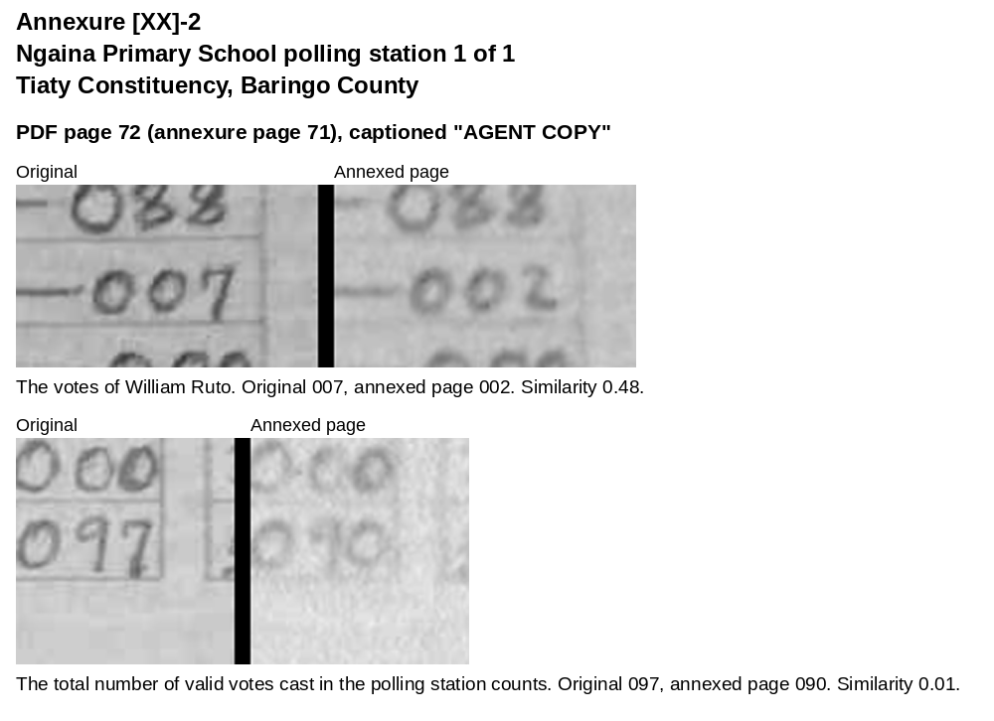
Annexure [XX]-3: Sukut Primary School polling station 1 of 1, Tiaty Constituency, Baringo County
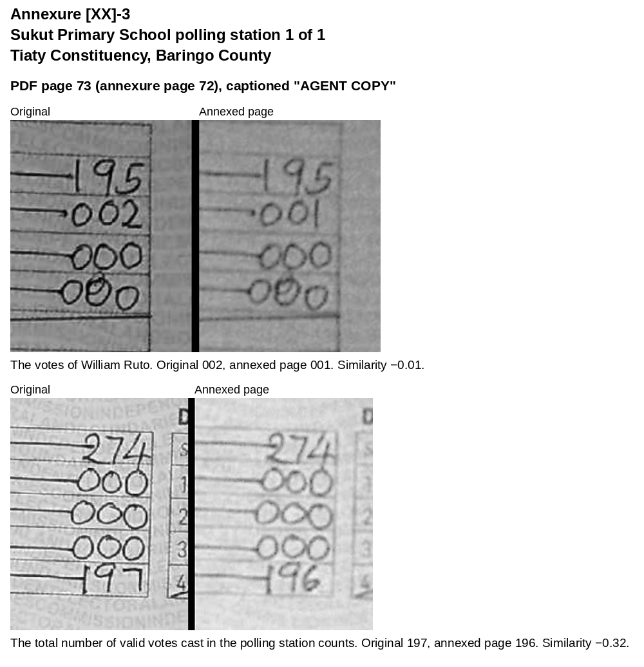
Annexure [XX]-4: Ngeleyo Pre-School polling station 1 of 1, Tiaty Constituency, Baringo County
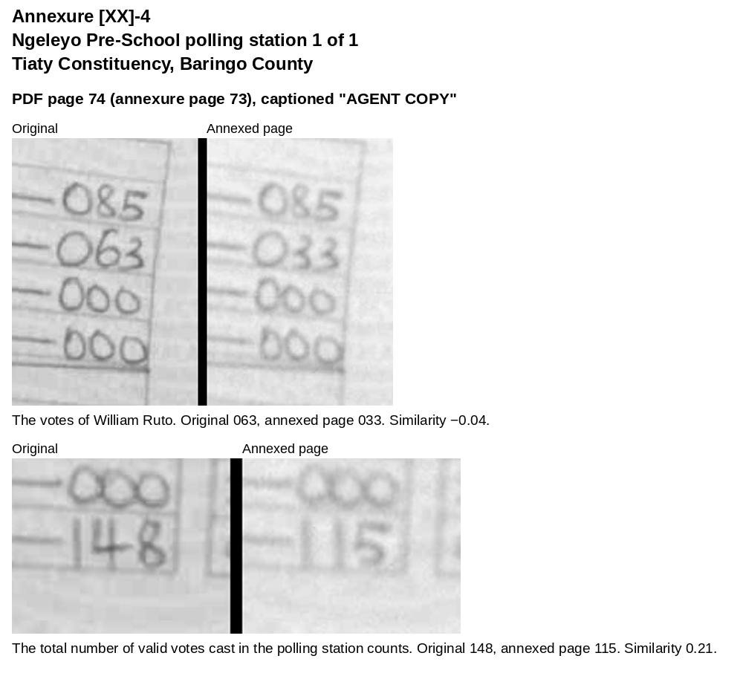
Annexure [XX]-5: Ngoron Primary School polling station 1 of 1, Tiaty Constituency, Baringo County
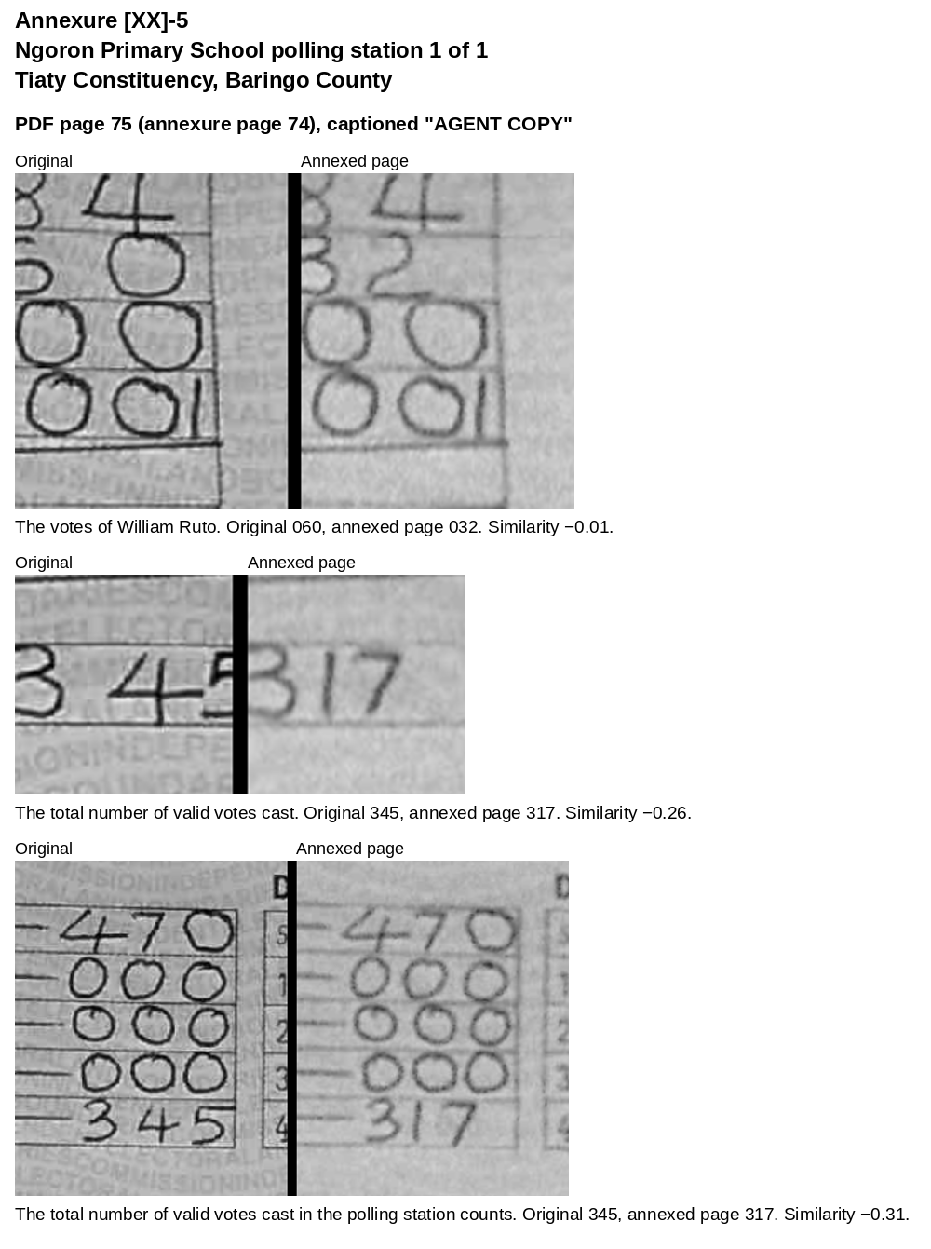
Annexure [XX]-6: Kapenguria Primary School polling station 1 of 1, Tiaty Constituency, Baringo County
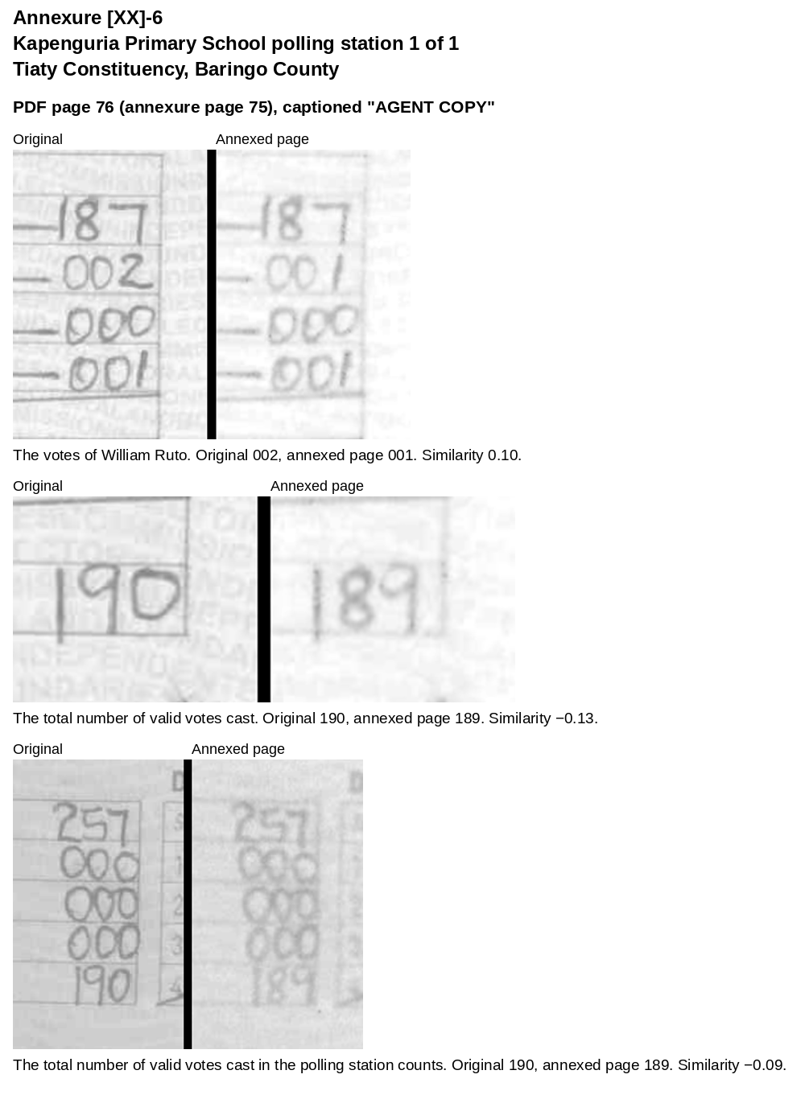
Annexure [XX]-7: Ptikii Primary School polling station 1 of 1, Tiaty Constituency, Baringo County
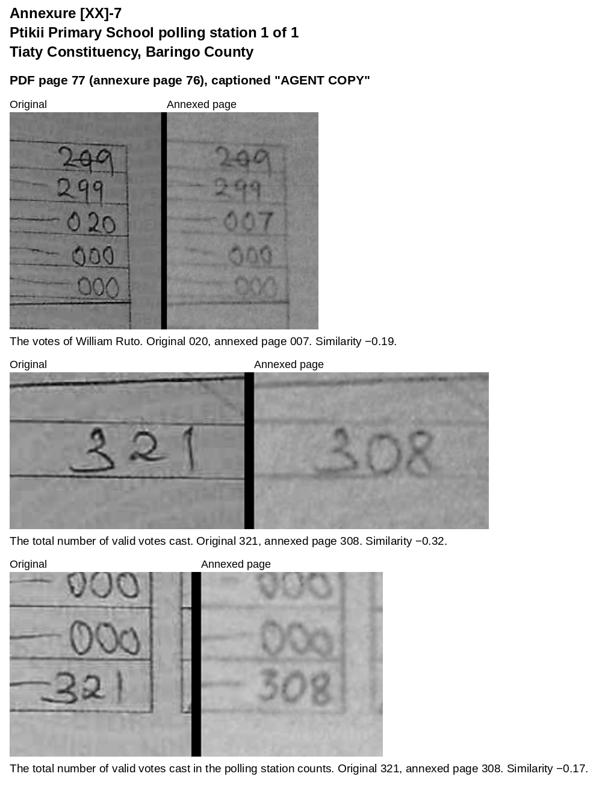
Annexure [XX]-8: Oronto Kreeze Primary School polling station 1 of 1, Tiaty Constituency, Baringo County
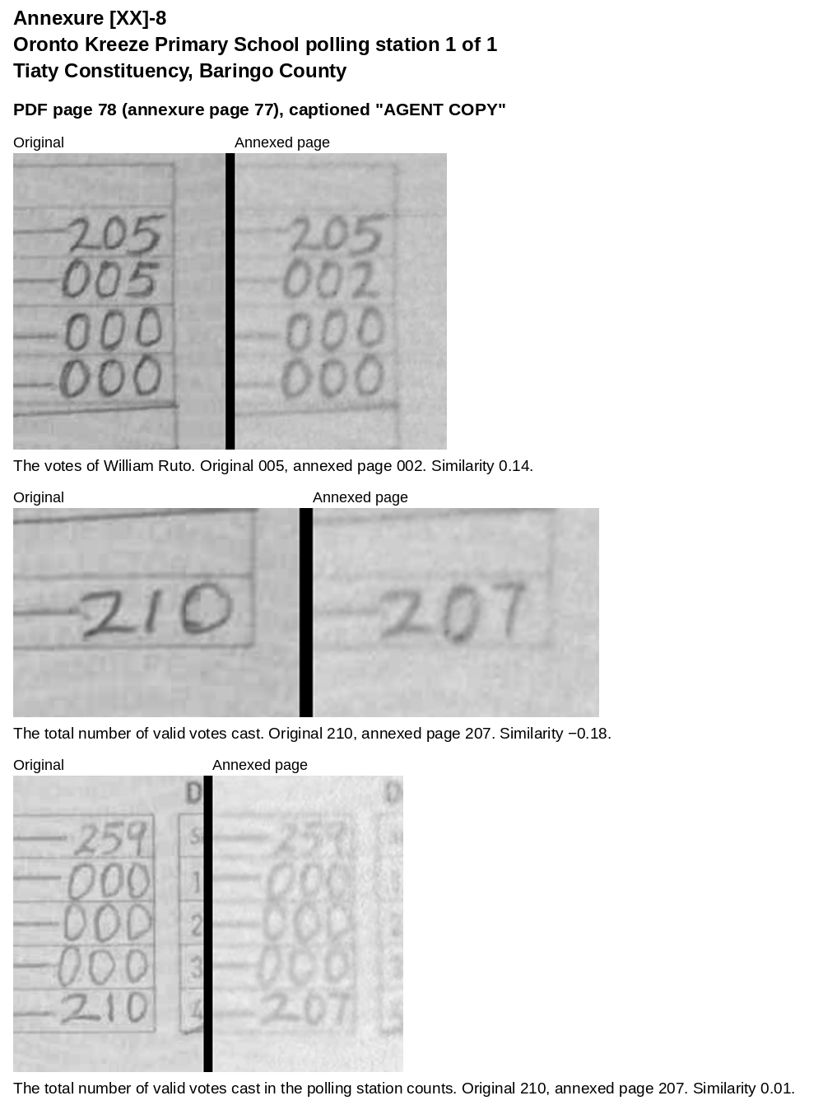
Annexure [XX]-9: Embositit Pre-School polling station 1 of 1, Tiaty Constituency, Baringo County
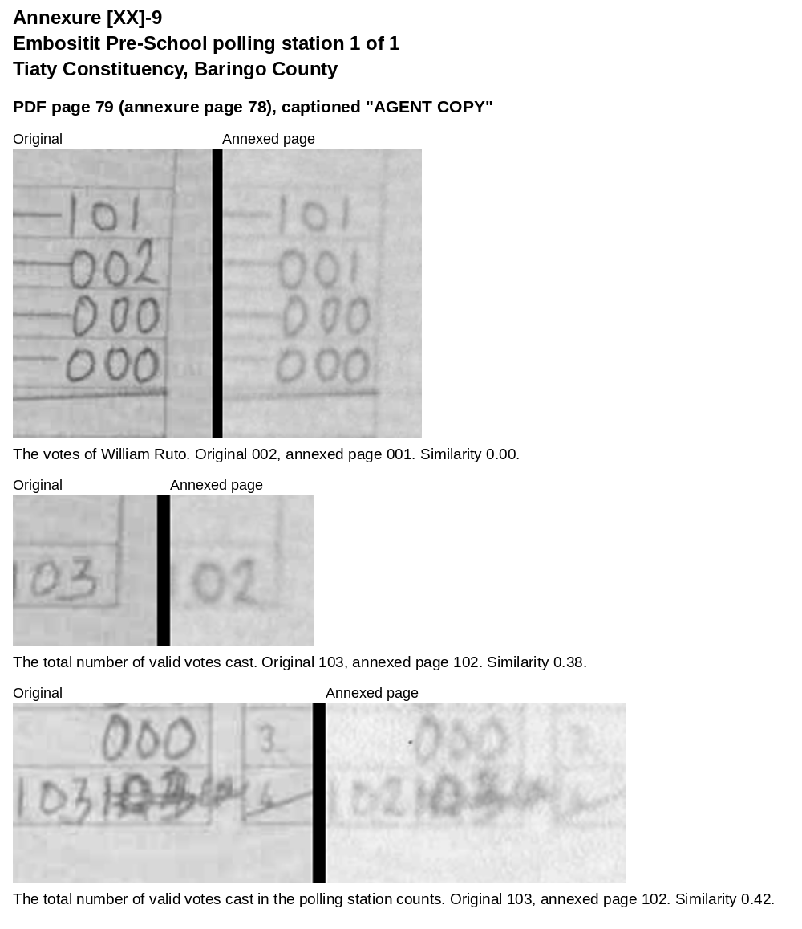
Annexure [XX]-10: Adomeyon Nursery School polling station 1 of 1, Tiaty Constituency, Baringo County
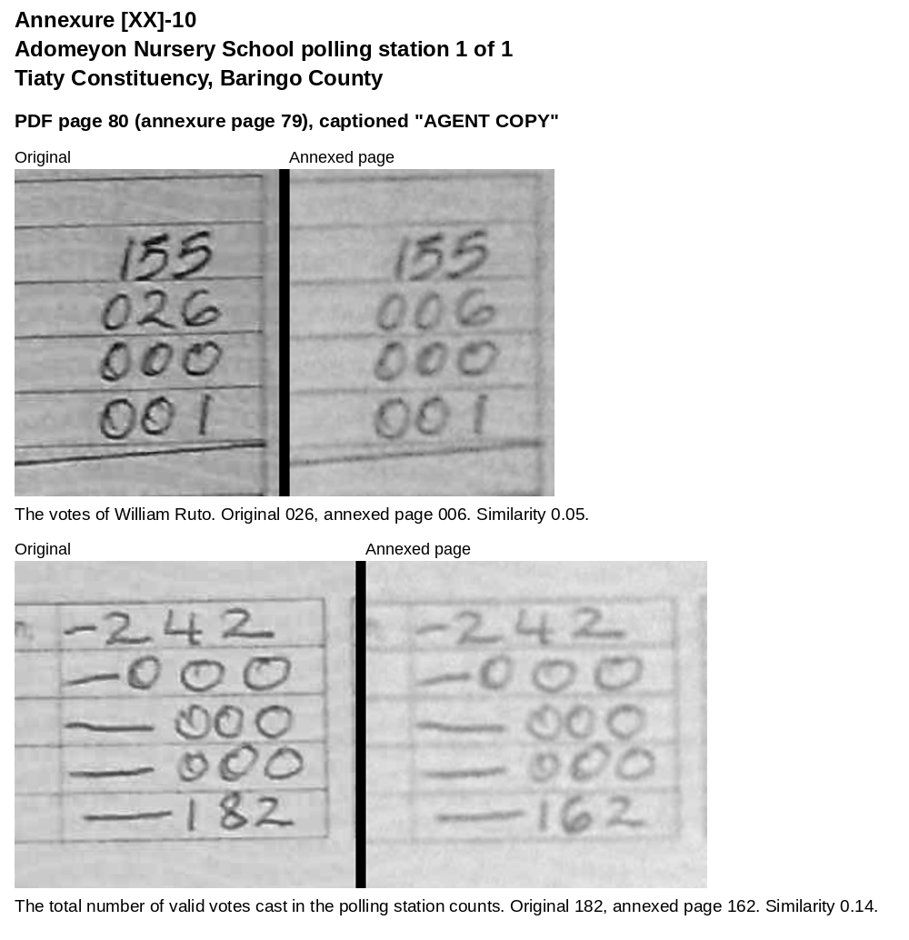
Annexure [XX]-11: Rotii Primary School polling station 1 of 1, Tiaty Constituency, Baringo County
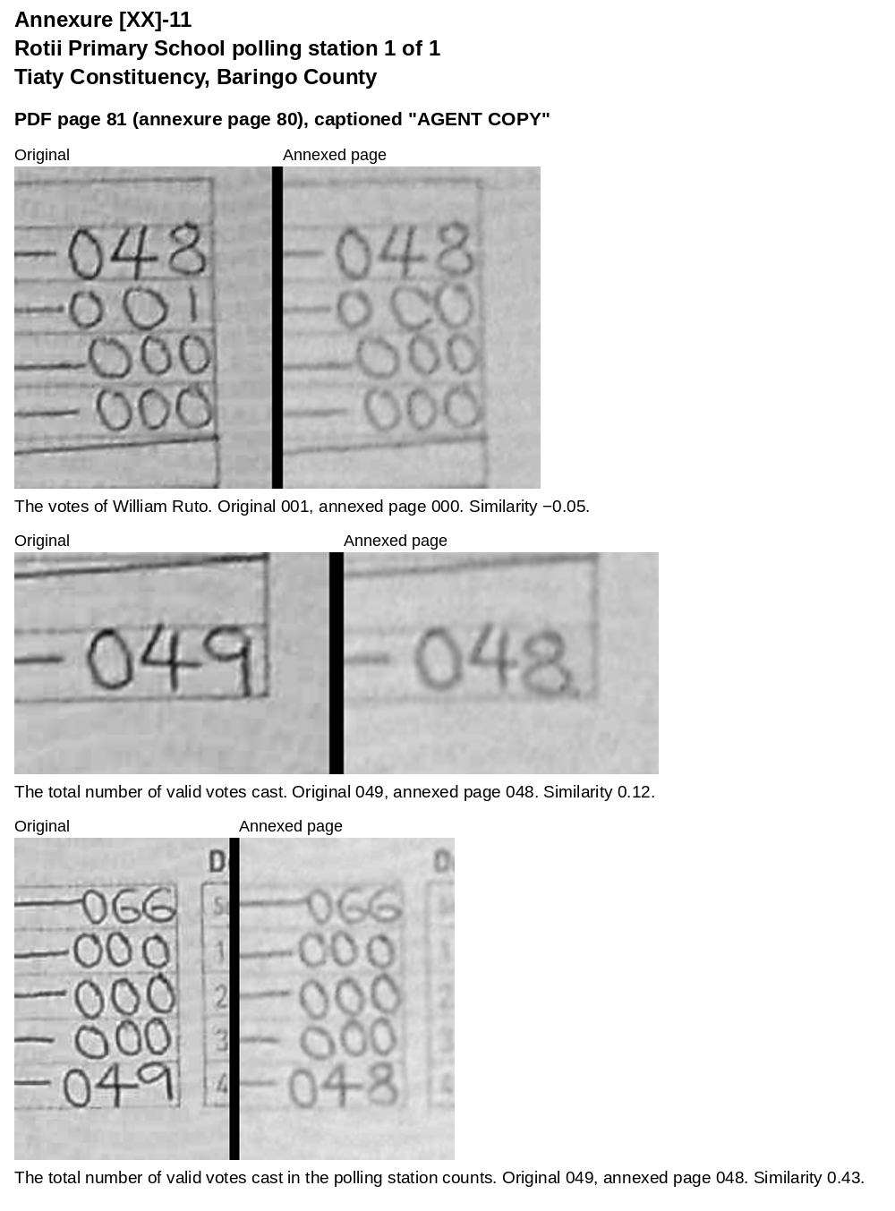
Annexure [XX]-12: Kimnyan Primary School polling station 1 of 1, Tiaty Constituency, Baringo County
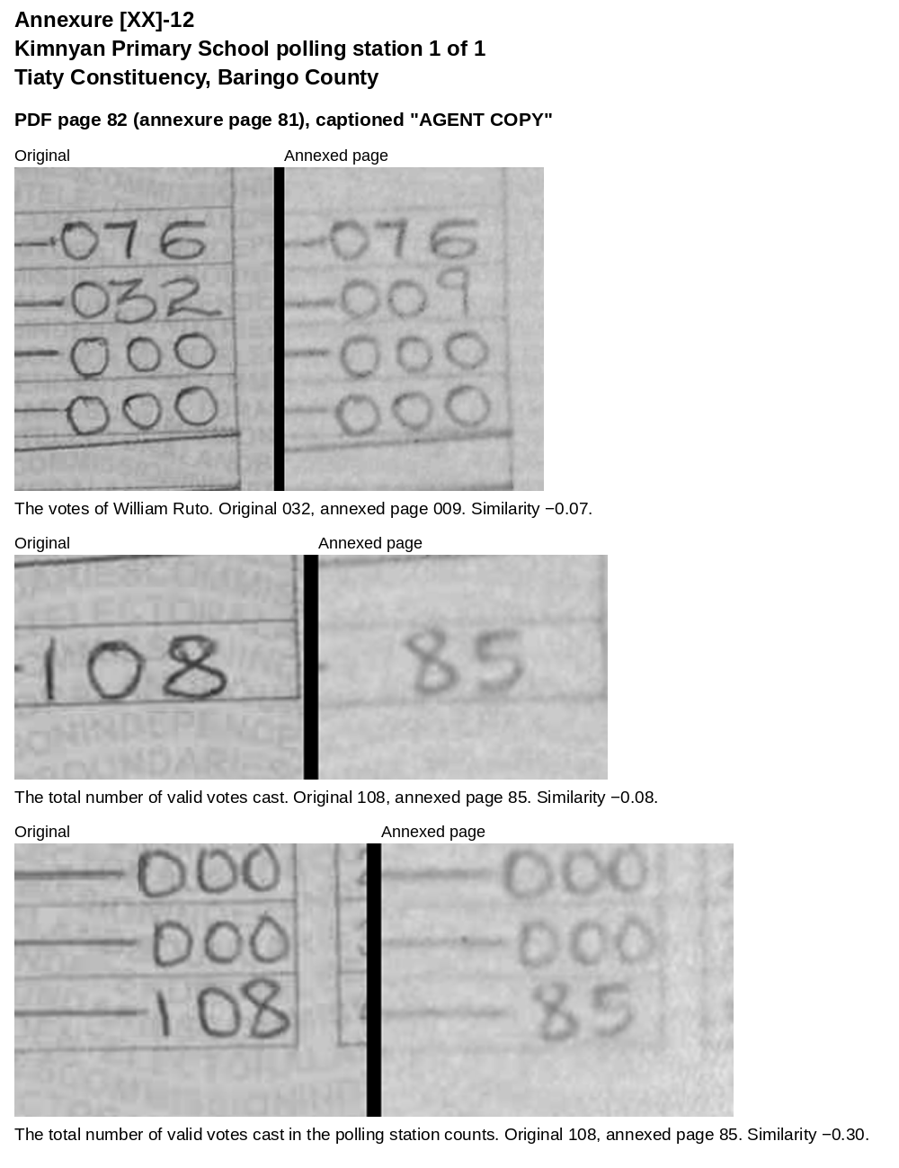
Annexure [XX]-13: Kong'or Village Mobile polling station 1 of 1, Tiaty Constituency, Baringo County
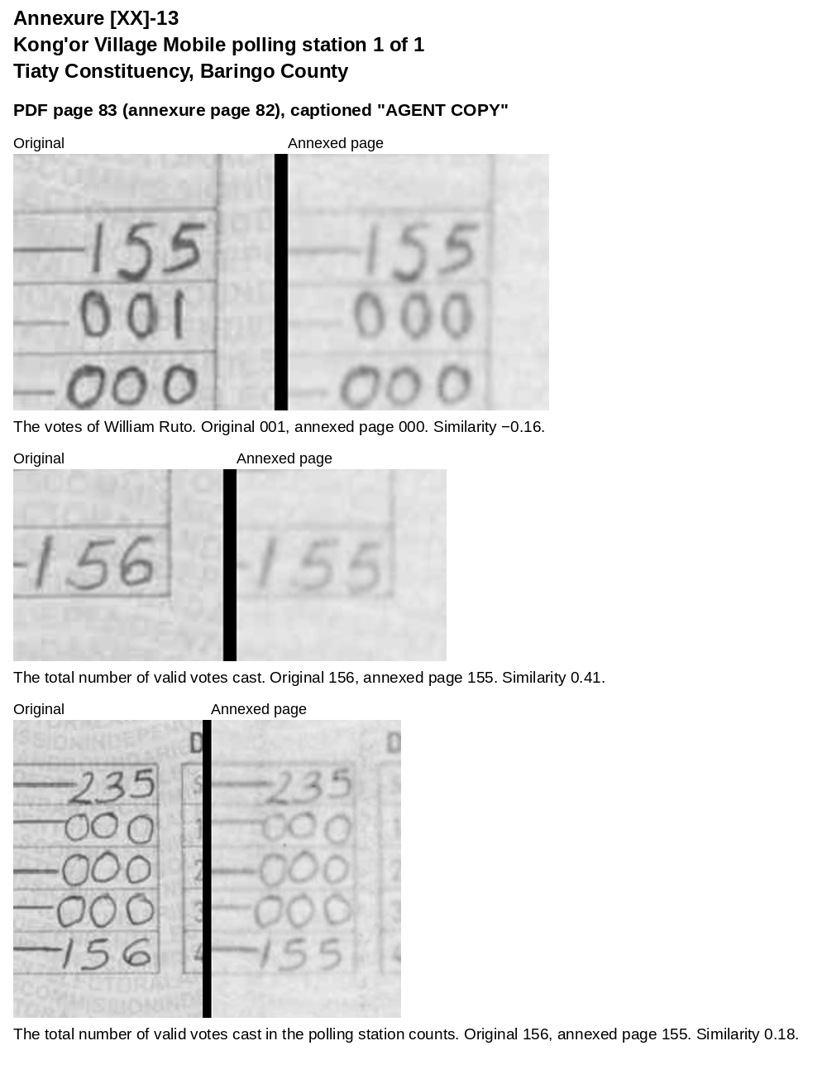
Annexure [XX]-14: Kamrio Primary School polling station 1 of 1, Tiaty Constituency, Baringo County
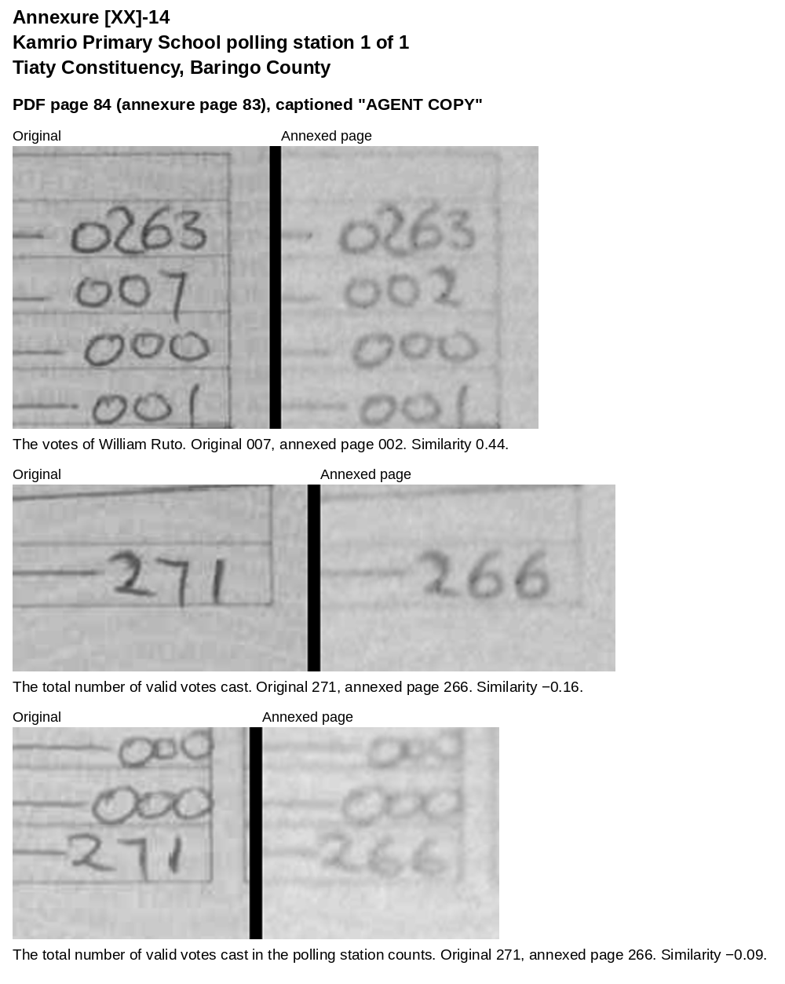
Annexure [XX]-15: Kapau Pre-School polling station 1 of 1, Tiaty Constituency, Baringo County
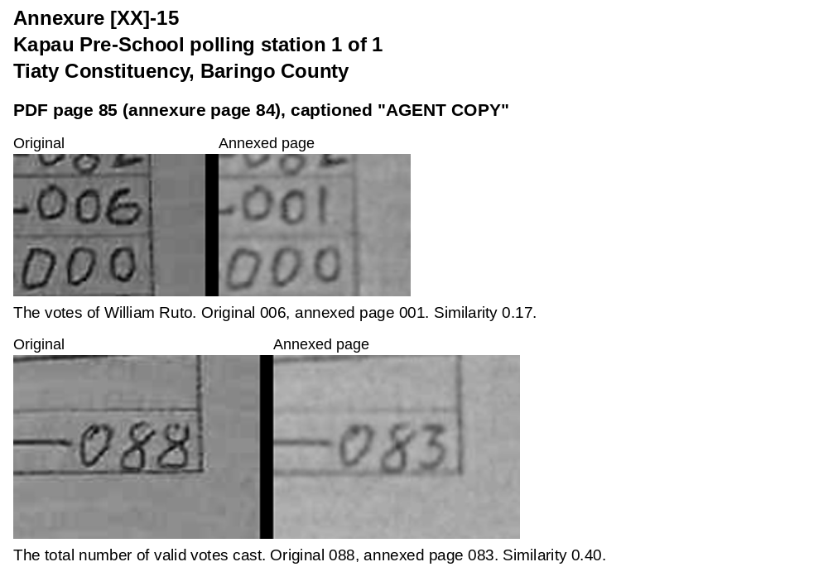
Annexure [XX]-16: Kapedo Primary School polling station 1 of 1, Tiaty Constituency, Baringo County
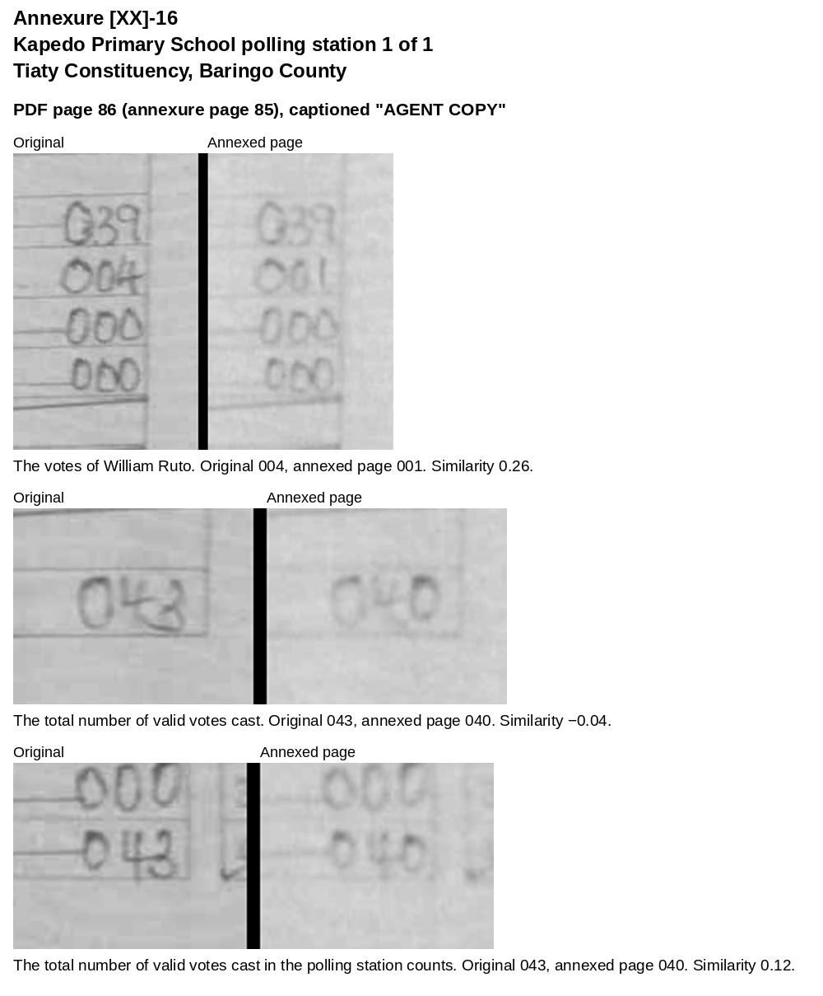
Annexure [XX]-17: Chesawach Primary School polling station 1 of 1, Tiaty Constituency, Baringo County
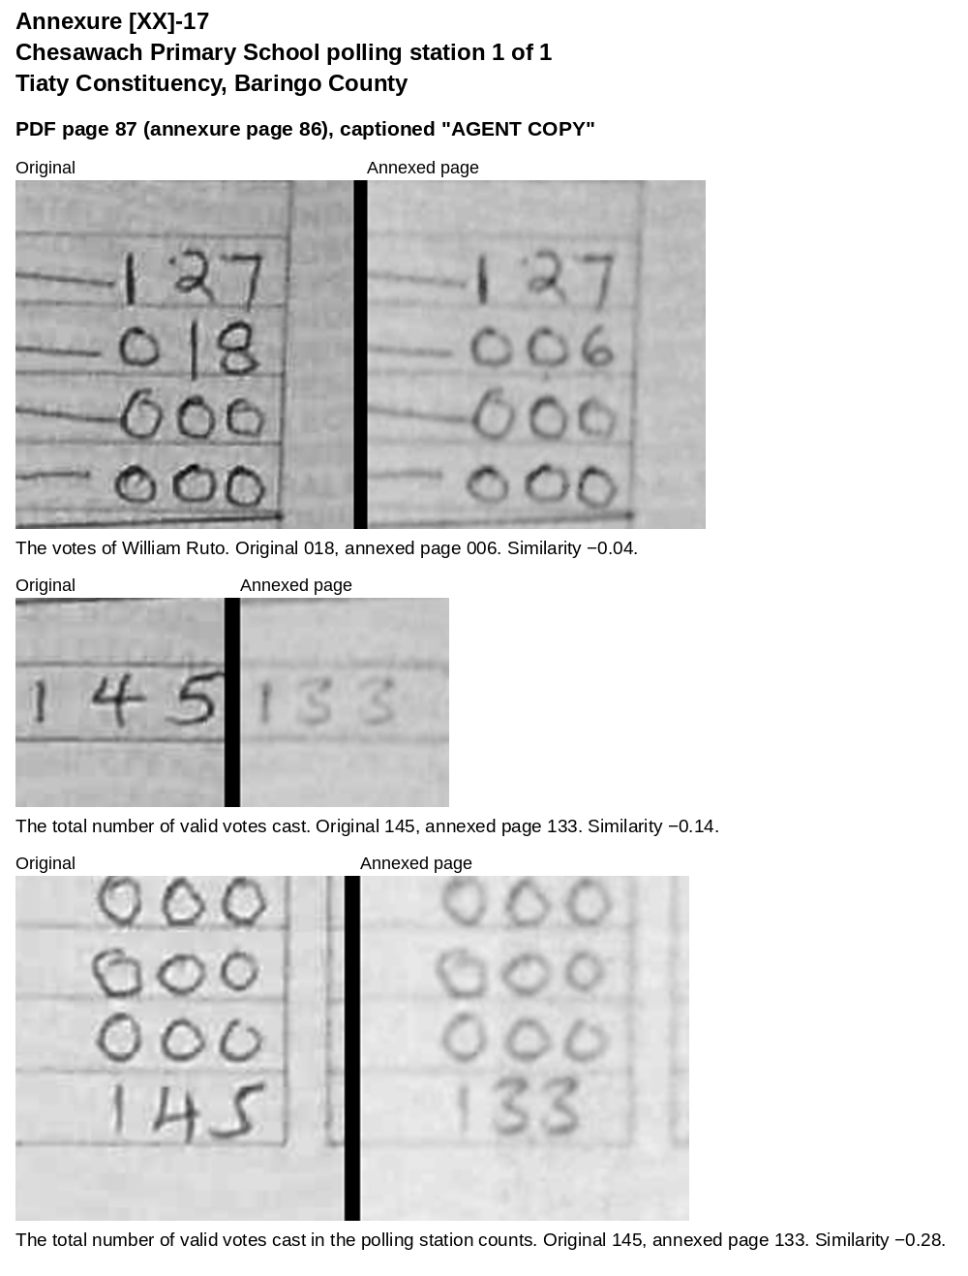
Annexure [XX]-18: Korelach Primary School polling station 1 of 1, Tiaty Constituency, Baringo County
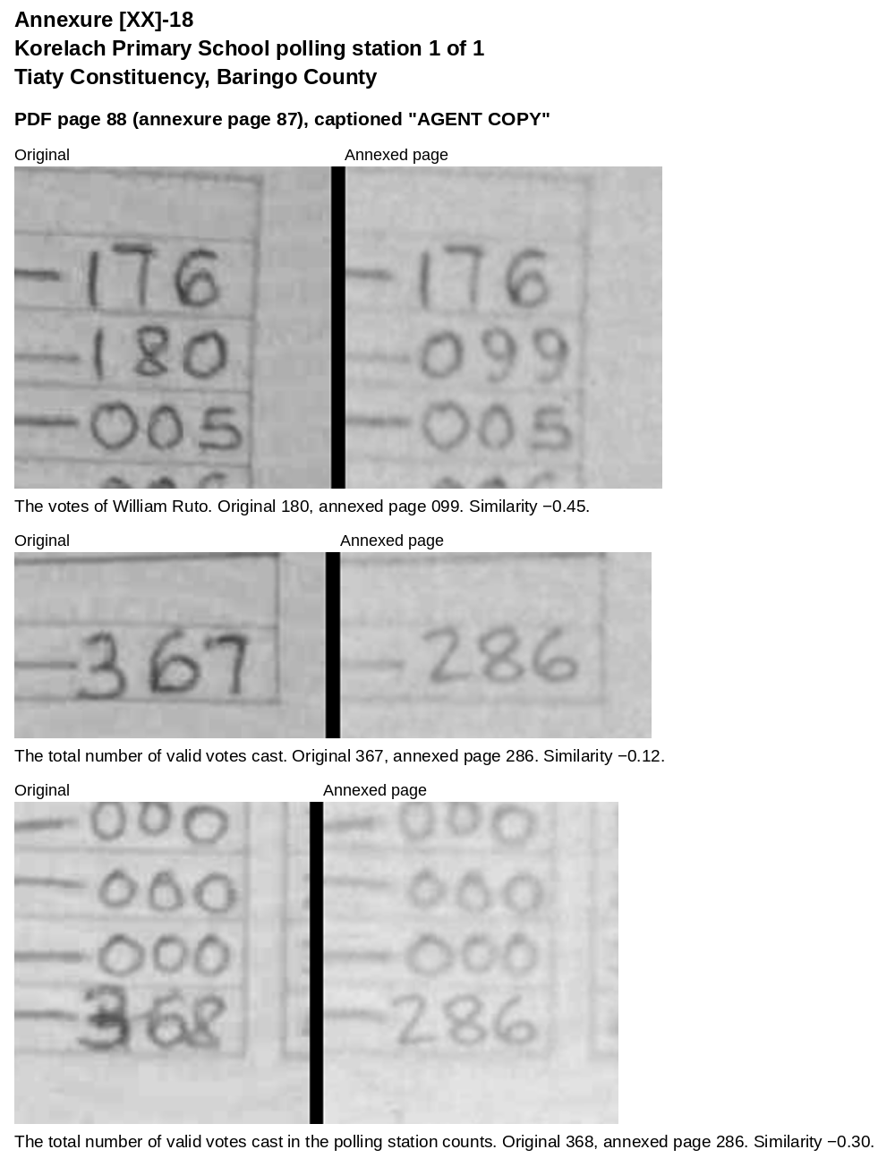
Annexure [XX]-19: Kamsino Primary School polling station 1 of 1, Tiaty Constituency, Baringo County
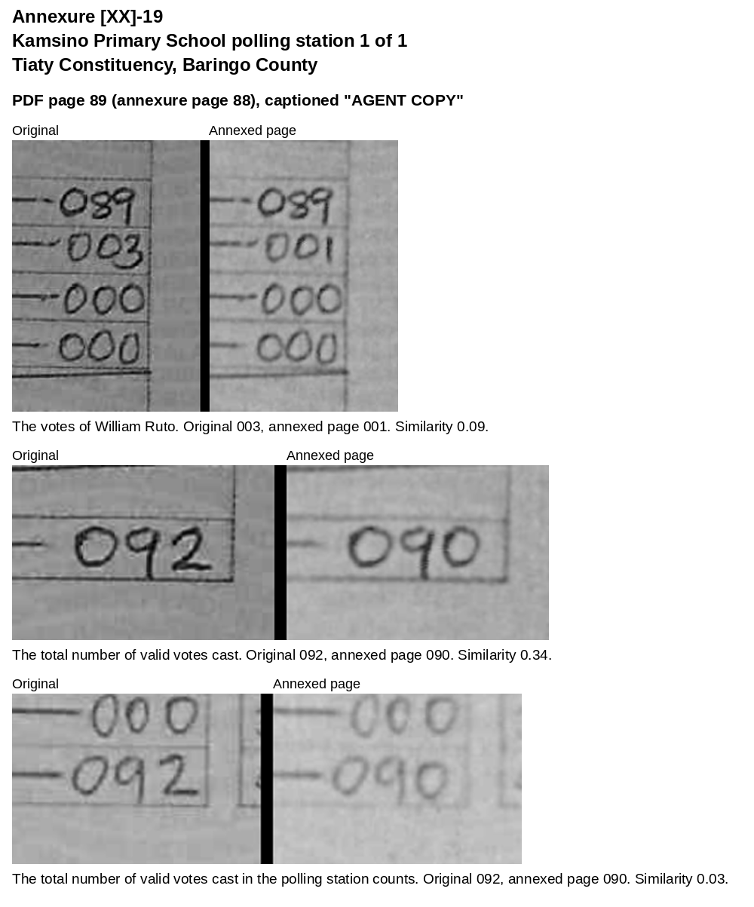
Annexure [XX]-20: Chemayes Primary School polling station 1 of 1, Tiaty Constituency, Baringo County
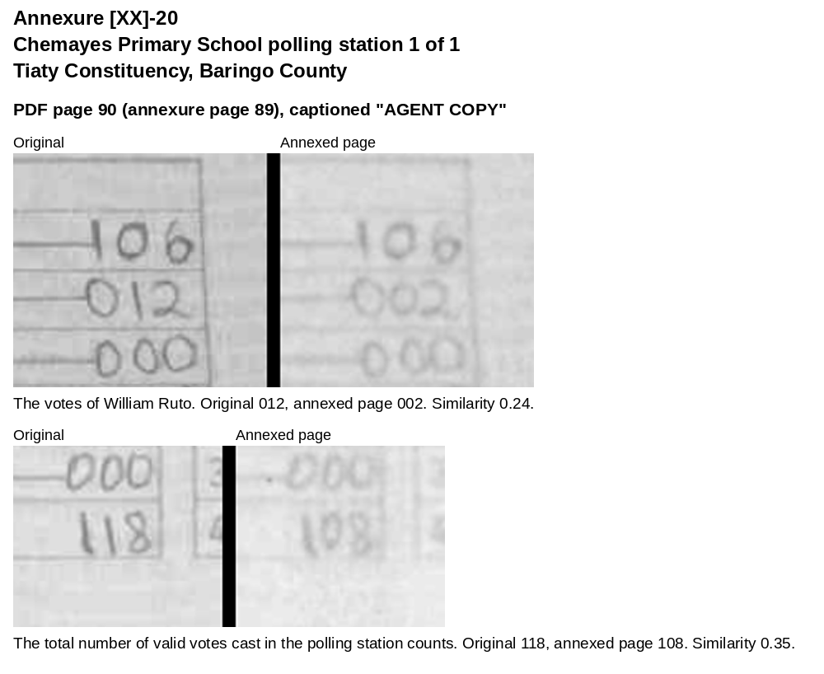
Annexure [XX]-21: Takawya Primary School polling station 1 of 1, Tiaty Constituency, Baringo County
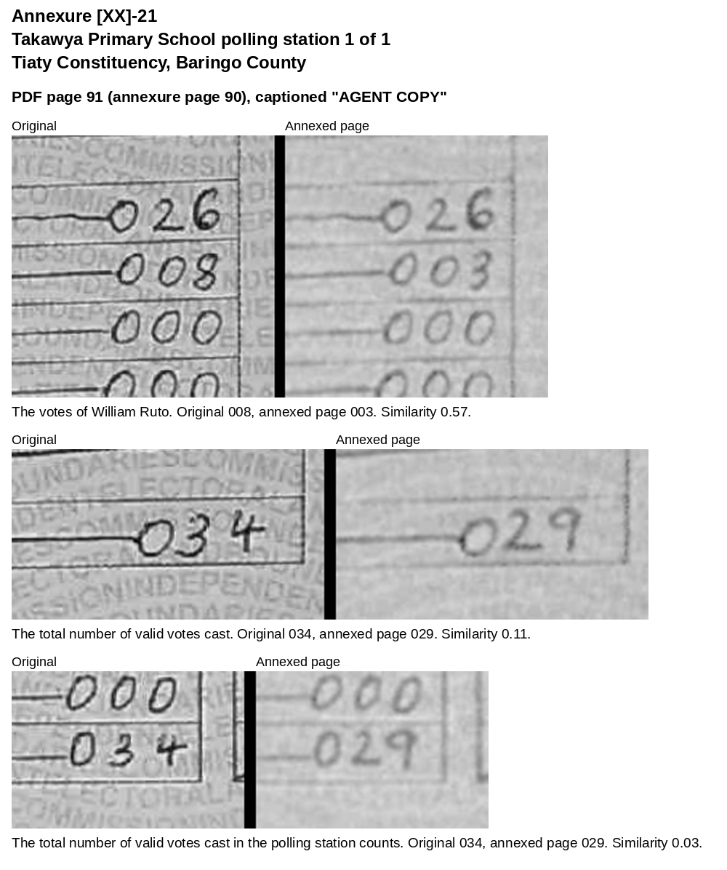
Annexure [XX]-22: Kangiruru Primary School polling station 1 of 1, Tiaty Constituency, Baringo County
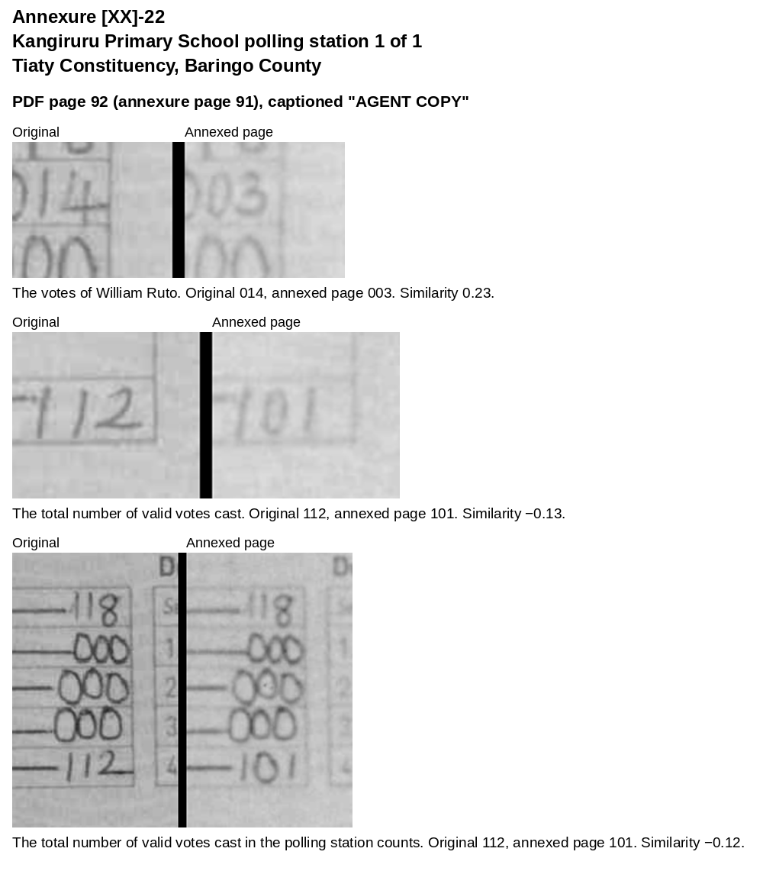
Annexure [XX]-23: Domo Primary School polling station 1 of 1, Tiaty Constituency, Baringo County
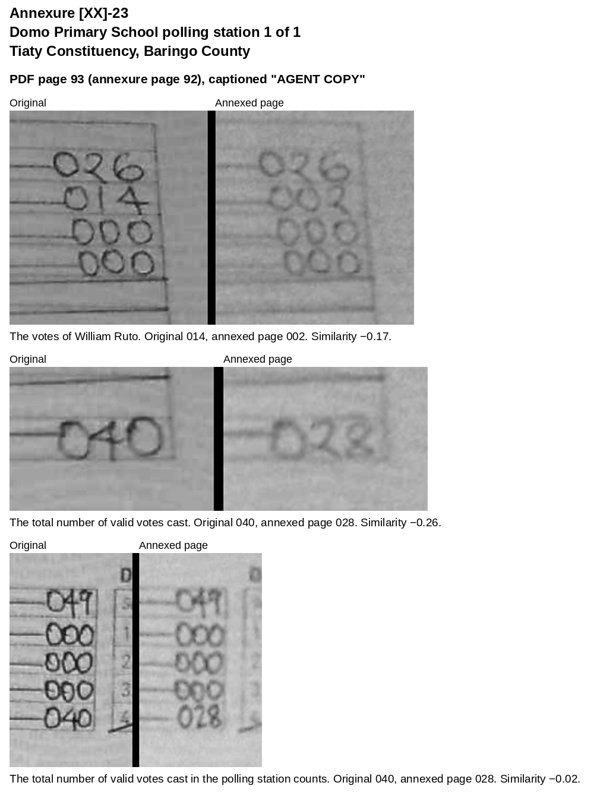
Annexure [XX]-24: Chepkirial Primary School polling station 1 of 1, Tiaty Constituency, Baringo County
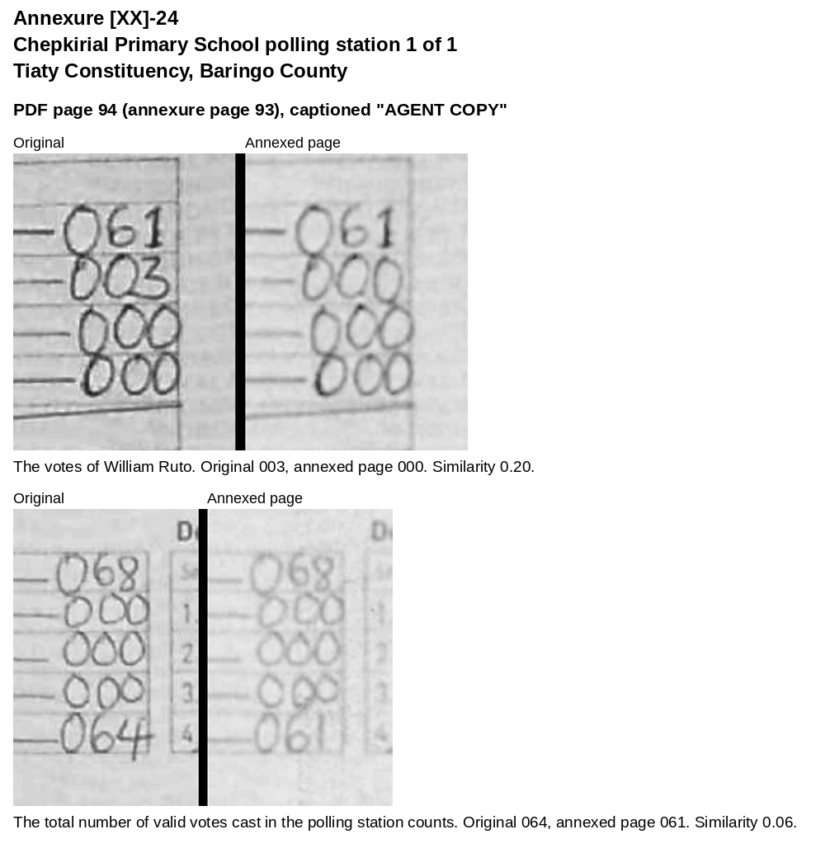
Annexure [XX]-25: Koipasiran Village polling station 1 of 1, Tiaty Constituency, Baringo County
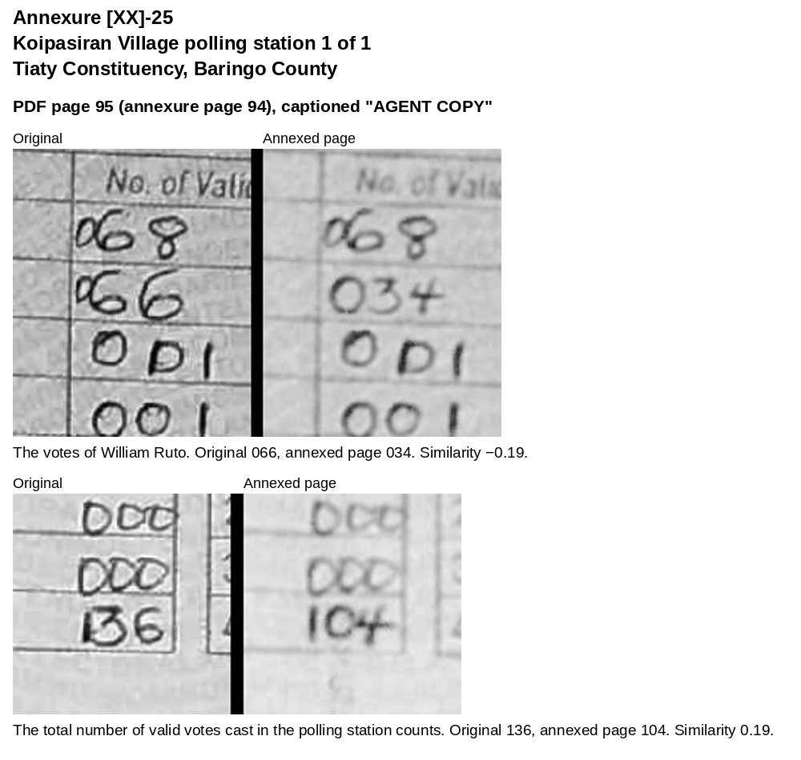
Annexure [XX]-26: Barbello Primary School polling station 1 of 1, Tiaty Constituency, Baringo County
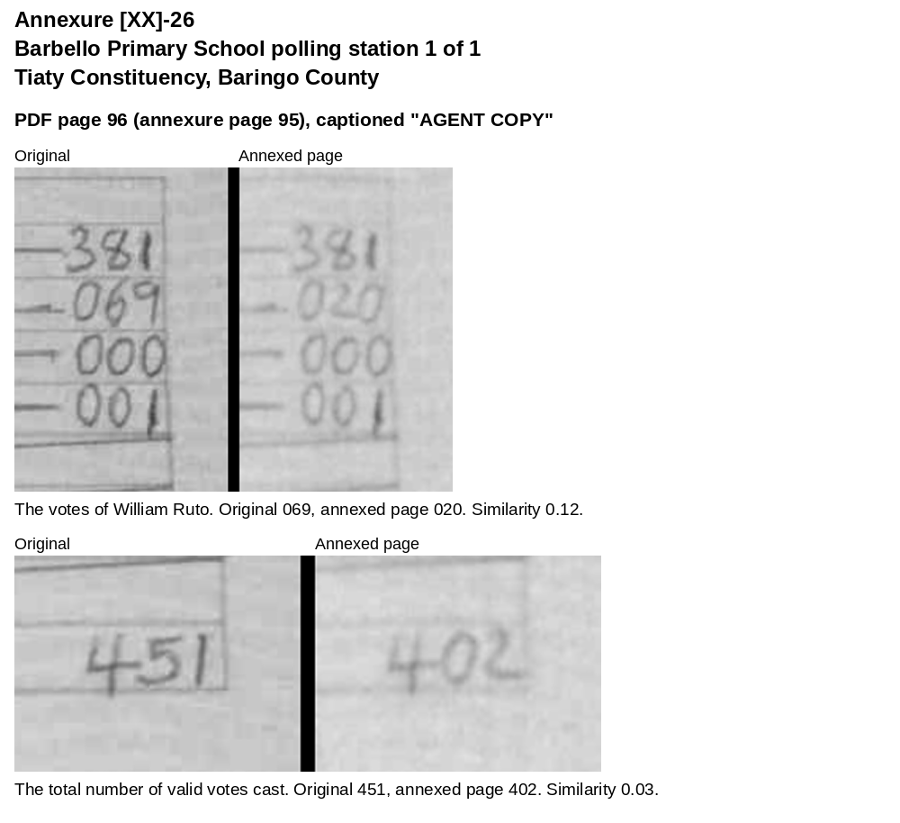
Annexure [XX]-27: Kabete Vetlab Primary School polling station 2 of 12, Kitisuru Ward, Westlands, Nairobi
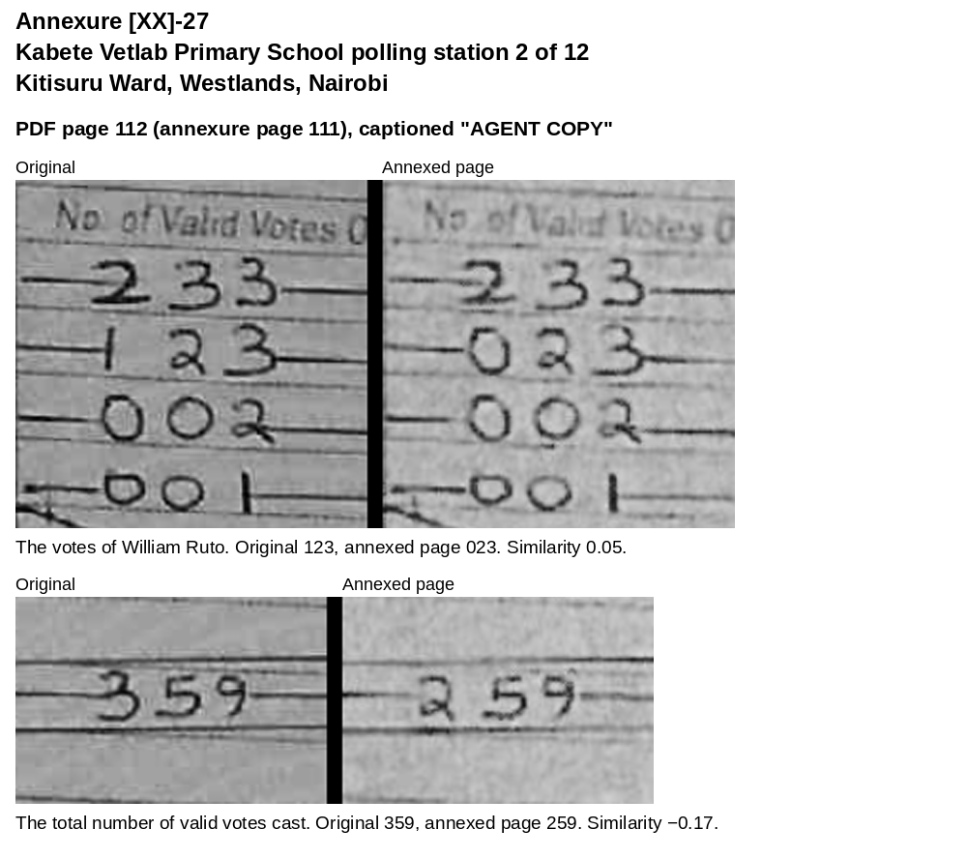
Annexure [XX]-28: Kabete Vetlab Primary School polling station 3 of 12, Kitisuru Ward, Westlands, Nairobi
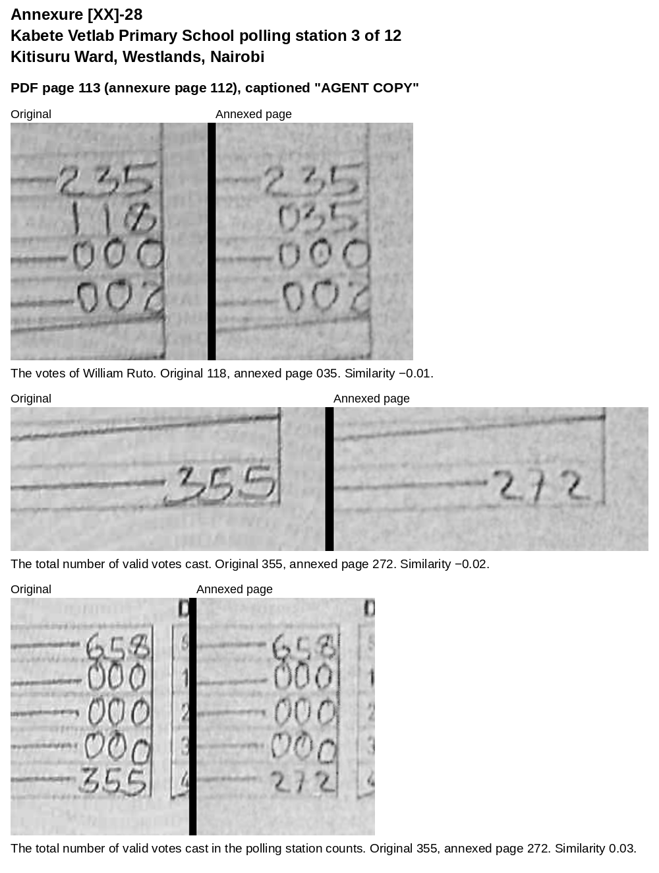
Annexure [XX]-29: Kabete Vetlab Primary School polling station 5 of 12, Kitisuru Ward, Westlands, Nairobi
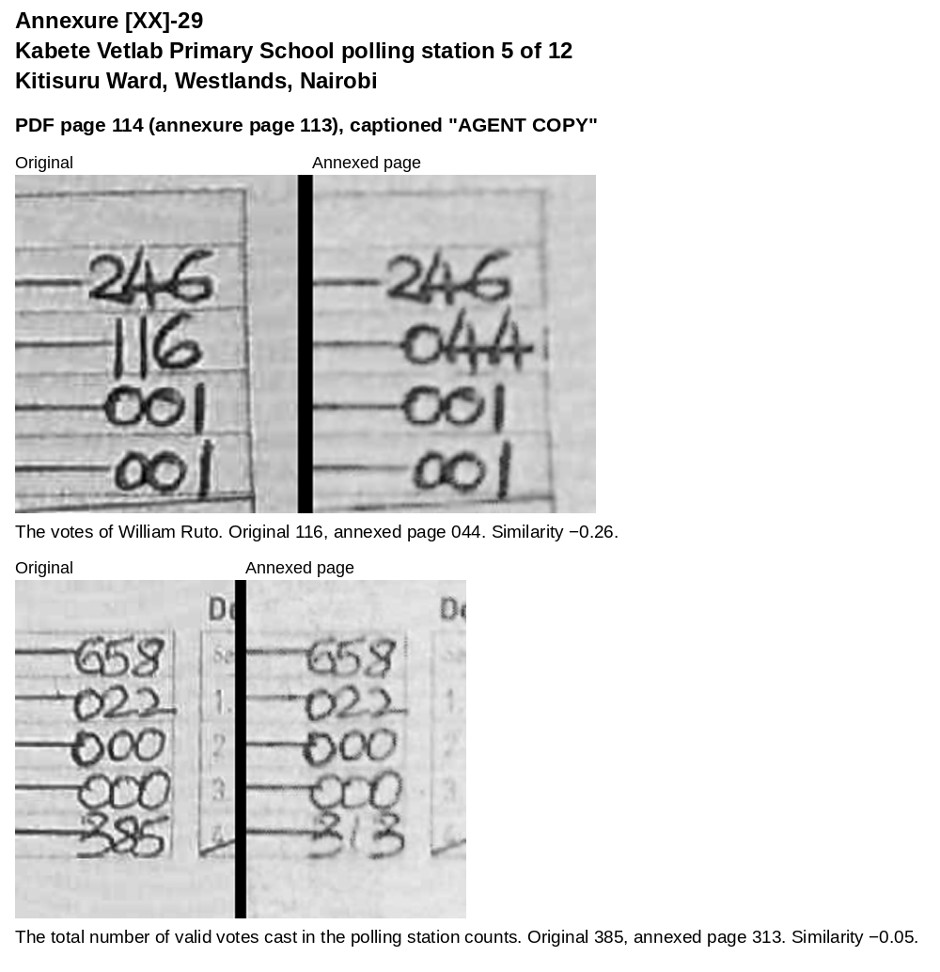
Annexure [XX]-30: Kabete Vetlab Primary School polling station 6 of 12, Kitisuru Ward, Westlands, Nairobi
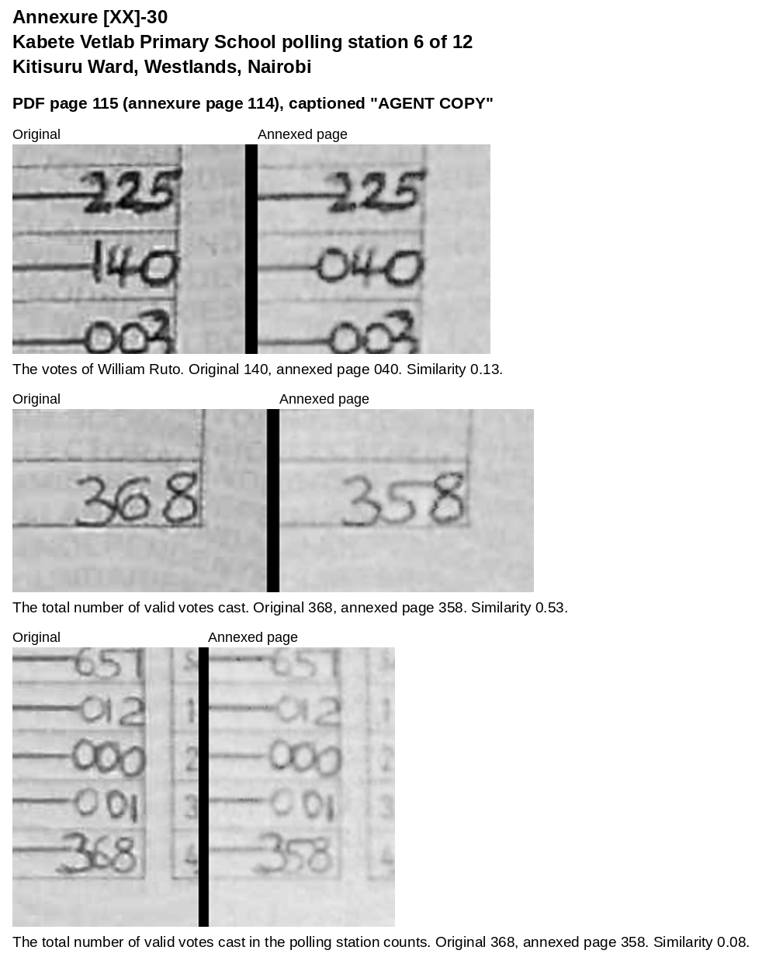
Annexure [XX]-31: Kabete Vetlab Primary School polling station 7 of 12, Kitisuru Ward, Westlands, Nairobi
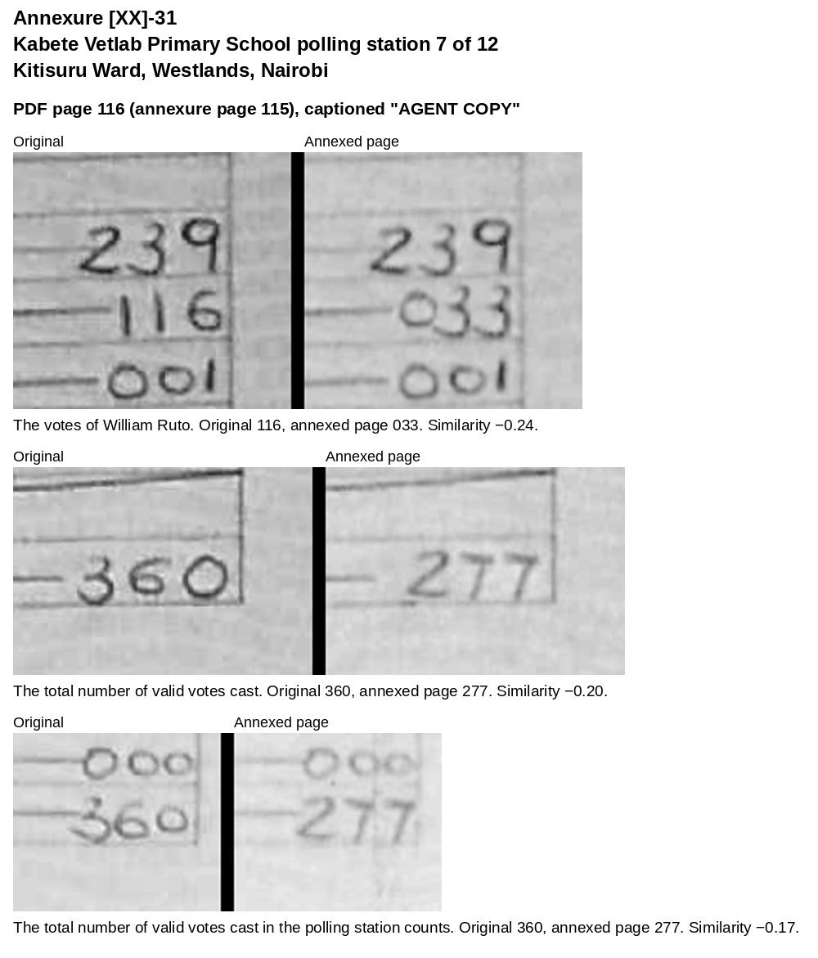
Annexure [XX]-32: Kabete Vetlab Primary School polling station 8 of 12, Kitisuru Ward, Westlands, Nairobi
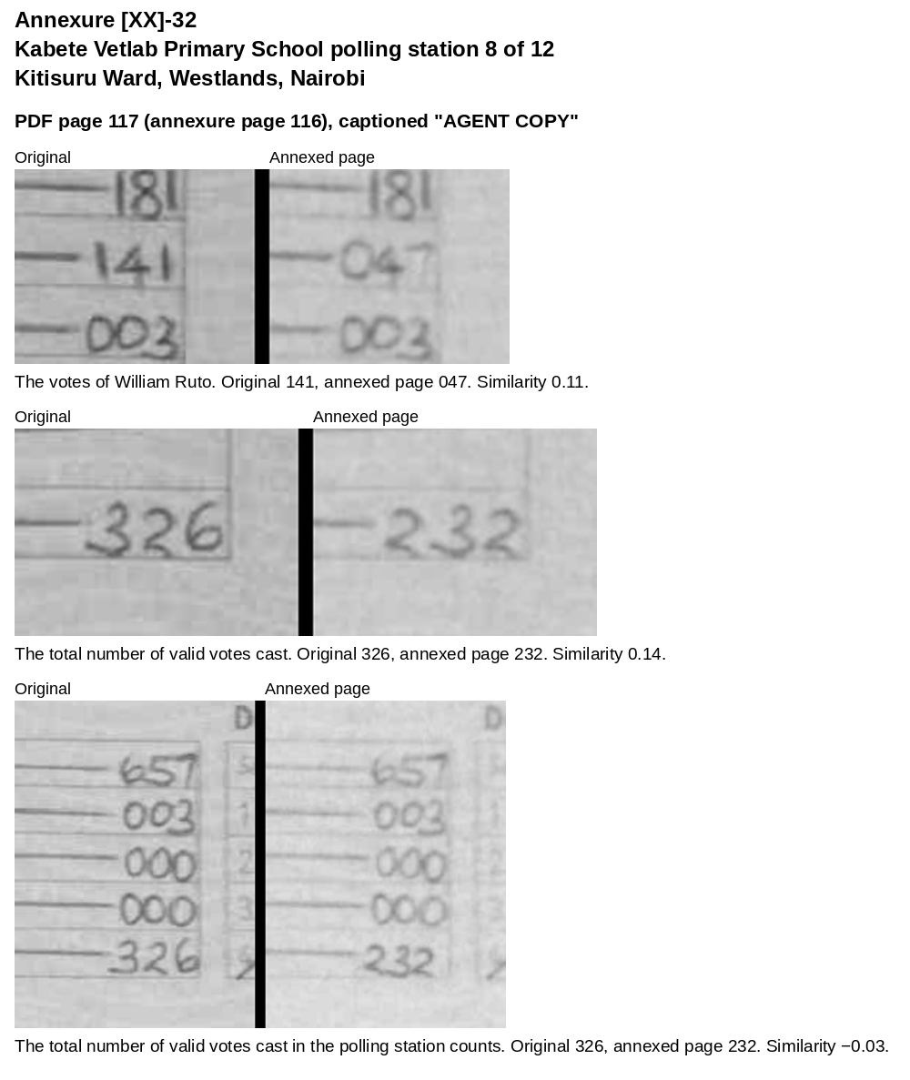
Annexure [XX]-33: Kabete Vetlab Primary School polling station 9 of 12, Kitisuru Ward, Westlands, Nairobi
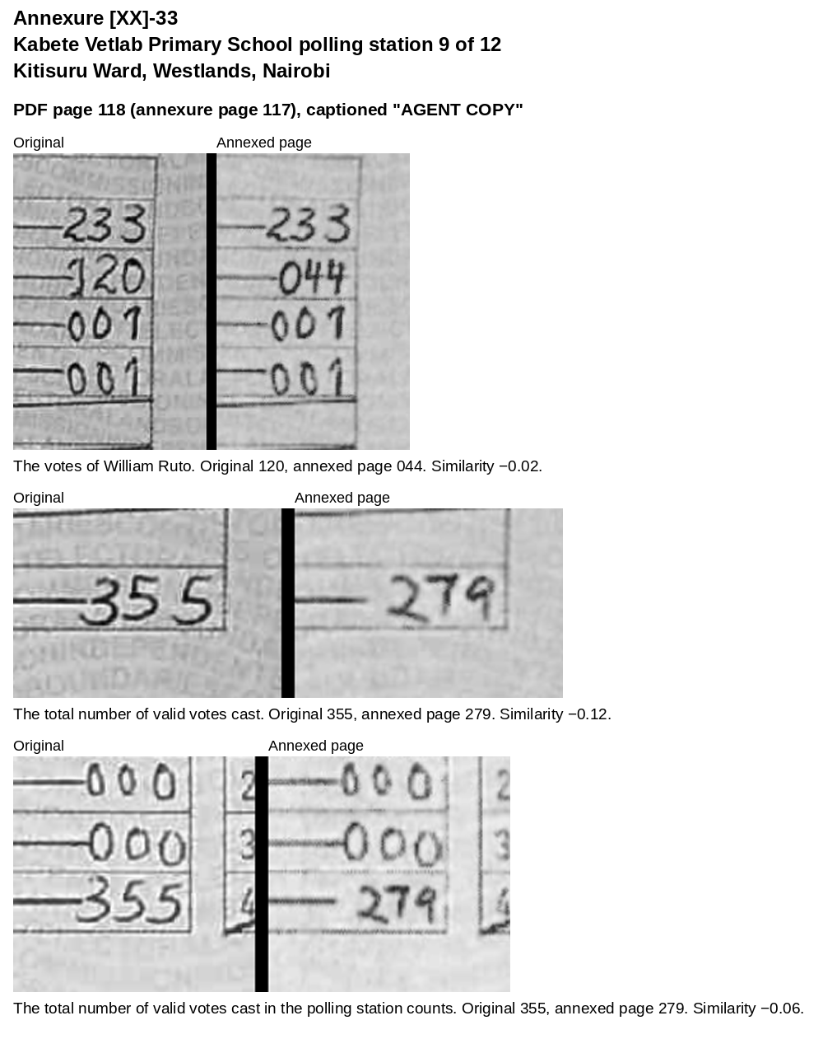
Annexure [XX]-34: Kabete Vetlab Primary School polling station 10 of 12, Kitisuru Ward, Westlands, Nairobi
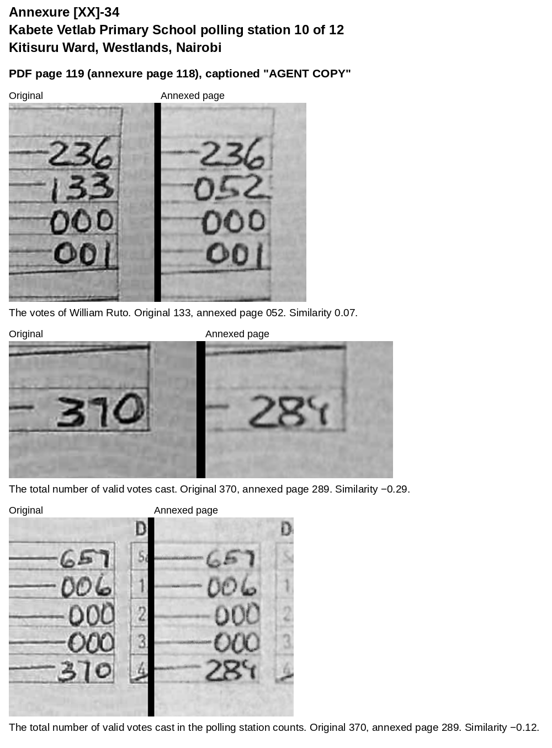
Annexure [XX]-35: Kabete Vetlab Primary School polling station 11 of 12, Kitisuru Ward, Westlands, Nairobi
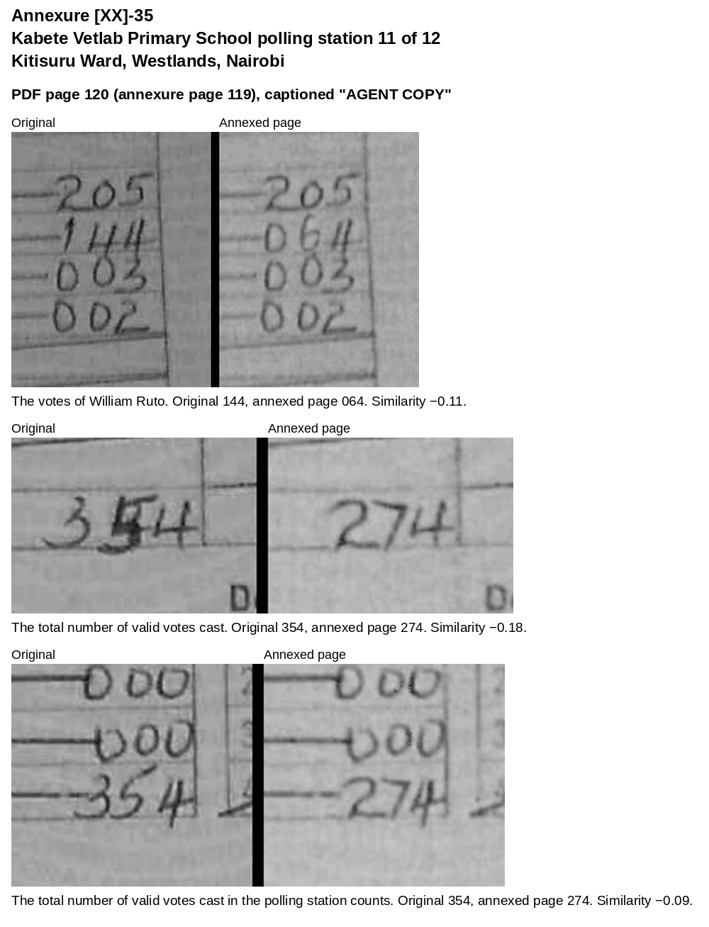
Annexure [XX]-36: St Martin's School Kibarage polling station 1 of 7, Kitisuru Ward, Westlands, Nairobi
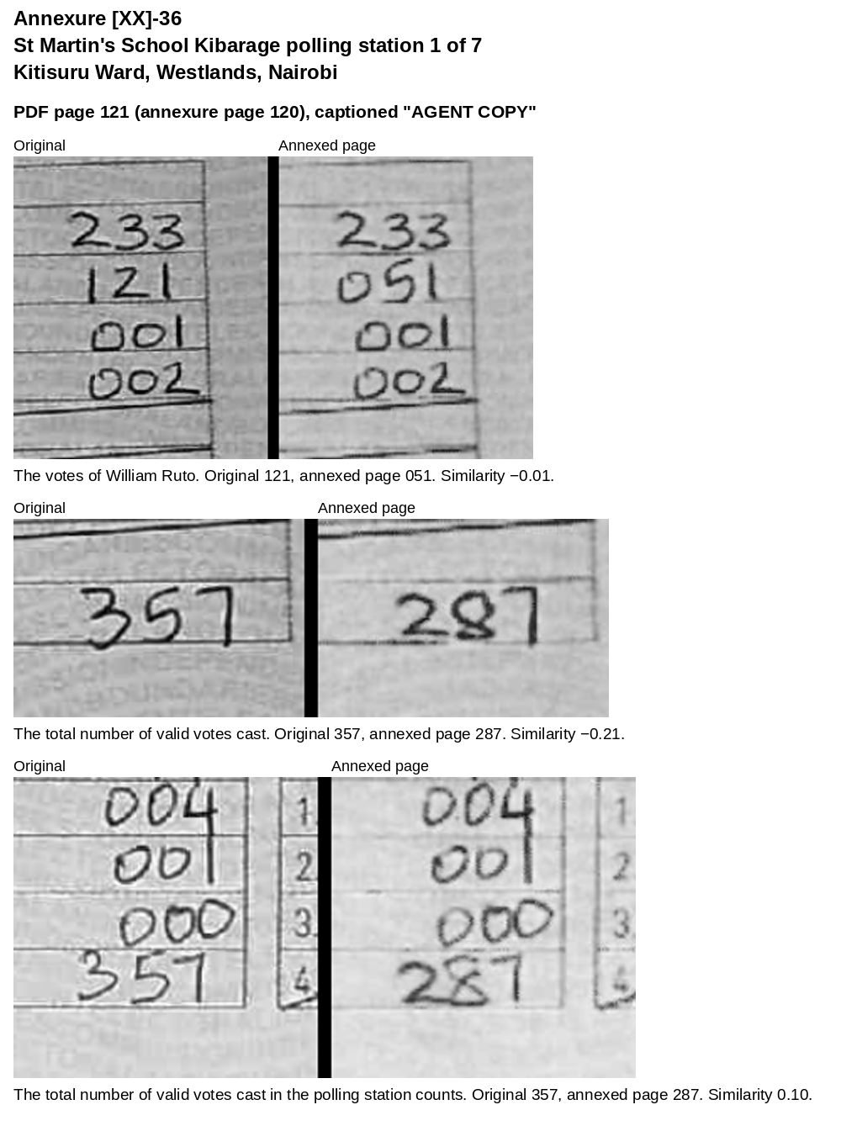
Annexure [XX]-37: St Martin's School Kibarage polling station 2 of 7, Kitisuru Ward, Westlands, Nairobi
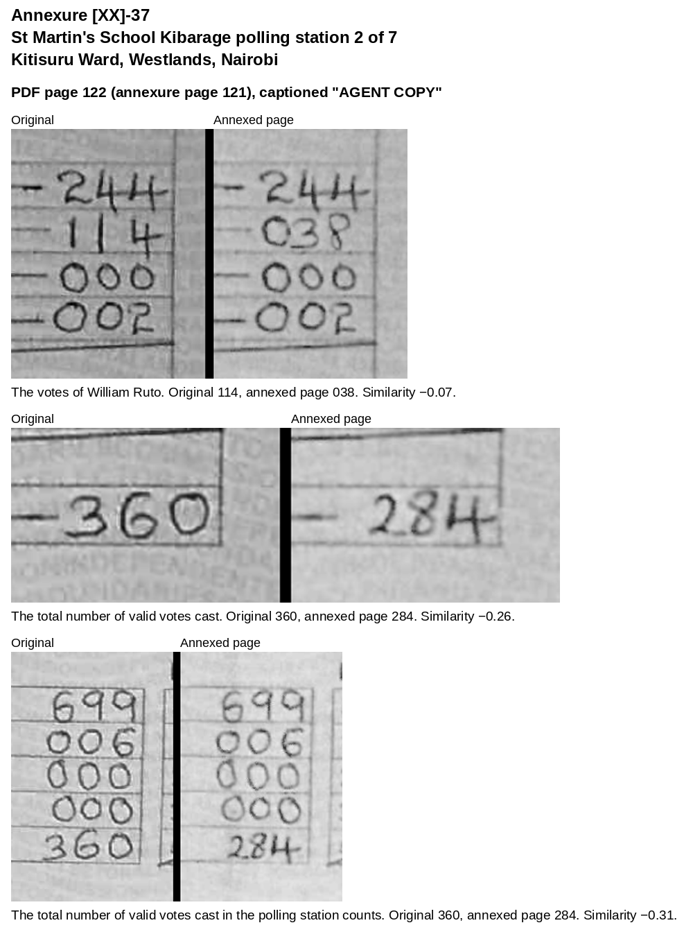
Annexure [XX]-38: St Martin's School Kibarage polling station 3 of 7, Kitisuru Ward, Westlands, Nairobi
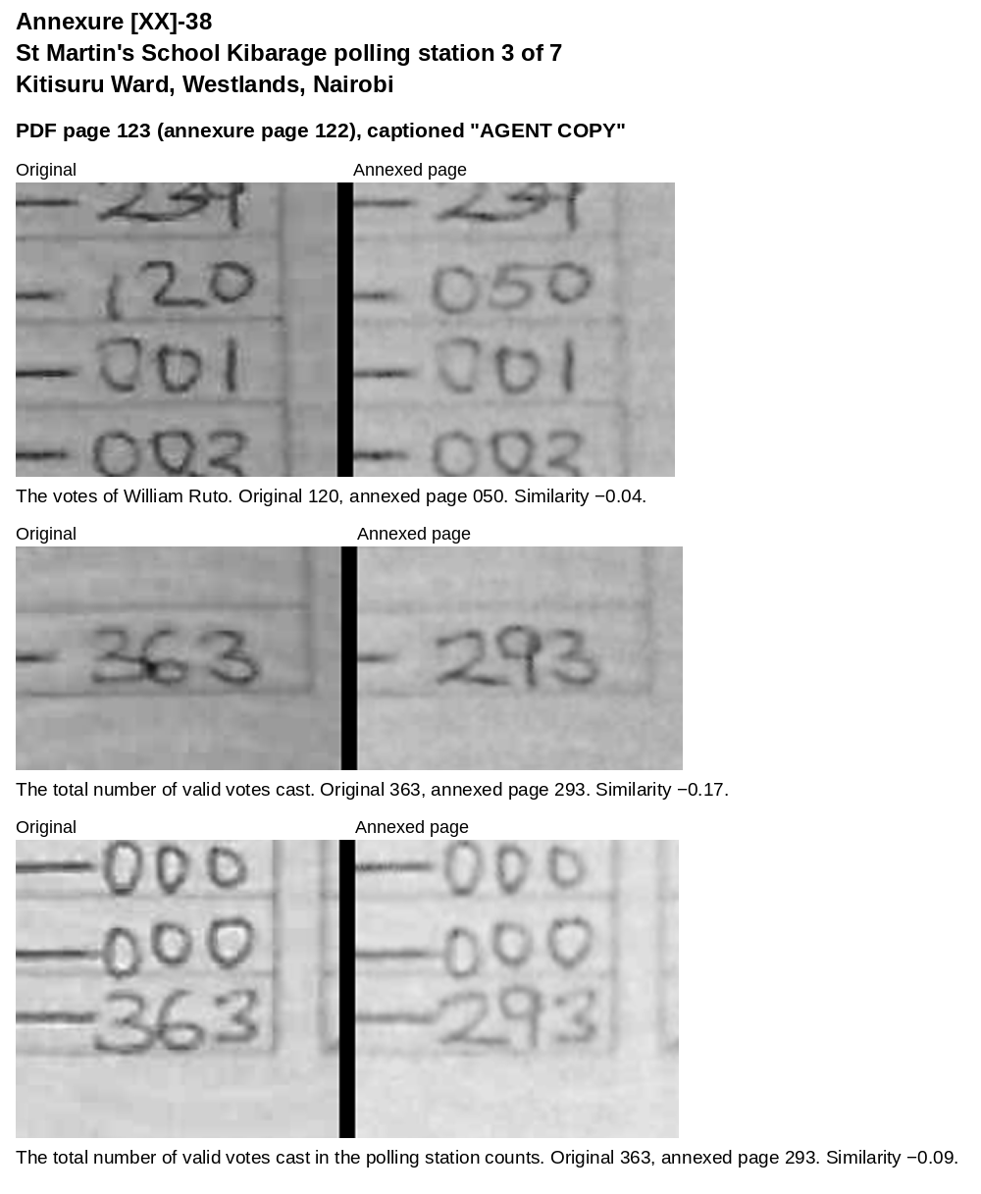
Annexure [XX]-39: St Martin's School Kibarage polling station 4 of 7, Kitisuru Ward, Westlands, Nairobi
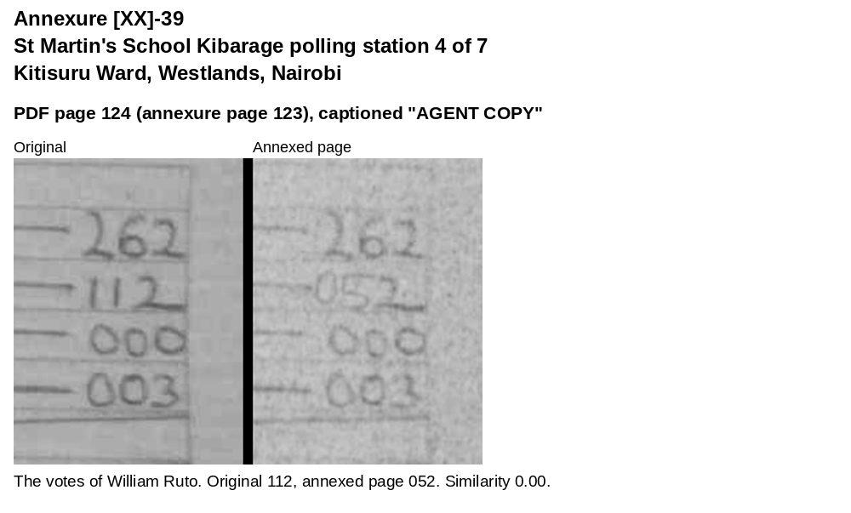
Annexure [XX]-40: Kagera Primary School polling station 1 of 2, Kiamwangi Ward, Gatundu South Constituency, Kiambu County
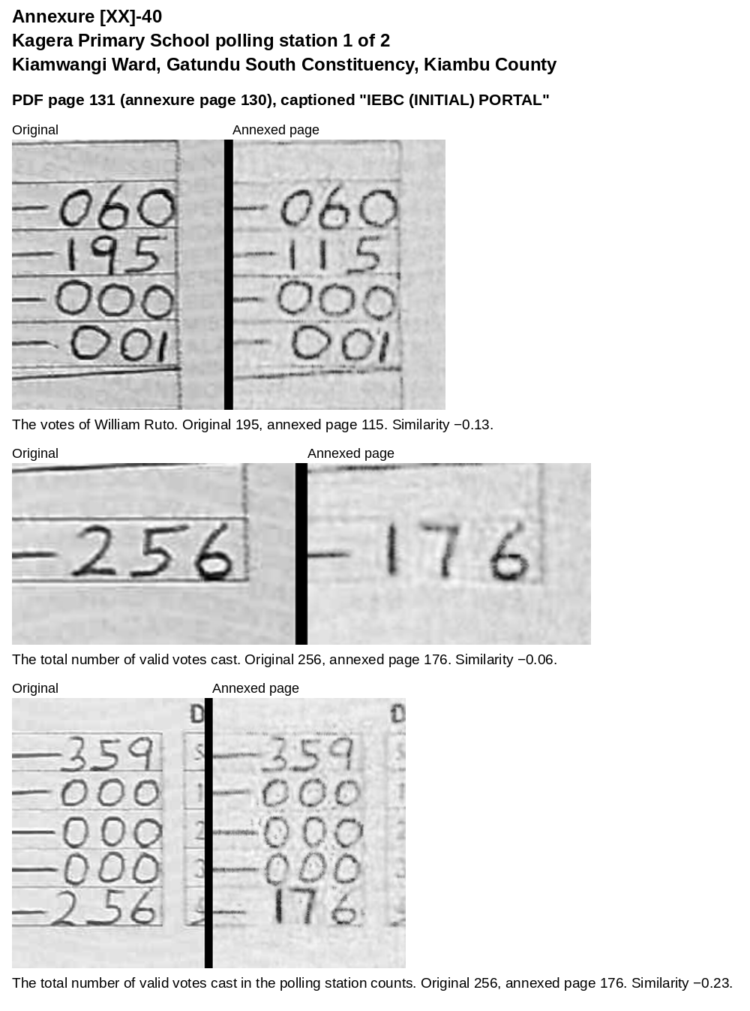
Annexure [XX]-41: Kagera Primary School polling station 1 of 2, the top of the sheet
