From Market Stalls to Mindsets: How One Youth Is Transforming Diets in Bangladesh

When Md. Faizar Hossain Miraz, a student from the University of Dhaka, joined the Food Systems Youth Leadership Training of Trainers (ToT) program by GAIN, he saw it as an opportunity to learn something new. What he did not expect was how much the experience would influence the way he viewed food choices in everyday life.
“I always wanted to do something useful for my community. The training helped me understand how food systems shape our health and habits in ways we do not always notice,” he said.


During the training, Miraz explored how food moves from farms to markets and finally to the plate. He learned how small decisions made during buying and cooking can affect nutrition and long-term wellbeing. One idea stood out to him. Bangladesh grows a wide range of vegetables, yet many people do not eat them regularly because they are unsure about their benefits.
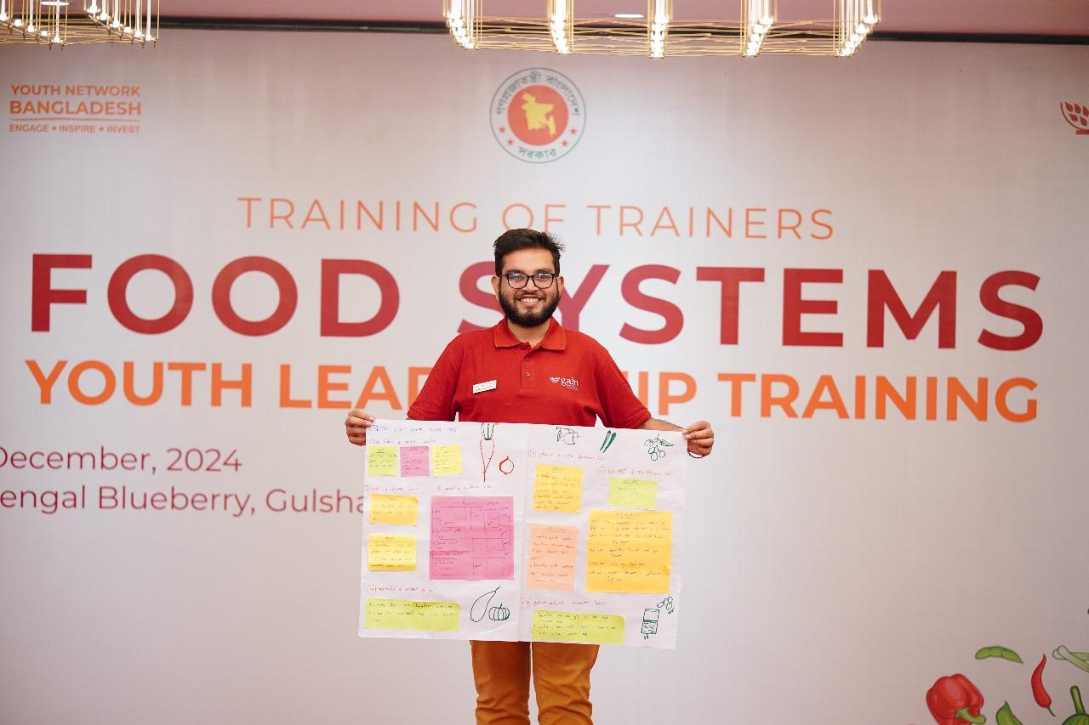
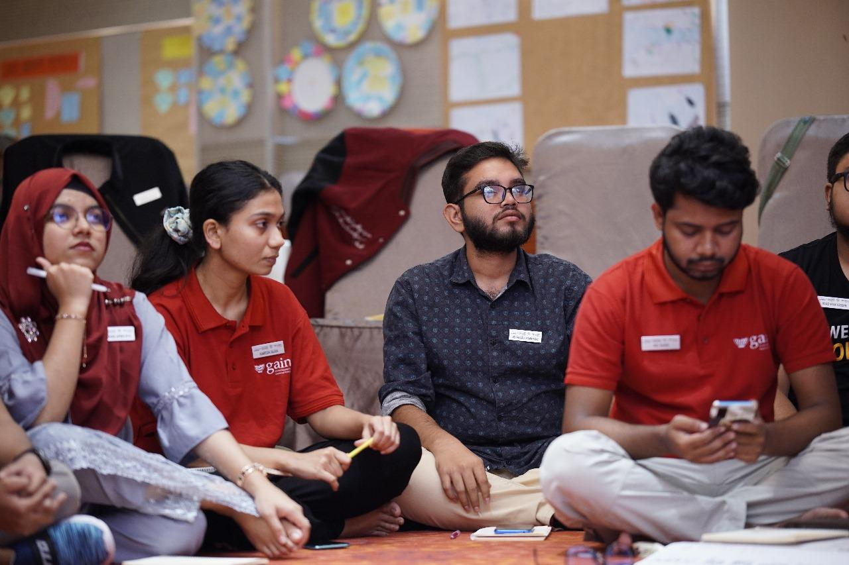

To understand this better, Miraz visited local markets and nearby neighbourhoods. He spoke with vendors, observed shoppers and looked at the variety of produce available. “It became clear that many people simply lacked information. They were surrounded by nutritious vegetables, but most did not know what each one could offer,” he explained.
This insight shaped his next step. Miraz created colourful info-cards for market stalls. Each card included the vegetable’s name, key nutrients and the health benefits. By placing the cards beside the produce, he turned market visits into small learning moments. The idea was straightforward. Make information visible, easy to understand and available at the point of purchase.
The response was encouraging. Shoppers paused to read the cards and began asking questions about vegetables they had previously ignored. Vendors noticed changes too. “At first, I was not sure about the cards. Now I see customers stopping to read them. Some ask me more about what is written. People are buying more leafy greens and different types of gourds since Miraz Bhai started this,” said vendor Karim Mia.
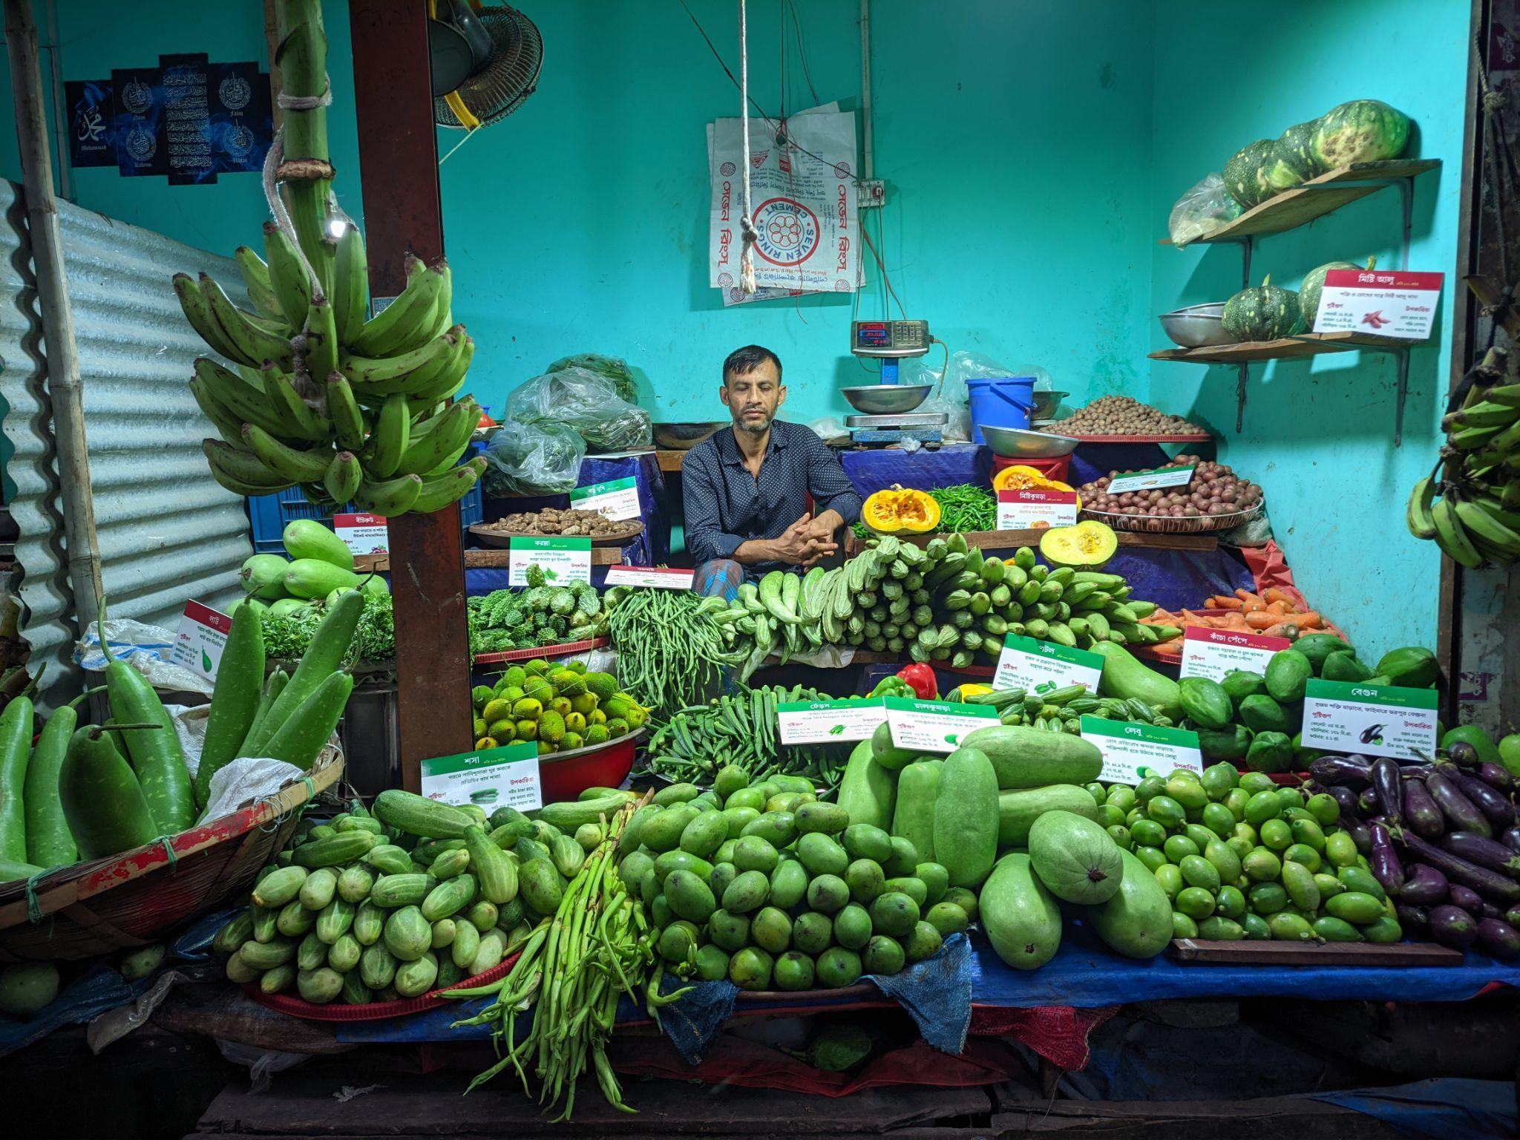
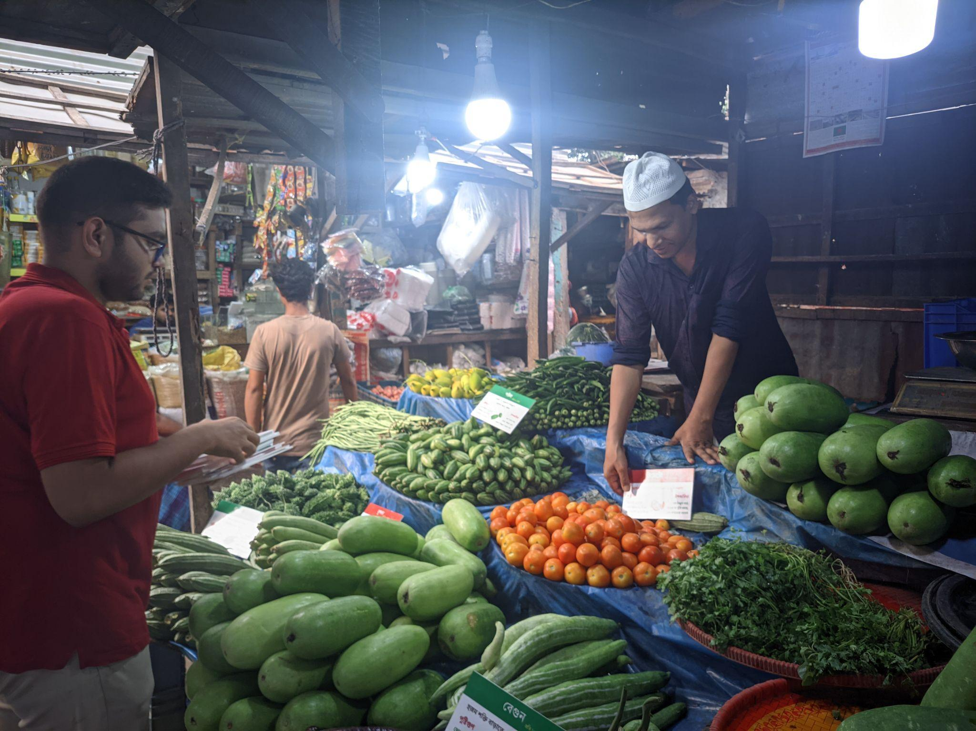

Motivated by the results, Miraz continued building on what he learned. After completing the ToT program, he and other participants organised two youth leadership training sessions, one at Global Platform Bangladesh in Dhaka and another at Bangladesh Agricultural University in Mymensingh. They shared their knowledge with new groups of young people, each of whom developed a community action plan. Miraz and his co-facilitators now host monthly mentorship calls to track progress and provide support.
For Miraz, this work is about helping people make informed decisions in simple, everyday settings. His project shows that a small change in how information is shared can influence healthier food choices in the community.
“Real change starts when people feel confident about the choices they make. Sometimes all they need is a little information at the right moment,” he said.

