A Comparative machine learning study to predict social media   
addiction in Bangladesh.

Submitted by

Md Masum

ID: 1834902579

Sajal Asfak Robin

ID: 1834902575

A project report submitted in partial fulfillment of the requirements for the degree of Bachelor of Science in Computer Science and Engineering from City University



DEPARTMENT OF COMPUTER SCIENCE AND ENGINEERING

CITY UNIVERSITY, DHAKA, BANGLADESH

February 2023

**DECLARATION**

This is to certify that the project titled “**a comparative machine learning study to predict social MEDIA ADDICTION in bangladesh**” is the result of our study in partial fulfillment of the B.Sc. Engineering degree under the supervision of Fahim Shahriar, Lecturer, Department of Computer Science and Engineering (CSE), City University, Bangladesh. It is also hereby declared that this project or any part of it has not been submitted elsewhere for the award of any degree.

|  |  |
| --- | --- |
| Signature of Author’s  Md Masum  ID: 1834902579  Dept. of Computer Science and Engineering  City University, Dhaka, Bangladesh  Sajal Asfak Robin  ID: 1834902575  Dept. of Computer Science and Engineering  City University, Dhaka, Bangladesh | Signature of Supervisor  Fahim Shahriar  Lecturer  Dept. of Computer Science and Engineering, City University, Dhaka, Bangladesh |

**ACKNOWLEDGEMENT**

First of all, we are thankful to the Almighty ALLAH for his Blessings. It is indeed with a great pleasure and immense sense of gratitude we acknowledge the help of our supervisor. We are highly indebted to our Supervisor Fahim Shahriar, Lecturer, City University, for the facilities provided to accomplish this main project.

I would like to acknowledge and give my warmest thanks to my supervisor Fahim Shahriar who made this work possible. His guidance and advice carried us through all the stages of writing my project. I would also like to thank my team member for letting my defense be an enjoyable moment, and for your brilliant comments and suggestions, thanks to you.

We feel elated in manifesting our sense of gratitude our internal project guide Fahim Shahriar, Lecturer, Department of Computer Science and Engineering, City University. He has been a constant source of inspiration for us and we are very deeply thankful to him for his support and valuable advice.

**ABSTRACT**

The purpose of the project entitled as “**A Comparative Machine Learning Study to Predict Social Media Addiction in Bangladesh.**” Social media addiction is a huge problem among the youth. According to Dhaka Tribune, more than 49.6 million people are addicted to social media in Bangladesh. Due to the outburst of various social media application people are getting addicted to social media. The issue of social media addiction is a rising one in the general masses especially amongst the teenagers and young adults. According to a survey conducted in 2023 of about 1560 people, most of the users of websites like TikTok, WhatsApp, Facebook, Telegram, Instagram are in between the age of 18-28, which is a very crucial period for a person. In this paper, we dig for the influential factors behind **Social Media** addiction and possible solutions to reduce the social media addiction rate. The research is held on the people of Dhaka, Bangladesh. Most of the data of people are collected from Trusted platform(Online and Offline). All are male and the age group of 18 to 45 years. Our primary data set is constructed including only 1560 qualitative data. Some suitable algorithms for this project have been employed including Logistic Regression, Decision Tree, Naive Bayes, Support Vector Machine (SVM), Logistic Regression, KNN without tuning and their results are compared.

**TABLE OF CONTENTS**

|  |  |  |  |
| --- | --- | --- | --- |
| **Name of The Content** | | | **Page** |
| Declaration | | | ii |
| Acknowledgement | | | iii |
| Abstract | | | iv |
| List of Figures | | | vii |
| List of Tables | | | viii |
|  | | |  |
| **Chapter 1: Introduction** | | | **1** |
| 1.1 | Introduction | | 1 |
| 1.2  1.3  1.4  1.5  1.6 | Problem Statement  Objective  Features  Why we choose this project?  Team member work distribution | | 4  5  5  5  6 |
|  |  | |  |
| **Chapter 2: Literature Review**  2.1 Background Study  2.2 Existing Work | | | 7  7  10 |
|  |  | |  |
| **Chapter 3: Methodology** | | | 11 |
| 3.1 | Required Algorithm | | 11 |
| 3.2 | Description of Algorithm | | 11 |
|  | 3.2.1 | Logistic Regression | 11 |
|  | 3.2.2  3.2.3  3.2.4  3.2.5 | Decision Tree  Support Vector Machine  KNN  K-Means++ | 11  12  12  12 |
| 3.3 | **Analysis** | | 12 |
|  | 3.3.1 | Data Collection and Overview | 12 |
|  | 3.3.2  3.3.3 | Data Pre-processing  Classification | 13  13 |
| 3.4  3.5  3.6 | Work Flow Diagram  Gantt Chart  Proposed Methodology Design | | 14  14  15 |
| **Chapter 4: Results and Discussion** | | | 16 |
| 4.1 | Result | | 16 |
| **Chapter 5: Conclusion and Recommendations** | | | 31 |
| 5.1  5.2 | Conclusion  Recommendations | | 31  32 |
|  |  | |  |
| **References** | | | 34 |
|  | | |  |

**LIST OF FIGURES**

|  |  |  |
| --- | --- | --- |
| **Figure No** | **Figure Contain** | **Page No** |
|  |  |  |
| Fig. 3.1 | Work Flow Diagram | 11 |
| Fig. 3.2 | Gantt Chart | 11 |
| Fig. 3.3 | Proposed Methodology Design | 12 |
| Fig. 3.4 | Steps of data preprocessing | 13 |
| Fig. 5.1  Fig. 5.2  Fig. 5.3  Fig. 5.4 | Dataset  Divided into 2 class  Checking Features overfitting  Our Features Sequentially Importance List | 14  14  15  15 |
| Fig. 5.5 | Every Two feature Ratio | 16 |
| Fig. 5.6 | Do you Excessive time in Addiction | 17 |
| Fig. 5.7 | How Much Time You Spend On Social Media Everyday In Addiction | 17 |
| Fig. 5.8 | Do You Have Status Update Anxiety In Addiction | 18 |
| Fig. 5.9 | Do ever virtually date in Addiction | 18 |
| Fig. 5.10  Fig. 5.11  Fig. 5.12 | Heatmap  ROC curve and AUC  Table of used algorithm Accuracy | 19  20  21 |

LIST OF TABLES

|  |  |  |
| --- | --- | --- |
| Table No | Table Contain | Page No |
|  |  |  |
| Table. 1  Table. 2 | Existing Work  Table of used algorithm Accuracy | 10  30 |

CHAPTER 1

INTRODUCTION

* 1. **Introduction**

In the 21st Century, the most practical and fastest way to reach information is undoubtedly the usage of social media platforms with the blessings of the internet technology.

The major difference of the virtual world from the real world is its temporary nature. Here the users can be of any virtual identity which makes the users remain highly active in these platforms. Social Media Platforms have massive advantages such as volunteering, aid, charity organizations, performing and sharing art works, discussing ideas and projects with experts who are not easily accessible in real life.

Addiction to social media is a growing problem in the general population, particularly among teenagers and young adults. The results of a poll of approximately, most of the 300 users of websites like Facebook, Instagram, and WhatsApp are between the ages of 18 and 24, which is a very important time for a person. The most frequent problems are account hacking, improper use of photos, exposure to offensive content, and creation of false profiles. For teenagers to kick this unnecessary addiction, they need guidance or counseling. They are the main age group that businesses that solely rely on social media for business targeting. Teenagers are instantly hooked on the unique, potentially viral content they produce.

The algorithms on well-known social media platforms like Facebook, YouTube, Instagram, and others are made to keep users from ever wanting to leave the website because there is always something new and exciting to see next. As a result, users become unwilling to leave the app and eventually develop an addiction. The effects of this addiction can be devastating to individuals. People have experienced many instances of depression as a direct result of their social media addiction.

The lack of any kind of supervision is the main contributor to social media addiction. The internet contains material that is inappropriate for some age groups. However, there is no system or algorithm that sorts through such content to determine whether it is appropriate for users to view. A few recent actions have been taken to address this problem.

Therefore, a centralized system that tracks a person's social media use is urgently needed in the modern world in order to stop people from becoming dependent on violent and potentially dangerous online content and from making drastic changes in their lives.

However, the system must not collect excessive data about a person's usage because it is private information that should be kept by the user.

Social media platforms do create an addiction. The social media addiction of an individual can about 80 percent of the social media addicts are students’ men of 15 to 40 years of age. We need to keep a special focus so that our youth do not become addicted to social media. Machine learning, a major branch of artificial intelligence (AI) can provide a solution to the problem just discussed above. The applications of machine learning vary on different application domains e.g., cancer prediction, software fault prediction, dermatological disease detection, and risk prediction and so on. Likewise, different conspicuous machine learning algorithms can be put into use for the work of prediction to drugs and alcohol. This paper tries to anticipate in advance if someone has the risk of becoming addicted to drugs and alcohol. First, we read relevant articles from different national and international journals, conference proceedings, and magazines and write-ups from different websites and newspapers. Then we talk to doctors and drug-and-alcohol-addicted people and find some driving factors for addiction such as age, gender, profession, health ability, mental pressure, trauma, family-and-friends’ history, life-changing incidents. Collecting raw data from both addicted and non-addicted people. We made an arduous endeavor for comparing our results with the results of similar research works even though no work has been observed, which addresses the problem of prediction of addiction to social media. We have followed and studied related works in the near past done by some other researchers on drugs and addiction prediction and understand the processes and methods expressed by them. Here are some descriptions of recent notable research work on machine learning. Dharwad et al. proposed a general disease prediction system, which was based on machine learning algorithms. Hegazi et al. proposed a model for stock market prediction with machine learning technology. Alonzo et al. presented a detailed comparison between various machine learning algorithms. They used the extreme gradient boosting (XG Boost) decision tree algorithm and found the best accuracy of 84.30% with maximum depth 24. Alaa et al. [14] proposed a machine learning-based model for predicting disease risk of cardiovascular on Biobank participants. Logistic regression had the best performance with 83.44% accuracy, 83% precision, 83.4% recall and 83.2% F-measure in their work. Lee et al. worked with a model that predicts social media uses decision make with a machine learning classifier. These prove that peoples’ social and behavioral concerns are somehow connected with and influenced by social media.

For example, one study found out sources of referral for prescription opioid admission to substance use disorder treatment facilities and their relative completion success rates using secondary analysis of an existing data set (treatment episode datasets—discharge). Their data-set’s variables are mainly focused on the frequency of using social media. However, their dataset played down the socio-cultural variables like bonding with family and friends, relation with peers, social behaviors etc. that we will mainly focus on our work. We had worked with the shortcomings of their works as well as many other works were investigated before performing the job which will be discussed in different section of the report.

In this paper we collect a dataset from students and Job holders. Here our dataset contains 1560 samples with 27 features. We use some algorithm (Logistic Regression, Decision Tree, Support Vector Machine (SVM), KNN to get accuracy for train and test our dataset. When we train and test our dataset, we cluster the data in 5 groups of health condition by using K-means clustering algorithm for finding health condition.

**1.2 Problem Statement**

## The Impact of Social Media Addiction

An immediate consequence of excessive social media use is that it takes away from time spent elsewhere. This includes time with family and friends, and engaging in hobbies and exercise. It may also begin getting in the way of important life obligations and productivity. As this happens, it is likely that others will begin noticing.

Excessive social media use may also sway your ability to independently make decisions. Since peer pressure in face-to-face situations has been known to have this effect as well, it’s no surprise that social media can have the same impact. People either begin questioning themselves or want to just go with the flow when the majority believes something different. Although children and teenagers are generally more likely to be swayed by peer pressure, this happens with adults as well.

Social media platforms also intentionally use advertising strategies specific to someone’s demographics and desires to update news feeds with specific information enticing to that individual. Although this helps fund the platform, it also makes it harder for the individual to lessen or abstain from engagement.

### Health Risks of Social Media Addiction

Possible health risks and concerns of excessive social media use include

* Problems concentrating
* Poor performance at work or school
* Problems within close interpersonal relationships
* Eating less
* Ruminating negative thoughts
* Inflated self-image
* Less physical activity
* Weight gain
* Spending money
* Anxiety
* Depression
* Neurosis
* Increased blood pressure/hypertension
* Emotional instability
* Decreased sleep

## How to Tell If You’re Addicted to Social Media

Since social media is so easily accessible, it’s easy to develop a problem. When you notice that your mood is directly related to your social media use, or that your sleep or relationships are being damaged by your use, that’s a sign that it’s time to get some help.

Some general signs of a social media addiction include

* Engagement in social media changes your mood – i.e. you feel happier when you’re on social media
* You have a behavioral, cognitive, and emotional preoccupation with social media
* You keep increasing your use of social media over time
* You experience unpleasant physical and emotional symptoms when social media use is restricted or stopped
* You have interpersonal problems due to your social media usage
* You quickly revert back to excessive social media usage after you try to take a break
* As the number of symptoms and their severity increases, the more likely you have a problem with social media use.
  1. **Objectives**

# Institute and family to identify student’s academic performance and addiction Recording information about the Patients that come.

# Find out the characteristics of a person that can prove his vulnerability to social media addiction.

1. Using a public dataset, data mining used to investigate spending time on social media.

# prediction of addicted user using a decision tree classifier.

**1.4 Features**

1. Identify Addiction Level.
2. Inform Health Risks of Social Media Addiction.
3. Suggest treatment.
4. Preventing Addiction measure in teenagers and academic Students.
5. Overcome The Challenges of Higher Accuracy.

**1.5 Why we choose this project?**

# There are many irregularities in Bangladesh social media platform such as physically and mentality torture of patients and illegally imprisoning healthy individuals within the institution even Sexual harassment and not given proper food.

# Bangladesh perspective.

# Help addicted individuals.

# Economic stability.

# Increasing recover rate.

**1.6 Team member work distribution**

# Put together a full list of projects and processes our team is responsible for.

# We Determine the scope and timing of work for each.

# We Break down projects into smaller tasks and workstreams.

# We Prioritize work based on importance and urgency.

CHAPTER 2

LITERATURE REVIEW

**2.1 Background Study**

In recent years, social media addiction has significantly increased in the whole world, especially in the South Asian countries like Bangladesh. In this country, this agent of human devastation has spread its tentacles to every nook and corner. International organizations like the United Nations and World Health Organization (WHO) are alarmed by the present proportion of social media addicts. This part will show the previous study conducted by various researchers on the social media addiction in Bangladesh. Studying different paper from online journals, thesis papers, articles and other relevant background study through the internet it is found that the social media addiction has epidemically spread among the students and young people of Bangladesh in the recent years. According to sources at different healthcare facilities, nowadays nearly 10 percent of outpatients are visiting the country’s hospitals with cases of mental health issues. According to Doctors, In the last two or three years, many more teens have been effected for using social media than 7-8 hours in a day. According to a WHO survey, most social media users are young, their age ranging from 18 to 30 years. Meanwhile, a separate study conducted by the Journal of Health, Population and Nutrition (JHPN) of the International Centre for Diarrheal Disease Research, Bangladesh (ICDDR, B) shows that in the capital, users are male are more addicted in social media. The average age of the social media addicts is 23. Students are mostly falling victims to social media addiction, which eventually lowers their standards of education and attendance at schools and colleges. The trend of social media using is higher in youth and teenagers, their age spanning between 18 and 30 years. They come from all strata of the society. Throughout 2022, on average there are about **50.3 million** active social media users in Bangladesh on a monthly basis with an annual growth rate of 10.1 % in 2022-23. This represents about 29.7 % of the total population. They spend over 6 hours every day on social media. According to a World Health Organization (WHO) survey, most users are young, ranging in age from 18 to 30 years.

**2.2 Existing Work**

|  |  |  |  |  |  |
| --- | --- | --- | --- | --- | --- |
| **Work Done** | **Objects (deal with)** | **Problem Domain** | **Size of feature sets** | **Algorithm** | **Accuracy** |
| M. D. Griffiths et al. [15] | Facebook Addiction and Depression | Prediction | 341 | Logistic Regression | 78% |
| Shanayyara Mahmood et al. [20] | Facebook addiction: Factors and Academic performance | Prediction | 150 | Linear Regression | NM |
| Bukit Jalil et al. [24] | Negative impacts on Social Networking Sites | Prediction | 152 | Linear Regression | 37.5% |
| Ainin S. et al. [21] | Facebook usage, socialization and academic performance | Prediction | 1165 | Regression Analysis | 87% |
| Md. Tarek Habib et al. [30] | Papaya disease recognition | Detection | 126 | SVM | 90.2% |

Table 1: Existing Work

CHAPTER 3

METHODOLOGY

This chapter introduces about the required algorithm and dataset to implement our proposed system. The specification and fundamental ideas of each algorithm is mentioned briefly in this chapter. This chapter also explains what we did and how we did it, allowing readers to evaluate the reliability and validity of our project. A detail analysis of theoretical studies, proposed diagram, Algorithm and implementation of proposed system should be placed in this chapter.

* 1. **Required Algorithm**
* Logistic Regression
* Random Forest Classifier
* AdaBoost Classifier
* XGB Classifier
* Naïve bayes
* Decision Tree
* Support Vector Machine
* KNN Algorithm
* K-Means++ clustering algorithm
  1. **Description of Algorithm**
     1. Logistic Regression: Logistic regression is an example of supervised learning. It is used to calculate or predict the probability of a binary (yes/no) event occurring. It is used to predict the probability of certain classes based on some dependent variables. In our taking dataset there are many discrete values. The logistic Regression algorithm works discrete data. So, we use this algorithm in our project to get maximum accuracy from our dataset.
     2. Decision Tree: A decision tree is a graphical representation of all possible solutions to a decision based on certain conditions. On each step or node of a decision tree, used for classification, we try to form a condition on the features to separate all the labels or classes contained in the dataset to the fullest purity in machine learning languages dataset class predication is most important for getting a good result. In our project we use Decision Tree algorithm for prediction dataset class.
     3. Support Vector Machine: Support Vector Machine (SVM) is a supervised machine learning algorithm used for both classification and regression. Though we say regression problems as well its best suited for classification. The objective of SVM algorithm is to find a hyperplane in an N-dimensional space that distinctly classifies the data points. In our project we use SMV for SVMs are used in applications like handwriting recognition, intrusion detection, face detection, email classification, gene classification, and in web pages. This is one of the reasons we use SVMs in machine learning. It can handle both classification and regression on linear and non-linear data.
     4. KNN Algorithm: The abbreviation KNN stands for “K-Nearest Neighbor”. It is a supervised machine learning algorithm. The algorithm can be used to solve both classification and regression problem statements.
     5. K-Means++ clustering algorithm: The main purpose of uses K-Means++ clustering algorithm in our projects is to find the data accuracy from the dataset. How much % of the data accuracy we get from the taking dataset and also select which data we assign in which group. So, The K-means clustering algorithm is used to find groups which have not been explicitly labeled in the data. This can be used to confirm business assumptions about what types of groups exist or to identify unknown groups in complex data sets. We can also predict which ages or which category’s people takes which types of Addiction.
  2. **Analysis**
     1. Data Collection and Overview:

In the current situation of Bangladesh, social media addiction is a very common and growing threat. Our main objective is to organize the machine learning concepts and reduce the addiction rate. So, primarily we have collected data for 27 specific features. Due to the missing data and privacy issue, we were not able to add all the features to the dataset. Most of the samples for people, we have collected from students. All the samples of age group of 17 to 45 years. Our primary data set is constructed on 1560 samples of 27 features. After cleaning and processing the initial dataset, the final dataset was of 1560 samples and 26 features.

* + 1. Data Pre-processing:

We have collected the data of 1560 people from educational organization. we have got so much messy data. So, for further processing, we needed to clean and process our data. There were several missing data and type mismatch features. The data type of each feature has been checked and fixed. Finally, our data set contains 1560 samples with 26 features. We have used a label encoder to encode the data to a numeric format for further processing. We have performed a different statistical analysis to find important features among those features. PCA (Principal Component Analysis) is performed. The PCA test has given us better accuracy in the final score. So, after finding out the score of each feature we’ve dropped the less important column that will help the model being simpler and more powerful. Finally, our data set contains 1560 samples with 26 features.

* + 1. Classification:
* Classification is a supervising technique that categorizes the data into the desired number of classes. The goal of this work is to find out the factors behind social media addiction and predict a person’s probability of being social media-addicted. In that manner, we can decrease the addiction rate and keep people especially teenagers away from this deadly addiction. So, we have employed classifiers: Decision Tree (DT), Logistic Regression (LR), Support Vector Machine (SVM), KNN, Random Forest Classifier, AdaBoost Classifier, XGB Classifier, Naïve bayes for train and test the dataset. Then we use means clustering algorithm to divide into 5 groups for finding health condition.
  1. **Work Flow diagram**

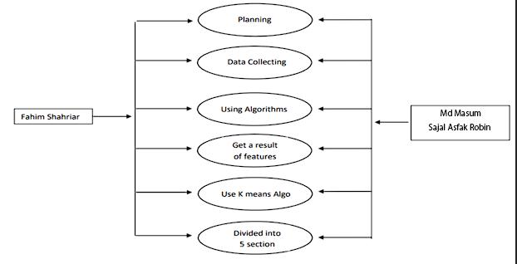

**Figure 3.1: Work flow diagram**

* 1. **Gantt Chart**

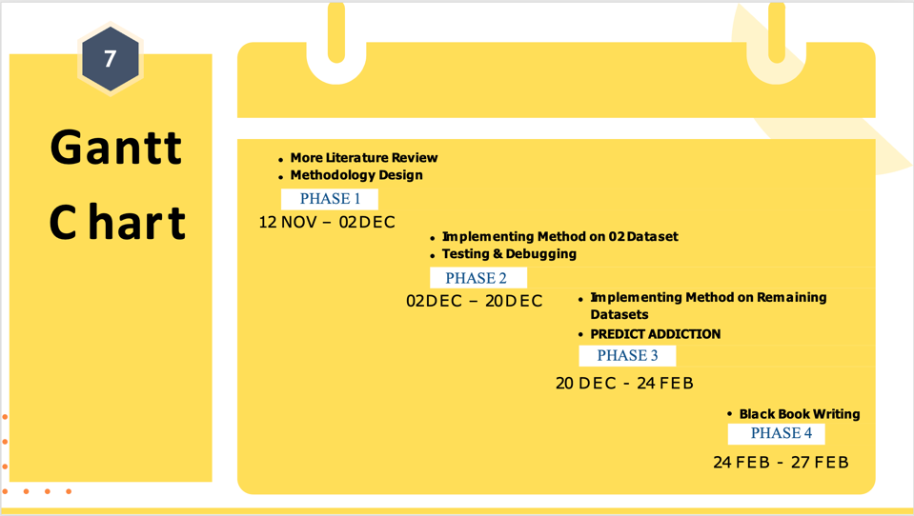

**Figure 3.2: Gantt Chart**

* 1. **Proposed Methodology Design** **:**

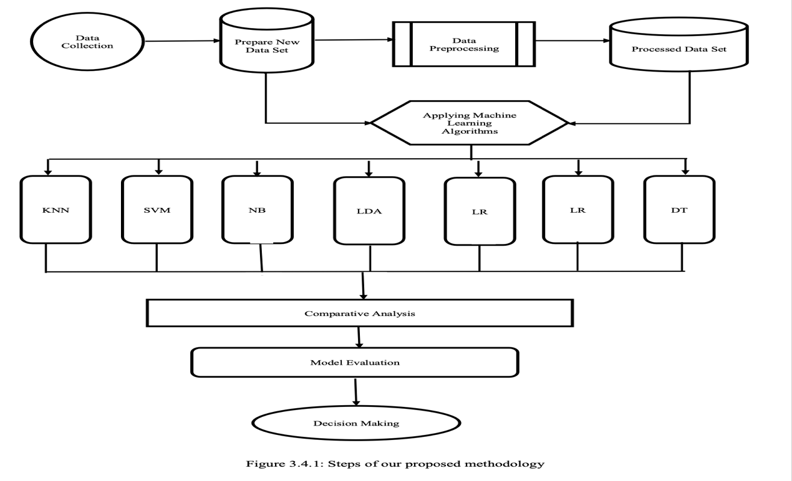

**Fig 3.3: Proposed Methodology Design**

At first, we collect a dataset from a trust platform. Then storing the data, we reach physically and collect raw data and store the raw data with in CVS format. Then we cleaning and preprocessing the data and analysis for important feature. After this we selecting the feature and applying the principal component analysis. We get 4 classification and applying some algorithm like as Logistic Regression, Decision Tree Support Vector Machine (SVM), KNN without tuning for checking the accuracy rate with different algorithm. Finally, we consider the performance evaluation with the accuracy.

# **Data preprocessing :**

After gathering the data, we get some missing data, categorical data, numerical and text data. Then we resolve that through data processing, we will type this data suitable for algorithms. Data processing is the capability to transform data into a suitable format after collecting data. Processing information or data in a specific format that helps to easily output.

Our data preprocessing method is shown below in

Raw Dataset

Null Value Check

Label Encoding

Solving Null Value Problem

Solving Noisy Value Problem

Correlation Analysis

Check for Noisy Value

Drop Outcome Feature

Normalization

Processed Data

**Figure 3.4:** **Steps of data preprocessing**.

First, we underway the exertion of data cleaning. If there is a null value in the data set then encode the level that converts the text data to numerical data. We resolved the missing value problem using imputer and median. If there is a noisy value in the data set using a box, we can see that there was some noisy data in the numerical data. We analyze the correlation matrix as a data integration process. This matrix shows us the ratio of each data connected to each data and data is highly interrelated by a positive value and the negative value means that the data is negatively connected and zero indicates that the data does not connect to itself. We remove noisy values by using outlier quantile detection then drops our outcome feature.

CHAPTER 5

Results and Discussion

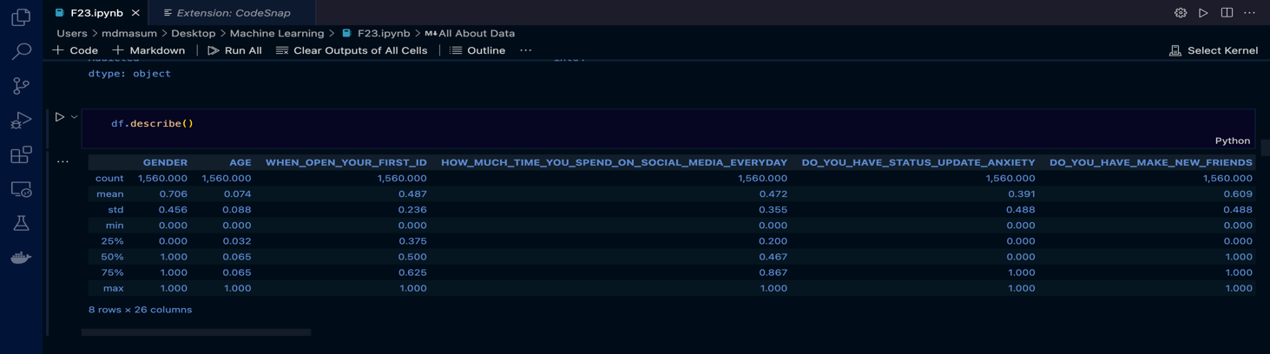

**Figrue 5.1: Dataset**

A machine learning dataset is a collection of data that is used to train the model. A dataset acts as an example to teach the machine learning algorithm how to make predictions. The common types of data include: Text data. Image data. Here is our Dataset, we collect our data from some trusted Platform. There are 27 features in our dataset. Our dataset is in CSV (comma-separated values) form.

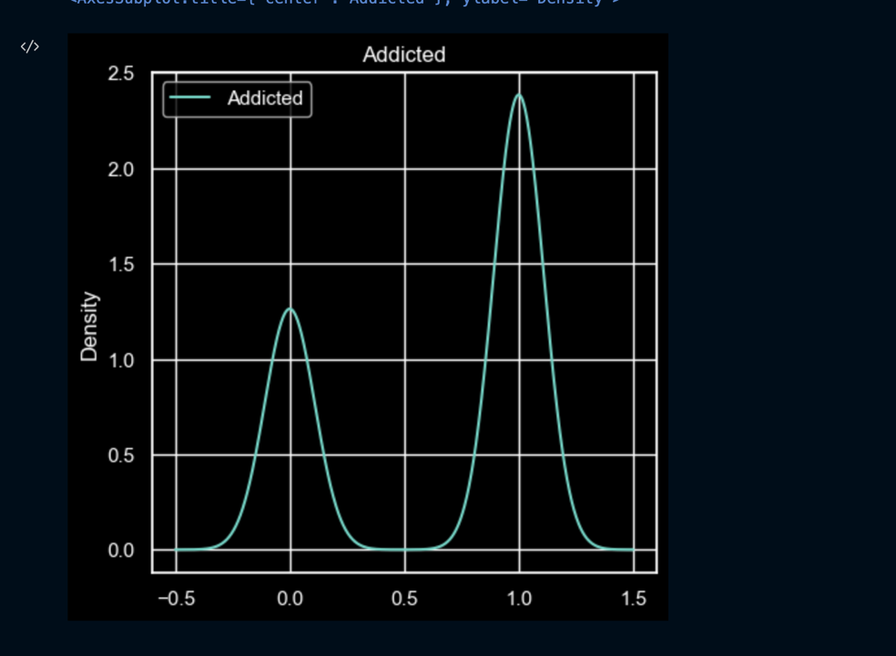

**Figure 5.2: Divided into 2 class**

Data Collecting and filtering is a hard process and [time-consuming](https://tr-ex.me/translation/english-bengali/time-consuming). After getting the data set of 1560 peoples, we divided the total number of people into 2 classes and keep the 730 people in every class. After getting the data set physically monitoring every people and identify the health condition, they divided them into 2 classes as the 1st classes people are most dangerous condition, 2nd level are also in danger. We give the different classes in different type of color.

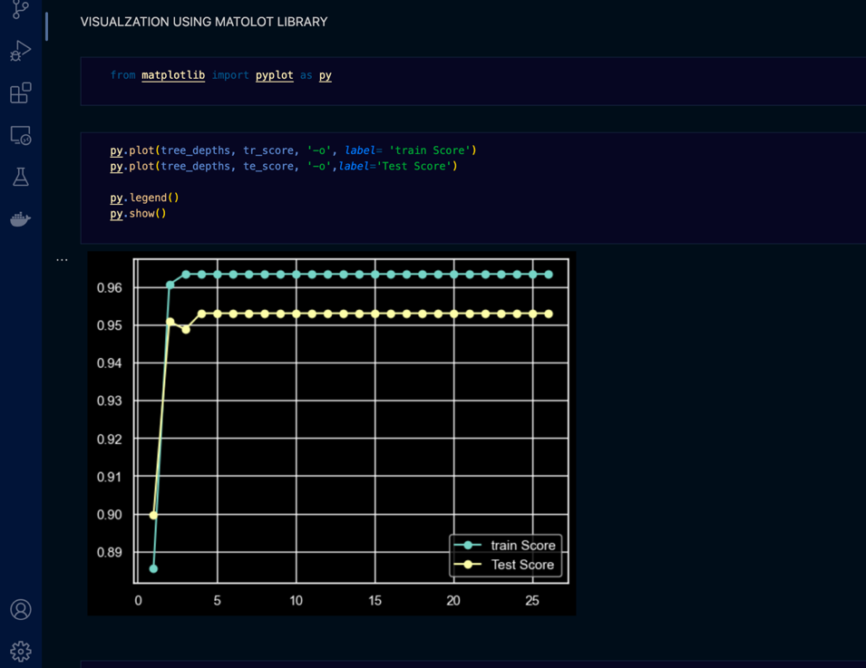

**Figure 5.3: Checking Features overfitting**

Here we identify our features are overfitting or not. Overfitting is probably one of the first things you’re taught to avoid as a data scientist. When you’re overfitting data, you’re basically creating a model that doesn’t generalize the learning of the training data.

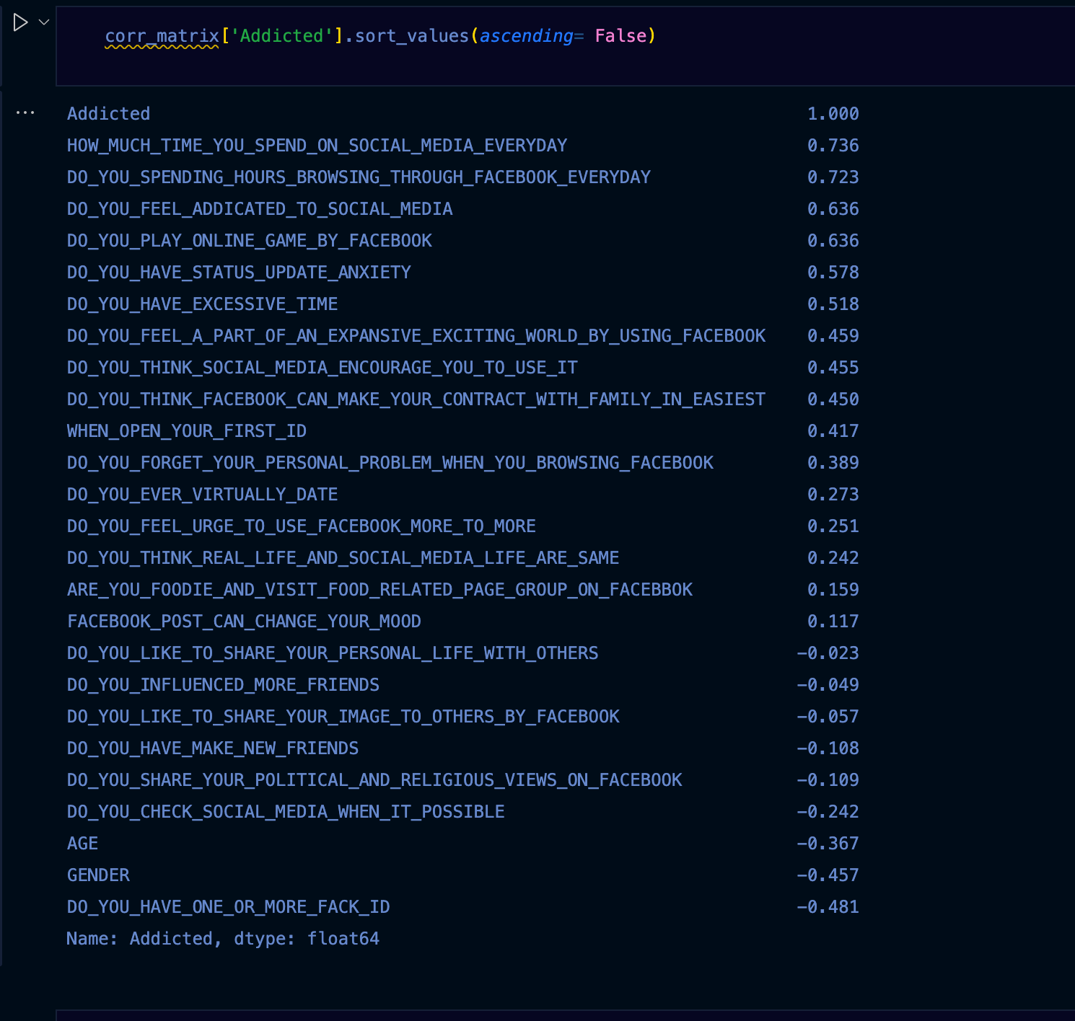

**Figure 5.4: Our Features Sequentially Importance List**

We identify every feature which is more important.

Feature Importance refers to techniques that calculate a score for all the input features for a given model — the scores simply represent the “importance” of each feature. A higher score means that the specific feature will have a larger effect on the model that is being used to predict a certain variable.

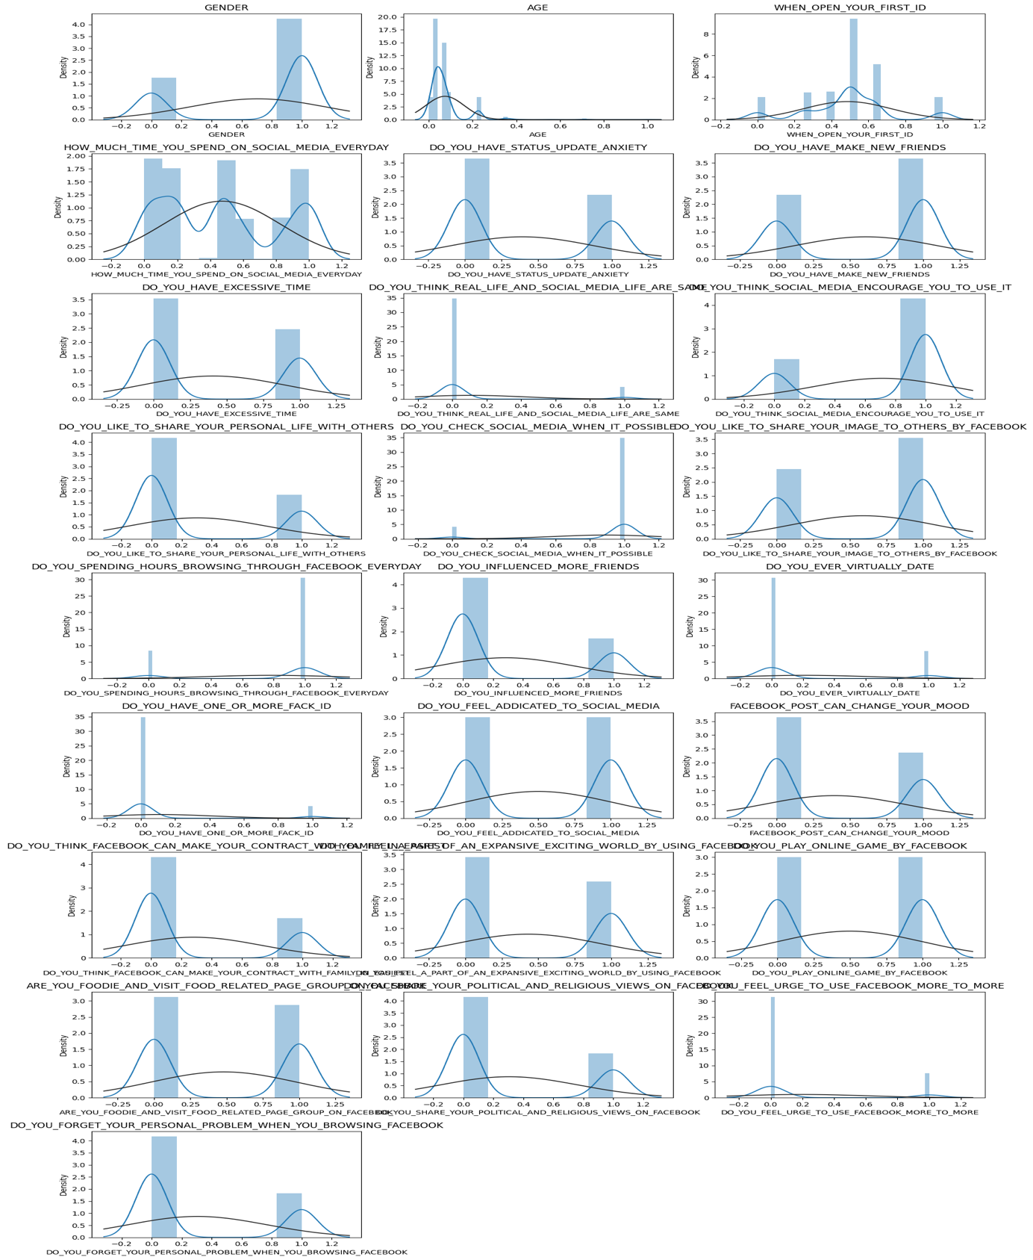

**Figure 5.5: Every Two feature Ratio**

This figure defines every feature ration in each other for statically. So, most of the people are addicted for the reason of Excessive time &amp; mostly male are danger addicted for excessive time in life.

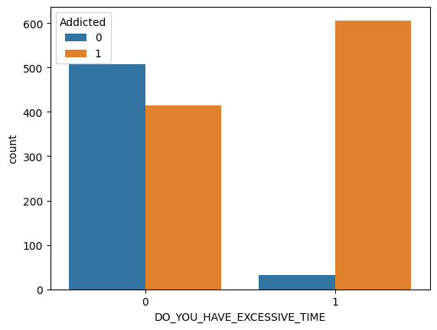

**Figure 5.6: Do you Excessive time in Addiction**

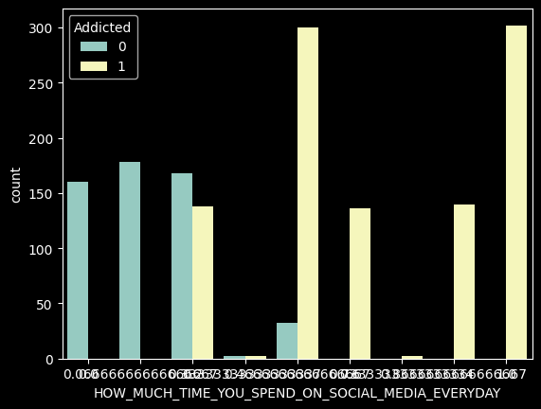

**Figure 5.7: How Much Time You Spend On Social Media Everyday In Addiction**

This figure defines how much time spend time in social media. So, most of the people are addicted for the reason of Excessive time &amp; mostly male are danger addicted for excessive time in life.

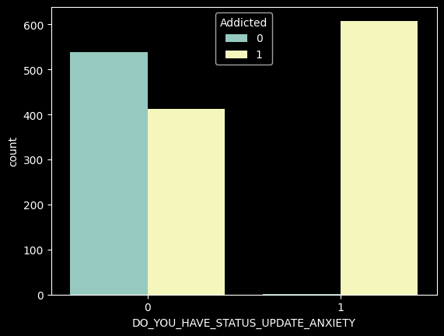

**Figure 5.8: Do You Have Status Update Anxiety** **In Addiction**

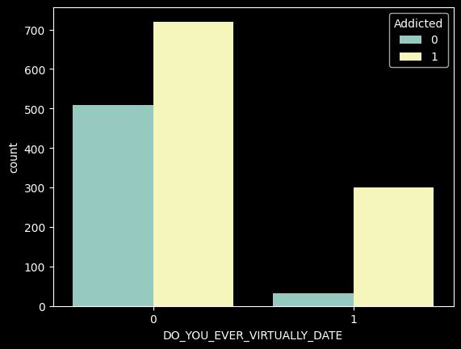

**Figure 5.9: Do ever virtually date in Addiction**

This figure defines do you virtually date. So, most of the people are addicted for the reason of date &amp; mostly female are danger addicted for excessive time in life.

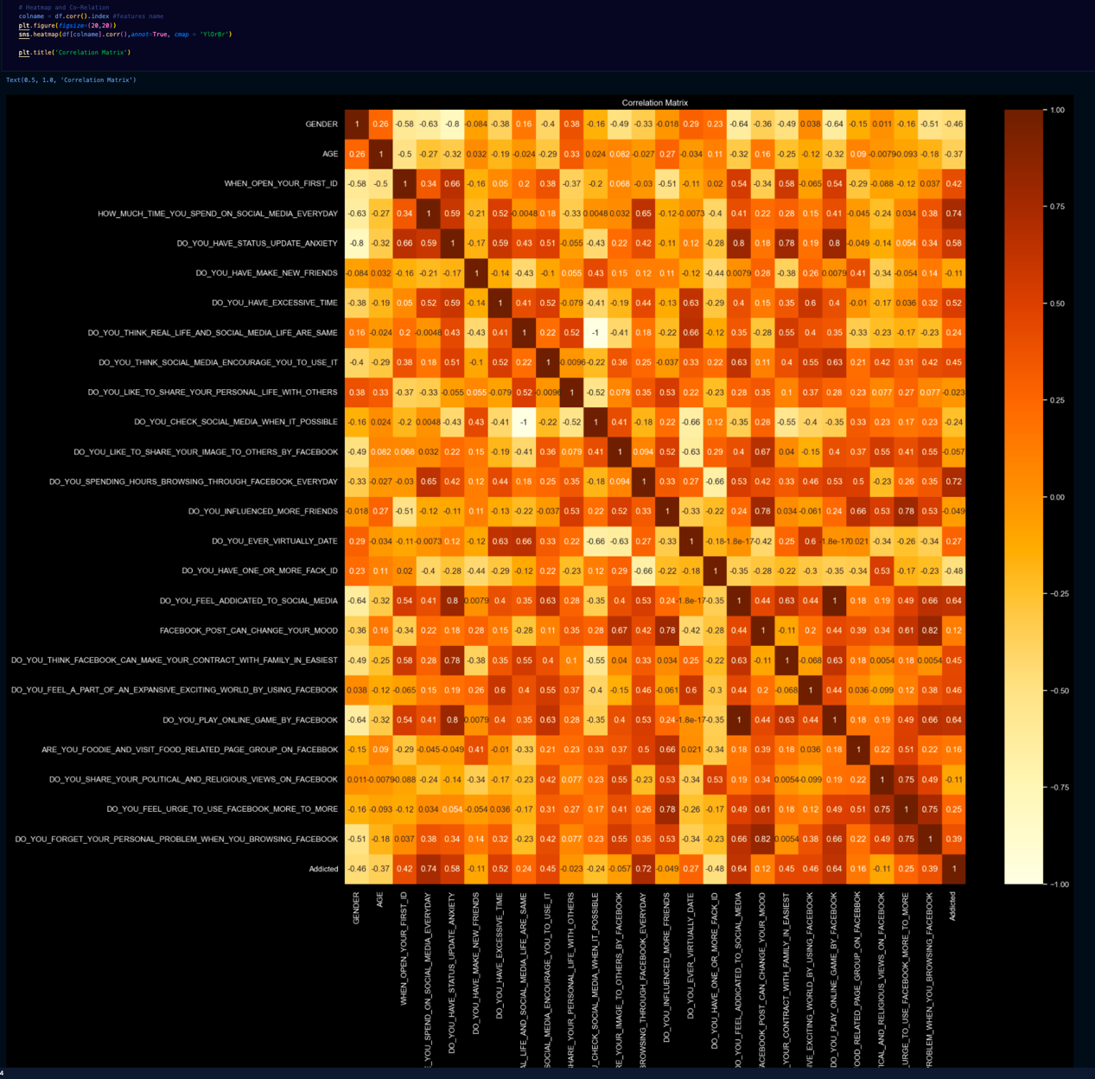

**Figure 5.10: Heatmap**

Here we identify every two features ratio to identify the combination of importance of every two features.

A heat map (or heatmap) is a [data visualization](https://en.wikipedia.org/wiki/Data_visualization" \o "Data visualization) technique that shows magnitude of a phenomenon as color in two dimensions. The variation in color may be by [hue](https://en.wikipedia.org/wiki/Hue" \o "Hue) or [intensity](https://en.wikipedia.org/wiki/Brightness" \o "Brightness), giving obvious visual cues to the reader about how the phenomenon is clustered or varies over space.

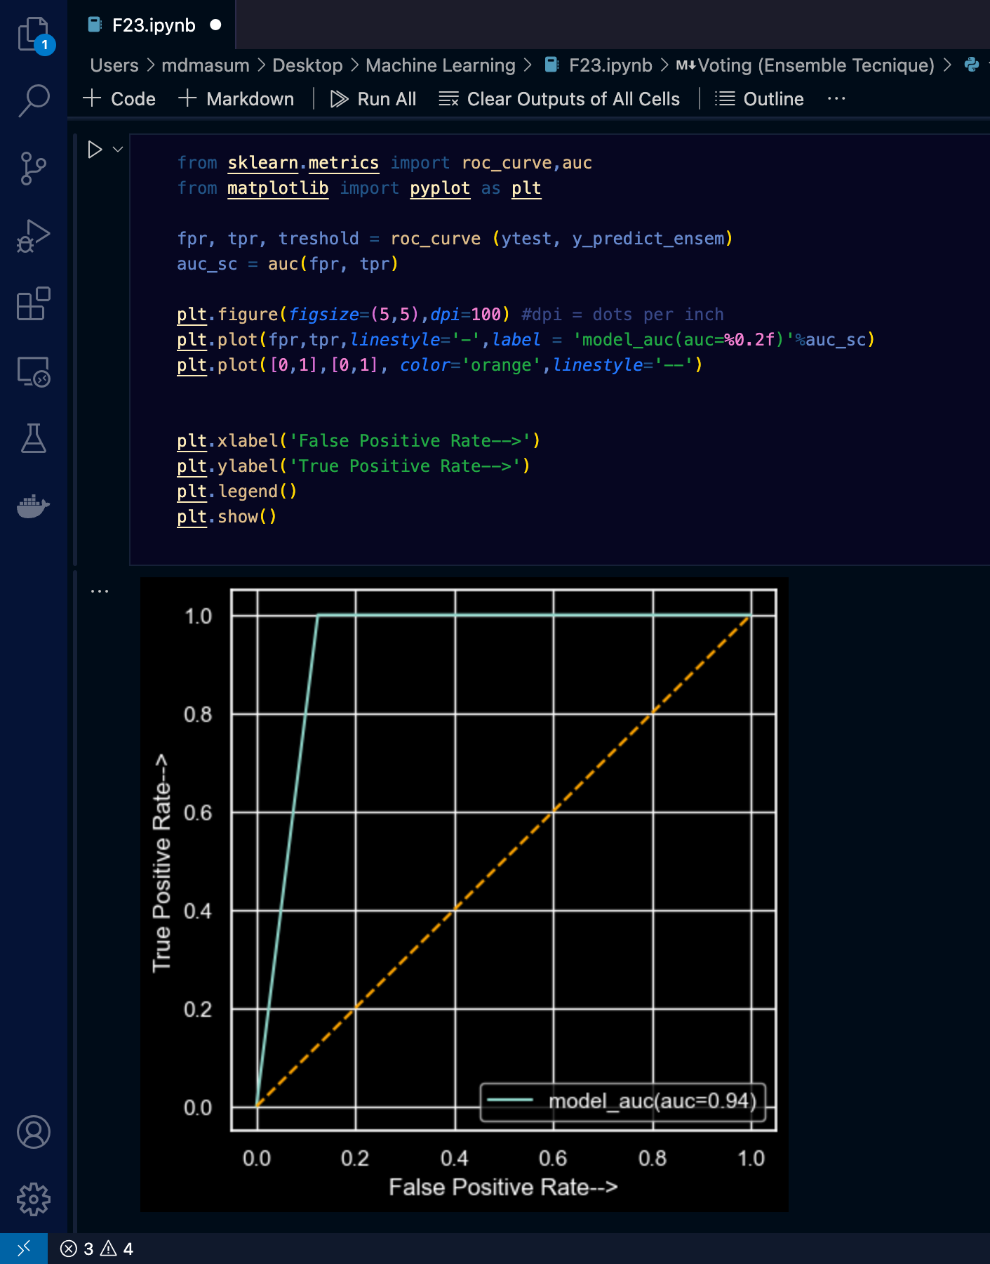

**Figure 5.11: ROC curve and AUC**

An **ROC curve** (**receiver operating characteristic curve**) is a graph showing the performance of a classification model at all classification thresholds. This curve plots two parameters:

* True Positive Rate
* False Positive Rate

**True Positive Rate** (**TPR**) is a synonym for recall and is therefore defined as follows:

TPR=TP/(TP+FP)

**False Positive Rate** (**FPR**) is defined as follows:

FPR=FP/(FP+TP)

An ROC curve plots TPR vs. FPR at different classification thresholds. Lowering the classification threshold classifies more items as positive, thus increasing both False Positives and True Positives. The following figure shows a typical ROC curve.

**Classification**

**Table 5.12: Table of used algorithm Accuracy**

The accuracy of a ML model is a metric for determining which model is the best at distinguishing associations and trends between variables in a dataset based on the input, or training data. The more a model can generalize to ‘unseen’ data, the more forecasts and ideas it can provide, and therefore the more market value it can provide.

ML models are used by businesses to make realistic business choices, and more reliable model results lead to better decisions. Errors have a high cost, but improving model accuracy lowers the cost. Of course, there is a point at which the benefit of developing a more reliable ML model does not result in a comparable gain in earnings, but it is also positive across the board. For example, a false-positive cancer diagnosis costs both the doctor and the patient. The advantages of improving prediction machine accuracy include saving time, resources, and tension.

CHAPTER 5

Conclusion and Recommendations

5.1 **Conclusion**

Based on present findings, we can cite that in Bangladesh many student become addicted to social media, and the addiction rate is rising day by day. However, social media addiction is not a problem of mental health only but it also affects their families, career and society as a whole. In this connection, it is obvious that the social media addicts are involved in cyber crime and their behavior causes many problems in our urban life, and appears as obstacles to our socioeconomic and cultural growth and development. Hence, it is our moral and social responsibility to rehabilitate the socia media addicts, bring them back from their life-killing habits to lead a normal life, and assimilate them back into society as productive citizens. Secondly, the traditional social control agents, such as the family, school, community, religious institutions etc. have to be strengthened so that they may play a significant role in establishing social norms, values and social rules. Finally, it is necessary to conduct further study about other dimensions of social media addiction.

This study will propose to help to get back, keep improve abilities that you need for daily life of an addicted person. These abilities may be physical, mental, or cognitive. Here we will collect social media user’s persons data and use some Algorithm (Logistic Regression, Decision Tree, Support Vector Machine) to train and test the dataset and to get a result to know their heath condition.

5.2 **Recommendation**

Recommendations made by the USPSTF are independent of the U.S. government. They should not be construed as an official position of the Agency for Healthcare Research and Quality or the U.S. Department of Health and Human Services.

Many people in the US experience problems related to unhealthy long time Social media use, defined in this recommendation statement as the use of illegal cyber crime and the nonmedical use of prescription psychoactive medications (use of medications for reasons, for duration, in amounts, or with frequency other than prescribed or use by persons other than the prescribed individual). In 2018, an estimated 12% of US residents 18 years or older reported current unhealthy long time social media use in a national survey.

1. Unhealthy social media use is more commonly reported by young adults aged 18 to 25 years (70%) than by older adults (10%) or adolescents aged 12 to 17 years (8%). In 2018, an estimated 5.4% of pregnant persons aged 15 to 44 years reported unhealthy social media use in the last month. Adults 18 years or older (10.5%) and adolescents aged 12 to 17 years (8.0%) more commonly reported cannabis use in the last month than nonmedical use of psychotherapeutic medications, including pain relievers (2.1% and 1.3%, respectively) and opioids (1.2% and 0.7%, respectively).1 In both age groups, less than 1% reported use of heroin, cocaine, hallucinogens, inhalants, or methamphetamines in the last month. An estimated 8 million persons 12 years or older met diagnostic criteria for social media dependence or abuse of social media in the past year.long time social media use is one of the most common causes of preventable disability.2,3 In 2019, unhealthy social media use caused more than 70,000 fatal overdoses.4 social media use can cause many serious health effects that vary by social media using type, administration mode, amount, and frequency of use, as well as pregnancy status.. Stimulants such as Facebook can cause mentally heather. Marijuana use is associated with slowed reaction time; problems with balance, coordination, learning, and memory; and chronic cough and frequent respiratory mentally unbalanced in social media use

may result in blood-borne viral and bacterial infections. Drug use during pregnancy can increase risk of obstetric complications such as placental abruption, preeclampsia, and third trimester bleeding, as well as adverse fetal and infant outcomes such as spontaneous abortion, abnormal brain growth, preterm delivery, low birth weight, and neonatal abstinence syndrome. Drug use is also associated with violence, criminal activity, incarceration, impaired school and work performance, interpersonal dysfunction, and other social and legal problems.

The USPSTF has issued recommendation statements on these related topics: Interventions to prevent drug use in children, adolescents, and young adults29 Screening and behavioral counseling interventions for reducing unhealthy alcohol use in adolescents and adults30 Interventions for tobacco smoking cessation in adults, including pregnant women 31

Primary care interventions to prevent tobacco use in children and adolescents 32

How to Stop Social Media Addiction

If you’re trying to stop or limit your time on social media, here are four tips:

1. Be Strict About Limiting Your Time

First and foremost, you should restrict your time on social media. In the very beginning it is best to abstain altogether. Once the timing is appropriate, social media may be used but in extremely limited quantities. A time frame of 15 minutes is appropriate to avoid returning to a problem. Using a timer, social media limiting app, or someone to monitor your use is recommended at this point.

2. Stick to One App

Limiting to one social media app rather than subscribing to many may also help here. If issues arise, then it is important to immediately abstain from social media use again.

3. Develop a Strong Support Network

You should also build reinforcements. Having a support network including loved ones, family, friends, a therapist, and a support group is ideal. For those who rely on social media to build their networks, it is advantageous to rely on alternative means of contact like phone calls, text messages, emails, snail mail, and meeting in person.

4. Have Healthy Off-Line Habits

Participating in offline hobbies that promote health and wellness are ideal.10 Engaging in regular positive self-talk will increase self-esteem and reduce the need to receive attention through social media.

# REFERENCES

1. Rajesh, K., Dev, K. (2016). Facebook use and its effects on the life of health science students in a private medical college of Nepal. *BMC Research Notes*, 9:378, 1-8.
2. I. . Valakunde, N. and Ravikumar, S., 2019, February. Prediction of addiction to social media. In *2019 IEEE international conference on electrical, computer and communication technologies (ICECCT)* (pp. 1-6). IEEE.
3. Mehrad Aria, Mustafa Ghaderzadeh, Davood Bashash, Hassan Abolghasemi, Farkhondeh Asadi, and Azamossadat Hosseini, “Acute Lymphoblastic Leukemia (ALL) image dataset.” Kaggle, (2021). DOI: 10.34740/KAGGLE/DSV/2175623.
4. Ainin, S., Muzamil Naqshbandi, M. (2014). Facebook usage, socialization and academic performance. *Computers and Education.* University of Malaya, Malaysia.
5. [5] Islam, M., Jannat, Z., Habib, M., Rahman, M. and Islam, G.Z., 2022. Detection of Facebook Addiction Using Machine Learning. In *International Conference on Image Processing and Capsule Networks* (pp. 625-638). Springer, Cham.
6. [6] D’Arienzo, M.C., Boursier, V. and Griffiths, M.D., 2019. Addiction to social media and attachment styles: A systematic literature review. *International Journal of Mental Health and Addiction*, *17*(4), pp.1094-1118.
7. Zivnuska, S., Carlson, J.R., Carlson, D.S., Harris, R.B. and Harris, K.J., 2019. Social media addiction and social media reactions: The implications for job performance. *The Journal of social psychology*, *159*(6), pp.746-760.
8. Hou, Y., Xiong, D., Jiang, T., Song, L. and Wang, Q., 2019. Social media addiction: Its impact, mediation, and intervention. *Cyberpsychology: Journal of psychosocial research on cyberspace*, *13*(1).
9. Savci, M. and Aysan, F., 2017. Technological addictions and social connectedness: predictor effect of internet addiction, social media addiction, digital game addiction and smartphone addiction on social connectedness. *Dusunen Adam: Journal of Psychiatry & Neurological Sciences*, *30*(3), pp.202-216.
10. Kim, S.J., Marsch, L.A., Hancock, J.T. and Das, A.K., 2017. Scaling up research on drug abuse and addiction through social media big data. *Journal of medical Internet research*, *19*(10), p.e6426.
11. Soron, T.R. (2015). Successful Management of Facebook Addiction in Bangladesh: A Case Report.
12. Nahar, Q. (2014). Perception of Personal Behavior of Facebook Users: A study of Students of Private Universities in Bangladesh. DIU Journal of Humanities & Social Science, 2:177-190
13. Soron, T.R. (2015). Successful Management of Facebook Addiction in Bangladesh: A Case Report.
14. Omar Faruq, M. (2017). Impact of Social Networking Sites in Bangladesh: Few Possible Solutions.
15. Griffiths Mark D., Al Mamun M.A. (2018). The association between Facebook addiction and depression: A pilot survey study among Bangladeshi students. *Psychiatry Research*, Vol. 12, 4-6.
16. docs.oracle.com (2019). [online] Available at: https://docs.oracle.com/cd/B28359_01/datamine.111/b28129/classify.htm#DMCON004 [Accessed on 19 August 2019].
17. Anindita Chakraborty, M.D. (). Facebook Addiction: An Emerging Problem. *The American Journal of Psychiatry Residents Journal,* 7-8
18. P.K. Anooj, “Clinical decision support system: Risk level prediction of heart disease using weighted fuzzy rules”, Journal of King Saudi University-Computer and Information sciences, 2012, pp. 27-40.
19. Pornsakulvanich, V. (2017). Excessive Use of Facebook: The influence of self-monitoring and Facebook usage on social support. Kasetsart Journal of Social Sciences, 4:1-6.
20. Shanayyara, M., Farooq, U. (2014). Facebook Addiction: A Study of Big-Five Factors and Academic Performance amongst Students of IUB. *Global Journals Inc. (USA),* Vol.14, 55-71
21. Ainin, S., Muzamil Naqshbandi, M. (2014). Facebook usage, socialization and academic performance.

*Computers and Education.* University of Malaya, Malaysia.

1. Ryan, T., Chester, A. (2014). The uses and abuses of Facebook: A review of Facebook Addiction.

*Journal of Behavioral Addictions*, Vol. 3, No. 2, pp. 133–148.

1. Ryan, M. (2009). The Effects of Facebook Use on College Student’s Interpersonal Development (Unpublished doctoral dissertation). Write State University, Dayton, Ohio.
2. Abdulahi, A., Samadi, B. (2014). A Study on the Negative Effects of Social Networking Sites Such as Facebook among Asia Pacific University Scholars in Malaysia. *International Journal of Business and Social Science,* Vol. 5, No. 10; September 2014.
3. Rajesh, K., Dev, K. (2016). Facebook use and its effects on the life of health science students in a private medical college of Nepal. *BMC Research Notes*, 9:378, 1-8.