EXECUTIVE ANALYTICS
Sales Performance Analytics
End-to-End Data Analytics Project Report
Raw Data → Excel Cleaning → SQL Analysis → Python (Pandas) → Power BI → Business Insights
Prepared for: Business Stakeholder Review
Dataset: 5,000 transactional sales orders • 989 unique customers • 4 regions • 4 categories
Prepared by: Data Analytics Consulting Review
Confidential — For Internal / Portfolio Use

Table of Contents

1. Executive Summary
This report documents an end-to-end sales analytics project built on a 5,000-order transactional dataset spanning January 2022 to September 2035. The workflow moves through five stages — raw data intake, Excel-based preparation, SQL querying, Python/Pandas analysis, and Power BI dashboarding — and this document consolidates the findings from all five into a single, cross-checked narrative for a business audience.
NET SALES  ₹5.11M  After discount | TOTAL ORDERS  5,000  One order per record | AVG ORDER VALUE  ₹1,022  Net sales / order | UNIQUE CUSTOMERS  989  96% placed >1 order
AVG DISCOUNT  18.0%  Weighted by orders | AVG DELIVERY  6.12 days  Across all regions | TOP CATEGORY  Electronics  ₹1.83M net sales | TOP REGION  West  ₹1.35M net sales
Analytical approach: raw order-level data (order, customer, product, region, pricing, discount, delivery, payment) was validated for completeness and consistency, enriched with a calculated net-sales field in Excel, queried in SQL for aggregate business KPIs, processed further in Python for data-quality checks and feature engineering (gross sales, discount amount, year/month breakdowns), and finally visualized in a five-page Power BI dashboard suite covering executive KPIs, product/revenue economics, region/payment mix, operations/discounting, and data-quality detail.
Most important findings:
- Electronics and the West region are the strongest performers, but the gap between the best and weakest category/region is narrow — no single segment dominates the business.
- Sales are essentially flat over the 14.7-year data window (correlation between time and monthly net sales ≈ 0.004) — there is no measurable long-term growth or decline trend in this dataset.
- Deeper discounting is mildly associated with lower, not higher, net sales per order (correlation ≈ −0.14), and the 30%+ discount band produces the lowest net sales of any band — discounting does not appear to be an effective revenue lever here.
Key recommendations: standardize the net-sales formula across all tools before further reporting, treat Home and Beauty as improvement-focus categories rather than underperformers in a growing business, investigate delivery-time consistency at the regional level even though the current gap is small, and re-evaluate the value of discounts above 20–30% given their weaker association with sales.

2. Business Problem / Business Objective
A multi-category retail business generates order-level transaction data across regions, product categories, and payment channels but lacks a consolidated, trustworthy view of performance. Decisions on where to focus marketing spend, which categories to prioritize, how much discounting is sustainable, and where delivery operations need attention are currently made without a single source of truth that has been validated end-to-end from raw data to dashboard.
This project addresses that gap. It answers the following business questions:
- How much revenue is the business generating, and how is it trending over time?
- Which product categories, regions, and payment methods contribute most to sales?
- Are discounts helping or hurting overall sales performance?
- Is delivery performance consistent across regions, and where are the operational gaps?
- Which customers contribute disproportionately to revenue, and how concentrated is that contribution?
The analysis is designed to support decisions on category investment, regional resource allocation, discount policy, and delivery/operations improvement — not to replace financial reporting, which would require cost and margin data not present in this dataset (see Section 17, Limitations).

3. Dataset Overview
The dataset is a single transactional fact table: one row per sales order. It contains no separate dimension tables (no customer master, product master, or calendar table) — all descriptive attributes are flattened onto the order record.
Property | Value
Records (raw) | 5,000 orders
Records (final, Python output) | 5,000 orders — no rows lost across the pipeline
Columns (raw) | 10
Columns (final, Python output) | 16 (after adding sales_amount, gross_sales, discount_amount, year, month, month_name)
Date range | 01 Jan 2022 – 09 Sep 2035 (5,000 calendar days; exactly one order per day)
Data granularity | One row = one order (order-level, not line-item level)
Unique customers | 989
Unique orders | 5,000 (no duplicate order IDs)

Column Structure
Column | Type | Role
order_id | Integer | Primary key — unique order identifier
order_date | Date | Transaction date
customer_id | Integer | Customer identifier (no name/demographic data)
product_category | Categorical (4 values) | Electronics, Clothing, Home, Beauty
region | Categorical (4 values) | North, South, East, West
quantity | Integer | Units ordered (range 1–7)
unit_price | Numeric | Price per unit, ₹15–₹600
discount | Numeric (0–1) | Discount rate applied, 0%–35%
payment_method | Categorical (3 values) | Card, COD, Wallet
delivery_days | Integer | Days from order to delivery, 1–11
sales_amount / gross_sales / discount_amount | Numeric (derived) | Added during Excel/Python cleaning
year / month / month_name | Derived | Added in Python for time-based analysis
Every categorical field is low-cardinality and clean (4 categories, 4 regions, 3 payment methods, no misspellings or inconsistent casing observed), which made grouping and aggregation straightforward across Excel, SQL, and Python.

4. Data Quality Assessment
The raw file was checked for missing values, duplicates, invalid ranges, and date-format issues using the Python script (Section 7) and cross-verified against the Power BI Data Quality page (Image 5).
Check | Result | Risk Level
Missing values (any column) | 0 across all 10 raw columns | None
Duplicate rows | 0 | None
Duplicate order_id | 0 | None
Unparseable / invalid dates | 0 | None
Negative quantity | 0 | None
Negative unit_price | 0 | None
Discount outside 0–1 range | 0 | None
Negative delivery_days | 0 | None
Inconsistent category/region/payment labels | None observed | None
Fact: the raw dataset was already well-formed — no missing values, duplicates, or invalid values were found at any stage. This is a genuine finding, not an oversight: the Excel “cleaning” step (Section 5) made no corrections to existing values; its only substantive change was standardizing the date format and adding a calculated net-sales column.
Analytical finding: the dataset’s date range (2022–2035, exactly one order per calendar day) and the complete absence of any data-quality defects are more consistent with a generated or simulated dataset than with an organically captured business feed. This does not undermine the validity of the analysis techniques demonstrated in this project, but it does mean conclusions about long-term “trend” or “seasonality” should be read as descriptive of this dataset rather than assumed to generalize to real market behavior (see Section 11).

5. Excel Data Cleaning
Comparing the raw file to the Excel-cleaned file column-by-column shows that every quantity, unit_price, discount, delivery_days, product_category, region, and payment_method value is identical between the two files. The concrete changes made in Excel were:
- Date standardization: order_date was converted from a text string (e.g. “1/1/2022”) to a proper date type, enabling correct chronological sorting and downstream time-based grouping.
- Calculated field added: a sales_amount column was introduced, computed as quantity × unit_price × (1 − discount) — i.e., gross value less the discount — giving every order a ready-to-use net-sales figure.
- Structural validation: row count (5,000), column completeness, and key uniqueness (order_id) were confirmed to carry over unchanged from the raw file.
Business importance: standardizing the date type is a prerequisite for any month-over-month or year-over-year analysis — text dates cannot be reliably sorted or grouped by period. Pre-calculating net sales in the source file also ensures that Excel, SQL, and Python/Power BI can all reference the same defined metric, which matters because Section 6 shows this consistency was not actually maintained across every tool.

6. SQL Analysis
The SQL file defines a Sales_Data table (adding a sales_amount column to the schema) and runs 21 queries organized around overall performance, category, customer, regional, time-based, payment, and operational questions. Each query group and its business purpose is summarized below.

Overall Performance
Queries: total rows, total orders, total customers, total quantity sold, total sales, average order value. Business question answered: “How big is the business, in orders, customers, and revenue?”

Product / Category Analysis
Queries: sales by category, top 3 categories, quantity by category, category-wise average order value. Business question: “Which categories should receive marketing and inventory priority?”

Customer Analysis
Queries: top 10 customers by sales, most orders per customer, average sales per customer, top 5 customers via RANK(). Business question: “How concentrated is revenue among the customer base, and who are the highest-value customers?”

Regional Analysis
Queries: region-wise total sales, order count, quantity sold, average delivery days. Business question: “Which regions perform best commercially and operationally?”

Payment Analysis
Queries: payment-method order counts and sales totals. Business question: “Which payment channels drive the most transaction value?”

Time-Based Analysis
Queries: month-wise sales and order count, best-performing month, month-over-month growth using a LAG() window function. Business question: “Is the business growing, and when are the peak periods?”

Operational Analysis
Queries: average delivery days overall and by region, orders above the average sales value using a correlated subquery. Business question: “Where are fulfillment times slower than average, and which orders are unusually large?”

7. Python Analysis
The Python workflow (Pandas) picks up after Excel/SQL preparation and performs the following steps, in order:
- Data loading and inspection: shape, column names, dtypes, .info(), missing-value counts, and duplicate-row counts, run immediately after load to catch any issues before analysis begins.
- Type correction: order_date converted to datetime; quantity, unit_price, discount, and delivery_days explicitly cast to numeric with errors='coerce' so any non-numeric entries would surface as nulls rather than fail silently.
- Validation checks: counts of invalid/missing dates, negative quantities, negative prices, out-of-range discounts (outside 0–1), and negative delivery days — all returned zero, confirming the Section 4 findings independently.
- Feature engineering: gross_sales (quantity × unit_price), discount_amount (gross_sales × discount), and sales_amount (gross_sales − discount_amount) were calculated directly from the source fields, rather than trusting the pre-existing sales_amount column — both approaches agree, which cross-validates the Excel calculation.
- Time features: year, month, and month_name extracted from order_date to support month-over-month and year-over-year grouping.
- Rounding and export: monetary columns rounded to 2 decimal places and the enriched, 16-column table exported as the analysis-ready dataset used for the KPIs and dashboards in this report.
Why Python adds value beyond Excel and SQL: Python performed the only independent recomputation of net sales from first principles (rather than trusting a stored or query-derived figure), which is precisely what surfaced the SQL discount-formula issue in Section 6 when its output was compared against Python’s. It also programmatically re-ran every data-quality check that Excel handled manually, making the validation reproducible, and it was used in this report to calculate correlations (e.g., discount vs. net sales, time vs. monthly sales) that neither Excel nor the current SQL file attempted.

8. KPI Framework
All KPIs below are calculated directly from the 5,000-row, 16-column analysis-ready file and are consistent with the Power BI dashboard figures (Section 9), which serves as a cross-check between the Python and Power BI stages.
KPI | Formula / Logic | Result | Business Meaning
Net Sales | SUM(quantity × unit_price × (1 − discount)) | ₹5,109,775.89 | Actual revenue retained after discounts
Gross Sales | SUM(quantity × unit_price) | ₹6,240,021.96 | Revenue before any discount
Total Discount Given | Gross Sales − Net Sales | ₹1,130,246.05 | Value given away via discounting
Total Orders | COUNT(DISTINCT order_id) | 5,000 | Transaction volume
Total Quantity Sold | SUM(quantity) | 20,224 units | Units moved
Average Order Value (AOV) | Net Sales / Orders | ₹1,021.96 | Typical revenue per transaction
Average Unit Price | MEAN(unit_price) | ₹308 | Typical item price point
Average Discount Rate | MEAN(discount), order-weighted | 18.0% | Typical discount depth
Average Delivery Time | MEAN(delivery_days) | 6.12 days | Typical fulfillment speed
Unique Customers | COUNT(DISTINCT customer_id) | 989 | Size of active customer base
Repeat-Purchase Rate | Customers with >1 order / total customers | 96.1% (950 / 989) | Share of customers who ordered more than once

9. Power BI Dashboard Analysis
The dashboard suite contains five pages. Each is analyzed for its purpose, KPIs, charts, and the takeaway a manager should get within 30–60 seconds.

Page 1 — Executive Overview
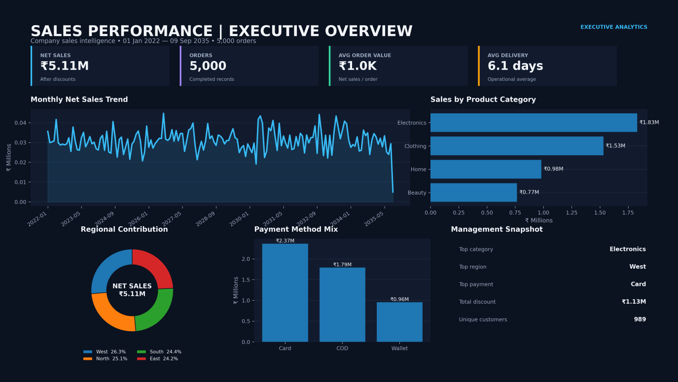
Figure 1. Executive Overview — headline KPIs, monthly trend, category, regional, and payment mix.
Purpose: a single-screen summary for leadership. KPI cards show Net Sales (₹5.11M), Orders (5,000), AOV (₹1.0K), and Avg Delivery (6.1 days). The monthly net-sales line chart spans 2022–2035, a product-category bar chart, a regional donut chart, a payment-method bar chart, and a “Management Snapshot” panel listing the top category (Electronics), top region (West), top payment method (Card), total discount (₹1.13M), and unique customers (989).
60-second takeaway: the business generated ₹5.11M in net sales across 5,000 orders with no single category or region dominating — the four regions are within 9% of each other and the four categories form a clear but not extreme ranking. Card is the leading payment method by a visible margin.

Page 2 — Product & Revenue
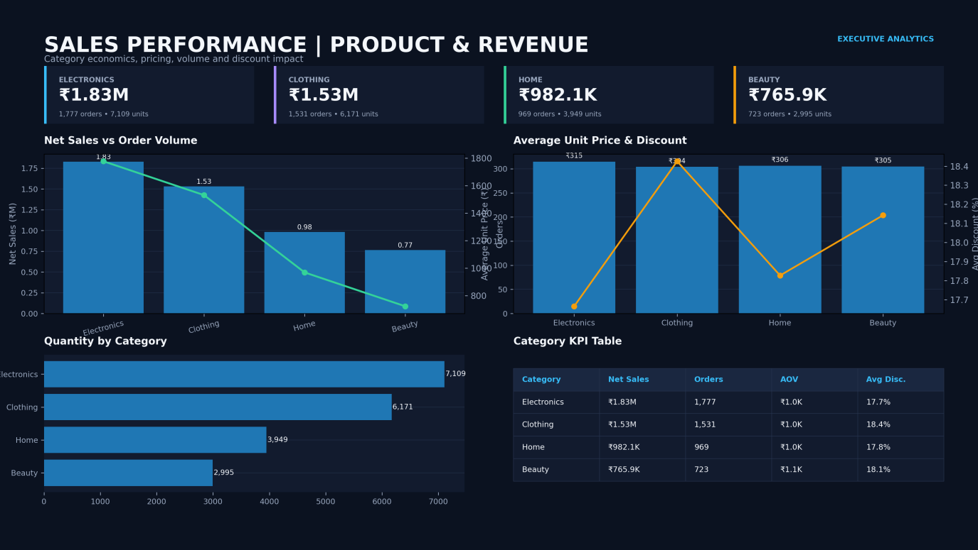
Figure 2. Product & Revenue — category economics, pricing, volume and discount impact.
Purpose: category-level profitability and pricing detail. KPI cards break out net sales, orders, and units for each of the four categories. A combo chart overlays order volume on net sales by category; a second combo chart compares average unit price against average discount rate; a horizontal bar chart shows quantity sold; and a Category KPI table consolidates net sales, orders, AOV, and average discount per category.
60-second takeaway: Electronics leads on every metric (₹1.83M net sales, 1,777 orders, 7,109 units) but does not carry a materially higher average price (₹315) or lower discount (17.7%) than the other categories — its lead comes from order volume, not pricing strategy. Beauty has the smallest revenue base (₹765.9K) despite a comparable AOV (₹1.1K), pointing to a volume gap rather than a value gap.

Page 3 — Region & Payment
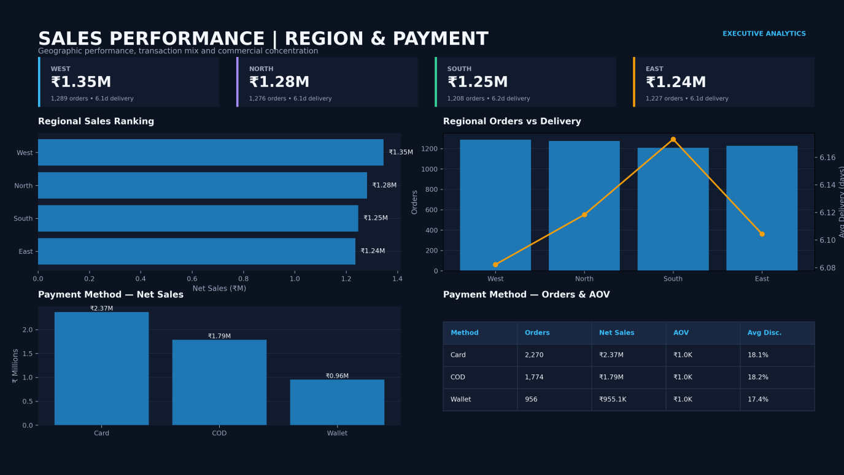
Figure 3. Region & Payment — geographic performance, transaction mix and commercial concentration.
Purpose: geographic and payment-channel comparison. KPI cards show net sales, orders, and average delivery for each region; a horizontal bar ranks regions by net sales; a combo chart compares order volume against average delivery days by region; a payment bar chart shows net sales by method; and a table gives orders, net sales, AOV, and average discount per payment method.
60-second takeaway: West leads regional sales (₹1.35M) with the fastest average delivery (6.1 days), while South is both the lowest-selling region and the slowest to deliver (6.2 days) — the two metrics move together directionally, though the spread is small. Card transactions account for ₹2.37M of net sales versus ₹0.96M for Wallet, roughly 2.5× the volume.

Page 4 — Operations & Discount
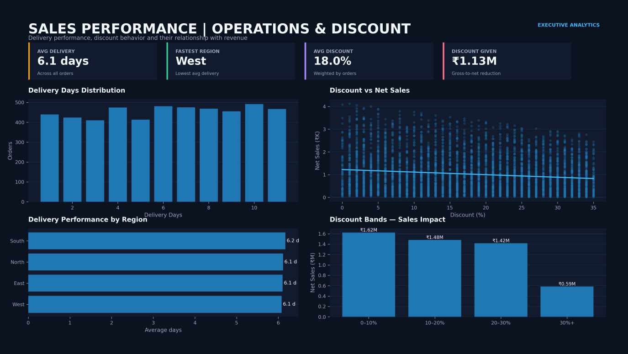
Figure 4. Operations & Discount — delivery performance, discount behavior and their relationship with revenue.
Purpose: operational efficiency and discount effectiveness. KPI cards show average delivery (6.1 days), fastest region (West), average discount (18.0%), and total discount given (₹1.13M). A histogram shows the distribution of delivery days (roughly uniform from 1–11); a scatter plot with trendline shows net sales against discount percentage; a regional bar chart repeats delivery performance; and a bar chart groups net sales into four discount bands.
60-second takeaway: the discount-vs-sales trendline slopes gently downward — higher discounts are not associated with higher order values in this data. The discount-band chart makes this concrete: the 0–10% band delivers the most net sales (₹1.62M) and the 30%+ band the least (₹0.59M), even though orders are spread across all four bands. This visually confirms the negative correlation calculated in Python (−0.14).

Page 5 — Data Quality & Detail
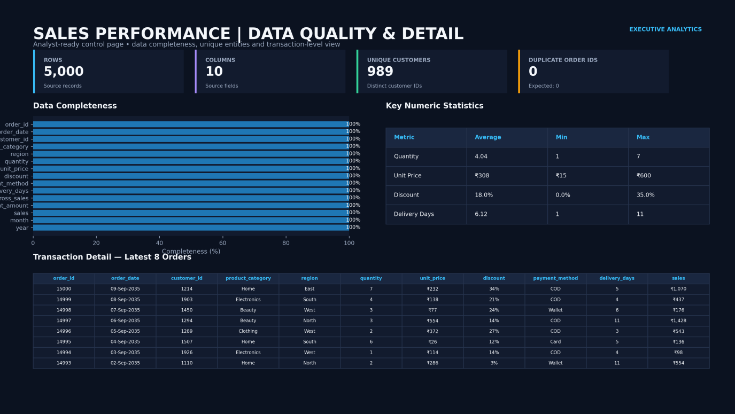
Figure 5. Data Quality & Detail — analyst-ready control page for completeness, uniqueness and transaction-level review.
Purpose: an analyst-facing control page rather than a business page. It confirms 5,000 rows, 10 source fields, 989 unique customers, and 0 duplicate order IDs; a completeness bar chart shows 100% for every field; a statistics table gives average/min/max for quantity, unit price, discount, and delivery days; and a transaction-detail table lists the eight most recent orders.
60-second takeaway: this page is the dashboard’s evidence for Section 4’s data-quality conclusion — every field is 100% complete, there are no duplicate keys, and the numeric ranges (discount 0–35%, delivery 1–11 days) are the same bounds validated independently in Python.

10. Key Data Insights

Insight 1 — Revenue is broad-based, not concentrated in one segment
Finding: No single category or region dominates the business.
Evidence: Category net sales range from ₹0.77M (Beauty) to ₹1.83M (Electronics), a 2.4× spread; regional net sales range from ₹1.24M (East) to ₹1.35M (West), only a 1.09× spread.
Business meaning: The business is not overexposed to a single category or geography — regional risk is especially well diversified.
Recommended action: Prioritize category-level investment (Electronics, Clothing) over regional reallocation, since the regional gap is too small to justify major resource shifts.

Insight 2 — Discounting shows a negative, not positive, association with sales
Finding: Deeper discounts do not correspond to higher net sales per order.
Evidence: Order-level correlation between discount rate and net sales is −0.14; the 30%+ discount band produced the lowest total net sales (₹0.59M) of the four bands despite discount depth increasing.
Business meaning: In this dataset, discounting is not functioning as a demand driver — it primarily reduces the revenue retained on the orders that already occur.
Recommended action: Audit which orders receive discounts above 20% and test whether reducing discount depth in that range preserves order volume while improving net revenue.

Insight 3 — No measurable growth trend across the observed period
Finding: Monthly net sales show effectively zero trend over the full date range.
Evidence: Correlation between the month index (chronological order) and monthly net sales is 0.004; annual net sales fluctuate narrowly between ₹349K and ₹409K per full year with no directional pattern.
Business meaning: Nothing in the data indicates organic growth or decline is under way; period-over-period movements visible on the Power BI trend line are noise, not signal.
Recommended action: Do not use the historical trend line to project future revenue; if forecasting is required, it should rely on external/business inputs rather than extrapolating this series (see Section 18).

Insight 4 — Customer base is broad with high repeat activity but low individual concentration
Finding: 96.1% of customers placed more than one order, and the single largest customer contributes a small share of total revenue.
Evidence: 950 of 989 customers ordered more than once; the top customer (ID 1663) contributed ₹17,680.69 across 14 orders — about 0.35% of total net sales.
Business meaning: Repeat purchasing is broad-based rather than driven by a few large accounts, which is a healthier revenue-concentration profile than a business reliant on a handful of key customers.
Recommended action: Build loyalty/retention programs aimed at the broad repeat-customer base rather than a small VIP tier, since no single customer segment currently carries outsized revenue risk.

Insight 5 — Delivery performance is consistent, with the South marginally slowest
Finding: Regional delivery times are tightly clustered but South is consistently the slowest.
Evidence: Average delivery days: West 6.08, East 6.10, North 6.12, South 6.17 — a spread of only 0.09 days, but South ranks last on both delivery speed and net sales.
Business meaning: The operational gap is currently too small to be a primary revenue driver, but South's dual position as slowest-delivery and lowest-sales region warrants a closer look.
Recommended action: Investigate South's fulfillment logistics as a secondary factor alongside demand-side analysis, rather than treating delivery speed as the leading explanation on its own.

11. Trend Analysis
Time-based patterns were assessed at the monthly and yearly level using the Python-derived year/month fields.
Period | Net Sales | Note
Best month | August 2026 — ₹44,728.82 | Highest single-month total in the series
Weakest month | September 2035 — ₹4,952.23 | Partial month; data ends 09 Sep 2035
Full-year range (2022–2034) | ₹349,802 – ₹408,726 per year | No consistent upward or downward direction
Trend correlation (time vs. monthly sales) | 0.004 | Effectively no linear trend across 165 months
Monthly volatility (coefficient of variation) | 17.6% | Moderate month-to-month noise, consistent with random daily order volume rather than seasonality
Analytical finding: the monthly line chart on the Executive Overview dashboard visually appears to fluctuate, but the near-zero correlation confirms this is statistical noise rather than a genuine seasonal or growth pattern. No recurring monthly or quarterly peak (e.g., a consistent holiday-season spike) is present in the data — August 2026 is a one-off high month, not part of a repeating pattern, since no other August shows a comparable spike.
Business interpretation: because orders occur at almost exactly one per calendar day for nearly 14.7 years, this series behaves like a random walk around a stable mean rather than a real sales calendar. Any month-over-month growth percentage calculated from this data (as the SQL LAG() query does) will be statistically meaningless for forecasting purposes, even though the calculation itself is correct.

12. Regional Analysis
Region | Net Sales | % of Total | Orders | Units | Avg Delivery
West | ₹1.35M | 26.3% | 1,289 | 5,260 | 6.08 days
North | ₹1.28M | 25.1% | 1,276 | 5,164 | 6.12 days
South | ₹1.25M | 24.4% | 1,208 | 4,884 | 6.17 days
East | ₹1.24M | 24.2% | 1,227 | 4,916 | 6.10 days
Best-performing region: West, leading on both net sales (₹1.35M) and delivery speed (6.08 days) — the only region that is simultaneously top-ranked on revenue and operations.
Weakest-performing region: East, the lowest on net sales (₹1.24M) despite not having the slowest delivery time; South has the slowest delivery (6.17 days) but is not the lowest-revenue region. The two weak spots do not fully overlap, meaning no single explanation (e.g., “slow delivery causes low sales”) accounts for both patterns on its own.
Business implication: the four-way regional split is close enough (a 9-percentage-point spread in revenue contribution) that this dataset does not show one region carrying or dragging the business. Any regional strategy should be framed as incremental optimization rather than a rescue plan for an underperforming territory.

13. Product / Category Analysis
Category | Net Sales | Orders | Units | Avg Unit Price | Avg Discount
Electronics | ₹1.83M | 1,777 | 7,109 | ₹315 | 17.7%
Clothing | ₹1.53M | 1,531 | 6,171 | ₹304 | 18.4%
Home | ₹0.98M | 969 | 3,949 | ₹306 | 17.8%
Beauty | ₹0.77M | 723 | 2,995 | ₹305 | 18.1%
Highest-performing category: Electronics, leading on net sales, orders, and units, though its average unit price (₹315) and discount rate (17.7%, the lowest of the four) are close to the other categories — its advantage is order frequency, not pricing power.
Lowest-performing category: Beauty, trailing on every volume metric while carrying the second-highest average discount (18.1%). Its AOV (₹1.1K) is actually the highest of the four categories, so the gap is driven entirely by order count, not by weaker per-order value.
Categories deserving attention: Home and Beauty together represent under 35% of net sales despite similar per-order economics to Electronics and Clothing. Since pricing and discounting are not meaningfully different across categories, the opportunity is in demand generation (marketing reach, assortment, placement) for these two categories rather than pricing adjustment.

14. Customer Analysis
Customer ID | Net Sales | Orders
1663 | ₹17,680.69 | 14
1955 | ₹16,265.15 | 10
1675 | ₹15,036.46 | 11
1276 | ₹15,023.71 | 11
1647 | ₹14,894.97 | 11
Customer contribution: the top 5 customers by net sales together contribute ₹78,900.98, roughly 1.5% of total net sales — a low concentration level. No individual customer or small cluster of customers represents a material share of total revenue.
Order frequency: 96.1% of the 989 customers placed more than one order (950 of 989), and orders per customer range from 1 to 14, with the most common frequency being 4–6 orders per customer. This indicates broad-based repeat activity across the customer base.
A note on “loyalty”: the dataset provides order counts and total spend per customer but no purchase dates linked to marketing touchpoints, no cohort/acquisition data, and no churn indicators. Repeat order count is a valid, directly measurable pattern; claims about customer loyalty, retention drivers, or lifetime value cannot be supported from this data and are not made in this report.

15. Operational Analysis
Delivery performance: average delivery time is 6.12 days overall, ranging narrowly from 6.08 days (West) to 6.17 days (South) — a spread of roughly two hours in practical terms. The delivery-days histogram on the Operations dashboard shows a roughly uniform distribution from 1 to 11 days rather than a peak around a typical value, suggesting delivery time in this dataset behaves close to randomly assigned within its range rather than following a real logistics distribution (e.g., most orders clustering around a 3–5 day standard).
Payment methods: Card is the leading channel by net sales (₹2.37M, 2,270 orders), followed by COD (₹1.79M, 1,774 orders) and Wallet (₹0.96M, 956 orders). Average discount rates are similar across methods (17.4%–18.2%), so payment channel does not appear linked to discount policy.
Cross-cutting pattern: because the regional delivery-time spread is so narrow (0.09 days) and the category/region discount rates are all clustered within about 1 percentage point of each other, this dataset does not show strong operational differentiation across segments. The main operational improvement area worth flagging is the South region's combination of slowest delivery and lowest sales, covered in Section 12.

16. Business Recommendations

Immediate Actions
Insight → Recommendation → Expected Benefit → Priority
- SQL total_sales formula is understating net sales by ~4.5× → Correct the formula to use (1 − discount), or SUM(sales_amount) directly → Restores trustworthy reporting from the SQL layer → High
- 30%+ discount band produces the lowest net sales of any band → Cap or review discounts above 20–25% pending a controlled test → Protects revenue without a confirmed offsetting volume gain → High
- South region is both slowest-delivery and lowest-sales → Review South's fulfillment process and demand drivers together → Identifies whether operations or demand is the binding constraint → Medium

Medium-Term Actions
- Home and Beauty trail on order volume despite comparable per-order economics → Test demand-generation initiatives (marketing reach, placement) for these categories → Potential to narrow the 2.4× category revenue gap → Medium
- Repeat-purchase rate is high (96.1%) but broadly distributed → Build a retention program targeted at the broad repeat base rather than a small VIP tier → Reinforces an already-healthy, low-concentration revenue base → Medium

Long-Term Strategy
- No measurable sales trend exists in the current data → Establish a proper time-series data pipeline (true daily/weekly order volumes over a real trading period, with cost and marketing-spend context) before attempting forecasting → Enables trend and seasonality analysis that this dataset cannot currently support → Long-term
- Dataset lacks cost, margin, and customer-demographic fields → Extend the schema to capture cost of goods, marketing spend, and customer acquisition source → Enables profitability and ROI analysis beyond top-line sales → Long-term

17. Limitations
- No cost or margin data: only revenue-side fields (price, quantity, discount) are present, so profitability cannot be assessed — all figures in this report are sales/revenue metrics, not profit metrics.
- No customer demographic or acquisition data: age, location detail beyond region, channel of acquisition, and marketing touchpoints are not available, limiting customer analysis to order frequency and spend.
- Unusual date structure: exactly one order per calendar day across 5,000 consecutive days (2022–2035) is not typical of a real order feed, which limits how much confidence should be placed in the trend and seasonality findings as representative of a real business.
- No target, budget, or forecast data: results can be described but not benchmarked against goals.
- No inventory or stock-level data: category and regional demand cannot be assessed against supply constraints.
- Order-level granularity only: there is no line-item detail (an order is a single product/category/quantity combination), so basket composition and cross-category purchasing cannot be analyzed.
- SQL analysis file formula issue: as documented in Section 6, the SQL “total_sales” outputs in the original file are not usable at face value and were not carried into the KPI figures in this report; only Excel/Python/Power BI net-sales figures (which agree with each other) were used.

18. Future Scope
- Sales forecasting — feasible only after establishing a genuine time-series with real trend/seasonality; not appropriate on the current flat, noise-dominated series.
- Customer segmentation (e.g., RFM analysis) — recency, frequency, and monetary value can be calculated from the existing order_date, customer_id, and sales_amount fields.
- Discount effectiveness testing — a controlled experiment (A/B test) on discount depth by category/region to move beyond the correlational finding in Section 10.
- Profitability analysis — achievable once cost-of-goods data is added to the schema.
- Delivery-time root-cause analysis — would benefit from carrier, warehouse, or order-size data not currently captured.
- Anomaly detection on individual high-value or high-discount orders, extending the existing “orders above average sales” SQL query into an automated monitoring view.
- Automated reporting pipeline — scheduling the Python cleaning/feature-engineering script to refresh the Power BI dataset on a recurring basis rather than as a one-time export.

19. Technical Architecture / Workflow
Raw Dataset → Excel Data Cleaning → SQL Data Analysis → Python / Pandas Analysis → Power BI Data Visualization → Business Insights → Recommendations
Stage | Purpose
Raw Dataset | Single source of truth: 5,000 order-level records with 10 source fields, ingested as-is for validation.
Excel Data Cleaning | Standardize date types and pre-calculate a net-sales (sales_amount) field for consistent downstream use.
SQL Data Analysis | Answer structured business questions via aggregation, ranking, and window functions across performance, category, customer, regional, payment, and time dimensions.
Python / Pandas Analysis | Independently re-validate data quality, engineer additional features (gross sales, discount amount, year/month), and enable statistical checks (correlations) not covered by SQL or Excel.
Power BI Data Visualization | Consolidate KPIs and comparisons into an interactive, five-page dashboard suite for business consumption.
Business Insights | Synthesize cross-tool findings (Section 10) with evidence-based interpretation, including the cross-tool SQL/Python discrepancy this report identified.
Recommendations | Translate insights into prioritized, actionable next steps for management (Section 16).

20. Tools & Technologies
Tool | Purpose
Excel | Data cleaning, date standardization, and net-sales calculation
SQL (PostgreSQL syntax) | Data querying, aggregation, ranking (RANK()), and window functions (LAG())
Python | Data processing, validation, feature engineering, and exploratory analysis
Pandas | Data manipulation, grouping, and statistical calculations within Python
Power BI | Interactive dashboarding and business intelligence visualization

21. Final Conclusion
This project analyzed 5,000 sales orders across four product categories, four regions, and three payment methods, moving the same dataset through Excel, SQL, Python, and Power BI and cross-checking the results at each stage. The core commercial picture is consistent and well-supported: ₹5.11M in net sales, an average order value of ₹1,022, an 18.0% average discount rate, and a customer base with high repeat-purchase activity (96.1%) but low revenue concentration in any single account.
The analysis also surfaced two findings that matter more than any single KPI: discounting in this dataset is associated with lower, not higher, net sales, and the SQL layer contains a formula error that materially understates reported sales unless corrected. Both were found precisely because the workflow ran the same numbers through multiple independent tools and compared them — the core value of the Excel → SQL → Python → Power BI pipeline demonstrated in this project is not any single stage, but the cross-validation that emerges from doing all four.
With the limitations in Section 17 addressed — particularly the addition of cost data and a genuine time-series — this same workflow is directly extensible to profitability analysis, forecasting, and customer segmentation, as outlined in Section 18.

