

Music Catalog Frontend

Axoni Coding Challenge

Report of Summary in brief

I implemented the task successfully. I implemented all the functionalities mentioned in the specification document (according to my understanding). I used HTML, CSS, BootStrap and jQuery AJAX for this project.
There are total 4 files for this project: -

- index.html
- index.js
- logo (PNG file)
- style.css.

Functionalities used by me for this project: -

- HTML
- CSS
- jQuery AJAX
- Bootstrap

1) On first opening the index.html in google chrome browser, you will see a list of different types of genres like rock, electronic, hip hop etc. Below is the attached screenshot

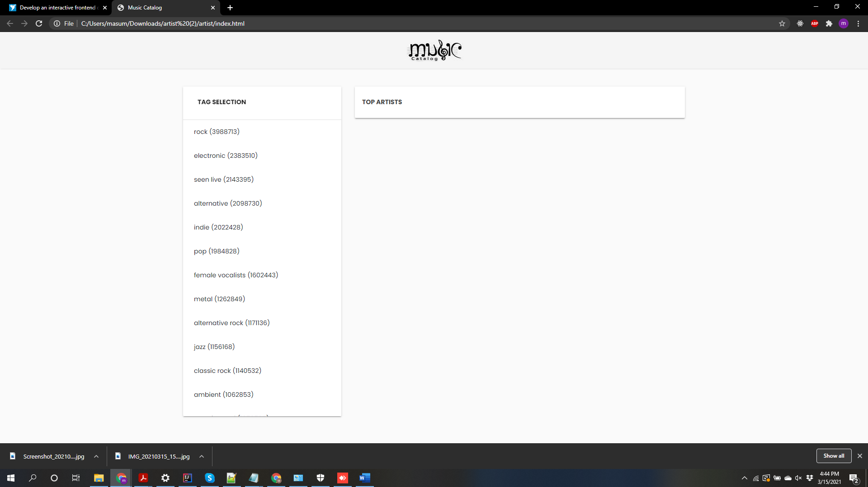

2) You can select any genre. By clicking on it, it’s top artists (sorted according to play count) will be listed. In the below screenshot, I have selected rock genre). As you can see, its top artists list is displayed. (Coldplay, Linkin Park, and so on)
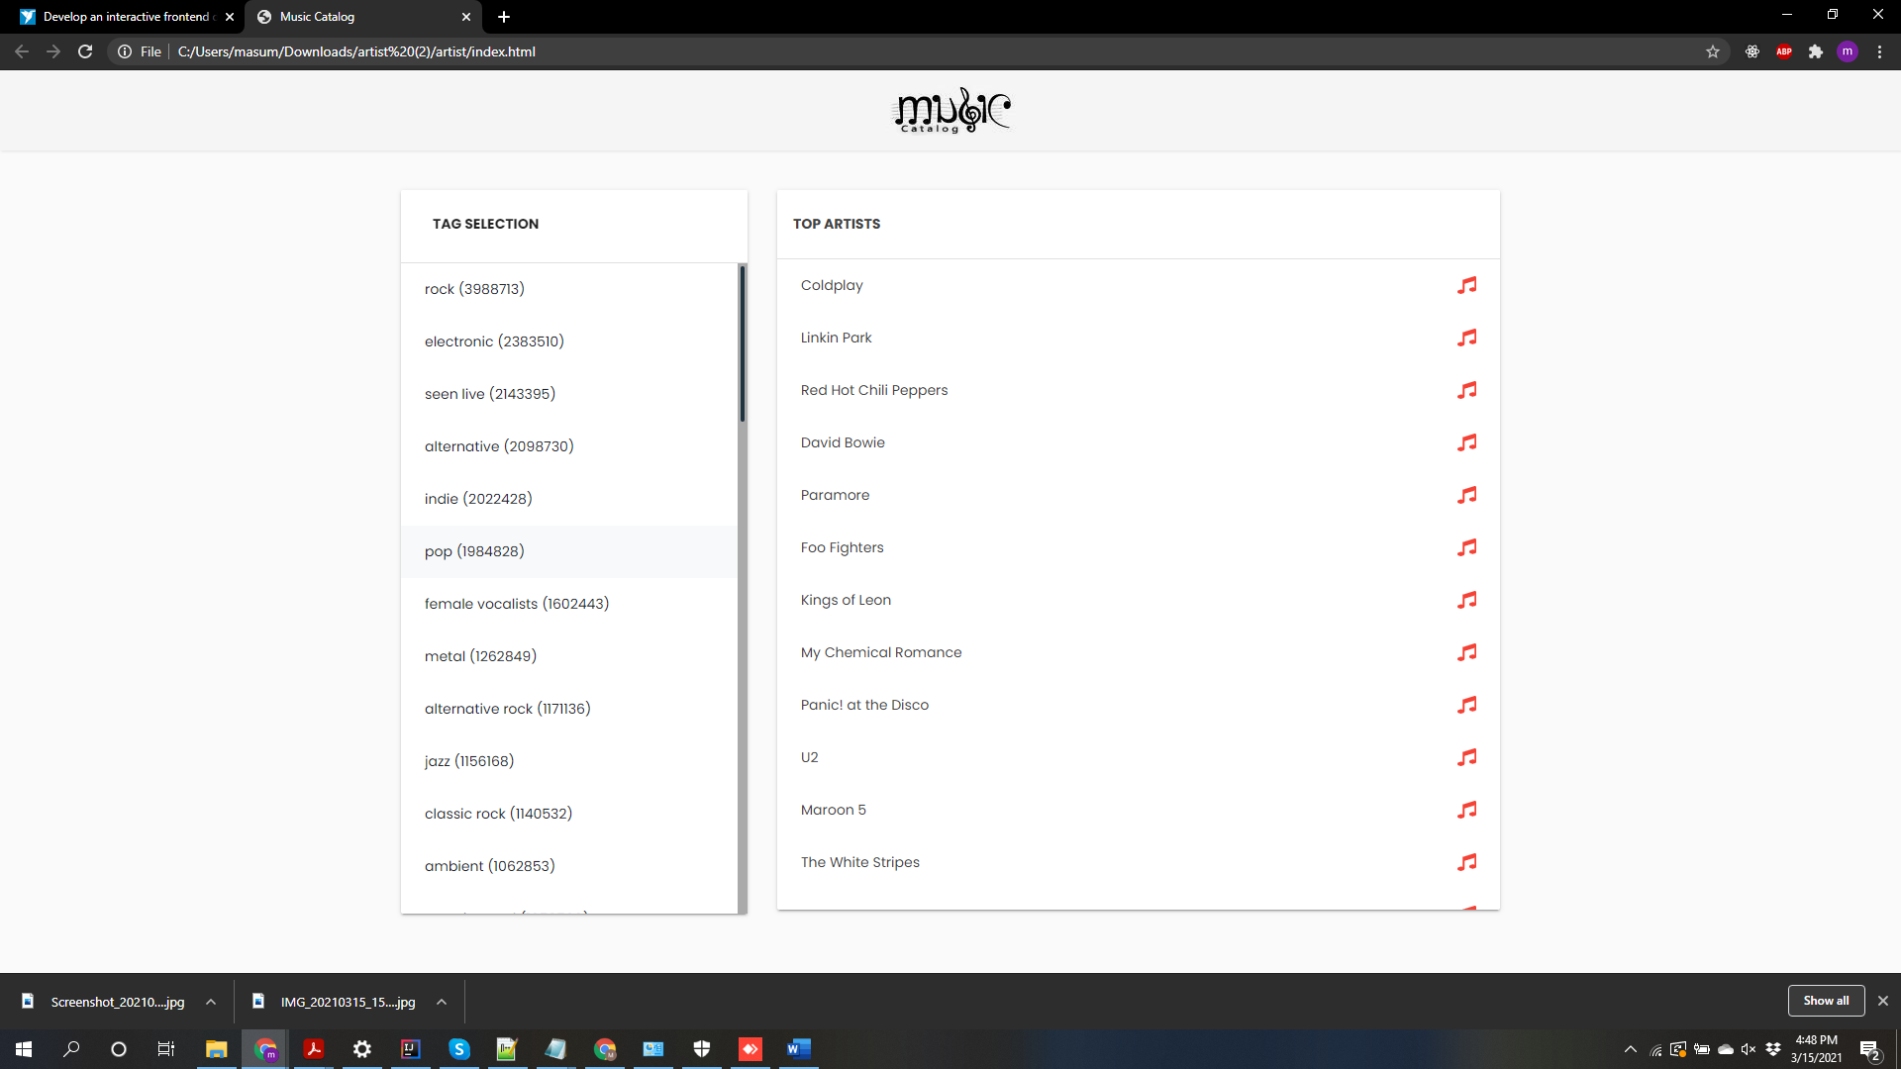

3) I kept a music icon (on right side) for each artist. On clicking that icon, top albums of that particular artist will be displayed. I clicked on Coldplay and top albums like (A Rush of Blood, Parachutes etc.) will be displayed.
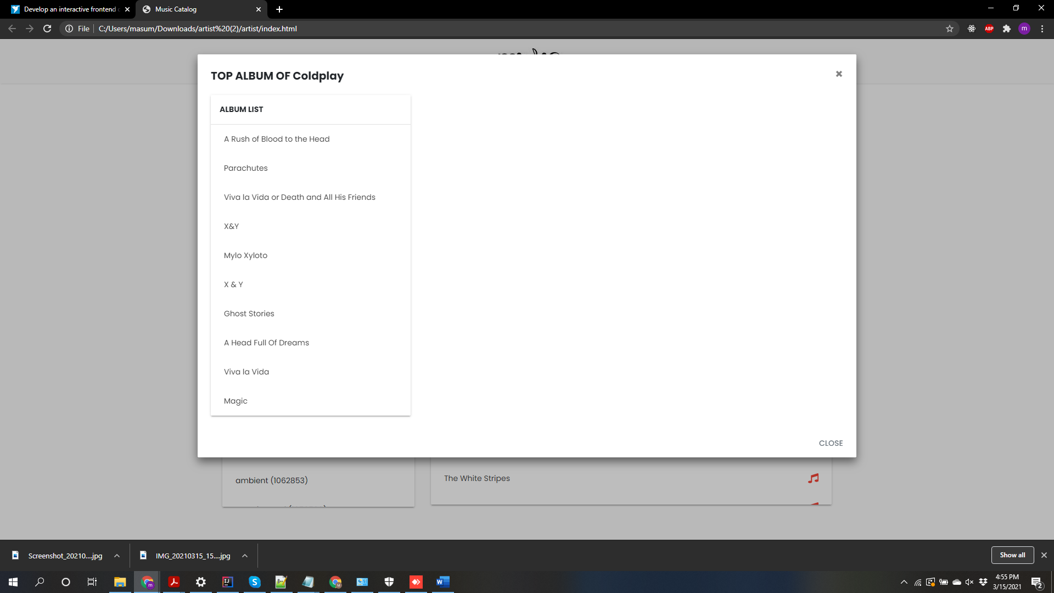

4) If I clicked on any particular album, all the information like the play count, total number of listeners, tags associated with the album, all the tracks of that album, summary, album image etc. will be displayed. All this data was fetched from API of last.fm.
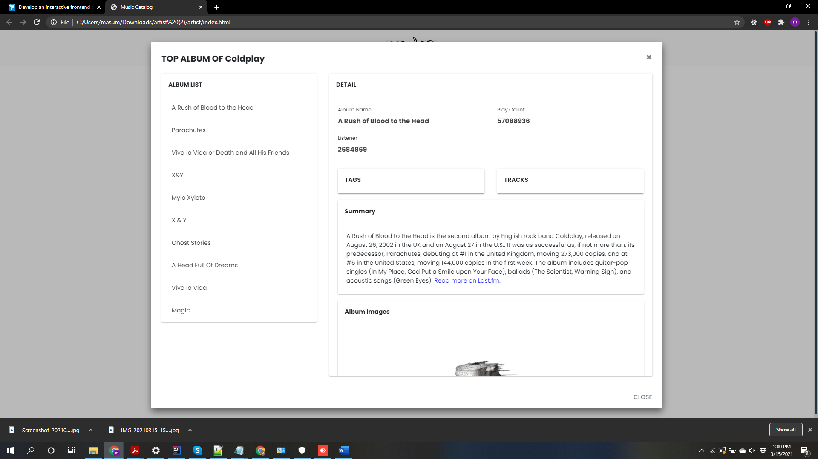

5) If I click on close button or x symbol (on right side top), it will route to the original page of that album displaying its top artists. Now, if I click on that artist name, it’s biography, albums, associated tags, similar artists suggestions, and top tracks of that artists will be displayed. Also, there will be image of that artist on the left side. There will be a back button right below the artist name. On clicking that, it will be routed to the original tag page of genre with the artist names of the selected genre displayed.
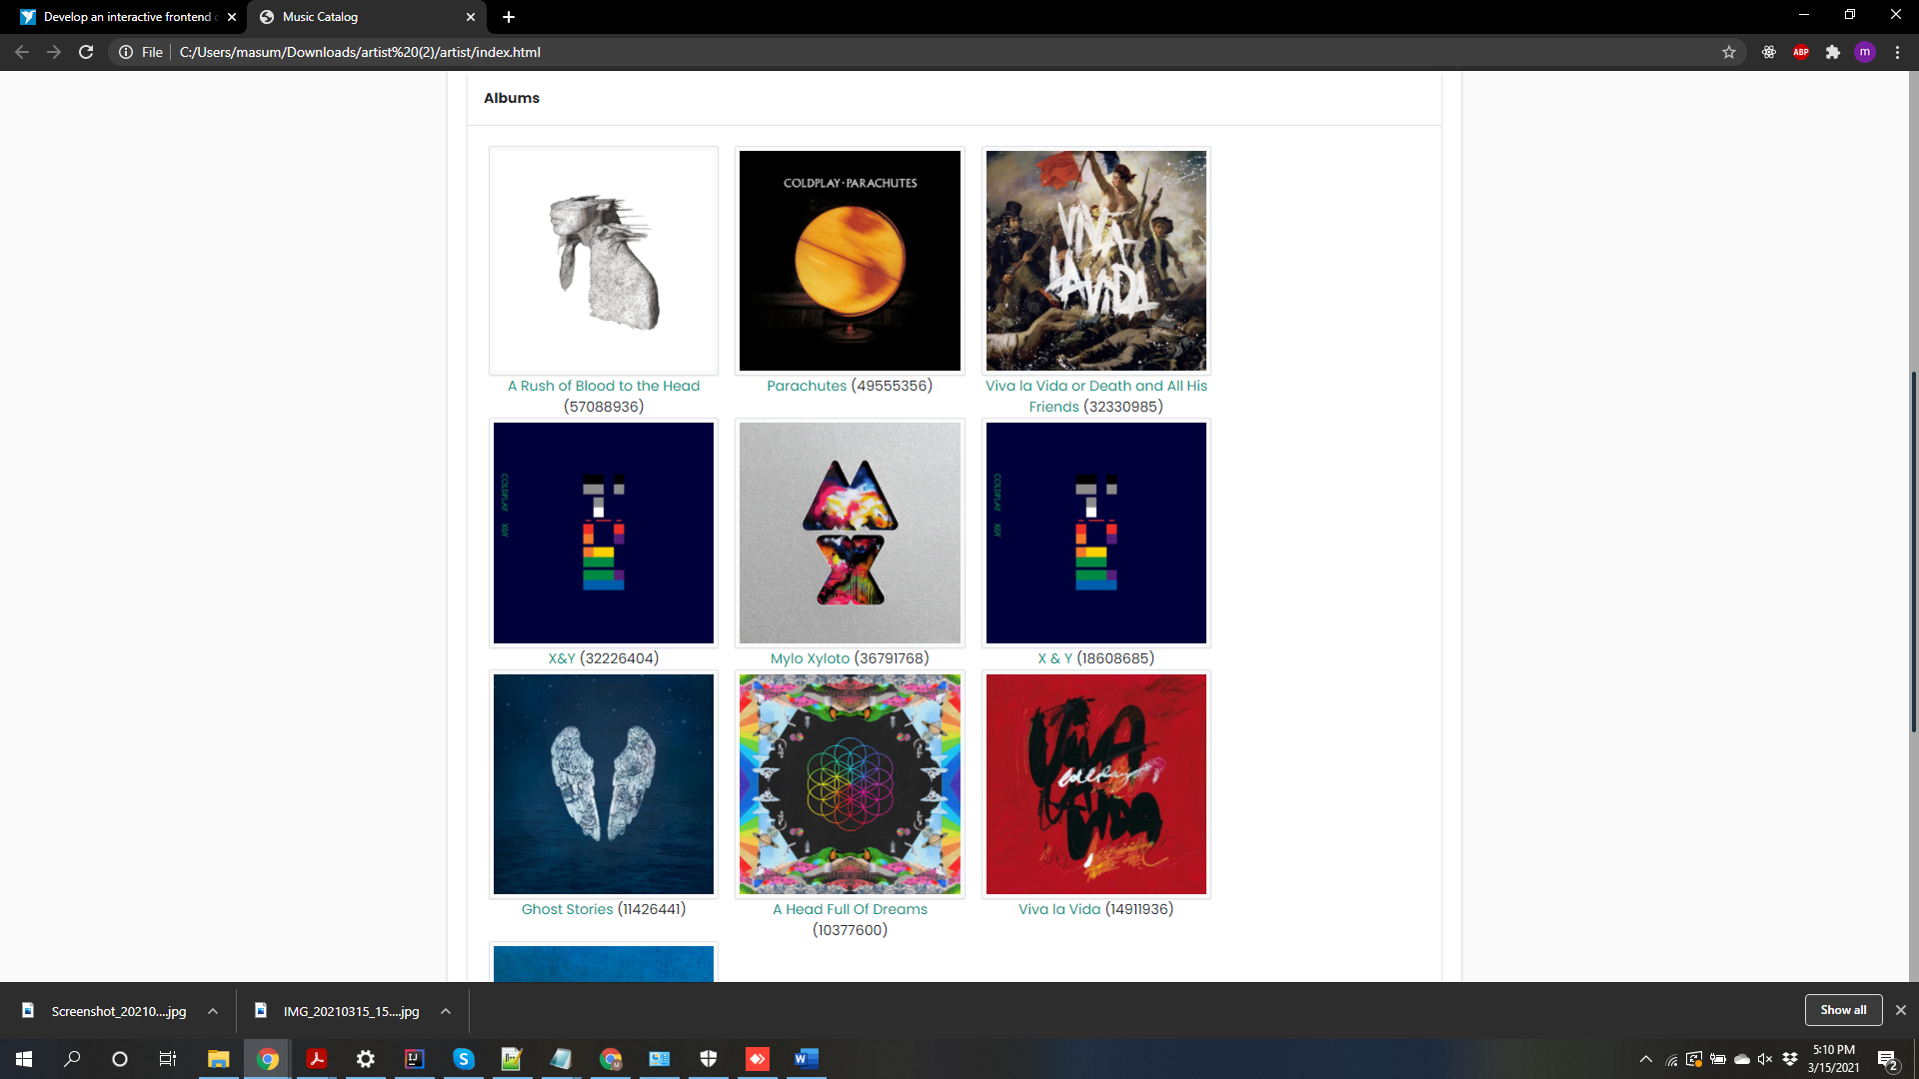
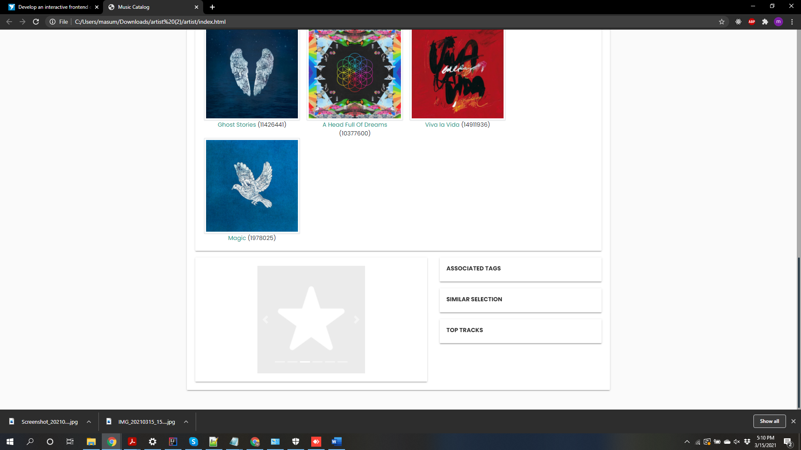

I tried my best to complete this task in given amount of time. I used my skills of coding and developing which I had gained through my previous internship at Infosys Ltd. and academic experience (Master’s in Computer Science from California State University and Bachelor’s in Information Technology Engineering from Dharmsinh Desai University).
I am expecting for next round of interview after my work is reviewed.

Thank you,
Masum Shah
LinkedIn profile: https://www.linkedin.com/in/masum10/
Portfolio (still in progress): https://masumshah1234.github.io/
GitHub: https://github.com/masumshah1234
Phone: 9164958173
Email: masummshah@gmail.com.

