Supporting Information for "Late S-wave coda of Utah FORGE downhole microearthquakes: elastic tests of smooth, deterministic and stochastic media"
Wiwit Suryanto (Universitas Gadjah Mada) and Peter Leary (Geoflow Imaging)
This file contains the diagnostics referred to in the main text. Figures S3, S4 and S11 and Table S14 come from a preliminary analysis (fixed σ = 0.13 for the exponential and Gaussian media, 150 events); they are retained for completeness and are superseded in the main text by the per-event test on all events, the common-grid comparison and the cluster-bootstrap coherence analysis.

Supplementary figures
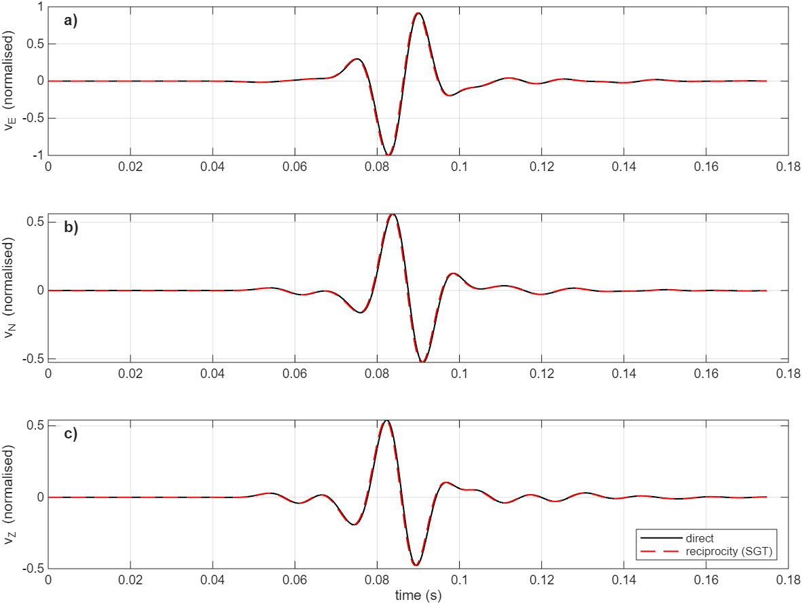
Figure S1. Reciprocity validation in a heterogeneous VTI pink-noise medium (σ = 0.045, ε = 0.05, δ = 0.02, γ = 0.05). a–c) East, north and vertical velocity at a sensor from a direct double-couple simulation (black) and from the strain-Green's-tensor reciprocity synthetic (red dashed). Correlation and amplitude ratio are 0.995.
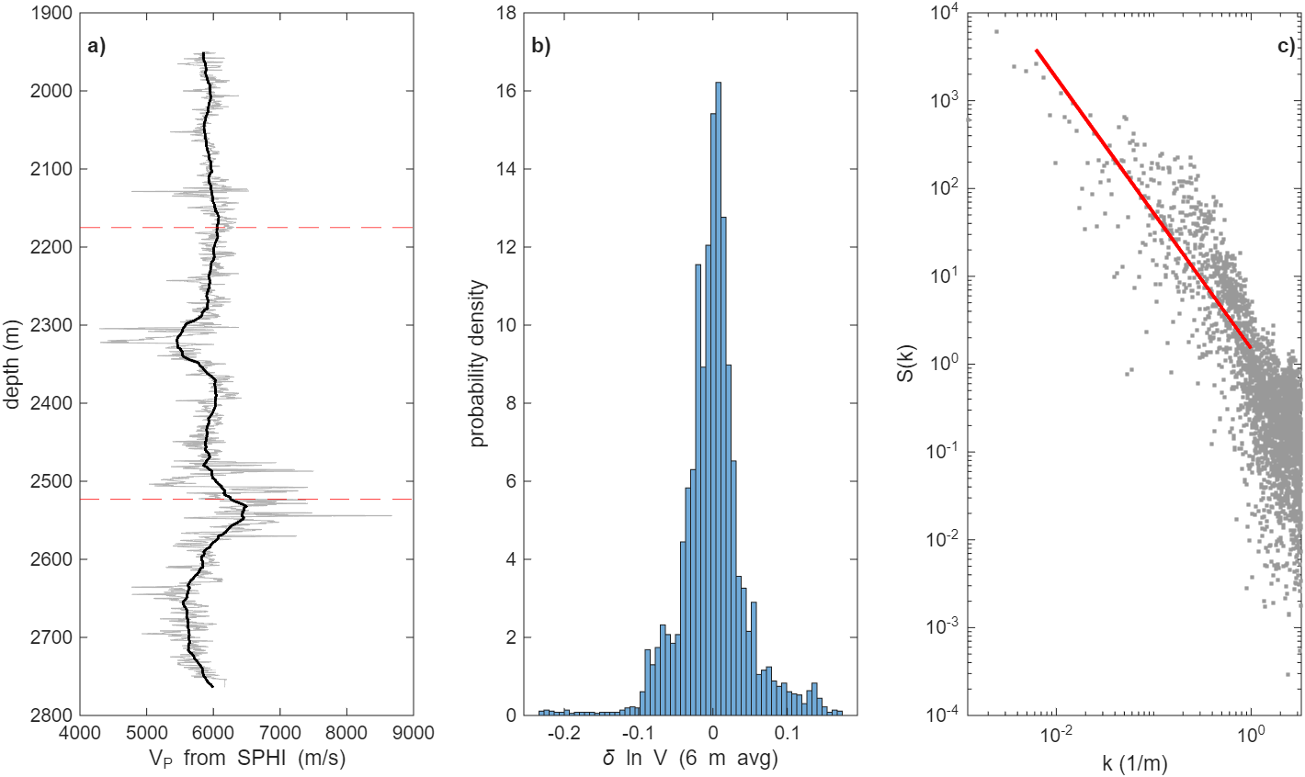
Figure S2. The 56-32 sonic log. a) Sonic-derived V_{P} (grey) and its 50-m block average (black); dashed lines mark the depths of sensors A and B. b) Distribution of the detrended, 6-m-averaged δln V. c) Periodogram of δln V with a power-law fit over 1–200 m. Slope uncertainty is given in Table S15 and main-text Fig. 9.
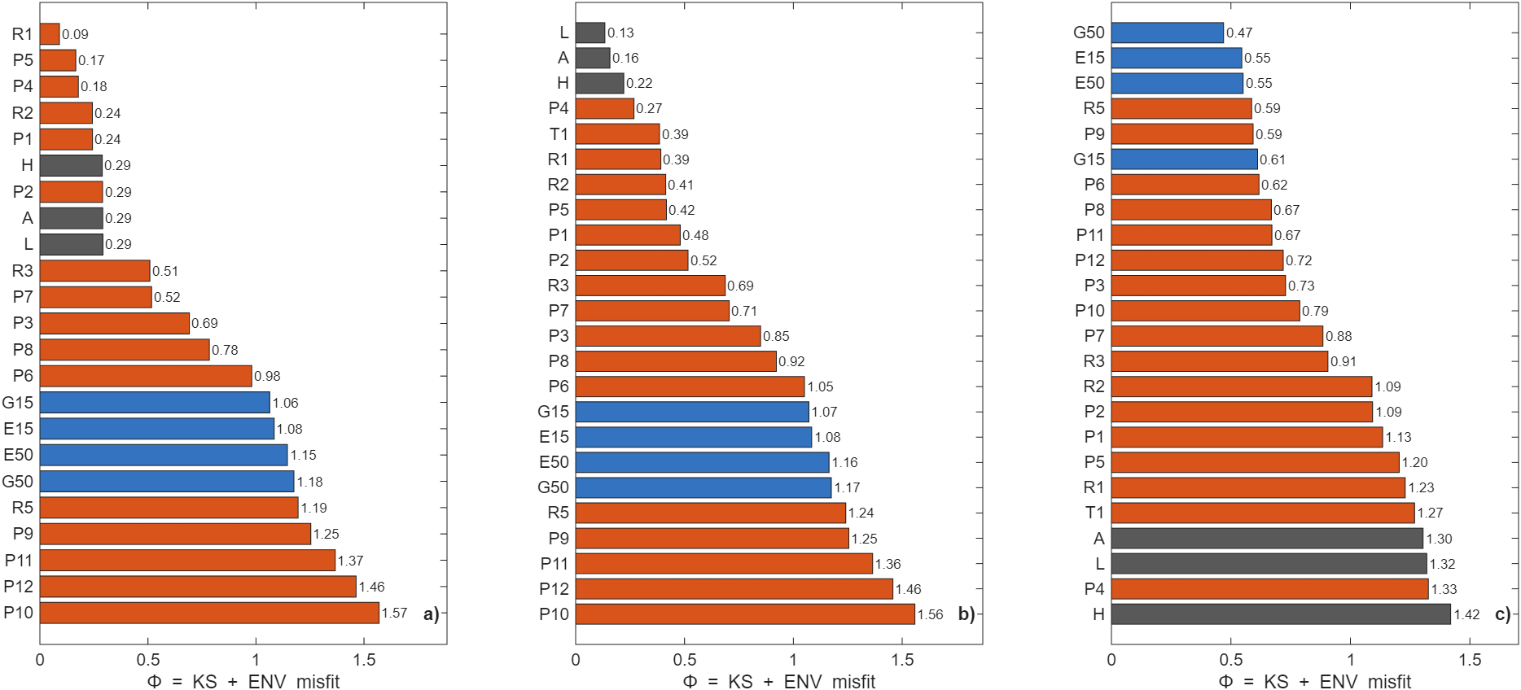
Figure S3. Earlier statistical-misfit ranking (Φ) for a) the synthetic pink truth T1 (σ = 0.045), b) the layered-VTI truth T2 and c) FORGE (preliminary model set: exponential and Gaussian media only at σ = 0.13). Grey: smooth media; orange: pink; blue: exponential and Gaussian. Lower is better. Superseded for FORGE by main-text Fig. 8.
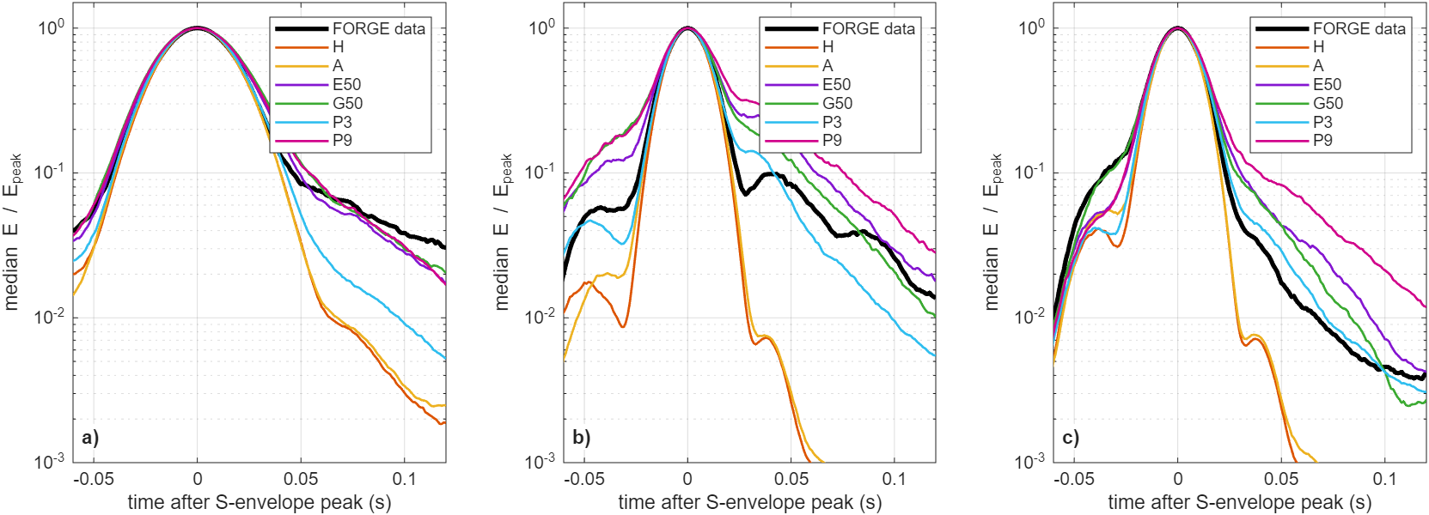
Figure S4. Median S-coda envelopes aligned on the S peak and normalized by it: a) sensor A, 20–40 Hz; b) sensor A, 40–80 Hz; c) sensor B, 40–80 Hz. Black: FORGE; H homogeneous; A VTI; E50/G50 exponential/Gaussian (a = 50 m, σ = 0.13); P3/P9 pink (σ = 0.09/0.18).
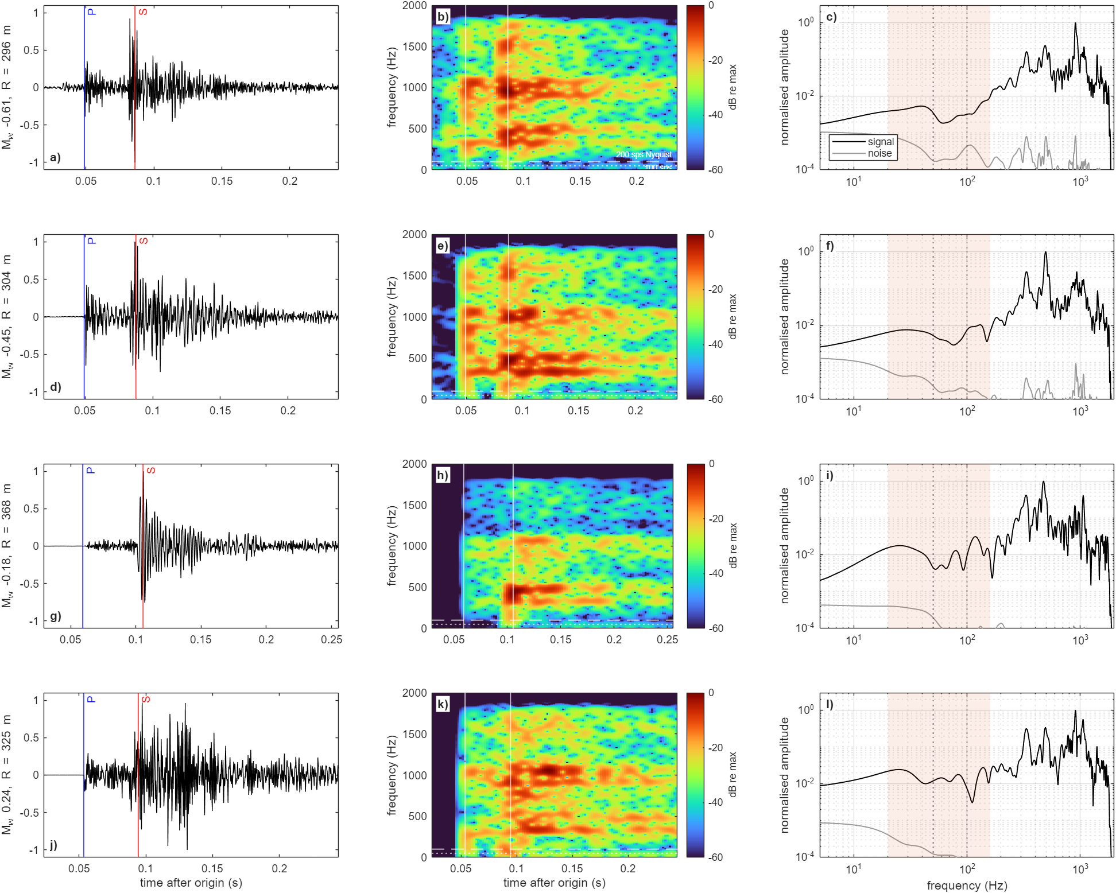
Figure S5. Four example events (magnitude −0.61 to +0.24) at sensor B, 4 kHz. a, d, g, j) Horizontal velocity (> 5 Hz) with P (blue) and S (red). b, e, h, k) Spectrograms to 2 kHz on a common dB scale relative to each event's maximum; white dashed and dotted lines mark 100 and 50 Hz, the Nyquist frequencies of 200 and 100 sample/s recording. c, f, i, l) S-window spectrum (black) and pre-event noise (grey); shaded: FD analysis band.
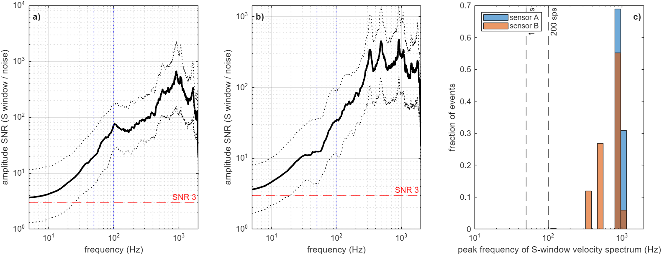
Figure S6. a, b) Median (solid) and interquartile range (dotted) of the S-window amplitude SNR spectrum for sensors A and B; horizontal line at SNR = 3. c) Peak frequency of the S-window velocity spectrum for all events. The clustering near 330, 480 and 920 Hz indicates tool or coupling resonances; the share of recorded velocity energy above 100 Hz is therefore not a source or path property.
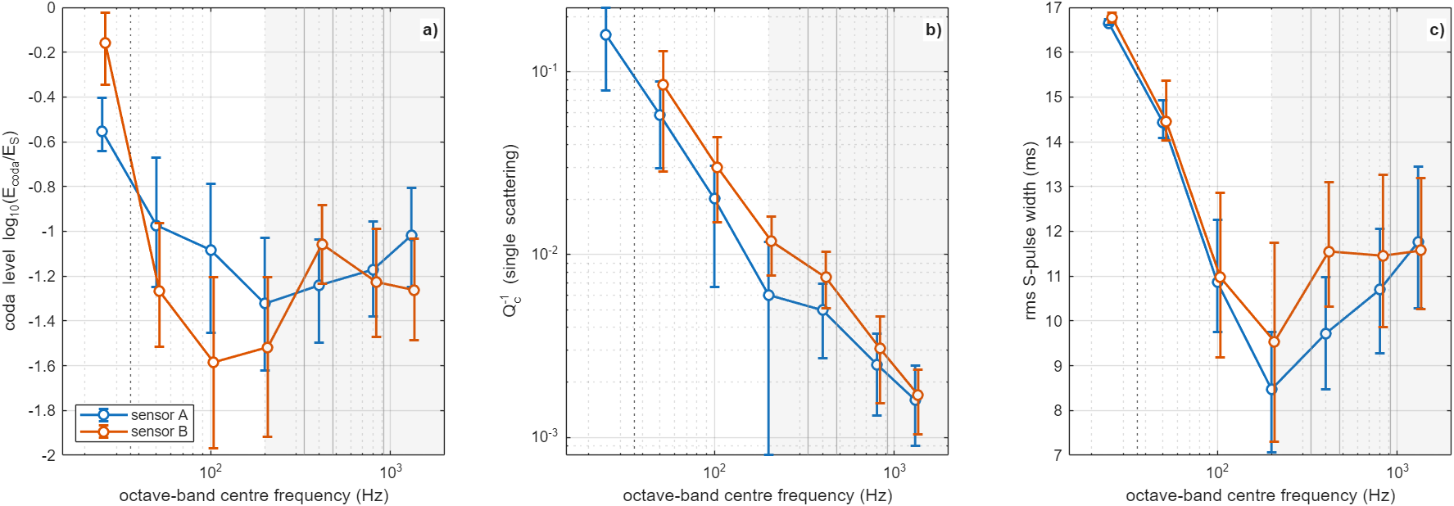
Figure S7. FORGE coda measures in seven octave bands (25 Hz to 1.3 kHz): a) coda level, b) single-scattering Q_{c}⁻¹ (finite-window diagnostic; at 25 Hz the window spans one to three periods), c) rms S-pulse width. Median and interquartile range for sensors A and B. Shaded (> 200 Hz): affected by the resonances.
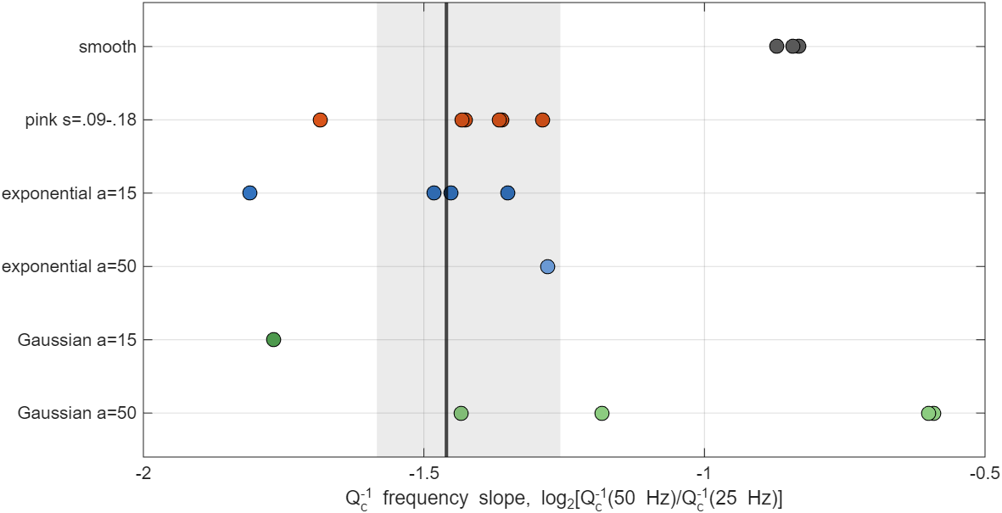
Figure S8. Q_{c}⁻¹ frequency slope log₂[Q_{c}⁻¹(50 Hz)/Q_{c}⁻¹(25 Hz)] at sensor A, FORGE (black line, grey 95 % bootstrap band) and simulated media (dots). A finite-window diagnostic: data and synthetics are measured identically, but the absolute values are not medium properties.
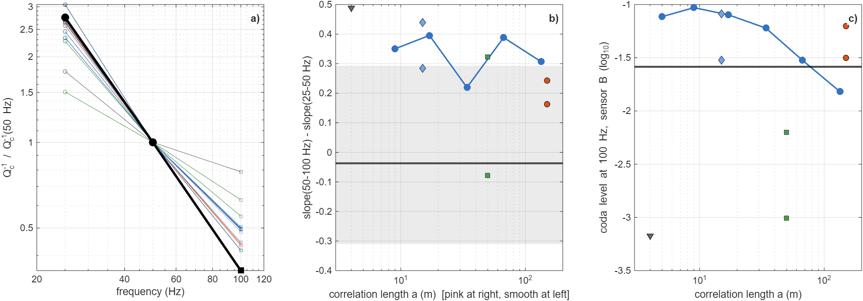
Figure S9. Exploratory high-frequency series (2.5-m grid, sensor B, reduced volume, noise-free synthetics, σ = 0.13). a) Q_{c}⁻¹ normalized at 50 Hz from the 25–50 Hz (sensor A, 5-m grid) and 50–100 Hz (sensor B, 2.5-m grid) slopes. b) Curvature of Q_{c}⁻¹ versus correlation length. c) Coda level at 100 Hz versus correlation length; black line: FORGE. Grid, domain, sensor and event subset change together between the two octaves, so the comparison is not a pure frequency effect.
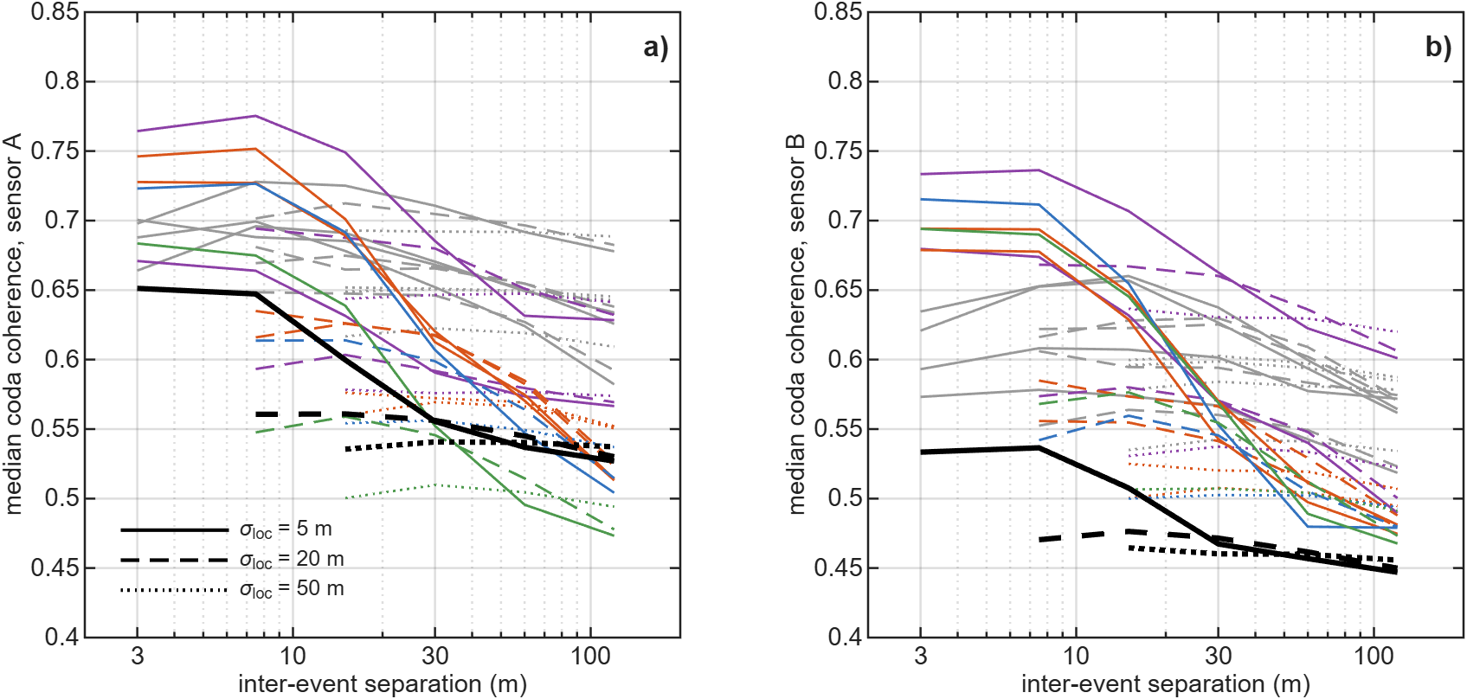
Figure S10. Location stress test of the inter-event coda coherence (window S + 40 to S + 100 ms): binned medians after perturbing the hypocentres used for binning by isotropic Gaussian errors of 5 m (solid), 20 m (dashed) and 50 m (dotted), for FORGE (black, thick) and the media (colours as in main-text Fig. 7). a) Sensor A. b) Sensor B. Large errors flatten the curves of data and media alike; the levels at ≥ 20 m separation are preserved.
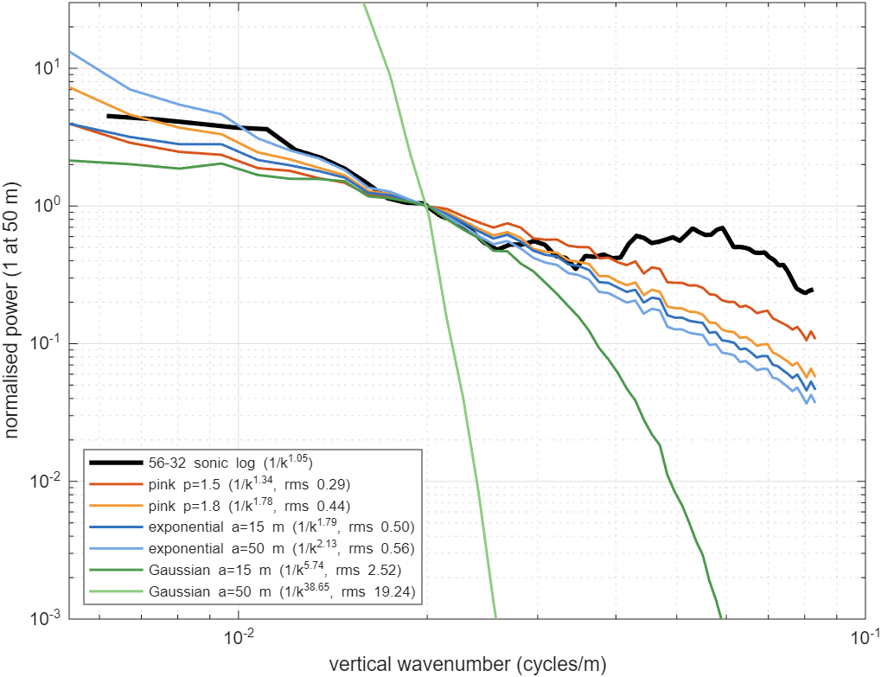
Figure S11. Vertical fluctuation spectra of the 56-32 sonic log (black) and of the model media over 12–200 m, normalized at 50 m. The rms log difference in the legend is a descriptive distance, not a likelihood.

Supplementary tables
Table S1. Window sensitivity of the per-event coda test
Fit end (ms) | Coda (ms) | H | L | L6 | GRAD3 | FZ | A | P1 | P3 | P6 | G50
S + 15 | S + 40–100 | −1.80/−1.09 | −1.64/−1.17 | −1.28/−0.53 | −1.67/−1.11 | −1.04/−0.39 | −1.91/−1.19 | −0.74/+0.02 | −0.14/+0.53 | +0.31/+0.78 | +0.29/+0.54
S + 15 | S + 50–110 | −2.21/−1.41 | −1.99/−1.39 | −1.46/−0.64 | −2.11/−1.44 | −1.33/−0.65 | −2.15/−1.42 | −0.90/−0.08 | −0.30/+0.50 | +0.14/+0.76 | +0.16/+0.49
S + 15 | S + 30–100 | −1.58/−0.99 | −1.45/−1.03 | −1.11/−0.48 | −1.49/−1.02 | −0.82/−0.19 | −1.55/−1.05 | −0.60/+0.05 | −0.03/+0.45 | +0.39/+0.72 | +0.35/+0.55
S + 10 | S + 40–100 | −1.77/−1.07 | −1.64/−1.16 | −1.29/−0.52 | −1.65/−1.09 | −1.04/−0.33 | −1.91/−1.20 | −0.59/+0.03 | −0.07/+0.58 | +0.33/+0.88 | +0.31/+0.59
S + 10 | S + 50–110 | −2.17/−1.41 | −1.99/−1.40 | −1.44/−0.64 | −2.09/−1.43 | −1.32/−0.61 | −2.15/−1.42 | −0.78/−0.08 | −0.22/+0.52 | +0.17/+0.84 | +0.16/+0.54
S + 10 | S + 30–100 | −1.57/−0.96 | −1.46/−1.03 | −1.12/−0.48 | −1.47/−0.99 | −0.82/−0.16 | −1.58/−1.05 | −0.50/+0.04 | +0.04/+0.52 | +0.41/+0.84 | +0.37/+0.58
S + 20 | S + 40–100 | −1.79/−1.08 | −1.64/−1.18 | −1.28/−0.53 | −1.67/−1.11 | −1.07/−0.39 | −1.91/−1.19 | −0.72/−0.00 | −0.15/+0.50 | +0.28/+0.78 | +0.26/+0.50
S + 20 | S + 50–110 | −2.21/−1.41 | −2.00/−1.41 | −1.45/−0.62 | −2.11/−1.44 | −1.32/−0.67 | −2.15/−1.42 | −0.90/−0.10 | −0.34/+0.48 | +0.14/+0.75 | +0.11/+0.45
S + 20 | S + 30–100 | −1.58/−0.98 | −1.46/−1.04 | −1.11/−0.47 | −1.49/−1.02 | −0.85/−0.20 | −1.55/−1.03 | −0.58/+0.02 | −0.02/+0.42 | +0.36/+0.68 | +0.31/+0.50
S + 60 | S + 40–100 | −1.79/−1.09 | −1.65/−1.18 | −1.28/−0.55 | −1.67/−1.13 | −1.13/−0.48 | −1.89/−1.20 | −0.86/−0.17 | −0.34/+0.28 | +0.10/+0.50 | +0.16/+0.25
S + 60 | S + 50–110 | −2.22/−1.41 | −1.98/−1.40 | −1.45/−0.63 | −2.12/−1.45 | −1.40/−0.74 | −2.14/−1.42 | −1.04/−0.21 | −0.48/+0.28 | +0.00/+0.53 | +0.07/+0.16
S + 60 | S + 30–100 | −1.59/−0.99 | −1.45/−1.03 | −1.12/−0.50 | −1.50/−1.03 | −0.93/−0.29 | −1.54/−1.03 | −0.73/−0.15 | −0.21/+0.25 | +0.23/+0.44 | +0.22/+0.22
Median log₁₀(predicted/observed late energy), sensor A/B. The fit window starts at P − 10 ms. Rows with fit end S + 60 ms overlap the coda window (for comparison only).
Table S2. Moment-tensor variants: coda prediction, fit, conditioning and decomposition
Medium | Full A/B | Deviatoric A/B | DC A/B | VR full | VR dev | VR DC | Cond. median (p90) | |ISO|/|CLVD|/DC (%)
H | −1.80/−1.09 | −1.83/−1.09 | −1.82/−1.11 | 0.75 | 0.71 | 0.67 | 17.6 (19.3) | 28/28/41
L | −1.64/−1.17 | −1.70/−1.16 | −1.71/−1.18 | 0.73 | 0.68 | 0.64 | 17.4 (18.8) | 29/31/38
L6 | −1.28/−0.53 | −1.33/−0.51 | −1.34/−0.51 | 0.73 | 0.68 | 0.66 | 17.8 (19.4) | 29/35/37
GRAD3 | −1.67/−1.11 | −1.69/−1.11 | −1.69/−1.13 | 0.74 | 0.69 | 0.66 | 17.4 (19.0) | 28/26/42
FZ | −1.04/−0.39 | −1.19/−0.49 | −1.24/−0.58 | 0.73 | 0.69 | 0.65 | 15.4 (18.5) | 30/27/41
A | −1.91/−1.19 | −2.04/−1.21 | −2.10/−1.25 | 0.64 | 0.59 | 0.54 | 16.4 (24.7) | 28/35/36
P1 | −0.74/+0.02 | −0.91/−0.16 | −0.93/−0.29 | 0.72 | 0.64 | 0.61 | 12.0 (17.0) | 34/28/36
P3 | −0.14/+0.53 | −0.22/+0.41 | −0.26/+0.35 | 0.67 | 0.60 | 0.57 | 8.1 (13.6) | 36/24/37
P6 | +0.31/+0.78 | +0.28/+0.73 | +0.23/+0.72 | 0.62 | 0.55 | 0.52 | 6.6 (11.1) | 35/22/41
E15 | +0.28/+0.94 | +0.34/+0.88 | +0.31/+0.84 | 0.64 | 0.55 | 0.51 | 6.2 (9.5) | 34/23/39
E50 | +0.31/+0.71 | +0.24/+0.69 | +0.23/+0.64 | 0.59 | 0.54 | 0.50 | 6.5 (10.6) | 30/21/42
G15 | +0.42/+1.12 | +0.41/+1.03 | +0.39/+0.98 | 0.64 | 0.55 | 0.52 | 6.5 (9.5) | 36/22/37
G50 | +0.29/+0.54 | +0.30/+0.57 | +0.30/+0.52 | 0.56 | 0.51 | 0.48 | 5.7 (8.1) | 31/24/41
VSD | −0.13/+0.54 | −0.14/+0.49 | −0.19/+0.46 | 0.66 | 0.62 | 0.58 | 8.8 (14.7) | 25/27/41
VSO | +0.32/+0.79 | +0.27/+0.74 | +0.22/+0.68 | 0.62 | 0.55 | 0.52 | 6.3 (11.3) | 31/23/42
Median log₁₀(pred/obs) at the primary windows. Condition number of the column-normalized design matrix. Decomposition of the full solutions (median absolute percentages); with two sensors in one well the non-DC parts are poorly resolved and are not interpreted.
Table S3. Per-event coda test for well-timed event subsets
Medium | All (416) | S peak ±10 ms (250) | S peak ±5 ms (168)
H | −1.80/−1.09 | −1.64/−0.98 | −1.58/−0.98
L | −1.64/−1.17 | −1.42/−1.14 | −1.35/−1.13
L6 | −1.28/−0.53 | −1.10/−0.53 | −1.04/−0.55
GRAD3 | −1.67/−1.11 | −1.52/−1.04 | −1.41/−1.05
FZ | −1.04/−0.39 | −0.88/−0.35 | −0.87/−0.42
A | −1.91/−1.19 | −1.70/−1.17 | −1.62/−1.20
P1 | −0.74/+0.02 | −0.46/+0.08 | −0.36/+0.05
P3 | −0.14/+0.53 | +0.02/+0.53 | +0.08/+0.51
P6 | +0.31/+0.78 | +0.38/+0.81 | +0.40/+0.80
E15 | +0.28/+0.94 | +0.39/+0.98 | +0.40/+0.95
E50 | +0.31/+0.71 | +0.45/+0.72 | +0.52/+0.68
G15 | +0.42/+1.12 | +0.64/+1.12 | +0.70/+1.09
G50 | +0.29/+0.54 | +0.51/+0.53 | +0.52/+0.53
Median log₁₀(pred/obs), sensor A/B. Subsets: events whose observed 40–80 Hz S-envelope peak lies within the stated interval of the predicted S time on both sensors.
Table S4. Sensor self-calibration: event bootstrap and leave-one-stage-out
Parameter | Estimate | Bootstrap s.d. | 95 % interval | Without stage 2 | Without stage 3
East (m) | 833.4 | 2.3 | [827.7, 836.7] | 826.0 | 834.0
North (m) | −5.9 | 3.1 | [−11.0, 2.2] | −9.9 | 9.0
Depth A (m) | 2179.5 | 6.1 | [2166.5, 2191.4] | 2182.1 | 2231.4
Depth B (m) | 2522.5 | 1.9 | [2519.4, 2526.3] | 2519.4 | 2573.9
Clock A (ms) | −5.0 | 0.9 | [−7.5, −3.7] | −6.7 | −7.6
Clock B (ms) | −3.0 | 0.6 | [−4.5, −2.3] | −4.4 | −11.7
V_{P} (m/s) | 5808.3 | 42.7 | [5710.2, 5873.0] | 5653.1 | 5372.6
Event bootstrap (500 resamples). Leaving out stage 3 (most events) shifts both sensors ~50 m deeper and lowers V_{P} by 8 %: depth, clock and velocity trade off with the catalogue locations, so the bootstrap intervals understate the true uncertainty.
Table S5. Apparent corner frequencies of S-window displacement spectra
Sensor | Magnitude | Events | % corner ≤ 300 Hz | Median corner (Hz) | % corner < 80 Hz | Slope 30–150 Hz
A | all | 550 | 99 | 128 | 21 | −0.45
A | −1 to −0.3 | 381 | 99 | 143 | 16 | −0.21
A | −0.3 to 0.3 | 165 | 100 | 100 | 31 | −0.75
A | ≥ 0.3 | 4 | 100 | 87 | 50 | −1.27
B | all | 533 | 85 | 90 | 34 | −0.52
B | −1 to −0.3 | 366 | 82 | 90 | 34 | −0.39
B | −0.3 to 0.3 | 163 | 92 | 90 | 35 | −0.74
B | ≥ 0.3 | 4 | 100 | 58 | 75 | −1.28
Apparent corner: first frequency above 50 Hz at which the smoothed displacement spectrum falls 6 dB below its 30–50 Hz level (searched to 300 Hz, below the resonances). It includes path attenuation and is therefore a lower bound on the source corner. Slope: log–log displacement-spectrum slope where amplitude SNR > 3.
Table S6. Sensitivity of synthetic late energy and S width to source duration
Medium | Brune corner (Hz) | Sensor | log₁₀ coda/S | S width (ms)
H | impulsive | A | −3.09 | 8.9
H | impulsive | B | −3.06 | 9.1
H | 150 | A | −2.95 | 9.0
H | 150 | B | −2.92 | 9.2
H | 100 | A | −2.87 | 9.2
H | 100 | B | −2.84 | 9.4
H | 60 | A | −2.74 | 9.4
H | 60 | B | −2.71 | 9.6
P6 | impulsive | A | −0.98 | 12.3
P6 | impulsive | B | −1.50 | 10.9
P6 | 150 | A | −0.95 | 12.4
P6 | 150 | B | −1.48 | 11.0
P6 | 100 | A | −0.94 | 12.5
P6 | 100 | B | −1.47 | 11.1
P6 | 60 | A | −0.95 | 12.7
P6 | 60 | B | −1.44 | 11.2
Homogeneous (H) and pink σ = 0.13 (P6) synthetics with double-couple sources, convolved with Brune moment-rate functions; median over events; windows as in the main text.
Table S7. Ringing tests: spectral-peak prominence and null-ringing deficits
Sensor / test | Band / resonance | S-spectrum peak prominence (dB) | Coda/S ratio peak prominence (dB)
A | 30-120 | 0.30 | 0.17
A | 280-380 | 0.29 | 0.47
A | 420-560 | 1.50 | 0.60
A | 850-1000 | 6.47 | 0.58
B | 30-120 | 0.35 | 0.36
B | 280-380 | 5.29 | 1.26
B | 420-560 | 7.86 | 1.92
B | 850-1000 | 9.60 | 0.36
null test | f_{r} 40 Hz, Q 5 | deficit A −1.99 | deficit B −1.33
null test | f_{r} 40 Hz, Q 10 | deficit A −1.98 | deficit B −1.32
null test | f_{r} 40 Hz, Q 20 | deficit A −1.93 | deficit B −1.28
null test | f_{r} 40 Hz, Q 40 | deficit A −1.91 | deficit B −1.26
null test | f_{r} 50 Hz, Q 5 | deficit A −1.63 | deficit B −0.97
null test | f_{r} 50 Hz, Q 10 | deficit A −1.61 | deficit B −0.96
null test | f_{r} 50 Hz, Q 20 | deficit A −1.67 | deficit B −1.02
null test | f_{r} 50 Hz, Q 40 | deficit A −1.72 | deficit B −1.06
null test | f_{r} 60 Hz, Q 5 | deficit A −1.90 | deficit B −1.24
null test | f_{r} 60 Hz, Q 10 | deficit A −1.88 | deficit B −1.23
null test | f_{r} 60 Hz, Q 20 | deficit A −1.87 | deficit B −1.21
null test | f_{r} 60 Hz, Q 40 | deficit A −1.87 | deficit B −1.21
null test | f_{r} 70 Hz, Q 5 | deficit A −1.85 | deficit B −1.18
null test | f_{r} 70 Hz, Q 10 | deficit A −1.80 | deficit B −1.15
null test | f_{r} 70 Hz, Q 20 | deficit A −1.80 | deficit B −1.15
null test | f_{r} 70 Hz, Q 40 | deficit A −1.82 | deficit B −1.16
null test | f_{r} 80 Hz, Q 5 | deficit A −1.82 | deficit B −1.17
null test | f_{r} 80 Hz, Q 10 | deficit A −1.82 | deficit B −1.17
null test | f_{r} 80 Hz, Q 20 | deficit A −1.84 | deficit B −1.18
null test | f_{r} 80 Hz, Q 40 | deficit A −1.85 | deficit B −1.19
Upper rows: maximum prominence of peaks in the smoothed median S spectrum and coda/S spectral ratio. Lower rows: homogeneous synthetics convolved with a single resonance scaled so that its spectral peak equals the observed 30–120 Hz prominence; deficit = log₁₀ of predicted/observed median coda/S.
Table S8. Observed late energy by stimulation stage
Sensor | Stage | Events | Median log₁₀ coda/S | Median distance (m)
A | 2 | 14 | −1.52 | 484
A | 3 | 402 | −1.23 | 392
B | 2 | 14 | −1.62 | 379
B | 3 | 402 | −1.88 | 300
Stage 2 has only 14 events and differs from stage 3 also in distance; a stage-by-stage test of stimulation-dependent scattering is not possible with these data.
Table S9. Random-field statistics after truncation
Medium | σ(ln V) after truncation | % cells truncated | V_{P} range (m/s) | V_{S} range (m/s)
pink s.13 p1.5 | 0.1297 | 0.28 | 3933–8579 | 2273–4959
pink s.18 p1.5 | 0.1780 | 1.25 | 3704–9109 | 2141–5265
exp a15 s.13 | 0.1297 | 0.28 | 3933–8579 | 2273–4959
exp a50 s.13 | 0.1297 | 0.25 | 3933–8579 | 2273–4959
Gauss a15 s.13 | 0.1296 | 0.28 | 3933–8579 | 2273–4959
Gauss a50 s.13 | 0.1297 | 0.26 | 3933–8579 | 2273–4959
Truncation at ±3σ (±2.5σ for σ > 0.15) without renormalisation; density is constant (2650 kg/m³).
Table S10. Numerical convergence of coda measures
Case | Measure | Band | Median 5-m reference | Median case | Median difference | Robust s.d. of difference | Events
C25 | log10 coda/S (S+40-100 ms) | 20-40 Hz | −1.4 | −1.23 | +0.156 | 0.127 | 358
C25 | log10 coda/S (S+40-100 ms) | 40-80 Hz | −1.41 | −1.42 | +0.007 | 0.109 | 358
C25 | coda level (log10) | 20-40 Hz | −0.704 | −0.67 | +0.036 | 0.044 | 358
C25 | coda level (log10) | 40-80 Hz | −0.945 | −0.953 | +0.002 | 0.076 | 358
C25 | log10 Qc^−1 | 20-40 Hz | −0.699 | −0.749 | +0.057 | 0.144 | 358
C25 | log10 Qc^−1 | 40-80 Hz | −1.02 | −0.991 | +0.026 | 0.072 | 358
C25 | S width (ms) | 20-40 Hz | 16.5 | 16.5 | +0.022 | 0.047 | 358
C25 | S width (ms) | 40-80 Hz | 14.5 | 14.6 | −0.004 | 0.228 | 358
C25 | decay rate (1/s) | 20-40 Hz | 49 | 45.4 | −3.082 | 4.920 | 358
C25 | decay rate (1/s) | 40-80 Hz | 48.4 | 50.8 | +2.141 | 5.484 | 358
CBIG | log10 coda/S (S+40-100 ms) | 20-40 Hz | −1.4 | −1.27 | +0.090 | 0.279 | 358
CBIG | log10 coda/S (S+40-100 ms) | 40-80 Hz | −1.41 | −0.982 | +0.403 | 0.240 | 358
CBIG | coda level (log10) | 20-40 Hz | −0.704 | −0.687 | +0.011 | 0.097 | 358
CBIG | coda level (log10) | 40-80 Hz | −0.945 | −0.726 | +0.187 | 0.175 | 358
CBIG | log10 Qc^−1 | 20-40 Hz | −0.699 | −0.983 | −0.262 | 0.239 | 358
CBIG | log10 Qc^−1 | 40-80 Hz | −1.02 | −1.68 | −0.669 | 0.522 | 358
CBIG | S width (ms) | 20-40 Hz | 16.5 | 16.4 | −0.023 | 0.065 | 358
CBIG | S width (ms) | 40-80 Hz | 14.5 | 14.6 | +0.023 | 0.194 | 358
CBIG | decay rate (1/s) | 20-40 Hz | 49 | 32.4 | −14.958 | 11.486 | 358
CBIG | decay rate (1/s) | 40-80 Hz | 48.4 | 20.6 | −26.329 | 13.229 | 358
CSP | log10 coda/S (S+40-100 ms) | 20-40 Hz | −1.4 | −1.5 | −0.131 | 0.210 | 358
CSP | log10 coda/S (S+40-100 ms) | 40-80 Hz | −1.41 | −1.27 | +0.125 | 0.135 | 358
CSP | coda level (log10) | 20-40 Hz | −0.704 | −0.74 | −0.035 | 0.061 | 358
CSP | coda level (log10) | 40-80 Hz | −0.945 | −0.904 | +0.052 | 0.082 | 358
CSP | log10 Qc^−1 | 20-40 Hz | −0.699 | −0.727 | +0.076 | 0.158 | 358
CSP | log10 Qc^−1 | 40-80 Hz | −1.02 | −1.12 | −0.095 | 0.084 | 358
CSP | S width (ms) | 20-40 Hz | 16.5 | 16.4 | −0.034 | 0.050 | 358
CSP | S width (ms) | 40-80 Hz | 14.5 | 14.6 | +0.001 | 0.125 | 358
CSP | decay rate (1/s) | 20-40 Hz | 49 | 46.8 | −1.337 | 8.200 | 358
CSP | decay rate (1/s) | 40-80 Hz | 48.4 | 41 | −6.333 | 4.949 | 358
C25: 2.5-m grid; CBIG: domain enlarged by 150 m on every side; CSP: sponge of 40 instead of 20 nodes. Same band-limited medium (σ = 0.13), sensor B, events and double-couple mechanisms as the 5-m reference C5. Differences are per event.
Table S11. Median predicted/observed late energy versus σ, and σ_{eff}
Family | σ | Realisations | Median log₁₀(pred/obs), A | Median, B
pink15 | 0.020 | 1 | −1.20 | −0.49
pink15 | 0.045 | 4 | −0.75 | −0.11
pink15 | 0.090 | 2 | −0.19 | +0.38
pink15 | 0.130 | 2 | +0.29 | +0.59
pink15 | 0.180 | 2 | +0.71 | +0.85
pink18 | 0.045 | 1 | −0.73 | −0.03
pink18 | 0.090 | 2 | −0.12 | +0.28
pink18 | 0.130 | 2 | +0.38 | +0.53
pink18 | 0.180 | 2 | +0.90 | +0.85
exp15 | 0.090 | 2 | −0.04 | +0.50
exp15 | 0.130 | 2 | +0.34 | +0.79
exp15 | 0.180 | 2 | +0.77 | +1.06
exp50 | 0.090 | 2 | −0.20 | +0.16
exp50 | 0.130 | 2 | +0.38 | +0.44
exp50 | 0.180 | 2 | +0.98 | +0.91
gau15 | 0.090 | 2 | +0.18 | +0.70
gau15 | 0.130 | 2 | +0.49 | +1.00
gau15 | 0.180 | 2 | +0.82 | +1.28
gau50 | 0.090 | 2 | −0.47 | −0.58
gau50 | 0.130 | 2 | +0.33 | −0.02
gau50 | 0.180 | 2 | +0.95 | +0.70
pink15 | σ_{eff} |  | 0.104 | 0.053
pink18 | σ_{eff} |  | 0.098 | 0.048
exp15 | σ_{eff} |  | 0.093 | outside grid
exp50 | σ_{eff} |  | 0.102 | outside grid
gau15 | σ_{eff} |  | outside grid | outside grid
gau50 | σ_{eff} |  | 0.112 | 0.131
Averaged over realizations; σ_{eff} interpolated linearly in ln σ at the zero crossing.
Table S12. Statistical misfit Φ with event-bootstrap 95 % intervals
Medium | Family | σ | p or a (m) | Φ | 95 % interval
X_exp_0.13_50_33 | exp50 | 0.130 | 50 | 0.246 | [0.237, 0.297]
X_pink_0.13_1.8_33 | pink | 0.130 | 1.8 | 0.291 | [0.273, 0.339]
X_exp_0.09_50_11 | exp50 | 0.090 | 50 | 0.371 | [0.347, 0.432]
P8 | pink | 0.090 | 1.8 | 0.397 | [0.377, 0.451]
R6 | pink | 0.130 | 1.5 | 0.400 | [0.370, 0.459]
G50 | gau50 | 0.130 | 50 | 0.402 | [0.377, 0.459]
E15b | exp15 | 0.130 | 15 | 0.418 | [0.394, 0.467]
X_pink_0.13_1.8_11 | pink | 0.130 | 1.8 | 0.455 | [0.429, 0.512]
E50 | exp50 | 0.130 | 50 | 0.459 | [0.431, 0.516]
VSD | pink-VpVs | 0.130 | 1.5 | 0.468 | [0.437, 0.529]
P3 | pink | 0.090 | 1.5 | 0.469 | [0.440, 0.522]
VSO | pink-VpVs | 0.130 | 1.5 | 0.476 | [0.457, 0.531]
P6 | pink | 0.130 | 1.5 | 0.483 | [0.460, 0.536]
X_exp_0.09_15_11 | exp15 | 0.090 | 15 | 0.496 | [0.466, 0.541]
R5 | pink | 0.180 | 1.5 | 0.522 | [0.480, 0.581]
G50b | gau50 | 0.130 | 50 | 0.523 | [0.493, 0.591]
X_gau_0.09_50_11 | gau50 | 0.090 | 50 | 0.535 | [0.491, 0.610]
E15 | exp15 | 0.130 | 15 | 0.551 | [0.522, 0.598]
X_gau_0.09_15_11 | gau15 | 0.090 | 15 | 0.569 | [0.539, 0.617]
X_gau_0.13_15_33 | gau15 | 0.130 | 15 | 0.572 | [0.541, 0.619]
X_exp_0.09_15_33 | exp15 | 0.090 | 15 | 0.577 | [0.535, 0.645]
X_gau_0.09_15_33 | gau15 | 0.090 | 15 | 0.598 | [0.559, 0.665]
X_exp_0.09_50_33 | exp50 | 0.090 | 50 | 0.608 | [0.552, 0.680]
X_pink_0.09_1.8_33 | pink | 0.090 | 1.8 | 0.609 | [0.559, 0.678]
R3 | pink | 0.090 | 1.5 | 0.613 | [0.570, 0.673]
X_exp_0.18_15_33 | exp15 | 0.180 | 15 | 0.627 | [0.579, 0.690]
P9 | pink | 0.180 | 1.5 | 0.640 | [0.605, 0.697]
X_gau_0.18_50_33 | gau50 | 0.180 | 50 | 0.646 | [0.590, 0.726]
X_pink_0.18_1.8_33 | pink | 0.180 | 1.8 | 0.647 | [0.597, 0.712]
G15 | gau15 | 0.130 | 15 | 0.652 | [0.621, 0.705]
X_exp_0.18_50_33 | exp50 | 0.180 | 50 | 0.679 | [0.626, 0.746]
P11 | pink | 0.180 | 1.8 | 0.732 | [0.684, 0.797]
X_exp_0.18_15_11 | exp15 | 0.180 | 15 | 0.733 | [0.691, 0.802]
X_gau_0.18_50_11 | gau50 | 0.180 | 50 | 0.733 | [0.685, 0.804]
X_gau_0.18_15_33 | gau15 | 0.180 | 15 | 0.745 | [0.706, 0.802]
X_gau_0.18_15_11 | gau15 | 0.180 | 15 | 0.757 | [0.735, 0.817]
X_exp_0.18_50_11 | exp50 | 0.180 | 50 | 0.761 | [0.719, 0.825]
X_gau_0.09_50_33 | gau50 | 0.090 | 50 | 0.863 | [0.814, 0.939]
L6 | deterministic |  |  | 1.014 | [0.962, 1.088]
FZ | deterministic |  |  | 1.165 | [1.113, 1.227]
L | smooth |  |  | 1.328 | [1.263, 1.403]
A | smooth |  |  | 1.356 | [1.293, 1.425]
GRAD3 | smooth |  |  | 1.459 | [1.403, 1.526]
H | smooth |  |  | 1.466 | [1.406, 1.532]
200 event-bootstrap resamples (identical for every medium). Φ as defined in the main text.
Table S13. Family comparison: best member, bootstrap and holdout
Family | Best Φ | Bootstrap median [95 %] | % bootstrap wins | Held-out Φ median [range]
exp50 | 0.246 | 0.264 [0.237, 0.297] | 98 | 0.265 [0.242, 0.353]
pink | 0.291 | 0.306 [0.273, 0.339] | 2 | 0.307 [0.273, 0.399]
gau50 | 0.402 | 0.414 [0.377, 0.459] | 0 | 0.416 [0.381, 0.709]
exp15 | 0.418 | 0.429 [0.394, 0.467] | 0 | 0.427 [0.383, 0.526]
pink-VpVs | 0.468 | 0.472 [0.437, 0.512] | 0 | 0.498 [0.453, 0.670]
gau15 | 0.569 | 0.571 [0.538, 0.606] | 0 | 0.589 [0.537, 0.669]
deterministic | 1.014 | 1.020 [0.962, 1.088] | 0 | 1.022 [0.941, 1.143]
smooth | 1.328 | 1.333 [1.263, 1.403] | 0 | 1.336 [1.247, 1.429]
Best member per bootstrap resample; holdout: best (σ, shape, seed) chosen on a training half and scored on the other half (20 random splits + near/far split, both directions).
Table S14. Equal-σ family test (σ = 0.13): family scores for nine synthetic truths
Truth | Pink | Exponential (a = 15 m) | Gaussian (a = 50 m) | Selected
pink (R6) | 0.25 | 0.34 | 0.46 | pink ✓
pink (R6c) | 0.27 | 0.21 | 0.35 | exponential ✗
pink (R6d) | 0.30 | 0.40 | 0.53 | pink ✓
exponential (E15b) | 0.21 | 0.24 | 0.34 | pink ✗
exponential (E15c) | 0.35 | 0.24 | 0.34 | exponential ✓
exponential (E15d) | 0.21 | 0.26 | 0.41 | pink ✗
Gaussian (G50b) | 0.39 | 0.43 | 0.36 | Gaussian ✓
Gaussian (G50c) | 0.45 | 0.36 | 0.30 | Gaussian ✓
Gaussian (G50d) | 0.41 | 0.43 | 0.53 | pink ✗
FORGE data (preliminary set) | 0.61 | 0.54 | 0.51 | —
Family score = mean Φ over candidate realizations whose seed differs from the truth. 5 of 9 correct; P(≥ 5 of 9 | p = 1/3) = 0.145. Pink and exponential fields built from the same seed are strongly correlated.
Table S15. Sonic-log spectral slope and spectral-model comparison
Detrend / band | PSD / model | Segment / parameter | β (12–200 m) / rms | β (1–200 m) / ΔAIC
mean | periodogram | full | 1.04 | 1.54
mean | welch | full | 0.87 | 1.51
mean | multitaper | full | 0.84 | 1.55
mean | multitaper | third 1 (1950-2221 m) | 0.85 | 1.20
mean | multitaper | third 2 (2221-2493 m) | 0.91 | 1.70
mean | multitaper | third 3 (2493-2764 m) | 1.21 | 1.68
linear | periodogram | full | 1.05 | 1.54
linear | welch | full | 0.87 | 1.51
linear | multitaper | full | 0.85 | 1.55
linear | multitaper | third 1 (1950-2221 m) | 0.59 | 1.18
linear | multitaper | third 2 (2221-2493 m) | 0.87 | 1.70
linear | multitaper | third 3 (2493-2764 m) | 0.95 | 1.67
quadratic | periodogram | full | 1.05 | 1.54
quadratic | welch | full | 0.87 | 1.51
quadratic | multitaper | full | 0.84 | 1.55
quadratic | multitaper | third 1 (1950-2221 m) | 0.57 | 1.18
quadratic | multitaper | third 2 (2221-2493 m) | 0.83 | 1.70
quadratic | multitaper | third 3 (2493-2764 m) | 0.78 | 1.66
12-200 m | power law |  | rms 0.302 | ΔAIC 0.0
12-200 m | exponential ACF (Lorentzian) | a = 2.3 m | rms 0.344 | ΔAIC 3.4
12-200 m | Gaussian ACF | a = 3.6 m | rms 0.348 | ΔAIC 3.7
12-200 m | power law with corner | a = 177032.3 m | rms 0.302 | ΔAIC 2.0
1-200 m | power law |  | rms 0.454 | ΔAIC 0.0
1-200 m | exponential ACF (Lorentzian) | a = 2.3 m | rms 0.483 | ΔAIC 2.2
1-200 m | Gaussian ACF | a = 0.8 m | rms 0.928 | ΔAIC 25.7
1-200 m | power law with corner | a = 8.2 m | rms 0.447 | ΔAIC 1.4
Upper rows: least-squares slope of ln PSD versus ln k (unbinned). Lower rows: fits to log-binned multitaper spectra (equal weight per log bin), which give a flatter power-law slope over 12–200 m (0.54) than the unbinned fit; the slope over this 1.2-decade band is poorly determined.
Table S16. Per-event coda test for every medium and seed
Medium | Median A/B (all 416) | % within ×3 A/B | VR | Median A/B (150 highest SNR)
A | −1.91/−1.19 | 1/11 | 0.64 | −1.86/−1.26
E15 | +0.28/+0.94 | 50/22 | 0.64 | +0.36/+0.84
E15b | +0.40/+0.64 | 37/29 | 0.68 | +0.57/+0.58
E50 | +0.31/+0.71 | 45/27 | 0.59 | +0.32/+0.55
FZ | −1.04/−0.39 | 24/45 | 0.73 | −0.77/−0.33
G15 | +0.42/+1.12 | 43/15 | 0.64 | +0.61/+1.05
G50 | +0.29/+0.54 | 45/33 | 0.56 | +0.26/+0.47
G50b | +0.36/−0.58 | 34/38 | 0.65 | +0.68/−0.69
GRAD3 | −1.67/−1.11 | 3/9 | 0.74 | −1.61/−1.12
H | −1.80/−1.09 | 2/9 | 0.75 | −1.74/−1.09
L | −1.64/−1.17 | 5/5 | 0.73 | −1.53/−1.21
L6 | −1.28/−0.53 | 15/41 | 0.73 | −1.22/−0.65
P1 | −0.74/+0.02 | 34/51 | 0.72 | −0.55/−0.05
P11 | +0.77/+1.06 | 29/15 | 0.56 | +0.72/+0.96
P2 | −0.73/−0.03 | 31/54 | 0.71 | −0.61/−0.13
P3 | −0.14/+0.53 | 50/35 | 0.67 | +0.00/+0.43
P4 | −1.20/−0.49 | 16/42 | 0.73 | −1.08/−0.52
P5 | −0.74/−0.01 | 32/49 | 0.72 | −0.60/−0.12
P6 | +0.31/+0.78 | 50/26 | 0.62 | +0.34/+0.70
P8 | −0.06/+0.50 | 51/36 | 0.66 | +0.02/+0.41
P9 | +0.61/+1.03 | 37/18 | 0.60 | +0.57/+0.92
R1 | −0.65/−0.08 | 32/51 | 0.73 | −0.45/−0.17
R2 | −0.72/−0.04 | 36/50 | 0.73 | −0.51/−0.16
R3 | −0.23/+0.24 | 43/45 | 0.72 | −0.04/+0.05
R5 | +0.82/+0.68 | 31/28 | 0.64 | +0.94/+0.63
R6 | +0.26/+0.40 | 47/40 | 0.69 | +0.39/+0.22
T1 | −0.89/−0.34 | 27/46 | 0.77 | −0.68/−0.38
VSD | −0.13/+0.54 | 53/35 | 0.66 | −0.13/+0.38
VSO | +0.32/+0.79 | 49/24 | 0.62 | +0.41/+0.68
X_exp_0.09_15_11 | −0.07/+0.61 | 51/33 | 0.68 | +0.01/+0.48
X_exp_0.09_15_33 | −0.00/+0.40 | 42/41 | 0.71 | +0.24/+0.27
X_exp_0.09_50_11 | −0.16/+0.39 | 48/41 | 0.65 | −0.12/+0.30
X_exp_0.09_50_33 | −0.25/−0.06 | 40/50 | 0.72 | −0.07/−0.15
X_exp_0.13_50_33 | +0.45/+0.18 | 34/47 | 0.67 | +0.63/+0.11
X_exp_0.18_15_11 | +0.70/+1.26 | 34/13 | 0.60 | +0.71/+1.11
X_exp_0.18_15_33 | +0.84/+0.86 | 30/24 | 0.64 | +1.10/+0.83
X_exp_0.18_50_11 | +0.81/+1.24 | 29/13 | 0.55 | +0.80/+1.12
X_exp_0.18_50_33 | +1.16/+0.57 | 22/33 | 0.60 | +1.34/+0.46
X_gau_0.09_15_11 | +0.14/+0.79 | 48/22 | 0.69 | +0.28/+0.76
X_gau_0.09_15_33 | +0.23/+0.62 | 45/36 | 0.71 | +0.41/+0.52
X_gau_0.09_50_11 | −0.45/−0.35 | 39/44 | 0.62 | −0.45/−0.54
X_gau_0.09_50_33 | −0.50/−0.80 | 26/30 | 0.71 | −0.28/−1.00
X_gau_0.13_15_33 | +0.56/+0.89 | 36/22 | 0.67 | +0.66/+0.75
X_gau_0.18_15_11 | +0.72/+1.37 | 32/10 | 0.60 | +0.79/+1.28
X_gau_0.18_15_33 | +0.91/+1.19 | 26/11 | 0.61 | +1.01/+1.10
X_gau_0.18_50_11 | +0.85/+1.48 | 25/10 | 0.54 | +0.86/+1.44
X_gau_0.18_50_33 | +1.05/−0.08 | 25/53 | 0.56 | +1.33/−0.21
X_pink_0.09_1.8_33 | −0.19/+0.06 | 41/51 | 0.71 | −0.03/−0.09
X_pink_0.13_1.8_11 | +0.34/+0.76 | 43/28 | 0.61 | +0.36/+0.64
X_pink_0.13_1.8_33 | +0.43/+0.29 | 36/45 | 0.65 | +0.50/+0.19
X_pink_0.18_1.8_33 | +1.04/+0.64 | 24/32 | 0.59 | +1.30/+0.60
Primary windows (fit P − 10 ms to S + 15 ms; coda S + 40 to S + 100 ms). Common-grid media are named X_<family>_<σ>_<p or a>_<seed>.
Table S17. Inter-event coda coherence over all pairs within 160 m, by window
Medium | Window | Sensor | Median coherence | 95 % interval | Pairs
data | S+15–100 ms | A | 0.503 | [0.488, 0.520] | 20000
data | S+15–100 ms | B | 0.501 | [0.480, 0.520] | 20000
H | S+15–100 ms | A | 0.850 | [0.829, 0.868] | 20000
H | S+15–100 ms | B | 0.731 | [0.708, 0.754] | 20000
L | S+15–100 ms | A | 0.841 | [0.820, 0.858] | 20000
L | S+15–100 ms | B | 0.739 | [0.716, 0.763] | 20000
GRAD3 | S+15–100 ms | A | 0.858 | [0.839, 0.877] | 20000
GRAD3 | S+15–100 ms | B | 0.729 | [0.706, 0.751] | 20000
A | S+15–100 ms | A | 0.823 | [0.800, 0.841] | 20000
A | S+15–100 ms | B | 0.781 | [0.753, 0.805] | 20000
L6 | S+15–100 ms | A | 0.832 | [0.814, 0.850] | 20000
L6 | S+15–100 ms | B | 0.666 | [0.643, 0.689] | 20000
FZ | S+15–100 ms | A | 0.801 | [0.785, 0.817] | 20000
FZ | S+15–100 ms | B | 0.685 | [0.663, 0.706] | 20000
P3 | S+15–100 ms | A | 0.594 | [0.577, 0.612] | 20000
P3 | S+15–100 ms | B | 0.618 | [0.605, 0.633] | 20000
P6 | S+15–100 ms | A | 0.503 | [0.488, 0.518] | 20000
P6 | S+15–100 ms | B | 0.576 | [0.563, 0.590] | 20000
E15 | S+15–100 ms | A | 0.485 | [0.472, 0.497] | 20000
E15 | S+15–100 ms | B | 0.536 | [0.520, 0.550] | 20000
G50 | S+15–100 ms | A | 0.475 | [0.461, 0.490] | 20000
G50 | S+15–100 ms | B | 0.550 | [0.533, 0.567] | 20000
data | S+40–100 ms | A | 0.535 | [0.521, 0.548] | 20000
data | S+40–100 ms | B | 0.454 | [0.443, 0.463] | 20000
H | S+40–100 ms | A | 0.643 | [0.623, 0.670] | 20000
H | S+40–100 ms | B | 0.583 | [0.565, 0.605] | 20000
L | S+40–100 ms | A | 0.639 | [0.615, 0.661] | 20000
L | S+40–100 ms | B | 0.531 | [0.514, 0.547] | 20000
GRAD3 | S+40–100 ms | A | 0.687 | [0.663, 0.711] | 20000
GRAD3 | S+40–100 ms | B | 0.581 | [0.559, 0.604] | 20000
A | S+40–100 ms | A | 0.604 | [0.582, 0.623] | 20000
A | S+40–100 ms | B | 0.577 | [0.555, 0.601] | 20000
L6 | S+40–100 ms | A | 0.573 | [0.556, 0.589] | 20000
L6 | S+40–100 ms | B | 0.515 | [0.501, 0.529] | 20000
FZ | S+40–100 ms | A | 0.638 | [0.617, 0.659] | 20000
FZ | S+40–100 ms | B | 0.615 | [0.595, 0.635] | 20000
P3 | S+40–100 ms | A | 0.545 | [0.533, 0.558] | 20000
P3 | S+40–100 ms | B | 0.502 | [0.492, 0.513] | 20000
P6 | S+40–100 ms | A | 0.544 | [0.529, 0.559] | 20000
P6 | S+40–100 ms | B | 0.491 | [0.481, 0.500] | 20000
E15 | S+40–100 ms | A | 0.532 | [0.518, 0.547] | 20000
E15 | S+40–100 ms | B | 0.491 | [0.481, 0.501] | 20000
G50 | S+40–100 ms | A | 0.491 | [0.481, 0.500] | 20000
G50 | S+40–100 ms | B | 0.488 | [0.477, 0.500] | 20000
data | S+50–110 ms | A | 0.543 | [0.527, 0.557] | 20000
data | S+50–110 ms | B | 0.447 | [0.437, 0.457] | 20000
H | S+50–110 ms | A | 0.587 | [0.569, 0.609] | 20000
H | S+50–110 ms | B | 0.558 | [0.539, 0.578] | 20000
L | S+50–110 ms | A | 0.569 | [0.551, 0.583] | 20000
L | S+50–110 ms | B | 0.528 | [0.511, 0.544] | 20000
GRAD3 | S+50–110 ms | A | 0.578 | [0.558, 0.599] | 20000
GRAD3 | S+50–110 ms | B | 0.558 | [0.537, 0.578] | 20000
A | S+50–110 ms | A | 0.594 | [0.573, 0.615] | 20000
A | S+50–110 ms | B | 0.564 | [0.544, 0.585] | 20000
L6 | S+50–110 ms | A | 0.511 | [0.499, 0.524] | 20000
L6 | S+50–110 ms | B | 0.552 | [0.534, 0.569] | 20000
FZ | S+50–110 ms | A | 0.603 | [0.585, 0.622] | 20000
FZ | S+50–110 ms | B | 0.589 | [0.571, 0.607] | 20000
P3 | S+50–110 ms | A | 0.514 | [0.502, 0.527] | 20000
P3 | S+50–110 ms | B | 0.502 | [0.489, 0.515] | 20000
P6 | S+50–110 ms | A | 0.524 | [0.510, 0.538] | 20000
P6 | S+50–110 ms | B | 0.490 | [0.479, 0.503] | 20000
E15 | S+50–110 ms | A | 0.512 | [0.500, 0.526] | 20000
E15 | S+50–110 ms | B | 0.501 | [0.488, 0.514] | 20000
G50 | S+50–110 ms | A | 0.496 | [0.485, 0.507] | 20000
G50 | S+50–110 ms | B | 0.497 | [0.485, 0.509] | 20000
data (noise window) | S+550–610 ms | A | 0.568 | [0.552, 0.585] | 20000
data (noise window) | S+550–610 ms | B | 0.477 | [0.464, 0.492] | 20000
Cluster-bootstrap intervals over events (500 resamples). Pairs subsampled to 20 000 where more exist. The noise window (S + 550 to S + 610 ms) contains no coda and gives the coherence of noise alone; every synthetic record contains its event's own recorded noise.
Table S18. Location stress test: binned coherence (20–40, 40–80, 80–160 m) after hypocentre perturbation
Medium | Window | Sensor | σ_{loc} = 5 m | σ_{loc} = 20 m | σ_{loc} = 50 m
data | S+15–100 ms | A | 0.54 / 0.51 / 0.49 | 0.53 / 0.52 / 0.49 | 0.52 / 0.51 / 0.51
data | S+15–100 ms | B | 0.57 / 0.51 / 0.48 | 0.56 / 0.52 / 0.49 | 0.52 / 0.52 / 0.50
H | S+15–100 ms | A | 0.87 / 0.86 / 0.84 | 0.87 / 0.86 / 0.84 | 0.86 / 0.85 / 0.85
H | S+15–100 ms | B | 0.77 / 0.75 / 0.72 | 0.77 / 0.75 / 0.72 | 0.74 / 0.74 / 0.74
L6 | S+15–100 ms | A | 0.85 / 0.84 / 0.82 | 0.85 / 0.84 / 0.83 | 0.84 / 0.84 / 0.83
L6 | S+15–100 ms | B | 0.70 / 0.68 / 0.65 | 0.70 / 0.69 / 0.66 | 0.68 / 0.68 / 0.67
FZ | S+15–100 ms | A | 0.81 / 0.80 / 0.79 | 0.82 / 0.81 / 0.80 | 0.81 / 0.81 / 0.80
FZ | S+15–100 ms | B | 0.73 / 0.69 / 0.67 | 0.73 / 0.70 / 0.68 | 0.70 / 0.70 / 0.69
P6 | S+15–100 ms | A | 0.63 / 0.53 / 0.46 | 0.61 / 0.56 / 0.48 | 0.54 / 0.53 / 0.51
P6 | S+15–100 ms | B | 0.67 / 0.61 / 0.54 | 0.66 / 0.62 / 0.56 | 0.61 / 0.60 / 0.58
E15 | S+15–100 ms | A | 0.62 / 0.51 / 0.44 | 0.60 / 0.54 / 0.46 | 0.52 / 0.52 / 0.49
E15 | S+15–100 ms | B | 0.64 / 0.57 / 0.49 | 0.63 / 0.59 / 0.51 | 0.57 / 0.56 / 0.55
G50 | S+15–100 ms | A | 0.57 / 0.48 / 0.45 | 0.55 / 0.51 / 0.46 | 0.50 / 0.50 / 0.48
G50 | S+15–100 ms | B | 0.68 / 0.58 / 0.51 | 0.66 / 0.60 / 0.52 | 0.59 / 0.58 / 0.56
data | S+40–100 ms | A | 0.56 / 0.54 / 0.53 | 0.56 / 0.54 / 0.53 | 0.54 / 0.54 / 0.54
data | S+40–100 ms | B | 0.47 / 0.46 / 0.45 | 0.47 / 0.46 / 0.45 | 0.46 / 0.46 / 0.46
H | S+40–100 ms | A | 0.67 / 0.65 / 0.63 | 0.67 / 0.65 / 0.64 | 0.65 / 0.65 / 0.65
H | S+40–100 ms | B | 0.64 / 0.60 / 0.56 | 0.63 / 0.61 / 0.57 | 0.60 / 0.60 / 0.59
L6 | S+40–100 ms | A | 0.59 / 0.57 / 0.57 | 0.59 / 0.58 / 0.57 | 0.58 / 0.58 / 0.57
L6 | S+40–100 ms | B | 0.57 / 0.54 / 0.49 | 0.57 / 0.55 / 0.50 | 0.54 / 0.53 / 0.52
FZ | S+40–100 ms | A | 0.69 / 0.63 / 0.63 | 0.68 / 0.65 / 0.63 | 0.65 / 0.65 / 0.64
FZ | S+40–100 ms | B | 0.66 / 0.62 / 0.60 | 0.66 / 0.64 / 0.61 | 0.63 / 0.63 / 0.62
P6 | S+40–100 ms | A | 0.62 / 0.57 / 0.51 | 0.62 / 0.58 / 0.52 | 0.57 / 0.57 / 0.55
P6 | S+40–100 ms | B | 0.54 / 0.50 / 0.47 | 0.54 / 0.51 / 0.48 | 0.51 / 0.50 / 0.49
E15 | S+40–100 ms | A | 0.61 / 0.55 / 0.50 | 0.60 / 0.56 / 0.51 | 0.56 / 0.55 / 0.54
E15 | S+40–100 ms | B | 0.55 / 0.48 / 0.48 | 0.55 / 0.51 / 0.48 | 0.50 / 0.50 / 0.49
G50 | S+40–100 ms | A | 0.55 / 0.50 / 0.47 | 0.55 / 0.51 / 0.48 | 0.51 / 0.50 / 0.49
G50 | S+40–100 ms | B | 0.57 / 0.49 / 0.47 | 0.55 / 0.51 / 0.47 | 0.51 / 0.50 / 0.49
data | S+50–110 ms | A | 0.56 / 0.54 / 0.54 | 0.56 / 0.55 / 0.54 | 0.55 / 0.55 / 0.55
data | S+50–110 ms | B | 0.46 / 0.45 / 0.44 | 0.46 / 0.45 / 0.44 | 0.45 / 0.45 / 0.45
H | S+50–110 ms | A | 0.61 / 0.59 / 0.58 | 0.61 / 0.60 / 0.58 | 0.59 / 0.59 / 0.59
H | S+50–110 ms | B | 0.61 / 0.57 / 0.54 | 0.60 / 0.58 / 0.55 | 0.57 / 0.57 / 0.56
L6 | S+50–110 ms | A | 0.53 / 0.51 / 0.51 | 0.53 / 0.52 / 0.51 | 0.52 / 0.52 / 0.51
L6 | S+50–110 ms | B | 0.63 / 0.58 / 0.52 | 0.62 / 0.59 / 0.54 | 0.57 / 0.57 / 0.56
FZ | S+50–110 ms | A | 0.65 / 0.62 / 0.58 | 0.65 / 0.62 / 0.59 | 0.62 / 0.62 / 0.61
FZ | S+50–110 ms | B | 0.63 / 0.60 / 0.57 | 0.63 / 0.61 / 0.58 | 0.61 / 0.60 / 0.59
P6 | S+50–110 ms | A | 0.58 / 0.54 / 0.50 | 0.58 / 0.55 / 0.51 | 0.54 / 0.54 / 0.53
P6 | S+50–110 ms | B | 0.54 / 0.51 / 0.47 | 0.54 / 0.52 / 0.48 | 0.51 / 0.51 / 0.50
E15 | S+50–110 ms | A | 0.56 / 0.52 / 0.49 | 0.57 / 0.54 / 0.50 | 0.53 / 0.53 / 0.52
E15 | S+50–110 ms | B | 0.55 / 0.50 / 0.49 | 0.55 / 0.52 / 0.49 | 0.52 / 0.51 / 0.50
G50 | S+50–110 ms | A | 0.55 / 0.50 / 0.48 | 0.55 / 0.52 / 0.48 | 0.51 / 0.51 / 0.50
G50 | S+50–110 ms | B | 0.57 / 0.51 / 0.47 | 0.56 / 0.53 / 0.48 | 0.52 / 0.52 / 0.50
Mean over 50 perturbation draws of the median coherence in the bins 20–40, 40–80 and 80–160 m; perturbations applied identically to data and media.

