Late S-wave coda of Utah FORGE downhole microearthquakes: elastic tests of smooth, deterministic and stochastic media
Wiwit Suryanto¹ and Peter Leary²
¹ Department of Physics, Faculty of Mathematics and Natural Sciences, Universitas Gadjah Mada, Sekip Utara BLS 21, Yogyakarta 55281, Indonesia. E-mail: ws@ugm.ac.id
² Geoflow Imaging, Auckland 1010, New Zealand
Corresponding author: Wiwit Suryanto (ws@ugm.ac.id)
Abbreviated title: Late S coda at Utah FORGE
SUMMARY
Downhole records of microearthquakes induced by the April 2022 stimulation at Utah FORGE contain long S-wave codas. We compare 416 events recorded at 4 kHz by two three-component geophones in well 56-32 with 3-D elastic finite-difference wavefields computed by reciprocity for smooth media (homogeneous, sonic-log layering in 50-m blocks, 3-D gradients, transverse isotropy), simple deterministic small-scale media (sonic-log layering at 6-m resolution, thin fracture zones) and lognormal random media with power-law, exponential and Gaussian spectra. Moment tensors fitted to the direct waves predict the 40–80 Hz energy 40–100 ms after the S arrival. The smooth media under-predict this late energy by median factors of 44–82 and 12–15 at the two sensors, a deficit that is robust to the analysis windows, the source parametrization, event timing and a worst-case instrument resonance. The deterministic small-scale media reduce the deficit to factors of 2–19, and the random media span the observations. In the early coda, records of neighbouring events decorrelate with separation as in the random media, whereas the smooth and deterministic media stay coherent; in the late coda the coherence is limited by noise and separates the data only from the smooth and fracture-zone media. Within isotropic lognormal media the late energy implies a fluctuation strength (standard deviation of ln V) of 0.05–0.13, probably an upper bound and of the same order as the sonic-log value of 0.045. Neither the waveforms nor the log resolve the spectral family at these frequencies. The late S energy therefore requires structure at the 5–10 m scale, unless an unmodelled site response of comparable size is present. Synthetic tests show that comparing waveforms with an arbitrary random realization favours smooth media, so heterogeneous media should be compared through wavefield statistics.
Key words: Coda waves; Wave scattering and diffraction; Computational seismology; Induced seismicity; Body waves
1 INTRODUCTION
Microseismic monitoring of engineered geothermal system (EGS) stimulation relies on a velocity model (Majer et al. 2007). In routine practice that model is homogeneous, layered or weakly anisotropic, smooth enough for ray theory to locate events and for a few source parameters to fit the direct waves. Everything after the direct S wave, the coda, is usually left unmodelled. Coda waves are generated by scattering on small-scale heterogeneity (Aki & Chouet 1975; Sato et al. 2012). Their envelopes and attenuation have been modelled with random media whose fluctuations have exponential, Gaussian or power-law autocorrelation functions, by 2-D finite differences (Frankel & Clayton 1986; Roth & Korn 1993; Hestholm et al. 1994), by 3-D simulations that include intrinsic attenuation (Takemura et al. 2017) and by envelope theory (Shapiro & Kneib 1993; Saito et al. 2003; Sato et al. 2012). Which heterogeneity produces the coda of a particular reservoir, and how strong it must be, remains much less clear, because near-source records with enough bandwidth to test it are rare.
Borehole logs provide an independent constraint. Sonic and resistivity logs in crystalline and sedimentary crust show power-law fluctuation spectra, S(k) ∝ k^{-β} with β ≈ 1–1.5, over metre-to-kilometre scales (Leary 1991; Wu et al. 1994; Holliger 1996), and the heterogeneity inferred from seismic scattering has likewise been described as fractal (Wu & Aki 1985). Core porosity and permeability co-vary lognormally (Leary 1997; Leary & Al-Kindy 2002), so a lognormal, spatially correlated field with a power-law spectrum (a "pink-noise" field) is a natural candidate for both flow and wave propagation; such a field has been used to describe the flow data of the FORGE reservoir (Leary 2026). Whether the seismic wavefield of the FORGE microearthquakes (MEQs) requires strong small-scale heterogeneity, and whether it can distinguish a power-law spectrum from spectra with a correlation length, has not been tested.
A second observable is the similarity of the coda of neighbouring events. Coda-wave interferometry exploits the sensitivity of multiply scattered waves to small changes of the medium or of the source position (Snieder et al. 2002; Planès et al. 2014; Margerin et al. 2016), and coda decorrelation has recently been used to follow fracture growth in EGS experiments (Pradhan et al. 2025). Here we use the decorrelation of the coda between neighbouring events as a descriptor of how the scattering structure varies in space.
We use the 4-kHz records of two downhole sensors in well 56-32 during the April 2022 stimulation and 3-D elastic finite-difference (FD) wavefields for several hundred event–sensor paths per model. We ask three questions, in decreasing order of what the data can answer. (1) Do smooth media, or media with deterministic small-scale structure (thin layers, planar fracture zones), reproduce the late S-wave energy and its inter-event coherence? (2) If not, what fluctuation strength do random media require? (3) Do the waveforms prefer a power-law spectrum over exponential or Gaussian spectra? The first question is the main test, and we subject it to controls for window overlap, source, instrument ringing, event selection and numerical convergence. The second and third are answered with their limitations, and the third is answered negatively; Section 5.4 discusses what would be needed to resolve it.
2 DATA
2.1 Records and event selection
Table 1. Event selection
Step | Events | Magnitude; distance to sensor mid-point; share of stage 3
GES catalogue, April 2022 stimulation of 16A(78)-32 | 36 641 | —
60-s SEG-2 files read (18–24 April 2022; 4 kHz, 6 channels) | 3556 files | —
Largest events with M ≥ −1 whose 1-s window lies inside a file (extraction cap, ordered by magnitude) | 800 | −0.44 [−0.61, 0.04]; 317 [262, 414] m; 83 %
Clean P onset on at least one sensor, hypocentre inside the FD interior | 555 | −0.44 [−0.60, −0.09]; 308 [261, 395] m; 92 %
Clean P onsets on both sensors: per-event coda test, D2, Φ | 416 | −0.44 [−0.60, −0.11]; 303 [261, 385] m; 97 %
150 highest P-wave SNR (sensitivity check only) | 150 | −0.40 [−0.60, −0.12]; 294 [267, 357] m; 96 %
Median [10th, 90th percentile]. Stage 3 dominates at every step; stage 2 contributes 14 of the 416 events used, and stage 1 none (Section 2.1).
Geo-Energie Suisse recorded the April 2022 stimulation of well 16A(78)-32 in 60-s SEG-2 files from monitoring well 56-32, which carried a two-level geophone string from stage 2 onwards (Whidden et al. 2023), and published a catalogue of 36 641 located events (Dyer et al. 2022). Fig. 1 shows the geometry, Fig. 2 example records, and Table 1 the selection steps. The only magnitude criterion is the extraction cap of 800 events; no step uses the coda. The per-event test uses all 416 events with clean P onsets on both sensors; the 150 events with the highest P-wave SNR serve as a sensitivity check. They have a slightly weaker, not stronger, observed coda than the remaining events (median log₁₀ coda/S −1.33 against −1.12 at sensor A), so the selection did not inflate the coda.
2.2 Sensor calibration
The file headers carry no receiver coordinates. Automatic P onsets (Maeda 1985) on the two three-component sensors (channels 1–3, sensor A; 4–6, sensor B) were inverted with the catalogue hypocentres for sensor position (both sensors in one vertical well), clock offsets and V_{P} (L1 misfit). The solution places the sensors at depths of 2179 m (A) and 2522 m (B) with V_{P} = 5808 m/s. The deeper sensor lies within 12 m of the reported reservoir depth of the string (8315 ft, 2534 m; Whidden et al. 2023), and V_{P} agrees with the 5.84 km/s used for the FORGE granitoid in tomographic models (Nakata et al. 2023). Event-bootstrap 95 % intervals are narrow (±12 m for A, ±81 m/s for V_{P}), but they understate the true uncertainty, because the catalogue locations were themselves computed with a smooth velocity model. Leaving out stimulation stage 3 moves both sensors 52 m deeper and lowers V_{P} by 8 %, which shows that depth, clock and velocity trade off structurally. We therefore regard sensor depths as uncertain by ~50 m and V_{P} by ~8 %, and test the effect of timing errors on the coda measurements directly (see below). The P travel-time residuals of neighbouring events are correlated up to ~40 m separation (Fig. 2c), which may reflect structure or correlated catalogue location error; we do not interpret them further. Channels 1 and 4 carry only ~3 % of the P energy and are not used; channels 2–3 and 5–6 behave as horizontal pairs, and all measurements use rotation-invariant horizontal energy. Sensor A is the shallower and sensor B the deeper of the two.
2.3 Sonic log
The 56-32 sonic log (1950–2780 m, calliper-screened) gives a detrended ln V with σ = 0.045 at 6-m and 0.032 at 50-m averaging. Its spectral slope depends on band and estimator (Fig. 9). Over 12–200 m the multitaper estimate is β = 0.85 ± 0.07 (taper jackknife), and across detrending orders, periodogram, Welch and multitaper estimators and three log segments it ranges from 0.57 to 1.21. Over 1–200 m it is 1.2–1.7. On log-binned spectra a power law is the best of four models over 12–200 m, but exponential and Gaussian autocorrelation spectra with correlation lengths of 2–4 m lie within ΔAIC = 3.4 and 3.7. Over 1–200 m the Gaussian spectrum is excluded (ΔAIC = 26), but the exponential one is not (ΔAIC = 2.2). The log is thus compatible with power-law fluctuations, but a single 830-m vertical log cannot establish scale invariance or exclude a short correlation length. It is also a sample of intact rock along one line, not of the stimulated volume that the MEQ waves traverse.
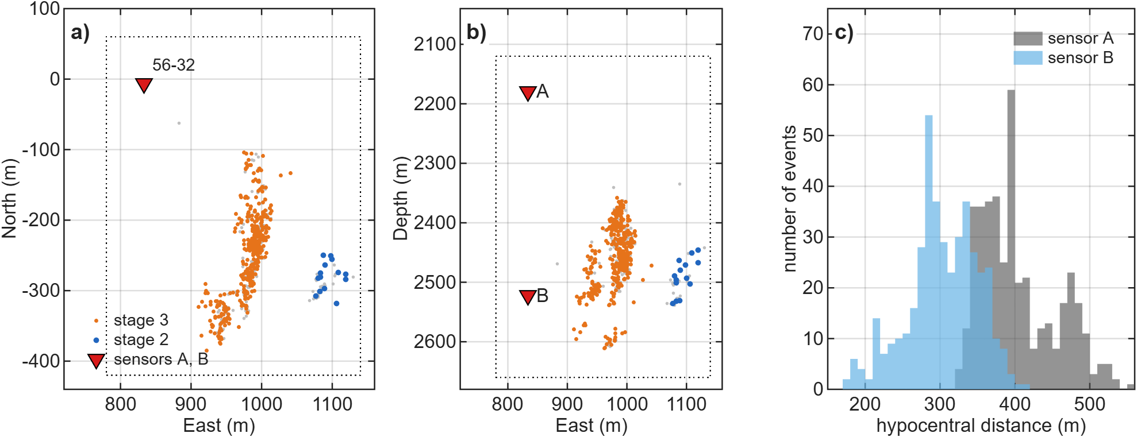
Figure 1. Utah FORGE 2022 geometry: stimulation MEQs, 56-32 sensors and FD volume. a) Map view and b) east–depth section of the 416 analysed MEQs (orange: stage 3; blue: stage 2) and of the other catalogued events inside the FD interior (grey), with the calibrated sensors A and B in well 56-32 (red triangles) and the FD interior (dotted). Coordinates relative to the 16A(78)-32 wellhead. c) Hypocentral distances of the 416 events to sensors A and B.
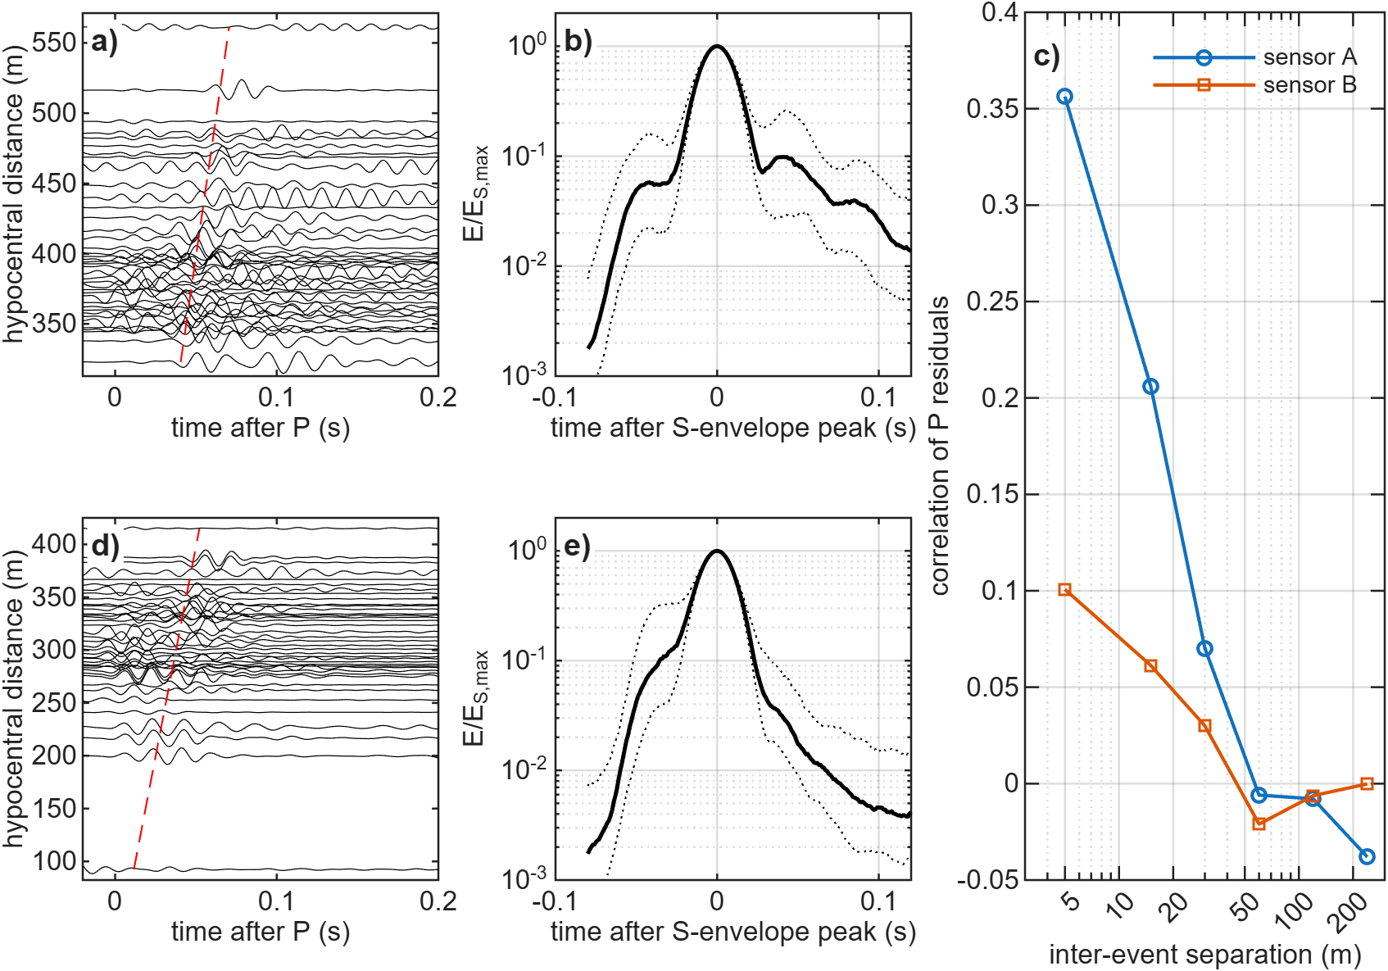
Figure 2. FORGE 56-32 records and S envelopes. a, d) Horizontal records (one component, 40–80 Hz) of 40 events ordered by hypocentral distance for sensors A and B; the dashed line is the predicted S time. b, e) Median (solid) and interquartile range (dotted) of the horizontal S envelope, 40–80 Hz. c) Correlation of P travel-time residuals versus inter-event separation.
3 METHODS
3.1 3-D elastic finite differences and reciprocity
We solve the velocity–stress equations on a staggered grid (Virieux 1986) with fourth-order spatial and second-order temporal differences (Levander 1988) for a transversely isotropic medium with a vertical symmetry axis (VTI; stiffnesses from V_{P}, V_{S}, ρ and the Thomsen parameters ε, δ, γ; Thomsen 1986). The treatment of anisotropy on the staggered grid follows Igel et al. (1995), and the MATLAB implementation grew out of the acoustic codes of Igel (2016), extended to 3-D elastic VTI media, moment-tensor and point-force sources and strain-rate recording. A Cerjan sponge (Cerjan et al. 1985) absorbs outgoing energy. The grid is 113×137×149 nodes at 5 m (a 0.36 × 0.48 × 0.54 km interior plus 20-node sponges), with Δt = 0.25 ms, 1300 steps and a 45-Hz Ricker source. The analysis band is 20–80 Hz, with ≥ 5.4 grid points per S wavelength at 80 Hz even for the slowest truncated S velocity of the σ = 0.18 media (media with σ = 0.22 and 0.25, which fall below 5 points, are shown only in Supporting Information). Three point-force runs per sensor record the strain-rate tensor at every event node, so that by reciprocity (Zhao et al. 2006) the velocity at sensor component n from a moment tensor M at x_{e} is
$v_{n}(x_{s},t)=M_{pq}\int_{0}^{t}{{\overset{˙}{ε}}_{pq}^{\left(n\right)}}(x_{e},τ)dτ.$ (1)
Because only horizontal components are used, the two horizontal-force runs per sensor suffice. Against direct moment-tensor simulations in a heterogeneous VTI medium, the reciprocity synthetics agree with correlation 0.995 and amplitude ratio 0.995 (Supporting Information, Fig. S1).
Coda amplitudes in a small domain could be affected by the grid, the domain edges and the sponge. We therefore simulated one band-limited stochastic medium (σ = 0.13, power-law spectrum with a 780-m outer scale, low-passed at 0.06–0.08 cycles/m so that it is identical on every grid) four times with sensor B, the same 358 events and the same double-couple mechanisms: on the reference 5-m grid, on a 2.5-m grid, in a domain extended by 150 m on every side, and with a sponge of 40 instead of 20 nodes. The coda measures of the three variants are compared event by event with the reference.
3.2 Media
All media have constant density ρ = 2650 kg/m³ and background V_{P} = 5808 m/s, V_{P}/V_{S} = 1.73, except where stated. Four smooth media contain no structure below ~50 m: a homogeneous medium (H), a layered medium from the 56-32 sonic log averaged in 50-m blocks (L), a medium with smooth 3-D gradients of ±3 % vertically and ±2 % horizontally across the box (GRAD3), and a homogeneous VTI medium with Thomsen parameters inverted from the P travel times (A). Two deterministic media contain small-scale structure: the sonic log sampled at its 6-m resolution on the 5-m grid (L6), and 12 planar fracture zones, one cell (5 m) thick, about 240 m tall, striking N25°E and dipping 75°, with V_{P} reduced by 10 % and V_{S} by 20 % (FZ, which also varies V_{P}/V_{S}).
The stochastic media are lognormal, V(x) = V̄ exp[σ f(x)], where f is a zero-mean, unit-variance Gaussian random field obtained by filtering white noise ŵ in the wavenumber domain. For the power-law (pink) field the filter is
$\hat{f}(n)∝\frac{\hat{w}(n)}{{\left(1+|n|\right)}^{p}},|n|=L|k|/2π,$ (2)
where n is the dimensionless FFT index, L the box length along each axis and k the wavenumber. The roll-off wavenumber is therefore k₀ = 2π/L (outer scale equal to the box, 0.6–0.75 km), and the power spectrum decays as |k|^{−2p} above it; p = 1.5 gives one-dimensional spectra ∝ k^{−1.05} and p = 1.8 gives ∝ k^{−1.48} along lines through the field. Because the 1-D spectrum of an isotropic 3-D field with spectrum ∝ |k|^{−2p} decays approximately as k^{-(2p-2)}, the sonic-log slopes (β ≈ 0.85 over 12–200 m and 1.2–1.7 over 1–200 m; Section 2.3) correspond to p ≈ 1.4–1.85, the range of the simulated media. Exponential and Gaussian fields use the filters (1 + k²a²)⁻¹ and exp(−k²a²/8) with the correlation length a in metres. All fields are periodic over the FD box, which is larger than any source–receiver path. After scaling, ln V is truncated at ±3σ (±2.5σ for σ > 0.15) without renormalization. Truncation affects 0.25–1.2 % of cells and reduces σ by ≤ 1.1 % (Supporting Information, Table S9). The truncated velocity range is wide: at σ = 0.13, V_{P} spans 3.9–8.6 km/s, and at σ = 0.18 3.7–9.1 km/s. The extremes occupy a small fraction of the volume, but they show that σ ≥ 0.13 is not a small perturbation.
In the default media V_{P} and V_{S} share one field, so V_{P}/V_{S} is constant. Two variants relax this at σ = 0.13: independent fields for V_{P} and V_{S} (VSD), and a V_{S}-dominated medium with σ(ln V_{S}) = 0.13 and σ(ln V_{P}) = 0.065 (VSO). Because σ absorbs any unmodelled contribution to the late energy, including density contrasts, anisotropic fracture scattering, intrinsic attenuation and site effects, we call the fitted value an effective scattering-strength parameter σ_{eff} within this isotropic model class, not a measured property of the rock.
Media were simulated in two sets (Table 2). A first set explores σ and p for the pink family. A second set forms a common grid for all three families: σ = 0.09, 0.13 and 0.18; p = 1.5 and 1.8 (pink), a = 15 and 50 m (exponential, Gaussian); two white-noise seeds each (11 and 33). Every family thus has the same number of candidates on the common grid. Fields of different families generated from the same seed share their phases and are strongly correlated (the pink and a = 15 m exponential fields with seed 33 by 96 %); this is a controlled comparison of spectral shape, not a test with independent fields.
Table 2. Media simulated
Model | Class | Parameters
H | smooth: homogeneous | V_{P} 5808 m/s, V_{P}/V_{S} 1.73
L | smooth: 1-D layered | 56-32 sonic log, 50-m blocks
GRAD3 | smooth: 3-D gradients | ±3 % vertical, ±2 % E and N
A | smooth: homogeneous VTI | travel-time inverted ε, δ
L6 | deterministic: 1-D layered | 56-32 sonic log at 6-m resolution
FZ | deterministic: fracture zones | 12 planar zones, 5 m thick, N25°E/75°, V_{P} −10 %, V_{S} −20 %
P4, P1, P3, P6, P9 | pink, p = 1.5 (seed 11) | σ = 0.02, 0.045, 0.09, 0.13, 0.18
T1, R1, R2; R3; R6; R5 | pink, p = 1.5 | further seeds at σ = 0.045; 0.09; 0.13; 0.18
P5, P2; P7, P8; P11 | pink, other p | p = 1.2, 1.8 at σ = 0.045, 0.09; p = 1.8 at 0.18
P12, P10 | pink, p = 1.5 | σ = 0.22, 0.25 (Supporting Information only)
Common grid | pink, exponential, Gaussian | σ = 0.09, 0.13, 0.18 × (p = 1.5, 1.8 or a = 15, 50 m) × seeds 11, 33
VSD, VSO | pink, variable V_{P}/V_{S} | σ = 0.13; independent V_{S} field; σ_{VS} = 0.13, σ_{VP} = 0.065
R6c, R6d, E15c/d, G50c/d | synthetic truths | σ = 0.13, seeds 44 and 55 (shape-resolution test)
T2 | synthetic truth | 50-m layering + VTI (ε = 0.06, δ = 0.03, γ = 0.06)
All media: ρ = 2650 kg/m³. Stochastic media: lognormal, truncated at ±3σ (±2.5σ for σ > 0.15). The common grid comprises 36 media (12 per family), 14 of which also belong to the first set.
3.3 Source and preprocessing
FD synthetics carry a 45-Hz Ricker source. To give data and synthetics the same source spectrum, each observed trace is convolved with the same Ricker wavelet. This is valid if the true source spectrum is flat in the analysis band, i.e. if corner frequencies exceed ~80 Hz. The S-window displacement spectra (raw data, 5–300 Hz) support this for most but not all events. The apparent corner, the first frequency above 50 Hz at which the spectrum falls 6 dB below its 30–50 Hz level, has a median of 128 Hz at sensor A and 90 Hz at B. Because it includes path attenuation, it is a lower bound on the source corner; 21 % (A) and 34 % (B) of events have apparent corners below 80 Hz. To bound the effect of finite source duration, we convolved the homogeneous and σ = 0.13 pink synthetics with Brune (1970) source-time functions with corners of 150, 100 and 60 Hz. Even the 60-Hz source raises the homogeneous coda-to-S ratio by only 0.35 log units (A) and changes the pink one by +0.03. Source duration therefore cannot close a deficit of 1–2 log units.
3.4 Per-event coda prediction test
For each event and medium, the moment tensor is fitted by linear least squares to the four horizontal traces (two sensors, 40–80 Hz) in the window P − 10 ms to S + 15 ms, with a per-sensor time shift of up to ±6 ms and the tool azimuth and handedness of each sensor fixed from a previous grid search. The fitted moment tensor then predicts the whole record. After a guard band of 25 ms, the test quantity is the ratio of mean horizontal energy in S + 40 to S + 100 ms to the peak S energy (S − 8 to S + 15 ms), compared per event between prediction and observation as log₁₀(predicted/observed). The fit and coda windows do not overlap. The sensitivity analysis varies the end of the fit window (S + 10, 15, 20 and, for comparison, an overlapping 60 ms) and the coda window (S + 30–100, 40–100 and 50–110 ms). It also compares a full moment tensor, a deviatoric one and a double couple (grid search over strike, dip and rake, with a least-squares scalar moment). Condition numbers of the column-normalized design matrix and the ISO, CLVD and DC fractions of the full solutions are reported. A timing check compares the observed S-envelope peak with the predicted S time. The test is repeated on the events whose S peak lies within ±10 ms (and ±5 ms) of the prediction on both sensors.
3.5 Tests for instrument and borehole ringing
A resonant sensor or borehole response h(t) moves energy from the S peak into later windows, so a coda-to-S ratio does not cancel it. We applied three tests. First, the S-window spectra and the coda/S spectral ratio were examined for resonance peaks. In the analysis band (30–120 Hz), any peak in the smoothed S spectrum is at most 0.35 dB above its surroundings. The same measure detects the resonances near 330, 480 and 920 Hz (prominence up to 10 dB), which serve as a positive control. Second, in a null-ringing test the homogeneous synthetics were convolved with the strongest single resonance (40–80 Hz, Q = 5–40) whose spectral peak does not exceed the observed in-band prominence, and the coda-to-S ratio was recomputed. Third, the two sensors, which have different coupling and different in-band peaks, are analysed separately throughout. No calibration shots, perforation shots or third sensor were available for 2022, so an empirical transfer function could not be measured.
3.6 Statistical comparison of media
With two sensors the realization of a random medium cannot be recovered, so stochastic media are compared with the data through wavefield statistics. On the horizontal energy envelope we measure three S-normalized features per event: the coda level log₁₀(E_{coda}/E_{S}) 30–100 ms after the S peak, the coda decay rate and the rms S-pulse width. We use three sensor–band combinations: A 20–40 Hz, A 40–80 Hz and B 40–80 Hz. B 20–40 Hz is excluded because it carries a persistent non-event plateau of unknown, probably mechanical or borehole, origin; the 40–80 Hz band used elsewhere is free of it. The misfit is
$Φ=Φ_{KS}+Φ_{E},$ (3)
with
$Φ_{KS}=\frac{1}{9}\sum_{k=1}^{9}{D_{KS,k}},$ (4)
$Φ_{E}=\frac{1}{3}\sum_{c=1}^{3}{{\left[\frac{1}{N_{τ}}\sum_{τ}{{\left(\log_{10}{\overset{\sim }{E}}_{c}^{obs}(τ)−\log_{10}{\overset{\sim }{E}}_{c}^{mod}(τ)\right)}^{2}}\right]}^{1/2}},$ (5)
where D_{KS,k} is the two-sample Kolmogorov–Smirnov distance between the observed and synthetic distributions for the k-th of the nine pairs of feature (three) and sensor–band combination c (three), Ẽ_{c} is the median post-peak S envelope, and τ runs over the N_{τ} samples 0–100 ms after the S peak. All nine KS terms and all three envelope terms are weighted equally, events are weighted equally, and events lacking a measurement in one combination are omitted from that combination only. The features are correlated, so Φ is a ranking statistic, not a likelihood. Its uncertainty is estimated by an event bootstrap (200 resamples, the same resample for every medium). Family comparisons use the best member of each family on the common grid per bootstrap sample, and a holdout test in which each family's best (σ, shape, seed) is chosen on half of the events and scored on the other half (20 random splits plus a near/far split by distance).
3.7 Inter-event coda coherence
For pairs of events recorded on the same sensor, D2 is the maximum normalized two-component cross-correlation (lag ±8 ms) of a 40–80 Hz coda window, summarized as the median in bins of inter-event separation (0–5 to 80–160 m) and as the median over all pairs within 160 m. Three windows are used: S + 15 to S + 100 ms (early coda, including the tail of the S pulse), S + 40 to S + 100 ms (the window of the late-energy test) and S + 50 to S + 110 ms. The coherence of noise alone is measured on the same records in a window S + 550 to S + 610 ms. Every synthetic record contains that event's own recorded noise at its observed SNR, so the noise contribution is common to data and media. Both events of a pair are recorded by the same sensor in the same (unknown) orientation, so the two-component correlation is a scalar product of horizontal vectors and does not depend on the sensor azimuth. Pairs that share an event are not independent, so 95 % intervals come from a cluster bootstrap over events (each resampled event carries all its pairs). To test sensitivity to location error, the hypocentres used for binning were perturbed by isotropic Gaussian errors of 5, 10, 20, 30 and 50 m, for data and media alike. The all-pairs median does not depend on the binning and is therefore insensitive to location error.
3.8 Synthetic truth tests
The ability of the statistical comparison to select a medium class was tested with synthetic truths. Two truths were used in the main test: a pink medium (T1, σ = 0.045) and 50-m layering with VTI (T2). A further nine truths at equal σ = 0.13 (pink, exponential a = 15 m and Gaussian a = 50 m, seeds 33, 44 and 55) tested resolution of the spectral family. Synthetic records use double-couple mechanisms consistent with the FORGE stress field, and real 56-32 noise at each event's observed SNR.
4 RESULTS
4.1 Smooth media under-predict the late S energy
Fig. 3 compares observed and predicted sensor-A seismograms for three events. The moment tensor fitted to the direct waves reproduces the P and S pulses in all media. In the homogeneous medium the prediction then decays to near zero within the guard band, whereas the observed traces keep oscillating through the coda window. Table 3 and Fig. 4 give the statistics over 416 events. The four smooth media under-predict the coda-to-S ratio by a median factor of 44–82 at sensor A and 12–15 at sensor B, and only 1–5 % (A) and 5–11 % (B) of events fall within a factor of three. Smooth 3-D gradients (−1.67/−1.11, A/B) and VTI anisotropy (−1.91/−1.19) alter the direct waves but add no late energy.
The two simple deterministic small-scale media tested change this substantially. The sonic log at its 6-m resolution (L6) gives −1.28/−0.53, and the thin fracture zones (FZ) give −1.04/−0.39: under-prediction by factors of 19 and 11 at sensor A but only 3.4 and 2.4 at sensor B, where 41 % and 45 % of events fall within a factor of three. Averaging the log in 50-m blocks therefore removes most of the late energy that the logged layering can generate. For the level of late energy, structure at the 5–10 m scale is the essential ingredient, whether it is layered, planar or random. Stochastic media span the observations: pink media with σ = 0.02 under-predict (−1.20/−0.49), σ = 0.09 is close at sensor A (−0.14) and σ = 0.045 at sensor B (+0.02), and the seed-11 stochastic media with σ = 0.13 over-predict (+0.28 to +1.12). The best stochastic media bring 53 % (A) and 54 % (B) of events within a factor of three. The residual scatter reflects the unknown realization. No single medium matches the median at both sensors; for the pink family, sensor B requires about half the σ of sensor A.
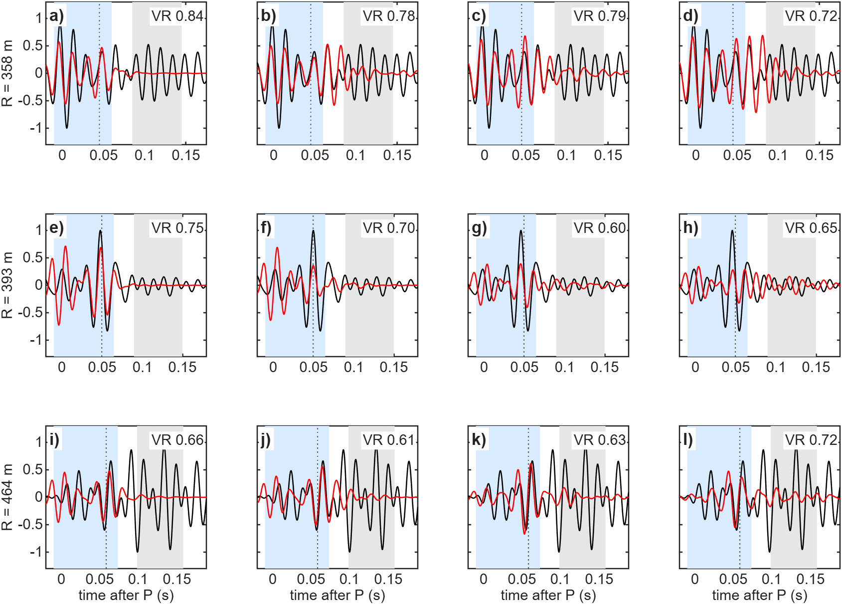
Figure 3. Observed and predicted sensor-A seismograms with non-overlapping fit and coda windows. Horizontal component 1, 40–80 Hz, for three events at increasing distance (rows; distance on the left). Columns: homogeneous medium, deterministic fracture zones (FZ), pink media with σ = 0.045 and 0.09. Black: observed; red: predicted with the moment tensor fitted in the light-blue window (P − 10 ms to S + 15 ms); grey: coda window (S + 40 to S + 100 ms); dotted: predicted S time. Variance reduction of the fit in each panel.
Table 3. Predicted versus observed late S energy for 416 FORGE events
Medium | Median log₁₀(pred/obs), A | Median, B | % within ×3, A | % within ×3, B | VR
smooth: homogeneous | −1.80 | −1.09 | 2 | 9 | 0.75
smooth: layered, 50 m | −1.64 | −1.17 | 5 | 5 | 0.73
smooth: 3-D gradients | −1.67 | −1.11 | 3 | 9 | 0.74
smooth: VTI | −1.91 | −1.19 | 1 | 11 | 0.64
deterministic: layered, 6 m | −1.28 | −0.53 | 15 | 41 | 0.73
deterministic: fracture zones | −1.04 | −0.39 | 24 | 45 | 0.73
pink σ = 0.02 | −1.20 | −0.49 | 16 | 42 | 0.73
pink σ = 0.045 | −0.74 | +0.02 | 34 | 51 | 0.72
pink σ = 0.09 | −0.14 | +0.53 | 50 | 35 | 0.67
pink σ = 0.13 | +0.31 | +0.78 | 50 | 26 | 0.62
pink σ = 0.18 | +0.61 | +1.03 | 37 | 18 | 0.60
pink σ = 0.13, independent V_{S} | −0.13 | +0.54 | 53 | 35 | 0.66
pink, V_{S}-dominated | +0.32 | +0.79 | 49 | 24 | 0.62
exponential a = 15 m, σ = 0.09 | −0.07 | +0.61 | 51 | 33 | 0.68
exponential a = 15 m, σ = 0.13 | +0.28 | +0.94 | 50 | 22 | 0.64
exponential a = 50 m, σ = 0.09 | −0.16 | +0.39 | 48 | 41 | 0.65
exponential a = 50 m, σ = 0.13 | +0.31 | +0.71 | 45 | 27 | 0.59
Gaussian a = 15 m, σ = 0.09 | +0.14 | +0.79 | 48 | 22 | 0.69
Gaussian a = 15 m, σ = 0.13 | +0.42 | +1.12 | 43 | 15 | 0.64
Gaussian a = 50 m, σ = 0.09 | −0.45 | −0.35 | 39 | 44 | 0.62
Gaussian a = 50 m, σ = 0.13 | +0.29 | +0.54 | 45 | 33 | 0.56
Late energy = mean horizontal energy S + 40 to S + 100 ms divided by the S-peak energy, 40–80 Hz. Moment tensors fitted in P − 10 ms to S + 15 ms (no overlap with the coda window). VR = median variance reduction of the direct-wave fit. Stochastic media: seed 11; other seeds in the Supporting Information.
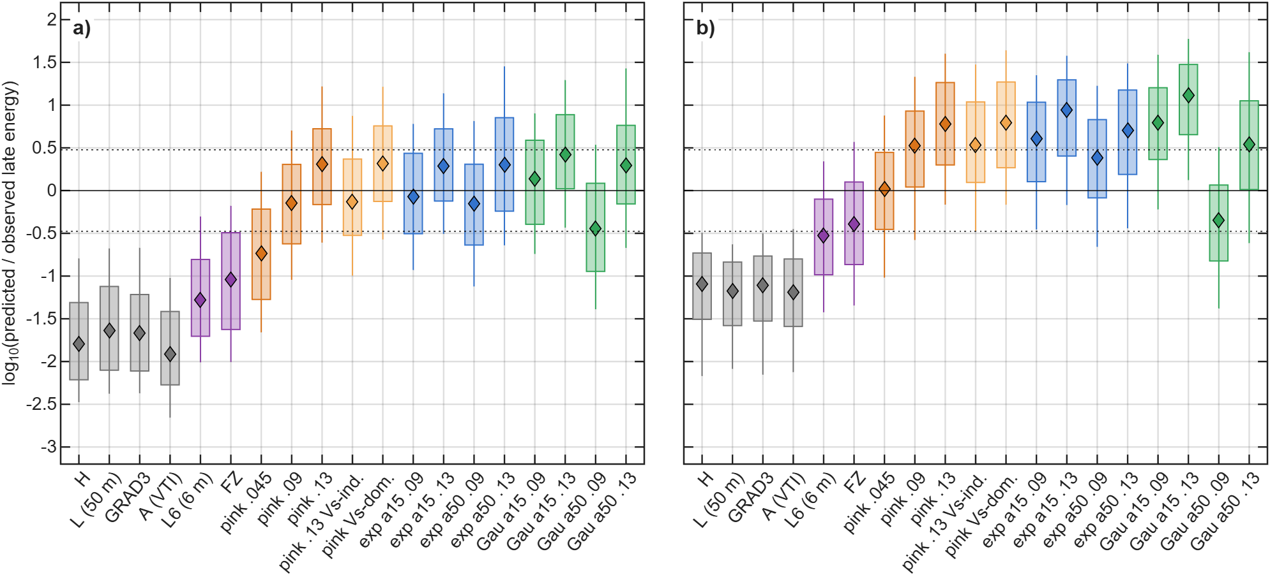
Figure 4. Per-event predicted/observed late S energy for all media. a) Sensor A. b) Sensor B. 416 events, 40–80 Hz, windows as in Table 3. Boxes: interquartile range; whiskers: 10–90 %; diamonds: median; dotted lines: factor of three. Grey: smooth media; purple: deterministic small-scale media (6-m layering, fracture zones); orange: pink media (light orange: variable V_{P}/V_{S}); blue: exponential; green: Gaussian.
4.2 Robustness of the deficit
Table 4. Robustness of the late-energy deficit of smooth and deterministic media
Variant | Smooth, A | Smooth, B | L6 and FZ, A | L6 and FZ, B
Primary (fit to S + 15 ms; coda S + 40–100 ms) | −1.91 to −1.64 | −1.19 to −1.09 | −1.28 to −1.04 | −0.53 to −0.39
Fit to S + 10 ms | −1.91 to −1.64 | −1.20 to −1.07 | −1.29 to −1.04 | −0.52 to −0.33
Fit to S + 20 ms | −1.91 to −1.64 | −1.19 to −1.08 | −1.28 to −1.07 | −0.53 to −0.39
Coda S + 50–110 ms | −2.21 to −1.99 | −1.44 to −1.39 | −1.46 to −1.33 | −0.65 to −0.64
Coda S + 30–100 ms | −1.58 to −1.45 | −1.05 to −0.99 | −1.11 to −0.82 | −0.48 to −0.19
Overlapping fit (S + 60 ms), coda S + 30–100 ms | −1.59 to −1.45 | −1.03 to −0.99 | −1.12 to −0.93 | −0.50 to −0.29
Deviatoric moment tensor | −2.04 to −1.69 | −1.21 to −1.09 | −1.33 to −1.19 | −0.51 to −0.49
Double couple | −2.10 to −1.69 | −1.25 to −1.11 | −1.34 to −1.24 | −0.58 to −0.51
150 highest-SNR events | −1.86 to −1.53 | −1.26 to −1.09 | −1.22 to −0.77 | −0.65 to −0.33
S peak within ±10 ms on both sensors (250 events) | −1.70 to −1.42 | −1.17 to −0.98 | −1.10 to −0.88 | −0.53 to −0.35
S peak within ±5 ms on both sensors (168 events) | −1.62 to −1.35 | −1.20 to −0.98 | −1.04 to −0.87 | −0.55 to −0.42
Homogeneous + worst in-band resonance (null-ringing test) | −1.99 to −1.61 | −1.33 to −0.96
Homogeneous, Brune source f_{c} = 60 Hz (change) | +0.35 | +0.35
Median log₁₀(predicted/observed late energy); range over the smooth media (H, L, GRAD3, A) and over the deterministic small-scale media (L6, FZ). Null-ringing test: range over resonance frequencies 40–80 Hz and Q = 5–40, for the median over events of the homogeneous double-couple synthetics relative to the observed median. Brune row: change of the homogeneous coda-to-S ratio relative to an impulsive source.
Table 4 shows that the deficit does not depend on the analysis choices. Ending the fit window at S + 10 or S + 20 ms, or moving the coda window, changes the smooth-model medians by a few tenths of a log unit. Even a fit window that overlaps the coda window (to S + 60 ms) changes them by at most 0.02, and a coda window beginning at S + 30 ms gives a smaller deficit only because it includes more of the early coda. Deviatoric and double-couple solutions give the same result, although they fit the direct waves less well (median VR in the homogeneous medium 0.75 for the full, 0.71 for the deviatoric and 0.67 for the double-couple solution). The moment-tensor problem is moderately conditioned (median condition number 16–18 for smooth and 4–16 for stochastic media, decreasing with σ). The full solutions carry large non-double-couple parts (median |ISO| 28 %, |CLVD| 28 % in the homogeneous medium). With two sensors in one well these parts are poorly resolved and we do not interpret them. They could absorb part of the path effects on the direct waves, but the double-couple solutions cannot, and they give the same deficit. The lower condition numbers in random media arise because scattered energy inside the fit window makes the six Green's-function columns less similar. The point is that no source constraint changes the coda deficit. The observed S peak lies within ±10 ms of the predicted time for 250 events on both sensors, and the deficit remains in that subset and in the ±5 ms subset. Timing and location errors therefore do not explain it.
The ringing tests constrain the instrument explanation (Fig. 5). Between 30 and 120 Hz the S spectra of both sensors are smooth, and the coda/S spectral ratio has no peak. The worst resonance compatible with this smoothness leaves the homogeneous medium 1.6–2.0 log units short at sensor A and 1.0–1.3 at B. The resonances above 300 Hz are strong and clearly visible, so an in-band resonance large enough to create the observed coda would not have escaped detection. This test excludes a single resonant mode, but not a broadband, non-resonant coupling response with a long impulse response. That possibility can be excluded only with an empirical transfer function, which is not available.
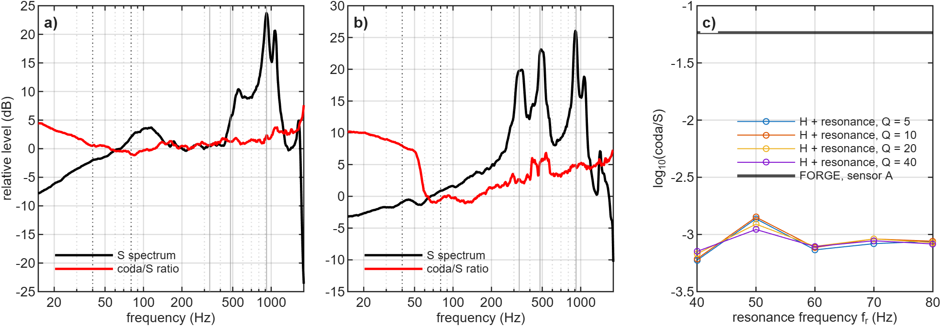
Figure 5. Tests for instrument or borehole ringing. a, b) Sensors A and B: median S-window spectrum normalized over 30–150 Hz (black) and median coda/S spectral ratio (red, normalized). Dotted lines mark the analysis band 40–80 Hz and grey lines the resonances near 330, 480 and 920 Hz. c) Null-ringing test: log₁₀ coda/S of the homogeneous synthetics (sensor A) after convolution with the strongest resonance compatible with the observed in-band spectral smoothness, versus resonance frequency, for Q = 5–40. Thick line: observed FORGE median.
Grid refinement and sponge thickness change the late energy little (Supporting Information, Table S10). Relative to the 5-m reference, the median coda-to-S ratio at 40–80 Hz changes by +0.01 log units on the 2.5-m grid and by +0.13 with the doubled sponge (+0.16 and −0.13 at 20–40 Hz). Enlarging the domain by 150 m on every side, however, raises it by +0.40 at 40–80 Hz (+0.09 at 20–40 Hz) and lowers the coda decay rate from 48 to 21 s⁻¹. Because the doubled sponge has a much smaller effect, this is not a boundary artefact. It reflects the larger scattering volume: in the reference domain the event cloud nearly fills the interior, so heterogeneity beyond it lies in the absorbing sponge and returns no scattered energy. For lapse times up to 100 ms after S, scatterers contribute to the coda window only within about V_{S}t/2 ≈ 170 m of the source–receiver paths, so a 150-m extension covers most of this volume and the effect should be close to saturation; larger domains were not tested. A smooth medium has no such scatterers, so the smooth-model deficit is unaffected. The slower decay in the larger domain is closer to the observed decay. For the stochastic media, the reference domain probably underestimates the late energy, and the effective scattering strength derived below is probably an upper bound. With the sensitivity of the median ratio to σ found below (0.80 log units per unit change of ln σ), this single test implies that σ_{eff} from the reference domain may be overestimated by a factor of about 1.7. Whether the same factor applies to other families and to sensor A was not tested.
4.3 Effective scattering strength
For each family the σ at which the median predicted late energy equals the observed one (σ_{eff}) is interpolated in ln σ between the simulated levels of the reference domain (Fig. 6; Supporting Information, Table S11). At sensors A and B it is 0.104 and 0.053 for pink media with p = 1.5, 0.098 and 0.048 with p = 1.8, 0.093 and < 0.09 for exponential media with a = 15 m, 0.102 and < 0.09 with a = 50 m, and 0.112 and 0.131 for Gaussian media with a = 50 m ("< 0.09": the smallest simulated σ already over-predicts). σ_{eff} thus differs between sensors and families, so it is a model-dependent summary of the late energy rather than a unique rock property. Media with less small-scale content need larger σ (Gaussian a = 50 m), and media richest in structure near the S wavelength need less (Gaussian a = 15 m: < 0.09 at both sensors). Realization scatter adds to this. The two seeds at one σ differ in the median ratio by up to 0.47 log units for pink media and 0.40 for exponential media with a = 15 m, i.e. a factor of about 1.8 in σ_{eff}, but by up to 1.57 for Gaussian media with a = 50 m, whose few large features make each realization idiosyncratic in a 0.5-km box.
Relaxing the constant V_{P}/V_{S} ratio changes the late energy only moderately. With independent V_{P} and V_{S} fields the median ratio is −0.13/+0.54 (A/B), against +0.31/+0.78 for the coupled medium. The V_{S}-dominated medium, with half the V_{P} perturbation, gives +0.32/+0.79. The S coda is controlled mainly by the V_{S} perturbation, so σ_{eff} should be read as a V_{S} scattering strength.
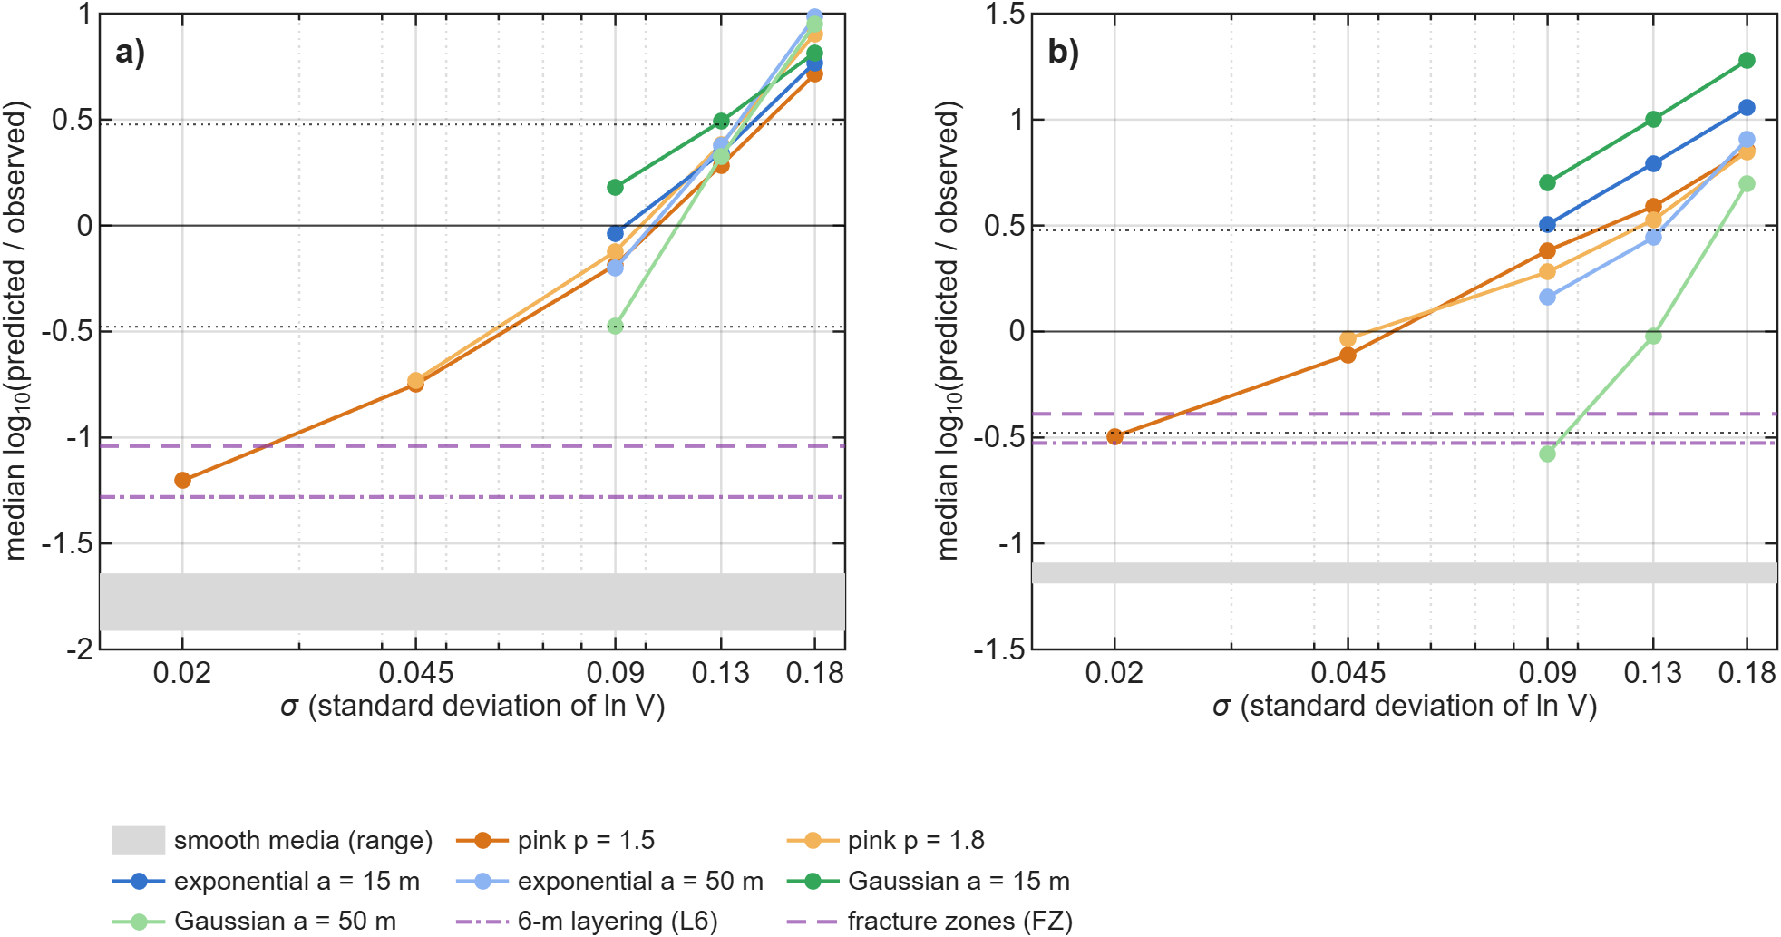
Figure 6. Median predicted/observed late S energy versus σ for each spectral family. a) Sensor A. b) Sensor B. Median over events of log₁₀(predicted/observed), averaged over realizations where several exist. The zero crossing defines σ_{eff}; dotted lines: factor of three; grey band: range of the smooth media; purple dash-dotted and dashed lines: 6-m layering (L6) and fracture zones (FZ).
4.4 Inter-event coda coherence
Fig. 7 shows D2 in the three windows. In the early coda (S + 15 to S + 100 ms) the observed coherence falls from 0.69 at 0–5 m to 0.49 at 80–160 m (sensor A; 0.75 to 0.48 at B). The smooth media stay coherent (all pairs within 160 m: 0.82–0.86 at A, 0.73–0.78 at B, against 0.50 at both sensors for the data), and so do the two deterministic small-scale media (0.80–0.83 and 0.67–0.69). The stochastic media decorrelate as the data do (0.48–0.59 and 0.54–0.62). This window, however, contains the tail of the S pulse and is close to the window of the source fit.
In the late windows the picture changes. All coherences are lower and approach the coherence of noise alone (0.57 at A and 0.48 at B). The observed late coda is at or below this level (0.53 and 0.45 for S + 40 to S + 100 ms; 0.54 and 0.45 for S + 50 to S + 110 ms). Because the synthetics carry the same noise, D2 in these windows measures how much coherent late energy a medium adds. The smooth media (0.60–0.69 at A, 0.53–0.58 at B) and the fracture zones (0.64, 0.62) remain more coherent than the data in both late windows; their 95 % intervals lie above the data interval in 19 of 20 medium–sensor–window cases (Supporting Information, Table S17). The stochastic media (0.49–0.55, 0.49–0.50) and the 6-m layering (0.57, 0.52) come closest; in S + 50 to S + 110 ms the 6-m layering is as close to the data as the stochastic media at sensor A (0.51 against 0.50–0.52 and 0.54 observed). In the pure late coda D2 therefore separates the data from the smooth media and from the planar fracture zones, but not from fine 1-D layering. The separation of distributed 3-D heterogeneity from fine layering rests on the early-coda window and is correspondingly less secure.
Location error does not change these conclusions. Perturbing the hypocentres of data and media by up to 50 m flattens the binned curves, as expected, but changes the observed medians at separations of 20 m or more by at most 0.05 (Supporting Information, Fig. S10), and the all-pairs levels, which do not depend on the binning, are unaffected. We therefore do not use the 0–5 and 5–10 m bins for inference (the 0–5 m bin contains only 64 pairs from 96 events). D2 is measured on the same records as the late energy, so it is a second descriptor of the same data, not an independent experiment.
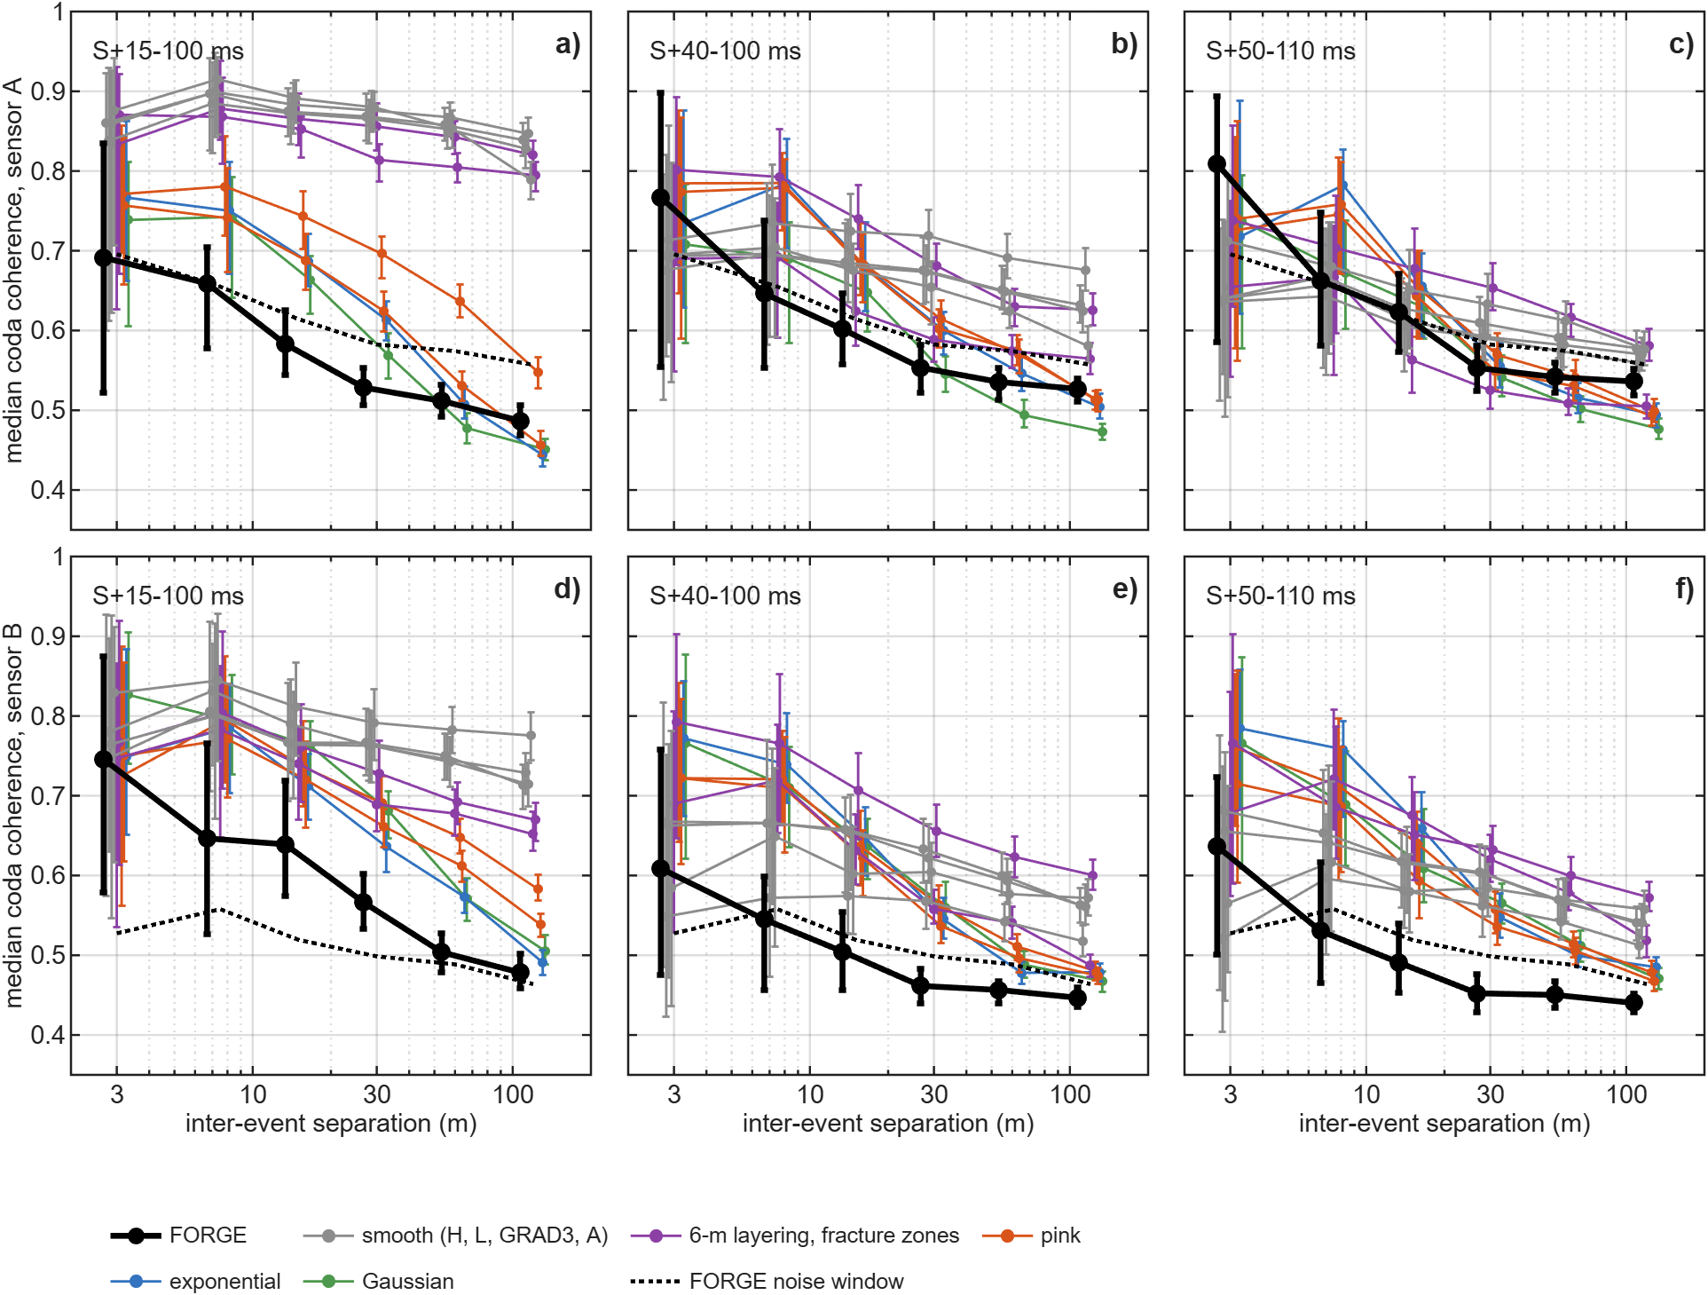
Figure 7. Inter-event coda coherence in early and late coda windows. Median coherence of the 40–80 Hz coda versus inter-event separation, with 95 % cluster-bootstrap intervals over events, for sensor A (a–c) and sensor B (d–f), in the windows S + 15 to S + 100 ms (a, d), S + 40 to S + 100 ms (b, e) and S + 50 to S + 110 ms (c, f). Black: FORGE; dotted: FORGE noise-only window (S + 550 to S + 610 ms); grey: smooth media (H, L, GRAD3, A); purple: 6-m layering and fracture zones; orange: pink (σ = 0.09, 0.13); blue: exponential (a = 15 m); green: Gaussian (a = 50 m), σ = 0.13. Symbols are offset horizontally for clarity.
4.5 Statistical comparison and the spectral family
In the synthetic tests the statistical comparison selected the generating class in both controlled examples. With the pink truth T1 the best medium was a pink medium with the true σ (R1, Φ = 0.09), ahead of H, L and A (Φ = 0.29 each). With the layered-VTI truth T2, L and A ranked first (0.13, 0.16) and every pink medium was rejected. Two examples do not establish that the procedure is unbiased. The deterministic moment-tensor fit behaved differently. For the pink truth it preferred the smoothest media (median VR 0.93 for H against 0.88 for a pink medium with the correct statistics but another realization), because a wrong realization places scattered energy at wrong times. This applies to selecting a model class from a set of arbitrary stochastic realizations. It does not imply that full-waveform inversion, which updates the structure itself, cannot recover heterogeneity when the data coverage allows it.
The equal-σ family test selected the correct family for 5 of 9 truths. Under a chance model with p = 1/3 the probability of at least 5 successes is 0.145, so this is not significant. Pink and exponential truths were assigned to the correct member of that pair in 3 of 6 cases (chance level), whereas small-scale-rich (pink or exponential) and Gaussian truths were separated in 8 of 9. With so few realizations, even the latter is only indicative.
On the FORGE data (Fig. 8), the smooth media (best Φ = 1.33) and the deterministic small-scale media (1.01) are separated from every stochastic family (best members 0.25–0.57) by far more than the bootstrap intervals. Between the stochastic families, the best single member belongs to the exponential a = 50 m family (Φ = 0.25 [0.24, 0.30]), which has the lowest Φ in 98 % of event-bootstrap resamples, ahead of the pink family (0.29 [0.27, 0.34]). In the holdout test the best training member scores a median held-out Φ of 0.26 (exponential a = 50 m) and 0.31 (pink). Both tests, however, resample events with the realization fixed, and the holdout selected the same realization in almost every split. They show that the ranking generalizes across events, not across realizations. The realization matters more: the two seeds at the same (σ, shape) differ by up to 0.33 in Φ (median 0.11), whereas the best members of the leading families differ by 0.05. Averaged over both seeds, the best grid point of each family gives exponential a = 50 m 0.35 (σ = 0.13); pink 0.37 (σ = 0.13, p = 1.8); Gaussian a = 50 m 0.46 (σ = 0.13); exponential a = 15 m 0.48 (σ = 0.13); Gaussian a = 15 m 0.58 (σ = 0.09). With two realizations per grid point, the 20–80 Hz statistics therefore do not select a spectral family; Gaussian media with a = 15 m fit least well, but even they are separated from the smooth and deterministic media by a margin (0.43 in Φ) larger than any realization effect.
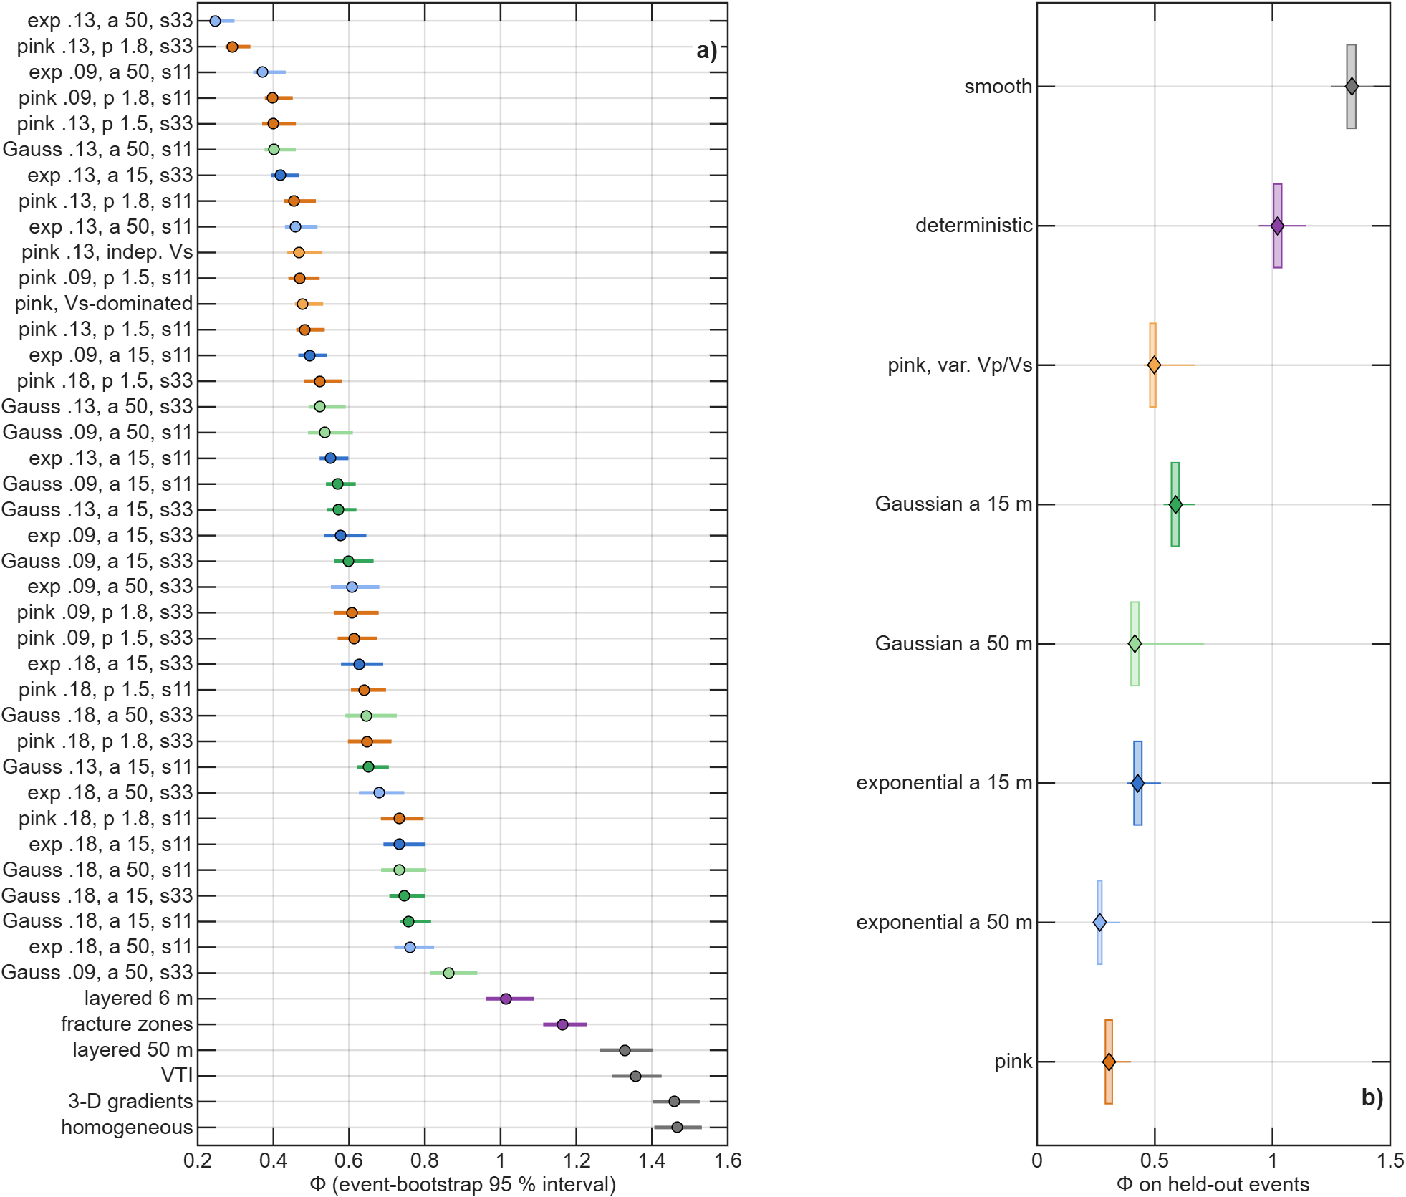
Figure 8. Statistical misfit Φ with event-bootstrap intervals and holdout scores. a) Φ for all media with the full event set (circles) and 95 % event-bootstrap intervals (bars), sorted by Φ. Labels give family, σ, p or a (m) and white-noise seed (s11, s33). Grey: smooth media; purple: deterministic small-scale media; orange: pink; light orange: variable V_{P}/V_{S}; blue: exponential (dark a = 15 m, light a = 50 m); green: Gaussian (dark a = 15 m, light a = 50 m). The intervals reflect event resampling only, not realization scatter. b) Held-out Φ of each family's best training member over 21 splits in both directions (box: interquartile range; whiskers: range).
4.6 Sonic-log spectrum
Fig. 9 shows the log spectrum with four fitted spectral models. The spectrum is consistent with a power law over 12–200 m, but this range spans only 1.2 decades. Short-correlation-length spectra fit almost as well, and the estimated slope depends on estimator and segment. The log therefore does not select a spectral family independently either.
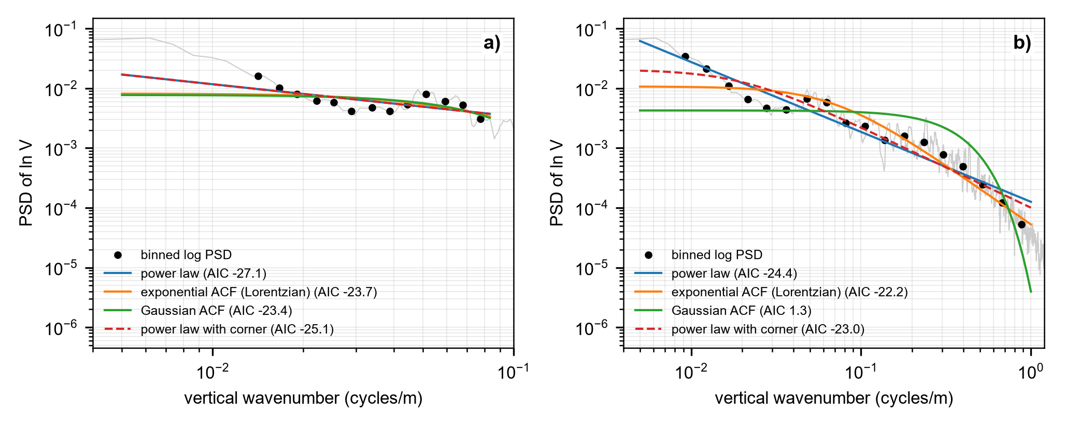
Figure 9. Spectral models of the 56-32 sonic-log fluctuations. Multitaper power spectrum of detrended ln V (grey) and log-binned values (dots), with least-squares fits of a power law, exponential and Gaussian autocorrelation spectra and a power law with a corner (dashed). a) 12–200 m; the corner model converges to a pure power law and overlies it. b) 1–200 m. AIC values in the legend.
5 DISCUSSION
5.1 What the data show
Three results are robust. Media without structure below ~50 m produce one to two orders of magnitude less late S energy than recorded. Media with deterministic structure at the 5–10 m scale supply much of the missing energy, but not the decorrelation of the early coda between neighbouring events. Random media reproduce both, at a fluctuation strength of the same order as that of the local sonic log. None of this depends on the power-law ("pink-noise") hypothesis, which the data neither require nor exclude. The main alternative to small-scale scattering is an unmodelled site or coupling response of comparable size, which only a measured sensor transfer function or a third, independently installed sensor could rule out.
5.2 Relation to earlier scattering studies
Two-dimensional FD studies showed that coda strength and apparent attenuation are controlled by the fluctuation strength and by the part of the heterogeneity spectrum near the wavelength (Frankel & Clayton 1986; Roth & Korn 1993; Shapiro & Kneib 1993; Hestholm et al. 1994), and envelope theory for power-law media relates coda excitation to the short-wavelength part of the spectrum (Saito et al. 2003; Sato et al. 2012). Our 3-D elastic simulations show the same behaviour in a borehole geometry at 40–80 Hz, where S wavelengths are 40–85 m. At fixed σ, the media richest in structure near the S wavelength (Gaussian, a = 15 m) produce the most late energy and need the smallest σ_{eff}, and the media whose heterogeneity is concentrated at large scales (Gaussian, a = 50 m) produce the least. This is why spectral family and fluctuation strength trade off. Three-dimensional simulations of regional high-frequency wavefields have examined how scattering and intrinsic attenuation together shape envelopes (Takemura et al. 2017); our data constrain the two only jointly (Section 5.3). The required fluctuation strength is of the same order as the velocity fluctuations measured in sonic logs (Wu et al. 1994; Holliger 1996), including the 56-32 log (0.045).
5.3 Intrinsic attenuation, density and the source
The FD media are elastic. Intrinsic attenuation reduces the energy of the coda window relative to the S peak by exp(−2πfΔt/Q_{S}), where Δt ≈ 70 ms is the mean delay of the coda window. At f = 60 Hz this amounts to 0.23, 0.11 and 0.04 log units for Q_{S} = 50, 100 and 300. Intrinsic attenuation therefore increases, rather than reduces, the smooth-media deficit, and no value of Q_{S} explains the late energy without scattering. In random media it raises the σ_{eff} needed to match the data by at most a factor of 1.3 for Q_{S} ≥ 50, comparable to the realization scatter. Separating scattering from intrinsic attenuation, as done regionally from S-wave energy versus distance (Fehler et al. 1992), would need more sensors and a wider distance range than two sensors in one well provide. Density is constant in all media. If it co-varied with velocity as in Gardner's relation, ρ ∝ V_{P}^{1/4} (Gardner et al. 1974), impedance fluctuations would be about 25 per cent larger than the velocity fluctuations, and a correspondingly smaller σ_{eff} (by up to ~20 per cent) would produce the same scattering. Finally, the moment tensor is fitted only to the direct waves. Its non-double-couple parts cannot create late energy that the double-couple solutions lack (Table 4), and a finite source duration down to a 60-Hz Brune corner raises the late energy of the homogeneous medium by only 0.35 log units (Section 3.3).
5.4 What would resolve the spectral family
At 20–80 Hz the per-event test, the common-grid statistics and the equal-σ truth tests do not separate power-law from exponential or Gaussian spectra, and the sonic log does not separate them either (Section 4.6). The families differ mainly at wavenumbers well above 1/a; for a = 15 m this means S wavelengths below ~15–30 m, i.e. frequencies above ~110–220 Hz. An exploratory comparison at 100 Hz on a 2.5-m grid suggested that a large-scale Gaussian medium loses its coda at that frequency (Supporting Information, Fig. S9), but it used a fixed σ, two realizations and noise-free synthetics, and the coda attenuation Q_{c}⁻¹ is only a finite-window diagnostic at 25 Hz (Figs S7 and S8). Resolving the family would require (i) simulations to at least 200 Hz on grids of 2.5 m or finer, in domains that extend at least ~170 m beyond the event cloud; (ii) ensembles of 10 or more realizations per parameter set, because realization scatter now exceeds the family differences; (iii) sensors at several azimuths and depths, so that realization-specific features average out; and (iv) measured sensor transfer functions, because fixed-frequency resonances near 330, 480 and 920 Hz prevent the use of the band above ~200 Hz. The 4-kHz FORGE records carry S energy above noise up to ~1.8 kHz (Figs S5 and S6), so the bandwidth exists; the limits are instrument calibration and computational cost.
5.5 The effective scattering strength and the two sensors
σ_{eff} is not a unique measure of rock heterogeneity. It absorbs every unmodelled contribution to the late energy: density contrasts, anisotropic or fluid-filled fracture scattering, intrinsic attenuation, and site or coupling effects that the ringing tests cannot exclude. It also depends on the simulation domain. One domain test (one medium, sensor B) suggests that the reference-domain values (0.05–0.13) may be about 1.7 times too large. With that correction the pink medium with the sonic-log value (σ = 0.045) would give median ratios of −0.33 (A) and +0.42 (B), within a factor of about 3 of the data at both sensors. This is consistency, not a measurement.
σ_{eff} at the shallower sensor A is about twice that at the deeper sensor B for the pink and exponential families. A sensor-depth error cannot explain this. An error of 50 m changes hypocentral distances by about 15 per cent (median distances 393 m at A and 303 m at B), and the predicted late-energy ratio of the random media varies with distance slowly enough that this shifts it by at most 0.26 (A) and 0.10 (B) log units, a factor of at most 1.4 in σ_{eff}. Distance itself does not explain it either. In the data the late energy decreases with distance at both sensors, by 0.19 (A) and 0.36 (B) log units from the nearest to the farthest third of the events (log–log slopes of −2.1 and −2.6), whereas the simulated media predict slopes between −0.3 and +4.4, i.e. a much weaker decrease or an increase. Moreover, sensor A records the events at larger distances but has the stronger late energy (median log₁₀ coda/S −1.24 against −1.87). The statistically uniform random media therefore reproduce neither the distance dependence nor the sensor dependence of the late energy. Both point to spatially non-uniform scattering, for example stronger heterogeneity along the paths to sensor A, which cross the upper part of the stimulated volume, or late energy generated close to the sources, or to a sensor-specific site response. Two sensors in one well cannot separate these possibilities.
Stimulation might raise the scattering strength by opening fluid-filled fractures, which lower V_{S} preferentially. This is a hypothesis. No pre-stimulation waveforms exist for these paths, and a stage comparison is not possible, because 402 of the 416 events belong to stage 3 (Supporting Information, Table S8). The V_{S}-dominated medium shows only that a V_{S}-weighted perturbation produces similar late energy, and the fracture-zone medium that twelve planar zones are not enough. Denser 3-D fracture networks, rough interfaces, irregular damage zones and anisotropic compliance were not tested, and a sufficiently dense deterministic network would approach a random medium.
5.6 Implications for induced-seismicity monitoring
Velocity models adequate for locating events at ~1-ms travel-time precision leave most of the late wavefield unexplained. This matters for EGS monitoring and induced-seismicity assessment (Majer et al. 2007; Ellsworth 2013) in three ways. First, waveform-based source studies that assume smooth media, such as moment-tensor inversion, source spectra and coda-based magnitudes, attribute the late energy to noise or to the source; with few sensors, non-double-couple components and apparent corner frequencies are particularly exposed. Second, high-frequency ground-motion and attenuation estimates for induced events depend on the balance between scattering and intrinsic attenuation (Fehler et al. 1992; Takemura et al. 2017), which these data constrain only jointly. Third, the coda carries information on the small-scale structure of the stimulated volume, and its decorrelation between events and over time can be followed with coda-wave methods (Snieder et al. 2002; Pradhan et al. 2025). Such comparisons must be statistical, because a deterministic comparison with an arbitrary random realization favours smooth media (Section 4.5). For models of crustal heterogeneity, the results are consistent with the power-law fluctuations inferred from well logs (Leary 1991; Wu et al. 1994; Holliger 1996), but they do not discriminate them from media with a short correlation length or, in the late coda, from fine layering.
5.7 Limitations
- Two sensors in one well, with unoriented horizontals and unreliable vertical channels; no calibration shots, perforation shots or independent sensors for 2022, so the sensor–borehole transfer function is not measured.
- No pre-stimulation records exist for these paths, so changes caused by the stimulation cannot be assessed.
- Sensor positions, clock offsets and V_{P} trade off with the catalogue locations (~50 m, ~8 per cent).
- The random media are isotropic, lognormal and elastic, with constant density; intrinsic attenuation, anisotropic fracture compliance and rough interfaces are not modelled.
- The domain-size effect on the random-media coda was measured for one medium and one sensor; the correction of σ_{eff} is approximate.
- The common grid has two realizations per grid point; realization scatter limits σ_{eff} to about a factor of 1.8 for pink and short-a media and much more for large-a Gaussian media.
- The analysis band is 20–80 Hz, where the spectral families differ least, and in the pure late coda the inter-event coherence is limited by noise.
6 CONCLUSIONS
(1) In 416 downhole records of the 2022 FORGE stimulation, the S-wave energy 40–100 ms after the S arrival exceeds that of smooth elastic media by one to two orders of magnitude. The excess is not an artefact of the analysis windows, the source parametrization, event timing or a resonant sensor response.
(2) A model that reproduces this energy needs structure at the 5–10 m scale. Fine layering and thin planar zones provide much of the energy; the early-coda decorrelation between neighbouring events is reproduced only by distributed 3-D heterogeneity, whereas in the noise-limited late coda only smooth and planar-zone media are excluded.
(3) In isotropic lognormal media the required fluctuation strength is 0.05–0.13. It depends on sensor and spectral family, is probably an upper bound, and is of the same order as the 56-32 sonic-log value.
(4) Neither the 20–80 Hz waveforms nor the sonic log resolve the spectral family. Doing so requires frequencies above ~200 Hz, calibrated sensors, several stations and realization ensembles.
(5) Selecting a medium class by matching waveforms to one random realization is biased towards smooth media; statistical descriptors of the wavefield avoid this bias.
ACKNOWLEDGEMENTS
We thank Heiner Igel for the acoustic finite-difference MATLAB codes from which the elastic solver used here was developed, Geo-Energie Suisse and the Utah FORGE project of the U.S. Department of Energy for the event catalogue and the downhole records, and an internal reviewer for critical readings of earlier versions. This research received no specific grant from any funding agency in the public, commercial or not-for-profit sectors. Author contributions: WS designed the waveform tests, processed the data, developed the software, carried out the simulations and analyses, prepared the figures and wrote the original draft; PL conceived the lognormal power-law crustal model, contributed to the methodology and reviewed and edited the manuscript.
DATA AVAILABILITY
The event catalogue (Dyer et al. 2022) and the downhole geophone records of wells 56-32, 58-32 and 78B-32 from the 2022 stimulation (Pankow 2023) are publicly available from the U.S. Department of Energy Geothermal Data Repository. The SEG-2 versions of the 56-32 records used here were provided by Geo-Energie Suisse. All code (finite-difference solver, reciprocity, feature extraction, tests and figure scripts, with fixed random seeds) and all derived result tables are available at https://github.com/maswiet/Paper2_PinkNoise_WaveformInversion, release v1.0-submission (commit 1dab05b).
CONFLICT OF INTEREST
The authors declare that they have no conflict of interest.
SUPPORTING INFORMATION
Supplementary data are available at GJI online: Figures S1–S11 and Tables S1–S18 (reciprocity validation, sonic log, earlier statistical tests, bandwidth and multi-octave diagnostics, location stress test of the coda coherence, window and moment-tensor sensitivity, S-timing subsets, calibration bootstrap, source spectra, ringing tests, stage comparison, field statistics, numerical convergence, σ_{eff} curves, complete Φ and holdout tables, equal-σ truth tests, log-spectrum variants, per-event results for every medium and seed, and coda-coherence tables). Please note: Oxford University Press is not responsible for the content or functionality of any supporting materials supplied by the authors. Any queries (other than missing material) should be directed to the corresponding author for the paper.
REFERENCES
Aki, K. & Chouet, B., 1975. Origin of coda waves: source, attenuation, and scattering effects, J. geophys. Res., 80(23), 3322–3342.
Brune, J.N., 1970. Tectonic stress and the spectra of seismic shear waves from earthquakes, J. geophys. Res., 75(26), 4997–5009.
Cerjan, C., Kosloff, D., Kosloff, R. & Reshef, M., 1985. A nonreflecting boundary condition for discrete acoustic and elastic wave equations, Geophysics, 50(4), 705–708.
Dyer, B., Karvounis, D. & Bethmann, F., 2022. Utah FORGE: updated seismic event catalogue from the April, 2022 stimulation of well 16A(78)-32, DOE Geothermal Data Repository, doi:10.15121/1908927.
Ellsworth, W.L., 2013. Injection-induced earthquakes, Science, 341(6142), 1225942, doi:10.1126/science.1225942.
Fehler, M., Hoshiba, M., Sato, H. & Obara, K., 1992. Separation of scattering and intrinsic attenuation for the Kanto-Tokai region, Japan, using measurements of S-wave energy versus hypocentral distance, Geophys. J. Int., 108, 787–800.
Frankel, A. & Clayton, R.W., 1986. Finite difference simulations of seismic scattering: implications for the propagation of short-period seismic waves in the crust and models of crustal heterogeneity, J. geophys. Res., 91(B6), 6465–6489.
Gardner, G.H.F., Gardner, L.W. & Gregory, A.R., 1974. Formation velocity and density—the diagnostic basics for stratigraphic traps, Geophysics, 39(6), 770–780.
Hestholm, S.O., Husebye, E.S. & Ruud, B.O., 1994. Seismic wave propagation in complex crust–upper mantle media using 2-D finite-difference synthetics, Geophys. J. Int., 118, 643–670.
Holliger, K., 1996. Upper-crustal seismic velocity heterogeneity as derived from a variety of P-wave sonic logs, Geophys. J. Int., 125(3), 813–829.
Igel, H., 2016. Computational Seismology: A Practical Introduction, Oxford Univ. Press, Oxford.
Igel, H., Mora, P. & Riollet, B., 1995. Anisotropic wave propagation through finite-difference grids, Geophysics, 60(4), 1203–1216.
Leary, P.C., 1991. Deep borehole log evidence for fractal distribution of fractures in crystalline rock, Geophys. J. Int., 107(3), 615–627.
Leary, P., 1997. Rock as a critical-point system and the inherent implausibility of reliable earthquake prediction, Geophys. J. Int., 131, 451–466.
Leary, P., 2026. EGS sustainability: deconstructing UtahForge engineered geothermal system flow data, Sustainability, 18, 5308, doi:10.3390/su18115308.
Leary, P.C. & Al-Kindy, F., 2002. Power-law scaling of spatially correlated porosity and log(permeability) sequences from north-central North Sea Brae oilfield well core, Geophys. J. Int., 148, 426–442.
Levander, A.R., 1988. Fourth-order finite-difference P-SV seismograms, Geophysics, 53(11), 1425–1436.
Maeda, N., 1985. A method for reading and checking phase times in autoprocessing system of seismic wave data, Zisin, 38, 365–379.
Majer, E.L., Baria, R., Stark, M., Oates, S., Bommer, J., Smith, B. & Asanuma, H., 2007. Induced seismicity associated with Enhanced Geothermal Systems, Geothermics, 36(3), 185–222.
Margerin, L., Planès, T., Mayor, J. & Calvet, M., 2016. Sensitivity kernels for coda-wave interferometry and scattering tomography: theory and numerical evaluation in two-dimensional anisotropically scattering media, Geophys. J. Int., 204(1), 650–666.
Nakata, N., Vasco, D.W., Shi, P., Bai, T., Lanza, F., Dyer, B., Chen, C., Park, S.-E. & Qiu, H., 2023. Elastic characterization at Utah FORGE: P-wave tomography and VSP subsurface imaging, in Proceedings, 48th Workshop on Geothermal Reservoir Engineering, SGP-TR-224, Stanford University, Stanford, CA.
Pankow, K., 2023. Utah FORGE: 2022 well stimulation seismicity data including SeGY data [data set], Geothermal Data Repository, https://gdr.openei.org/submissions/1494.
Planès, T., Larose, E., Margerin, L., Rossetto, V. & Sens-Schönfelder, C., 2014. Decorrelation and phase-shift of coda waves induced by local changes: multiple scattering approach and numerical validation, Waves Random Complex Media, 24(2), 99–125.
Pradhan, K., Sprinkle, P., Chaput, J., Knox, H. & EGS Collab Team, 2025. Characterizing hydraulic fracture formation during enhanced geothermal system experiments using coda waves, Leading Edge, 44(3), 163–169.
Roth, M. & Korn, M., 1993. Single scattering theory versus numerical modelling in 2-D random media, Geophys. J. Int., 112(1), 124–140.
Saito, T., Sato, H., Fehler, M. & Ohtake, M., 2003. Simulating the envelope of scalar waves in 2D random media having power-law spectra of velocity fluctuation, Bull. seism. Soc. Am., 93(1), 240–252.
Sato, H., Fehler, M.C. & Maeda, T., 2012. Seismic Wave Propagation and Scattering in the Heterogeneous Earth, 2nd edn, Springer, Berlin.
Shapiro, S.A. & Kneib, G., 1993. Seismic attenuation by scattering: theory and numerical results, Geophys. J. Int., 114(2), 373–391.
Snieder, R., Grêt, A., Douma, H. & Scales, J., 2002. Coda wave interferometry for estimating nonlinear behavior in seismic velocity, Science, 295(5563), 2253–2255.
Takemura, S., Kobayashi, M. & Yoshimoto, K., 2017. High-frequency seismic wave propagation within the heterogeneous crust: effects of seismic scattering and intrinsic attenuation on ground motion modelling, Geophys. J. Int., 210(3), 1806–1822.
Thomsen, L., 1986. Weak elastic anisotropy, Geophysics, 51(10), 1954–1966.
Virieux, J., 1986. P-SV wave propagation in heterogeneous media: velocity-stress finite-difference method, Geophysics, 51(4), 889–901.
Whidden, K.M., Petersen, G. & Pankow, K.L., 2023. Seismic monitoring of the 2022 Utah FORGE stimulation: the view from the surface, in Proceedings, 48th Workshop on Geothermal Reservoir Engineering, SGP-TR-224, Stanford University, Stanford, CA.
Wu, R.-S. & Aki, K., 1985. The fractal nature of the inhomogeneities in the lithosphere evidenced from seismic wave scattering, Pure appl. Geophys., 123, 805–818.
Wu, R.-S., Xu, Z. & Li, X.-P., 1994. Heterogeneity spectrum and scale-anisotropy in the upper crust revealed by the German Continental Deep-Drilling (KTB) holes, Geophys. Res. Lett., 21(10), 911–914.
Zhao, L., Chen, P. & Jordan, T.H., 2006. Strain Green's tensors, reciprocity, and their applications to seismic source and structure studies, Bull. seism. Soc. Am., 96(5), 1753–1763.

