Utah FORGE microearthquake waveforms reject smooth crustal models: 3-D elastic tests of a pink-noise crust against layered, anisotropic and correlation-length random media
Wiwit Suryanto^{1*}, Peter Leary², [CO-AUTHORS TO BE CONFIRMED]
¹ Department of Physics, Faculty of Mathematics and Natural Sciences, Universitas Gadjah Mada, Sekip Utara BLS 21, Yogyakarta 55281, Indonesia
² Geoflow Imaging, Auckland 1010, New Zealand
* Corresponding author: Wiwit Suryanto, ws@ugm.ac.id

Abstract
Well logs, cores and flow data from sedimentary, crystalline and volcanic crust share a spatial-fluctuation signature: power spectra scaling as S(k) ∝ 1/k over cm–km scales and lognormal permeability, κ ∝ exp(αφ). If the seismogenic crust is a pink-noise medium in this sense, the microearthquakes (MEQs) induced by geothermal stimulation should carry its imprint. We test this with 3-D elastic finite-difference (FD) wavefields and the April 2022 stimulation of well 16A(78)-32 at Utah FORGE. A pink-noise crust is compared with homogeneous, layered and transversely isotropic (VTI) crusts, and with random media that have an exponential or Gaussian correlation function. 555 catalogued MEQs recorded by two downhole sensors in well 56-32 were extracted from continuous SEG-2 records. The sensors were self-calibrated from about 1000 P onsets (depths 2179 and 2522 m; V_{P} = 5808 m/s). Strain Green's tensors computed by reciprocity give synthetics for every event–sensor path from six FD runs per model, with realistic mechanisms and real noise. A deterministic moment-tensor waveform inversion prefers the smoothest model even when the synthetic truth is pink noise, so it cannot identify the medium class. A statistical inversion of S-coda features and envelopes recovers a pink truth and a layered-VTI truth without bias. For FORGE, all smooth crusts fail. With moment tensors fitted to the direct waves of 150 observed events, the VTI crust predicts S coda 29 times too weak (median, sensor A), and only 1 % of events fall within a factor of three. Smooth crusts also keep the coda of neighbouring events coherent (median 0.86→0.84 from 0–5 to 80–160 m separation), whereas the observed coda decorrelates (0.69→0.49) as in scattering media. The statistical misfit is 1.30–1.42 for smooth crusts and 0.59 for the best pink crust (σ = 0.18, bracketed by runs at σ = 0.13 and 0.25). The seismic data do not, however, establish spectral shape. An equal-σ truth test with three realisations per family classifies a pink, exponential or Gaussian truth correctly in 5 of 9 cases. It separates small-scale-rich (pink or exponential) from Gaussian media in 8 of 9 cases, but pink from exponential only at chance (3 of 6), because on the simulated scales the two fields are 96 % correlated. With two realisations per family, the FORGE misfits (pink 0.61, exponential 0.54, Gaussian 0.51) differ by less than the realisation scatter, so the data prefer no family. Shape is constrained instead by the 56-32 sonic log. Its 12–200 m spectrum is scale-free and is matched by pink noise (rms 0.29 in log power), less well by exponential media (0.50–0.56), and not at all by Gaussian media (≥ 2.5). The 4-kHz downhole records are broadband: the S wave exceeds noise by a factor of three up to about 1.8 kHz, far above the 100-Hz Nyquist frequency of 200-sample/s recording. Over the resonance-free band 25–200 Hz, the single-scattering coda attenuation follows one power law, Q_{c}⁻¹ ∝ f^{-1.48} (sensor A) and f^{-1.39} (sensor B). Simulations with correlation lengths of 5–134 m show, however, that such a power law is not diagnostic of scale-free heterogeneity. A 2.5-m-grid simulation series extended to 100 Hz is more selective. At 100 Hz the observed coda level (-1.58 in log₁₀ of coda/S energy) is close to that of pink media (-1.50 to -1.20) and is bracketed by exponential media (-1.82 to -1.03, decreasing with a), whereas the Gaussian medium with a = 50 m (-3.01 to -2.20) and the homogeneous crust (-3.17) lose their coda. The MEQ wavefields thus reject the smooth crustal models of routine microseismic practice and require a strongly scattering crust. The power-law (pink) character of that crust is supported by the borehole data, not independently by the seismic wavefield.
Keywords: EGS; Utah FORGE; microseismicity; seismic scattering; pink noise; 3-D finite difference; coda; statistical waveform inversion

Introduction
Engineered geothermal system (EGS) stimulation is monitored almost entirely through induced microseismicity, and the interpretation of that microseismicity rests on a crustal model. Standard practice treats the reservoir as homogeneous, layered or weakly anisotropic: the model is smooth enough that ray theory holds, travel times locate events and waveforms are fitted by a few source parameters. A different view emerges from borehole data. Well-log fluctuation spectra in sedimentary, crystalline and volcanic settings scale as S(k) ∝ 1/k^{β} with β ≈ 1 over cm–km scales, and well-core porosity φ and permeability κ follow κ ∝ exp(αφ) with large α [1–4]. The ambient crust is then a spatially correlated, lognormally distributed "pink-noise" medium without a characteristic scale. This is the physical basis of geoflow imaging (GFI), in which MEQ emissions map the flow structure of that medium [4,5].
Paper 1 of this series quantified the α, β and γ descriptors of flow heterogeneity at Utah FORGE from logs, cores, flow and catalogue data [6]. The present paper asks whether the seismic wavefield of FORGE stimulation MEQs carries the imprint of a pink-noise crust, and whether that imprint can be distinguished from conventional smooth crustal models. Short-period seismic scattering by random media is well established [7–9]. However, to our knowledge no study has used FORGE downhole MEQ waveforms to test a well-log-constrained pink-noise model against homogeneous, layered and VTI alternatives within a single 3-D elastic framework and with synthetic truth tests.
We make four contributions: (i) a reproducible extraction and self-calibration of the April 2022 56-32 downhole records; (ii) a reciprocity-based 3-D elastic FD framework that yields full-waveform synthetics for hundreds of event–sensor paths per model; (iii) a demonstration, with synthetic truths, that deterministic waveform inversion cannot identify the medium class whereas statistical (coda/envelope) waveform inversion can; and (iv) a direct comparison of observed and predicted FORGE seismograms for smooth, correlation-length and pink-noise crusts, combined with the independent constraint of the sonic log.

The pink-noise crust
Following the GFI recipe [4], a 3-D pink-noise field f(x) is generated by filtering Gaussian white noise in the wavenumber domain,
$$\hat{f}(k)=\frac{\hat{w}(k)}{{\left(1+|k|\right)}^{p}}$$ | (1)
normalised to zero mean and unit variance. Seismic velocities follow the lognormal form of the poro-permeability relation,
$$V_{P}(x)={\overline{V}}_{P}e^{σf(x)},V_{S}(x)={\overline{V}}_{S}e^{σf(x)}$$ | (2)
with σ the standard deviation of ln V at grid scale. One-dimensional lines through the field reproduce well-log spectra: p = 1.5 gives S(k) ∝ k^{-1.05} (the canonical 1/k) and p = 1.8 gives k^{-1.48}, the slope measured on the 56-32 sonic log (β = 1.54). The conventional alternatives are a homogeneous crust (H), a layered crust built from 50-m blocks of the 56-32 sonic log (L), and a homogeneous VTI crust (A) whose Thomsen parameters are inverted from P travel times [10].
To test whether the spectral shape matters, and not only the strength of heterogeneity, we also use conventional random media with a correlation length a [9]. Their fields are generated from the same white noise with amplitude spectra
$${\hat{f}}_{exp}∝\frac{\hat{w}}{1+k^{2}a^{2}},{\hat{f}}_{Gauss}∝\hat{w}e^{−k^{2}a^{2}/8}$$ | (3)
corresponding to exponential and Gaussian autocorrelation functions. We use a = 15 and 50 m and set σ = 0.13 with the same ±3σ truncation as the pink model P6, so that the two families differ only in spectral shape.

Data

Stimulation MEQs and continuous downhole records
Geo-Energie Suisse recorded the April 2022 stimulation of well 16A(78)-32 (stages 1–3) in 60-s SEG-2 files (4 kHz, six channels, GPS-timed) from monitoring well 56-32, and published a catalogue of 36 641 located events [11]. We read the acquisition time of 3556 files (18–24 April 2022) and cut 1-s windows at catalogue origin times for events with M ≥ −1, which gave 800 events. Of these, 555 with a clean P onset lie inside the simulation volume (Fig. 1).

Sensor self-calibration
The file headers carry no receiver coordinates, and the 2024 56-32 sensor position predicts P arrivals ~0.1 s too late. Automatic AIC onsets [12] on the two three-component sensors (channels 1–3 and 4–6) were therefore inverted jointly with the catalogue hypocentres for sensor position, clock offset and V_{P}. An L1 misfit was used, the sensors were constrained to one vertical well and outliers were rejected. The solution places both sensors at E = 833 m, N = -6 m (16A wellhead frame), depths 2179 m (A) and 2522 m (B), with V_{P} = 5808 m/s and residual MAD 0.57 ms. The S–P time grows with distance at 1.31 × 10⁻⁴ s/m, consistent with V_{P}/V_{S} ≈ 1.73–1.76, which confirms the phase identification. Channels 1 and 4 carry only ~3 % of the P energy and have much lower SNR, whereas channels 2–3 and 5–6 behave as horizontal pairs (P rectilinearity 0.82 and 0.98). The analysis therefore uses rotation-invariant horizontal energy.

Sonic log
The 56-32 ThruBit sonic porosity (1950–2780 m, calliper-screened) converts to a mean V_{P} of 5895 m/s, close to the travel-time value. The detrended ln V has σ = 0.045 at 6-m and 0.032 at 50-m averaging and a spectrum S(k) ∝ k^{-1.54} over 1–200 m (Fig. 2). These values set the reference pink-noise model P1 (σ = 0.045) and bracket the model grid.
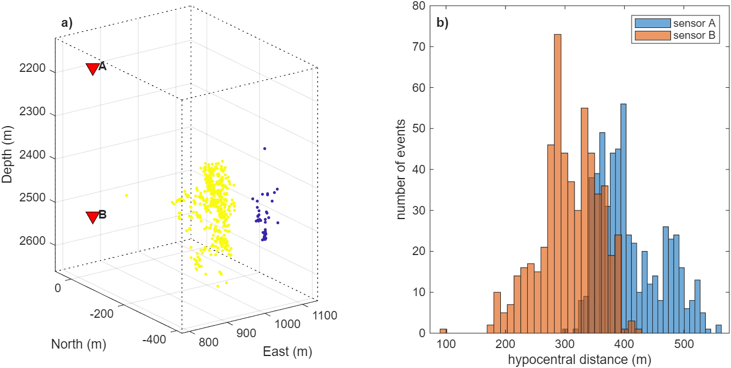
Fig. 1 Utah FORGE 2022 geometry: stimulation MEQs, 56-32 sensors and FD volume
a) 555 catalogued MEQs (colour = stimulation stage), the self-calibrated sensors A and B (red triangles) and the interior of the FD volume (dotted box). b) Distribution of hypocentral distances to sensors A and B.
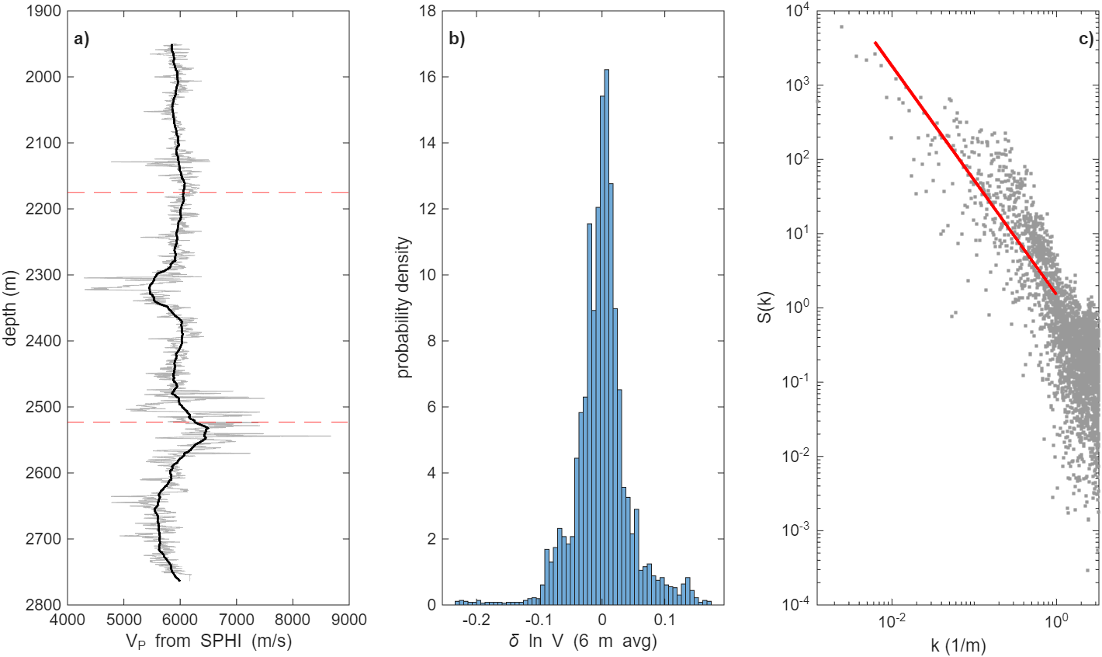
Fig. 2 Velocity fluctuation statistics of the 56-32 sonic log
a) Sonic-derived V_{P} (grey) and its 50-m block average (black); dashed lines mark the depths of sensors A and B. b) Distribution of the detrended, 6-m-averaged δln V (σ = 0.045). c) Power spectrum of δln V with the power-law fit S(k) ∝ k^{-1.54} (red).

Methods

3-D elastic finite differences
We solve the velocity–stress equations on a staggered grid [13] with fourth-order spatial and second-order temporal differences [14] for a VTI medium (stiffnesses from V_{P}, V_{S}, ρ and Thomsen ε, δ, γ). The treatment of anisotropy on the staggered grid follows Igel, Mora and Riollet [15], and the MATLAB implementation grew out of the acoustic finite-difference codes of Igel [16], which we extended to 3-D elastic VTI media, moment-tensor and point-force sources and strain-rate recording. A Cerjan sponge [17] absorbs outgoing energy. The grid is 113×137×149 nodes at 5 m (0.46 × 0.58 × 0.64 km interior plus 20-node sponges), with Δt = 0.25 ms (the data sampling), 1300 steps and a 45-Hz Ricker wavelet; the analysis band is 20–80 Hz (≥ 5 grid points per minimum S wavelength). In a homogeneous test the solver reproduces the P velocity to 0.6 %.

Reciprocity and strain Green's tensors
Instead of one run per event, three point-force runs per sensor record the strain-rate tensor at every event node. By reciprocity the velocity at sensor component n from a moment tensor M at event x_{e} is
$$v_{n}(x_{s},t)=M_{pq}\int_{0}^{t}{{\overset{˙}{ε}}_{pq}^{\left(n\right)}}(x_{e},τ)dτ$$ | (4)
[18]. A validation in a heterogeneous VTI pink-noise medium reproduces direct moment-tensor simulations with correlation 0.995 and amplitude ratio 0.995 (Fig. 3). Six runs per model thus give synthetics for all ~1100 event–sensor paths with any mechanism.
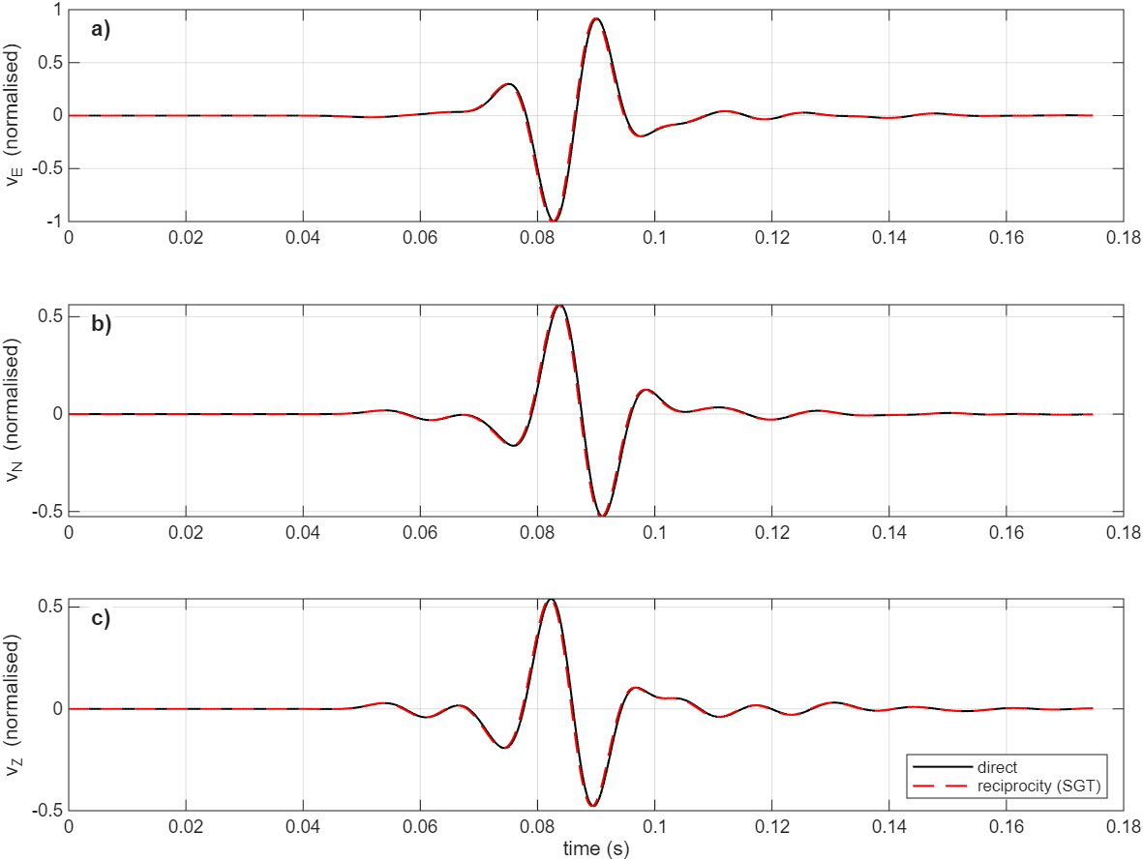
Fig. 3 Reciprocity validation in a heterogeneous VTI pink-noise medium
a–c) East, north and vertical velocity at a sensor from a direct double-couple simulation (black) and from the strain-Green's-tensor reciprocity synthetic (red dashed), in a pink-noise medium with σ = 0.045, ε = 0.05, δ = 0.02 and γ = 0.05.

Model suite
Table 1 Crustal models simulated
Model | Class | Parameters
H | homogeneous | V_{P} 5808 m/s, V_{P}/V_{S} 1.73
L | layered | 56-32 sonic, 50-m blocks
A | VTI | travel-time inverted ε, δ
P4, P1, P3, P6, P9, P12, P10 | pink, p = 1.5 | σ = 0.02, 0.045, 0.09, 0.13, 0.18, 0.22, 0.25
P5, P2 | pink, σ = 0.045 | p = 1.2, 1.8
P7, P8 | pink, σ = 0.09 | p = 1.2, 1.8
P11 | pink, σ = 0.18 | p = 1.8
T1, R1, R2 | pink σ = 0.045, p = 1.5 | independent realisations (T1 = synthetic truth)
R3; R5 | pink, p = 1.5 | independent realisations of σ = 0.09; 0.18
E15, E50 | exponential ACF | σ = 0.13, a = 15, 50 m
G15, G50 | Gaussian ACF | σ = 0.13, a = 15, 50 m
T2 | layered + VTI | synthetic truth: ε = 0.06, δ = 0.03, γ = 0.06
Fields with σ > 0.1 are truncated at ±3σ (±2.5σ for σ ≥ 0.18). For σ ≥ 0.22 the time step is halved for stability; at σ = 0.25 the slowest S waves have only 4.5 grid points per wavelength at 80 Hz.
Synthetic records use double-couple mechanisms consistent with FORGE stress (strike 0–50°, dip 55–85°, rake −90 ± 30°); a second set uses fully random mechanisms. Real 56-32 noise is added to each record at that event's observed SNR, and the data are convolved with the same Ricker wavelet, so data and synthetics share a source spectrum (FORGE MEQ corner frequencies lie well above 80 Hz).

Deterministic waveform inversion
For each of 150 events we invert the six moment-tensor elements linearly from the four horizontal traces, with 20–80 Hz filtering, a window from P − 10 ms to S + 60 ms and a per-sensor time shift of ±6 ms. For the data, the tool azimuth and handedness of each sensor are grid-searched. Fit quality is the variance reduction (VR).

Statistical waveform inversion
Because the realisation of a random medium is unknowable from two sensors, we invert the statistics of the wavefield. On the horizontal energy envelope we measure three mechanism-robust, S-normalised features: coda level log₁₀(E_{coda}/E_{S}) 30–100 ms after the S peak, coda decay rate, and rms S-pulse width. The misfit between observed and model features is
$$Φ=\overset{―}{D_{KS}}+\overset{―}{{\left\|\log_{10}{\overset{\sim }{E}}_{obs} − \log_{10}{\overset{\sim }{E}}_{mod}\right\|}_{rms}}$$ | (5)
where D_{KS} is the two-sample Kolmogorov–Smirnov distance per feature, sensor and band, and Ẽ is the median post-peak S envelope. Sensor B at 20–40 Hz is excluded because it carries a persistent non-event plateau, likely a borehole resonance. P travel-time residual statistics are reported separately, since catalogue location error dominates them in the data.

Coda prediction test
The moment tensor fitted to the direct waves (P − 10 ms to S + 60 ms) of each of the 150 events is used to predict the complete record, including the S coda 30–100 ms after the S peak. That coda lies outside the fitting window and is therefore a pure prediction of the medium. For each event and model we compare the predicted and observed coda-to-S energy ratios at 40–80 Hz.

Shape-sensitive diagnostics
Two further observables are chosen because scale-free and correlation-length media should differ in them. D1 is the frequency dependence of the coda: per event, the coda level at 40–80 Hz minus that at 20–40 Hz (sensor A). D2 is the inter-event coherence of the coda: for pairs of events recorded on the same sensor, the maximum normalised two-component cross-correlation (lag ±8 ms) of the 40–80 Hz window S + 15 … S + 100 ms, summarised as the median in bins of inter-event separation (0–5 to 80–160 m). To test whether these observables and Φ can resolve spectral shape, nine further synthetic truths were simulated at equal σ = 0.13: pink, exponential with a = 15 m and Gaussian with a = 50 m, each with seeds 33, 44 and 55. Candidates are two realisations per family (seeds 11 and 33). A candidate that shares the truth's seed is excluded, in which case only seed 11 is used for every family. The family score is the mean Φ over its candidate realisations, and the truth is assigned to the family with the lowest score.

Multi-octave coda analysis of the raw records
The raw 4-kHz records (no source-wavelet convolution) are analysed in octave bands centred at 25, 50, 100, 200, 400 and 800 Hz, plus 1000–1700 Hz. For each event, sensor and band we measure four quantities on the horizontal-energy envelope. The first is the coda level, defined as the energy 30–100 ms after the S peak divided by the S-peak energy. The second is the energy decay rate, taken from 20 to 120 ms after the S peak. The third is the single-scattering coda attenuation Q_{c}⁻¹ [7], from the slope of ln(E t²) against lapse time t, where E t² ∝ exp(−2πft/Q_{c}). The fourth is the rms width of the S pulse. A band is used only when the coda energy exceeds five times the pre-event noise energy in that band. All four measures are energy ratios within one band, so a linear instrument or coupling response cancels. The frequency dependence is tested by comparing a single power law in f with a continuous two-segment law, using BIC. A medium with a correlation length a should show a change of behaviour near ka ≈ 1 (about 36 Hz for a = 15 m and 11 Hz for a = 50 m at V_{S} ≈ 3.4 km/s), whereas a scale-free medium should not. The same measures are computed on the FD synthetics in the 25 and 50 Hz bands, which the 5-m grid resolves (sensors A and B).

High-frequency simulations and correlation-length series
To reach 100 Hz the FD grid is refined to 2.5 m (169×209×153 nodes, Δt = 0.125 ms, 2200 steps, Ricker 90 Hz; at least 5.7 grid points per minimum S wavelength at 160 Hz). To keep the cost manageable the volume is reduced to sensor B and the core of the event cloud, which retains 542 events at 92–392 m. The records are decimated to the 4-kHz data sampling. This grid is run for the homogeneous crust, pink σ = 0.13 (two realisations), exponential a = 15 m (two), Gaussian a = 50 m (two) and an exponential correlation-length series with a = 5, 9, 17, 34, 67 and 134 m (σ = 0.13). The series a = 9–134 m is also run on the 5-m grid. Together the two grids give Q_{c}⁻¹ and coda level at 25 and 50 Hz (sensor A, 5-m grid) and at 50 and 100 Hz (sensor B, 2.5-m grid). The curvature, slope(50–100 Hz) − slope(25–50 Hz), measures a change of slope of the kind expected near ka ≈ 1. Synthetic records on the 2.5-m grid are noise-free.

Results

Travel times
P onsets fit a homogeneous crust with MAD 0.57 ms. A vertical gradient (ΔAIC = -11.7, ΔBIC = -6.8) and VTI (ΔAIC = -10.9, ΔBIC = -1.1) barely improve the fit. However, the residuals are spatially correlated between neighbouring events (ρ = 0.36/0.10 at < 10 m and 0.21/0.06 at 10–20 m for sensors A/B, falling to zero beyond 40 m; Fig. 4). Such correlation is not predicted by any smooth model; it could arise from structure or from correlated location error.
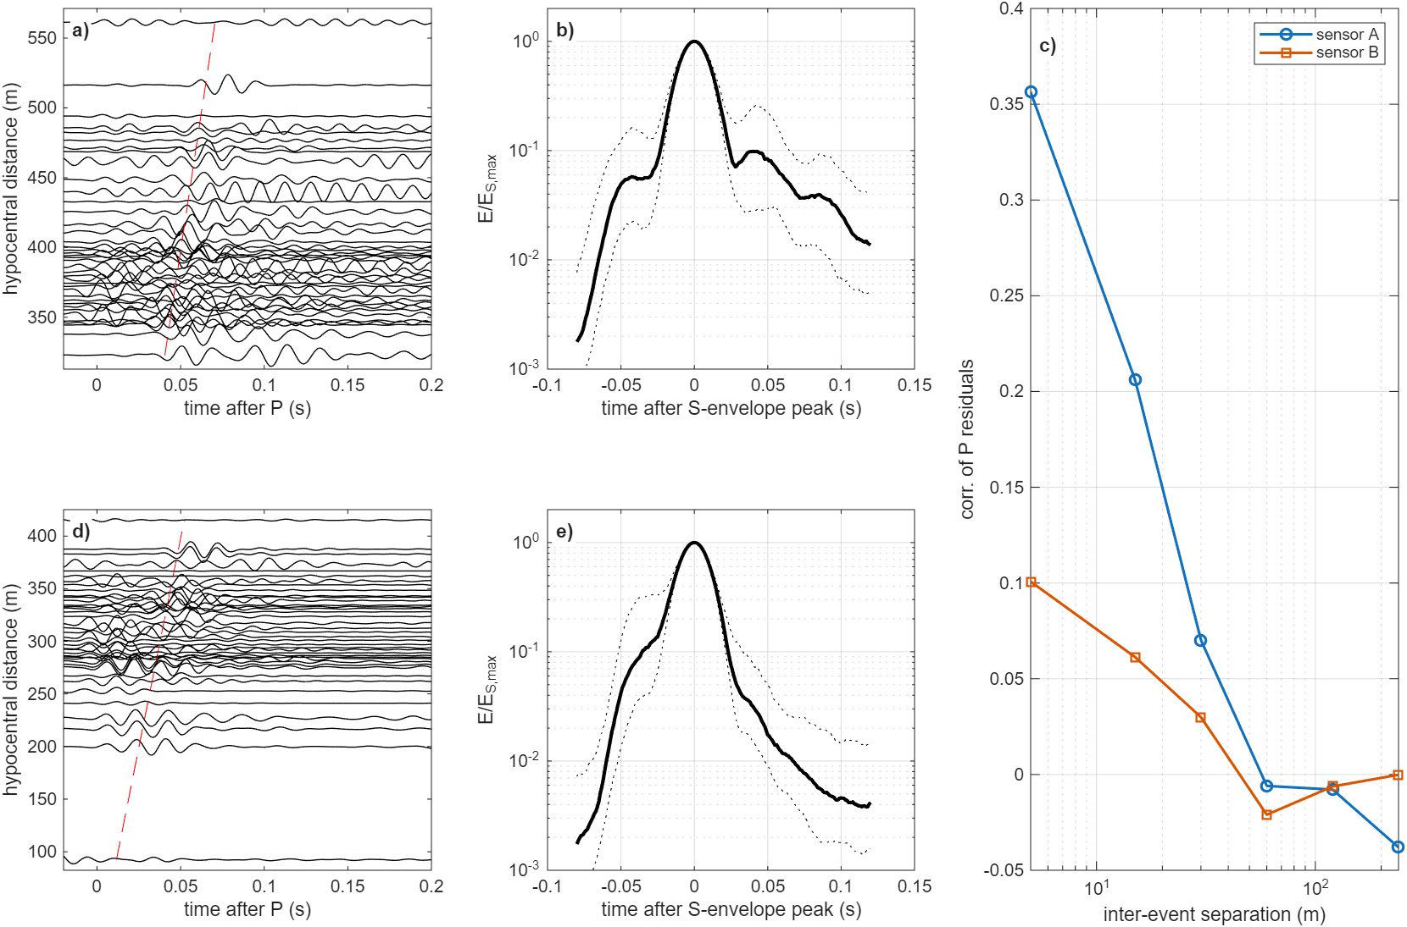
Fig. 4 FORGE 56-32 records, S envelopes and travel-time residual correlation
a, d) Horizontal records (H1, 40–80 Hz) of 40 events ordered by hypocentral distance for sensors A and B; the dashed line is the predicted S time. b, e) Median (solid) and interquartile range (dotted) of the horizontal S envelope, 40–80 Hz, for sensors A and B. c) Correlation of P travel-time residuals (high-frequency picks, homogeneous model) versus inter-event separation.

Synthetic truth tests
With a pink-noise truth (T1), the deterministic inversion prefers the smooth models: VR 0.93 (H) and 0.91 (L), against 0.88 for P1, which has the correct statistics but a different realisation. VR falls monotonically with σ (0.71 for σ = 0.09, 0.54 for 0.13), because a wrong realisation places scattered energy at wrong times. The statistical inversion instead ranks a pink model with the true σ first (best R1, an independent realisation of the truth statistics, Φ = 0.09). Pink models with σ = 0.02–0.045 and p ≤ 1.5 follow (Φ ≤ 0.24), ahead of H, L and A (0.289–0.292). All models with σ ≥ 0.09 are rejected (Φ ≥ 0.51). Realisation scatter at the true parameters (Φ = 0.09–0.24) limits the σ resolution to about a factor of two. With a layered-VTI truth (T2), L and A are ranked first (Φ = 0.13, 0.16) and every pink model is rejected (Φ ≥ 0.27). The method therefore resolves the medium class and σ, is not biased toward pink noise, and resolves the spectral exponent p only weakly (the correct-σ model with p = 1.8 ties with the smooth models, Φ = 0.29). The correlation-length media were simulated only at σ = 0.13 and are rejected for both truths (Φ ≥ 1.06 for T1, ≥ 1.07 for T2) because of their σ. Resolution of spectral shape at equal σ is tested separately below.
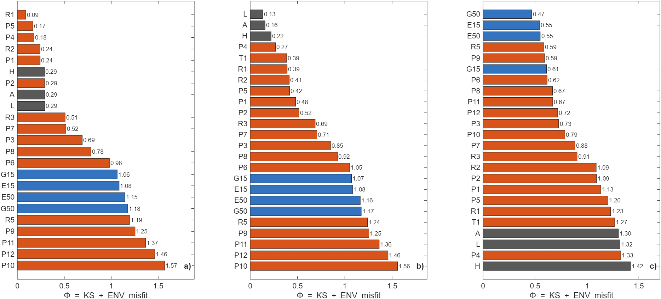
Fig. 5 Model ranking by statistical waveform misfit for synthetic truths and FORGE
a) Synthetic truth T1 (pink, σ = 0.045, p = 1.5). b) Synthetic truth T2 (layered + VTI). c) Utah FORGE 2022 data (56-32 sensors). Grey: smooth crusts (H, L, A); orange: pink-noise crusts; blue: exponential and Gaussian random media (σ = 0.13). Lower Φ is better.

Utah FORGE
On the FORGE data the deterministic inversion again prefers the smooth crust (VR 0.52 for H to 0.38 for P6), yet it leaves coda energy equal to 49 % of the S-window energy unexplained. The same smooth model leaves only 3–3 % unexplained when fitted to the synthetic truths. The statistical inversion ranks every pink crust with σ ≥ 0.045 ahead of every conventional crust (Figs. 5 and 7). Φ decreases from 1.42 (H), 1.32 (L) and 1.30 (A) through 1.09–1.27 (σ = 0.045, 4 realisations) and 0.73–0.91 (σ = 0.09) to 0.62 (σ = 0.13) and 0.59–0.59 (σ = 0.18, two realisations). It then rises to 0.72 (σ = 0.22) and 0.79 (σ = 0.25), which brackets the optimum near σ ≈ 0.18. At σ = 0.18 the exponent p = 1.8 fits worse than 1.5 (0.67). Realisation spread is up to 0.18 at σ ≤ 0.09 but only 0.006 at σ = 0.18. At σ = 0.045 the worst realisation comes within 0.04 of the best smooth crust, so the evidence is decisive only for σ ≥ 0.09. With random mechanisms the smooth crusts again rank last (Φ ≥ 1.35).
The physics is visible in the envelopes (Fig. 6). Smooth models predict an S pulse followed by a coda two orders of magnitude below the peak within 50 ms. The data retain 10⁻²–10⁻¹ of the peak energy for ≥ 100 ms. At 40–80 Hz the median coda level is -1.19 (A) and -1.78 (B), against -2.60 and -2.65 for H. The S pulse is also broader in the data (17.4 ms versus 10.7 ms for H at sensor A). Scattering media with σ ≈ 0.09–0.18 reproduce both. Residual differences are a slower coda decay in the data and excess coda at 20–40 Hz; these point to a spectral exponent or intrinsic attenuation not captured by the grid.
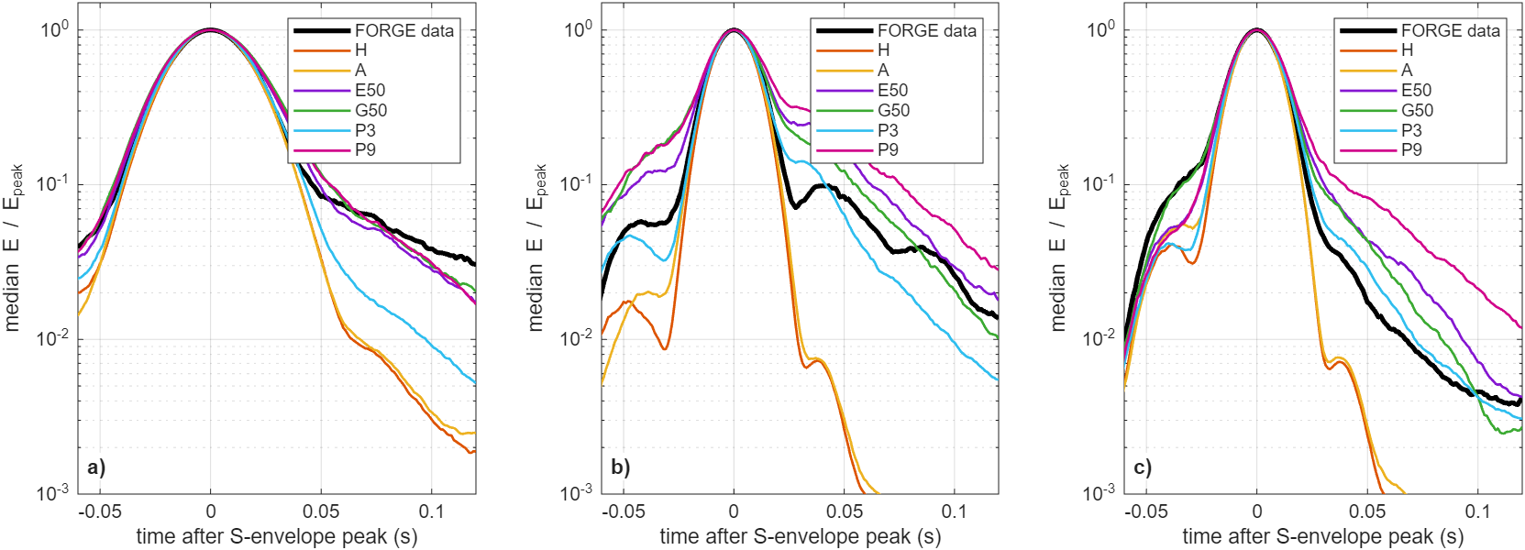
Fig. 6 Median S-coda envelopes: FORGE data versus crustal model classes
Envelopes of horizontal energy aligned on the S peak and normalised by it. a) Sensor A, 20–40 Hz. b) Sensor A, 40–80 Hz. c) Sensor B, 40–80 Hz. Black: FORGE data; H homogeneous, A VTI, E50/G50 exponential/Gaussian (a = 50 m, σ = 0.13), P3/P9 pink (σ = 0.09/0.18).
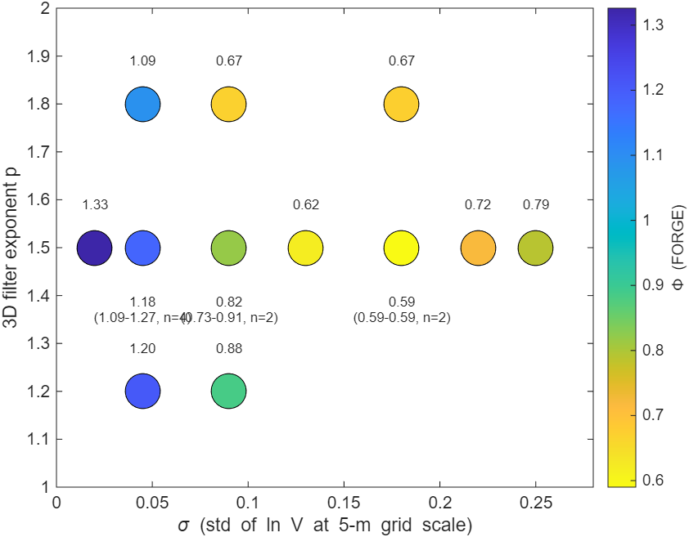
Fig. 7 Statistical waveform misfit over pink-noise parameters (σ, p)
Colour and labels: Φ for FORGE data at each (σ, p), with mean and range where several realisations exist. For comparison, the best smooth crust is A (Φ = 1.30) and the best correlation-length medium is G50 (Φ = 0.47).

Observed versus predicted seismograms
Fig. 8 shows sensor-A records of four events at 359–419 m with the predictions of five crusts; the moment tensor was fitted to the direct waves only. In the grey coda window, homogeneous and VTI predictions are flat, whereas the observed traces keep oscillating at 10–60 % of the S peak. Pink and correlation-length crusts produce coda of comparable amplitude, though not the same wiggles, since the realisation is unknown. On the direct waves the smooth models often reach higher VR (median 0.60 for H against 0.49 for P6), as in the truth tests. Fig. 9 shows the same events as envelopes for both sensors. Smooth-model coda falls to 10⁻³–10⁻⁴ of the S peak within 50–80 ms, whereas the observed and scattering-model coda stays at 10⁻²–10⁻¹.
Table 2 Predicted versus observed S-coda ratio for 150 FORGE events
Model | Median log₁₀(pred/obs), A | Median, B | % within ×3, A | % within ×3, B
H (homogeneous) | -1.48 | -1.10 | 7 | 11
L (layered) | -1.35 | -1.11 | 7 | 7
A (VTI) | -1.47 | -1.18 | 1 | 9
E15 (exponential, a = 15 m) | +0.32 | +0.44 | 57 | 54
E50 (exponential, a = 50 m) | +0.20 | +0.31 | 61 | 63
G15 (Gaussian, a = 15 m) | +0.41 | +0.46 | 57 | 51
G50 (Gaussian, a = 50 m) | +0.19 | +0.10 | 72 | 64
P3 (pink, σ = 0.09) | -0.06 | +0.04 | 63 | 57
P6 (pink, σ = 0.13) | +0.26 | +0.29 | 57 | 61
P9 (pink, σ = 0.18) | +0.46 | +0.57 | 51 | 41
Coda ratio = mean energy 30–100 ms after the S peak divided by S-peak energy, 40–80 Hz horizontals. Moment tensors were fitted to P − 10 ms … S + 60 ms, so the coda is a prediction.
Across all 150 events (Table 2, Fig. 10) the smooth crusts under-predict the coda by a factor of 22–30 at sensor A and 12–15 at sensor B, and only 1–11 % of events fall within a factor of three. The VTI crust is indistinguishable from the homogeneous one. The pink crust with σ = 0.09 is unbiased (median -0.06/+0.04), while σ = 0.13–0.18 over-predicts by a factor of 2–4. This per-event test places the effective σ near 0.09–0.13, slightly below the statistical optimum. The correlation-length media perform comparably; the Gaussian medium with a = 50 m has the most events within a factor of three (72/64 %).
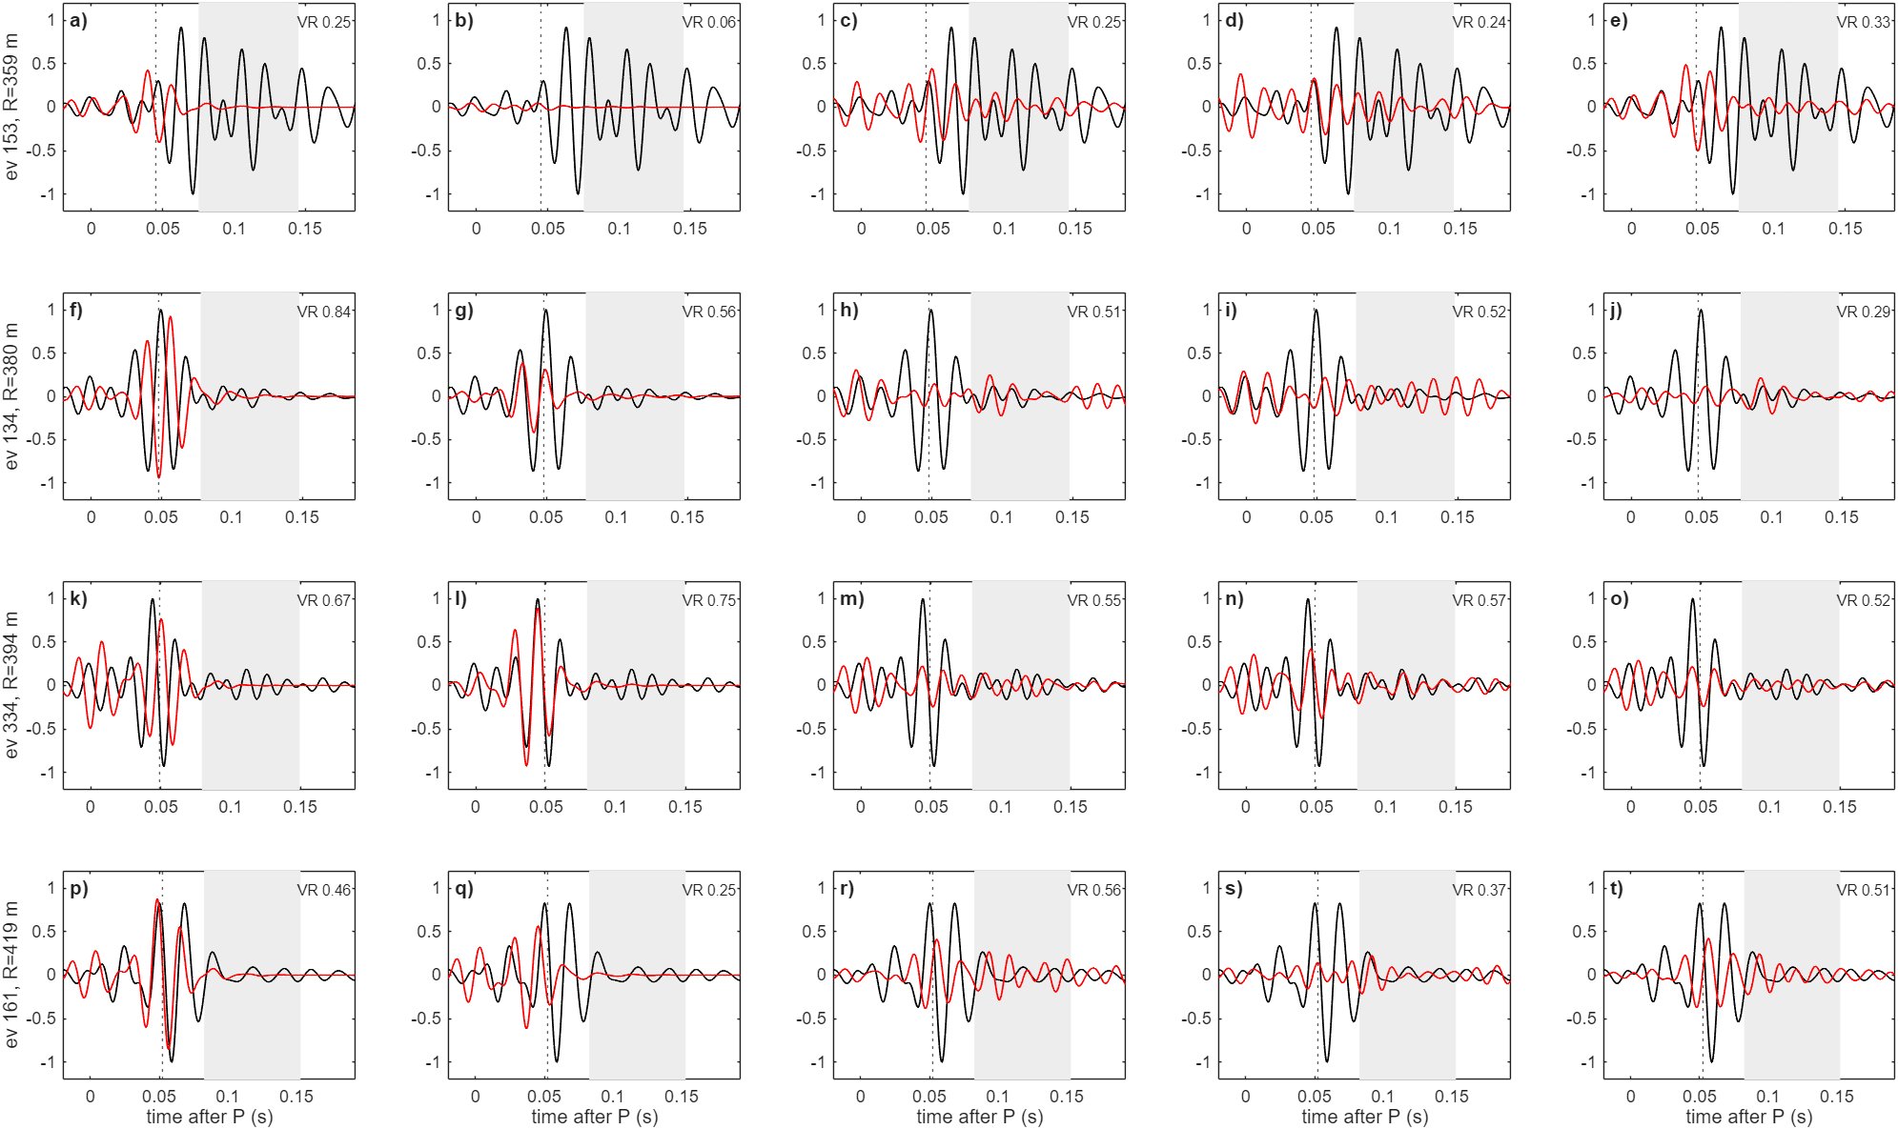
Fig. 8 Observed FORGE seismograms versus predictions of five crustal models
Sensor A, horizontal H1, 40–80 Hz. Rows: four events at increasing distance (event number and hypocentral distance on the left). Columns: a, f, k, p) homogeneous; b, g, l, q) VTI; c, h, m, r) exponential, a = 15 m; d, i, n, s) Gaussian, a = 15 m; e, j, o, t) pink, σ = 0.13. Black: observed; red: predicted with the moment tensor fitted to P − 10 ms … S + 60 ms; grey: coda prediction window; dotted: S. The VR of the fit is given in each panel.
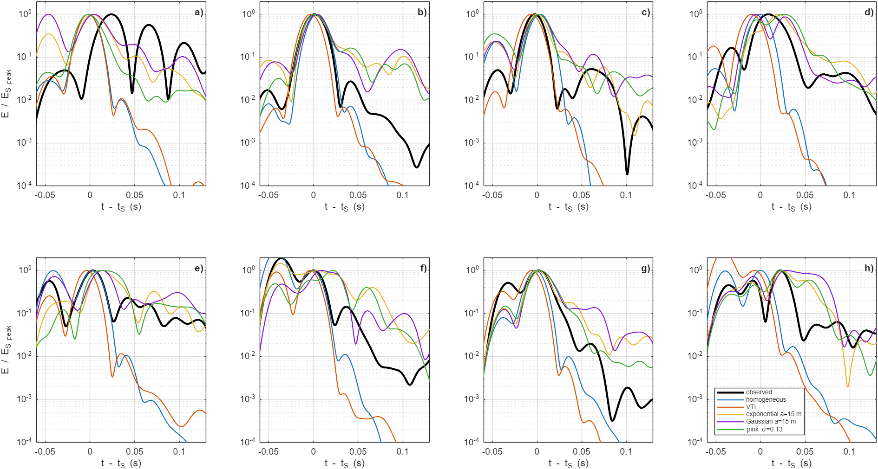
Fig. 9 Observed and predicted S envelopes for the events of Fig. 8
Horizontal-energy envelopes normalised by the S peak for the four events of Fig. 8: a–d) sensor A, e–h) sensor B, events in the same order as the rows of Fig. 8. Black: observed; colours: model predictions (legend).
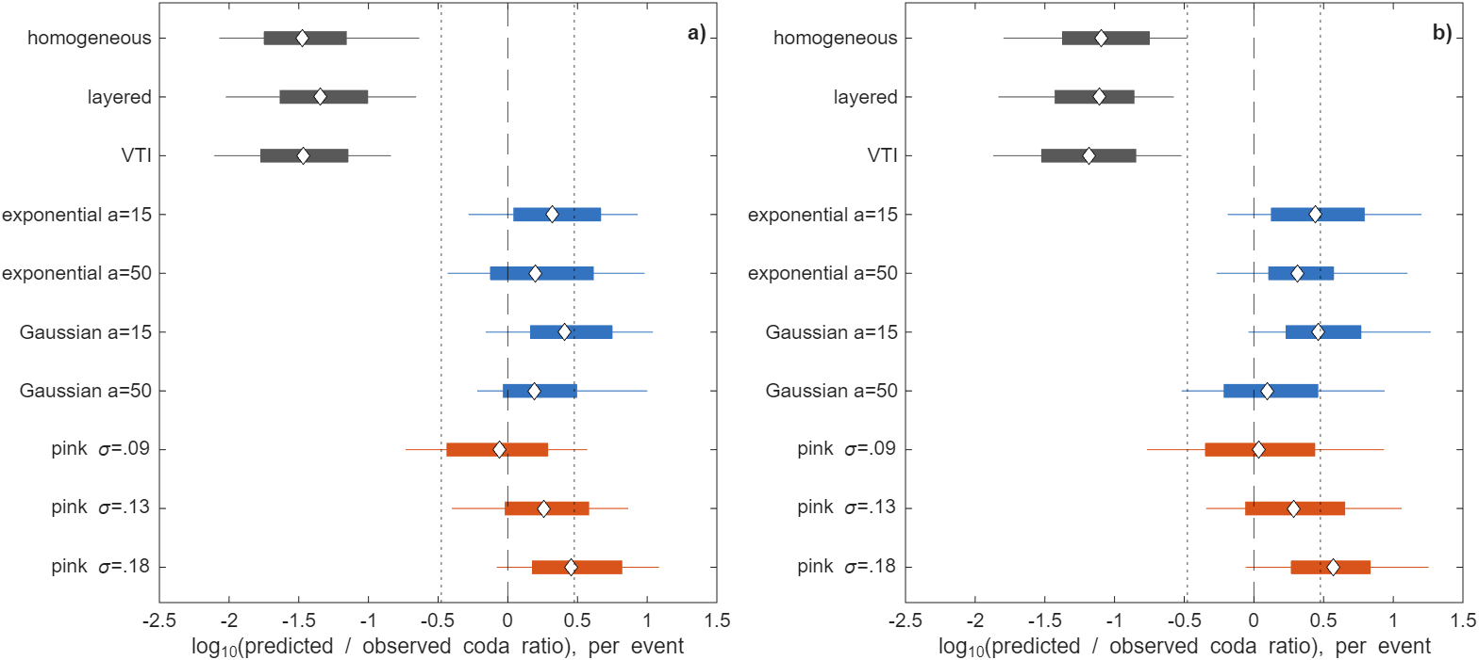
Fig. 10 Per-event predicted/observed S-coda ratio for 150 FORGE events
a) Sensor A. b) Sensor B. 40–80 Hz, 150 events. Boxes: interquartile range; whiskers: 10–90 %; diamonds: median; dotted lines: factor of three. Grey: smooth crusts; blue: correlation-length media (σ = 0.13); orange: pink crusts.

Inter-event coda coherence and frequency dependence
Fig. 11 shows D1 and D2 for FORGE and the models. Neighbouring FORGE events have coda coherence 0.69 (sensor A) and 0.75 (B) at 0–5 m separation, falling to 0.49 and 0.48 at 80–160 m. In the homogeneous and VTI crusts the coda is a deterministic tail of the direct S wave and stays coherent (0.86→0.84 for H, 0.88→0.79 for VTI at sensor A). Every scattering medium reproduces the observed decorrelation (0.70→0.41 for pink σ = 0.18, 0.74→0.45 for Gaussian a = 50 m). This independent observable rejects smooth crust for the same reason as the coda level. The observed D1 (median -0.21) is likewise far from the smooth crusts (-1.20) and just below the range of the scattering media (-0.10 to +0.25). D1 is, however, also sensitive to intrinsic attenuation, which the FD model omits.
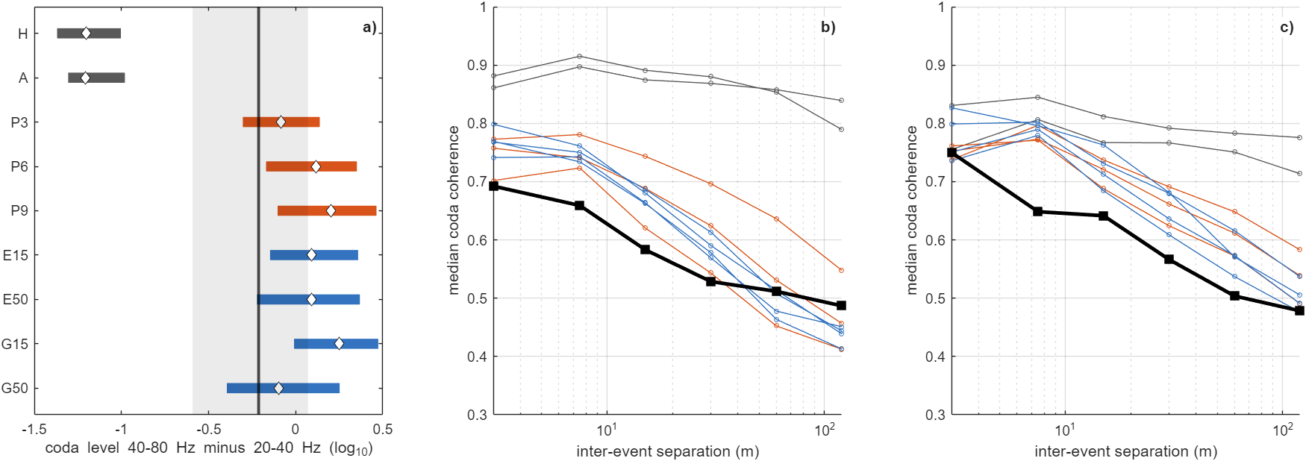
Fig. 11 Frequency dependence and inter-event coherence of the S coda
a) D1, coda level at 40–80 Hz minus that at 20–40 Hz (sensor A); bars are interquartile ranges, the black line and grey band the FORGE median and interquartile range. b, c) D2, median coda coherence versus inter-event separation for sensors A and B. Black: FORGE; grey: smooth crusts; blue: correlation-length media; orange: pink crusts.

Can spectral shape be resolved? Equal-σ truth test
Table 3 Equal-σ shape-resolution test: family scores for nine synthetic truths and FORGE
Truth | Pink | Exponential (a = 15 m) | Gaussian (a = 50 m) | Selected
pink (R6) | 0.25 | 0.34 | 0.46 | pink ✓
pink (R6c) | 0.27 | 0.21 | 0.35 | exponential ✗
pink (R6d) | 0.30 | 0.40 | 0.53 | pink ✓
exponential (E15b) | 0.21 | 0.24 | 0.34 | pink ✗
exponential (E15c) | 0.35 | 0.24 | 0.34 | exponential ✓
exponential (E15d) | 0.21 | 0.26 | 0.41 | pink ✗
Gaussian (G50b) | 0.39 | 0.43 | 0.36 | Gaussian ✓
Gaussian (G50c) | 0.45 | 0.36 | 0.30 | Gaussian ✓
Gaussian (G50d) | 0.41 | 0.43 | 0.53 | pink ✗
FORGE data | 0.61 | 0.54 | 0.51 | —
Family score = mean Φ over candidate realisations with a seed different from the truth; σ = 0.13 throughout. FORGE row: mean over seeds 11 and 33 (pink 0.62/0.60, exponential 0.55/0.54, Gaussian 0.47/0.56).
Table 3 lists the nine truth tests. The correct family is selected in 5 of 9 cases, against 3 expected by chance. The errors are structured. Pink and exponential truths are confused with each other: 3 of 6 are assigned to the right member of the pair, which is chance level. However, none of the six is assigned to the Gaussian family, and small-scale-rich and Gaussian media are separated in 8 of 9 cases overall. The pink–exponential confusion has a simple cause. Built from the same white noise, the pink field and the exponential field with a = 15 m are 96 % correlated over the simulated scales (10–700 m), whereas the Gaussian field with a = 50 m is 60 % correlated with it. Over this range the two are almost the same medium, and they would separate only at scales outside the FD band. The D1 and D2 diagnostics add no shape information: the combined D1–D2 score selected the Gaussian candidate for every truth in the single-realisation test.
The second realisation changes the reading of the FORGE comparison. With seed 11 the Gaussian medium fits best (Φ = 0.47), but with seed 33 it scores 0.56, behind the exponential medium. The family means (0.61, 0.54 and 0.51 for pink, exponential and Gaussian) differ by 0.09. This is less than the median spread between family scores in the truth tests (0.14) and comparable to the realisation scatter of a single family (0.09 for the Gaussian medium). The seismic data therefore do not prefer any of the three spectral families.

Competing random media and the well log
At equal σ = 0.13, the correlation-length media fit the FORGE coda statistics as well as or better than the pink crust: Φ = 0.55 and 0.55 (exponential), 0.61 and 0.47 (Gaussian, a = 15 and 50 m), against 0.62 for P6 and 0.59 for the best pink crust. The same holds with random mechanisms. In the 20–80 Hz band and at 100–600 m range, the coda therefore constrains the strength of heterogeneity but not its spectral shape.
The shape is constrained by the sonic log (Fig. 12). Over 12–200 m the 56-32 log spectrum is a straight power law with no corner. Vertical lines through the pink field reproduce it best (rms difference 0.29 in log₁₀ power for p = 1.5; 0.44 for p = 1.8). The exponential media do so less well (0.50 and 0.56), because their spectra steepen toward k⁻² above the corner. The Gaussian media, with their exponential cut-off, are incompatible with the log (2.5 and 19). The log therefore excludes the one family that the wavefield can separate from pink noise, and leaves pink and exponential media, which the wavefield cannot separate, with a modest preference for pink.
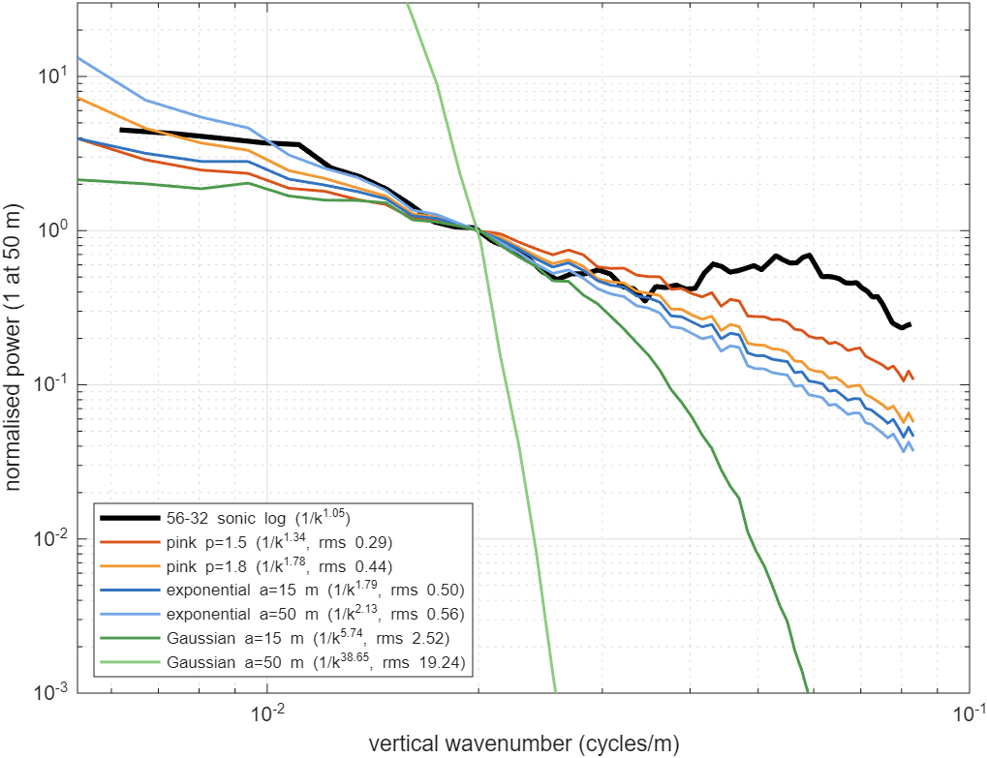
Fig. 12 Vertical fluctuation spectra of the 56-32 sonic log and of the model media
Spectra of detrended ln V along vertical lines, normalised at 50-m wavelength, over the common 12–200 m band, for the 56-32 sonic log (black) and the model media. The legend gives the fitted slope and the rms log₁₀ difference from the log.

Bandwidth of the FORGE records
The FD analysis above is confined to 20–80 Hz, but the 56-32 records extend much higher. Fig. 13 shows four events of magnitude −0.6 to +0.2 at 300–370 m from sensor B. Their spectrograms carry S and coda energy up to about 1.5 kHz, and the S-window spectra stand one to three orders of magnitude above pre-event noise from about 20 Hz to the anti-alias limit. Over all events (Fig. 14), the median amplitude SNR rises from about 4 at 5 Hz to several hundred at 300–1000 Hz, and every event exceeds SNR 3 up to about 1.8 kHz (550 events at sensor A, 533 at B). A recorder sampling at 200 samples/s (Nyquist 100 Hz) would capture only the low-frequency tail of these S waves. Nearly all of the S-wave velocity energy lies above 100 Hz (median 99.8 % at A, 99.9 % at B). This percentage is inflated, however, by sharp spectral peaks near 330, 480 and 920 Hz, which occur in nearly every event. Peak frequencies cluster at these fixed values, so the peaks are most likely resonances of the tool or its coupling rather than source or path properties.
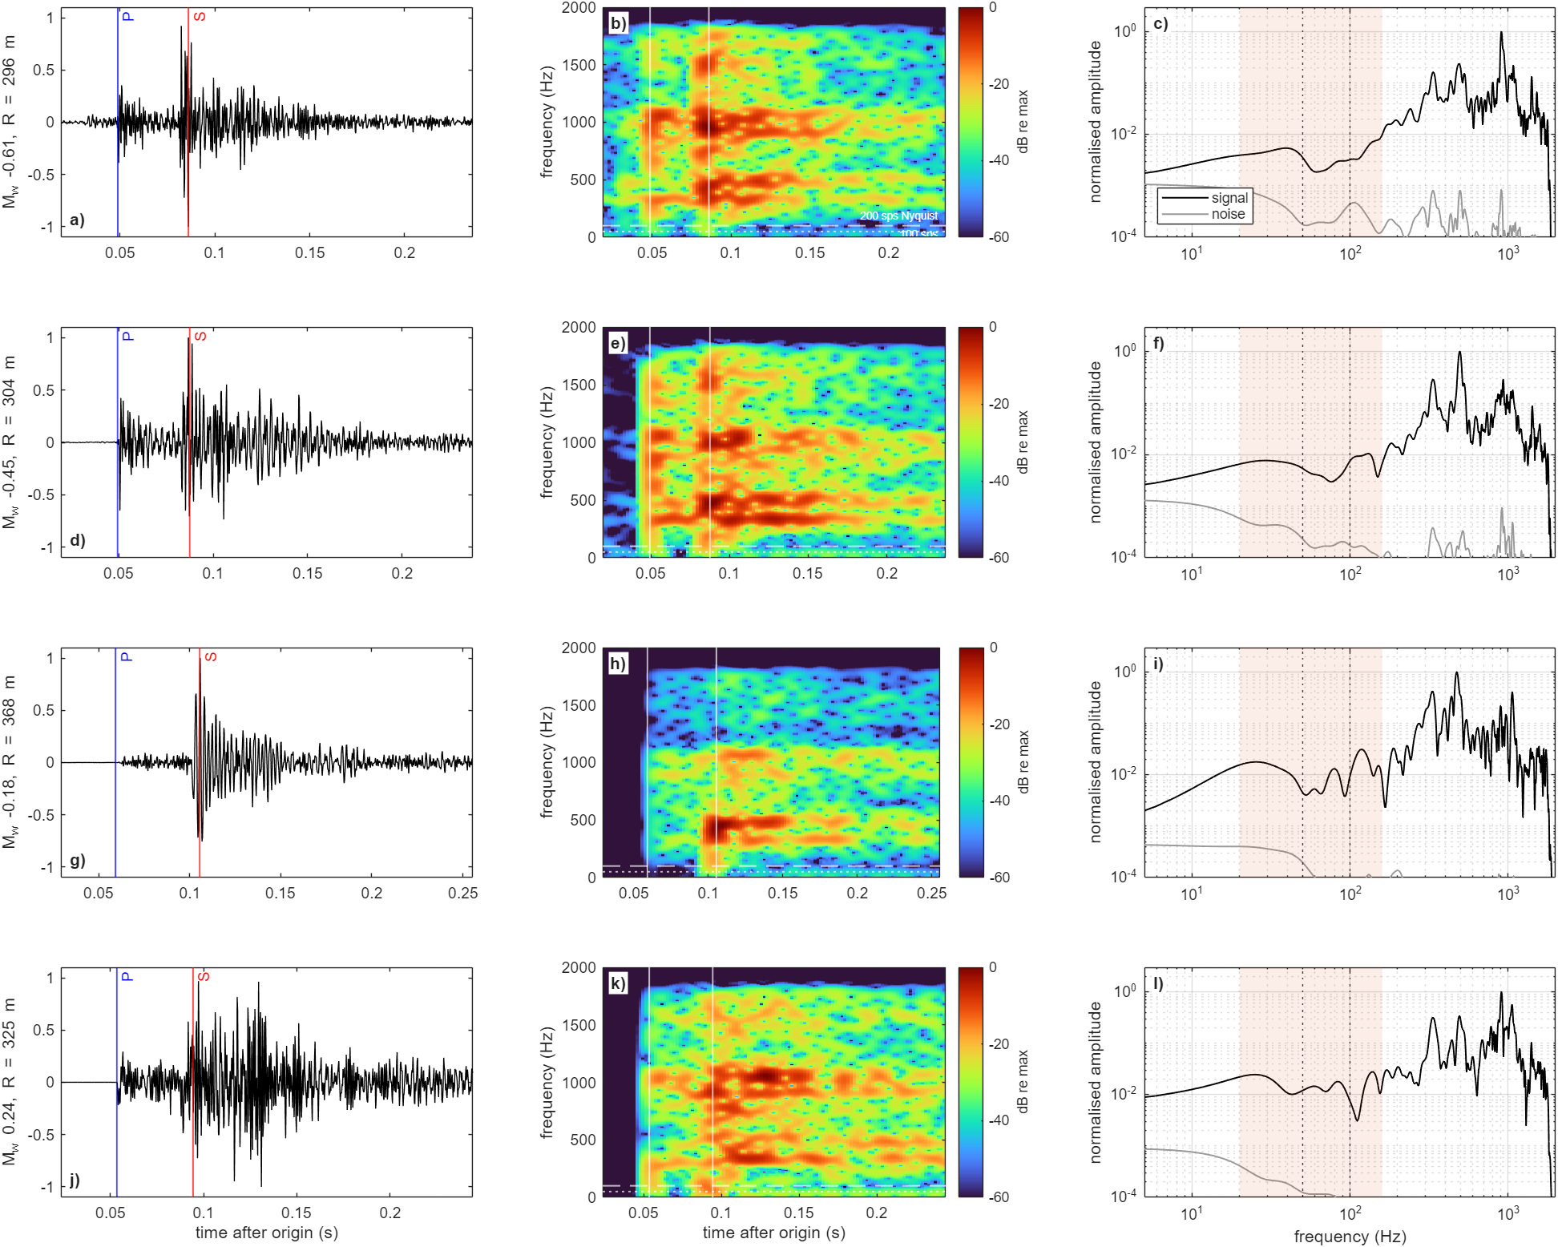
Fig. 13 Example FORGE 2022 microearthquakes recorded at 4 kHz in well 56-32
Four events (rows; magnitude −0.61 to +0.24) at sensor B, 4 kHz. a, d, g, j) Horizontal velocity (> 5 Hz) with P (blue) and S (red) marked. b, e, h, k) Spectrograms to 2 kHz on a common dB scale relative to each event's maximum; white dotted and dashed lines mark the Nyquist frequencies of 100 and 200 sample/s recording, and vertical lines the P and S times. c, f, i, l) S-window spectrum (black) and pre-event noise (grey); shaded, the FD analysis band 20–160 Hz.
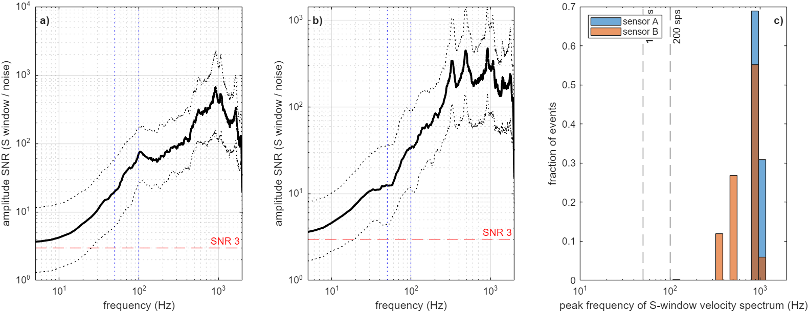
Fig. 14 Signal-to-noise ratio and spectral peak frequency of all FORGE records
a, b) Median (solid) and interquartile range (dotted) of the S-window amplitude SNR spectrum for sensors A and B; vertical lines at 50 and 100 Hz, horizontal line at SNR = 3. c) Peak frequency of the S-window velocity spectrum for all events. The clustering at about 330, 480 and 920 Hz indicates instrument or coupling resonances. Median share of S-wave velocity energy above 100 Hz: 99.8 % (A) and 99.9 % (B).

Frequency dependence of the coda over two decades
Fig. 15 and Table 4 give the coda measures in seven octave bands. Q_{c}⁻¹ falls steadily from 0.16 at 25 Hz to 0.0016 at 1.3 kHz (sensor A), so the energy decay rate varies little with frequency (19–36 s⁻¹ over all bands). The coda level and the S-pulse width decrease up to 200 Hz and rise again above it. The rise coincides with the suspected resonance bands. A high-Q resonance does not change within-band energy ratios in the linear limit, but its ringing lengthens the S pulse and raises the coda. We therefore interpret only the resonance-free band, 25–200 Hz (S wavelengths of about 17–134 m; 50–200 Hz at sensor B, whose 25-Hz band carries the borehole plateau).
Table 4 Frequency dependence of FORGE coda measures in the resonance-free band
Sensor | Measure | Band (Hz) | Power-law slope [95 %] | ΔBIC (break − single) | Break (Hz)
A | Q_{c}⁻¹ | 25-200 | -1.48 [-1.54, -1.41] | +9 | —
A | coda level | 25-200 | -0.88 [-0.92, -0.83] | -65 | 50
A | S-pulse width | 25-200 | -0.34 [-0.35, -0.33] | -94 | 50
B | Q_{c}⁻¹ | 50-200 | -1.39 [-1.45, -1.31] | +14 | —
B | coda level | 50-200 | -0.57 [-0.65, -0.48] | -44 | 100
B | S-pulse width | 50-200 | -0.33 [-0.34, -0.31] | -5 | 100
Slopes are d log₁₀(measure)/d log₁₀ f (for the coda level, d log₁₀(E_{coda}/E_{S})/d log₁₀ f). Confidence intervals are from 500 bootstrap resamples of events. Negative ΔBIC favours a break at the listed frequency.
In this band Q_{c}⁻¹ follows a single power law on both sensors, f^{-1.48} [-1.54, -1.41] at A and f^{-1.39} [-1.45, -1.31] at B. A break is disfavoured (ΔBIC = +9 and +14), so Q_{c}⁻¹ shows no characteristic frequency over S wavelengths of about 17–134 m. For a medium with a correlation length a, a change of behaviour would be expected near ka ≈ 1. For 25–200 Hz this corresponds to a ≈ 3–21 m, not to the wavelengths themselves. Whether this test can detect a correlation length is examined with simulations below (Table 5); it turns out that it cannot. The coda level, by contrast, flattens above 50–100 Hz (ΔBIC = -65 and -44). This may reflect the growing influence of the resonances toward 200 Hz, and we do not use it for inference.
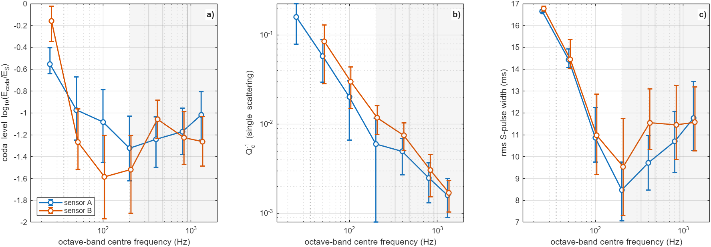
Fig. 15 FORGE S-coda measures in seven octave bands from 25 Hz to 1.3 kHz
Median and interquartile range for sensors A and B of a) the coda level, b) the single-scattering Q_{c}⁻¹ and c) the rms S-pulse width. The dotted line marks ka = 1 for a = 15 m. Thin grey lines mark the suspected resonance frequencies, and the shaded band (> 200 Hz) is affected by them.
The FD synthetics resolve the 25 and 50 Hz bands, which gives a direct test of the Q_{c}⁻¹ slope between them (Fig. 16). The FORGE slope at sensor A is -1.46 (95 % bootstrap interval -1.58 to -1.26). Smooth crusts give -0.87 to -0.83 and are excluded. Six pink realisations give -1.68 to -1.29 (median -1.40), and four exponential (a = 15 m) realisations give -1.81 to -1.35 (median -1.47); both bracket the data. The Gaussian medium with a = 50 m gives -1.43 to -0.59 (median -0.89), and only 1 of 4 realisations fall inside the data interval. The Gaussian medium with a = 15 m is also steep (-1.77). The slope is therefore sensitive to heterogeneity at scales of about 15 m and below rather than to spectral form as such. It favours media that contain such small-scale structure, which is the property the log also shows. In the 25-Hz band the coda window spans only one to three periods, and even the homogeneous crust gives a non-zero Q_{c}⁻¹. Data and synthetics are measured identically, so the comparison is fair, but the absolute Q_{c}⁻¹ values at 25 Hz should not be read as medium properties.
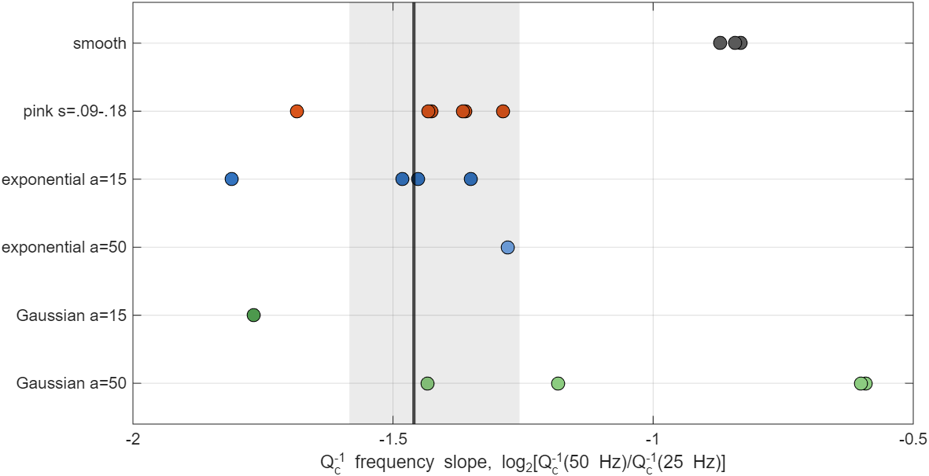
Fig. 16 Q_{c}⁻¹ frequency slope between 25 and 50 Hz: FORGE versus simulated realisations
Q_{c}⁻¹ frequency slope log₂[Q_{c}⁻¹(50 Hz)/Q_{c}⁻¹(25 Hz)] at sensor A. Each dot is one simulated medium (σ = 0.13 unless stated; pink σ = 0.09–0.18). Black line and grey band: FORGE with its 95 % bootstrap interval.

Coda at 100 Hz and the correlation-length series
Table 5 Q_{c}⁻¹ slopes, their curvature and the 100-Hz coda level
Medium (σ = 0.13) | Slope 25–50 Hz (A) | Slope 50–100 Hz (B) | Curvature | Coda level 100 Hz (B)
homogeneous | -0.83 | -0.34 | +0.49 | -3.17
pink (seed 11) | -1.43 | -1.18 | +0.24 | -1.20
pink (seed 33) | -1.37 | -1.20 | +0.16 | -1.50
exponential, a = 15 m | -1.48 | -1.04 | +0.44 | -1.09
exponential, a = 15 m (seed 33) | -1.45 | -1.17 | +0.28 | -1.52
Gaussian, a = 50 m | -1.18 | -0.86 | +0.32 | -2.20
Gaussian, a = 50 m (seed 33) | -0.59 | -0.67 | -0.08 | -3.01
exponential, a = 5 m | — | -1.46 | — | -1.11
exponential, a = 9 m | -1.61 | -1.26 | +0.35 | -1.03
exponential, a = 17 m | -1.41 | -1.02 | +0.40 | -1.10
exponential, a = 34 m | -1.22 | -1.00 | +0.22 | -1.22
exponential, a = 67 m | -1.40 | -1.01 | +0.39 | -1.52
exponential, a = 134 m | -1.30 | -0.99 | +0.31 | -1.82
FORGE data | -1.46 [-1.59, -1.27] | -1.50 [-1.70, -1.18] | -0.04 [-0.31, +0.29] | -1.58
Slopes are log₂ ratios of median Q_{c}⁻¹ between octave bands; curvature = slope(50–100) − slope(25–50). Brackets: 95 % bootstrap intervals over events. Coda level = log₁₀(E_{coda}/E_{S}) at 100 Hz. The 25–50 Hz slope uses the 5-m grid, the 50–100 Hz slope and 100-Hz level the 2.5-m grid; a = 5 m is not resolved on the 5-m grid.
Table 5 and Fig. 17 give the results of the correlation-length series. The Q_{c}⁻¹ curvature does not identify a correlation length. The simulated media, including the pink, Gaussian and homogeneous crusts, give curvatures of -0.08 to +0.49, positive in all but one, with no systematic dependence on a, while FORGE gives -0.04 [-0.31, +0.29]. The single power law of the observed Q_{c}⁻¹ is therefore not evidence for scale-free heterogeneity. The common positive curvature of the models probably reflects the short coda window in the 25-Hz band rather than the medium. The coda level at 100 Hz is far more selective. It falls steadily with correlation length in the exponential series (-1.03 for a = 9 m to -1.82 for a = 134 m), because large-a media lack the small-scale structure that scatters 30-m wavelengths. The Gaussian media with a = 50 m (-2.20, -3.01) and the homogeneous crust (-3.17) fall 0.6–1.6 log units below FORGE (-1.58). The pink realisations (-1.20, -1.50) and the exponential media with a ≳ 30 m lie within about 0.4. The Gaussian medium that matched the 20–80 Hz coda statistics as well as pink noise is thus rejected once the analysis reaches 100 Hz. The observed 50–100 Hz slope (-1.50) is steeper than in every simulated medium except the smallest-scale exponential ones (a = 5 and 9 m: -1.46, -1.26); the pink realisations (-1.18, -1.20) lie at the edge of its interval. Among the simulated media, only pink noise comes close to both the 100-Hz coda level and the 50–100 Hz slope. Media rich in very small scales match the slope but give too much 100-Hz coda at σ = 0.13, and media with large a match the level but not the slope. With one realisation per correlation length and σ fixed, this is suggestive rather than decisive.
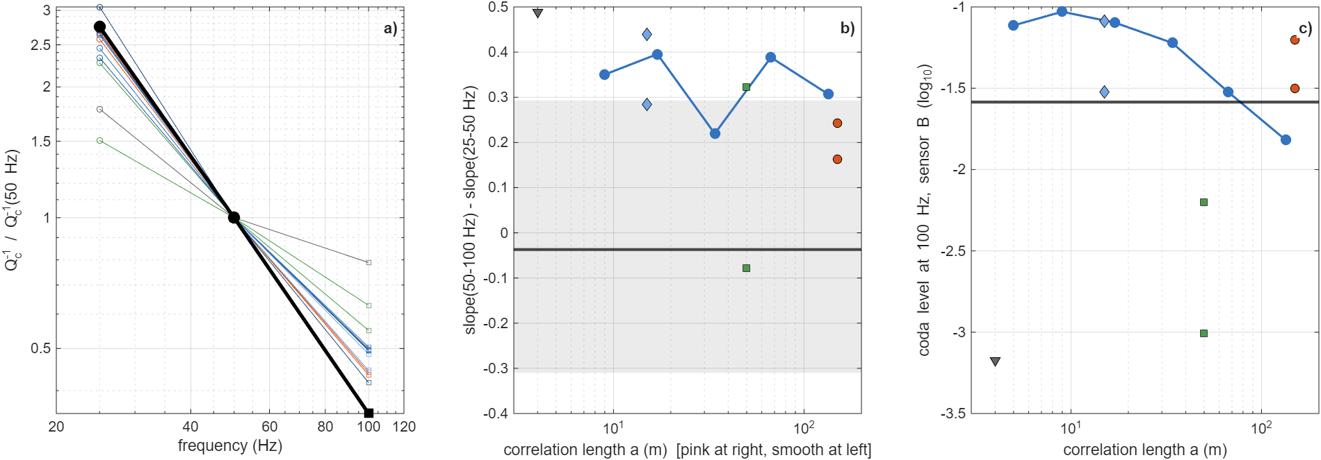
Fig. 17 Q_{c}⁻¹ frequency dependence and 100-Hz coda level versus correlation length
a) Q_{c}⁻¹ normalised at 50 Hz, from the 25–50 Hz slope (sensor A, 5-m grid, circles) and the 50–100 Hz slope (sensor B, 2.5-m grid, squares); black: FORGE; blue: exponential series (darker = larger a); orange: pink; green: Gaussian a = 50 m; grey: homogeneous. b) Curvature, slope(50–100 Hz) − slope(25–50 Hz), versus correlation length; black line and grey band: FORGE with 95 % bootstrap interval; pink (orange) and homogeneous (grey) media are plotted at the right and left edges. c) Coda level at 100 Hz (sensor B) versus correlation length; black line: FORGE; symbols as in b).

Discussion

Why deterministic waveform fitting favours smooth crust
With two sensors, the realisation of a scale-free random medium cannot be recovered, and any assumed realisation adds coherent scattered energy at wrong times. Deterministic waveform fitting, whether by moment-tensor or full-waveform inversion, therefore penalises heterogeneity: it favours the smoothest model that fits the direct waves and assigns the coda to noise. Our truth test shows that this preference persists when the truth is a pink-noise crust. Conventional practice is thus biased toward the smooth models it assumes [19]. A scale-free crust has to be tested through wavefield statistics.

Heterogeneity strength: log versus wavefield
The FORGE coda requires σ ≈ 0.09–0.18 at 5-m scale (per-event test near 0.09–0.13, statistical optimum near 0.18), about 2–4 times the sonic-log value. Several effects may contribute. (i) The log samples one vertical line in intact rock outside the stimulated volume, whereas the MEQ paths cross the fracture volume being pressurised by injection, where fluid-filled fractures lower V_{S} strongly; in the GFI framework this is the poro-connectivity enhancement of stimulation. (ii) Fluid-filled fractures scatter S waves more strongly than an isotropic lognormal perturbation with coupled V_{P} and V_{S}. (iii) Near-sensor effects such as cement coupling and borehole modes add coda that our model lacks; the sensor-B 20–40 Hz plateau is one example. (iv) Intrinsic attenuation is absent from the FD model, although it would shorten the coda and so cannot explain the excess. The inferred σ should therefore be read as an effective scattering strength of the stimulated volume, with the log value as a reference for intact ambient crust.

What the data do and do not constrain
Three results should be kept apart. First, every smooth crust (homogeneous, layered, VTI) fails, on three independent observables. It under-predicts the observed S coda by more than an order of magnitude, event by event; it keeps the coda of neighbouring events coherent where the data decorrelate; and it fails the statistical test. VTI anisotropy changes the direct waves but creates neither coda nor decorrelation. Second, the coda requires strong heterogeneity (σ of roughly 0.1–0.2 at 5-m scale) but does not establish its spectral shape. In repeated truth tests the wavefield separates small-scale-rich media from Gaussian media reliably, but cannot separate pink from exponential media, which are nearly the same field over 10–700 m. On FORGE, with two realisations per family, it prefers no family in the 20–80 Hz coda statistics. Higher frequencies are more selective. The 25–50 Hz Q_{c}⁻¹ slope excludes smooth crusts and most large-scale Gaussian realisations, and the 100-Hz coda level rejects the large-scale Gaussian medium outright while matching pink noise. Third, the borehole data supply the shape. The sonic log is scale-free over 12–200 m, which is consistent with pink noise, marginally with an exponential medium and not with a Gaussian one. The two lines of evidence are complementary rather than in conflict: the seismic data fix the strength of heterogeneity in the stimulated volume, and the log fixes its scaling in the intact rock. Taken together they support a strongly scattering crust with power-law heterogeneity, as assumed in GFI. The MEQ wavefield alone is not independent proof of the pink 1/k spectrum. Testing the shape seismically would require wider-band records, up to the kHz corner frequencies of FORGE MEQs, and a finer FD grid, because the pink and exponential media differ mainly below the present 10-m resolution.

What kind of heterogeneity makes the coda?
That coda waves are scattered by crustal heterogeneity is long established [7,9], and power-law heterogeneity spectra have been inferred from well logs [1,3]. What has remained open is which heterogeneity produces the coda of a given reservoir. Stochastic models are often chosen for convenience and fitted with a free correlation length. The FORGE data allow a more specific answer at the reservoir scale. The heterogeneity must be strong (σ ≈ 0.1–0.2 at 5-m scale), and it must retain enough small-scale structure to sustain the coda at 100 Hz. That requirement rejects the smooth crusts and the large-scale Gaussian medium. Of the media tested, pink noise alone comes close to both the 100-Hz coda level and the 50–100 Hz Q_{c}⁻¹ slope. The single power law of Q_{c}⁻¹ over 25–200 Hz is not, by itself, evidence of scale-free heterogeneity, because media with correlation lengths of 9–134 m reproduce it equally well in our simulations. The borehole data show a scale-free spectrum over 12–200 m. A lognormal pink-noise field, the same statistical object that describes poro-permeability in the GFI framework, is consistent with all of these observations. If this holds more widely, the coda is not a nuisance tail but a direct observable of the flow-controlling heterogeneity. This link can be tested only with broadband near-source records such as those at FORGE. At 200 samples/s the band above 100 Hz, which carries most of the S-wave energy of these events, is not recorded at all. Our own results show why the band matters: at 20–80 Hz a Gaussian medium fits the coda as well as pink noise, and it fails only at 100 Hz. The present data do not, however, exclude an exponential medium, which differs from pink noise mainly below 10 m.

Implications for microseismic flow imaging
A strongly heterogeneous crust with σ of several percent is invisible to travel-time location (residuals of ~1 ms) but dominates the MEQ coda. For EGS monitoring this means that (a) travel-time residuals of ~1 ms are compatible with smooth-model locations, whereas (b) the scattered wavefield carries information on the heterogeneity that controls flow. Coda and envelope statistics, rather than ray-theoretical travel times, are the natural observables for GFI/seismic emission tomography [4].

Limitations
- Only two downhole sensors, with unoriented horizontals and questionable vertical channels, are available for 2022.
- The FD band (20–80 Hz) covers only the low end of the FORGE MEQ spectrum; the data-model comparison of the Q_{c}⁻¹ slope uses two octave bands only, and the 25-Hz band is short relative to the coda window.
- Spectral peaks near 330, 480 and 920 Hz, attributed to the tool or its coupling, prevent interpretation of the coda above about 200 Hz.
- The model grid in (σ, p) is coarse and p is weakly resolved; intrinsic Q and fracture-specific (non-lognormal) scatterers were not included.
- Correlation-length competitors were simulated only at σ = 0.13, with at most two candidate and three truth realisations per family and a single realisation per correlation length in the a = 5–134 m series; a full (σ, a) search was not performed, so the trade-off between σ and a in the 100-Hz coda level is not resolved.
- The 25–50 Hz and 50–100 Hz slopes come from different sensors and grids, and the 2.5-m-grid synthetics are noise-free.
- Catalogue hypocentres were computed by the operator with a smooth velocity model, so the travel-time residual statistics mix structure with location error.

Conclusions
- Downhole MEQ records of the 2022 FORGE stimulation were matched to the catalogue and the 56-32 sensors self-calibrated (depths 2179 and 2522 m).
- Reciprocity-based 3-D elastic FD gives full-waveform synthetics for hundreds of paths per model, validated to 0.995 correlation in heterogeneous VTI media.
- Deterministic waveform inversion favours the smoothest crust even for a pink-noise truth and cannot identify the medium class.
- Statistical waveform inversion recovers a pink and a layered-VTI synthetic truth without bias.
- For FORGE, homogeneous, layered and VTI crusts under-predict the observed S coda of 150 events by a factor of about 10–30, keep the coda of neighbouring events coherent where the data decorrelate, and rank last in the statistical inversion. Smooth crustal models are rejected.
- The coda requires strong heterogeneity: the pink optimum is σ ≈ 0.18, bracketed by runs at σ = 0.13 and 0.25, and the per-event test gives σ ≈ 0.09–0.13. This is several times the sonic-log value, which suggests stimulation-enhanced scattering.
- At equal σ, nine synthetic truth tests show that the wavefield separates small-scale-rich from Gaussian media (8 of 9) but not pink from exponential media (3 of 6), which are 96 % correlated on the simulated scales. At 20–80 Hz the FORGE data prefer no spectral family; at 100 Hz they reject the large-scale Gaussian medium. The scale-free 56-32 log spectrum favours pink noise and excludes Gaussian media. The seismic data establish heterogeneity strength; the pink spectral form rests on the borehole data.
- The 4-kHz records carry S-wave energy above noise to about 1.8 kHz. Over 25–200 Hz the coda attenuation follows a single power law, Q_{c}⁻¹ ∝ f^{-1.5}. Simulations with correlation lengths of 5–134 m show that this is not diagnostic of scale-free heterogeneity.
- Raising the simulated band to 100 Hz (2.5-m grid) separates the media that 20–80 Hz could not. The 100-Hz coda level rejects the large-scale Gaussian medium and the smooth crust by 0.6–1.6 log units. Pink noise comes closest to both the 100-Hz coda level and the 50–100 Hz Q_{c}⁻¹ slope; with one realisation per medium this is suggestive rather than decisive. Everything above 100 Hz is inaccessible at 200 samples/s.

Availability of data and materials
The GES 2022 catalogue is public [11]. The 56-32 SEG-2 records were provided to the authors; their public release is being confirmed. All MATLAB code (FD solver, reciprocity, features, inversion) and derived results are in the Paper2_PinkNoise_WaveformInversion repository [URL TO BE ADDED].

Competing interests
[TO BE COMPLETED BY AUTHORS]

Funding
[TO BE COMPLETED BY AUTHORS]

Authors' contributions
[TO BE COMPLETED BY AUTHORS]

Acknowledgements
We thank Heiner Igel for the acoustic finite-difference MATLAB codes from which the elastic solver used here was developed. [FURTHER ACKNOWLEDGEMENTS TO BE COMPLETED BY AUTHORS]

References
1. Leary P. Rock as a critical-point system and the inherent implausibility of reliable earthquake prediction. Geophys J Int. 1997;131:451–66.
2. Leary PC, Al-Kindy F. Power-law scaling of spatially correlated porosity and log(permeability) sequences from north-central North Sea Brae oilfield well core. Geophys J Int. 2002;148:426–42.
3. Holliger K. Upper-crustal seismic velocity heterogeneity as derived from a variety of P-wave sonic logs. Geophys J Int. 1996;125:813–29.
4. Leary P. The αβγ of EGS crustal heat extraction. J Energy Power Technol. 2026; in press.
5. Leary P. EGS sustainability: deconstructing UtahForge engineered geothermal system flow data. Sustainability. 2026;18:5308. https://doi.org/10.3390/su18115308.
6. Suryanto W, Leary P, Saunders G, Onto, Fleure T, Pramono B, et al. Data-constrained multiscale descriptors of heterogeneous flow and microseismicity in enhanced geothermal systems. Geotherm Energy. 2026; submitted.
7. Aki K, Chouet B. Origin of coda waves: source, attenuation, and scattering effects. J Geophys Res. 1975;80:3322–42.
8. Frankel A, Clayton RW. Finite difference simulations of seismic scattering: implications for the propagation of short-period seismic waves in the crust and models of crustal heterogeneity. J Geophys Res. 1986;91:6465–89.
9. Sato H, Fehler MC, Maeda T. Seismic wave propagation and scattering in the heterogeneous Earth. 2nd ed. Berlin: Springer; 2012.
10. Thomsen L. Weak elastic anisotropy. Geophysics. 1986;51:1954–66.
11. Dyer B, Karvounis D. Utah FORGE: updated seismic event catalogue from the April 2022 stimulation of well 16A(78)-32. DOE Data Explorer. 2022. https://www.osti.gov/dataexplorer/biblio/dataset/1908927. Accessed 26 Sep 2026.
12. Maeda N. A method for reading and checking phase times in autoprocessing system of seismic wave data. Zisin. 1985;38:365–79.
13. Virieux J. P-SV wave propagation in heterogeneous media: velocity-stress finite-difference method. Geophysics. 1986;51:889–901.
14. Levander AR. Fourth-order finite-difference P-SV seismograms. Geophysics. 1988;53:1425–36.
15. Igel H, Mora P, Riollet B. Anisotropic wave propagation through finite-difference grids. Geophysics. 1995;60:1203–16.
16. Igel H. Computational seismology: a practical introduction. Oxford: Oxford University Press; 2016.
17. Cerjan C, Kosloff D, Kosloff R, Reshef M. A nonreflecting boundary condition for discrete acoustic and elastic wave equations. Geophysics. 1985;50:705–8.
18. Zhao L, Chen P, Jordan TH. Strain Green's tensors, reciprocity, and their applications to seismic source and structure studies. Bull Seismol Soc Am. 2006;96:1753–63.
19. Virieux J, Operto S. An overview of full-waveform inversion in exploration geophysics. Geophysics. 2009;74:WCC1–26.

