Late S-wave energy and decorrelation in Utah FORGE downhole microearthquakes: elastic tests of smooth, layered, fracture-zone and stochastic media
Wiwit Suryanto^{1*} and Peter Leary²
¹ Department of Physics, Faculty of Mathematics and Natural Sciences, Universitas Gadjah Mada, Sekip Utara BLS 21, Yogyakarta 55281, Indonesia
² Geoflow Imaging, Auckland 1010, New Zealand
* Corresponding author: Wiwit Suryanto, ws@ugm.ac.id

Abstract
Downhole records of microearthquakes (MEQs) induced by the April 2022 stimulation at Utah FORGE contain long S-wave codas. 416 MEQs recorded at 4 kHz by two three-component sensors in well 56-32 are compared with 3-D finite-difference wavefields computed by reciprocity for smooth media (homogeneous, 50-m sonic-log layering, 3-D gradients, transverse isotropy), deterministic small-scale media (6-m sonic-log layering, 5-m-thick fracture zones) and lognormal stochastic media with power-law, exponential and Gaussian spectra. Moment tensors fitted to the direct waves (P − 10 ms to S + 15 ms) predict the 40–80 Hz energy from S + 40 to S + 100 ms. The smooth media under-predict this late energy by median factors of 44–82 at the upper and 12–15 at the lower sensor, robustly to windows, source constraints, source duration, event timing and a worst-case in-band tool resonance. Thin layers and fracture zones reduce it to factors of 11–19 (upper) and 2.4–3.4 (lower sensor); stochastic media span the observed late-energy distributions. In the early coda the waveforms of neighbouring events decorrelate with separation, as in the stochastic media, whereas the tested smooth and simple deterministic media stay coherent. In the pure late coda all media approach the noise level, and only the smooth media and the planar fracture zones remain more coherent than the data. The late energy implies an effective scattering strength σ_{eff} ≈ 0.05–0.13 (standard deviation of ln V), depending on sensor and family; one domain-size test suggests that these are upper bounds, comparable to the sonic-log value of 0.045. At 20–80 Hz neither per-event nor common-grid statistical comparisons (event bootstrap, holdout) distinguish power-law from exponential or Gaussian spectra, and the sonic-log spectrum (β = 0.85 ± 0.07 over 12–200 m) does not exclude a short correlation length. Within elastic modelling, the late S energy thus requires structure at the 5–10 m scale, and its decorrelation favours distributed 3-D heterogeneity without excluding fine layering, unless an unmodelled site response of comparable size is present; the spectral form is not resolved. Deterministic comparison against an unknown stochastic realisation favours smooth media, so medium-class selection should use wavefield statistics.
Keywords: EGS; Utah FORGE; microseismicity; seismic scattering; coda; random media; 3-D finite difference; downhole seismics

Introduction
Microseismic monitoring of engineered geothermal system (EGS) stimulation relies on a velocity model. In routine practice that model is homogeneous, layered or weakly anisotropic, smooth enough for ray theory to locate events and for a few source parameters to fit the direct waves. Everything after the direct S wave, the coda, is usually left unmodelled. That coda waves are generated by scattering on crustal heterogeneity is long established [1,2], and finite-difference simulations have shown how random media produce them [3]. Which heterogeneity produces the coda of a particular reservoir, and how strong it must be, remains much less clear, because near-source records with enough bandwidth to test it are rare.
Borehole data provide one candidate. Well-log fluctuation spectra in sedimentary, crystalline and volcanic rocks scale approximately as S(k) ∝ k^{-β} with β ≈ 1–1.5 over centimetre-to-kilometre scales, and core porosity and permeability are related lognormally [4–6]. A medium with these statistics (a lognormal, spatially correlated "pink-noise" medium) is the basis of geoflow imaging (GFI) [7,8], and Paper 1 of this series quantified such descriptors at Utah FORGE [9]. Whether the seismic wavefield of FORGE MEQs requires strong small-scale heterogeneity, and whether it can distinguish a power-law spectrum from spectra with a correlation length, has not been tested.
Here we use the 4-kHz records of two downhole sensors in well 56-32 during the April 2022 stimulation and 3-D elastic finite-difference (FD) wavefields for several hundred event–sensor paths per model. We ask three questions, in decreasing order of what the data can answer. (1) Do smooth media, or media with deterministic small-scale structure (thin layers, planar fracture zones), reproduce the late S-wave energy and its inter-event coherence? (2) If not, what effective scattering strength do stochastic media require? (3) Do the waveforms prefer a power-law (pink) spectrum over exponential or Gaussian spectra? We treat the first question as the main test, subject it to controls for window overlap, source, instrument ringing, event selection and numerical convergence, and report the second and third with their limitations. A methodological by-product is a synthetic demonstration that deterministic waveform comparison against an unknown stochastic realisation favours smooth models, so that medium-class selection must use wavefield statistics.

Data

Records and event selection
Table 1 Event selection
Step | Events | Magnitude; distance to sensor mid-point; share of stage 3
GES catalogue, April 2022 stimulation of 16A(78)-32 | 36 641 | —
60-s SEG-2 files read (18–24 April 2022; 4 kHz, 6 channels) | 3556 files | —
Largest events with M ≥ −1 whose 1-s window lies inside a file (extraction cap, ordered by magnitude) | 800 | −0.44 [−0.61, 0.04]; 317 [262, 414] m; 83 %
Clean P onset on at least one sensor, hypocentre inside the FD interior | 555 | −0.44 [−0.60, −0.09]; 308 [261, 395] m; 92 %
Clean P onsets on both sensors: per-event coda test, D2, Φ | 416 | −0.44 [−0.60, −0.11]; 303 [261, 385] m; 97 %
150 highest P-wave SNR (subset of the original analysis; sensitivity only) | 150 | −0.40 [−0.60, −0.12]; 294 [267, 357] m; 96 %
Median [10th, 90th percentile]. Stage 3 dominates at every step; stage 2 contributes 14 of the 416 events used, and stage 1 none.
Geo-Energie Suisse recorded the April 2022 stimulation of well 16A(78)-32 in 60-s SEG-2 files from monitoring well 56-32 and published a catalogue of 36 641 located events [10]. Fig. 1 shows the geometry, Fig. 2 example records, and Table 1 the selection steps. The only magnitude criterion is the extraction cap of 800 events; no step uses the coda. The per-event test uses all 416 events with clean P onsets on both sensors. The original analysis used the 150 events with the highest P-wave SNR. These have a slightly weaker, not stronger, observed coda than the remaining events (median log₁₀ coda/S −1.33 against −1.12 at sensor A), so the selection did not inflate the coda.

Sensor calibration
The file headers carry no receiver coordinates. Automatic P onsets [11] on the two three-component sensors (channels 1–3, sensor A; 4–6, sensor B) were inverted with the catalogue hypocentres for sensor position (both sensors in one vertical well), clock offsets and V_{P} (L1 misfit). The solution places the sensors at depths of 2179 m (A) and 2522 m (B) with V_{P} = 5808 m/s. Event-bootstrap 95 % intervals are narrow (±12 m for A, ±81 m/s for V_{P}), but they understate the true uncertainty, because the catalogue locations were themselves computed with a smooth velocity model. Leaving out stimulation stage 3 moves both sensors 52 m deeper and lowers V_{P} by 8 %, which shows that depth, clock and velocity trade off structurally. We therefore regard sensor depths as uncertain by ~50 m and V_{P} by ~8 %, and test the effect of timing errors on the coda measurements directly (see below). The P travel-time residuals of neighbouring events are correlated up to ~40 m separation (Fig. 2c), which may reflect structure or correlated catalogue location error; we do not interpret them further. Channels 1 and 4 carry only ~3 % of the P energy and are not used; channels 2–3 and 5–6 behave as horizontal pairs, and all measurements use rotation-invariant horizontal energy.

Sonic log
The 56-32 sonic log (1950–2780 m, calliper-screened) gives a detrended ln V with σ = 0.045 at 6-m and 0.032 at 50-m averaging. Its spectral slope depends on band and estimator (Fig. 9). Over 12–200 m the multitaper estimate is β = 0.85 ± 0.07 (taper jackknife), and across detrending orders, periodogram, Welch and multitaper estimators and three log segments it ranges from 0.57 to 1.21. Over 1–200 m it is 1.2–1.7. On log-binned spectra a power law is the best of four models over 12–200 m, but exponential and Gaussian autocorrelation spectra with correlation lengths of 2–4 m lie within ΔAIC = 3.4 and 3.7. Over 1–200 m the Gaussian spectrum is excluded (ΔAIC = 26), but the exponential one is not (ΔAIC = 2.2). The log is thus compatible with power-law fluctuations, but a single 830-m vertical log cannot establish scale invariance or exclude a short correlation length. It is also a sample of intact rock along one line, not of the stimulated volume that the MEQ waves traverse.
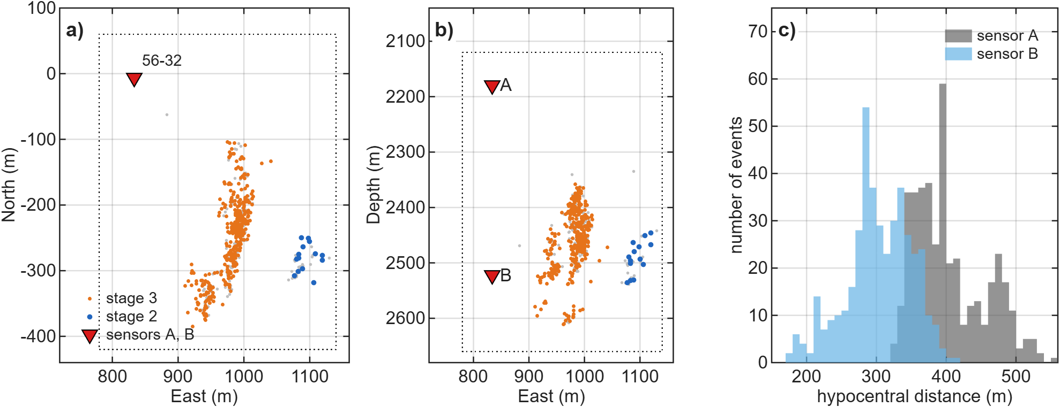
Fig. 1 Utah FORGE 2022 geometry: stimulation MEQs, 56-32 sensors and FD volume
a) Map view and b) east–depth section of the 416 analysed MEQs (orange: stage 3; blue: stage 2) and of the other catalogued events inside the FD interior (grey), with the calibrated sensors A and B in well 56-32 (red triangles) and the FD interior (dotted). Coordinates relative to the 16A(78)-32 wellhead. c) Hypocentral distances of the 416 events to sensors A and B.
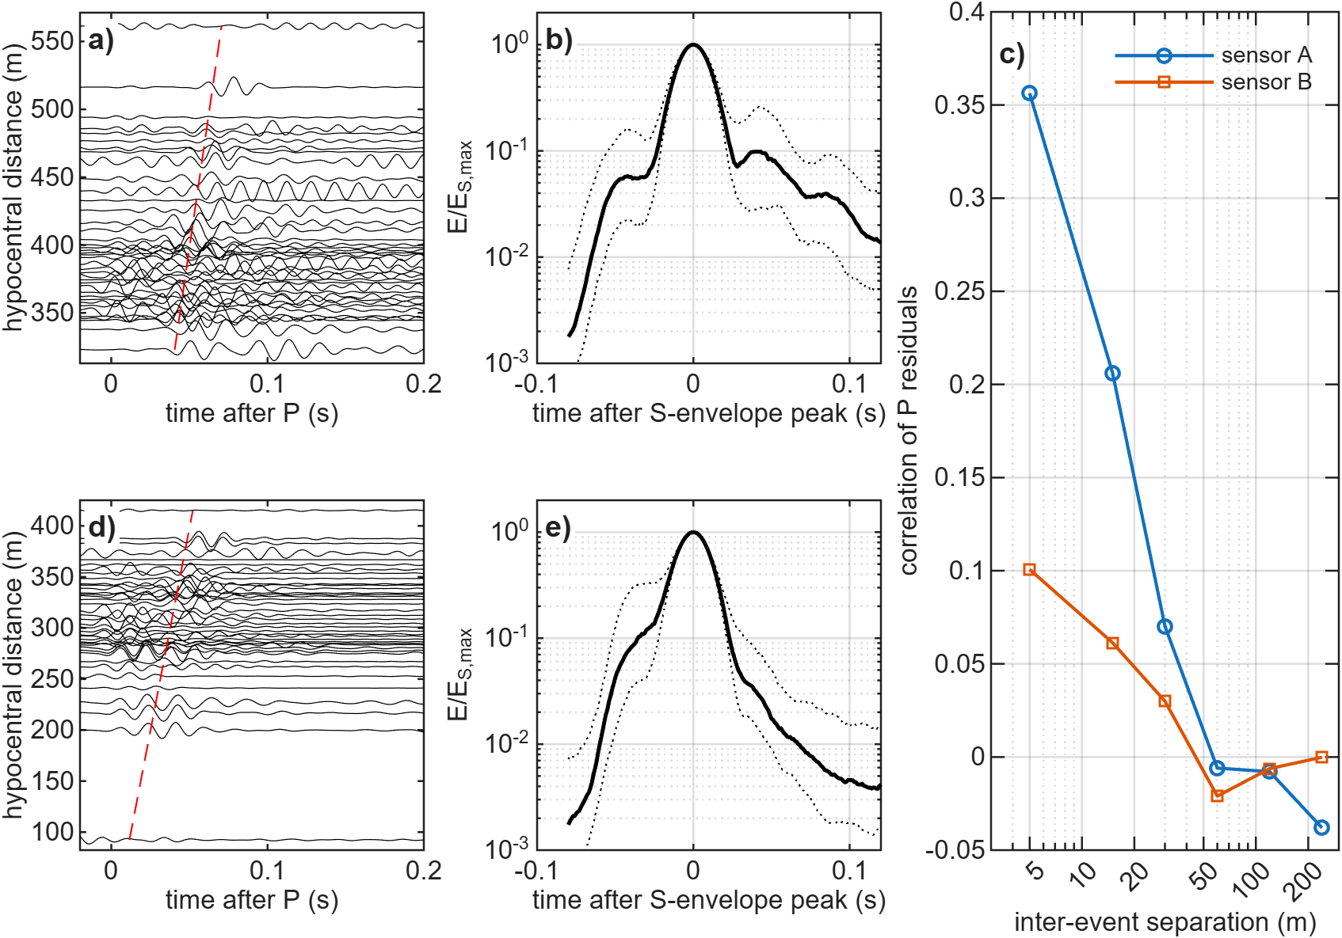
Fig. 2 FORGE 56-32 records and S envelopes
a, d) Horizontal records (one component, 40–80 Hz) of 40 events ordered by hypocentral distance for sensors A and B; the dashed line is the predicted S time. b, e) Median (solid) and interquartile range (dotted) of the horizontal S envelope, 40–80 Hz. c) Correlation of P travel-time residuals versus inter-event separation.

Methods

3-D elastic finite differences and reciprocity
We solve the velocity–stress equations on a staggered grid [12] with fourth-order spatial and second-order temporal differences [13] for a transversely isotropic medium with a vertical symmetry axis (VTI; stiffnesses from V_{P}, V_{S}, ρ and Thomsen ε, δ, γ [14]). The treatment of anisotropy on the staggered grid follows Igel, Mora and Riollet [15], and the MATLAB implementation grew out of the acoustic codes of Igel [16], extended to 3-D elastic VTI media, moment-tensor and point-force sources and strain-rate recording. A Cerjan sponge [17] absorbs outgoing energy. The grid is 113×137×149 nodes at 5 m (a 0.36 × 0.48 × 0.54 km interior plus 20-node sponges), with Δt = 0.25 ms, 1300 steps and a 45-Hz Ricker source. The analysis band is 20–80 Hz, with ≥ 5.4 grid points per S wavelength at 80 Hz even for the slowest truncated S velocity of the σ = 0.18 media (media with σ = 0.22 and 0.25, which fall below 5 points, are shown only in Additional file 1). Three point-force runs per sensor record the strain-rate tensor at every event node, so that by reciprocity [18] the velocity at sensor component n from a moment tensor M at x_{e} is
$$v_{n}(x_{s},t)=M_{pq}\int_{0}^{t}{{\overset{˙}{ε}}_{pq}^{\left(n\right)}}(x_{e},τ)dτ.$$ | (1)
Because only horizontal components are used, the two horizontal-force runs per sensor suffice. Against direct moment-tensor simulations in a heterogeneous VTI medium, the reciprocity synthetics agree with correlation 0.995 and amplitude ratio 0.995 (Additional file 1: Fig. S1).
Coda amplitudes in a small domain could be affected by the grid, the domain edges and the sponge. We therefore simulated one band-limited stochastic medium (σ = 0.13, power-law spectrum with a 780-m outer scale, low-passed at 0.06–0.08 cycles/m so that it is identical on every grid) four times with sensor B, the same 358 events and the same double-couple mechanisms: on the reference 5-m grid, on a 2.5-m grid, in a domain extended by 150 m on every side, and with a sponge of 40 instead of 20 nodes. The coda measures of the three variants are compared event by event with the reference.

Media
All media have constant density ρ = 2650 kg/m³ and background V_{P} = 5808 m/s, V_{P}/V_{S} = 1.73, except where stated. Four smooth media contain no structure below ~50 m: a homogeneous medium (H), a layered medium from the 56-32 sonic log averaged in 50-m blocks (L), a medium with smooth 3-D gradients of ±3 % vertically and ±2 % horizontally across the box (GRAD3), and a homogeneous VTI medium with Thomsen parameters inverted from the P travel times (A). Two deterministic media contain small-scale structure: the sonic log sampled at its 6-m resolution on the 5-m grid (L6), and 12 planar fracture zones, one cell (5 m) thick, about 240 m tall, striking N25°E and dipping 75°, with V_{P} reduced by 10 % and V_{S} by 20 % (FZ, which also varies V_{P}/V_{S}).
The stochastic media are lognormal, V(x) = V̄ exp[σ f(x)], where f is a zero-mean, unit-variance Gaussian random field obtained by filtering white noise ŵ in the wavenumber domain. For the power-law (pink) field the filter is
$$\hat{f}(n)∝\frac{\hat{w}(n)}{{\left(1+|n|\right)}^{p}},|n|=L|k|/2π,$$ | (2)
where n is the dimensionless FFT index, L the box length along each axis and k the wavenumber. The roll-off wavenumber is therefore k₀ = 2π/L (outer scale equal to the box, 0.6–0.75 km), and the power spectrum decays as |k|^{−2p} above it; p = 1.5 gives one-dimensional spectra ∝ k^{−1.05} and p = 1.8 gives ∝ k^{−1.48} along lines through the field. Exponential and Gaussian fields use the filters (1 + k²a²)⁻¹ and exp(−k²a²/8) with the correlation length a in metres. All fields are periodic over the FD box, which is larger than any source–receiver path. After scaling, ln V is truncated at ±3σ (±2.5σ for σ > 0.15) without renormalisation. Truncation affects 0.25–1.2 % of cells and reduces σ by ≤ 1.1 % (Additional file 1: Table S9). The truncated velocity range is wide: at σ = 0.13, V_{P} spans 3.9–8.6 km/s, and at σ = 0.18 3.7–9.1 km/s. The extremes occupy a small fraction of the volume, but they show that σ ≥ 0.13 is not a small perturbation.
In the default media V_{P} and V_{S} share one field, so V_{P}/V_{S} is constant. Two variants relax this at σ = 0.13: independent fields for V_{P} and V_{S} (VSD), and a V_{S}-dominated medium with σ(ln V_{S}) = 0.13 and σ(ln V_{P}) = 0.065 (VSO). Because σ absorbs any unmodelled contribution to the late energy, including density contrasts, anisotropic fracture scattering, intrinsic attenuation and site effects, we call the fitted value an effective scattering-strength parameter σ_{eff} within this isotropic model class, not a measured property of the rock.
Media were simulated in two sets (Table 2). The original set explores σ and p for the pink family. The revision adds a common grid for all three families: σ = 0.09, 0.13 and 0.18; p = 1.5 and 1.8 (pink), a = 15 and 50 m (exponential, Gaussian); two white-noise seeds each (11 and 33). Every family thus has the same number of candidates on the common grid. Fields of different families generated from the same seed share their phases and are strongly correlated (the pink and a = 15 m exponential fields with seed 33 by 96 %); this is a controlled comparison of spectral shape, not a test with independent fields.
Table 2 Media simulated
Model | Class | Parameters
H | smooth: homogeneous | V_{P} 5808 m/s, V_{P}/V_{S} 1.73
L | smooth: 1-D layered | 56-32 sonic log, 50-m blocks
GRAD3 | smooth: 3-D gradients | ±3 % vertical, ±2 % E and N
A | smooth: homogeneous VTI | travel-time inverted ε, δ
L6 | deterministic: 1-D layered | 56-32 sonic log at 6-m resolution
FZ | deterministic: fracture zones | 12 planar zones, 5 m thick, N25°E/75°, V_{P} −10 %, V_{S} −20 %
P4, P1, P3, P6, P9 | pink, p = 1.5 (seed 11) | σ = 0.02, 0.045, 0.09, 0.13, 0.18
T1, R1, R2; R3; R6; R5 | pink, p = 1.5 | further seeds at σ = 0.045; 0.09; 0.13; 0.18
P5, P2; P7, P8; P11 | pink, other p | p = 1.2, 1.8 at σ = 0.045, 0.09; p = 1.8 at 0.18
P12, P10 | pink, p = 1.5 | σ = 0.22, 0.25 (Additional file 1 only)
Common grid | pink, exponential, Gaussian | σ = 0.09, 0.13, 0.18 × (p = 1.5, 1.8 or a = 15, 50 m) × seeds 11, 33
VSD, VSO | pink, variable V_{P}/V_{S} | σ = 0.13; independent V_{S} field; σ_{VS} = 0.13, σ_{VP} = 0.065
R6c, R6d, E15c/d, G50c/d | synthetic truths | σ = 0.13, seeds 44 and 55 (shape-resolution test)
T2 | synthetic truth | 50-m layering + VTI (ε = 0.06, δ = 0.03, γ = 0.06)
All media: ρ = 2650 kg/m³. Stochastic media: lognormal, truncated at ±3σ (±2.5σ for σ > 0.15). The common grid comprises 36 media (12 per family), 14 of which already existed in the original set.

Source and preprocessing
FD synthetics carry a 45-Hz Ricker source. To give data and synthetics the same source spectrum, each observed trace is convolved with the same Ricker wavelet. This is valid if the true source spectrum is flat in the analysis band, i.e. if corner frequencies exceed ~80 Hz. The S-window displacement spectra (raw data, 5–300 Hz) support this for most but not all events. The apparent corner, the first frequency above 50 Hz at which the spectrum falls 6 dB below its 30–50 Hz level, has a median of 128 Hz at sensor A and 90 Hz at B. Because it includes path attenuation, it is a lower bound on the source corner; 21 % (A) and 34 % (B) of events have apparent corners below 80 Hz. To bound the effect of finite source duration, we convolved the homogeneous and σ = 0.13 pink synthetics with Brune source-time functions with corners of 150, 100 and 60 Hz. Even the 60-Hz source raises the homogeneous coda-to-S ratio by only 0.35 log units (A) and changes the pink one by +0.03. Source duration therefore cannot close a deficit of 1–2 log units.

Per-event coda prediction test
For each event and medium, the moment tensor is fitted by linear least squares to the four horizontal traces (two sensors, 40–80 Hz) in the window P − 10 ms to S + 15 ms, with a per-sensor time shift of up to ±6 ms and the tool azimuth and handedness of each sensor fixed from a previous grid search. The fitted moment tensor then predicts the whole record. After a guard band of 25 ms, the test quantity is the ratio of mean horizontal energy in S + 40 to S + 100 ms to the peak S energy (S − 8 to S + 15 ms), compared per event between prediction and observation as log₁₀(predicted/observed). The fit and coda windows do not overlap. In the original version of this analysis the fit window extended to S + 60 ms and overlapped 43 % of the coda window; that version is superseded. The sensitivity analysis varies the end of the fit window (S + 10, 15, 20 and, for comparison, the original 60 ms) and the coda window (S + 30–100, 40–100 and 50–110 ms). It also compares a full moment tensor, a deviatoric one and a double couple (grid search over strike, dip and rake, with a least-squares scalar moment). Condition numbers of the column-normalised design matrix and the ISO, CLVD and DC fractions of the full solutions are reported. A timing check compares the observed S-envelope peak with the predicted S time. The test is repeated on the events whose S peak lies within ±10 ms (and ±5 ms) of the prediction on both sensors.

Tests for instrument and borehole ringing
A resonant sensor or borehole response h(t) moves energy from the S peak into later windows, so a coda-to-S ratio does not cancel it. We applied three tests. First, the S-window spectra and the coda/S spectral ratio were examined for resonance peaks. In the analysis band (30–120 Hz), any peak in the smoothed S spectrum is at most 0.35 dB above its surroundings. The same measure detects the resonances near 330, 480 and 920 Hz (prominence up to 10 dB), which serve as a positive control. Second, in a null-ringing test the homogeneous synthetics were convolved with the strongest single resonance (40–80 Hz, Q = 5–40) whose spectral peak does not exceed the observed in-band prominence, and the coda-to-S ratio was recomputed. Third, the two sensors, which have different coupling and different in-band peaks, are analysed separately throughout. No calibration shots, perforation shots or third sensor were available for 2022, so an empirical transfer function could not be measured.

Statistical comparison of media
With two sensors the realisation of a random medium cannot be recovered, so stochastic media are compared with the data through wavefield statistics. On the horizontal energy envelope we measure three S-normalised features per event: the coda level log₁₀(E_{coda}/E_{S}) 30–100 ms after the S peak, the coda decay rate and the rms S-pulse width. We use three sensor–band combinations: A 20–40 Hz, A 40–80 Hz and B 40–80 Hz. B 20–40 Hz is excluded because it carries a persistent non-event plateau. The misfit is
$$Φ=\frac{1}{9}\sum_{c=1}^{3}{\sum_{j=1}^{3}{D_{KS}}}\left(F_{cj}^{obs} , F_{cj}^{mod}\right)+\frac{1}{3}\sum_{c=1}^{3}{{\left[\frac{1}{N_{τ}}\sum_{τ=0}^{100ms}{{\left(\log_{10}{\overset{\sim }{E}}_{c}^{obs}(τ)−\log_{10}{\overset{\sim }{E}}_{c}^{mod}(τ)\right)}^{2}}\right]}^{1/2}}$$ | (3)
where D_{KS} is the two-sample Kolmogorov–Smirnov distance between the observed and synthetic distributions of feature j for combination c, and Ẽ_{c} is the median post-peak S envelope. All nine KS terms and all three envelope terms are weighted equally, events are weighted equally, and events lacking a measurement in one combination are omitted from that combination only. The features are correlated, so Φ is a ranking statistic, not a likelihood. Its uncertainty is estimated by an event bootstrap (200 resamples, the same resample for every medium). Family comparisons use the best member of each family on the common grid per bootstrap sample, and a holdout test in which each family's best (σ, shape, seed) is chosen on half of the events and scored on the other half (20 random splits plus a near/far split by distance).

Inter-event coda coherence
For pairs of events recorded on the same sensor, D2 is the maximum normalised two-component cross-correlation (lag ±8 ms) of a 40–80 Hz coda window, summarised as the median in bins of inter-event separation (0–5 to 80–160 m) and as the median over all pairs within 160 m. Three windows are used: S + 15 to S + 100 ms (early coda, including the tail of the S pulse), S + 40 to S + 100 ms (the window of the late-energy test) and S + 50 to S + 110 ms. The coherence of noise alone is measured on the same records in a window S + 550 to S + 610 ms. Every synthetic record contains that event's own recorded noise at its observed SNR, so the noise contribution is common to data and media. Pairs that share an event are not independent, so 95 % intervals come from a cluster bootstrap over events (each resampled event carries all its pairs). To test sensitivity to location error, the hypocentres used for binning were perturbed by isotropic Gaussian errors of 5, 10, 20, 30 and 50 m, for data and media alike. The all-pairs median does not depend on the binning and is therefore insensitive to location error.

Synthetic truth tests
The ability of the statistical comparison to select a medium class was tested with synthetic truths. Two truths were used in the main test: a pink medium (T1, σ = 0.045) and 50-m layering with VTI (T2). A further nine truths at equal σ = 0.13 (pink, exponential a = 15 m and Gaussian a = 50 m, seeds 33, 44 and 55) tested resolution of the spectral family. Synthetic records use double-couple mechanisms consistent with the FORGE stress field, and real 56-32 noise at each event's observed SNR.

Results

Smooth media under-predict the late S energy
Fig. 3 compares observed and predicted sensor-A seismograms for three events. The moment tensor fitted to the direct waves reproduces the P and S pulses in all media. In the homogeneous medium the prediction then decays to near zero within the guard band, whereas the observed traces keep oscillating through the coda window. Table 3 and Fig. 4 give the statistics over 416 events. The four smooth media under-predict the coda-to-S ratio by a median factor of 44–82 at sensor A and 12–15 at sensor B, and only 1–5 % (A) and 5–11 % (B) of events fall within a factor of three. Smooth 3-D gradients (−1.67/−1.11, A/B) and VTI anisotropy (−1.91/−1.19) alter the direct waves but add no late energy.
The two simple deterministic small-scale media tested change this substantially. The sonic log at its 6-m resolution (L6) gives −1.28/−0.53, and the thin fracture zones (FZ) give −1.04/−0.39: under-prediction by factors of 19 and 11 at sensor A but only 3.4 and 2.4 at sensor B, where 41 % and 45 % of events fall within a factor of three. Averaging the log in 50-m blocks, as in the original analysis, therefore removed most of the late energy that the logged layering can generate. For the level of late energy, structure at the 5–10 m scale is the essential ingredient, whether it is layered, planar or random. Stochastic media span the observations: pink media with σ = 0.02 under-predict (−1.20/−0.49), σ = 0.09 is close at sensor A (−0.14) and σ = 0.045 at sensor B (+0.02), and the seed-11 stochastic media with σ = 0.13 over-predict (+0.28 to +1.12). The best stochastic media bring 53 % (A) and 54 % (B) of events within a factor of three. The residual scatter reflects the unknown realisation. No single medium matches the median at both sensors; for the pink family, sensor B requires about half the σ of sensor A.
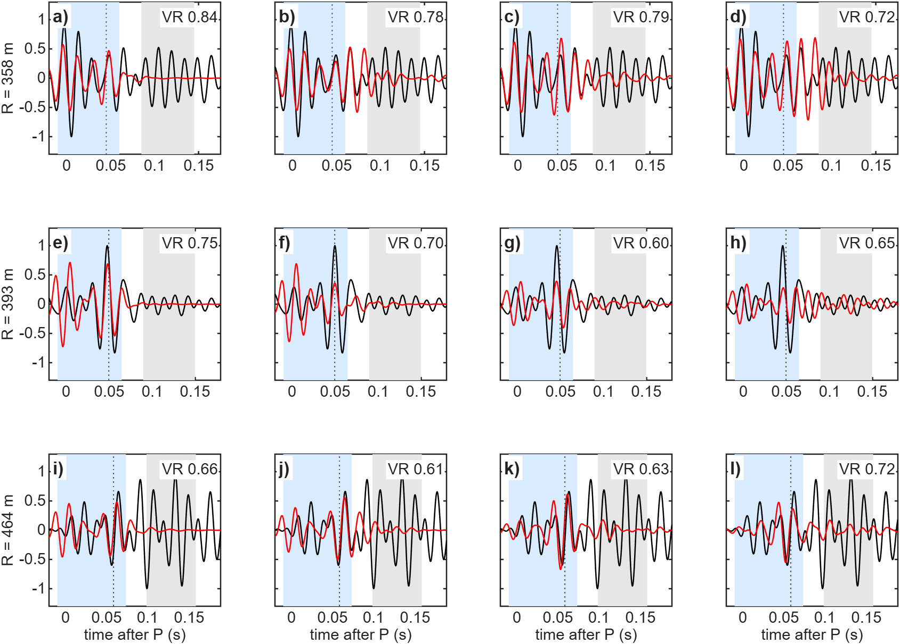
Fig. 3 Observed and predicted sensor-A seismograms with non-overlapping fit and coda windows
Horizontal component 1, 40–80 Hz, for three events at increasing distance (rows; distance on the left). Columns: homogeneous medium, deterministic fracture zones (FZ), pink media with σ = 0.045 and 0.09. Black: observed; red: predicted with the moment tensor fitted in the light-blue window (P − 10 ms to S + 15 ms); grey: coda window (S + 40 to S + 100 ms); dotted: predicted S time. Variance reduction of the fit in each panel.
Table 3 Predicted versus observed late S energy for 416 FORGE events
Medium | Median log₁₀(pred/obs), A | Median, B | % within ×3, A | % within ×3, B | VR
smooth: homogeneous | −1.80 | −1.09 | 2 | 9 | 0.75
smooth: layered, 50 m | −1.64 | −1.17 | 5 | 5 | 0.73
smooth: 3-D gradients | −1.67 | −1.11 | 3 | 9 | 0.74
smooth: VTI | −1.91 | −1.19 | 1 | 11 | 0.64
deterministic: layered, 6 m | −1.28 | −0.53 | 15 | 41 | 0.73
deterministic: fracture zones | −1.04 | −0.39 | 24 | 45 | 0.73
pink σ = 0.02 | −1.20 | −0.49 | 16 | 42 | 0.73
pink σ = 0.045 | −0.74 | +0.02 | 34 | 51 | 0.72
pink σ = 0.09 | −0.14 | +0.53 | 50 | 35 | 0.67
pink σ = 0.13 | +0.31 | +0.78 | 50 | 26 | 0.62
pink σ = 0.18 | +0.61 | +1.03 | 37 | 18 | 0.60
pink σ = 0.13, independent V_{S} | −0.13 | +0.54 | 53 | 35 | 0.66
pink, V_{S}-dominated | +0.32 | +0.79 | 49 | 24 | 0.62
exponential a = 15 m, σ = 0.09 | −0.07 | +0.61 | 51 | 33 | 0.68
exponential a = 15 m, σ = 0.13 | +0.28 | +0.94 | 50 | 22 | 0.64
exponential a = 50 m, σ = 0.09 | −0.16 | +0.39 | 48 | 41 | 0.65
exponential a = 50 m, σ = 0.13 | +0.31 | +0.71 | 45 | 27 | 0.59
Gaussian a = 15 m, σ = 0.09 | +0.14 | +0.79 | 48 | 22 | 0.69
Gaussian a = 15 m, σ = 0.13 | +0.42 | +1.12 | 43 | 15 | 0.64
Gaussian a = 50 m, σ = 0.09 | −0.45 | −0.35 | 39 | 44 | 0.62
Gaussian a = 50 m, σ = 0.13 | +0.29 | +0.54 | 45 | 33 | 0.56
Late energy = mean horizontal energy S + 40 to S + 100 ms divided by the S-peak energy, 40–80 Hz. Moment tensors fitted in P − 10 ms to S + 15 ms (no overlap with the coda window). VR = median variance reduction of the direct-wave fit. Stochastic media: seed 11; other seeds in Additional file 1.
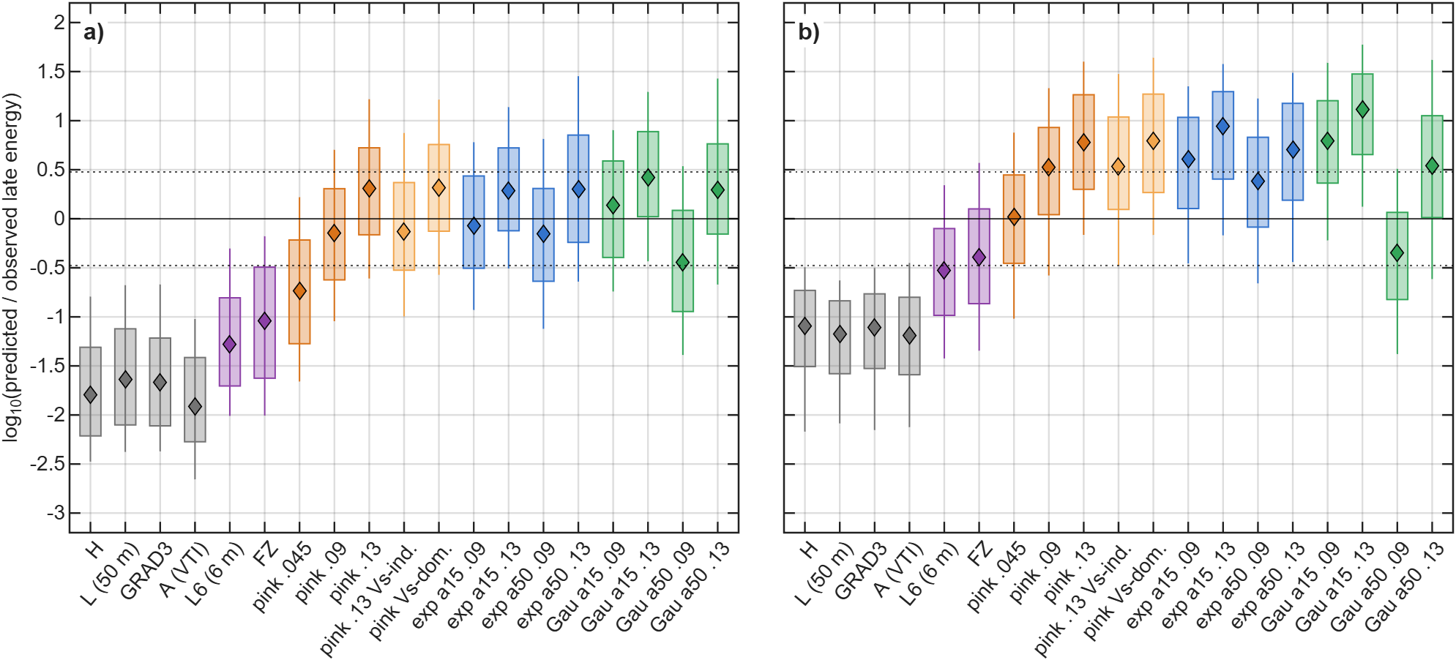
Fig. 4 Per-event predicted/observed late S energy for all media
a) Sensor A. b) Sensor B. 416 events, 40–80 Hz, windows as in Table 3. Boxes: interquartile range; whiskers: 10–90 %; diamonds: median; dotted lines: factor of three. Grey: smooth media; purple: deterministic small-scale media (6-m layering, fracture zones); orange: pink media (light orange: variable V_{P}/V_{S}); blue: exponential; green: Gaussian.

Robustness of the deficit
Table 4 Robustness of the late-energy deficit of smooth and deterministic media
Variant | Smooth, A | Smooth, B | L6 and FZ, A | L6 and FZ, B
Primary (fit to S + 15 ms; coda S + 40–100 ms) | −1.91 to −1.64 | −1.19 to −1.09 | −1.28 to −1.04 | −0.53 to −0.39
Fit to S + 10 ms | −1.91 to −1.64 | −1.20 to −1.07 | −1.29 to −1.04 | −0.52 to −0.33
Fit to S + 20 ms | −1.91 to −1.64 | −1.19 to −1.08 | −1.28 to −1.07 | −0.53 to −0.39
Coda S + 50–110 ms | −2.21 to −1.99 | −1.44 to −1.39 | −1.46 to −1.33 | −0.65 to −0.64
Coda S + 30–100 ms | −1.58 to −1.45 | −1.05 to −0.99 | −1.11 to −0.82 | −0.48 to −0.19
Original overlapping fit (S + 60 ms), coda S + 30–100 ms | −1.59 to −1.45 | −1.03 to −0.99 | −1.12 to −0.93 | −0.50 to −0.29
Deviatoric moment tensor | −2.04 to −1.69 | −1.21 to −1.09 | −1.33 to −1.19 | −0.51 to −0.49
Double couple | −2.10 to −1.69 | −1.25 to −1.11 | −1.34 to −1.24 | −0.58 to −0.51
150 highest-SNR events | −1.86 to −1.53 | −1.26 to −1.09 | −1.22 to −0.77 | −0.65 to −0.33
S peak within ±10 ms on both sensors (250 events) | −1.70 to −1.42 | −1.17 to −0.98 | −1.10 to −0.88 | −0.53 to −0.35
S peak within ±5 ms on both sensors (168 events) | −1.62 to −1.35 | −1.20 to −0.98 | −1.04 to −0.87 | −0.55 to −0.42
Homogeneous + worst in-band resonance (null-ringing test) | −1.99 to −1.61 | −1.33 to −0.96
Homogeneous, Brune source f_{c} = 60 Hz (change) | +0.35 | +0.35
Median log₁₀(predicted/observed late energy); range over the smooth media (H, L, GRAD3, A) and over the deterministic small-scale media (L6, FZ). Null-ringing test: range over resonance frequencies 40–80 Hz and Q = 5–40, for the median over events of the homogeneous double-couple synthetics relative to the observed median. Brune row: change of the homogeneous coda-to-S ratio relative to an impulsive source.
Table 4 shows that the deficit does not depend on the analysis choices. Ending the fit window at S + 10 or S + 20 ms, or moving the coda window, changes the smooth-model medians by a few tenths of a log unit. For the smooth media the window overlap of the original analysis had little effect: with the same coda window, fitting to S + 60 instead of S + 15 ms changes the medians by at most 0.02. The original coda window, which began at S + 30 ms, gave a smaller deficit than the corrected one simply because it included more of the early coda. Deviatoric and double-couple solutions give the same result, although they fit the direct waves less well (median VR in the homogeneous medium 0.75 for the full, 0.71 for the deviatoric and 0.67 for the double-couple solution). The moment-tensor problem is moderately conditioned (median condition number 16–18 for smooth and 4–16 for stochastic media, decreasing with σ). The full solutions carry large non-double-couple parts (median |ISO| 28 %, |CLVD| 28 % in the homogeneous medium). With two sensors in one well these parts are poorly resolved and we do not interpret them. The point is that no source constraint changes the coda deficit. The observed S peak lies within ±10 ms of the predicted time for 250 events on both sensors, and the deficit remains in that subset and in the ±5 ms subset. Timing and location errors therefore do not explain it.
The ringing tests constrain the instrument explanation (Fig. 5). Between 30 and 120 Hz the S spectra of both sensors are smooth, and the coda/S spectral ratio has no peak. The worst resonance compatible with this smoothness leaves the homogeneous medium 1.6–2.0 log units short at sensor A and 1.0–1.3 at B. The resonances above 300 Hz are strong and clearly visible, so an in-band resonance large enough to create the observed coda would not have escaped detection. This test excludes a single resonant mode, but not a broadband, non-resonant coupling response with a long impulse response. That possibility can be excluded only with an empirical transfer function, which is not available.
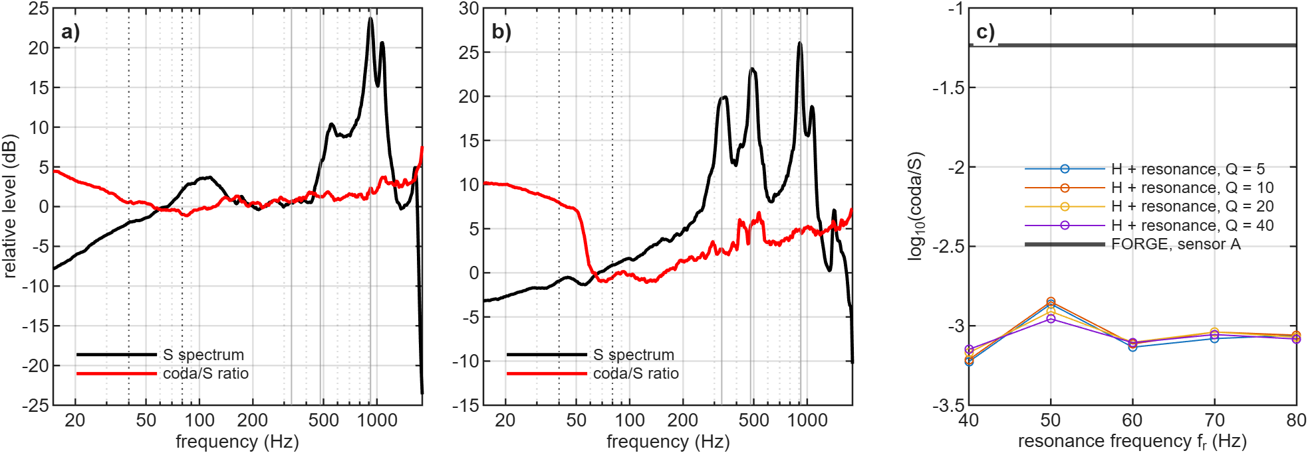
Fig. 5 Tests for instrument or borehole ringing
a, b) Sensors A and B: median S-window spectrum normalised over 30–150 Hz (black) and median coda/S spectral ratio (red, normalised). Dotted lines mark the analysis band 40–80 Hz and grey lines the resonances near 330, 480 and 920 Hz. c) Null-ringing test: log₁₀ coda/S of the homogeneous synthetics (sensor A) after convolution with the strongest resonance compatible with the observed in-band spectral smoothness, versus resonance frequency, for Q = 5–40. Thick line: observed FORGE median.
Grid refinement and sponge thickness change the late energy little (Additional file 1: Table S10). Relative to the 5-m reference, the median coda-to-S ratio at 40–80 Hz changes by +0.01 log units on the 2.5-m grid and by +0.13 with the doubled sponge (+0.16 and −0.13 at 20–40 Hz). Enlarging the domain by 150 m on every side, however, raises it by +0.40 at 40–80 Hz (+0.09 at 20–40 Hz) and lowers the coda decay rate from 48 to 21 s⁻¹. Because the doubled sponge has a much smaller effect, this is not a boundary artefact. It reflects the larger scattering volume: in the reference domain the event cloud nearly fills the interior, so heterogeneity beyond it lies in the absorbing sponge and returns no scattered energy. A smooth medium has no such scatterers, so the smooth-model deficit is unaffected. The slower decay in the larger domain may also explain why the observed coda decayed more slowly than the simulated coda in the original analysis. For the stochastic media, the reference domain probably underestimates the late energy, and the effective scattering strength derived below is probably an upper bound. With the sensitivity of the median ratio to σ found below (0.80 log units per unit change of ln σ), this single test implies that σ_{eff} from the reference domain may be overestimated by a factor of about 1.7. Whether the same factor applies to other families and to sensor A was not tested.

Effective scattering strength
For each family the σ at which the median predicted late energy equals the observed one (σ_{eff}) is interpolated in ln σ between the simulated levels of the reference domain (Fig. 6; Additional file 1: Table S11). At sensors A and B it is 0.104 and 0.053 for pink media with p = 1.5, 0.098 and 0.048 with p = 1.8, 0.093 and < 0.09 for exponential media with a = 15 m, 0.102 and < 0.09 with a = 50 m, and 0.112 and 0.131 for Gaussian media with a = 50 m ("< 0.09": the smallest simulated σ already over-predicts). σ_{eff} thus differs between sensors and families, so it is a model-dependent summary of the late energy rather than a unique rock property. Media with less small-scale content need larger σ (Gaussian a = 50 m), and media richest in structure near the S wavelength need less (Gaussian a = 15 m: < 0.09 at both sensors). Realisation scatter adds to this. The two seeds at one σ differ in the median ratio by up to 0.47 log units for pink media and 0.40 for exponential media with a = 15 m, i.e. a factor of about 1.8 in σ_{eff}, but by up to 1.57 for Gaussian media with a = 50 m, whose few large features make each realisation idiosyncratic in a 0.5-km box.
Relaxing the constant V_{P}/V_{S} ratio changes the late energy only moderately. With independent V_{P} and V_{S} fields the median ratio is −0.13/+0.54 (A/B), against +0.31/+0.78 for the coupled medium. The V_{S}-dominated medium, with half the V_{P} perturbation, gives +0.32/+0.79. The S coda is controlled mainly by the V_{S} perturbation, so σ_{eff} should be read as a V_{S} scattering strength.
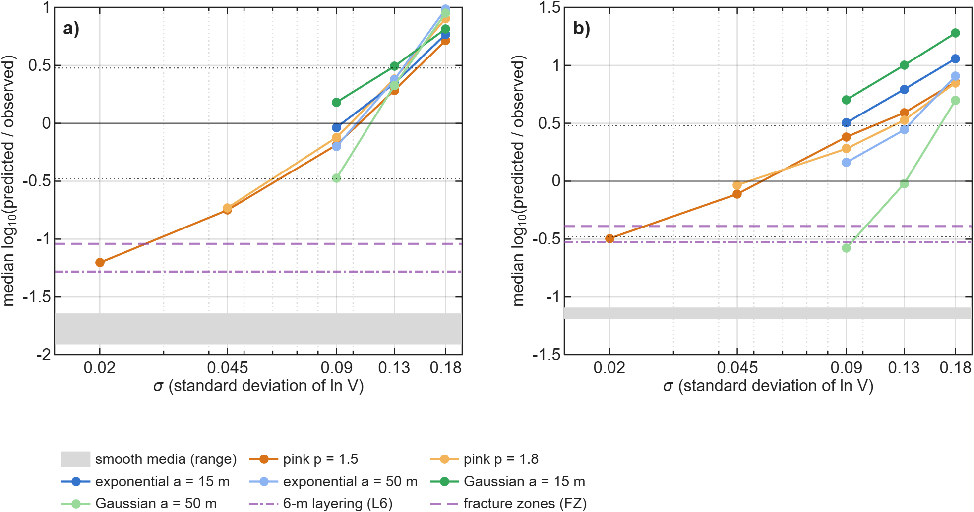
Fig. 6 Median predicted/observed late S energy versus σ for each spectral family
a) Sensor A. b) Sensor B. Median over events of log₁₀(predicted/observed), averaged over realisations where several exist. The zero crossing defines σ_{eff}; dotted lines: factor of three; grey band: range of the smooth media; purple dash-dotted and dashed lines: 6-m layering (L6) and fracture zones (FZ).

Inter-event coda coherence
Fig. 7 shows D2 in the three windows. In the early coda (S + 15 to S + 100 ms) the observed coherence falls from 0.69 at 0–5 m to 0.49 at 80–160 m (sensor A; 0.75 to 0.48 at B). The smooth media stay coherent (all pairs within 160 m: 0.82–0.86 at A, 0.73–0.78 at B, against 0.50 at both sensors for the data), and so do the two deterministic small-scale media (0.80–0.83 and 0.67–0.69). The stochastic media decorrelate as the data do (0.48–0.59 and 0.54–0.62). This window, however, contains the tail of the S pulse and is close to the window of the source fit.
In the late windows the picture changes. All coherences are lower and approach the coherence of noise alone (0.57 at A and 0.48 at B). The observed late coda is at or below this level (0.53 and 0.45 for S + 40 to S + 100 ms; 0.54 and 0.45 for S + 50 to S + 110 ms). Because the synthetics carry the same noise, D2 in these windows measures how much coherent late energy a medium adds. The smooth media (0.60–0.69 at A, 0.53–0.58 at B) and the fracture zones (0.64, 0.62) remain more coherent than the data in both late windows; their 95 % intervals lie above the data interval in 19 of 20 medium–sensor–window cases (Additional file 1: Table S17). The stochastic media (0.49–0.55, 0.49–0.50) and the 6-m layering (0.57, 0.52) come closest; in S + 50 to S + 110 ms the 6-m layering is as close to the data as the stochastic media at sensor A (0.51 against 0.50–0.52 and 0.54 observed). In the pure late coda D2 therefore separates the data from the smooth media and from the planar fracture zones, but not from fine 1-D layering. The separation of distributed 3-D heterogeneity from fine layering rests on the early-coda window and is correspondingly less secure.
Location error does not change these conclusions. Perturbing the hypocentres of data and media by up to 50 m flattens the binned curves, as expected, but changes the observed medians at separations of 20 m or more by at most 0.05 (Additional file 1: Fig. S10), and the all-pairs levels, which do not depend on the binning, are unaffected. We therefore do not use the 0–5 and 5–10 m bins for inference (the 0–5 m bin contains only 64 pairs from 96 events). D2 is measured on the same records as the late energy, so it is a second descriptor of the same data, not an independent experiment.
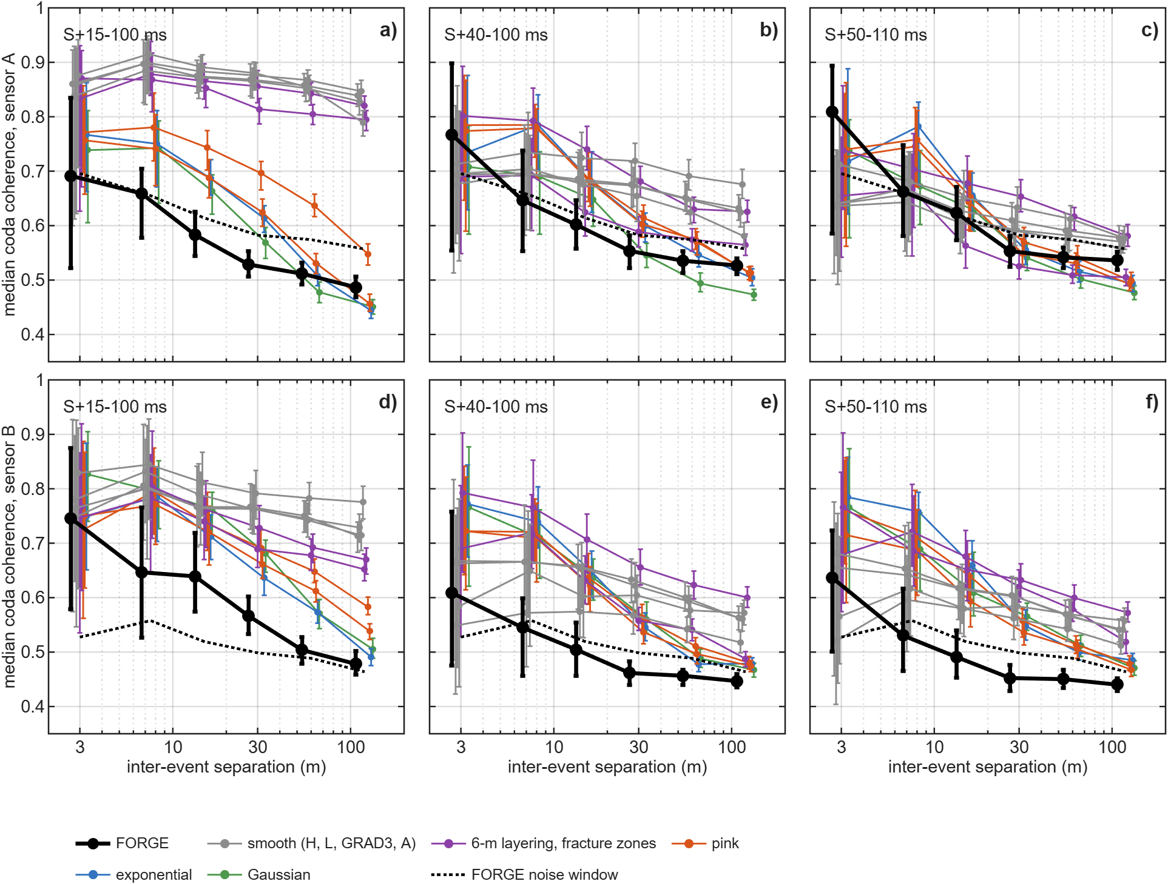
Fig. 7 Inter-event coda coherence in early and late coda windows
Median coherence of the 40–80 Hz coda versus inter-event separation, with 95 % cluster-bootstrap intervals over events, for sensor A (a–c) and sensor B (d–f), in the windows S + 15 to S + 100 ms (a, d), S + 40 to S + 100 ms (b, e) and S + 50 to S + 110 ms (c, f). Black: FORGE; dotted: FORGE noise-only window (S + 550 to S + 610 ms); grey: smooth media (H, L, GRAD3, A); purple: 6-m layering and fracture zones; orange: pink (σ = 0.09, 0.13); blue: exponential (a = 15 m); green: Gaussian (a = 50 m), σ = 0.13. Symbols are offset horizontally for clarity.

Statistical comparison and the spectral family
In the synthetic tests the statistical comparison selected the generating class in both controlled examples. With the pink truth T1 the best medium was a pink medium with the true σ (R1, Φ = 0.09), ahead of H, L and A (Φ = 0.29 each). With the layered-VTI truth T2, L and A ranked first (0.13, 0.16) and every pink medium was rejected. Two examples do not establish that the procedure is unbiased. The deterministic moment-tensor fit behaved differently. For the pink truth it preferred the smoothest media (median VR 0.93 for H against 0.88 for a pink medium with the correct statistics but another realisation), because a wrong realisation places scattered energy at wrong times. This applies to selecting a model class from a set of arbitrary stochastic realisations. It does not imply that full-waveform inversion, which updates the structure itself, cannot recover heterogeneity when the data coverage allows it.
The equal-σ family test selected the correct family for 5 of 9 truths. Under a chance model with p = 1/3 the probability of at least 5 successes is 0.145, so this is not significant. Pink and exponential truths were assigned to the correct member of that pair in 3 of 6 cases (chance level), whereas small-scale-rich (pink or exponential) and Gaussian truths were separated in 8 of 9. With so few realisations, even the latter is only indicative.
On the FORGE data (Fig. 8), the smooth media (best Φ = 1.33) and the deterministic small-scale media (1.01) are separated from every stochastic family (best members 0.25–0.57) by far more than the bootstrap intervals. Between the stochastic families, the best single member belongs to the exponential a = 50 m family (Φ = 0.25 [0.24, 0.30]), which has the lowest Φ in 98 % of event-bootstrap resamples, ahead of the pink family (0.29 [0.27, 0.34]). In the holdout test the best training member scores a median held-out Φ of 0.26 (exponential a = 50 m) and 0.31 (pink). Both tests, however, resample events with the realisation fixed, and the holdout selected the same realisation in almost every split. They show that the ranking generalises across events, not across realisations. The realisation matters more: the two seeds at the same (σ, shape) differ by up to 0.33 in Φ (median 0.11), whereas the best members of the leading families differ by 0.05. Averaged over both seeds, the best grid point of each family gives exponential a = 50 m 0.35 (σ = 0.13); pink 0.37 (σ = 0.13, p = 1.8); Gaussian a = 50 m 0.46 (σ = 0.13); exponential a = 15 m 0.48 (σ = 0.13); Gaussian a = 15 m 0.58 (σ = 0.09). With two realisations per grid point, the 20–80 Hz statistics therefore do not select a spectral family; Gaussian media with a = 15 m fit least well, but even they are separated from the smooth and deterministic media by a margin (0.43 in Φ) larger than any realisation effect.
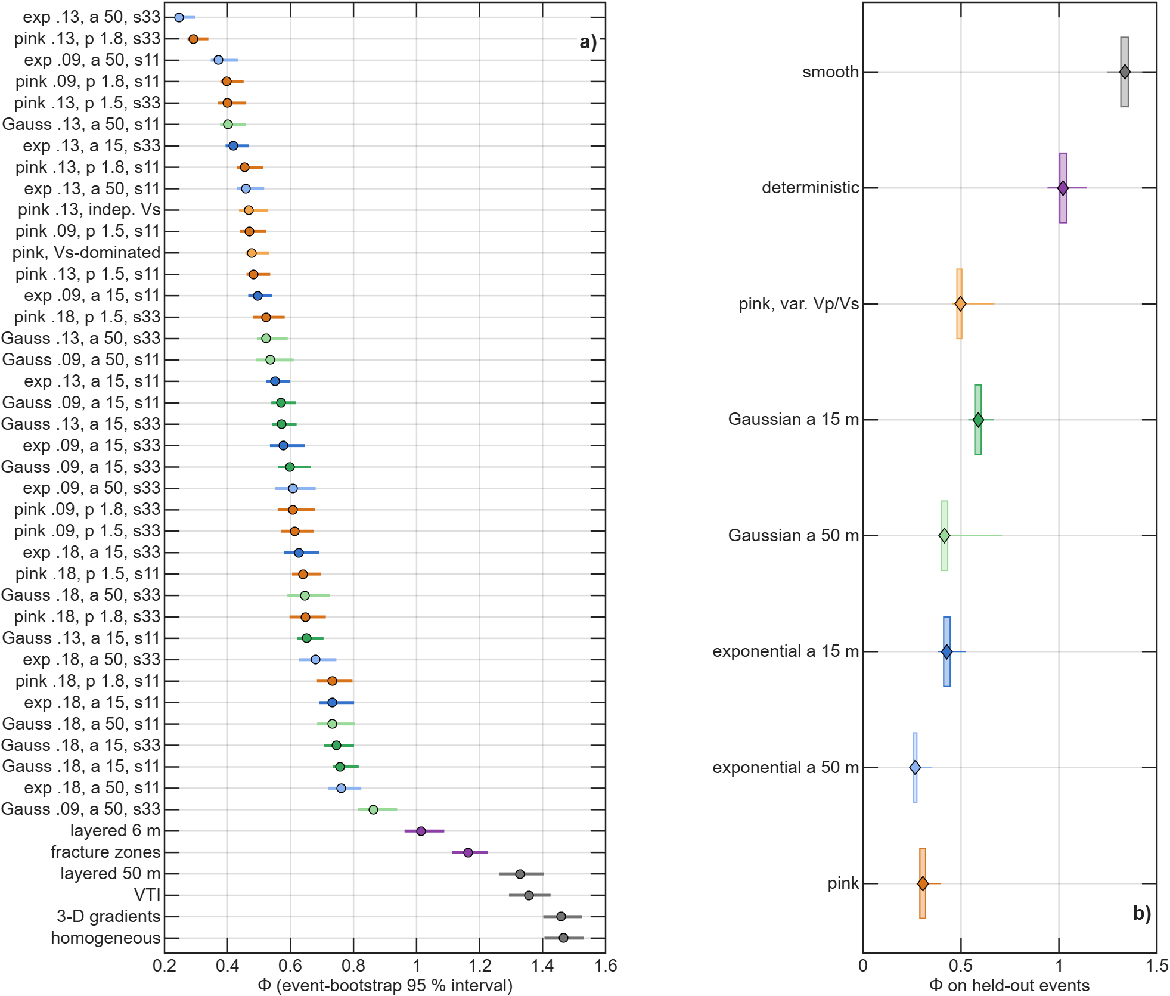
Fig. 8 Statistical misfit Φ with event-bootstrap intervals and holdout scores
a) Φ for all media with the full event set (circles) and 95 % event-bootstrap intervals (bars), sorted by Φ. Labels give family, σ, p or a (m) and white-noise seed (s11, s33). Grey: smooth media; purple: deterministic small-scale media; orange: pink; light orange: variable V_{P}/V_{S}; blue: exponential (dark a = 15 m, light a = 50 m); green: Gaussian (dark a = 15 m, light a = 50 m). The intervals reflect event resampling only, not realisation scatter. b) Held-out Φ of each family's best training member over 21 splits in both directions (box: interquartile range; whiskers: range).

Sonic-log spectrum
Fig. 9 shows the log spectrum with four fitted spectral models. The spectrum is consistent with a power law over 12–200 m, but this range spans only 1.2 decades. Short-correlation-length spectra fit almost as well, and the estimated slope depends on estimator and segment. The log therefore does not select a spectral family independently either.
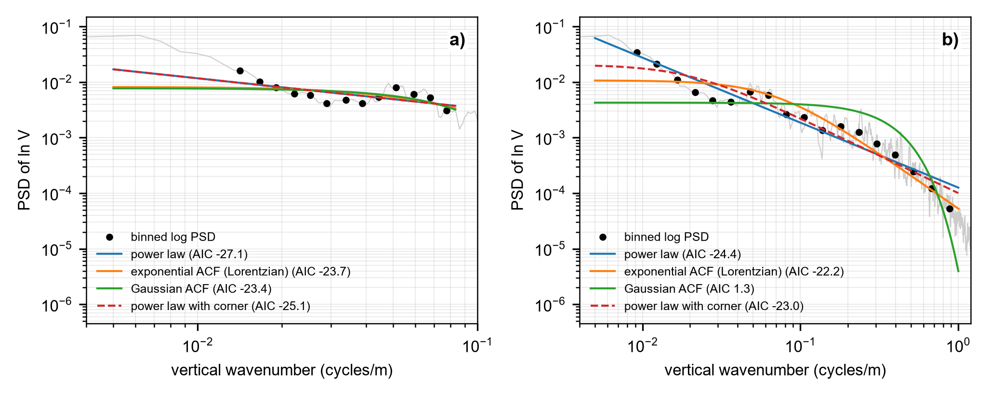
Fig. 9 Spectral models of the 56-32 sonic-log fluctuations
Multitaper power spectrum of detrended ln V (grey) and log-binned values (dots), with least-squares fits of a power law, exponential and Gaussian autocorrelation spectra and a power law with a corner (dashed). a) 12–200 m; the corner model converges to a pure power law and overlies it. b) 1–200 m. AIC values in the legend.

Discussion

What the data show
Media without structure below ~50 m (homogeneous, 50-m layering, smooth 3-D gradients, VTI) produce one to two orders of magnitude less late S energy than recorded, event by event. This deficit survives non-overlapping windows, alternative source constraints, finite source duration, S-timing selection and a bounded single-resonance ringing model, and the simulated coda is converged with respect to grid and absorbing boundary. The two simple deterministic media with structure at the 5–10 m scale that we tested, the logged layering at full resolution and twelve thin planar fracture zones, produce much of the missing energy, particularly at the deeper sensor. In the early coda such structure keeps neighbouring events coherent, whereas the observed coda decorrelates as in the stochastic media. In the pure late coda the planar fracture zones and the smooth media remain too coherent, but the 6-m layering and the stochastic media both approach the noise-limited coherence of the data. What remains true if the term "pink noise" is removed from this paper is therefore: within elastic modelling, the late S energy in the 56-32 records requires structure at the 5–10 m scale, and its decorrelation favours distributed 3-D heterogeneity over smooth media and planar fracture zones, without excluding fine layering, unless an unmodelled site or coupling response of comparable size is present.

What the data do not show
First, the waveforms do not identify the spectral family. At 20–80 Hz, power-law, exponential and Gaussian media reach comparable agreement once σ is adjusted, and the equal-σ truth tests do not separate pink from exponential media. The original analysis had suggested that the 100-Hz coda level (2.5-m grid, sensor B) rejects a large-scale Gaussian medium. That comparison used fixed σ = 0.13, two Gaussian realisations and noise-free synthetics, and changed grid, domain and sensor at once. We therefore report it only as an exploratory result (Additional file 1: Fig. S9). The same applies to the coda-attenuation diagnostics (Q_{c}⁻¹): at 25 Hz the coda window spans one to three periods and even the homogeneous medium yields a non-zero Q_{c}⁻¹. We treat them as finite-window diagnostics and draw no inference from the number of octave bands (Additional file 1: Figs. S7, S8).
Second, σ_{eff} is not a unique measure of rock heterogeneity. It absorbs every unmodelled contribution to the late energy: density contrasts, anisotropic or fluid-filled fracture scattering, intrinsic attenuation (which would reduce the coda and raise σ_{eff}), and site or coupling effects that the ringing test cannot exclude. It also depends on the simulation domain. In the reference domain σ_{eff} = 0.05–0.13, depending on sensor and family. One domain test (one medium, sensor B) suggests that these values may be about 1.7 times too large. In the original analysis, the misfit optimum (σ ≈ 0.18) and the per-event optimum (σ ≈ 0.09–0.13) disagreed with the sonic log (0.045 at 6-m averaging) by up to a factor of four. With non-overlapping windows, all events, separate sensors and the domain effect, the discrepancy is much reduced. Adding the domain effect to the pink medium with the log value (σ = 0.045) gives median ratios of −0.33 (A) and +0.42 (B), within a factor of about 3 at both sensors. This agreement rests on one domain test at one sensor and should be read as consistency, not as a measurement.
Third, the log and the wavefield sample different volumes: one vertical line through intact rock outside the stimulated zone, and the paths through the zone being stimulated. Stimulation might raise the scattering strength by opening fluid-filled fractures, which lower V_{S} preferentially. This is a hypothesis. A stage-by-stage comparison is not possible, because 402 of the 416 events belong to stage 3 (the 14 stage-2 events show no significant difference; Additional file 1: Table S8). No pre-stimulation waveforms exist for these paths. The V_{S}-dominated medium shows only that a V_{S}-weighted perturbation would produce similar late energy, and the fracture-zone medium shows that twelve planar zones are not enough; neither shows that stimulated fractures produced the coda. Denser 3-D fracture networks, rough interfaces, irregular damage zones and anisotropic compliance were not tested, and a sufficiently dense deterministic network would approach a random medium.

Implications
For microseismic practice, the result means that velocity models adequate for locating events at ~1-ms travel-time precision leave most of the late wavefield unexplained. Fine deterministic layering can supply much of its level, and its spatial incoherence is matched best, though not uniquely, by distributed 3-D heterogeneity. The late wavefield carries information on small-scale structure, but it must be compared statistically, because the realisation cannot be recovered from two sensors. For the GFI concept, the result is consistent but not decisive. Strong small-scale heterogeneity is required, and a lognormal power-law medium with roughly the logged σ provides it. The present seismic data do not, however, distinguish it from media with a short correlation length, nor fully from fine layering. Decisive tests of spectral shape need records at more stations, measured sensor transfer functions, larger simulation domains, and simulations above 100 Hz, where the families differ most. The 4-kHz FORGE records contain S energy above noise up to about 1.8 kHz (Additional file 1: Figs. S5, S6), but fixed-frequency tool resonances near 330, 480 and 920 Hz currently prevent interpreting that band as source or path energy.

Limitations
- Two sensors in one well, with unoriented horizontals and unreliable vertical channels; no calibration shots, perforation shots or independent sensors for 2022, so the sensor–borehole transfer function is not measured.
- Sensor positions, clock offsets and V_{P} trade off with the catalogue locations (~50 m, ~8 %).
- The stochastic media are isotropic, lognormal and elastic, with constant density; intrinsic attenuation, anisotropic fracture compliance and rough interfaces are not modelled.
- The domain-size effect on the stochastic coda was measured for one medium and one sensor; the correction of σ_{eff} is approximate.
- The common grid has two realisations per grid point, fewer than a full ensemble; realisation scatter limits σ_{eff} to about a factor of 1.8 for pink and short-a media and much more for large-a Gaussian media.
- The analysis band is 20–80 Hz, where the spectral families differ least.
- In the pure late coda the inter-event coherence is limited by noise and does not separate fine layering from distributed heterogeneity.

Conclusions
- Media without structure below ~50 m (homogeneous, 50-m layering, 3-D gradients, VTI) under-predict the late S energy of 416 FORGE MEQs by one to two orders of magnitude when the moment tensor is fitted to the direct waves only. The deficit is robust to windows, source constraints, source duration, event timing and a bounded in-band resonance, and the simulated coda is converged in grid and boundary.
- The tested simple deterministic 5–10 m structures (6-m sonic-log layering, twelve thin fracture zones) supply much of the late energy. In the early coda they keep neighbouring events more coherent than observed; in the pure late coda, where coherence is limited by noise, only the smooth media and the fracture zones remain distinguishable from the data.
- Stochastic 3-D media span the observed late energy and reproduce the loss of inter-event coherence more closely than the other tested media, with an effective scattering strength σ_{eff} = 0.05–0.13 in the reference domain. In one sensor-B sensitivity test, enlarging the domain implied that these values may be overestimated by a factor of about 1.7, which would bring them close to the sonic-log value of 0.045.
- Within 20–80 Hz the waveforms do not distinguish power-law, exponential and Gaussian spectra; the sonic log is compatible with a power law but does not exclude a short correlation length.
- Deterministic comparison against unknown stochastic realisations favours smooth media, so medium-class selection should use wavefield statistics.

Supplementary information
Additional file 1: Figures S1–S11 and Tables S1–S18 (reciprocity validation, sonic log, earlier statistical tests, bandwidth and multi-octave diagnostics, location stress test of the coda coherence, window and moment-tensor sensitivity, S-timing subsets, calibration bootstrap, source spectra, ringing tests, stage comparison, field statistics, numerical convergence, σ_{eff} curves, complete Φ and holdout tables, equal-σ truth tests, log-spectrum variants, per-event results for every medium and seed, and coda-coherence tables).

Availability of data and materials
The GES 2022 event catalogue is publicly available [10]. The 2022 56-32 SEG-2 downhole records are available from Utah FORGE and Geo-Energie Suisse on reasonable request. All code (FD solver, reciprocity, feature extraction, tests and figure scripts, with fixed random seeds) and all derived result tables are available at https://github.com/maswiet/Paper2_PinkNoise_WaveformInversion, release v1.0-submission (commit 1dab05b).

Competing interests
The authors declare that they have no competing interests.

Funding
This research received no specific grant from any funding agency in the public, commercial or not-for-profit sectors.

Authors' contributions
WS: conceptualisation, methodology, software, formal analysis, investigation, data curation, visualisation, writing – original draft. PL: conceptualisation of the geoflow-imaging (GFI) framework and of the pink-noise crustal model, methodology, writing – review and editing. Both authors read and approved the final manuscript.

Acknowledgements
We thank Heiner Igel for the acoustic finite-difference MATLAB codes from which the elastic solver used here was developed, Geo-Energie Suisse and the Utah FORGE project of the U.S. Department of Energy for the event catalogue and the downhole records, and an internal reviewer for a critical reading of earlier versions.

References
1. Aki K, Chouet B. Origin of coda waves: source, attenuation, and scattering effects. J Geophys Res. 1975;80:3322–42.
2. Sato H, Fehler MC, Maeda T. Seismic wave propagation and scattering in the heterogeneous Earth. 2nd ed. Berlin: Springer; 2012.
3. Frankel A, Clayton RW. Finite difference simulations of seismic scattering: implications for the propagation of short-period seismic waves in the crust and models of crustal heterogeneity. J Geophys Res. 1986;91:6465–89.
4. Leary P. Rock as a critical-point system and the inherent implausibility of reliable earthquake prediction. Geophys J Int. 1997;131:451–66.
5. Leary PC, Al-Kindy F. Power-law scaling of spatially correlated porosity and log(permeability) sequences from north-central North Sea Brae oilfield well core. Geophys J Int. 2002;148:426–42.
6. Holliger K. Upper-crustal seismic velocity heterogeneity as derived from a variety of P-wave sonic logs. Geophys J Int. 1996;125:813–29.
7. Leary P. The αβγ of EGS crustal heat extraction. J Energy Power Technol. 2026; in press.
8. Leary P. EGS sustainability: deconstructing UtahForge engineered geothermal system flow data. Sustainability. 2026;18:5308. https://doi.org/10.3390/su18115308.
9. Suryanto W, Leary P, Saunders G, Onto, Fleure T, Pramono B, et al. Data-constrained multiscale descriptors of heterogeneous flow and microseismicity in enhanced geothermal systems. Geotherm Energy. 2026; submitted.
10. Dyer B, Karvounis D. Utah FORGE: updated seismic event catalogue from the April 2022 stimulation of well 16A(78)-32. DOE Data Explorer. 2022. https://www.osti.gov/dataexplorer/biblio/dataset/1908927. Accessed 26 Sep 2026.
11. Maeda N. A method for reading and checking phase times in autoprocessing system of seismic wave data. Zisin. 1985;38:365–79.
12. Virieux J. P-SV wave propagation in heterogeneous media: velocity-stress finite-difference method. Geophysics. 1986;51:889–901.
13. Levander AR. Fourth-order finite-difference P-SV seismograms. Geophysics. 1988;53:1425–36.
14. Thomsen L. Weak elastic anisotropy. Geophysics. 1986;51:1954–66.
15. Igel H, Mora P, Riollet B. Anisotropic wave propagation through finite-difference grids. Geophysics. 1995;60:1203–16.
16. Igel H. Computational seismology: a practical introduction. Oxford: Oxford University Press; 2016.
17. Cerjan C, Kosloff D, Kosloff R, Reshef M. A nonreflecting boundary condition for discrete acoustic and elastic wave equations. Geophysics. 1985;50:705–8.
18. Zhao L, Chen P, Jordan TH. Strain Green's tensors, reciprocity, and their applications to seismic source and structure studies. Bull Seismol Soc Am. 2006;96:1753–63.

