Additional file 1 — Late S-wave energy in Utah FORGE downhole microearthquakes is not reproduced by smooth elastic models: 3-D tests against stochastic small-scale heterogeneity
Wiwit Suryanto, Peter Leary, [AUTHOR LIST TO BE CONFIRMED]
This file contains the diagnostics referred to in the main text. Figures S3, S4 and S10–S12 and Table S14 come from the original analysis (fixed σ = 0.13 for the exponential and Gaussian media, 150 events); they are retained for completeness and are superseded in the main text by the per-event test on all events, the common-grid comparison and the cluster-bootstrap coherence analysis.

Supplementary figures
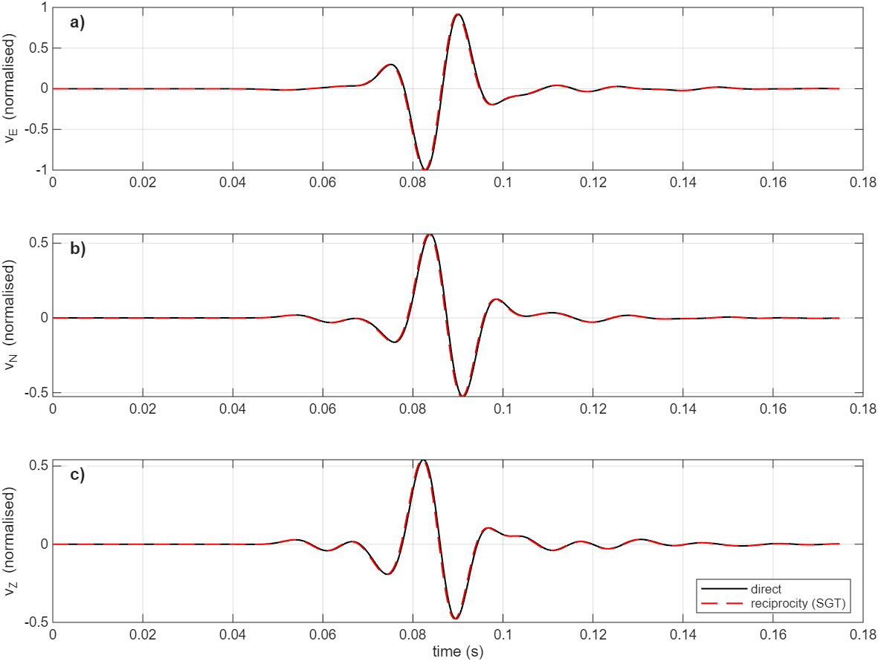
Fig. S1 Reciprocity validation in a heterogeneous VTI pink-noise medium (σ = 0.045, ε = 0.05, δ = 0.02, γ = 0.05). a–c) East, north and vertical velocity at a sensor from a direct double-couple simulation (black) and from the strain-Green's-tensor reciprocity synthetic (red dashed). Correlation and amplitude ratio are 0.995.
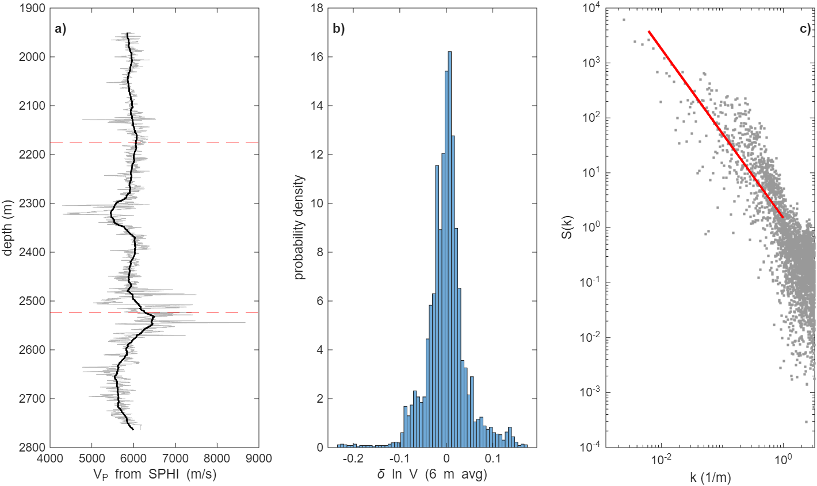
Fig. S2 The 56-32 sonic log. a) Sonic-derived V_{P} (grey) and its 50-m block average (black); dashed lines mark the depths of sensors A and B. b) Distribution of the detrended, 6-m-averaged δln V. c) Periodogram of δln V with the original power-law fit over 1–200 m. Slope uncertainty is given in Table S15 and main-text Fig. 9.
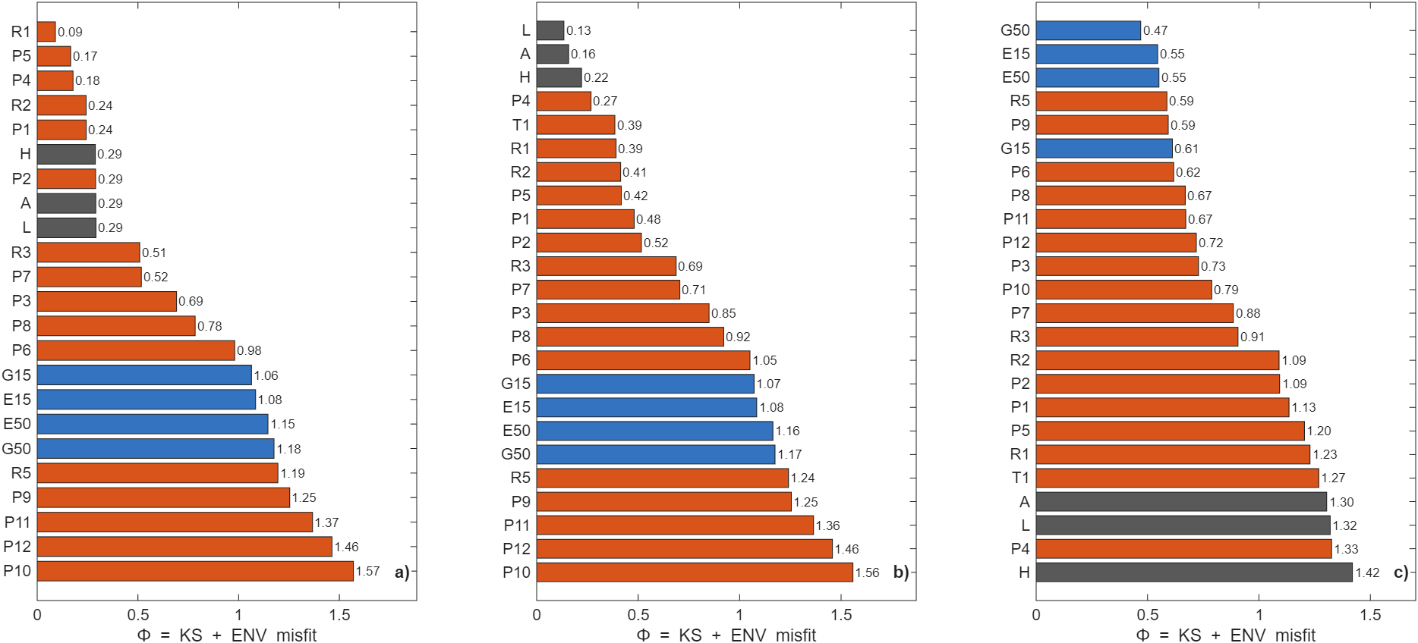
Fig. S3 Original statistical-misfit ranking (Φ) for a) the synthetic pink truth T1 (σ = 0.045), b) the layered-VTI truth T2 and c) FORGE (original model set: exponential and Gaussian media only at σ = 0.13). Grey: smooth media; orange: pink; blue: exponential and Gaussian. Lower is better. Superseded for FORGE by main-text Fig. 8.
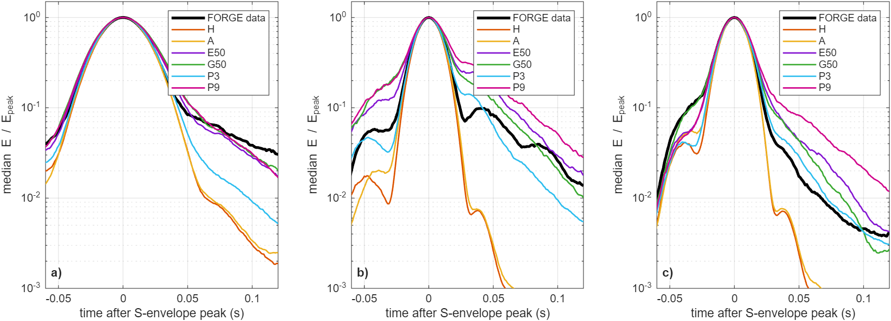
Fig. S4 Median S-coda envelopes aligned on the S peak and normalised by it: a) sensor A, 20–40 Hz; b) sensor A, 40–80 Hz; c) sensor B, 40–80 Hz. Black: FORGE; H homogeneous; A VTI; E50/G50 exponential/Gaussian (a = 50 m, σ = 0.13); P3/P9 pink (σ = 0.09/0.18).
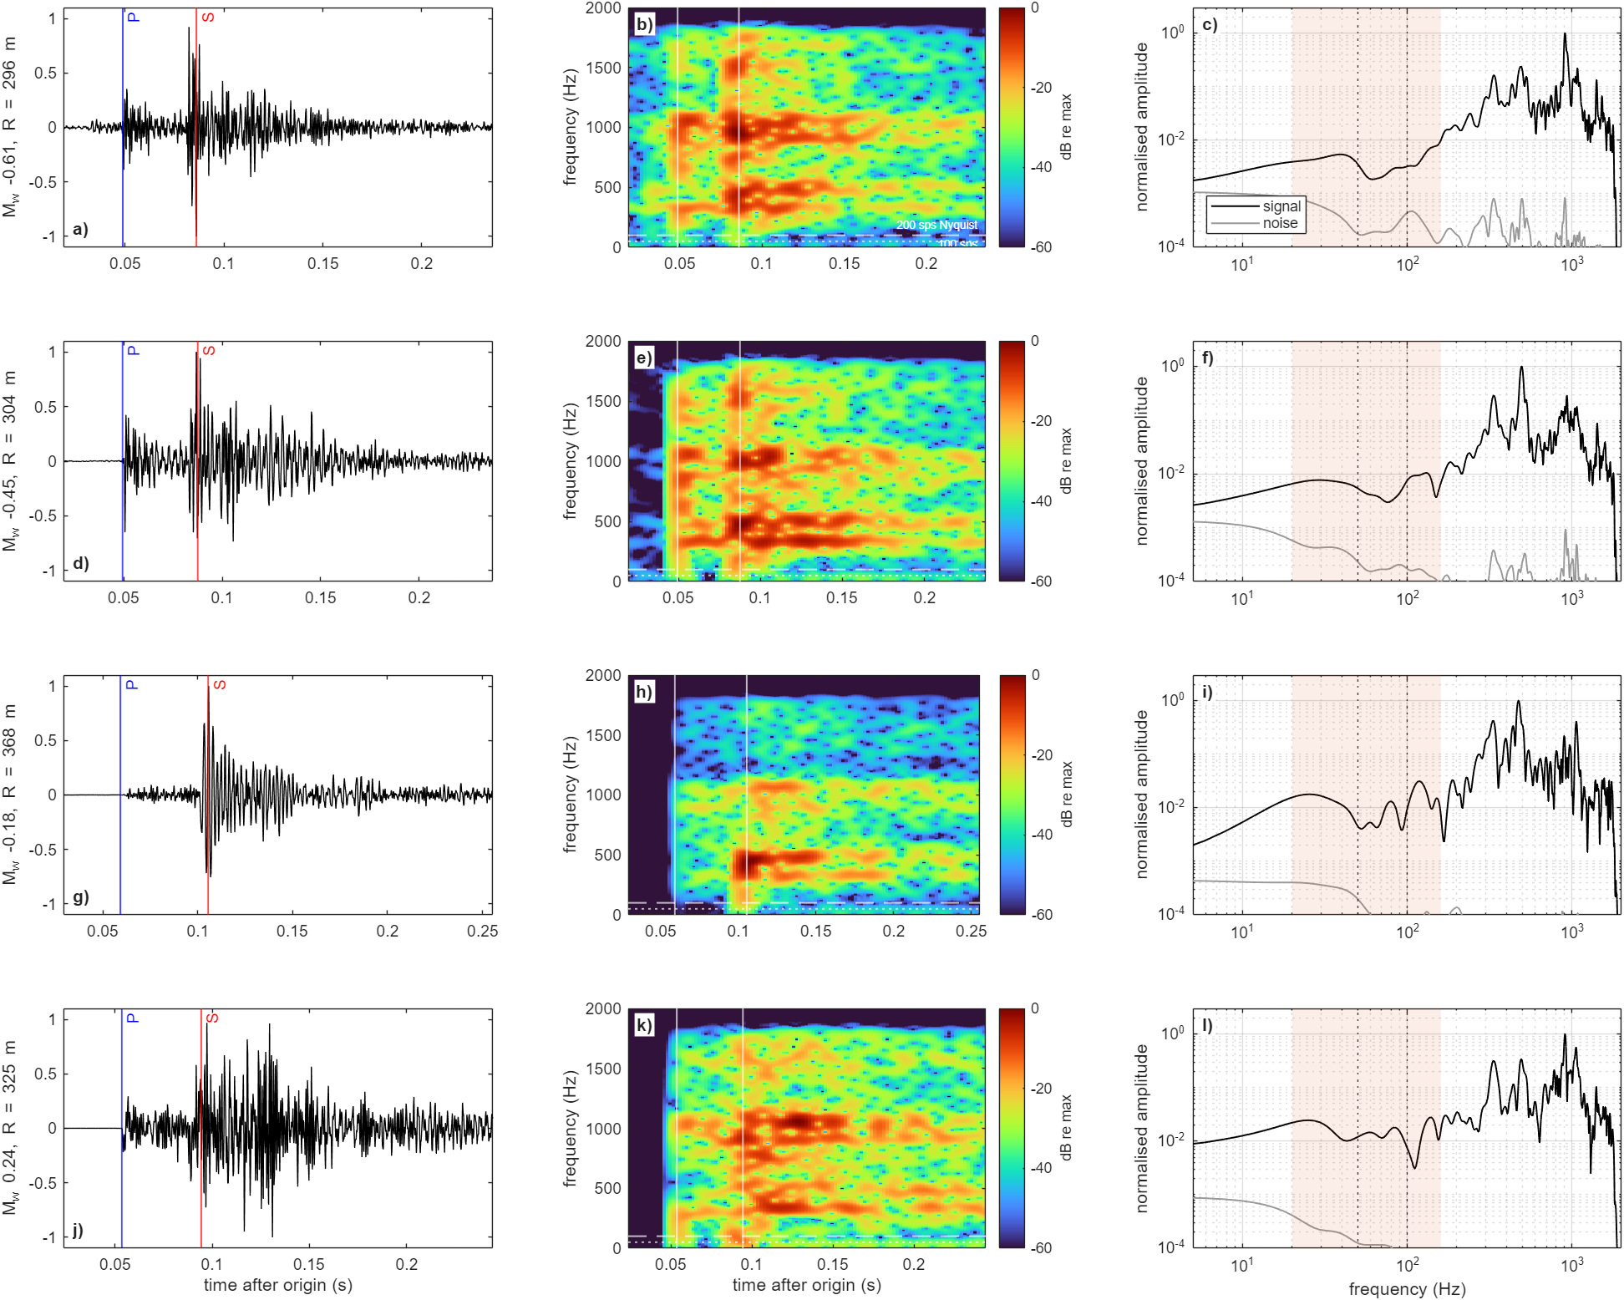
Fig. S5 Four example events (magnitude −0.61 to +0.24) at sensor B, 4 kHz. a, d, g, j) Horizontal velocity (> 5 Hz) with P (blue) and S (red). b, e, h, k) Spectrograms to 2 kHz on a common dB scale relative to each event's maximum; white dashed and dotted lines mark 100 and 50 Hz, the Nyquist frequencies of 200 and 100 sample/s recording. c, f, i, l) S-window spectrum (black) and pre-event noise (grey); shaded: FD analysis band.
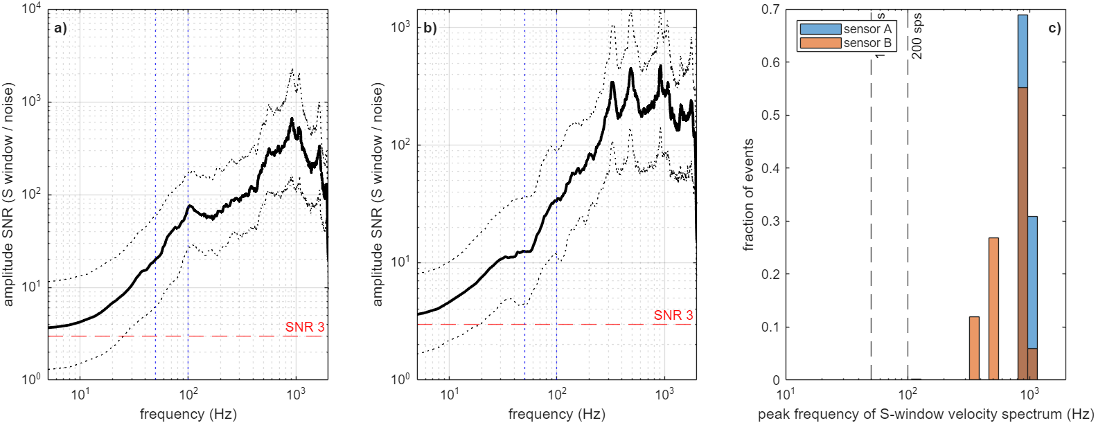
Fig. S6 a, b) Median (solid) and interquartile range (dotted) of the S-window amplitude SNR spectrum for sensors A and B; horizontal line at SNR = 3. c) Peak frequency of the S-window velocity spectrum for all events. The clustering near 330, 480 and 920 Hz indicates tool or coupling resonances; the share of recorded velocity energy above 100 Hz is therefore not a source or path property.
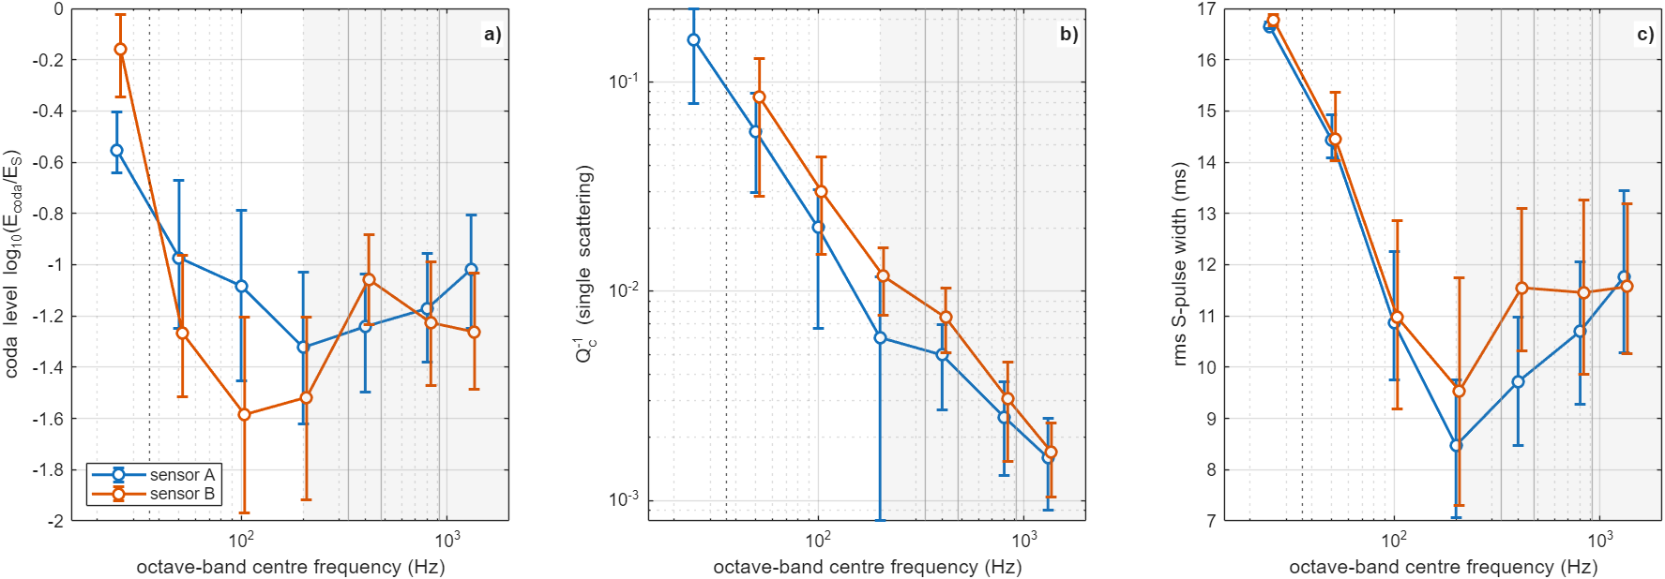
Fig. S7 FORGE coda measures in seven octave bands (25 Hz to 1.3 kHz): a) coda level, b) single-scattering Q_{c}⁻¹ (finite-window diagnostic; at 25 Hz the window spans one to three periods), c) rms S-pulse width. Median and interquartile range for sensors A and B. Shaded (> 200 Hz): affected by the resonances.
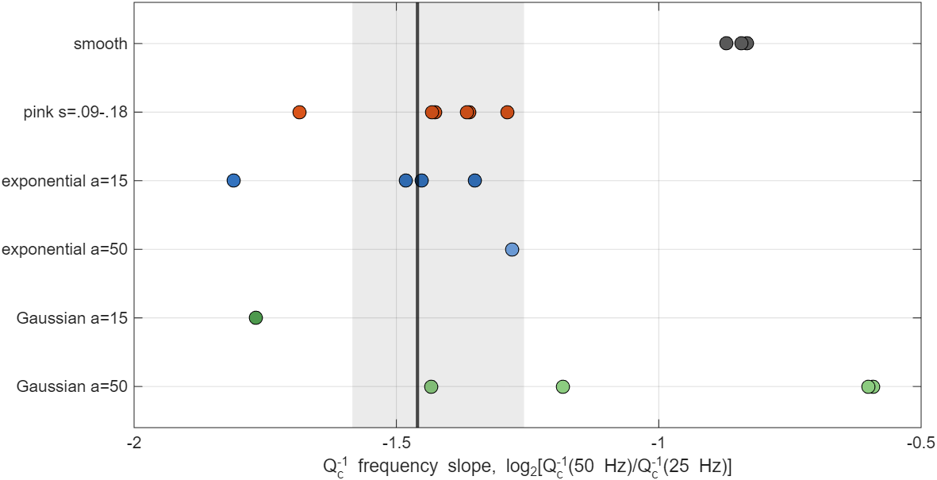
Fig. S8 Q_{c}⁻¹ frequency slope log₂[Q_{c}⁻¹(50 Hz)/Q_{c}⁻¹(25 Hz)] at sensor A, FORGE (black line, grey 95 % bootstrap band) and simulated media (dots). A finite-window diagnostic: data and synthetics are measured identically, but the absolute values are not medium properties.
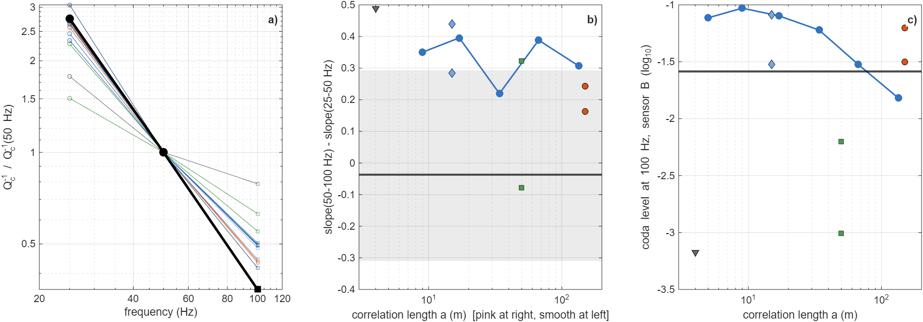
Fig. S9 Exploratory high-frequency series (2.5-m grid, sensor B, reduced volume, noise-free synthetics, σ = 0.13). a) Q_{c}⁻¹ normalised at 50 Hz from the 25–50 Hz (sensor A, 5-m grid) and 50–100 Hz (sensor B, 2.5-m grid) slopes. b) Curvature of Q_{c}⁻¹ versus correlation length. c) Coda level at 100 Hz versus correlation length; black line: FORGE. Grid, domain, sensor and event subset change together between the two octaves, so the comparison is not a pure frequency effect.
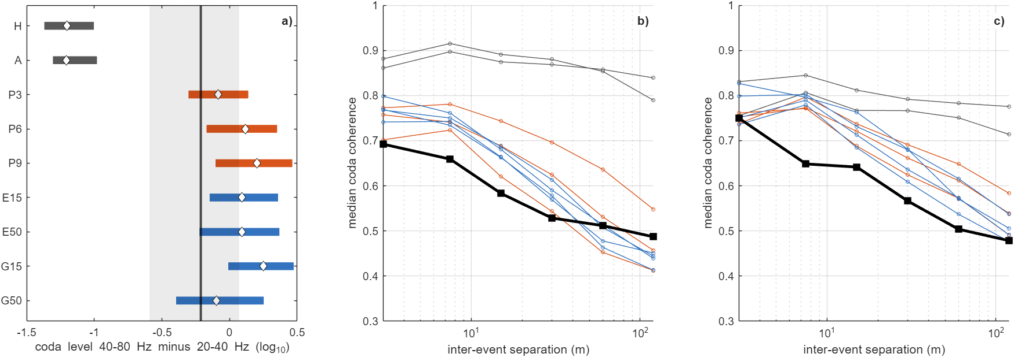
Fig. S10 Original D1 (coda level at 40–80 Hz minus 20–40 Hz, sensor A) and D2 (median coda coherence versus separation) without uncertainty; superseded by main-text Fig. 7.
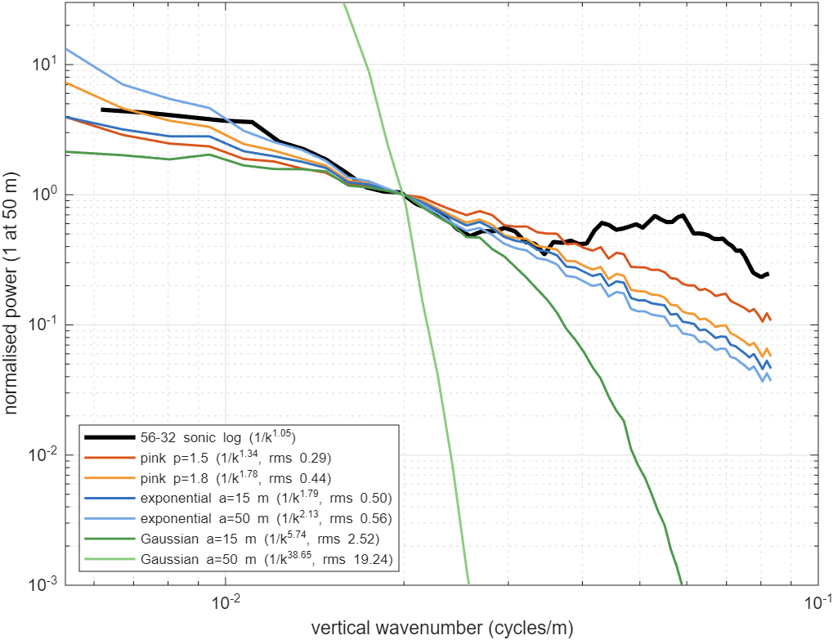
Fig. S11 Vertical fluctuation spectra of the 56-32 sonic log (black) and of the model media over 12–200 m, normalised at 50 m. The rms log difference in the legend is a descriptive distance, not a likelihood.
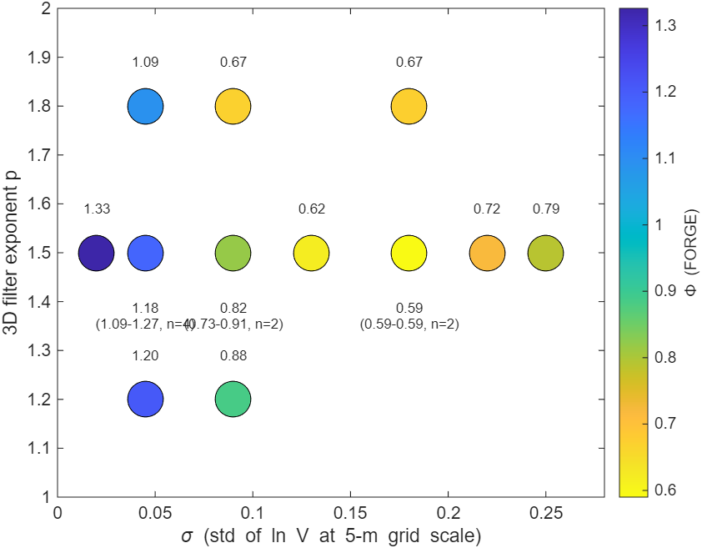
Fig. S12 Original Φ over the pink-family parameters (σ, p) for FORGE; mean and range where several realisations exist. σ = 0.22 and 0.25 have fewer than five grid points per minimum S wavelength at 80 Hz.

Supplementary tables
Table S1 Window sensitivity of the per-event coda test
Fit end (ms) | Coda (ms) | H | L | L6 | GRAD3 | FZ | A | P1 | P3 | P6 | G50
S + 15 | S + 40–100 | −1.80/−1.09 | −1.64/−1.17 | −1.28/−0.53 | −1.67/−1.11 | −1.04/−0.39 | −1.91/−1.19 | −0.74/+0.02 | −0.14/+0.53 | +0.31/+0.78 | +0.29/+0.54
S + 15 | S + 50–110 | −2.21/−1.41 | −1.99/−1.39 | −1.46/−0.64 | −2.11/−1.44 | −1.33/−0.65 | −2.15/−1.42 | −0.90/−0.08 | −0.30/+0.50 | +0.14/+0.76 | +0.16/+0.49
S + 15 | S + 30–100 | −1.58/−0.99 | −1.45/−1.03 | −1.11/−0.48 | −1.49/−1.02 | −0.82/−0.19 | −1.55/−1.05 | −0.60/+0.05 | −0.03/+0.45 | +0.39/+0.72 | +0.35/+0.55
S + 10 | S + 40–100 | −1.77/−1.07 | −1.64/−1.16 | −1.29/−0.52 | −1.65/−1.09 | −1.04/−0.33 | −1.91/−1.20 | −0.59/+0.03 | −0.07/+0.58 | +0.33/+0.88 | +0.31/+0.59
S + 10 | S + 50–110 | −2.17/−1.41 | −1.99/−1.40 | −1.44/−0.64 | −2.09/−1.43 | −1.32/−0.61 | −2.15/−1.42 | −0.78/−0.08 | −0.22/+0.52 | +0.17/+0.84 | +0.16/+0.54
S + 10 | S + 30–100 | −1.57/−0.96 | −1.46/−1.03 | −1.12/−0.48 | −1.47/−0.99 | −0.82/−0.16 | −1.58/−1.05 | −0.50/+0.04 | +0.04/+0.52 | +0.41/+0.84 | +0.37/+0.58
S + 20 | S + 40–100 | −1.79/−1.08 | −1.64/−1.18 | −1.28/−0.53 | −1.67/−1.11 | −1.07/−0.39 | −1.91/−1.19 | −0.72/−0.00 | −0.15/+0.50 | +0.28/+0.78 | +0.26/+0.50
S + 20 | S + 50–110 | −2.21/−1.41 | −2.00/−1.41 | −1.45/−0.62 | −2.11/−1.44 | −1.32/−0.67 | −2.15/−1.42 | −0.90/−0.10 | −0.34/+0.48 | +0.14/+0.75 | +0.11/+0.45
S + 20 | S + 30–100 | −1.58/−0.98 | −1.46/−1.04 | −1.11/−0.47 | −1.49/−1.02 | −0.85/−0.20 | −1.55/−1.03 | −0.58/+0.02 | −0.02/+0.42 | +0.36/+0.68 | +0.31/+0.50
S + 60 | S + 40–100 | −1.79/−1.09 | −1.65/−1.18 | −1.28/−0.55 | −1.67/−1.13 | −1.13/−0.48 | −1.89/−1.20 | −0.86/−0.17 | −0.34/+0.28 | +0.10/+0.50 | +0.16/+0.25
S + 60 | S + 50–110 | −2.22/−1.41 | −1.98/−1.40 | −1.45/−0.63 | −2.12/−1.45 | −1.40/−0.74 | −2.14/−1.42 | −1.04/−0.21 | −0.48/+0.28 | +0.00/+0.53 | +0.07/+0.16
S + 60 | S + 30–100 | −1.59/−0.99 | −1.45/−1.03 | −1.12/−0.50 | −1.50/−1.03 | −0.93/−0.29 | −1.54/−1.03 | −0.73/−0.15 | −0.21/+0.25 | +0.23/+0.44 | +0.22/+0.22
Median log₁₀(predicted/observed late energy), sensor A/B. The fit window starts at P − 10 ms. Rows with fit end S + 60 ms overlap the coda window (original analysis).
Table S2 Moment-tensor variants: coda prediction, fit, conditioning and decomposition
Medium | Full A/B | Deviatoric A/B | DC A/B | VR full | VR dev | VR DC | Cond. median (p90) | |ISO|/|CLVD|/DC (%)
H | −1.80/−1.09 | −1.83/−1.09 | −1.82/−1.11 | 0.75 | 0.71 | 0.67 | 17.6 (19.3) | 28/28/41
L | −1.64/−1.17 | −1.70/−1.16 | −1.71/−1.18 | 0.73 | 0.68 | 0.64 | 17.4 (18.8) | 29/31/38
L6 | −1.28/−0.53 | −1.33/−0.51 | −1.34/−0.51 | 0.73 | 0.68 | 0.66 | 17.8 (19.4) | 29/35/37
GRAD3 | −1.67/−1.11 | −1.69/−1.11 | −1.69/−1.13 | 0.74 | 0.69 | 0.66 | 17.4 (19.0) | 28/26/42
FZ | −1.04/−0.39 | −1.19/−0.49 | −1.24/−0.58 | 0.73 | 0.69 | 0.65 | 15.4 (18.5) | 30/27/41
A | −1.91/−1.19 | −2.04/−1.21 | −2.10/−1.25 | 0.64 | 0.59 | 0.54 | 16.4 (24.7) | 28/35/36
P1 | −0.74/+0.02 | −0.91/−0.16 | −0.93/−0.29 | 0.72 | 0.64 | 0.61 | 12.0 (17.0) | 34/28/36
P3 | −0.14/+0.53 | −0.22/+0.41 | −0.26/+0.35 | 0.67 | 0.60 | 0.57 | 8.1 (13.6) | 36/24/37
P6 | +0.31/+0.78 | +0.28/+0.73 | +0.23/+0.72 | 0.62 | 0.55 | 0.52 | 6.6 (11.1) | 35/22/41
E15 | +0.28/+0.94 | +0.34/+0.88 | +0.31/+0.84 | 0.64 | 0.55 | 0.51 | 6.2 (9.5) | 34/23/39
E50 | +0.31/+0.71 | +0.24/+0.69 | +0.23/+0.64 | 0.59 | 0.54 | 0.50 | 6.5 (10.6) | 30/21/42
G15 | +0.42/+1.12 | +0.41/+1.03 | +0.39/+0.98 | 0.64 | 0.55 | 0.52 | 6.5 (9.5) | 36/22/37
G50 | +0.29/+0.54 | +0.30/+0.57 | +0.30/+0.52 | 0.56 | 0.51 | 0.48 | 5.7 (8.1) | 31/24/41
VSD | −0.13/+0.54 | −0.14/+0.49 | −0.19/+0.46 | 0.66 | 0.62 | 0.58 | 8.8 (14.7) | 25/27/41
VSO | +0.32/+0.79 | +0.27/+0.74 | +0.22/+0.68 | 0.62 | 0.55 | 0.52 | 6.3 (11.3) | 31/23/42
Median log₁₀(pred/obs) at the primary windows. Condition number of the column-normalised design matrix. Decomposition of the full solutions (median absolute percentages); with two sensors in one well the non-DC parts are poorly resolved and are not interpreted.
Table S3 Per-event coda test for well-timed event subsets
Medium | All (416) | S peak ±10 ms (250) | S peak ±5 ms (168)
H | −1.80/−1.09 | −1.64/−0.98 | −1.58/−0.98
L | −1.64/−1.17 | −1.42/−1.14 | −1.35/−1.13
L6 | −1.28/−0.53 | −1.10/−0.53 | −1.04/−0.55
GRAD3 | −1.67/−1.11 | −1.52/−1.04 | −1.41/−1.05
FZ | −1.04/−0.39 | −0.88/−0.35 | −0.87/−0.42
A | −1.91/−1.19 | −1.70/−1.17 | −1.62/−1.20
P1 | −0.74/+0.02 | −0.46/+0.08 | −0.36/+0.05
P3 | −0.14/+0.53 | +0.02/+0.53 | +0.08/+0.51
P6 | +0.31/+0.78 | +0.38/+0.81 | +0.40/+0.80
E15 | +0.28/+0.94 | +0.39/+0.98 | +0.40/+0.95
E50 | +0.31/+0.71 | +0.45/+0.72 | +0.52/+0.68
G15 | +0.42/+1.12 | +0.64/+1.12 | +0.70/+1.09
G50 | +0.29/+0.54 | +0.51/+0.53 | +0.52/+0.53
Median log₁₀(pred/obs), sensor A/B. Subsets: events whose observed 40–80 Hz S-envelope peak lies within the stated interval of the predicted S time on both sensors.
Table S4 Sensor self-calibration: event bootstrap and leave-one-stage-out
Parameter | Estimate | Bootstrap s.d. | 95 % interval | Without stage 2 | Without stage 3
East (m) | 833.4 | 2.3 | [827.7, 836.7] | 826.0 | 834.0
North (m) | −5.9 | 3.1 | [−11.0, 2.2] | −9.9 | 9.0
Depth A (m) | 2179.5 | 6.1 | [2166.5, 2191.4] | 2182.1 | 2231.4
Depth B (m) | 2522.5 | 1.9 | [2519.4, 2526.3] | 2519.4 | 2573.9
Clock A (ms) | −5.0 | 0.9 | [−7.5, −3.7] | −6.7 | −7.6
Clock B (ms) | −3.0 | 0.6 | [−4.5, −2.3] | −4.4 | −11.7
V_{P} (m/s) | 5808.3 | 42.7 | [5710.2, 5873.0] | 5653.1 | 5372.6
Event bootstrap (500 resamples). Leaving out stage 3 (most events) shifts both sensors ~50 m deeper and lowers V_{P} by 8 %: depth, clock and velocity trade off with the catalogue locations, so the bootstrap intervals understate the true uncertainty.
Table S5 Apparent corner frequencies of S-window displacement spectra
Sensor | Magnitude | Events | % corner ≤ 300 Hz | Median corner (Hz) | % corner < 80 Hz | Slope 30–150 Hz
A | all | 550 | 99 | 128 | 21 | −0.45
A | −1 to −0.3 | 381 | 99 | 143 | 16 | −0.21
A | −0.3 to 0.3 | 165 | 100 | 100 | 31 | −0.75
A | ≥ 0.3 | 4 | 100 | 87 | 50 | −1.27
B | all | 533 | 85 | 90 | 34 | −0.52
B | −1 to −0.3 | 366 | 82 | 90 | 34 | −0.39
B | −0.3 to 0.3 | 163 | 92 | 90 | 35 | −0.74
B | ≥ 0.3 | 4 | 100 | 58 | 75 | −1.28
Apparent corner: first frequency above 50 Hz at which the smoothed displacement spectrum falls 6 dB below its 30–50 Hz level (searched to 300 Hz, below the resonances). It includes path attenuation and is therefore a lower bound on the source corner. Slope: log–log displacement-spectrum slope where amplitude SNR > 3.
Table S6 Sensitivity of synthetic late energy and S width to source duration
Medium | Brune corner (Hz) | Sensor | log₁₀ coda/S | S width (ms)
H | impulsive | A | −3.09 | 8.9
H | impulsive | B | −3.06 | 9.1
H | 150 | A | −2.95 | 9.0
H | 150 | B | −2.92 | 9.2
H | 100 | A | −2.87 | 9.2
H | 100 | B | −2.84 | 9.4
H | 60 | A | −2.74 | 9.4
H | 60 | B | −2.71 | 9.6
P6 | impulsive | A | −0.98 | 12.3
P6 | impulsive | B | −1.50 | 10.9
P6 | 150 | A | −0.95 | 12.4
P6 | 150 | B | −1.48 | 11.0
P6 | 100 | A | −0.94 | 12.5
P6 | 100 | B | −1.47 | 11.1
P6 | 60 | A | −0.95 | 12.7
P6 | 60 | B | −1.44 | 11.2
Homogeneous (H) and pink σ = 0.13 (P6) synthetics with double-couple sources, convolved with Brune moment-rate functions; median over events; windows as in the main text.
Table S7 Ringing tests: spectral-peak prominence and null-ringing deficits
Sensor / test | Band / resonance | S-spectrum peak prominence (dB) | Coda/S ratio peak prominence (dB)
A | 30-120 | 0.30 | 0.17
A | 280-380 | 0.29 | 0.47
A | 420-560 | 1.50 | 0.60
A | 850-1000 | 6.47 | 0.58
B | 30-120 | 0.35 | 0.36
B | 280-380 | 5.29 | 1.26
B | 420-560 | 7.86 | 1.92
B | 850-1000 | 9.60 | 0.36
null test | f_{r} 40 Hz, Q 5 | deficit A −1.99 | deficit B −1.33
null test | f_{r} 40 Hz, Q 10 | deficit A −1.98 | deficit B −1.32
null test | f_{r} 40 Hz, Q 20 | deficit A −1.93 | deficit B −1.28
null test | f_{r} 40 Hz, Q 40 | deficit A −1.91 | deficit B −1.26
null test | f_{r} 50 Hz, Q 5 | deficit A −1.63 | deficit B −0.97
null test | f_{r} 50 Hz, Q 10 | deficit A −1.61 | deficit B −0.96
null test | f_{r} 50 Hz, Q 20 | deficit A −1.67 | deficit B −1.02
null test | f_{r} 50 Hz, Q 40 | deficit A −1.72 | deficit B −1.06
null test | f_{r} 60 Hz, Q 5 | deficit A −1.90 | deficit B −1.24
null test | f_{r} 60 Hz, Q 10 | deficit A −1.88 | deficit B −1.23
null test | f_{r} 60 Hz, Q 20 | deficit A −1.87 | deficit B −1.21
null test | f_{r} 60 Hz, Q 40 | deficit A −1.87 | deficit B −1.21
null test | f_{r} 70 Hz, Q 5 | deficit A −1.85 | deficit B −1.18
null test | f_{r} 70 Hz, Q 10 | deficit A −1.80 | deficit B −1.15
null test | f_{r} 70 Hz, Q 20 | deficit A −1.80 | deficit B −1.15
null test | f_{r} 70 Hz, Q 40 | deficit A −1.82 | deficit B −1.16
null test | f_{r} 80 Hz, Q 5 | deficit A −1.82 | deficit B −1.17
null test | f_{r} 80 Hz, Q 10 | deficit A −1.82 | deficit B −1.17
null test | f_{r} 80 Hz, Q 20 | deficit A −1.84 | deficit B −1.18
null test | f_{r} 80 Hz, Q 40 | deficit A −1.85 | deficit B −1.19
Upper rows: maximum prominence of peaks in the smoothed median S spectrum and coda/S spectral ratio. Lower rows: homogeneous synthetics convolved with a single resonance scaled so that its spectral peak equals the observed 30–120 Hz prominence; deficit = log₁₀ of predicted/observed median coda/S.
Table S8 Observed late energy by stimulation stage
Sensor | Stage | Events | Median log₁₀ coda/S | Median distance (m)
A | 2 | 14 | −1.52 | 484
A | 3 | 402 | −1.23 | 392
B | 2 | 14 | −1.62 | 379
B | 3 | 402 | −1.88 | 300
Stage 2 has only 14 events and differs from stage 3 also in distance; a stage-by-stage test of stimulation-dependent scattering is not possible with these data.
Table S9 Random-field statistics after truncation
Medium | σ(ln V) after truncation | % cells truncated | V_{P} range (m/s) | V_{S} range (m/s)
pink s.13 p1.5 | 0.1297 | 0.28 | 3933–8579 | 2273–4959
pink s.18 p1.5 | 0.1780 | 1.25 | 3704–9109 | 2141–5265
exp a15 s.13 | 0.1297 | 0.28 | 3933–8579 | 2273–4959
exp a50 s.13 | 0.1297 | 0.25 | 3933–8579 | 2273–4959
Gauss a15 s.13 | 0.1296 | 0.28 | 3933–8579 | 2273–4959
Gauss a50 s.13 | 0.1297 | 0.26 | 3933–8579 | 2273–4959
Truncation at ±3σ (±2.5σ for σ > 0.15) without renormalisation; density is constant (2650 kg/m³).
Table S10 Numerical convergence of coda measures
Case | Measure | Band | Median 5-m reference | Median case | Median difference | Robust s.d. of difference | Events
C25 | log10 coda/S (S+40-100 ms) | 20-40 Hz | −1.4 | −1.23 | +0.156 | 0.127 | 358
C25 | log10 coda/S (S+40-100 ms) | 40-80 Hz | −1.41 | −1.42 | +0.007 | 0.109 | 358
C25 | coda level (log10) | 20-40 Hz | −0.704 | −0.67 | +0.036 | 0.044 | 358
C25 | coda level (log10) | 40-80 Hz | −0.945 | −0.953 | +0.002 | 0.076 | 358
C25 | log10 Qc^−1 | 20-40 Hz | −0.699 | −0.749 | +0.057 | 0.144 | 358
C25 | log10 Qc^−1 | 40-80 Hz | −1.02 | −0.991 | +0.026 | 0.072 | 358
C25 | S width (ms) | 20-40 Hz | 16.5 | 16.5 | +0.022 | 0.047 | 358
C25 | S width (ms) | 40-80 Hz | 14.5 | 14.6 | −0.004 | 0.228 | 358
C25 | decay rate (1/s) | 20-40 Hz | 49 | 45.4 | −3.082 | 4.920 | 358
C25 | decay rate (1/s) | 40-80 Hz | 48.4 | 50.8 | +2.141 | 5.484 | 358
CBIG | log10 coda/S (S+40-100 ms) | 20-40 Hz | −1.4 | −1.27 | +0.090 | 0.279 | 358
CBIG | log10 coda/S (S+40-100 ms) | 40-80 Hz | −1.41 | −0.982 | +0.403 | 0.240 | 358
CBIG | coda level (log10) | 20-40 Hz | −0.704 | −0.687 | +0.011 | 0.097 | 358
CBIG | coda level (log10) | 40-80 Hz | −0.945 | −0.726 | +0.187 | 0.175 | 358
CBIG | log10 Qc^−1 | 20-40 Hz | −0.699 | −0.983 | −0.262 | 0.239 | 358
CBIG | log10 Qc^−1 | 40-80 Hz | −1.02 | −1.68 | −0.669 | 0.522 | 358
CBIG | S width (ms) | 20-40 Hz | 16.5 | 16.4 | −0.023 | 0.065 | 358
CBIG | S width (ms) | 40-80 Hz | 14.5 | 14.6 | +0.023 | 0.194 | 358
CBIG | decay rate (1/s) | 20-40 Hz | 49 | 32.4 | −14.958 | 11.486 | 358
CBIG | decay rate (1/s) | 40-80 Hz | 48.4 | 20.6 | −26.329 | 13.229 | 358
CSP | log10 coda/S (S+40-100 ms) | 20-40 Hz | −1.4 | −1.5 | −0.131 | 0.210 | 358
CSP | log10 coda/S (S+40-100 ms) | 40-80 Hz | −1.41 | −1.27 | +0.125 | 0.135 | 358
CSP | coda level (log10) | 20-40 Hz | −0.704 | −0.74 | −0.035 | 0.061 | 358
CSP | coda level (log10) | 40-80 Hz | −0.945 | −0.904 | +0.052 | 0.082 | 358
CSP | log10 Qc^−1 | 20-40 Hz | −0.699 | −0.727 | +0.076 | 0.158 | 358
CSP | log10 Qc^−1 | 40-80 Hz | −1.02 | −1.12 | −0.095 | 0.084 | 358
CSP | S width (ms) | 20-40 Hz | 16.5 | 16.4 | −0.034 | 0.050 | 358
CSP | S width (ms) | 40-80 Hz | 14.5 | 14.6 | +0.001 | 0.125 | 358
CSP | decay rate (1/s) | 20-40 Hz | 49 | 46.8 | −1.337 | 8.200 | 358
CSP | decay rate (1/s) | 40-80 Hz | 48.4 | 41 | −6.333 | 4.949 | 358
C25: 2.5-m grid; CBIG: domain enlarged by 150 m on every side; CSP: sponge of 40 instead of 20 nodes. Same band-limited medium (σ = 0.13), sensor B, events and double-couple mechanisms as the 5-m reference C5. Differences are per event.
Table S11 Median predicted/observed late energy versus σ, and σ_{eff}
Family | σ | Realisations | Median log₁₀(pred/obs), A | Median, B
pink15 | 0.020 | 1 | −1.20 | −0.49
pink15 | 0.045 | 4 | −0.75 | −0.11
pink15 | 0.090 | 2 | −0.19 | +0.38
pink15 | 0.130 | 2 | +0.29 | +0.59
pink15 | 0.180 | 2 | +0.71 | +0.85
pink18 | 0.045 | 1 | −0.73 | −0.03
pink18 | 0.090 | 2 | −0.12 | +0.28
pink18 | 0.130 | 2 | +0.38 | +0.53
pink18 | 0.180 | 2 | +0.90 | +0.85
exp15 | 0.090 | 2 | −0.04 | +0.50
exp15 | 0.130 | 2 | +0.34 | +0.79
exp15 | 0.180 | 2 | +0.77 | +1.06
exp50 | 0.090 | 2 | −0.20 | +0.16
exp50 | 0.130 | 2 | +0.38 | +0.44
exp50 | 0.180 | 2 | +0.98 | +0.91
gau15 | 0.090 | 2 | +0.18 | +0.70
gau15 | 0.130 | 2 | +0.49 | +1.00
gau15 | 0.180 | 2 | +0.82 | +1.28
gau50 | 0.090 | 2 | −0.47 | −0.58
gau50 | 0.130 | 2 | +0.33 | −0.02
gau50 | 0.180 | 2 | +0.95 | +0.70
pink15 | σ_{eff} |  | 0.104 | 0.053
pink18 | σ_{eff} |  | 0.098 | 0.048
exp15 | σ_{eff} |  | 0.093 | outside grid
exp50 | σ_{eff} |  | 0.102 | outside grid
gau15 | σ_{eff} |  | outside grid | outside grid
gau50 | σ_{eff} |  | 0.112 | 0.131
Averaged over realisations; σ_{eff} interpolated linearly in ln σ at the zero crossing.
Table S12 Statistical misfit Φ with event-bootstrap 95 % intervals
Medium | Family | σ | p or a (m) | Φ | 95 % interval
X_exp_0.13_50_33 | exp50 | 0.130 | 50 | 0.246 | [0.237, 0.297]
X_pink_0.13_1.8_33 | pink | 0.130 | 1.8 | 0.291 | [0.273, 0.339]
X_exp_0.09_50_11 | exp50 | 0.090 | 50 | 0.371 | [0.347, 0.432]
P8 | pink | 0.090 | 1.8 | 0.397 | [0.377, 0.451]
R6 | pink | 0.130 | 1.5 | 0.400 | [0.370, 0.459]
G50 | gau50 | 0.130 | 50 | 0.402 | [0.377, 0.459]
E15b | exp15 | 0.130 | 15 | 0.418 | [0.394, 0.467]
X_pink_0.13_1.8_11 | pink | 0.130 | 1.8 | 0.455 | [0.429, 0.512]
E50 | exp50 | 0.130 | 50 | 0.459 | [0.431, 0.516]
VSD | pink-VpVs | 0.130 | 1.5 | 0.468 | [0.437, 0.529]
P3 | pink | 0.090 | 1.5 | 0.469 | [0.440, 0.522]
VSO | pink-VpVs | 0.130 | 1.5 | 0.476 | [0.457, 0.531]
P6 | pink | 0.130 | 1.5 | 0.483 | [0.460, 0.536]
X_exp_0.09_15_11 | exp15 | 0.090 | 15 | 0.496 | [0.466, 0.541]
R5 | pink | 0.180 | 1.5 | 0.522 | [0.480, 0.581]
G50b | gau50 | 0.130 | 50 | 0.523 | [0.493, 0.591]
X_gau_0.09_50_11 | gau50 | 0.090 | 50 | 0.535 | [0.491, 0.610]
E15 | exp15 | 0.130 | 15 | 0.551 | [0.522, 0.598]
X_gau_0.09_15_11 | gau15 | 0.090 | 15 | 0.569 | [0.539, 0.617]
X_gau_0.13_15_33 | gau15 | 0.130 | 15 | 0.572 | [0.541, 0.619]
X_exp_0.09_15_33 | exp15 | 0.090 | 15 | 0.577 | [0.535, 0.645]
X_gau_0.09_15_33 | gau15 | 0.090 | 15 | 0.598 | [0.559, 0.665]
X_exp_0.09_50_33 | exp50 | 0.090 | 50 | 0.608 | [0.552, 0.680]
X_pink_0.09_1.8_33 | pink | 0.090 | 1.8 | 0.609 | [0.559, 0.678]
R3 | pink | 0.090 | 1.5 | 0.613 | [0.570, 0.673]
X_exp_0.18_15_33 | exp15 | 0.180 | 15 | 0.627 | [0.579, 0.690]
P9 | pink | 0.180 | 1.5 | 0.640 | [0.605, 0.697]
X_gau_0.18_50_33 | gau50 | 0.180 | 50 | 0.646 | [0.590, 0.726]
X_pink_0.18_1.8_33 | pink | 0.180 | 1.8 | 0.647 | [0.597, 0.712]
G15 | gau15 | 0.130 | 15 | 0.652 | [0.621, 0.705]
X_exp_0.18_50_33 | exp50 | 0.180 | 50 | 0.679 | [0.626, 0.746]
P11 | pink | 0.180 | 1.8 | 0.732 | [0.684, 0.797]
X_exp_0.18_15_11 | exp15 | 0.180 | 15 | 0.733 | [0.691, 0.802]
X_gau_0.18_50_11 | gau50 | 0.180 | 50 | 0.733 | [0.685, 0.804]
X_gau_0.18_15_33 | gau15 | 0.180 | 15 | 0.745 | [0.706, 0.802]
X_gau_0.18_15_11 | gau15 | 0.180 | 15 | 0.757 | [0.735, 0.817]
X_exp_0.18_50_11 | exp50 | 0.180 | 50 | 0.761 | [0.719, 0.825]
X_gau_0.09_50_33 | gau50 | 0.090 | 50 | 0.863 | [0.814, 0.939]
L6 | deterministic |  |  | 1.014 | [0.962, 1.088]
FZ | deterministic |  |  | 1.165 | [1.113, 1.227]
L | smooth |  |  | 1.328 | [1.263, 1.403]
A | smooth |  |  | 1.356 | [1.293, 1.425]
GRAD3 | smooth |  |  | 1.459 | [1.403, 1.526]
H | smooth |  |  | 1.466 | [1.406, 1.532]
200 event-bootstrap resamples (identical for every medium). Φ as defined in the main text.
Table S13 Family comparison: best member, bootstrap and holdout
Family | Best Φ | Bootstrap median [95 %] | % bootstrap wins | Held-out Φ median [range]
exp50 | 0.246 | 0.264 [0.237, 0.297] | 98 | 0.265 [0.242, 0.353]
pink | 0.291 | 0.306 [0.273, 0.339] | 2 | 0.307 [0.273, 0.399]
gau50 | 0.402 | 0.414 [0.377, 0.459] | 0 | 0.416 [0.381, 0.709]
exp15 | 0.418 | 0.429 [0.394, 0.467] | 0 | 0.427 [0.383, 0.526]
pink-VpVs | 0.468 | 0.472 [0.437, 0.512] | 0 | 0.498 [0.453, 0.670]
gau15 | 0.569 | 0.571 [0.538, 0.606] | 0 | 0.589 [0.537, 0.669]
deterministic | 1.014 | 1.020 [0.962, 1.088] | 0 | 1.022 [0.941, 1.143]
smooth | 1.328 | 1.333 [1.263, 1.403] | 0 | 1.336 [1.247, 1.429]
Best member per bootstrap resample; holdout: best (σ, shape, seed) chosen on a training half and scored on the other half (20 random splits + near/far split, both directions).
Table S14 Equal-σ family test (σ = 0.13): family scores for nine synthetic truths
Truth | Pink | Exponential (a = 15 m) | Gaussian (a = 50 m) | Selected
pink (R6) | 0.25 | 0.34 | 0.46 | pink ✓
pink (R6c) | 0.27 | 0.21 | 0.35 | exponential ✗
pink (R6d) | 0.30 | 0.40 | 0.53 | pink ✓
exponential (E15b) | 0.21 | 0.24 | 0.34 | pink ✗
exponential (E15c) | 0.35 | 0.24 | 0.34 | exponential ✓
exponential (E15d) | 0.21 | 0.26 | 0.41 | pink ✗
Gaussian (G50b) | 0.39 | 0.43 | 0.36 | Gaussian ✓
Gaussian (G50c) | 0.45 | 0.36 | 0.30 | Gaussian ✓
Gaussian (G50d) | 0.41 | 0.43 | 0.53 | pink ✗
FORGE data (original set) | 0.61 | 0.54 | 0.51 | —
Family score = mean Φ over candidate realisations whose seed differs from the truth. 5 of 9 correct; P(≥ 5 of 9 | p = 1/3) = 0.145. Pink and exponential fields built from the same seed are strongly correlated.
Table S15 Sonic-log spectral slope and spectral-model comparison
Detrend / band | PSD / model | Segment / parameter | β (12–200 m) / rms | β (1–200 m) / ΔAIC
mean | periodogram | full | 1.04 | 1.54
mean | welch | full | 0.87 | 1.51
mean | multitaper | full | 0.84 | 1.55
mean | multitaper | third 1 (1950-2221 m) | 0.85 | 1.20
mean | multitaper | third 2 (2221-2493 m) | 0.91 | 1.70
mean | multitaper | third 3 (2493-2764 m) | 1.21 | 1.68
linear | periodogram | full | 1.05 | 1.54
linear | welch | full | 0.87 | 1.51
linear | multitaper | full | 0.85 | 1.55
linear | multitaper | third 1 (1950-2221 m) | 0.59 | 1.18
linear | multitaper | third 2 (2221-2493 m) | 0.87 | 1.70
linear | multitaper | third 3 (2493-2764 m) | 0.95 | 1.67
quadratic | periodogram | full | 1.05 | 1.54
quadratic | welch | full | 0.87 | 1.51
quadratic | multitaper | full | 0.84 | 1.55
quadratic | multitaper | third 1 (1950-2221 m) | 0.57 | 1.18
quadratic | multitaper | third 2 (2221-2493 m) | 0.83 | 1.70
quadratic | multitaper | third 3 (2493-2764 m) | 0.78 | 1.66
12-200 m | power law |  | rms 0.302 | ΔAIC 0.0
12-200 m | exponential ACF (Lorentzian) | a = 2.3 m | rms 0.344 | ΔAIC 3.4
12-200 m | Gaussian ACF | a = 3.6 m | rms 0.348 | ΔAIC 3.7
12-200 m | power law with corner | a = 177032.3 m | rms 0.302 | ΔAIC 2.0
1-200 m | power law |  | rms 0.454 | ΔAIC 0.0
1-200 m | exponential ACF (Lorentzian) | a = 2.3 m | rms 0.483 | ΔAIC 2.2
1-200 m | Gaussian ACF | a = 0.8 m | rms 0.928 | ΔAIC 25.7
1-200 m | power law with corner | a = 8.2 m | rms 0.447 | ΔAIC 1.4
Upper rows: least-squares slope of ln PSD versus ln k (unbinned). Lower rows: fits to log-binned multitaper spectra (equal weight per log bin), which give a flatter power-law slope over 12–200 m (0.54) than the unbinned fit; the slope over this 1.2-decade band is poorly determined.
Table S16 Per-event coda test for every medium and seed
Medium | Median A/B (all 416) | % within ×3 A/B | VR | Median A/B (150 highest SNR)
A | −1.91/−1.19 | 1/11 | 0.64 | −1.86/−1.26
E15 | +0.28/+0.94 | 50/22 | 0.64 | +0.36/+0.84
E15b | +0.40/+0.64 | 37/29 | 0.68 | +0.57/+0.58
E50 | +0.31/+0.71 | 45/27 | 0.59 | +0.32/+0.55
FZ | −1.04/−0.39 | 24/45 | 0.73 | −0.77/−0.33
G15 | +0.42/+1.12 | 43/15 | 0.64 | +0.61/+1.05
G50 | +0.29/+0.54 | 45/33 | 0.56 | +0.26/+0.47
G50b | +0.36/−0.58 | 34/38 | 0.65 | +0.68/−0.69
GRAD3 | −1.67/−1.11 | 3/9 | 0.74 | −1.61/−1.12
H | −1.80/−1.09 | 2/9 | 0.75 | −1.74/−1.09
L | −1.64/−1.17 | 5/5 | 0.73 | −1.53/−1.21
L6 | −1.28/−0.53 | 15/41 | 0.73 | −1.22/−0.65
P1 | −0.74/+0.02 | 34/51 | 0.72 | −0.55/−0.05
P11 | +0.77/+1.06 | 29/15 | 0.56 | +0.72/+0.96
P2 | −0.73/−0.03 | 31/54 | 0.71 | −0.61/−0.13
P3 | −0.14/+0.53 | 50/35 | 0.67 | +0.00/+0.43
P4 | −1.20/−0.49 | 16/42 | 0.73 | −1.08/−0.52
P5 | −0.74/−0.01 | 32/49 | 0.72 | −0.60/−0.12
P6 | +0.31/+0.78 | 50/26 | 0.62 | +0.34/+0.70
P8 | −0.06/+0.50 | 51/36 | 0.66 | +0.02/+0.41
P9 | +0.61/+1.03 | 37/18 | 0.60 | +0.57/+0.92
R1 | −0.65/−0.08 | 32/51 | 0.73 | −0.45/−0.17
R2 | −0.72/−0.04 | 36/50 | 0.73 | −0.51/−0.16
R3 | −0.23/+0.24 | 43/45 | 0.72 | −0.04/+0.05
R5 | +0.82/+0.68 | 31/28 | 0.64 | +0.94/+0.63
R6 | +0.26/+0.40 | 47/40 | 0.69 | +0.39/+0.22
T1 | −0.89/−0.34 | 27/46 | 0.77 | −0.68/−0.38
VSD | −0.13/+0.54 | 53/35 | 0.66 | −0.13/+0.38
VSO | +0.32/+0.79 | 49/24 | 0.62 | +0.41/+0.68
X_exp_0.09_15_11 | −0.07/+0.61 | 51/33 | 0.68 | +0.01/+0.48
X_exp_0.09_15_33 | −0.00/+0.40 | 42/41 | 0.71 | +0.24/+0.27
X_exp_0.09_50_11 | −0.16/+0.39 | 48/41 | 0.65 | −0.12/+0.30
X_exp_0.09_50_33 | −0.25/−0.06 | 40/50 | 0.72 | −0.07/−0.15
X_exp_0.13_50_33 | +0.45/+0.18 | 34/47 | 0.67 | +0.63/+0.11
X_exp_0.18_15_11 | +0.70/+1.26 | 34/13 | 0.60 | +0.71/+1.11
X_exp_0.18_15_33 | +0.84/+0.86 | 30/24 | 0.64 | +1.10/+0.83
X_exp_0.18_50_11 | +0.81/+1.24 | 29/13 | 0.55 | +0.80/+1.12
X_exp_0.18_50_33 | +1.16/+0.57 | 22/33 | 0.60 | +1.34/+0.46
X_gau_0.09_15_11 | +0.14/+0.79 | 48/22 | 0.69 | +0.28/+0.76
X_gau_0.09_15_33 | +0.23/+0.62 | 45/36 | 0.71 | +0.41/+0.52
X_gau_0.09_50_11 | −0.45/−0.35 | 39/44 | 0.62 | −0.45/−0.54
X_gau_0.09_50_33 | −0.50/−0.80 | 26/30 | 0.71 | −0.28/−1.00
X_gau_0.13_15_33 | +0.56/+0.89 | 36/22 | 0.67 | +0.66/+0.75
X_gau_0.18_15_11 | +0.72/+1.37 | 32/10 | 0.60 | +0.79/+1.28
X_gau_0.18_15_33 | +0.91/+1.19 | 26/11 | 0.61 | +1.01/+1.10
X_gau_0.18_50_11 | +0.85/+1.48 | 25/10 | 0.54 | +0.86/+1.44
X_gau_0.18_50_33 | +1.05/−0.08 | 25/53 | 0.56 | +1.33/−0.21
X_pink_0.09_1.8_33 | −0.19/+0.06 | 41/51 | 0.71 | −0.03/−0.09
X_pink_0.13_1.8_11 | +0.34/+0.76 | 43/28 | 0.61 | +0.36/+0.64
X_pink_0.13_1.8_33 | +0.43/+0.29 | 36/45 | 0.65 | +0.50/+0.19
X_pink_0.18_1.8_33 | +1.04/+0.64 | 24/32 | 0.59 | +1.30/+0.60
Primary windows (fit P − 10 ms to S + 15 ms; coda S + 40 to S + 100 ms). Common-grid media are named X_<family>_<σ>_<p or a>_<seed>.

