Lab 1: Requirements Engineering & UML Use-Case Modelling
Problem Statement #32 — Personal Subscription & Recurring Expense Auditor
Role: Requirements Engineer
Abdul Mateen Shaikh
PES1UG24AM332
Context: A micro-app that aggregates recurring bank charges, alerts users ahead of subscription renewal dates, calculates monthly burn rates, and provides one-click cancellation guides. Actors: Individual User, Finance Auditor.

1. Requirements Table
Five Functional Requirements (FR) and two Non-Functional Requirements (NFR), each with Req ID, Type, Description, Priority, measurable Acceptance Criteria, and Rationale.
Req ID | Type | Description | Priority | Acceptance Criteria (Pass/Fail) | Rationale
FR-001 | Functional | The system shall analyze transaction logs to identify recurring billing patterns and project total monthly subscription expenditure. | High | Pass if, given a log with ≥3 same-merchant charges at consistent interval (±3 days) and amount (±5%), the system flags it as recurring and includes it in the monthly burn total. Fail if a known recurring pattern is missed or a one-off charge is misclassified. | Core value proposition — no other feature (alerts, burn rate, cancellation) can function without pattern detection.
FR-002 | Functional | The system shall send a renewal alert to the user a configurable number of days (default 3) before a detected subscription's next billing date. | High | Pass if an alert is generated and delivered within the configured window for 100% of active subscriptions in test data. Fail if any active subscription passes its renewal date without a prior alert. | Enables users to make cancel/keep decisions before being charged.
FR-003 | Functional | The system shall calculate and display the user's total monthly and annualized recurring expense burn rate, broken down by category. | High | Pass if the displayed total equals the sum of all active recurring subscriptions normalized to monthly frequency, verified against manual calculation. Fail if total deviates >1% or a category is omitted. | Gives users a consolidated financial picture, a primary stated capability of the app.
FR-004 | Functional | The system shall provide a one-click cancellation guide (link, phone number, or in-app instructions) for each identified subscription merchant. | Medium | Pass if selecting “Cancel” returns a valid, merchant-specific cancellation resource for ≥90% of merchants in the reference database; unmatched merchants show a generic checklist. Fail if no guidance is returned. | Reduces friction in acting on insights — converts awareness into actual expense reduction.
FR-005 | Functional | The system shall allow a Finance Auditor to export a consolidated, read-only report of all detected recurring expenses across a defined date range. | Medium | Pass if the exported report contains all subscriptions active within the selected range with merchant, amount, frequency, and category populated. Fail if any active-in-range subscription is missing. | Supports the Finance Auditor's oversight/reconciliation role, distinct from day-to-day use.
NFR-001 | Non-Functional (Performance & Security) | Financial transaction imports (CSV/OFX) must be parsed securely without storing raw banking credentials in cleartext at any point (memory, disk, or logs). | High | Pass if a security audit of storage/logs after import finds zero cleartext credentials, and all persisted credential-adjacent data is encrypted at rest (AES-256 or equivalent). Fail if any cleartext credential is found. | Protects users from catastrophic data breach given the sensitivity of banking data; baseline trust requirement.
NFR-002 | Non-Functional (Usability & Reliability) | The system shall complete recurring-pattern analysis for a standard 12-month history (≤5,000 transactions) within 5 seconds, and shall be available 99.5% of monthly uptime. | Medium | Pass if 95% of test runs on a 5,000-transaction dataset complete in ≤5 seconds, and 30-day uptime logs show ≥99.5% availability. Fail if either threshold is not met. | Keeps the app responsive and trustworthy enough for habitual use, needed to catch renewals in time.

2. UML Use-Case Diagram
The diagram below models both actors (Individual User, Finance Auditor), the system boundary, all nine use cases, five «include» relationships (mandatory sub-behavior), and two «extend» relationships (optional, condition-triggered behavior). An interactive version of this diagram was generated with the draw.io connector; the rendering below is the submission-ready export.
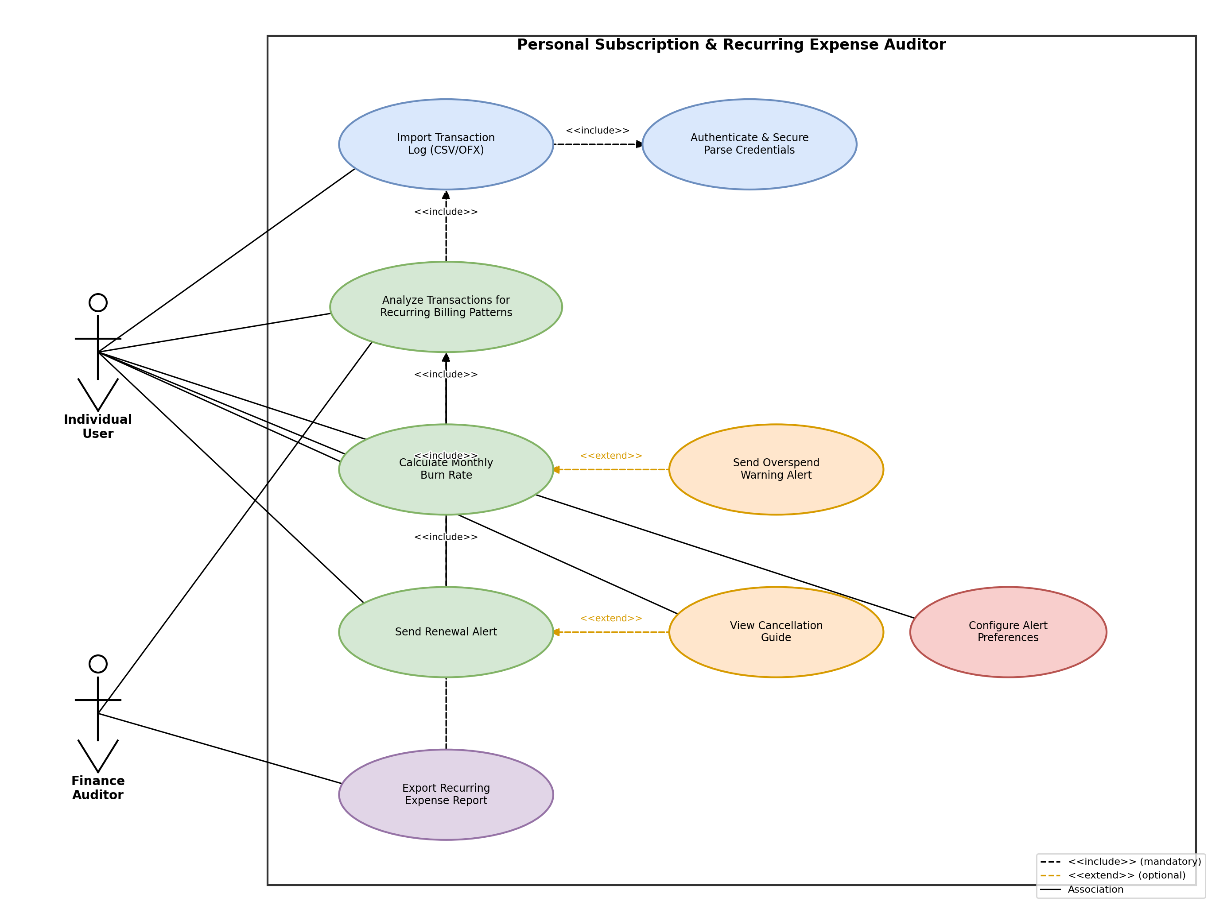

Diagram Notes
- System Boundary: the rectangle labeled “Personal Subscription & Recurring Expense Auditor” encloses all nine use cases.
- «include» relationships: Import Transaction Log always includes Authenticate & Secure Parse Credentials; Analyze Transactions always includes Import Transaction Log; Calculate Burn Rate, Send Renewal Alert, and Export Report always include Analyze Transactions, since they depend on recurring-pattern data.
- «extend» relationships: Send Overspend Warning Alert optionally extends Calculate Monthly Burn Rate, triggered only when the projected burn rate exceeds a user-defined threshold. View Cancellation Guide optionally extends Send Renewal Alert, offered only when the user chooses to act on an alert.
- PlantUML source for this diagram is provided in Appendix A for portability/version control.

3. Use-Case Flow Specification

Use Case: UC3 — Analyze Transactions for Recurring Billing Patterns
Actors: Individual User (primary), Finance Auditor (secondary, read access)
Brief Description: The system ingests an imported transaction log and applies pattern-detection logic to identify recurring charges, distinguishing them from one-time purchases, and classifies each detected subscription by merchant, amount, frequency, and category.

Preconditions
- The user has successfully completed UC1 (Import Transaction Log) and UC2 (Secure Parse), so a validated, decrypted transaction dataset exists in the system's working memory/session.
- The transaction log covers a minimum of 60 days of history (required for the pattern-detection algorithm to establish a baseline interval).
- The user is authenticated and has an active session.

Postconditions — Success
- All detected recurring subscriptions are persisted to the user's subscription profile with merchant name, amount, billing frequency, next projected billing date, and category.
- The monthly burn rate (FR-003) is recalculated and updated.
- Renewal alert schedules (FR-002) are generated or refreshed for each detected subscription.
- A summary of newly detected, changed, and removed subscriptions is presented to the user.

Postconditions — Failure
- No partial or corrupted subscription records are persisted.
- The user is notified of the failure reason and prior subscription data remains unchanged (rollback).

Main Success Scenario
1. The user (or scheduled system trigger) initiates transaction analysis after a successful import.
2. The system retrieves the validated transaction dataset from the current session.
3. The system groups transactions by normalized merchant identifier (handling naming variants, e.g., “NETFLIX.COM” vs. “Netflix”).
4. For each merchant group, the system calculates the interval between consecutive charges and the variance in charge amount.
5. The system flags a merchant group as “recurring” if it meets the pattern threshold (≥3 occurrences, interval consistency within ±3 days, amount consistency within ±5%).
6. The system classifies each recurring group by frequency (weekly/monthly/quarterly/annual) and assigns a spending category using a merchant-category lookup.
7. The system calculates the projected next billing date for each recurring subscription.
8. The system persists the detected subscriptions to the user's profile, updating existing records and adding new ones.
9. The system triggers recalculation of the monthly burn rate (FR-003) and refreshes renewal alert schedules (FR-002).
10. The system displays a summary screen showing: newly detected subscriptions, subscriptions no longer detected (possibly cancelled), and subscriptions with changed amounts (possible price increases).
11. Use case ends successfully.

Alternate Flow A1 — Insufficient Transaction History (branches after Step 2)
1a. The system determines the transaction log covers fewer than 60 days.
2a. The system aborts pattern analysis and displays: “More transaction history is needed for accurate detection. Please import at least 60 days of data.”
3a. The system suggests the user re-import a longer log or wait for more data to accumulate.
4a. Use case ends without persisting any subscription changes.

Alternate Flow A2 — Ambiguous Merchant Pattern (branches after Step 5)
1a. A merchant group partially meets the recurrence threshold (e.g., consistent amount but irregular interval, such as a variable-usage utility bill).
2a. The system flags the group as “Possible Subscription — Needs Review” rather than auto-confirming it.
3a. The system presents the ambiguous group to the user with a prompt to manually confirm or reject it as recurring.
4a. If confirmed, flow resumes at Step 6 for that group. If rejected, the group is excluded and flow resumes at Step 7 for remaining groups.

Alternate Flow A3 — Price Change Detected on Existing Subscription (branches after Step 6)
1a. The system detects a previously known recurring subscription now has a charge amount outside the ±5% tolerance from its historical average.
2a. The system updates the subscription's amount but flags it with a “Price Increase Detected” indicator for that entry.
3a. Flow resumes at Step 7.

Exception Flow E1 — Analysis Engine Failure
1a. An unexpected error occurs during pattern matching (e.g., malformed transaction record, timeout exceeding NFR-002's 5-second threshold).
2a. The system halts processing, discards any in-progress (non-persisted) results, and logs the error securely, excluding sensitive data per NFR-001.
3a. The system displays an error message to the user with an option to retry or contact support.
4a. Use case ends in failure; prior subscription data remains unchanged.

Appendix A: PlantUML Source (Use-Case Diagram)
@startuml left to right direction skinparam packageStyle rectangle actor "Individual User" as User actor "Finance Auditor" as Auditor rectangle "Personal Subscription & Recurring Expense Auditor" { usecase "Import Transaction Log\n(CSV/OFX)" as UC1 usecase "Authenticate & Secure\nParse Credentials" as UC2 usecase "Analyze Transactions for\nRecurring Billing Patterns" as UC3 usecase "Calculate Monthly\nBurn Rate" as UC4 usecase "Send Renewal Alert" as UC5 usecase "Send Overspend\nWarning Alert" as UC6 usecase "View Cancellation Guide" as UC7 usecase "Export Recurring\nExpense Report" as UC8 usecase "Configure Alert\nPreferences" as UC9 } User --> UC1 User --> UC3 User --> UC4 User --> UC7 User --> UC9 Auditor --> UC8 Auditor --> UC3 UC1 .> UC2 : <<include>> UC3 .> UC1 : <<include>> UC4 .> UC3 : <<include>> UC5 .> UC3 : <<include>> UC8 .> UC3 : <<include>> UC6 .> UC4 : <<extend>> UC7 .> UC5 : <<extend>> @enduml

