USDA defines a Food Desert as an area more than a mile away from a supermarket and they estimate 23.5million Americans fall under this category.

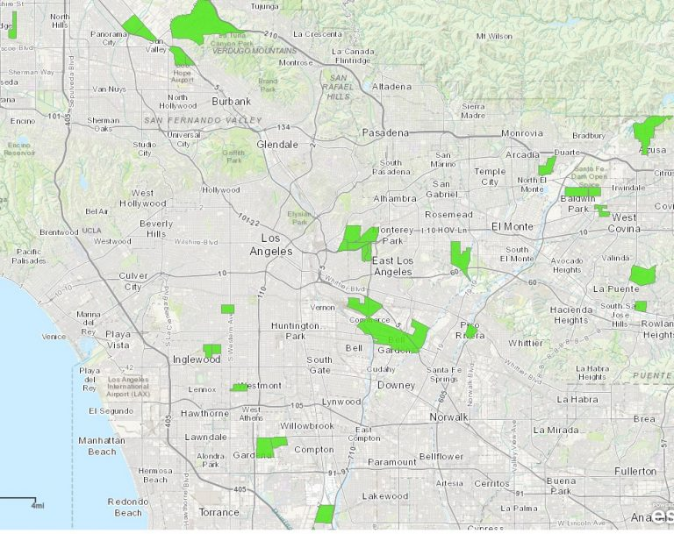

*Map from Foodforward.org*

11.5 million of them live at or below federal poverty thresholds.

Data.city.org & USDA.gov

Using census statistics can we help find more areas with the greatest need?