Hydroclimatic variability drove human-megafauna-environment interactions during the late Pleistocene/Early Holocene in central Chile

Matías Frugone-Álvarezª (MFA), Rafael Labarca^{b} (RL), Josu Aranbarri^{c} (JA), Matías Briceño^{d} (MB), Leonardo A. Villacís^{e} (LAV), Carolina Godoy-Aguirre^{b} (CGA), Antonio Delgado-Huertas^{f} (ADH), José Blanco^{g} (JB), Claudio Latorre^{h} (CL), Erwin González-Guarda^{i} (EGG), Natalia Villavicencio^{j} (NV), Carlos Tornero^{k} (CT), José Iriarte^{l} (JI), Blas Valero-Garcés^{m} (BVG).

a. MFA: Instituto de Alta Investigación, Universidad de Tarapacá, Arica, Chile. e-mail: matutefrugone@gmail.com. https://orcid.org/0000-0002-4182-9902
b. RL: Escuela de Antropología, Facultad de Ciencias Sociales, Pontificia Universidad Católica de Chile https://orcid.org/0000-0002-5791-5522
c. JA: Departamento de Geografía, Prehistoria y Arqueología, Universidad del País Vasco/Euskal Herriko Unibertsitatea, Vitoria-Gasteiz, Spain, https://orcid.org/0000-0002-4903-9593
d. MB:Departamento de Geofísica, Universidad de Chile, Santiago, Chile. https://orcid.org/0009-0002-4397-3112
b. CGA: Escuela de Antrpopología, Pontificia Universidad Católica de Chile https://orcid.org/0000-0001-8471-0808
e. JI: Department of Archaeology, University of Exeter, Exeter, UK. https://orcid.org/0000-0002-8155-5360
f. LAV: Climate Change Institute, University of Maine, Maine, USA. School of Biology and Ecology, University of Maine, Maine, USA. https://orcid.org/0000-0002-3940-6708
g. ADH: Instituto Andaluz de Ciencias de la Tierra (CSIC), Armilla, Spain. https://orcid.org/0000-0002-7240-1570
h. CL:Pontificia Universidad Católica de Chile: Santiago, Santiago, Chile. https://orcid.org/0000-0003-4708-7599
i. JB: https://orcid.org/0000-0003-1651-5538. Sociedad Chilena de Arqueología
j. EGG: Instituto de Ciencias de la Ingeniería, Universidad de O'Higgins, Libertador Bernardo O'Higgins, 611, Rancagua, Chile. ​​https://orcid.org/0000-0002-5342-7281
k. NV: Instituto de Ciencias de la Ingeniería, Universidad de O'Higgins, Libertador Bernardo O'Higgins, 611, Rancagua, Chile https://orcid.org/0000-0001-8453-1914.
l. CT: Institut Català de Paleoecologia Humana i Evolució Social (IPHES-CERCA), Tarragona, Spain. https://orcid.org/0000-0002-2870-8989
m. BVG: Instituto Pirenaico de Ecología - Consejo Superior de Investigaciones Científicas (IPE-CSIC) 50059 Zaragoza, Spain. https://orcid.org/0000-0003-2214-7057

Abstract

Major environmental changes were occurring when the first modern humans arrived in South America during the Pleistocene-Holocene transition. How these changes shaped human-environmental interactions across this period remain unclear. We analyzed the stratigraphy, biogeochemistry, and paleoclimatic models from the Ancient Tagua Tagua Lake (ATTL) in central Chile, one of the few continuous records of human and megafauna interactions with their environment in South America, to reconstruct the ATTL’s ecosystem dynamics over the past 20,000 years. Results reveal that the ATTL transitioned from a shallow, cool lake with storm-driven alluvial deposition to a warmer, deeper, and more productive lake about 12,500 years ago, aligning with early humans' arrival. The ATTL became wetter but experienced severe droughts between 11,000 and 8,500 years ago, linked to shifts in Southern Westerly Winds and ENSO-like patterns. Fluctuating conditions drove humans and fauna to seek refuge in the basin, emphasizing local paleohydrology’s role in shaping early human-ecosystem interactions.

Key words: Ancient Tagua Tagua Lake; Facies analysis; Biogeochemical proxies; Archaeology; Paleoclimate model; Human-ecosystem interactions

1. Introduction
Modern humans settled the Americas at a time of profound ecological and hydroclimatic transformations (Barnosky et al., 2004; Gutiérrez and Stockli, 2023; Mann et al., 2019). These rapid environmental changes (REC) —including the extinction and redistribution of key ecosystem-structuring species, shifts in resource availability, and alterations in atmospheric and oceanic circulation— represented one of the last major continental scale socio-ecological thresholds before modern global environmental changes (Andermann et al., 2020; Braje and Erlandson, 2013; Malhi et al., 2016; Mottl et al., 2021). Such transformations reconfigured ecological landscapes and could have shaped how early human populations adapted and expanded across South America (Baumann, 2023).
Yet, how did these REC shape early human migration, settlement, and adaptation during the initial colonization of South America? A range of diverse sources of information, including palaeoecological, archaeological, and climatic data are needed to adequately address this question (Mayle and Iriarte, 2014). The role of climate teleconnections, including large-scale systems such as the Southeast Pacific Subtropical Anticyclone (SPSA) and the Southern Westerly Winds (SWW), have been identified as key factors influencing regional hydroclimates along the western slope of the subtropical Andes during the Last Glacial Termination (Garreaud et al., 2017; Herrera-Ossandón et al., 2023; Orellana et al., 2023; Valero-Garcés et al., 2005) (Fig. 1). Presently, prolonged positive anomalies in the SPSA block storm fronts from reaching the subtropical Andes (Fig. 1a), frequently resulting in winter drought which impacts water resources, regional livestock, and agriculture (Garreaud et al., 2017). In contrast, the SWW has entrained storm systems that travel across the southern mid-latitudes, redistributing moisture and bringing heavy rainfall that support ecosystems but also cause flooding and economic losses (Garreaud et al., 2017). These climatic drivers are modulated by phenomena such as the El Niño–Southern Oscillation (ENSO) and the Southern Annular Mode (SAM), which influence regional and global climate dynamics, including the frequency and intensity of the upper-level Pacific Subtropical Jet Stream (PSJ) and atmospheric rivers (Campos and Rondanelli, 2023; Garreaud, 2007; Garreaud et al., 2009; Gillett et al., 2021; Lu et al., 2008). In mid-latitudes, anomalies in these climatic drivers are marked by extreme events, including droughts, pluvial floods, and severe storms. Early hunter-gatherers must have been well suited and adapted to such variability (Collazo et al., 2024; Garreaud et al., 2017).
Despite considerable research and progress in identifying global paleoclimatic drivers, discerning the impact of climate on human mobility and population density in past environments remains a significant challenge (Moreno and León, 2003; Sandweiss et al., 2020). The paucity of closely related high-resolution paleoenvironmental and archaeological records hinders comparisons of whether and how climate influenced human adaptation and resource use during this early stages of exploration and colonization, leaving uncertainties about the impact of REC (Borrero, 1999; Labarca et al., 2024; Ugalde et al., 2024). Paleoclimate records from southern mid-latitudes indicate an intensification of the SWW, modulated by the effects of ENSO/SAM and the Southern Ocean (controlling CO₂ fluxes) during the last deglaciation (Moreno et al., 2010; Moy et al., 2002; Soteres et al., 2022; Villacís et al., 2023). Alternative hypothesis suggest that the displacement of the SWW (Kilian and Lamy, 2012; Lamy et al., 2010), was driven by shifts in the Intertropical Convergence Zone (ITCZ), in turn influenced by teleconnections with the Northern Hemisphere—particularly those associated with North Atlantic ice-rafting events and reductions in thermohaline circulation—as well as by orbital changes (Kaiser et al., 2024; Li and Liu, 2022; Schneider et al., 2014). In contrast, the interaction of the SPSA with climate dynamics that directly impact human activity—such as droughts, storms and floods associated with storm tracks—remains poorly studied (Flores-Aqueveque et al., 2020). Past changes in the dynamics of the SPSA and SWW provide an opportunity to study the mechanisms that cause paleoenvironmental changes, and to assess the influence of mid-latitude climate variability and its interaction with human activities at an early stage (Sandweiss et al., 2020).
The Last Glacial Termination and the onset of the Holocene marked pronounced environmental shifts in South America, including early human colonization and fire use, the mass extinction of large continental mammals (>100 kg), large temperature changes (e.g. Antarctic Cold Reversal; ∼14.5-12.9 cal ka BP or thousands of calibrated years before 1950), and major precipitation anomalies (e.g. Central Andes Pluvial Event, CAPE I and II, between 18-14 cal ka BP and 13-9 cal ka BP, respectively) (Latorre et al., 2006; Martin et al., 2018; Pedro et al., 2016; Prates and Perez, 2021; Ugalde et al., 2024; Villavicencio et al., 2016). Furthermore, geological and archaeological records clearly indicate that population expansion and megafaunal extinctions occurred relatively synchronously with climate variations observed during Termination I (T1) in the Northern Hemisphere, such as the Heinrich Stadial 1 (HS1, ~ 18-15 cal ka BP), Oldest Dryas (17.5-14.5 cal ka BP), Bølling-Allerød (14.7-12.9 cal ka BP), and Younger Dryas Stadial (~12.9-11.7 cal ka BP) (Alley, 2000; Barnosky et al., 2004; Cheng et al., 2020; Liu et al., 2009; Moreno-Mayar et al., 2018). However, the magnitude and distribution of these possible teleconnections at the South American mid-latitudes remain unclear and are not well constrained. Hence, the study of past environmental records, especially those linked to human activity, is of paramount importance for understanding coupled human-environment systems and the global, regional, and local mechanisms that drove ecosystem changes during the Last Glacial Termination.
Here, we examine hydroclimatic and ecosystem shifts at the ATTL geoarchaeological sites in central Chile, highlighting their importance for understanding late Pleistocene/Early Holocene human–environment interactions. ATTL is a key geoarchaeological area that preserves evidence of extinct faunal assemblages and human occupation from the Late Pleistocene to the Late Holocene (Montané, J., 1968). Our study features a comprehensive multi-proxy analysis of a newly obtained 2.8-meter stratigraphic profile from the TT19-3A sequence (Fig. 1b), offering key insights into the climatic conditions surrounding the arrival of the first hunter-gatherers in the region. This record integrates data from sedimentary facies, grain size distributions (GSDs), geochemical proxies (TOC, TIC, C/N, TS, δ¹³C_{car} and δ¹⁸O_{car}), and biological indicators, including phytoliths, pollen, non-pollen palynomorphs (NPPs), and diatoms. In addition, we use an ensemble of simulations from the Paleoclimate Modeling Intercomparison Project phase 4 (PMIP4), integrated into the Coupled Model Intercomparison Project phase 6 (CMIP6), to analyze zonal wind and precipitation patterns during the Last Glacial Maximum (LGM) and the Middle Holocene, focusing on their variability under humid and dry conditions in central Chile. This approach provides a comparative baseline of atmospheric circulation conditions before and after the arrival of the first hunter-gatherers in central Chile, thus enabling a direct contrast between these large-scale patterns and our local sedimentary record. Overall, our results highlight the interplay between hydroclimatic variability and human activity during the Last Glacial Termination, shedding deeper insight into how early populations interacted with shifting environmental conditions.

2. Materials and Methods
In November 2019, we recovered a sedimentary sequence measuring 15 cm in length, 10 cm in width, and 280 cm in depth from the exposed profile of the eastern wall of a 1 × 2 m excavation, corresponding to Unit 1 of the geoarchaeological test pits at TT-3 site (TT19-3A-1E, Fig. 1). Sediment samples, between 50 and 100 g of material, were obtained at 1-cm intervals along the sequence (see Supplementary Methods for more details). The uppermost 8 samples (0 - 0.38 m) were discarded due to sediment alteration due to modern agricultural practices. Sixty-six samples taken every 2 cm were analyzed for total carbon (TC), total inorganic carbon (TIC), total organic carbon (TOC = TC − TIC), total nitrogen (TN), and total sulfur (TS) using a LECO SCN furnace at the Pyrenean Institute of Ecology (IPE-CSIC) in Spain. Stable isotope compositions (δ¹³C_{car} and δ¹⁸O_{car}) of the carbonate fraction from these samples were determined using a Gas Bench system interfaced with a Delta XP mass spectrometer (Thermo Finnigan, Bremen, Germany) at the Andalusian Institute of Earth Science (CSIC) in Granada, Spain. The GSDs (from 0.04 µm to 2000 µm) were measured in triplicate using a Malvern Mastersizer 2000 APA2000 with Hydro 2000G AWA2000 at IPE-CSIC. Bulk sediment samples were pre-treated to remove organic matter and carbonates. Forty sediment samples were prepared for palynomorph extraction following standard chemical procedures (Heusser, 1971; Magri and Di Rita, 2015). Due to taphonomic and preservation issues, terrestrial pollen is highly underrepresented; therefore, only pollen from hygro-hydrophytes, fern spores, and other NPPs have been analyzed (Van Geel, 2001; van Geel et al., 2003).
The extraction of phytoliths and diatoms was conducted on twenty sediment samples, which were processed at the Archaeobotany and Palaeoecology Laboratory of the University of Exeter. A protocol based on standard procedures for phytolith extraction was employed, using approximately 5 g of sediment. We removed carbonates using 36% HCl and digested organic materials with 70% HNO3. Phytoliths and diatoms were separated through flotation using ZnBr2 prepared to a density of 2.3 g/cm3. We counted phytoliths, analyzing up to 200 specimens per sample, or the total number of specimens examined in cases where the slide contained fewer than 200. Finally, the phytoliths were classified according to the International Code for Phytolith Nomenclature (International Committee for Phytolith Taxonomy (ICPT), 2019; Piperno, 2006, 1988). Diatom valves on Naphrax mounted slides were observed using a Zeiss Axioscope A1 stereomicroscope with an oil immersion objective of 1000x. A minimum of 400 valves were counted when possible, identifying to species level with the exception of small fragilaroids that require higher magnification (Morales et al., 2001). We reconstructed the TT19-3A chronology using fourteenth AMS radiocarbon dates on charcoal and bulk sediments (Table S1).

2.1 Statistical Analysis
Radiocarbon ages were calibrated using the Southern Hemisphere calibration curve (Hogg et al., 2020), and age-at-depth assemblage was established using the Bacon and Bchron models implemented in the 'geochronR' package (Blaauw and Christen, 2011; McKay et al., 2021; Parnell et al., 2008). Robust End-member Mixing Analysis (rEMMA) was performed using the R package 'EMMAgeo' v0.9.8 to infer sediment sources, transport, and depositional processes (Dietze and Dietze, 2019; Dietze et al., 2022). Sedimentary facies were characterized based on macroscopic and microscopic descriptions (Schnurrenberger et al., 2003), and artificial facies clusters were identified using machine learning techniques (Hall, 2016). The analysis employed an unsupervised classification algorithm, utilizing geochemical data (TOC, TIC, TN, TS, GSDs, and stable isotopes) implemented in the 'scikit-learn' library (Pedregosa et al., 2011) in Python v3.9. Stratigraphic diagrams and time-series analyses were conducted and visualized in R (version 4.2.2)(see Supplementary Methods). Circulation anomalies for the Middle Holocene, and LGM periods were analyzed using PMIP4 ensembles simulations from the MPI-ESM1-2-LR, MIROC-ES2L, CESM2-WACCM-FV2, AWI-ESM1-2-LR and CESM2 models. These analyses focused on global changes in zonal wind at 500 hPa and total precipitation relative to the pre-industrial period (piControl). To define wet and dry events in central Chile (75°W-70°W, 32°S-40°S), a Regional Precipitation Index (RPI) was applied, defining wet events as RPI > 120% and dry events as RPI < 80% (see Supplementary Methods). We employed the Python libraries climlab and pyleoclim (Python 3.9) to perform wavelet and spectral analyses of past orbital parameters and paleoclimate time series. Human activities were assessed at the local scale through the analysis of lithic components found at TT-3, and at the regional scale using the p3k14c database (Bird et al., 2022) of archaeological radiocarbon dates. We calculated summed probability distributions (SPD) of archaeological radiocarbon dates using the 'rcarbon' v1.5.1 package (Crema and Bevan, 2021) in R 4.2.2 for South America and central Chile (between 32° and 37°S). Environmental and orbital changes from paleoclimate records and models were summarized using available literature.

3. Results

3.1. Stratigraphy and facies: depositional variability and geochemical shifts

The TT19-3A sequence comprises 15 sedimentary facies distributed in 8 stratigraphic units, and several sedimentary clusters (Figs. 1, 2 and supplementary material). At the base (Unit 8; 2.80 m - 2.30 m), brown to greenish sediments include clayey silty facies (L8; 2.80 m - 2.61 m) and sandy facies (L7; 2.61 m - 2.33 m), associated with clusters 4, 7, and 2 (Fig. 2). A coarsening-upward sequence (L8b→L8a→L7) with desiccation cracks lies above these sandy layers and may indicate subaerial exposure or subaquatic fracturing related to degassing. Units 7 and 6 consist of greenish-brown sandy and silty sediments (facies L6; 2.33 m - 1.84 m; and L5; 1.84 m -1.65 m), linked to clusters 3 and 7 (Figs. 2 and S1). Unit 7 forms a fining-upward sequence with fine sands containing subrounded clasts and dispersed fish vertebrae (L6b), overlain by sandy silts (L6a). Unit 6 is composed of dark grayish-green sandy silts with reworked gastropod and bivalve shells. A marked erosive unconformity formed at the base of Unit 5 (1.65 m - 1.50 m), which is composed of massive light grayish green silt with millimeter to centimeter sized carbon fragments, faunal remains and lithic artifacts and abundant Biomphalaria taguataguensis (Planorbidae) shells (L4b facies). Facies L4 corresponds to cluster 1. The top of Unit 5 (L4a) is a dark brown, fine-grained, carbonate-rich (6% TIC) silt layer (Figs. 2 and S1). Unit 4 (1.50 m -0.80 m) contains carbonate (2-5% TIC) and diatom-rich coarse gray silts and fine sands, defined by four facies. Facies L3d (1.50 m -1.30 m) consists of fine-grained light gray silts with some large volcanic clasts up to 3.5 cm. Facies L3c (1.30 m -1.10 m) is characterized by massive to banded gray clay silts with some millimetric clasts, higher carbonate content (up to 4% TIC), and abundant shells of B. taguataguensis, randomly dispersed but more abundant towards the top. Facies L3b (1.10 m- 0.90 m) comprises massive to banded fine-to-medium gray clay silts with B. taguataguensis shells and millimeter- to centimeter-sized charcoal fragments. Facies L3a (0.90-0.80 m) are massive medium-grained gray to dark gray sandy silts with sub-rounded clasts, higher carbonate content and shells of B. taguataguensis. Units 3 and 2 contain finer gray sediments with relatively high carbonate (Unit 3, 1-5% TIC) and organic (Unit 2, up to 2.5% TOC) contents. Unit 3 (0.80-0.45 m) is composed of gray fine sandy silts with silty sand lenses or pockets, and shells of B. taguataguensis and Diplodon sp. (facies L2). Unit 2 (0.45 m- 0.38 m) consists of dark gray fine sandy silts with charcoal fragments (up to 1 cm) and gastropod shells. Finally, Unit 1 (0.38 m -0 m) consists of light brownish-gray clays with abundant diatoms, higher organic content and presence of charcoal (facies L2), as well as silty sands containing rounded gravel clasts (0.5–1 cm) and larger charcoal fragments (0.2–1.5 cm; facies L1). Abundant clasts, macrocharcoal, and elevated TOC and TN in Unit 1 suggest post-depositional reworking, soil formation, and anthropogenic influence.

Overall, sediments are mostly silt (~50%) and sand (~40%), with 5–20% clay and <5% fine gravels (Fig. 2). The TT19-3A sequence displays a multimodal grain size distribution (GSD). Using rEMMA, we identified five end-members [modes; rEM1: 8 ɸ, rEM2: 4.1 ɸ, rEM3: 2.7 ɸ, rEM4: 1.3 ɸ and rEM5: 0.47 ɸ] that explain ~78% of the total variance (Figs. S2 and S3). The rEM2 end-member (peak at ~60 µm) dominates the upper half of the record (~40% variance), particularly in diatom-rich lacustrine facies (L3a, L3b, L3c). In contrast, rEM1 (peak ~4 µm; ~18% variance) characterizes silty clay facies such as L8 and L6, while rEM3 (peak ~160 µm; ~15% variance) occurs in fine-grained, diatom-rich intervals (1.30-0.80 m). The rEM4 end-member, with a bimodal distribution (~420 µm and ~60 µm), and rEM5, with a dominant coarse sand peak (~720 µm), each explain ~14% of the variance.

Carbonate and TOC contents vary among units. Units 8 to 6 are essentially carbonate-free, with TC <0.1%. Facies L8a and L8b exhibit relatively high TS (0.1-1%) and low TC (~0.1%), alongside δ¹⁸O_{car} and δ¹³C_{car} values near -5‰ and -10‰, respectively. Facies L7 shows a gradual decrease in the δ¹⁸O_{car} values (cluster 2, Fig. S1), reaching the lowest values ​​of the sequence. Unit 7 (facies L6) is characterized by two sedimentary clusters: the cluster 7, with increasing δ¹⁸O_{car} and δ¹³C_{car} values and cluster 3, with low rEM1 and rEM2 values and the absence of rEM5. In Unit 6 (L5 facies), rEM5 increases while δ¹⁸O_{car}, rEM1 and rEM2 values decrease. In Unit 5 (L4 facies), TC, TIC, δ¹⁸O_{car}, δ¹³C_{car} and rEM2 values increase, whereas rEM1, rEM4 and rEM5 values diminish. Facies L4a records the highest TIC (>7%), δ¹⁸O_{car} (>-1 ‰), δ¹³C_{car} (>1‰) and rEM2 values, along with minimal rEM1, rEM3, rEM4 and rEM5. In Unit 4 (L3 facies), there is a gradual increase in the TOC/TN ratio (>5), δ¹⁸O_{car} (>-1 ‰) and δ¹³C_{car} values, along with variable GSD percentages. In Unit 3 (L2 facies), geochemical values show reduced variability, with high TC, TIC, TOC/TN, and rEM2 values. Finally, in Unit 2 (facies 2), TC values reach their highest levels, primarily due to the increase in TOC.

3.2 Aquatic–terrestrial ecosystem proxies and community shifts

The diatom record in the TT19-3A sequence (Figs. 3 and S4) is dominated by benthic taxa with high specific conductance optima—such as Anomoeoneis sculpta (Ehrenberg) Cleve, Nitzschia amphibia Grunow, Epithemia turgida (Ehrenberg) Kützing, Cymbella cymbiformis Bahls, Gomphonema affine Kützing. This overall dominance is interrupted by an interval of increased tychoplanktonic small fragilarioids between 150 and 120 cm (L3d, L3c). At the base of the sequence (Unit 8, L8b), diatom valves are absent. Moving upward (L8a, Units 7 and 6), we observe the presence of A. sculpta (most abundant), N. amphibia, E. turgida, G. affine, and Ulnaria sp. In Unit 5 (L4b), A. sculpta remains the dominant taxon (~84% abundance), and diatom valves are ubiquitous, allowing for the estimation of relative abundances. A notable assemblage shift occurs in L4a (Unit 5), L3d, and L3c (Unit 4), where A. sculpta nearly disappears and diatom diversity increases substantially. Here, small fragilarioids, N. amphibia, E. turgida, C. cymbiformis, and G. affine all become more common, accompanied by planktonic species such as Stephanocyclus meneghinianus (Kütz) Kulikovskiy, Genkal and Kociolek, Aulacoseira granulata (Ehrenberg) Simonsen, and Ulnaria sp.). L4a and L3d differ from L3c in that small fragilarioids and A. granulata are more abundant, whereas N. amphibia, S. meneghinianus, and A. sculpta (~5% abundance) are more common in L3c. Subsequently, L3b records a marked recovery of A. sculpta (~77%), accompanied by a decrease in other taxa. In L3a, A. sculpta declines (~22%) as G. affine and N. amphibia increase. In Unit 3 (L2) and Unit 2 (L1), A. sculpta partially recovers (~36%) alongside slight increases in planktonic taxa S. meneghinianus and A. granulata.
The pollen and NPP data (Fig. 3, S5) reveal distinct assemblages of hygro-hydrophytes, ferns, freshwater algae, and spores of coprophilous fungi. Two well-defined sections are apparent. The first section (263-150 cm; Units 8, 7, 6, and 5) is characterized by high abundances of freshwater algae Botryococcus and Spirogyra, along with occasional Mougeotia and Pediastrum. Units 8 and 7 (263–185 cm), Typha, ferns (Pteris), Botryococcus, and Spirogyra dominate. Towards the upper part of this first section (238-150 cm), abundance of Botryococcus, Spirogyra, and arbuscular mycorrhizal fungi (Glomus) remains elevated, but littoral and floating vegetation reach their lowest values. The second section (150-38 cm) shows a progressive increase in water surface indicators and the colonization of littoral (Cyperaceae, Juncaceae, Typha) and floating vegetation (Lemna, Nuphar) especially pronounced between 55 and 38 cm. Freshwater algae remain present throughout this interval.
Phytolith analysis (Figs. 3 and S6) identifies opal phytoliths from Cyperaceae, Poaceae, and Arecaceae. Within Poaceae, subfamilies Bambusoideae, Chloridoideae, and Pooideae were distinguished. At the species level, we detected Jubaea chilensis within Arecaceae, as well as phytoliths from woody dicotyledons. Unit 8 exhibits very low phytolith concentrations compared to the rest of the record. Here, Poaceae phytoliths dominate (~90%), with fewer Bambusoideae and Chloridoideae phytoliths (~5%). Unit 7 (230-175 cm), Bambusoideae and Chloridoideae reach their highest percentages (46% and 26%, respectively), while Cyperaceae increases modestly (~13%). Unit 6 (175–165 cm) shows the highest overall Poaceae content, though Bambusoideae, Pooideae, and Chloridoid percentages decrease. From Unit 5 to Unit 3 (165–40 cm), the total phytolith content rises, accompanied by the first appearance of woody and shrub morphotypes indicative of sclerophyll forests (woody dicotyledons and J. chilensis). During this interval, Bambusoideae and Chloridoid proportions slightly decline in Unit 3. Additionally, Cyperaceae levels increase again (to ~13%) between Units 5 and 4 (150–142 cm) before stabilizing at lower values (~2%) thereafter.

3.3. Chronological context
The chronological framework for the TT19-3A sequence provided by the age-depth models (Bacon and Bchron; Fig. 4) supports these interpretations, offering a robust temporal backdrop for correlating cultural and environmental shifts. The models excluded two outlier ages. Bulk sediment and charcoal samples taken at the same depths showed no significant differences, ruling out a reservoir effect. According to the ensemble age-depth model, the TT19-3A sequence covers the last 20.5 cal ka BP (Table S1 and Fig. 4), with a higher model robustness in the upper four units. Unit 8 (2.66 m - 2.30 m) spans from ~20.5 to 16 cal ka BP with an accumulation rate of ~200 a cm⁻¹. Unit 7 (2.30 m - 1.84 m) was deposited between ~16 and 12.5 cal ka BP with an accumulation rate of ~100 a cm⁻¹. Unit 6 (1.84 m - 1.65 m) was deposited between 13 and 12.6 cal ka BP with an accumulation rate of ~20 a cm⁻¹. Unit 5 (1.65 m - 1.50 m), encompassing the Pleistocene-Holocene transition (12.6 - 11.3 cal ka BP), has an accumulation rate of ~100 a cm⁻¹. Unit 4 (1.50 m - 0.80 m) extends from 11.3 to 8.6 cal ka BP, characterized by ~50 a cm⁻¹. Unit 3 (0.80 m - 0.45 m) spans between 8.6 and 6.5 cal ka BP with a median rate of ~60 a cm⁻¹. Unit 2 (0.45 - 0.38 m) covers between 6.5 and 6.0 cal ka BP with an accumulation rate of ~80 a cm⁻¹.

4. Discussion

4.1. Depositional dynamics and associated hydroclimatic changes during the Last Glacial Termination (20.5–12.8 cal ka BP)
The ATTL record highlights the climatic shifts at mid-latitude South America during the Last Glacial Termination (T1; ca. 20.5 - 12.5 cal ka BP), showing shallow littoral lacustrine conditions and high-energy sediment input prior to the first human settlements in central Chile (Figs. 5 and 7). Drier conditions prevailed between 20.5 and 18.5 cal ka BP as indicated by fine-grained deposition consistent with greater meltwater drainage and dust input (Amann et al., 2022; Sun et al., 2002; Vandenberghe, 2013; Vandenberghe et al., 2018), whereas low δ¹³C_{car} and δ¹⁸O_{car} values reflect reduced evaporation and increased freshwater input from snowmelt (Dansgaard, 1964; Gonfiantini et al., 2001; Rozanski et al., 1993) (Fig. 5F-H). During the final stage of the LGM, the ATTL basin was characterized by the deposition of fine L8 facies, with high silt and clay contents (>80%), very low TC (<0.1%), and relatively elevated TS percentages (Figs. 2, 3, and 4). The unimodal grain size distribution (~4 μm mode) and low sorting suggest gradual, year-round sediment input, either via long-distance aeolian transport (Zielhofer et al., 2017) or meltwater flows from glaciated areas (Amann et al., 2022). As in other glaciated settings, the fine-grained material deposited during glacial times was likely related to glacier dynamics, aeolian dust (Amann et al., 2022; Sun et al., 2002; Vandenberghe et al., 2018), and local clays derived from weathered soils in the catchment (Sun et al., 2002). Stratigraphic correlations show that the L8 facies can be correlated with “Member 5” (Varela, 1976) and “Unit 5” (Valero-Garcés et al., 2005) (Fig. 1C) from previously described ATTL profiles, dated to ca. 21.5 ± 0.65 and 20.4 ± 1.3 cal ka BP, respectively (Heusser, 1983; Montané, 1969; Valero-Garcés et al., 2005). Researchers originally interpreted these deposits as a massive clay layer rich in Nothofagus dombeyi/obliqua type pollen, suggesting cold and wet conditions or shallow lacustrine environments. However, the limited presence of planktonic diatoms, aquatic pollen, and phytoliths, along with only minor benthic diatoms and freshwater algae, points instead to a shallow littoral lake setting under persistent, fine detrital input influenced by a glaciated watershed. A brief high-energy alluvial event at ~19.5 cal ka BP did not significantly elevate lake levels or bioproductivity (Figs. 3 and 5F-H). Varela (Varela, 1976) describes subvertical cracks filled with authigenic magnesium oxide and iron minerals in Member 5, consistent with those in the L8 and L7 facies (Unit 8). Subvertical cracks filled with authigenic minerals can be interpreted as desiccation cracks, sub-aquatic sedimentary fractures, or fragipan features (Beal et al., 2009; Ciolkosz et al., 1990; Fathi-Moghadam et al., 2011; Wang et al., 2022). These cracks, lacking mud curls and filled with magnesium oxide, iron, and sulfur minerals, suggest salinity fluctuations or anoxic conditions promoted shrinkage through deflocculation or intracrystalline dewatering (Beal et al., 2009; Wang et al., 2022). The high sulfur content of these facies suggests methane emissions and anaerobic sulfate or metal reduction by methanotrophic archaea (Wang et al., 2022), reinforcing the notion of a littoral depositional environment strongly shaped by watershed inputs.
A high-energy depositional phase occurred between 18.5 and 16.5 cal ka BP, marked by sandy L7 facies (about 70% - 80% sand) with low TC values, and the lowest δ¹³C_{car} and δ¹⁸O_{car} values in the record (Figs. 2 and 4).The coarse, bimodal grain size distribution (rEM4; main peak ~420 µm, secondary ~60 µm, see Fig. S3) suggests heavy rainfall/intense storm, or rapid melt-driven discharge that delivered coarse sediments into the lake’s littoral zone (Dietze et al., 2014; Sun et al., 2002; Vandenberghe et al., 2018). The lowest δ¹⁸O values likely reflect colder waters, an increase in the amount effect or a different moisture source (Dansgaard, 1964), whereas lower δ¹³C values possibly reflect increased CO₂ input from terrestrial respiration or lower aquatic productivity. Later, from 16.5 to 14.5 cal ka BP, a shift to coarser sediments and stormier conditions occurred again without increasing lake levels (Figs. 5A, B, E). This interval corresponds to a period of intense hydrological and depositional variability, linking local sedimentary patterns to the broader regional climate context.
To understand the atmospheric patterns during this period, we analyzed precipitation and zonal wind outputs from the PMIP4-CMIP6 multimodel ensemble simulations for the LGM (Figs. 6, 7S–9S; Table S2). The multimodel ensemble indicates that during the LGM, dry conditions were associated with intensified zonal wind speeds at low and mid-latitudes, accompanied by negative anomalies at subtropical and high latitudes (Figs. 6a, 6c). In contrast, wet anomalies are linked to weakened tropical trade winds, akin to warm ENSO-like conditions, accompanied by positive anomalies along extratropical storm tracks (Figs. 6E, 6G). Zonal wind speeds at tropical and subtropical latitudes show positive anomalies over the southern Pacific, while negative anomalies prevail over the central-southern Andes. A similar atmospheric pattern to those of the glacial period likely contributed to extreme events between 18.5 and 14.5 cal ka BP (Figs. 5A, 5B). Sedimentological and limnological evidence, however, suggests this was insufficient to maintain elevated lake levels.
Between 16.5 and 12.8 cal ka BP, sedimentation reverted to sandy silts (Unit 7, L6a and L6b facies), with varying clay percentages and low TS and TC values. Microfossils remained with low abundance, except for two samples showing a temporary increase in Poaceae phytoliths, benthic diatoms, and Cyperaceae, hinting at short-lived stabilization of littoral and riparian communities (Figs. 3 and S4). The presence of freshwater algae (Botryococcus and Spirogyra), littoral vegetation such as Typha, and sporadic fern spores (Pteris) indicates wetlands and riparian areas adjacent to the basin (Fig. S5). δ¹³C_{car} and δ¹⁸O_{car} values rose relative to Unit 8, indicating changes in hydrological balance (precipitation - evaporation balance), seasonality or source area. From 16.5 to 14.5 cal ka BP (L6b facies), grain size distributions (rEM5) were bimodal (~700 μm and ~65 μm), more consistent with fluvial or reworked fluvial/lacustrine-aeolian processes (Amann et al., 2022; Dietze et al., 2014; Sun et al., 2002; Vandenberghe, 2013; Vandenberghe et al., 2018). Such distributions occur where braided rivers and fluvial processes overlap, mixing coarse and fine sediments (Sun et al., 2002; Zhang et al., 2018). Proximal aeolian coarse-grained silt transport typically shows a unimodal grain-size distribution between 40 and 90 μm (Sun et al., 2002; Zhang et al., 2018). In contrast, GSDs exceeding a ~250 μm mode suggest high-energy fluvial processes. Moreover, in other environments and depositional process simulations, grain sizes ranging from 250 to 850 μm have been linked to intense runoff, alluvial fan formation, and are also observed in sandy coastal settings as well as wind-eroded sediments (Orton and Reading, 1993; van der Vegt et al., 2020; van IJzendoorn et al., 2023). After 14.5 cal ka BP (L6a facies), a shift toward finer particles (rEM1, ~3.8 µm; rEM2, ~60 µm) suggests improved hydrodynamic sorting, potentially linked to rising lake levels or greater availability of finer sediments. These conditions reflect a dynamic interplay between wind-driven, glacial- mediated and fluvial processes influencing deposition at the ATTL site during glacial time. Further analysis of the quartz surface texture is necessary to differentiate between aeolian and fluvial processes.
Our interpretation contrasts with earlier suggestions of cold and wet conditions at the end of the LGM (Heusser, 1983, 1971; Valero-Garcés et al., 2005; Varela, 1976). Heusser (1983) proposed the presence of a closed-canopy Nothofagus forest between 28 and 11 ka BP, suggesting cool and wet conditions potentially driven by a northward shift of the SWW. Recalibrated pollen chronologies, however, suggest that the percentages of the Nothofagus antarctica/dombeyi type declined earlier than previously reported (Fig. S6), occurring between approximately 19-16 cal ka BP (initially dated at 14.5 ± 0.35 cal ka BP; Unit 2a, Figs. 7H and S6) in Heusser (1983) and between 14.9-12.7 cal ka BP (initially dated at 11.71 ± 0.43 cal ka BP; Unit 3, Fig. 1) in Valero-Garcés et al. (2005). In the central Chile valley, Nothofagus dombeyi/obliqua exhibits a more restricted distribution compared to other members of the genus and subgenus Lophozonia (Mathiasen et al., 2020). Germination studies reveal that these species are not strictly dependent on high moisture levels, challenging the assumption that their expansion was moisture-driven (León-Lobos and Ellis, 2005; Reyes-Díaz et al., 2005). León-Lobos and Ellis (2007) found that the germination of Nothofagus species (N. alpina, N. dombeyi, N. leonii, N. glauca, and N. obliqua) varies more significantly with temperature, suggesting that moisture was important but not critical for their expansion into central Chile.
Intensified alluvial activity, associated with more frequent and severe storms at ATTL, is practically coeval with the HS1 (Broecker, 1995; Martin et al., 2018), CAPE I (Gayo et al., 2012; González-Pinilla et al., 2021; Quade et al., 2008; Ugalde et al., 2024) and ACR/Bölling–Alleröd events (Pedro et al., 2016) (Fig. 7), during a period characterized by increasing winter insolation and decreasing summer insolation (Figs. 7D, 7E, 7O, and 7P). These changes have been linked to shifts in global temperature gradients driven by residual Milankovitch effects (precession and obliquity; Figs. 7A and 7B). Some authors have posited that these shifts may have triggered a southward migration of the ITCZ and SWW, a weakening of the American Monsoon System, and modifications to the PSJ (Kaiser et al., 2024, 2008; Lamy et al., 1999; Novello et al., 2017). This atmospheric configuration, coupled with the reactivation of ENSO-like conditions ca. 16 cal ka BP (Figs. 7J and 7Q), likely amplified the frequency and intensity of alluvial events, displaying atmospheric patterns similar to those observed in simulations for the LGM (Fig 6G). Marine sediment cores off the Chilean coast date T1 to between 19.2 and 18.5 cal ka BP, indicating arid conditions (Lamy et al., 1999). Similarly, Andean glaciers (33°S - 36°S) retreated between 28.0 and 18.0 ka BP (Fig. 7I) without subsequent re-advances during T1 (Fernández-Navarro et al., 2024; Herrera-Ossandón et al., 2023; Singer et al., 2000). Changes in leaf wax δD and δ¹³C isotopes from marine sediment cores suggest hydrological changes influenced by precessional cycles, with SWW retreating during T1 (Figs. 7N and 7G), reaching a minimum at 11 cal ka BP and again between 5-6 cal ka BP (Kaiser et al., 2024). Marine records also show a 6°C-7°C rise in SST between 19 and 12.5 cal ka BP, interrupted by cooling around 14.8 - 13.3 cal ka BP, corresponding to the ACR (Kaiser et al., 2024, 2008, 2005; Kim et al., 2002). The decline in high-energy processes after ca. 14.8 cal ka BP was accompanied by fluvial and fine-grained sediment deposition (Fig. 7J-K-L). Orbital changes alone cannot fully explain these phenomena. Instead, multiple high-magnitude events associated with rapid coupled oceanic–atmospheric changes likely interacted with gradual orbital processes to produce the alluvial and fluvial deposits in TT19-3A between ~18.5 and 14.5 cal ka BP. Further studies are required to better understand the interplay among these factors and their implications for regional paleoecology.

4.2. Changing lake environments, new habitats and first human settlement (12.8– 6.5 cal ka BP)
Archaeological evidence from the ATTL indicates that human occupation at sites TT-1 (Montané, 1968; Varela, 1976), TT-2 (Nuñez et al., 1994), and TT-3 (Labarca et al., 2023) began around 12.6 - 11.6 ka cal BP during deposition of Unit 5 in the TT19-3A sequence (Fig. 1c). Between ca. 12.8 and 12.4 cal ka BP (Unit 5), coarser L5b and L5a facies (with a grain size mode at ~700 µm; rEM5) indicate high-energy conditions and stronger alluvial influence in the lake shoreline (Figs. 2, 4, and 5). The increasing ubiquity of the diatom species Anomoeoneis sculpta (Figs. 3 and S4) —known for inhabiting alkaline (1350 mg/L CaCO3), shallow freshwater environments with elevated pH (9.3) and conductivity (5760 µmS/cm) (Fritz, 2013; Stenger-Kovács et al., 2023)— and the rise of planktonic diatoms (e.g., small fragilarioids) suggest a permanent, alkaline lake established in the basin (Fig. S4). The presence of Sporormiella spores, megaherbivore remains, and evidence of early human occupation around 12.5 cal ka BP (Labarca et al., 2024) coincides with this transitory alkaline lake phase. From 12.5 to 11.2 cal ka BP (Unit 5), a significant depositional and biogeochemical shift occurred. Greenish to gray sandy silts with coarser GSDs (rEM2; L4b facies) had abundant gastropods and charcoal spicules, higher carbonate (TIC) content, more positive δ¹³C_{car} and δ¹⁸O_{car}, increased diatom abundance (especially A. sculpta), and a rise in woody, shrub, and Jubaea chilensis pytholiths (Figs. 2, 3, and 4). This suggest a moderately alkaline, shallow lake environment characterized by higher bioproductivity, more stable water levels, and warmer, more humid conditions. In general, freshwater lakes with high conductivity and salinity levels exhibit a negative correlation with diatom diversity (Fritz, 2013). The presence of Jubaea chilensis corresponds to the endemic Chilean palm, currently distributed between ~30°S and 35°S (Jara-Arancio et al., 2022). Their occurrence near the 1.65 m depth (ca. 12.4 cal ka BP; see Fig. 4) may indicate increased humidity, reduced megafaunal pressure, or human transport for food, temporary habitation, or other uses (Robinson et al., 2021; Trepel et al., 2024). Alternatively, other taphonomic and sedimentary transport processes associated with a rising lake level could also explain its presence. A brief interval between ~11.4 and 11.2 cal ka BP (L4a facies) shows even higher TIC, δ¹³C_{car}, δ¹⁸O_{car}, and rEM₂ values, as well as a shift in diatom assemblages toward tychoplanktonic small fragilarioids and A. granulata. These changes suggest a decrease in salinity and an increase in lake turbulence (Figs. 2, 3, and 4). During this period, freshwater algae dominate the palynomorph assemblage, and woody and shrub taxa appear alongside Poaceae, Bambusoideae, and Chloridoid phytoliths (Fig. 3).
Isotope signatures support warmer conditions and higher lake levels at the onset of the Holocene. In ATTL sediments, calcite is the principal carbonate phase. Elevated δ¹³C_{car} (~1‰) and δ¹⁸O_{car} (~-0.2‰) values in authigenic calcite indicate evaporation-driven isotopic enrichment of dissolved inorganic carbon (DIC). This enrichment, facilitated by isotopic equilibrium exchange with CO₂, is regulated by temperature, the isotopic composition of inflows, pH, and lacustrine bioproductivity (Horton et al., 2016; McCormack et al., 2019; McCrea, 1950; Valero-Garcés et al., 2005). Currently, there is no data to validate the isotopic enrichment model for meteoric precipitation proposed by Valero-Garcés et al. (2005) for ATTL. However, McCormack et al. (2019) suggest that δ¹⁸O_{car} and δ¹³C_{car} values are closer to freshwater runoff compared to other carbonates like aragonite or dolomite. The isoscape from Chilean lakes serves as an analogue for time-averaged local precipitation isotopes where direct data are lacking (Scott et al., 2021). In central Chile, meteoric water δ¹⁸O averages from -4‰ to -2‰ in summer and -7.6‰ to -5.9‰ in winter (Scott et al., 2021; Terzer-Wassmuth et al., 2021). Data from the HOLOCHILL project show notable isotopic variability in lakes by altitude (Fig. 10S). Coastal areas, such as Lago Vichuquén, exhibit δ¹⁸O values ranging from -2‰ to 0‰, while Laguna Matanzas shows values between 7‰ to 8‰. In contrast, mountain lakes like Laguna del Maule and Laguna Lo Encañado have δ¹⁸O values of -11‰ to -12‰. Altogether, these data suggest a rise in lake levels under warm and humid conditions at the onset of the Holocene, consistent with an environment transitioning toward a new ecological state (Labarca et al., 2024).
No archaeological radiocarbon dates have been identified between ca. 11.5 and 9.0 ka cal BP at the ATTL; however, open-air residential camps and extensive lithic knapping areas appear at ca. 9.0 ka cal BP (Labarca et al., 2024). Between 11.2 and 8.6 cal ka BP (Unit 4), a series of fluctuations in water levels, detrital input, and carbonate isotopic signals are documented by several proxies (Figs. 2 and 3). Facies L3a-d show alternating clayey silty sands and sandy silts with variable TIC, δ¹³C_{car} and δ¹⁸O_{car} values, as well as shifts in diatom communities and phytolith assemblages (Fig. 3). L3d facies (ca. 11.2 and 10.4 cal ka BP) show a shift in the isotopic signal of authigenic calcite, accompanied by an abrupt increase in rEM₅ percentages. Episodes of high-energy alluvial transport, variations in the presence of A. sculpta and small fragilarioids, and frequent planktonic diatoms reflect changing littoral environments and variable lake levels (Figs. 3 and S4). Small fragilarioids —facultative planktonic organisms from lentic and deltaic environments— and A. granulata indicate a rise in lake levels, reduced light availability, and increased wind or tidal turbulence, consistent with high rEM5 values (Benito et al., 2015; Starratt et al., 2021). Woody and shrub phytoliths, along with Poaceae and Bambusoideae, reflect nearby vegetation responses to these hydrological and climatic oscillations (Figs. 3). The L3c facies (10.4 and 9.8 cal ka BP) show variable percentages of rEM2 and rEM3, accompanied by elevated rEM4 values, which highlight high variability of alternating sedimentary processes (littoral, fluvial, aeolian). During deposition of facies L3b (between ca. 9.8 and 9.0 cal ka BP), changes in the fluvial sediment delivery (rEM3) suggest some hydroclimatic instability. A. sculpta increases rapidly in this facies, while small fragilarioids practically disappear, indicating a shallow to ephemeral and subaerial depositional environment. The phytolith assemblage remains virtually unchanged. Finally, deposition of L3a facies, (9.0 - 8.6 cal ka BP) characterized by a high content of fine sand (rEM4), and a decrease in planktonic diatom species. These changes culminated in the Early Holocene, where stable lake levels, finer sediments (rEM2 and a minority of rEM1), a dominance of hygro-hydrophilous communities and elevated organic productivity (Units 3 and 2, ca. 8.6 - 6.0 cal ka BP) fostered greater diatom diversity and more mesotrophic, alkaline conditions. Finer sedimentation and sustained presence of planktonic diatoms (i.e., Stephanodiscus meneghinianus) suggest relatively higher lake levels compared to Unit 4, and less sediment input from the watershed. At the time of deposition of Unit 3 (8.6 - 6.5 cal ka BP), the later occupation of the archaeological site TT-3 occurred.

4.3 Early human–ecosystem interactions in ATTL during the Pleistocene–Holocene transition
The progressive transformation of the landscape toward the end of the Pleistocene and the onset of the Holocene —evidenced by rising lake levels and the diversification of available resources (Labarca et al., 2024)— represented a turning point for human occupation in the ATTL. These changes broadened subsistence possibilities for the earliest hunter-gatherers, marking the onset of a distinct ecological stage in South America. In the ATTL, the transition from the Pleistocene to the Holocene (14.5 to 11.7 cal ka BP) is characterized by a gradual rise in lake levels (Figs. 5D and 7L). An alluvial event between ca. 12.8 and 12.5 cal ka BP and the development of beach-like depositional environments in littoral areas indicate a return to drier conditions (Figs. 5 and 7). The end of this event coincided with the discovery of a combustion feature along with megafaunal remains, dated to 12.5 - 12.4 cal ka BP (Labarca et al., 2024).
In a broader regional context, the SPD of archaeological radiocarbon dates for South America and central Chile (32°S - 37°S), reveal a pronounced increase around 12.6 ka cal BP (Figs. 7F). This uptick aligns with the timing of initial human presence documented at the ATTL and the environmental shifts described earlier, underscoring a notable rise in human activity as climates warmed and landscapes transformed. Archaeological evidence indicates that human occupation of the ATTL began during the Fishtail point horizon (Prates et al., 2020). The archaeological sites in the ATTL (TT-1, TT-2, and TT-3) dated to ca. 12.6 - 11.6 cal ka BP, provide unequivocal evidence of direct human–megafauna interactions, including gomphotheres, horses, and cervids (Labarca et al., 2024; Lizama-Catalán and Labarca, 2023; Méndez and Jackson, 2015; Montané, 1968; Núñez et al., 1994). These sites also document the consistent exploitation of small game (primarily birds and frogs) and the use of local plant resources (Labarca et al., 2024; Lizama-Catalán and Labarca, 2023; Méndez and Jackson, 2015; Montané, 1968; Núñez et al., 1994). Interpreted as logistic or ephemeral camps, these settlements were part of a broader and more complex mobility system that included at least the Andean range (Labarca et al., 2024; Méndez and Jackson, 2015). Regionally, however, late Pleistocene settlements are conspicuously absent, whereas Early Holocene archaeological sites are common in the Andes, along the coastal range, and the coastline (Barnosky et al., 2004; Moreno-Mayar et al., 2018).
Amid these regional cultural developments, ATTL paleoclimatic proxies record increased water availability and warming during between ca. 15 and 11 cal ka BP (Fig. 7L), followed by a marked increase in extreme hydroclimatic events between 11 and 9 cal ka BP (Figs. 7J-K). Marine records off the northern Chilean coast show a progressive decline in SWW influence near 30° S toward the end of the Late Pleistocene, as evidenced by elevated δD values of the n-C31 alkane from GeoB7139-2 marine sediments between 14 and 12 cal ka BP (Kaiser et al., 2024; Figs. 2, 3, 7L–N). During the Early Holocene, Kaiser et al. (2024) document two concurrent climate shifts: a rapid intensification of the SWW at 45°S and a progressive northward expansion of these winds to 30° S between 12 and 6 cal ka BP —likely driven by a weakened subtropical anticyclone. Futhermore, both shifts coincided with large-amplitude REC episodes linked to the Younger Dryas and ENSO-like variability (Cheng et al., 2020; Kaiser et al., 2024; Rein et al., 2005; Wang et al., 2020). These processes—partially driven by obliquity-induced orbital changes and ENSO-like variability—likely governed the variability of both the SWW and the SPSA in central Chile between ca. 12.5 and 9 cal ka BP, forming a complex interplay not fully captured by other records at this latitude (Fernández-Navarro et al., 2024; Herrera-Ossandón et al., 2023; Kaiser et al., 2024).
Against this dynamic environmental backdrop, the earliest human groups present at ATTL adopted logistical settlement patterns under increasingly favorable conditions, taking advantage of a wide range of lacustrine resources. This strategy persisted until around 11-9 cal ka BP (Labarca et al., 2024; Núñez et al., 1994). The intertwined development of climate, megafauna, and human strategies underscores the profound impact that shifting environmental regimes had on the cultural trajectories of early hunter-gatherer communities.

4.4 Early-Middle Holocene: increased environmental variability and emerging human settlement patterns
Early and Middle Holocene environmental reconstructions in central Chile suggest a dynamic interplay among regional teleconnections, climate-driven erosive processes, tectonics, volcanism, and the evolving impacts of early hunter-gatherers on the ecosystem (Varela, 1976; Heusser, 1983; Jenny et al., 2002; Valero-Garcés et al., 2005; Maldonado et al., 2010; Ortega et al., 2012; Frugone-Álvarez et al., 2020). The TT19-3A sequence shows that, compared to the Late Pleistocene, the Early Holocene was characterized by higher lake levels, intensified evaporative regimes, and the emergence of more diverse ecological assemblages (Figs. 5 and 7). The higher abundance of woody dicotyledon phytoliths indicates the prevalence of sclerophyll forests, whereas the occurrence of J. chilensis highlights the abundance of palm trees, likely more prevalent due to the absence of megaherbivores, humid climatic conditions, and/or human use (e.g., for food or other purposes) (Robinson et al., 2021). Phytoliths from Poaceae and Pooideae groups indicate the coexistence of grassland and sclerophyll shrubs. An increase in Bambusoideae morphotypes suggests the expansion of Chusquea sp., while the presence of Chloridoid phytoliths—commonly found in arid or semi-arid regions—points to possible drought periods. Throughout the Early to Middle Holocene (ca. 11.7-6.0 ka cal BP), the SPD remains elevated, albeit with intermittent variability. When considered alongside local archaeological evidence, these trends imply a continuous human presence with episodic shifts in occupation intensity in central Chile. Between 11.5 and 11 cal ka BP, the proportion of fluvial deposits reached its highest levels (Figs. 5D and 7L), possibly triggered by a northward shift of the SWW (Kaiser et al., 2024) and weakening of the SPSA (Figs. 7N and 7G). After this peak fluvial input, the record indicates shifts in high-energy sedimentary transport and an increase in diatoms (small fragilarioids) associated with turbulent lacustrine environments between 11 and 8.5 cal ka BP (Figs. 7J-L). It is possible that high ENSO-like activity along the Peruvian coast (Fig. 7R) aligns with the changes recorded in the ATTL and drought periods at Laguna Aculeo (Jenny et al., 2002; Rein et al., 2005). Such large-scale events might have triggered a scaling break effect, potentially strengthening STJ conditions and contributing to drought events (Collazo et al., 2024; Zhu et al., 2019). Variability in STJ intensity, influenced by ENSO-like phenomena and possibly combined with residual effects of glacial-interglacial orbital changes (Milankovitch cycles), may have contributed to the formation of alluvial and fluvial deposits observed during this period in central Chile (Gillett et al., 2021; Zhu et al., 2019).
During the first half of the Middle Holocene (8.5 – 6 cal ka BP), central Chile gradually became more arid. This trend, however, was less severe than the drying episode between 11.0 and 8.5 ka cal BP (Figs. 5, 7H-J). This is supported by PMIP4-CMIP6 multi-model ensemble outputs (Figs. 6, 11S-13S; Table S2), show that, during simulated wetter intervals, zonal winds strengthened slightly relative to the pre-industrial control (Fig. 6F). At lower latitudes, negative zonal wind anomalies suggest La Niña-like or ENSO-neutral conditions, linked to drier periods in central Chile (Garreaud et al., 2017, 2020). Wetter phases exhibit slightly higher precipitation than the pre-industrial mean, whereas drier phases show anomalies near zero for both rainfall and zonal winds (Figs. 6D and 6H). There is no indication of a northward shift of the SWW during the Middle Holocene. Nevertheless, the TT19-3A record shows elevated fluvial inputs and stable lake levels compared to other contemporaneous basins, suggesting ATTL may have served as a hydrological refuge under regional aridity (Jenny et al., 2002, 2003).
Early Holocene begins with an important change in the hunter gatherer settlement pattern at the ATTL but also in the surrounding areas. Late Pleistocene logistical and/or ephemeral bases are replaced by more intensive residential camps at ca. 9.0 cal ka BP (Barberena et al., 2017; Tagle and del Río, 2005). This shift coincided with the second phase of human occupation identified at TT-3 (Labarca et al., 2024) in the lower portion of the L2 facies (ca. 8.5 cal ka BP). Nevertheless, considering the available radiocarbon dates, Middle Holocene (between ca. 7.2 - 6.0 ka cal BP) was possibly the most intensive period of human occupation of the ATTL (Tagle and del Río, 2005). Human burials were added into residential areas, conforming complex mounds characterized by intensive domestic refuse and mixed stratigraphic deposits. Some isolated dates suggest that these sites were probably occupied less recurrently until the beginning of the Late Holocene (ca. 4.0 cal ka BP). At least seven of these structures were documented at the lake’s shore, but only a few were systematically excavated, thus, their synchronicity, anthropological, artefactual and ecofactual particularities and their possible relations are not yet fully understood. The systematic presence of human burials in these sites stress the pivotal role that ATTL played for the hunter-gatherers during climatic oscillations, and allows us to hypothesize mobility reduction and, possibly, incipient territorialism. On a regional scale, human concentration in particularly productive locations such as the ATTL could explain the scarce record of mid-Holocene archaeological sites elsewhere in central Chile. In this scenario, the lake acts as a refuge by concentrating abundant resources such as water, food, and raw materials, especially during periods of prolonged drought (Barberena et al., 2017; Núñez and Grosjean, 2003).

5. Conclusions

The ATTL basin in central Chile offers a detailed record of climatic and human dynamics during the Late Pleistocene and the beginning of the Holocene. The integration of stratigraphic, geochemical, and paleoecological data highlights the role of regional hydroclimatic changes in guiding early human mobility, resource use, and settlement choices.
Coupling local lacustrine evidence with large-scale climate models (PMIP4-CMIP6) shows that regional drivers (SWW, SPSA, STJ, ENSO-like phenomena) manifested in a highly localized manner. This underscores the importance of linking local data sets to global circulation patterns to avoid oversimplification of paleoclimate scenarios. During the Late Pleistocene, high-energy fluvial inflows driven by atmospheric shifts (STJ intensity, ITCZ, and SWW displacement) occurred, but these changes did not significantly impact the lake's water balance, indicating a complex hydrological regime needing further study. These shifts coincide with global climate phenomena such as the HS1, B/A, and the CAPE and ACR events in South America.
The Pleistocene-Holocene transition brought warmer, wetter conditions, driving rapid environmental changes and the development of new habitats in the lake and its watershed. The clear association of human presence with megafaunal remains and Sporormiella spores indicates that shifting shoreline habitats, prey distribution, and hunter-gatherer activities converged at ATTL. The TT19-3A record provides valuable insights into how climate and humans jointly influenced the extinction and dispersal of Late Pleistocene fauna. Rapid lake-level fluctuations and episodes of high-energy deposition during the Late Pleistocene and Holocene serve as analogs for modern climate variability. Historical ecology, including research on safe environmental enclaves and the reorganization of human settlements during extreme climate events, provides valuable perspectives on resilience strategies for contemporary and future water resource planning.
Evidence from the ATTL basin indicates that, after a humid Early Holocene phase, increased depositional variability and shoreline habitat changes were driven by ENSO-like shifts. However, during the Middle Holocene, the ATTL shows relatively stable lake levels —contrasting with other central Chilean sites— thereby providing favorable conditions for humans and fauna. This hydrological stability, coupled with abundant resources, suggests that the ATTL basin functioned as an ecological refuge during drought periods. The intensification of occupation, formation of mounds, and emergence of more complex social practices (e.g., burials) reflect how favorable local conditions could catalyze socio-cultural development.
The TT19-3A sequence underscores the strong interplay between climate and human history in central Chile, showing how early hunter-gatherers adapted to periods of both abundance and stress. While the “ecorefugio” model derived from this study provides valuable insights, caution is warranted when applying it to other South American contexts, where variations in geology, topography, and climate may yield distinct sedimentological and ecological outcomes. Although robust age-depth models have been used, certain stratigraphic units —particularly those from the late Pleistocene— remain less densely dated, potentially obscuring abrupt environmental fluctuations and complicating the correlation of short-lived events.

6. Acknowledgments
We are especially grateful to Fundación Añañuca and the communities of La Laguna and Santa Inés for their invaluable logistical support. We also gratefully acknowledge the field and laboratory assistance provided by Elena Royo, Arsenio Granados, Elisa Calás, César Miranda, Álvaro Lizama-Catalán, Paula Soto-Huenchuman, Liz Vilches , Cristóbal Oyarzo, Jhonatán Alarcón-Muñoz, Felipe Suazo, Daniel Varas, and Rodrigo Mendoza. Our heartfelt thanks go to Don Ernesto Núñez and his family for granting us permission to excavate on their land. All archaeological excavations and sample submissions were authorized by the I. Municipalidad de San Vicente, the Chilean National Monuments Council, and the Ministry of Cultures, Arts, and Heritage of Chile.

7. Data availability
All code for data processing, written in Python and R, is publicly available on Zenodo (DOI: 10.5281/zenodo.15354127) and on GitHub (https://github.com/mat1506/TT3).

8. Financial support.
Funding for MFA, RL, CGA, CL, and EGG was provided by ANID-FONDECYT (grants 11220930, 3180368, 1230860, 1231820, 3230700), the IEB (through ANID FB210006), and the Millennium Science Initiative Program Nucleus NCS2022_24. Universidad de O'Higgins and the I. Municipalidad de San Vicente de Tagua Tagua also supported EGG, CGA, NV, MFA, and RL. Additional funding for MFA was provided by the Universidad de Tarapacá (UTA 8799−23, S/CV 2024000429).

9. Author contributions
MFA conceived the study and wrote the manuscript with contributions from all coauthors.
Conceptualization: MFA, RL.
Methodology: MFA, RL, CGA, JA, MB, LAV, ADH, BVG, JI.
Investigation: MFA, RL, CGA, JA, MB, LAV, ADH, BVG, CL, EGG, NV.
Visualization: MFA, MB, LAV.
Supervision: MFA, RL.
Writing—original draft: MFA.
Writing—review & editing: MFA, RL, CGA, JA, MB, LAV, ADH, BVG, JI, CL, EGG.

10. Competing interests
The authors declare that they have no competing interests.

11. References
Alley, R.B., 2000. The Younger Dryas cold interval as viewed from central Greenland. Quat. Sci. Rev. 19, 213–226. https://doi.org/10.1016/S0277-3791(99)00062-1
Amann, B., Bertrand, S., Alvarez-Garreton, C., Reid, B., 2022. Seasonal Variations in Fjord Sediment Grain Size: A Pre-requisite for Hydrological and Climate Reconstructions in Partially Glacierized Watersheds (Baker River, Patagonia). J. Geophys. Res. Earth Surf. 127, e2021JF006391. https://doi.org/10.1029/2021JF006391
Andermann, T., Faurby, S., Turvey, S.T., Antonelli, A., Silvestro, D., 2020. The past and future human impact on mammalian diversity. Sci. Adv. 6, eabb2313. https://doi.org/10.1126/sciadv.abb2313
Barberena, R., Méndez, C., de Porras, M.E., 2017. Zooming out from archaeological discontinuities: The meaning of mid-Holocene temporal troughs in South American deserts. J. Anthropol. Archaeol., Archaeological discontinuities: Comparative perspectives for the southern hemisphere 46, 68–81. https://doi.org/10.1016/j.jaa.2016.07.003
Barnosky, A.D., Koch, P.L., Feranec, R.S., Wing, S.L., Shabel, A.B., 2004. Assessing the Causes of Late Pleistocene Extinctions on the Continents. Science 306, 70–75. https://doi.org/10.1126/science.1101476
Baumann, C., 2023. The paleo-synanthropic niche: a first attempt to define animal’s adaptation to a human-made micro-environment in the Late Pleistocene. Archaeol. Anthropol. Sci. 15, 63. https://doi.org/10.1007/s12520-023-01764-x
Beal, E.J., House, C.H., Orphan, V.J., 2009. Manganese- and Iron-Dependent Marine Methane Oxidation. Science 325, 184–187. https://doi.org/10.1126/science.1169984
Benito, X., Trobajo, R., Ibáñez, C., 2015. Benthic diatoms in a Mediterranean delta: ecological indicators and a conductivity transfer function for paleoenvironmental studies. J. Paleolimnol. 54, 171–188. https://doi.org/10.1007/s10933-015-9845-3
Bird, D., Miranda, L., Vander Linden, M., Robinson, E., Bocinsky, R.K., Nicholson, C., Capriles, J.M., Finley, J.B., Gayo, E.M., Gil, A., d’Alpoim Guedes, J., Hoggarth, J.A., Kay, A., Loftus, E., Lombardo, U., Mackie, M., Palmisano, A., Solheim, S., Kelly, R.L., Freeman, J., 2022. p3k14c, a synthetic global database of archaeological radiocarbon dates. Sci. Data 9, 27. https://doi.org/10.1038/s41597-022-01118-7
Blaauw, M., Christen, J.A., 2011. Flexible paleoclimate age-depth models using an autoregressive gamma process. Bayesian Anal. 6, 457–474. https://doi.org/10.1214/11-BA618
Borrero, L.A., 1999. The Prehistoric Exploration and Colonization of Fuego-Patagonia. J. World Prehistory 13, 321–355. https://doi.org/10.1023/A:1022341730119
Braje, T.J., Erlandson, J.M., 2013. Human acceleration of animal and plant extinctions: A Late Pleistocene, Holocene, and Anthropocene continuum. Anthropocene, When Humans Dominated the Earth: Archeological Perspectives on the Anthropocene 4, 14–23. https://doi.org/10.1016/j.ancene.2013.08.003
Broecker, W.S., 1995. The glacial world according to Wally. Eldigio Press.
Campos, D., Rondanelli, R., 2023. ENSO-Related Precipitation Variability in Central Chile: The Role of Large Scale Moisture Transport. J. Geophys. Res. Atmospheres 128, e2023JD038671. https://doi.org/10.1029/2023JD038671
Cheng, H., Zhang, H., Spötl, C., Baker, J., Sinha, A., Li, H., Bartolomé, M., Moreno, A., Kathayat, G., Zhao, J., Dong, X., Li, Y., Ning, Y., Jia, X., Zong, B., Ait Brahim, Y., Pérez-Mejías, C., Cai, Y., Novello, V.F., Cruz, F.W., Severinghaus, J.P., An, Z., Edwards, R.L., 2020. Timing and structure of the Younger Dryas event and its underlying climate dynamics. Proc. Natl. Acad. Sci. 117, 23408–23417. https://doi.org/10.1073/pnas.2007869117
Ciolkosz, E.J., Carter, B.J., Hoover, M.T., Cronce, R.C., Waltman, W.J., Dobos, R.R., 1990. Genesis of soils and landscapes in the Ridge and Valley province of central Pennsylvania. Geomorphology, Proceedings of the 21st Annual Binghamton Symposium in Geomorphology 3, 245–261. https://doi.org/10.1016/0169-555X(90)90006-C
Collazo, S., García-Herrera, R., Barriopedro, D., 2024. Summer upper-level jets modulate the response of South American climate to ENSO. Clim. Dyn. 62, 1031–1054. https://doi.org/10.1007/s00382-023-06955-9
Crema, E.R., Bevan, A., 2021. INFERENCE FROM LARGE SETS OF RADIOCARBON DATES: SOFTWARE AND METHODS. Radiocarbon 63, 23–39. https://doi.org/10.1017/RDC.2020.95
Dansgaard, W., 1964. Stable isotopes in precipitation. Tellus 16, 436–468. https://doi.org/10.3402/tellusa.v16i4.8993
Dietze, E., Maussion, F., Ahlborn, M., Diekmann, B., Hartmann, K., Henkel, K., Kasper, T., Lockot, G., Opitz, S., Haberzettl, T., 2014. Sediment transport processes across the Tibetan Plateau inferred from robust grain-size end members in lake sediments. Clim. Past 10, 91–106. https://doi.org/10.5194/cp-10-91-2014
Fathi-Moghadam, M., Arman, A., Emamgholizadeh, S., Alikhani, A., 2011. Settling Properties of Cohesive Sediments in Lakes and Reservoirs. J. Waterw. Port Coast. Ocean Eng. 137, 204–209. https://doi.org/10.1061/(ASCE)WW.1943-5460.0000078
Fernández-Navarro, H., García, J.-L., Nussbaumer, S.U., Tikhomirov, D., Pérez, F., Gärtner-Roer, I., Christl, M., Egli, M., 2024. 10Be chronology of the Last Glacial Maximum and Termination in the Andes of central Chile: The record of the Universidad Glacier (34° S). Quat. Sci. Rev. 344, 108968. https://doi.org/10.1016/j.quascirev.2024.108968
Flores-Aqueveque, V., Rojas, M., Aguirre, C., Arias, P.A., González, C., 2020. South Pacific Subtropical High from the late Holocene to the end of the 21st century: insights from climate proxies and general circulation models. Clim. Past 16, 79–99. https://doi.org/10.5194/cp-16-79-2020
Fritz, S.C., 2013. DIATOM METHODS | Salinity and Climate Reconstructions from Continental Lakes, in: Elias, S.A., Mock, C.J. (Eds.), Encyclopedia of Quaternary Science (Second Edition). Elsevier, Amsterdam, pp. 507–515. https://doi.org/10.1016/B978-0-444-53643-3.00221-1
Frugone-Álvarez, M., Latorre, C., Barreiro-Lostres, F., Giralt, S., Moreno, A., Polanco-Martínez, J., Maldonado, A., Carrevedo, M.L., Bernárdez, P., Prego, R., Delgado Huertas, A., Fuentealba, M., Valero-Garcés, B., 2020. Volcanism and climate change as drivers in Holocene depositional dynamic of Laguna del Maule (Andes of central Chile – 36° S). Clim Past 16, 1097–1125. https://doi.org/10.5194/cp-16-1097-2020
Garreaud, R., 2007. Precipitation and Circulation Covariability in the Extratropics. J. Clim. 20, 4789–4797. https://doi.org/10.1175/JCLI4257.1
Garreaud, R.D., Alvarez-Garreton, C., Barichivich, J., Boisier, J.P., Christie, D., Galleguillos, M., LeQuesne, C., McPhee, J., Zambrano-Bigiarini, M., 2017. The 2010–2015 megadrought in central Chile: impacts on regional hydroclimate and vegetation. Hydrol. Earth Syst. Sci. 21, 6307–6327. https://doi.org/10.5194/hess-21-6307-2017
Garreaud, R.D., Boisier, J.P., Rondanelli, R., Montecinos, A., Sepúlveda, H.H., Veloso‐Aguila, D., 2020. The Central Chile Mega Drought (2010–2018): A climate dynamics perspective. Int. J. Climatol. 40, 421–439. https://doi.org/10.1002/joc.6219
Garreaud, R.D., Vuille, M., Compagnucci, R., Marengo, J., 2009. Present-day South American climate. Palaeogeogr. Palaeoclimatol. Palaeoecol., Long-term multi-proxy climate reconstructions and dynamics in South America (LOTRED-SA): State of the art and perspectives 281, 180–195. https://doi.org/10.1016/j.palaeo.2007.10.032
Gayo, E.M., Latorre, C., Jordan, T.E., Nester, P.L., Estay, S.A., Ojeda, K.F., Santoro, C.M., 2012. Late Quaternary hydrological and ecological changes in the hyperarid core of the northern Atacama Desert (~ 21°S). Earth-Sci. Rev. 113, 120–140. https://doi.org/10.1016/j.earscirev.2012.04.003
Gillett, Z.E., Hendon, H.H., Arblaster, J.M., Lim, E.-P., 2021. Tropical and Extratropical Influences on the Variability of the Southern Hemisphere Wintertime Subtropical Jet. J. Clim. 34, 4009–4022. https://doi.org/10.1175/JCLI-D-20-0460.1
Gonfiantini, R., Roche, M.-A., Olivry, J.-C., Fontes, J.-C., Zuppi, G.M., 2001. The altitude effect on the isotopic composition of tropical rains. Chem. Geol. 181, 147–167. https://doi.org/10.1016/S0009-2541(01)00279-0
González-Pinilla, F.J., Latorre, C., Rojas, M., Houston, J., Rocuant, M.I., Maldonado, A., Santoro, C.M., Quade, J., Betancourt, J.L., 2021. High- and low-latitude forcings drive Atacama Desert rainfall variations over the past 16,000 years. Sci. Adv. 7, eabg1333. https://doi.org/10.1126/sciadv.abg1333
Gutiérrez, E.G., Stockli, D.F., 2023. Fluvial response to Late Pleistocene–Holocene climate change in the Colorado River drainage, central Texas, USA. Geology 51, 929–934. https://doi.org/10.1130/G51239.1
Hall, B., 2016. Facies classification using machine learning. Lead. Edge 35, 906–909. https://doi.org/10.1190/tle35100906.1
Herrera-Ossandón, M., Easton, G., Antinao, J.L., Forman, S.L., 2023. Late Quaternary glacier advances in the Andes of Santiago, central Chile, and paleoclimatic implications. Front. Earth Sci. 11. https://doi.org/10.3389/feart.2023.1192812
Heusser, C.J., 1983. Quaternary Pollen Record from Laguna de Tagua Tagua, Chile. Science 219, 1429–1432. https://doi.org/10.1126/science.219.4591.1429
Heusser, C.J., 1971. Pollen and spores of Chile. Modern types of the Pteridophyta, Gymnospermae, and Angiospermae. University of Arizona Press.
Hogg, A.G., Heaton, T.J., Hua, Q., Palmer, J.G., Turney, C.S., Southon, J., Bayliss, A., Blackwell, P.G., Boswijk, G., Ramsey, C.B., Pearson, C., Petchey, F., Reimer, P., Reimer, R., Wacker, L., 2020. SHCal20 Southern Hemisphere Calibration, 0–55,000 Years cal BP. Radiocarbon 62, 759–778. https://doi.org/10.1017/RDC.2020.59
Horton, T.W., Defliese, W.F., Tripati, A.K., Oze, C., 2016. Evaporation induced 18O and 13C enrichment in lake systems: A global perspective on hydrologic balance effects. Quat. Sci. Rev., Water Isotope Systematics 131, 365–379. https://doi.org/10.1016/j.quascirev.2015.06.030
International Committee for Phytolith Taxonomy (ICPT), 2019. International Code for Phytolith Nomenclature (ICPN) 2.0. Ann. Bot. 124, 189–199. https://doi.org/10.1093/aob/mcz064
Jara-Arancio, P., da Silva Carvalho, C., Carmona-Ortiz, M.R., Bustamante, R.O., Schmidt Villela, P.M., da Silva Andrade, S.C., Peña-Gómez, F.T., González, L.A., Fleury, M., 2022. Genetic Diversity and Population Structure of Jubaea chilensis, an Endemic and Monotype Gender from Chile, Based on SNP Markers. Plants 11, 1959. https://doi.org/10.3390/plants11151959
Jenny, B., Valero-Garcés, B.L., Villa-Martinez, R., Urrutia, R., Geyh, M., Veit, H., 2002. Early to Mid-Holocene Aridity in Central Chile and the Southern Westerlies: The Laguna Aculeo Record (34°S). Quat. Res. 58, 160–170. https://doi.org/10.1006/qres.2002.2370
Jenny, B., Wilhelm, D., Valero-Garcés, B., 2003. The Southern Westerlies in Central Chile: Holocene precipitation estimates based on a water balance model for Laguna Aculeo (33 50′ S). Clim. Dyn. 20, 269–280.
Kaiser, J., Lamy, F., Hebbeln, D., 2005. A 70-kyr sea surface temperature record off southern Chile (Ocean Drilling Program Site 1233). Paleoceanography 20. https://doi.org/10.1029/2005PA001146
Kaiser, J., Schefuß, E., Collins, J., Garreaud, R., Stuut, J.-B.W., Ruggieri, N., De Pol-Holz, R., Lamy, F., 2024. Orbital modulation of subtropical versus subantarctic moisture sources in the southeast Pacific mid-latitudes. Nat. Commun. 15, 7512. https://doi.org/10.1038/s41467-024-51985-4
Kaiser, J., Schefu\ss, E., Lamy, F., Mohtadi, M., Hebbeln, D., 2008. Glacial to Holocene changes in sea surface temperature and coastal vegetation in north central Chile: high versus low latitude forcing. Quat. Sci. Rev. 27, 2064–2075.
Khider, D., Emile-Geay, J., Zhu, F., James, A., Landers, J., Ratnakar, V., Gil, Y., 2022. Pyleoclim: Paleoclimate Timeseries Analysis and Visualization With Python. Paleoceanogr. Paleoclimatology 37, e2022PA004509. https://doi.org/10.1029/2022PA004509
Kilian, R., Lamy, F., 2012. A review of Glacial and Holocene paleoclimate records from southernmost Patagonia (49–55°S). Quat. Sci. Rev. 53, 1–23. https://doi.org/10.1016/j.quascirev.2012.07.017
Kim, J.-H., Schneider, R.R., Hebbeln, D., Müller, P.J., Wefer, G., 2002. Last deglacial sea-surface temperature evolution in the Southeast Pacific compared to climate changes on the South American continent. Quat. Sci. Rev. 21, 2085–2097. https://doi.org/10.1016/S0277-3791(02)00012-4
Labarca, R., Frugone-Álvarez, M., Vilches, L., Blanco, J.F., Peñaloza, Á., Godoy-Aguirre, C., Lizama-Catalán, Á., Oyarzo, C., Tornero, C., González-Guarda, E., Delgado, A., Sepúlveda, M., Soto-Huenchuman, P., 2024. Taguatagua 3: A new late Pleistocene settlement in a highly suitable lacustrine habitat in central Chile (34°S). PLOS ONE 19, e0302465. https://doi.org/10.1371/journal.pone.0302465
Lamy, F., Hebbeln, D., Wefer, G., 1999. High-Resolution Marine Record of Climatic Change in Mid-latitude Chile during the Last 28,000 Years Based on Terrigenous Sediment Parameters. Quat. Res. 51, 83–93. https://doi.org/10.1006/qres.1998.2010
Lamy, F., Kilian, R., Arz, H.W., Francois, J.-P., Kaiser, J., Prange, M., Steinke, T., 2010. Holocene changes in the position and intensity of the southern westerly wind belt. Nat. Geosci. 3, 695–699. https://doi.org/10.1038/ngeo959
Latorre, C., Betancourt, J.L., Arroyo, M.T.K., 2006. Late Quaternary vegetation and climate history of a perennial river canyon in the Río Salado basin (22°S) of Northern Chile. Quat. Res. 65, 450–466. https://doi.org/10.1016/j.yqres.2006.02.002
León-Lobos, P., Ellis, R.H., 2005. Seed survival in Chilean Nothofagus in response to desiccation and storage. Seed Sci. Res. 15, 113–123. https://doi.org/10.1079/SSR2005204
Li, S., Liu, W., 2022. Deciphering the Migration of the Intertropical Convergence Zone During the Last Deglaciation. Geophys. Res. Lett. 49, e2022GL098806. https://doi.org/10.1029/2022GL098806
Liu, Z., Otto-Bliesner, B.L., He, F., Brady, E.C., Tomas, R., Clark, P.U., Carlson, A.E., Lynch-Stieglitz, J., Curry, W., Brook, E., Erickson, D., Jacob, R., Kutzbach, J., Cheng, J., 2009. Transient Simulation of Last Deglaciation with a New Mechanism for Bølling-Allerød Warming. Science 325, 310–314. https://doi.org/10.1126/science.1171041
Lizama-Catalán, Á., Labarca, R., 2023. Who eats What: Unravelling a complex taphonomic scenario in the lacustrine deposits of the late Pleistocene archaeological site, Taguatagua 1, central Chile. Quat. Sci. Rev. 300, 107831. https://doi.org/10.1016/j.quascirev.2022.107831
Lu, J., Chen, G., Frierson, D.M.W., 2008. Response of the Zonal Mean Atmospheric Circulation to El Niño versus Global Warming. J. Clim. 21, 5835–5851. https://doi.org/10.1175/2008JCLI2200.1
Magri, D., Di Rita, F., 2015. Archaeopalynological Preparation Techniques, in: Yeung, E.C.T., Stasolla, C., Sumner, M.J., Huang, B.Q. (Eds.), Plant Microtechniques and Protocols. Springer International Publishing, Cham, pp. 495–506. https://doi.org/10.1007/978-3-319-19944-3_27
Maldonado, A., Méndez, C., Ugalde, P., Jackson, D., Seguel, R., Latorre, C., 2010. Early Holocene climate change and human occupation along the semiarid coast of north-central Chile. J. Quat. Sci. 25, 985–988. https://doi.org/10.1002/jqs.1385
Malhi, Y., Doughty, C.E., Galetti, M., Smith, F.A., Svenning, J.-C., Terborgh, J.W., 2016. Megafauna and ecosystem function from the Pleistocene to the Anthropocene. Proc. Natl. Acad. Sci. 113, 838–846. https://doi.org/10.1073/pnas.1502540113
Mann, D.H., Groves, P., Gaglioti, B.V., Shapiro, B.A., 2019. Climate-driven ecological stability as a globally shared cause of Late Quaternary megafaunal extinctions: the Plaids and Stripes Hypothesis. Biol. Rev. 94, 328–352. https://doi.org/10.1111/brv.12456
Martin, L.C.P., Blard, P.-H., Lavé, J., Condom, T., Prémaillon, M., Jomelli, V., Brunstein, D., Lupker, M., Charreau, J., Mariotti, V., Tibari, B., ASTER Team, Davy, E., 2018. Lake Tauca highstand (Heinrich Stadial 1a) driven by a southward shift of the Bolivian High. Sci. Adv. 4, eaar2514. https://doi.org/10.1126/sciadv.aar2514
Mathiasen, P., Venegas-González, A., Fresia, P., Premoli, A.C., 2020. A relic of the past: current genetic patterns of the palaeoendemic tree Nothofagus macrocarpa were shaped by climatic oscillations in central Chile. Ann. Bot. 126, 891–904. https://doi.org/10.1093/aob/mcaa111
Mayle, F.E., Iriarte, J., 2014. Integrated palaeoecology and archaeology – a powerful approach for understanding pre-Columbian Amazonia. J. Archaeol. Sci., The world reshaped: practices and impacts of early agrarian societies 51, 54–64. https://doi.org/10.1016/j.jas.2012.08.038
McCormack, J., Nehrke, G., Jöns, N., Immenhauser, A., Kwiecien, O., 2019. Refining the interpretation of lacustrine carbonate isotope records: Implications of a mineralogy-specific Lake Van case study. Chem. Geol. 513, 167–183. https://doi.org/10.1016/j.chemgeo.2019.03.014
McCrea, J.M., 1950. On the Isotopic Chemistry of Carbonates and a Paleotemperature Scale. J. Chem. Phys. 18, 849–857. https://doi.org/10.1063/1.1747785
McKay, N.P., Emile-Geay, J., Khider, D., 2021. geoChronR – an R package to model, analyze, and visualize age-uncertain data. Geochronology 3, 149–169. https://doi.org/10.5194/gchron-3-149-2021
Méndez, C., Jackson, D., 2015. Terminal pleistocene lithic technology and use of space in Central Chile. Chungara Rev. Antropol. Chil. 47, 53–65.
Montané, J., 1969. Fechado del nivel superior de Tagua Tagua. Not. Mens. Mus. Nac. Hist. Nat. 14, 9–10.
Montané, J., 1968. Paleo-Indian Remains from Laguna de Tagua Tagua, Central Chile. Science 161, 1137–1138. https://doi.org/10.1126/science.161.3846.1137
Morales, E.A., Siver, P.A., Trainor, F.R., 2001. Identification of diatoms (Bacillariophyceae) during ecological assessments: Comparison between Light Microscopy and Scanning Electron Microscopy techniques. Proc. Acad. Nat. Sci. Phila. 151, 95–103. https://doi.org/10.1635/0097-3157(2001)151[0095:IODBDE]2.0.CO;2
Moreno, P.I., Francois, J.P., Moy, C.M., Villa-Martínez, R., 2010. Covariability of the Southern Westerlies and atmospheric CO2 during the Holocene. Geology 38, 727–730. https://doi.org/10.1130/G30962.1
Moreno, P.I., León, A.L., 2003. Abrupt vegetation changes during the last glacial to Holocene transition in mid-latitude South America. J. Quat. Sci. 18, 787–800. https://doi.org/10.1002/jqs.801
Moreno-Mayar, J.V., Vinner, L., Damgaard, P. de B., Fuente, C. de la, Chan, J., Spence, J.P., Allentoft, M.E., Vimala, T., Racimo, F., Pinotti, T., Rasmussen, S., Margaryan, A., Orbegozo, M.I., Mylopotamitaki, D., Wooller, M., Bataille, C., Becerra-Valdivia, L., Chivall, D., Comeskey, D., Devièse, T., Grayson, D.K., George, L., Harry, H., Alexandersen, V., Primeau, C., Erlandson, J., Rodrigues-Carvalho, C., Reis, S., Bastos, M.Q.R., Cybulski, J., Vullo, C., Morello, F., Vilar, M., Wells, S., Gregersen, K., Hansen, K.L., Lynnerup, N., Lahr, M.M., Kjær, K., Strauss, A., Alfonso-Durruty, M., Salas, A., Schroeder, H., Higham, T., Malhi, R.S., Rasic, J.T., Souza, L., Santos, F.R., Malaspinas, A.-S., Sikora, M., Nielsen, R., Song, Y.S., Meltzer, D.J., Willerslev, E., 2018. Early human dispersals within the Americas. Science 362. https://doi.org/10.1126/science.aav2621
Mottl, O., Flantua, S.G.A., Bhatta, K.P., Felde, V.A., Giesecke, T., Goring, S., Grimm, E.C., Haberle, S., Hooghiemstra, H., Ivory, S., Kuneš, P., Wolters, S., Seddon, A.W.R., Williams, J.W., 2021. Global acceleration in rates of vegetation change over the past 18,000 years. Science 372, 860–864. https://doi.org/10.1126/science.abg1685
Moy, C.M., Seltzer, G.O., Rodbell, D.T., Anderson, D.M., 2002. Variability of El Niño/Southern Oscillation activity at millennial timescales during the Holocene epoch. Nature 420, 162–165. https://doi.org/10.1038/nature01194
Novello, V.F., Cruz, F.W., Vuille, M., Stríkis, N.M., Edwards, R.L., Cheng, H., Emerick, S., de Paula, M.S., Li, X., Barreto, E. de S., Karmann, I., Santos, R.V., 2017. A high-resolution history of the South American Monsoon from Last Glacial Maximum to the Holocene. Sci. Rep. 7, 44267. https://doi.org/10.1038/srep44267
Nuñez, L., Varela, J., Casamiquela, R., Schiappacasse, V., Niemeyer, H., & Villagrán, C., 1994. Taguatagua Basin in Chile: The Late Pleistocene environment and human occupations. Revista Chilena de Historia Natural, 67(3), 503–519.
Núñez, L., Grosjean, M., 2003. Biodiversity and Human Impact During the Last 11,000 Years in North-Central Chile, in: Bradshaw, G.A., Marquet, P.A. (Eds.), How Landscapes Change: Human Disturbance and Ecosystem Fragmentation in the Americas. Springer, Berlin, Heidelberg, pp. 7–17. https://doi.org/10.1007/978-3-662-05238-9_2
Núñez, L., Varela, J., Casamiquela, R., Villagrán, C., 1994. Reconstruccion Multidisciplinaria de la Ocupacion Prehistorica de Quereo, Centro de Chile. Lat. Am. Antiq. 5, 99–118. https://doi.org/10.2307/971558
Orellana, H., Latorre, C., García, J.-L., Lambert, F., 2023. Spatial analysis of paleoclimate variations based on proxy records in the south-central Andes (18°- 35° S) from 32 to 4 ka. Quat. Sci. Rev. 313, 108174. https://doi.org/10.1016/j.quascirev.2023.108174
Ortega, C., Vargas, G., Rutllant, J.A., Jackson, D., Méndez, C., 2012. Major hydrological regime change along the semiarid western coast of South America during the early Holocene. Quat. Res. 78, 513–527. https://doi.org/10.1016/j.yqres.2012.08.002
Orton, G.J., Reading, H.G., 1993. Variability of deltaic processes in terms of sediment supply, with particular emphasis on grain size. Sedimentology 40, 475–512. https://doi.org/10.1111/j.1365-3091.1993.tb01347.x
Parnell, A.C., Haslett, J., Allen, J.R.M., Buck, C.E., Huntley, B., 2008. A flexible approach to assessing synchroneity of past events using Bayesian reconstructions of sedimentation history. Quat. Sci. Rev. 27, 1872–1885. https://doi.org/10.1016/j.quascirev.2008.07.009
Pedregosa, F., Varoquaux, G., Gramfort, A., Michel, V., Thirion, B., Grisel, O., Blondel, M., Prettenhofer, P., Weiss, R., Dubourg, V., Vanderplas, J., Passos, A., Cournapeau, D., Brucher, M., Perrot, M., Duchesnay, É., 2011. Scikit-learn: Machine Learning in Python. J. Mach. Learn. Res. 12, 2825–2830.
Pedro, J.B., Bostock, H.C., Bitz, C.M., He, F., Vandergoes, M.J., Steig, E.J., Chase, B.M., Krause, C.E., Rasmussen, S.O., Markle, B.R., Cortese, G., 2016. The spatial extent and dynamics of the Antarctic Cold Reversal. Nat. Geosci. 9, 51–55. https://doi.org/10.1038/ngeo2580
Piperno, D.R., 2006. Phytoliths. In A Comprehensive Guide for Archaeologists and Palaeoecologists. Altamira Press, USA, New York.
Piperno, D.R., 1988. Phytolith Analysis. An Archaeological and Geological Perspective. 5 - laboratory techniques, in: Piperno, D.R. (Ed.), Phytolith Analysis. Academic Press, San Diego, pp. 119–130. https://doi.org/10.1016/B978-0-12-557175-3.50009-X
Prates, L., Perez, S.I., 2021. Late Pleistocene South American megafaunal extinctions associated with rise of Fishtail points and human population. Nat. Commun. 12, 2175. https://doi.org/10.1038/s41467-021-22506-4
Prates, L., Politis, G.G., Perez, S.I., 2020. Rapid radiation of humans in South America after the last glacial maximum: A radiocarbon-based study. PLOS ONE 15, e0236023. https://doi.org/10.1371/journal.pone.0236023
Quade, J., Rech, J.A., Betancourt, J.L., Latorre, C., Quade, B., Rylander, K.A., Fisher, T., 2008. Paleowetlands and regional climate change in the central Atacama Desert, northern Chile. Quat. Res. 69, 343–360. https://doi.org/10.1016/j.yqres.2008.01.003
Rein, B., Lückge, A., Reinhardt, L., Sirocko, F., Wolf, A., Dullo, W.-C., 2005. El Niño variability off Peru during the last 20,000 years. Paleoceanography 20. https://doi.org/10.1029/2004PA001099
Reyes-Díaz, M., Alberdi, M., Piper, F., Bravo, L.A., Corcuera, L.J., 2005. Low temperature responses of Nothofagus dombeyi and Nothofagus nitida, two evergreen species from south central Chile. Tree Physiol. 25, 1389–1398. https://doi.org/10.1093/treephys/25.11.1389
Robinson, M., Morcote-Rios, G., Aceituno, F.J., Roberts, P., Berrío, J.C., Iriarte, J., 2021. ‘Moving South’: Late Pleistocene Plant Exploitation and the Importance of Palm in the Colombian Amazon. Quaternary 4, 26. https://doi.org/10.3390/quat4030026
Rozanski, K., Araguás‐Araguás, L., Gonfiantini, R., 1993. Isotopic patterns in modern global precipitation. Clim. Change Cont. Isot. Rec. 78, 1–36.
Sandweiss, D.H., Andrus, C.F.T., Kelley, A.R., Maasch, K.A., Reitz, E.J., Roscoe, P.B., 2020. Archaeological climate proxies and the complexities of reconstructing Holocene El Niño in coastal Peru. Proc. Natl. Acad. Sci. 117, 8271–8279. https://doi.org/10.1073/pnas.1912242117
Schneider, T., Bischoff, T., Haug, G.H., 2014. Migrations and dynamics of the intertropical convergence zone. Nature 513, 45–53. https://doi.org/10.1038/nature13636
Scott, W.P., Contreras, S., Bowen, G.J., Arnold, T.E., Bustamante-Ortega, R., Werne, J.P., 2021. Lake water based isoscape in central-south Chile reflects meteoric water. Sci. Rep. 11, 8725. https://doi.org/10.1038/s41598-021-87566-4
Singer, B., Hildreth, W., Vincze, Y., 2000. 40Ar/39Ar evidence for early deglaciation of the central Chilean Andes. Geophys. Res. Lett. 27, 1663–1666. https://doi.org/10.1029/1999GL011065
Soteres, R.L., Sagredo, E.A., Kaplan, M.R., Martini, M.A., Moreno, P.I., Reynhout, S.A., Schwartz, R., Schaefer, J.M., 2022. Glacier fluctuations in the northern Patagonian Andes (44°S) imply wind-modulated interhemispheric in-phase climate shifts during Termination 1. Sci. Rep. 12, 10842. https://doi.org/10.1038/s41598-022-14921-4
Starratt, S.W., Kirby, M.E., Glover, K., 2021. Diatom Record of Holocene Moisture Variability in the San Bernardino Mountains, California, USA, in: Rosen, M.R., Finkelstein, D.B., Park Boush, L., Pla-Pueyo, S. (Eds.), Limnogeology: Progress, Challenges and Opportunities : A Tribute to Elizabeth Gierlowski-Kordesch. Springer International Publishing, Cham, pp. 329–365. https://doi.org/10.1007/978-3-030-66576-0_11
Stenger-Kovács, C., Béres, V.B., Buczkó, K., Tapolczai, K., Padisák, J., Selmeczy, G.B., Lengyel, E., 2023. Diatom community response to inland water salinization: a review. Hydrobiologia 850, 4627–4663. https://doi.org/10.1007/s10750-023-05167-w
Sun, D., Bloemendal, J., Rea, D.K., Vandenberghe, J., Jiang, F., An, Z., Su, R., 2002. Grain-size distribution function of polymodal sediments in hydraulic and aeolian environments, and numerical partitioning of the sedimentary components. Sediment. Geol. 152, 263–277. https://doi.org/10.1016/S0037-0738(02)00082-9
Tagle, B., del Río, C., 2005. Informe de prospecciones arqueológicas y excavación de túmulos funerarios en las provincias de Colchagua y Cachapoal. Inf. Al Cons. Monum. Nac. Ms.
Terzer-Wassmuth, S., Wassenaar, L.I., Welker, J.M., Araguás-Araguás, L.J., 2021. Improved high-resolution global and regionalized isoscapes of δ18O, δ2H and d-excess in precipitation. Hydrol. Process. 35, e14254. https://doi.org/10.1002/hyp.14254
Trepel, J., le Roux, E., Abraham, A.J., Buitenwerf, R., Kamp, J., Kristensen, J.A., Tietje, M., Lundgren, E.J., Svenning, J.-C., 2024. Meta-analysis shows that wild large herbivores shape ecosystem properties and promote spatial heterogeneity. Nat. Ecol. Evol. 8, 705–716. https://doi.org/10.1038/s41559-024-02327-6
Ugalde, P.C., Joly, D., Latorre, C., Gayo, E.M., Labarca, R., Simunovic, M., McRostie, V., Holliday, V.T., Quade, J., Santoro, C.M., 2024. The first peoples of the Atacama Desert lived among the trees: A 11,600- to 11,200-year-old grove and congregation site. Proc. Natl. Acad. Sci. 121, e2320506121. https://doi.org/10.1073/pnas.2320506121
Valero-Garcés, B.L., Jenny, B., Rondanelli, M., Delgado-Huertas, A., Burns, S.J., Veit, H., Moreno, A., 2005. Palaeohydrology of Laguna de Tagua Tagua (34° 30′ S) and moisture fluctuations in Central Chile for the last 46 000 yr. J. Quat. Sci. 20, 625–641. https://doi.org/10.1002/jqs.988
van der Vegt, H., Storms, J.E.A., Walstra, D.-J.R., Nordahl, K., Howes, N.C., Martinius, A.W., 2020. Grain size fractionation by process-driven sorting in sandy to muddy deltas. Depositional Rec. 6, 217–235. https://doi.org/10.1002/dep2.85
van IJzendoorn, C.O., Hallin, C., Reniers, A.J.H.M., de Vries, S., 2023. Modeling Multi-Fraction Coastal Aeolian Sediment Transport With Horizontal and Vertical Grain-Size Variability. J. Geophys. Res. Earth Surf. 128, e2023JF007155. https://doi.org/10.1029/2023JF007155
Vandenberghe, J., 2013. Grain size of fine-grained windblown sediment: A powerful proxy for process identification. Earth-Sci. Rev. 121, 18–30. https://doi.org/10.1016/j.earscirev.2013.03.001
Vandenberghe, J., Sun, Y., Wang, X., Abels, H.A., Liu, X., 2018. Grain-size characterization of reworked fine-grained aeolian deposits. Earth-Sci. Rev. 177, 43–52. https://doi.org/10.1016/j.earscirev.2017.11.005
Varela, J., 1976. Geología del Cuaternario de Laguna de Taguatagua (Provincia de O’Higgins), in: Congreso Geológico Chileno. pp. D81–D114.
Villacís, L.A., Moreno, P.I., Vilanova, I., Henríquez, C.A., Henríquez, W.I., Villa-Martínez, R.P., Sepúlveda-Zúñiga, E.A., Maidana, N.I., 2023. A freshwater diatom perspective on the evolution of the southern westerlies for the past ∼14,000 years in southwestern Patagonia. Quat. Sci. Rev. 301, 107929. https://doi.org/10.1016/j.quascirev.2022.107929
Villavicencio, N.A., Lindsey, E.L., Martin, F.M., Borrero, L.A., Moreno, P.I., Marshall, C.R., Barnosky, A.D., 2016. Combination of humans, climate, and vegetation change triggered Late Quaternary megafauna extinction in the Última Esperanza region, southern Patagonia, Chile. Ecography 39, 125–140. https://doi.org/10.1111/ecog.01606
Wang, X., Xie, G.-J., Tian, N., Dang, C.-C., Cai, C., Ding, J., Liu, B.-F., Xing, D.-F., Ren, N.-Q., Wang, Q., 2022. Anaerobic microbial manganese oxidation and reduction: A critical review. Sci. Total Environ. 822, 153513. https://doi.org/10.1016/j.scitotenv.2022.153513
Wang, Y., Shipley, B.R., Lauer, D.A., Pineau, R.M., McGuire, J.L., 2020. Plant biomes demonstrate that landscape resilience today is the lowest it has been since end-Pleistocene megafaunal extinctions. Glob. Change Biol. 26, 5914–5927. https://doi.org/10.1111/gcb.15299
Zhang, X., Zhou, A., Wang, X., Song, M., Zhao, Y., Xie, H., Russell, J.M., Chen, F., 2018. Unmixing grain-size distributions in lake sediments: a new method of endmember modeling using hierarchical clustering. Quat. Res. 89, 365–373. https://doi.org/10.1017/qua.2017.78
Zhu, F., Emile-Geay, J., McKay, N.P., Hakim, G.J., Khider, D., Ault, T.R., Steig, E.J., Dee, S., Kirchner, J.W., 2019. Climate models can correctly simulate the continuum of global-average temperature variability. Proc. Natl. Acad. Sci. 116, 8728–8733. https://doi.org/10.1073/pnas.1809959116
Zielhofer, C., von Suchodoletz, H., Fletcher, W.J., Schneider, B., Dietze, E., Schlegel, M., Schepanski, K., Weninger, B., Mischke, S., Mikdad, A., 2017. Millennial-scale fluctuations in Saharan dust supply across the decline of the African Humid Period. Quat. Sci. Rev. 171, 119–135. https://doi.org/10.1016/j.quascirev.2017.07.010

12. Figures
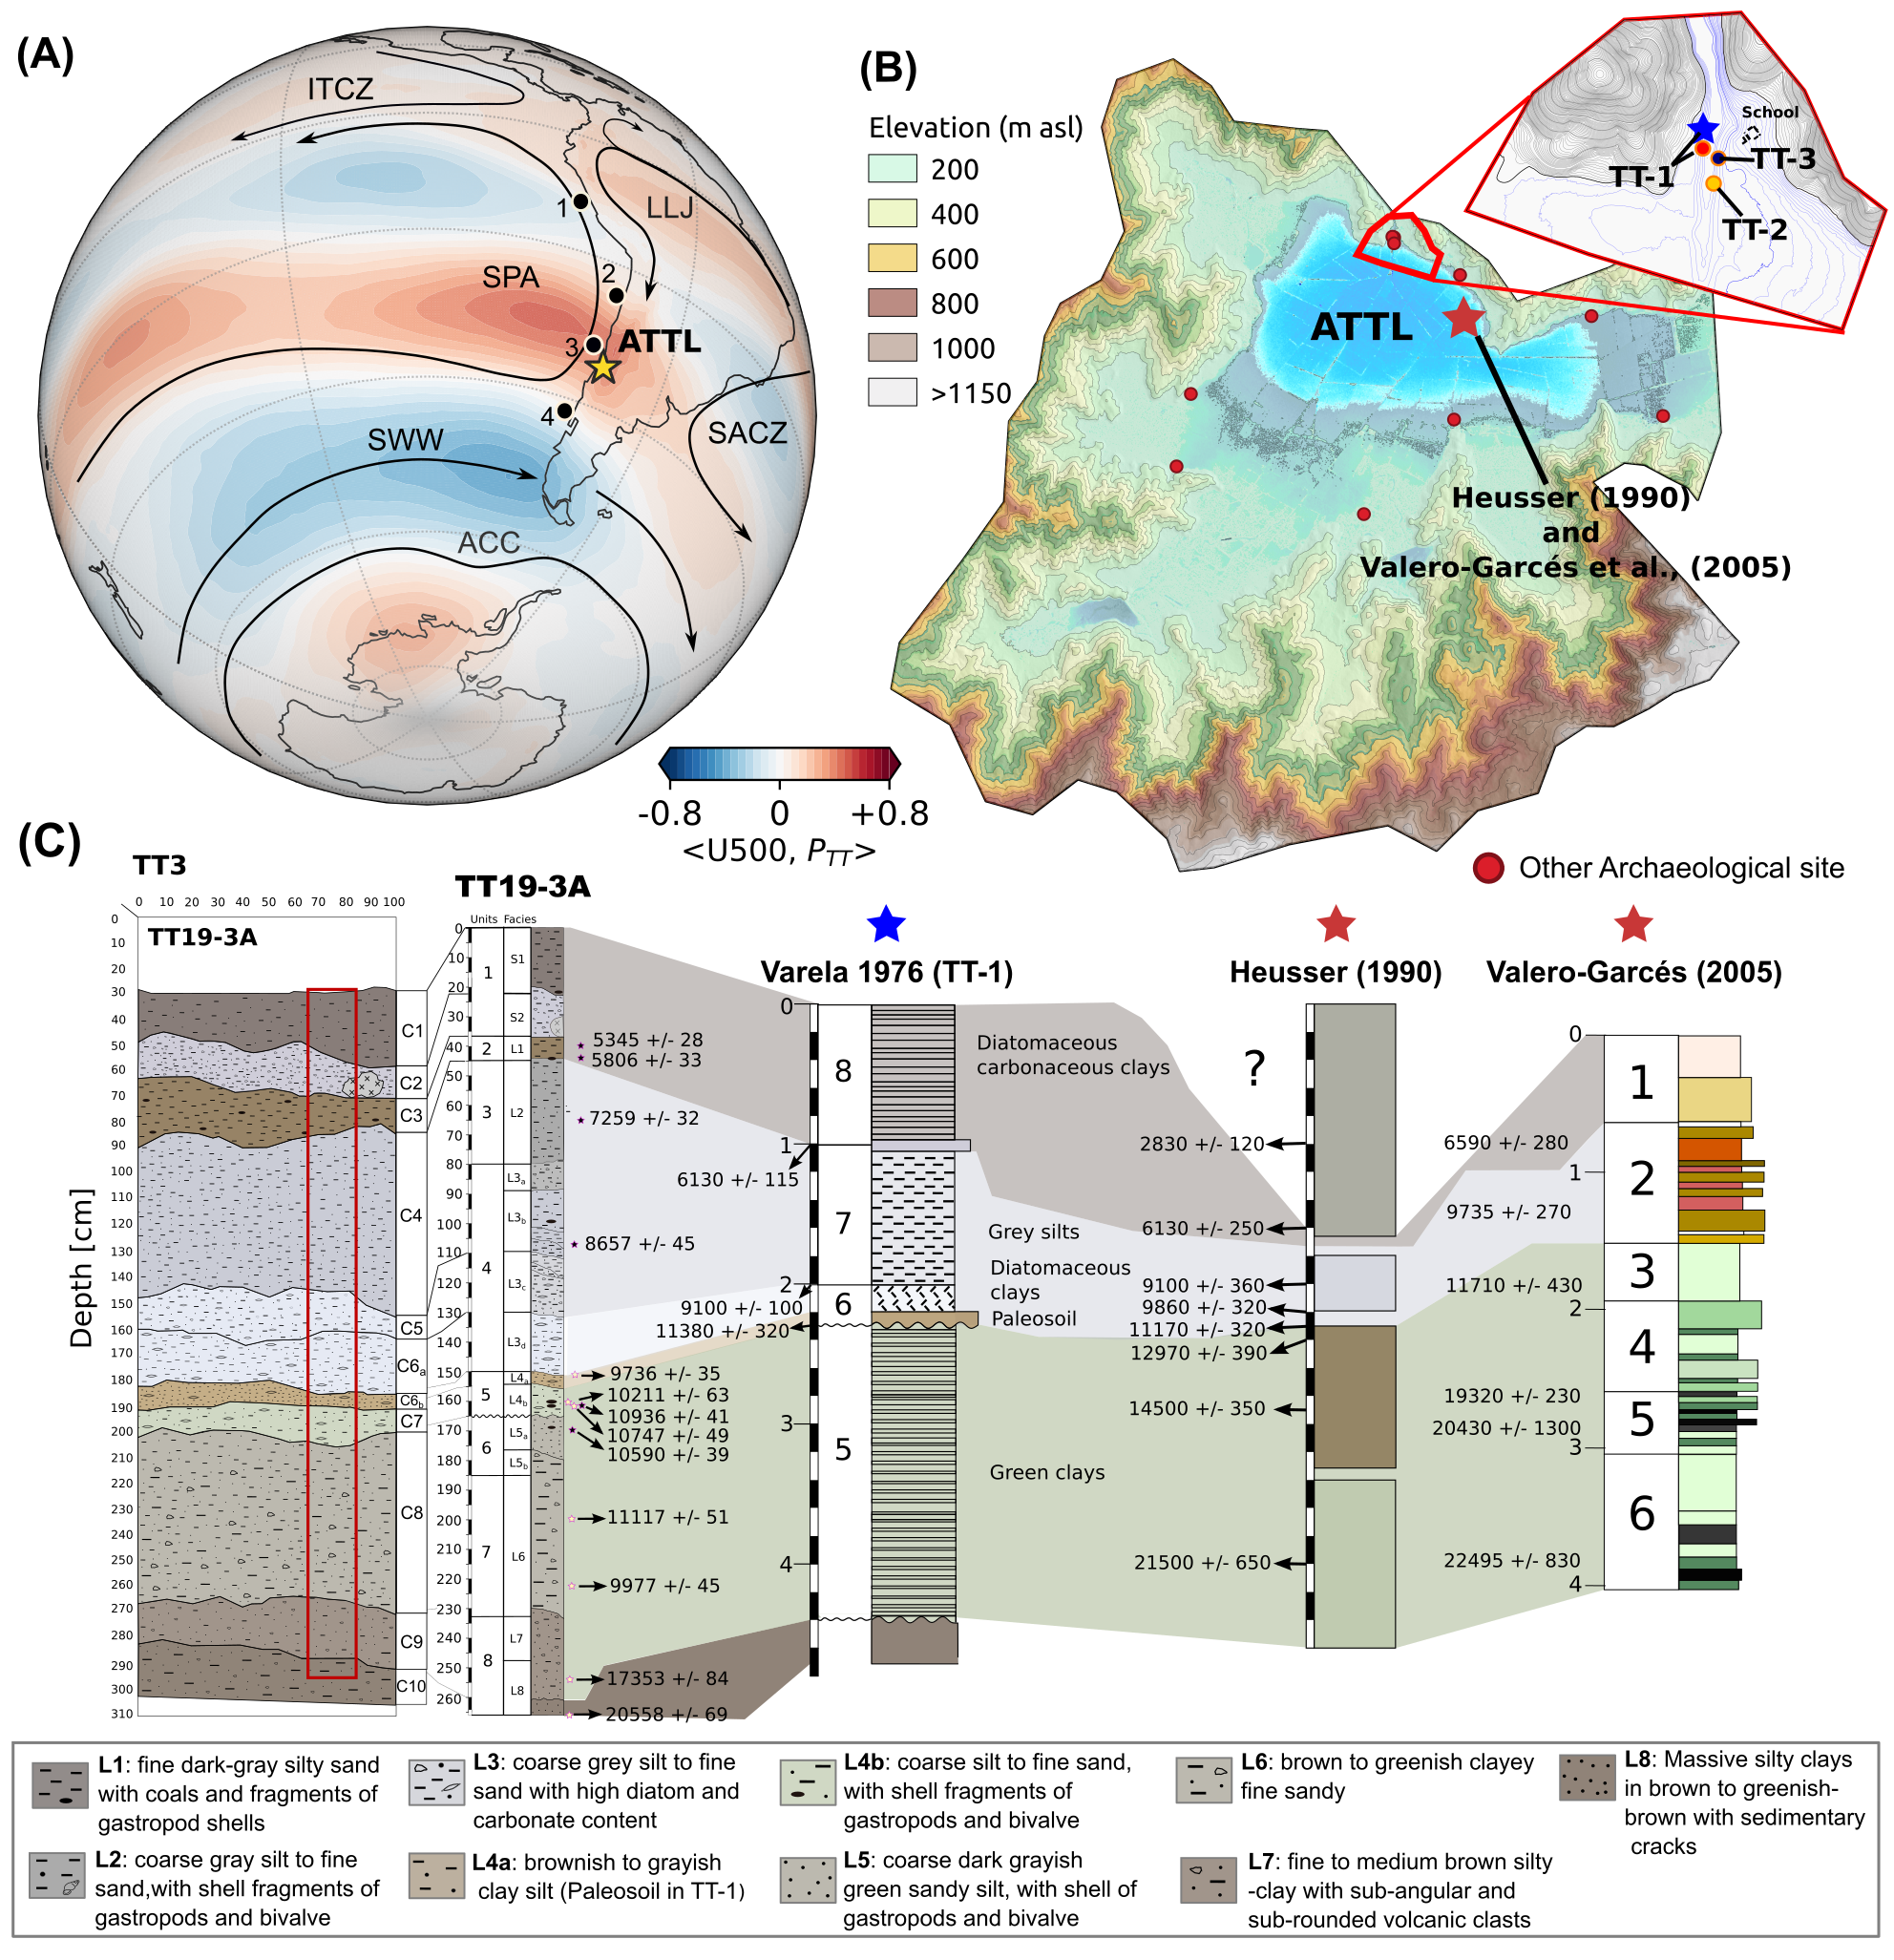
Figure 1. Climate Dynamics and Stratigraphic Correlations at the ATTL. (A) Correlation between monthly-mean 500 hPa zonal-wind anomalies and precipitation in the ATTL region of central Chile, calculated from ERA-5 reanalysis data. The map shows the principal low-level atmospheric flows over South America, including the southern westerly winds (SWW), the southeast Pacific anticyclone (SPA), trade winds (TW), the Intertropical Convergence Zone (ITCZ), the subtropical low-level jet (LLJ), the South Atlantic Convergence Zone (SACZ), and the Antarctic Circumpolar Current (ACC), modified from Garreaud et al. (2009). Marine core locations along the Pacific coast are also indicated: 1 – SO147-106KL (12°S), 2 – GeoB3375/15016 (27°S), 3 – GeoB7139-2 (30°S), and 4 – ODP1233/GeoB7196-1 (41°S). (B) Hydrological basin, topography, and locations of Taguatagua archaeological sites —TT-1 (Montané, 1968; Varela, 1976), TT-2 (Nuñez et al., 1994), and TT-3 (Labarca et al., 2024) —and nearby Taguatagua paleoclimatic records (red star: Heusser, 1990; Valero-Garcés et al., 2005) and (C) Stratigraphic correlation of geoarchaeological and paleoclimatic profiles from the ATTL area.
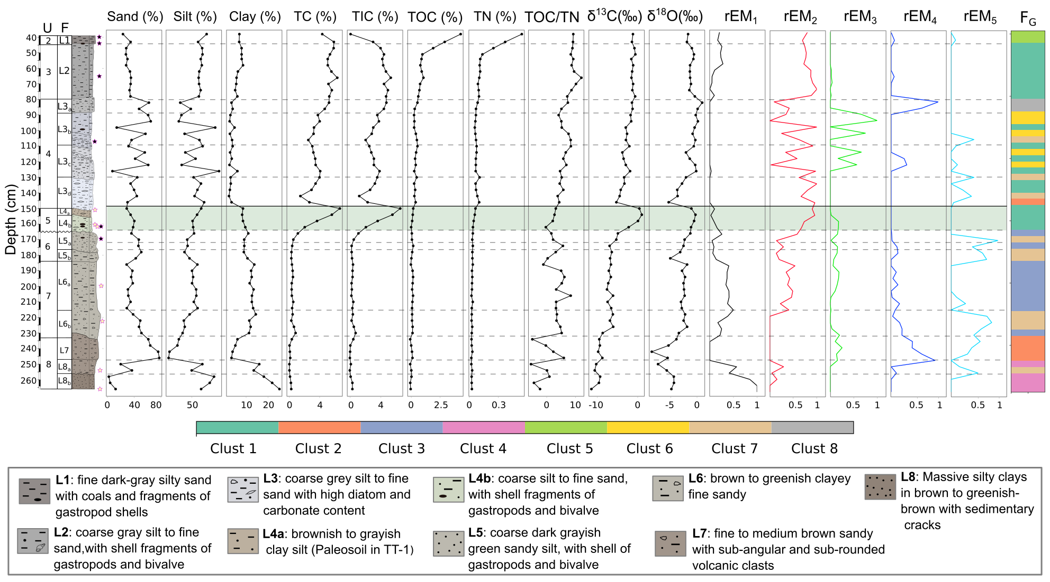
Figure 2. Sedimentary Facies (F) and Units (U) of the TT19-3A Sequence. Stratigraphic profile showing grain-size distributions (sand, silt, clay) and geochemical proxies—total carbon (TC), total inorganic carbon (TIC), total organic carbon (TOC), total nitrogen (TN), TOC/TN ratio, and the isotopic compositions of δ¹³C and δ¹⁸O. The figure also presents end-member models (EM1–EM5) and cluster classifications (Clusters 1–8), which represent distinct granulometric and geochemical associations. The shaded green region indicates the onset of the Holocene.
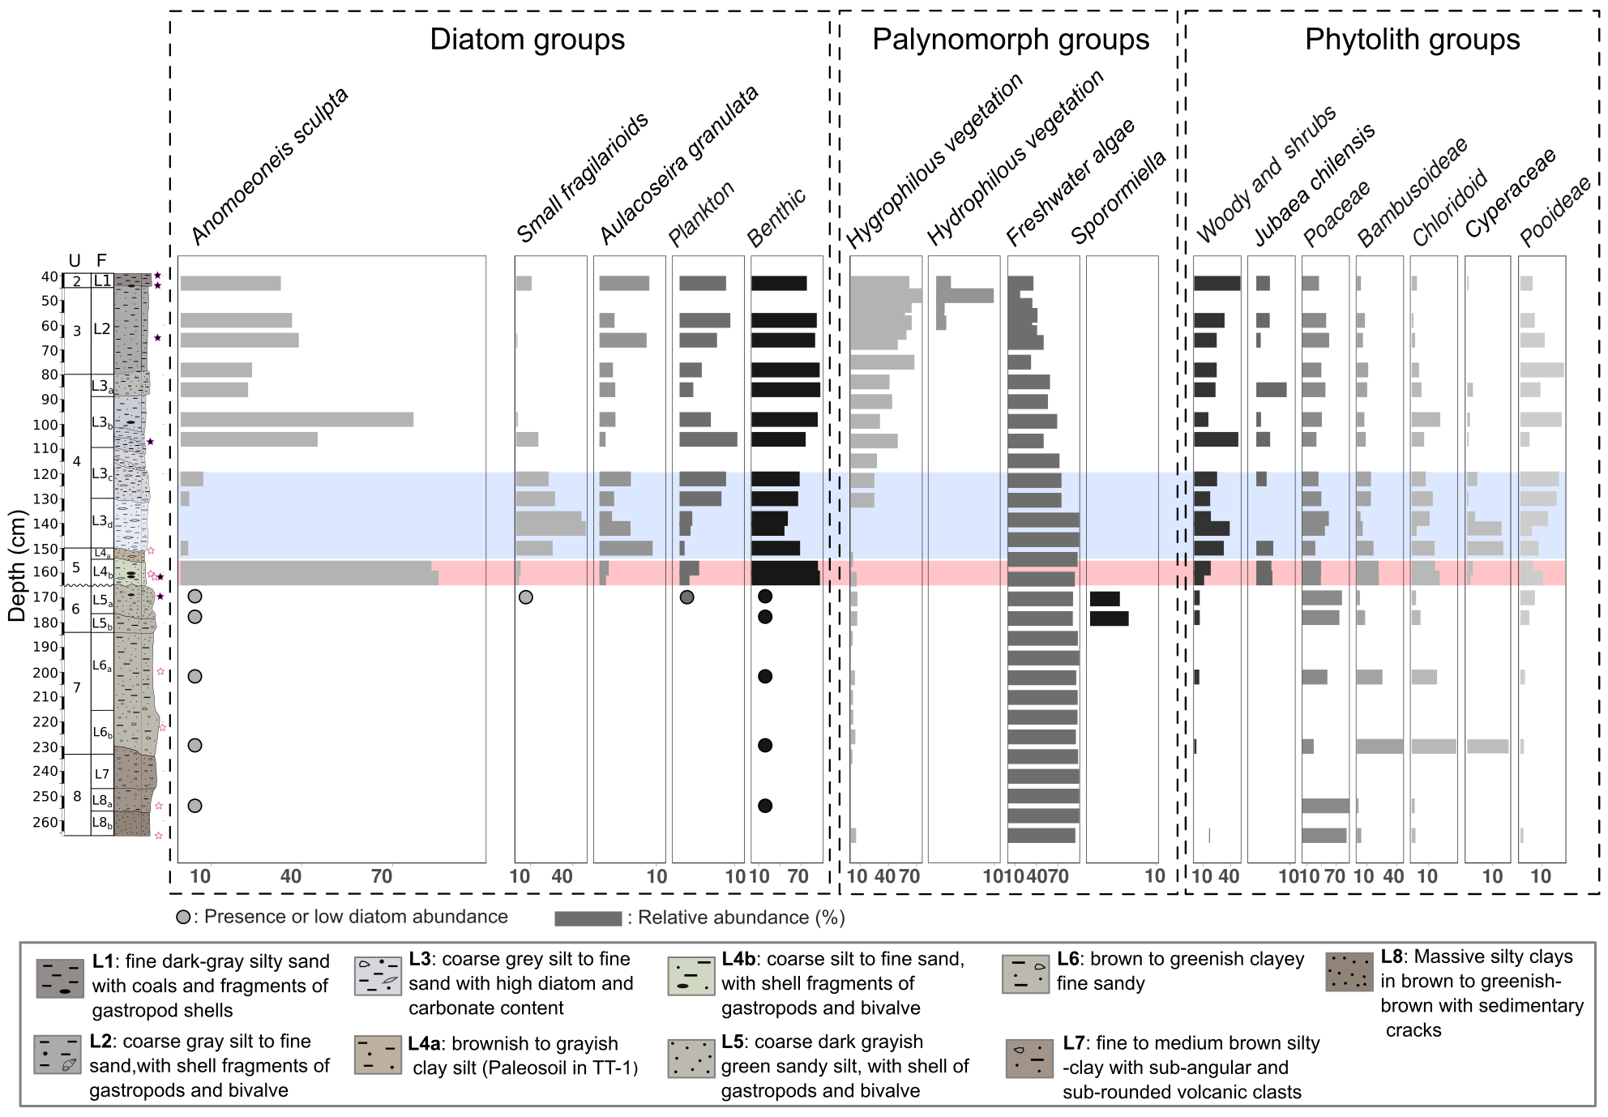
Figure 3. Biostratigraphy of Aquatic–Terrestrial proxies in the TT19-3A sequence. The figure shows changes in relative abundances of diatom, palynomorph, and phytolith functional groups throughout the sequence. Diatoms are categorized as small fragilarioids, Aulacoseira granulata, planktonic, and benthic types. Palynomorphs include hygrophytes, hydrophytes, freshwater algae, and Sporormiella. Phytoliths comprise woody and shrub types, Jubaea chilensis, Poaceae, Bambusoideae, Chloridoid, Cyperaceae, and Pooideae. Sedimentary facies and unit descriptions are shown on the left. Blue and red shaded areas indicate significant lake level changes during the recorded period.
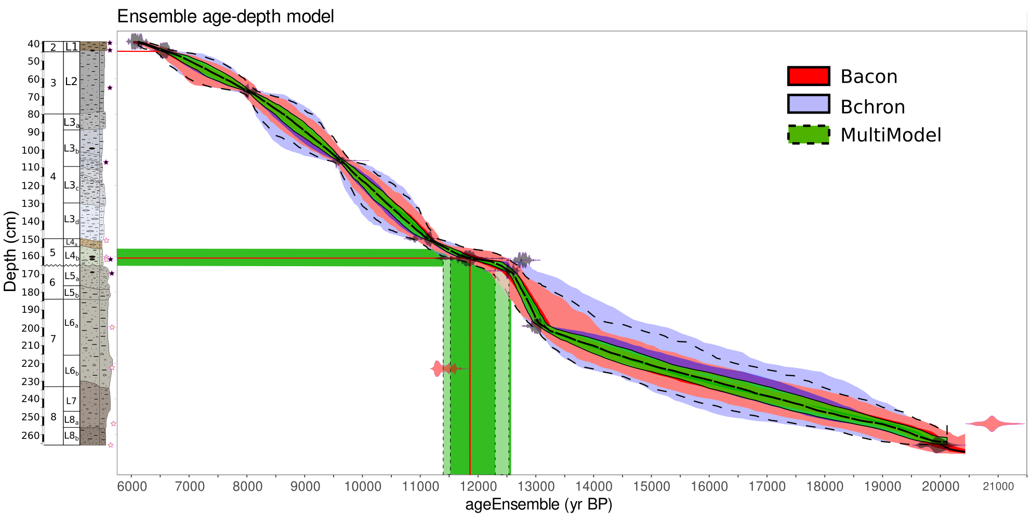
Figure 4. Ensemble age-depth model for core TT19-3A. The figure shows age modeling results for core TT19-3A using two Bayesian methods: Bacon (red) and Bchron (blue). The green shading represents the combined multimodel output, with shaded areas indicating 95% confidence intervals. Shaded green region marking the onset of the Holocene.
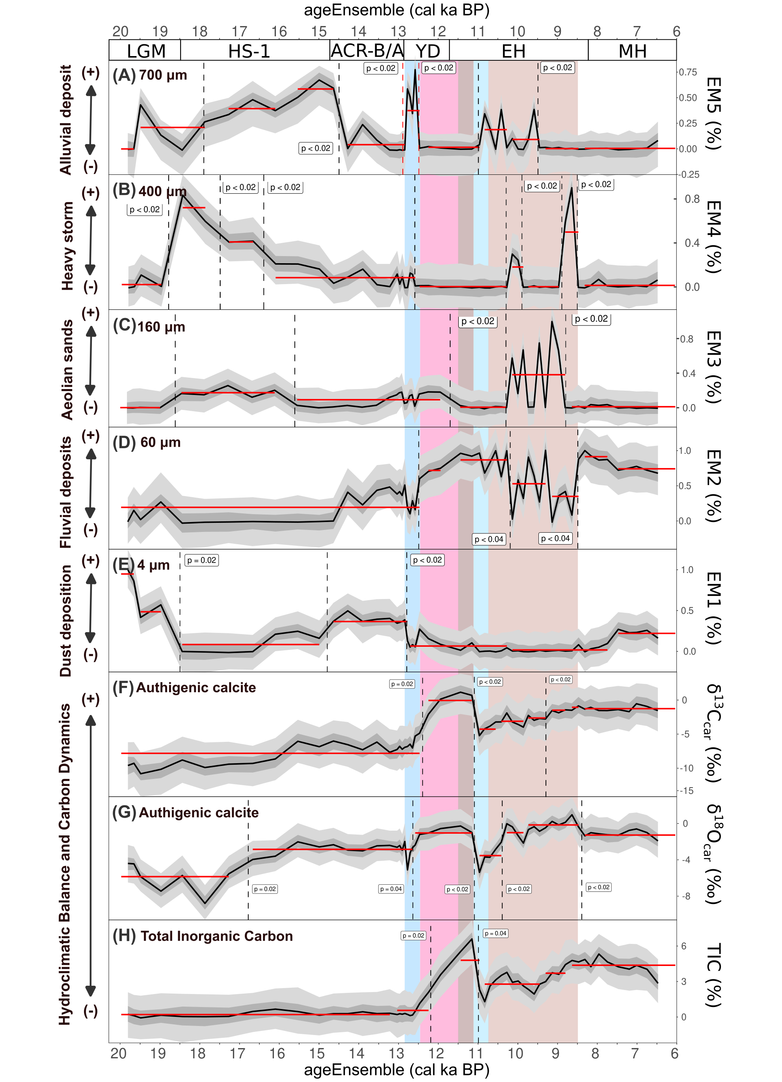
Figure 5. Multi-proxy record from core TT19-3A showing grain size distributions, elemental and isotopic data over the past 20.0 ka BP. Showing key climatic intervals: Last Glacial Maximum (LGM), Heinrich Stadial 1 (HS-1), Antarctic Cold Reversal/Bølling-Allerød (ACR-BA), Younger Dryas (YD), Early Holocene (EH), and Middle Holocene (MH). Panels (a) to (d) display particle size distributions for different grain size fractions: (A) 700 μm (alluvial deposits), (B) 400 μm (heavy storm layers), (C) 160 μm (aeolian sands), and (D) 60 μm (fluvial deposits). Panel (E) represents fine dust particles (<4 μm). Panels (F) to (H) show geochemical proxies for authigenic calcite, including δ¹³C (per mil), δ¹⁸O (per mil), and total inorganic carbon (TIC). Shaded areas highlight climatic transitions, and the black lines represent ensemble averages with confidence intervals (grey shading). Red and black lines indicate statistically significant changes in the time series (p < 0.02 and p < 0.04, respectively).
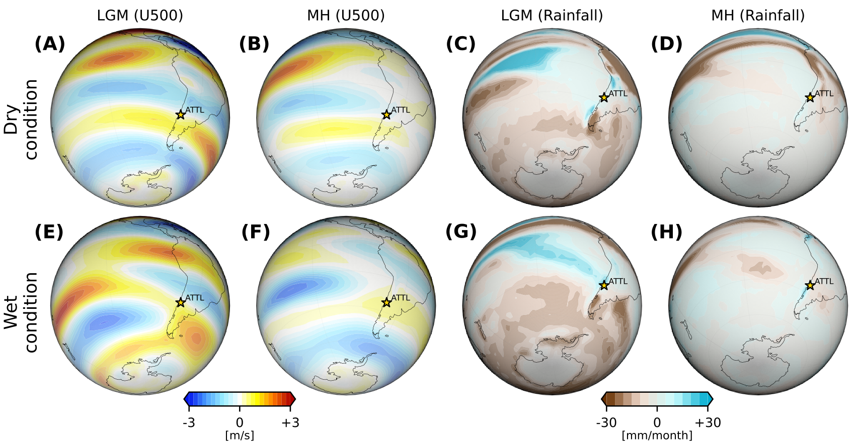
Figure 6. Zonal wind and precipitation anomalies from the PMIP4 multi-model ensemble for the LGM and Middle Holocene (MH) periods. Panels (A-D) show dry anomalies relative to the pre-Industrial simulation. Panels (A-B) depict zonal wind (m/s), while panels (C-D) illustrate precipitation (mm/month). Figures (E-H) show wet anomalies for the same periods, with panels (E-F) showing zonal wind (m/s) and panels (G-H) displaying precipitation (mm/month). The yellow star marks the location of the ALTT.
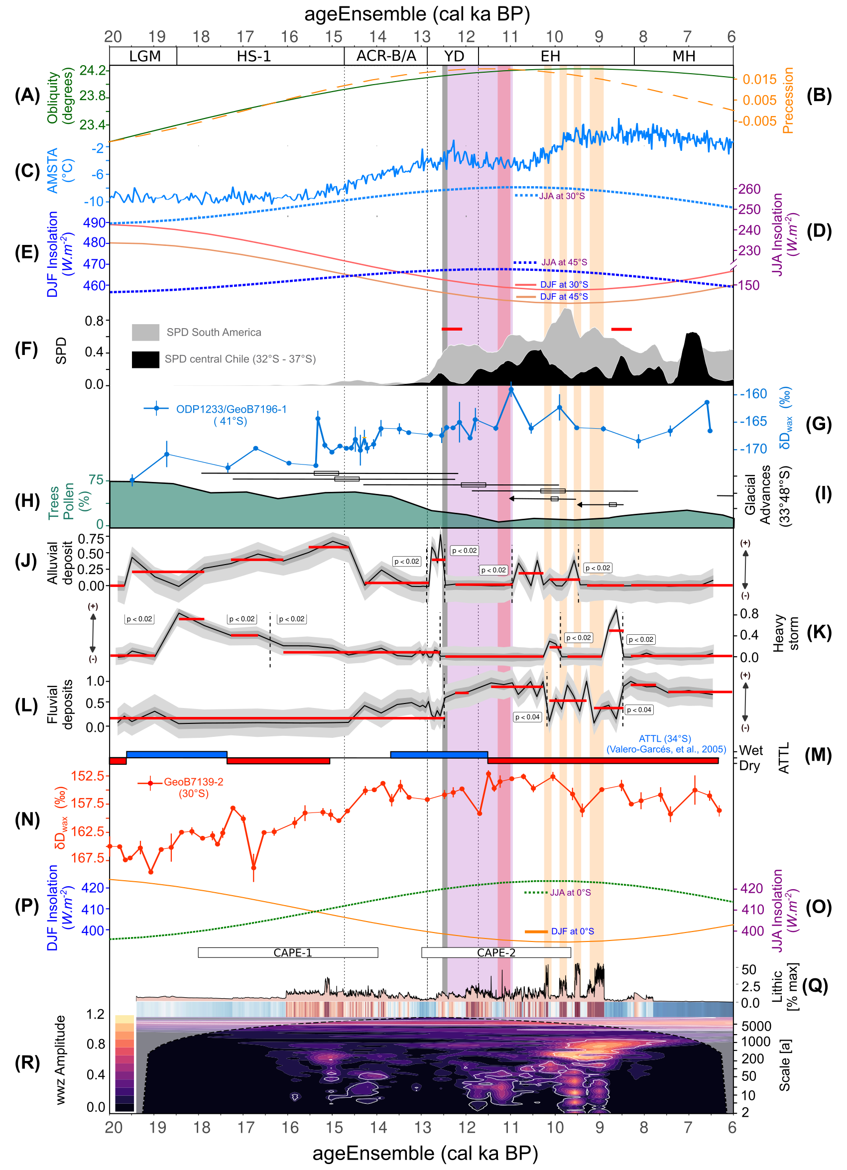
Figure 7. Multi-proxy comparison of climatic and environmental indicators for the ALTT over the last 20 cal ka BP. (A) Obliquity (green line) and (B) Precession (orange line) cycles. (C) Antarctic temperature anomaly (AMSG7TA, °C) from EPICA Dome C. (D) Winter (DJF) and (E) Summer (JJA) insolation curves (W·m⁻²) at 30°S and 45°S. (F) Summed Probability Distributions (SPD) of archaeological dates: central Chile (32°S–37°S, black shading) and South America (grey shading). (G) δDwax values from marine core ODP1233/GeoB7196-1 (41°S). (H) Tree pollen percentage from the ATTL. (I) Evidence of Andean glacial advances (33°–34°S). (J–L) Sedimentary features in the ATTL: relative frequency of alluvial deposits (J), heavy storms (K), and fluvial deposits (L). (M) Wet and dry periods in the ATTL based on Valero-Garcés et al., 2005. (N) δDwax values from GeoB7139-2, indicating changes in moisture sources and aridity. (O) JJA and (P) DJF insolation for 0°S. (Q) Sedimentary lithic content (% max) and (R) Wavelet analysis (WWZ amplitude) from the 106KL marine sedimentary record off the Peruvian coast. CAPE: Central Andes Precipitation Events. Shaded vertical bands highlight major climatic periods and events: LGM (Last Glacial Maximum), HS-1 (Heinrich Stadial 1), ACR-B/A (Antarctic Cold Reversal–Bølling/Allerød), YD (Younger Dryas), EH (Early Holocene), and MH (Middle Holocene).

