
Universidad de Tarapacá
Avenida 18 de Septiembre N° 2222
Arica, Chile
May 08, 2025

Dear Professor Sun,
Editor, Global and Planetary Change,

On behalf of my co-authors, I am writing in response to the editorial comments on our manuscript entitled, “Hydroclimatic variability drove human-megafauna-environment interactions during the late Pleistocene/Early Holocene in central Chile”. We thank you and Reviewer #1 for your careful evaluation and constructive suggestions. We appreciate the constructive feedback for the review process. In the accompanying document, we have provided a detailed account of the revisions made to address each recommendation. We believe these changes have strengthened the manuscript and look forward to its possible publication in Global and Planetary Change.
Sincerely,
Matías Frugone-Álvarez
On behalf of all co-authors

Comments from the Reviewers:

1. Reviewer #1.
1.1 Comments #1.
In the study by Frugone-Álvarez et al., records based on sedimentary facies, grain size distributions, geochemical proxies and biological indicators are used to characterise the paleoclimate and paleoenvironment of the Ancient Tagua Tagua Lake located in central Chile between ca. 20,000 and 6,000 years ago. Paleoclimate modelling results are included to support the suggested climate mechanisms affecting the Ancient Tagua Tagua Lake region. The main results suggest that the Ancient Tagua Tagua Lake transitioned from a shallow lake under a relatively cold and dry climate between 20,000 and 12,500 years ago to a deeper and more productive lake in a warmer and wetter climate. These results are combined with published archeological data to link human history with climate variability. The authors conclude that local paleohydrology is shaping early human-ecosystem interactions.

The manuscript is well-written and clearly structured. The results and discussion are well founded, detailed and not over-interpreted. The figures are clear and well prepared. The study presents important new and challenging results exposing important aspects in climate-human-ecosystem interactions. I really enjoyed reading this manuscript and I recommend its publication with some minor revisions. However, one relatively important aspect needs to be cleared up: the authors suggest that the early Holocene was wet although published results show that the climate was dry in central Chile at this time.

Reply specific comments #1.
We thank the reviewer for highlighting this discrepancy. Our multiproxy record shows that, when benchmarked against Last Glacial Termination conditions, the Early Holocene in central Chile was wetter, particularly between ~12.5 and 9.0 ka cal BP —contrary to other inland records that label it “dry” only relative to the Late Holocene (e.g., Jenny et al., 2002). However, well-dated, high-resolution records covering the Last Glacial Termination in central Chile remain scarce. Existing datasets from the ATTL (Heusser 1971, 1983; Valero-Garcés et al. 2005; Varela 1976; see Fig. 7) are limited by three main issues. First, although invaluable, these early records suffer from low temporal resolution —often only nine samples spanning 11–20 ka— and large ¹⁴C uncertainties. Second, “wet” conditions have frequently been inferred primarily from Nothofagus pollen, an approach valid in temperate regions but less appropriate for central Chile’s Mediterranean climate (see Discussion 4.2). Third, the recalibrated SHCal20 ages (Supplementary Fig. S6; Heusser 1983) document a marked decline in Nothofagus abundance after ∼20 ka, supporting a progressive shift toward warmer, drier conditions at the end of the Pleistocene.

Furthermore, outputs from four PMIP4 models comparing the Last Glacial Maximum with piControl PMIP4 simulations reveal three consistent features that support our interpretation of a wetter Early Holocene relative to the Last Glacial Termination and its associated sedimentary dynamics: 1) A global decrease in humidity relative to pre-industrial levels during the LGM; 2) A wet anomaly south of 36° S in the PMIP4 outputs, corresponding to a region where present-day ERA-5 reanalysis shows an inverse correlation between precipitation and the 500 hPa zonal wind in the ATTL (see Figs. 1A and S8) and 3) A clear increase in moisture near the surface of the equator and at mid-latitudes, likely caused by an intensified Pacific Subtropical Jet Stream and ENSO-like variability associated with storms.

Together, these lines of evidence reconcile our local multiproxy data, showing wetter intervals between ~12.5 and 9.0 ka cal BP, with regional records that emphasize Early Holocene aridity. Our data reveal a distinct Early Holocene wet phase with important implications for SWW intensification/displacement and human–ecosystem interactions.

1.2 Comments #2.
Highlights:
“Orbital, ENSO-like, Southern Westerly Winds, and Westerly Wind shifts shaped hydroclimate and early societies": this point sounds a bit too much like a series of words, and includes twice Westerly Winds … I suggest to rewrite this bullet point.

"Archaeology reveals megafauna-human cohabitation amid rapid climate transitions": unclear … I suggest to rewrite this bullet point.

Reply specific comments #2.: Thank you for letting us know about the mistakes in the wording and the repetition in our highlights. We have revised both points to make them clearer and more concise:

Revised:
New Highlights

- A 20 ka Tagua Tagua Lake record unveils earliest climate–human feedbacks in central Chile
- Multiproxy proxies reveal ecological and cultural refugia at the Pleistocene–Holocene transition
- Orbital forcing, ENSO-like, SWW and PSJ events shaped late Pleistocene hydroclimate
- Multiproxy evidence documents human–megafauna co-occurrence during abrupt hydroclimatic changes
- Early Holocene (12.5–8.6 ka BP) featured enhanced moisture and ENSO-driven pulses

1.3 Comments #3.
Abstract:
Line 47: To what refers "its"? Unclear. Please, rephrase.

Reply specific comments #3: Thank you for pointing out the unclear pronoun. We have replaced “its” with “ATTL’s ecosystem dynamics” to clarify the referent. The revised sentence now reads:

“ …, to reconstruct the ATTL’s ecosystem dynamics over the past 20,000 years”

New Abstract:
Major environmental changes were occurring when the first modern humans arrived in South America during the Pleistocene-Holocene transition. How these changes shaped human-environmental interactions across this period remain unclear. We analyzed the stratigraphy, biogeochemistry, and paleoclimatic models from the Ancient Tagua Tagua Lake (ATTL) in central Chile, one of the few continuous records of human and megafauna interactions with their environment in South America, to reconstruct the ATTL’s ecosystem dynamics over the past 20,000 years. Results reveal that the ATTL transitioned from a shallow, cool lake with storm-driven alluvial deposition to a warmer, deeper, and more productive lake about 12,500 years ago, aligning with early humans' arrival. The ATTL became wetter but experienced severe droughts between 11,000 and 8,500 years ago, linked to shifts in Southern Westerly Winds and ENSO-like patterns. Fluctuating conditions drove humans and fauna to seek refuge in the basin, emphasizing local paleohydrology’s role in shaping early human-ecosystem interactions.

1.4 Comments #4.
Main text:
Line 133: Please, add references here.

- Reply specific comments #4: Done.

Revised:
“ATTL is a key geoarchaeological area that preserves evidence of extinct faunal assemblages and human occupation from the Late Pleistocene to the Late Holocene (Montané, J., 1968).”(in Line 135)

- Montané, J., 1968. Paleo-Indian Remains from Laguna de Tagua Tagua, Central Chile. Science 161, 1137–1138. https://doi.org/10.1126/science.161.3846.1137

1.5 Comments #5.
Line 325: While TT-1 is indicated in fig. 1C, it is not the case of TT-2 (Heusser, I guess) and TT-3 (Valero-Garcés, I guess). Please, indicate TT-2 and TT-3 as well in the figure.

Reply specific comments #5. We agree with the reviewer about the clear description of archaeological sites and have changed Figure 1C and caption to:
- Revised:
New Figure 1 (see figure 1B):

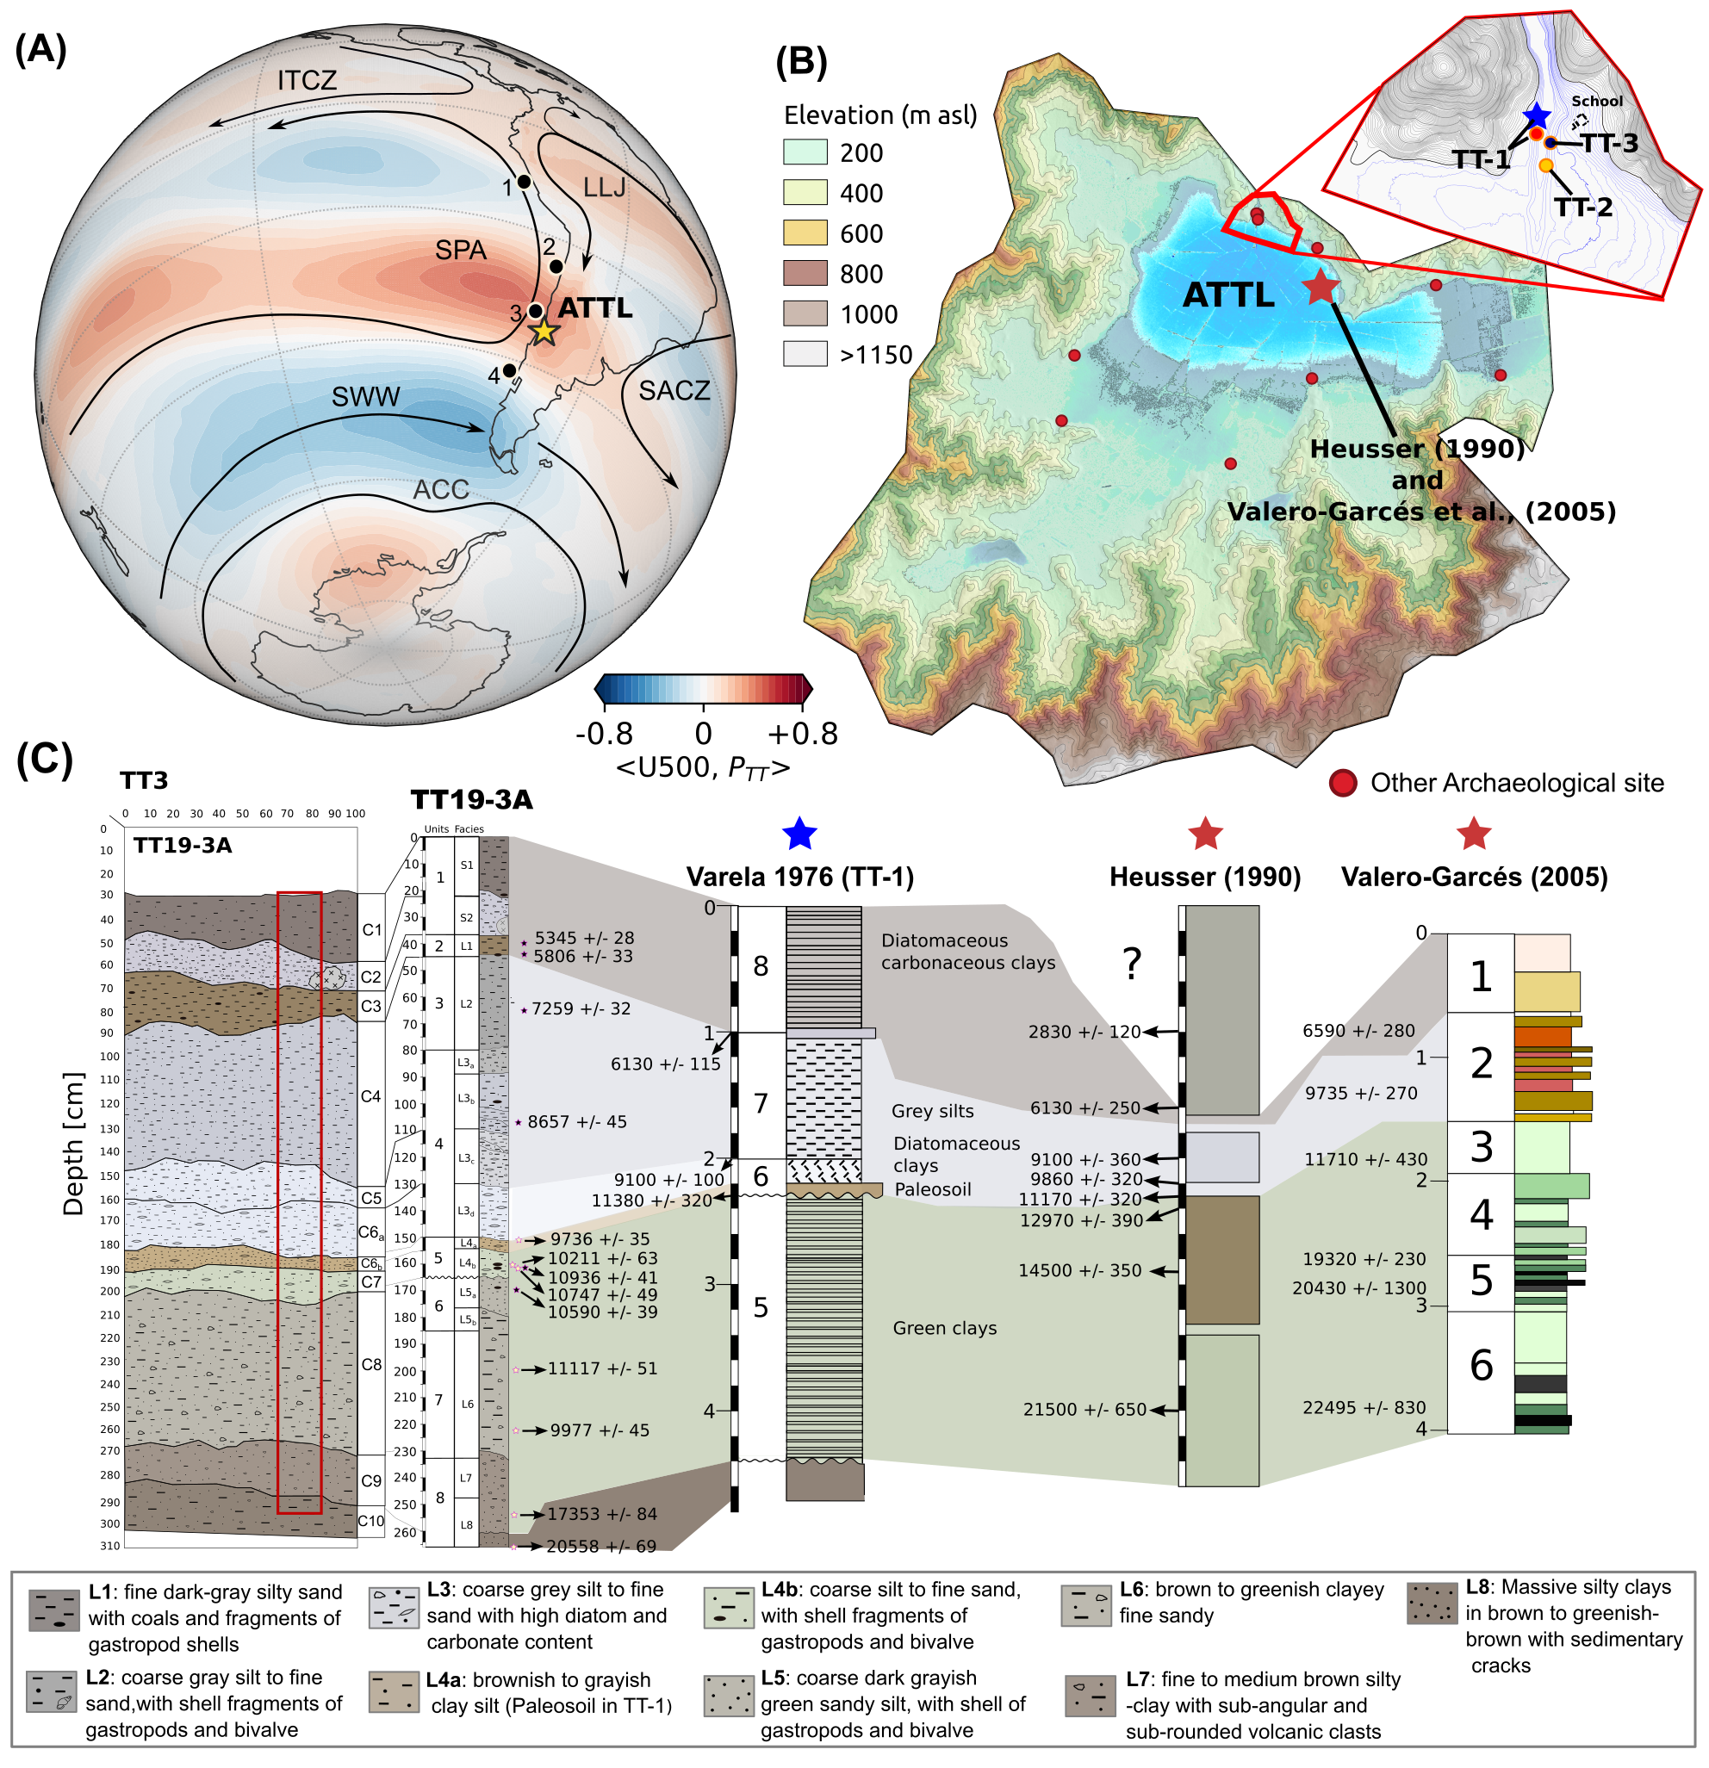
- Revised caption:
Original: Figure 1 “…(B) Location of the Tagua Tagua site (TT3) alongside related archaeological and paleoclimatic records.”
Revised Figure 1 “…(B) Hydrological basin, topography, and locations of Taguatagua archaeological sites —TT-1 (Montané, 1968; Varela, 1976), TT-2 (Nuñez et al., 1994), and TT-3 (Labarca et al., 2024) —and nearby Taguatagua paleoclimatic records (red star: Heusser, 1990; Valero-Garcés et al., 2005).…”

- Added reference:

Nuñez, L., Varela, J., Casamiquela, R., Schiappacasse, V., Niemeyer, H., & Villagrán, C. (1994). Taguatagua Basin in Chile: The Late Pleistocene environment and human occupations. Revista Chilena de Historia Natural, 67(3), 503–519.

1.6 Comments #6.
Lines 323-363: The first part of this subchapter is about archeological evidences. But, if I understood correctly, no archeological evidences were discovered in the present study. These are from previous publications (Heusser, 1983; Valero-Garcés et al., 2005; Varela, 1976). This part also reads more like a discussion. Therefore, I'd recommend to move this part to the Discussion and focus here only on the results produced in the present study, i.e. the part about the age model.

Reply specific comments #6. We thank the reviewer for pointing out the overlap between the Results and Discussion sections. In response, we have retitled the subsection and removed the introductory paragraph along with the first half of the subsequent paragraph. The results now present only the sedimentation rate analysis, while all interpretative discussion has been relocated to the Discussion section.

Retitled the subsection
- Original: “3.3. Cultural signals, megafauna and chronological context”
- Now: “3.3. Chronological context” (Line 331)

- Revised “3.3. Chronological context” (Results: lines 332-346)
The chronological framework for the TT19-3A sequence provided by the age-depth models (Bacon and Bchron; Fig. 4), offering a robust temporal backdrop for correlating cultural and environmental shifts. The models excluded two outlier ages. Bulk sediment and charcoal samples taken at the same depths showed no significant differences, ruling out a reservoir effect. According to the ensemble age-depth model, the TT19-3A sequence covers the last 20.5 cal ka BP (Table S1 and Fig. 4), with a higher model robustness in the upper four units. Unit 8 (2.66 m - 2.30 m) spans from ~20.5 to 16 cal ka BP with an accumulation rate of ~200 a cm⁻¹. Unit 7 (2.30 m - 1.84 m) was deposited between ~16 and 12.5 cal ka BP with an accumulation rate of ~100 a cm⁻¹. Unit 6 (1.84 m - 1.65 m) was deposited between 13 and 12.6 cal ka BP with an accumulation rate of ~20 a cm⁻¹. Unit 5 (1.65 m - 1.50 m), encompassing the Pleistocene-Holocene transition (12.6 - 11.3 cal ka BP), has an accumulation rate of ~100 a cm⁻¹. Unit 4 (1.50 m - 0.80 m) extends from 11.3 to 8.6 cal ka BP, characterized by ~50 a cm⁻¹. Unit 3 (0.80 m - 0.45 m) spans between 8.6 and 6.5 cal ka BP with a median rate of ~60 a cm⁻¹. Unit 2 (0.45 - 0.38 m) covers between 6.5 and 6.0 cal ka BP with an accumulation rate of ~80 a cm⁻¹.
All interpretative discussion of archaeological sites and cultural signals has been moved to the Discussion (see Seccions. 4.2, 4.3 and 4.4).

In “4.2. Changing lake environments, new habitats and first human settlement (12.9–8.6 cal ka BP)”
(Lines 491-494). “Archaeological evidence from the ATTL indicates that human occupation at sites TT-1 (Montané, 1968; Varela, 1976), TT-2 (Nuñez et al., 1994), and TT-3 (Labarca et al., 2023) began around 12.6 - 11.6 ka cal BP during deposition of Unit 5 in the TT19-3A sequence (Fig. 1c).” Between ca. 12.8 and 12.4 cal ka BP (Unit 5)….
(Lines 543-545). “No archaeological radiocarbon dates have been identified between ca. 11.5 and 9.0 ka cal BP at the ATTL; however, open-air residential camps and extensive lithic knapping areas appear at ca. 9.0 ka cal BP.” Between 11.2 and 8.6 cal ka BP (Unit 4), a series of fluctuations in water levels, detrital input…

4.3 Early human–ecosystem interactions in ATTL during the Pleistocene–Holocene transition
(Lines 588-590). “In a broader regional context, the SPD of archaeological radiocarbon dates for South America and central Chile (32°S - 37°S), reveal a pronounced increase around 12.6 ka cal BP (Figs. 7F)”. This uptick aligns with...

4.4 Early-Middle Holocene: increased environmental variability and emerging human settlement patterns
(Lines 636-639). “The TT19-3A sequence shows that, compared to the Late Pleistocene, the Early Holocene was characterized by higher lake levels, intensified evaporative regimes, and the emergence of more diverse ecological assemblages (Figs. 5 and 7).”

(Lines 647-650). “Throughout the Early to Middle Holocene (ca. 11.7-6.0 ka cal BP), the SPD remains elevated, albeit with intermittent variability. When considered alongside local archaeological evidence, these trends imply a continuous human presence with episodic shifts in occupation intensity in central Chile”. Between 11.5 and 11 cal ka BP...
(Lines 685-689). ...Human burials were added into residential areas, conforming complex mounds characterized by intensive domestic refuse and mixed stratigraphic deposits. Some isolated dates suggest that these sites were probably occupied less recurrently until the beginning of the Late Holocene (ca. 4.0 cal ka BP). At least seven of these structures….
1.7 Comments #7.
Lines 507-508: Please, add a reference for the early human occupation.

Reply specific comments #7. Done.
Revised:
(Lines 502). “The presence of Sporormiella spores, megaherbivore remains, and evidence of early human occupation around 12.5 cal ka BP (Labarca et al., 2024) coincides with this transitory alkaline lake phase.”

Labarca, R., Frugone-Álvarez, M., Vilches, L., Blanco, J.F., Peñaloza, Á., Godoy-Aguirre, C.,
Lizama-Catalán, Á., Oyarzo, C., Tornero, C., González-Guarda, E., Delgado, A., Sepúlveda, M., Soto-Huenchuman, P., 2024. Taguatagua 3: A new late Pleistocene settlement in a highly suitable lacustrine habitat in central Chile (34°S). PLOS ONE 19, e0302465. https://doi.org/10.1371/journal.pone.0302465

1.8 Comments #8.
Lines 498-499: The time interval mentioned here should be 12.9-6.5 cal ka BP as the last sentences of this chapter are about changes in environmental conditions until 6.5 (or even 6.0) cal ka BP.

Reply specific comments #8. Thank you for pointing this out.
We have corrected the interval to 12.9–6.5 cal ka BP (line 489) in lines 498-499 to align with the discussion (4.2) of environmental changes through 6.5 cal ka BP.

1.9 Comments #9.
Lines 605-607: But the literature suggests a southward shift of the SWW in the early Holocene…How do you explain these contrasting results?

Reply specific comments #9. We have rewritten this paragraph to clarify the changes.

(Lines 606-623) “Amid these regional cultural developments, ATTL paleoclimatic proxies record increased water availability and warming during between ca. 15 and 11 cal ka BP (Fig. 7L), followed by a marked increase in extreme hydroclimatic events between 11 and 9 cal ka BP (Figs. 7J-K). Marine records off the northern Chilean coast show a progressive decline in SWW influence near 30° S toward the end of the Late Pleistocene, as evidenced by elevated δD values of the n-C31 alkane from GeoB7139-2 marine sediments between 14 and 12 cal ka BP (Kaiser et al., 2024; Figs. 2, 3, 7L–N). During the Early Holocene, Kaiser et al. (2024) document two concurrent climate shifts: a rapid intensification of the SWW at 45°S and a progressive northward expansion of these winds to 30° S between 12 and 6 cal ka BP —likely driven by a weakened subtropical anticyclone. Futhermore, both shifts coincided with large-amplitude REC episodes linked to the Younger Dryas and ENSO-like variability (Cheng et al., 2020; Kaiser et al., 2024; Rein et al., 2005; Wang et al., 2020). These processes—partially driven by obliquity-induced orbital changes and ENSO-like variability—likely governed the variability of both the SWW and the SPSA in central Chile between ca. 12.5 and 9 cal ka BP, forming a complex interplay not fully captured by other records at this latitude (Fernández-Navarro et al., 2024; Herrera-Ossandón et al., 2023; Kaiser et al., 2024)..”

1.10 Comments #10.
Lines 655-658: This is unexpected as the mid-Holocene is considered as the driest Holocene period in central Chile. Please, try to suggest some possible explanation for elevated lake levels and higher fluvial inputs. Could it be a local phenomenon?

Reply specific comments #10. We thank the reviewer for pointing out this apparent discrepancy. In our revised manuscript, we have added two modified paragraphs in Section 4.4 (lines 655–670) to brift explain the unusually stable lake levels and fluvial inputs during the Middle Holocene:

Original: “During the first half of the Mid Holocene (8.5 - 6 cal ka BP), central Chile experienced a gradual shift toward increased aridity—though less extreme than events recorded between 11 and 8.5 cal ka BP (Figs. 5, 7H-J). This is supported by PMIP4-CMIP6 multi-model ensemble outputs (Figs. 6, 11S-13S; Table S2), which indicate a slight increase in zonal winds in central Chile under wet conditions compared to pre-industrial levels (Fig. 6F). At lower latitudes, negative zonal wind anomalies suggest La Niña-like or ENSO-neutral conditions, linked to drier periods in central Chile (Garreaud et al., 2020, 2017). Wet conditions, however, show a slight increase in precipitation relative to the pre-industrial period, while dry conditions exhibit precipitation and zonal wind patterns similar to pre-industrial levels (Figs. 6D and 6H). Although no evidence suggests a northward displacement of the SWW during the Mid Holocene, the TT19-3A record indicates higher fluvial inputs and elevated lake levels compared to other central Chilean lacustrine records from the same period (Jenny et al., 2003, 2002).”

Paragraph rewritten (Lines 664-677) : During the first half of the Middle Holocene (8.5 – 6 cal ka BP), central Chile gradually became more arid. This trend, however, was less severe than the drying episode between 11.0 and 8.5 ka cal BP (Figs. 5, 7H-J). This is supported by PMIP4-CMIP6 multi-model ensemble outputs (Figs. 6, 11S-13S; Table S2), show that, during simulated wetter intervals, zonal winds strengthened slightly relative to the pre-industrial control (Fig. 6F). At lower latitudes, negative zonal wind anomalies suggest La Niña-like or ENSO-neutral conditions, linked to drier periods in central Chile (Garreaud et al., 2017, 2020). Wetter phases exhibit slightly higher precipitation than the pre-industrial mean, whereas drier phases show anomalies near zero for both rainfall and zonal winds (Figs. 6D and 6H). There is no indication of a northward shift of the SWW during the Middle Holocene. Nevertheless, the TT19-3A record shows elevated fluvial inputs and stable lake levels compared to other contemporaneous basins, suggesting ATTL may have served as a hydrological refuge under regional aridity (Jenny et al., 2002, 2003).

1.11 Comments #11.
Lines 722-733: I suggest removing (or shortening) this paragraph for three main reasons: (1) further analyses will always help understanding a system better (why not doing all the mentioned analyses within the frame of the present study and publishing later?), (2) some methods/analyses are mentioned, but their potential and aims are not explained; it does not help the reader further (e.g. what are GDGTs?), and (3) the Conclusions are already quiet extensive (1.5 pages).

Reply specific comments #11. We appreciate your suggestion. We agree that the proposed paragraph on additional analyses is overly detailed for the Conclusions. Accordingly, we have removed the entire paragraph (formerly lines 722–733). The Conclusions section is now more concise and focused on our core findings.

1.12 Comments #12.
Figure 1A: Normally a positive correlation exists between SWW and rainfall in southern Chile. However, this map suggests a negative correlation. Is it correct?

Reply specific comments #12. Thank you for this important point.
The negative sign in Figure 1A is correct and reflects that we computed the correlation between 500 hPa zonal-wind anomalies and precipitation in the ATTL region (central Chile) using monthly-mean ERA-5 reanalysis data. South of ∼40° S, a strengthening of the SWW delivers more frontal rainfall there, yielding a negative correlation with precipitation in central Chile. North of ∼40° S, however, an intensified SWW shifts storm tracks into our study area, increasing central Chilean rainfall and producing a positive correlation. Thus, the overall negative correlation in Figure 1A arises because stronger westerlies tend to displace the primary rain belt south of our ATTL window.

Changes made to the manuscript: We have added a clearer explanation to the Figure 1A caption and included this explanation in the Supplementary Methods.

Figure 1.… “(A) Correlation between monthly-mean 500 hPa zonal-wind anomalies and precipitation in the ATTL region of central Chile, calculated from ERA-5 reanalysis data (see Supplementary Methods). The map shows the principal low-level atmospheric flows over South America, including the southern westerly winds (SWW), the southeast Pacific anticyclone (SPA), trade winds (TW), the Intertropical Convergence Zone (ITCZ), the subtropical low-level jet (LLJ), the South Atlantic Convergence Zone (SACZ), and the Antarctic Circumpolar Current (ACC), modified from Garreaud et al. (2009). Marine core locations along the Pacific coast are also indicated: 1 – SO147-106KL (12°S), 2 – GeoB3375/15016 (27°S), 3 – GeoB7139-2 (30°S), and 4 – ODP1233/GeoB7196-1 (41°S)…”

- Supplementary Methods
“Climate Model Simulations: To compare regional atmospheric circulation patterns with sedimentary changes at the study site, we calculated circulation anomalies using monthly‐mean ERA5 reanalysis data (1979–2021) and PMIP4 model outputs for the Mid-Holocene (~6 ka) and Last Glacial Maximum (~21 ka) periods. We computed Pearson correlation coefficients between 500 hPa zonal‐wind anomalies and precipitation over the ATTL region (central Chile, ∼30-36°S) using monthly‐mean ERA-5 reanalysis data (1979-2021). Zonal‐wind anomalies at 500 hPa were obtained by subtracting the 1981-2010 climatological monthly mean from the instantaneous fields. Precipitation fields were aggregated to monthly means on the same 0.25°×0.25° grid. Correlations were calculated at each grid point between the time series of zonal‐wind anomalies and precipitation over the ATTL domain. The resulting map (Fig. 1A) captures negative correlations south of ∼40°S —reflecting enhanced frontal precipitation delivery by stronger westerlies outside the ATTL —and positive correlations north of ∼40° S, which indicate storm‐track shifts into central Chile under intensified SWW conditions.”

Information to Ensure a Fair Review Process:
Originality: We confirm that this manuscript is original, unpublished, and not under consideration elsewhere.
Conflict of Interest: The authors declare no conflicts of interest that could have influenced the outcomes or interpretation of this study.
Data Availability: All raw and processed datasets, as well as the complete analysis and figure-generation scripts, are publicly available at Zenodo (DOI: 10.5281/zenodo.15354127) and on GitHub (https://github.com/mat1506/TT3)..

Thank you for considering our manuscript. We look forward to contributing to your journal and to engaging with the reviewer feedback.

