* Hydroclimate variations over the last 17,000 years as estimated by leaf waxes

2in rodent middens from the south-central Atacama Desert, Chile

* Matías Frugone-Álvareza,b,c,∗, Sergio Contrerasa,e,∗, Oliver Meseguer-Ruizf, Eduardo Tejosa, Antonio
* Delgado-Huertasg, Blas Valero-Garcésh, Francisca P. Díazi,b,j, Matías Briceñok, Manuel Bustos-Moralesk,

5 Claudio Latorrek,i,c,∗

* *Universidad Católica de la Santísima Concepción, Departamento de Química Ambiental, Alonso de Ribera 2850, Concepción,*

*Chile, 4090541*

*bANID-Millennium Science Initiative Nucleus (AFOREST), Vicuña Mackenna 4860, Macul, Santiago, Chile, 7820436 cANID-Millennium Science Initiative Nucleus (UPWELL), Raúl Bitrán 1305, La Serena, Chile,*

* *Universidad Católica de la Santísima Concepción, Departamento de Química Ambiental, Facultad de Ciencias, Alonso de Ribera 2850, Concepción, Chile, 4090541*
* *Centro de Investigación en Biodiversidad y Ambientes Sustentables (CIBAS), Alonso de Ribera 2850, Concepción, Chile,*
* *Universidad de Tarapacá, Departamento de Ciencias Históricas y Geográficas, Luis Emilio Recabarren 2477, Iquique,*

*Chile, 1101783*

* *Instituto Andaluz de Ciencias de la Tierra (CSIC-UGR), Av. de las Palmeras, 4, 18100 Armilla, Granada, Spain,*
* *Instituto Pirenaico de Ecología-CSIC, Quaternary Paleoenvironments and Global Change, Avda. Montañana, 1005, Zaragoza,*

*Spain,*

*iInstituto de Ecología y Biodiversidad, Chile, Las Palmeras 3425, Ñuñoa, Santiago, Chile, 7800024*

* *Pontificia Universidad Católica de Valparaíso. Instituto de Geografía, Avenida Brasil 2241, Valparaíso, Chile, 2362807*
* *Pontificia Universidad Católica de Chile, Departamento de Ecología-Centro UC Desierto de Atacama, Av. Libertador Bernardo O’Higgins 340., Santiago, Chile,*
* **Abstract**

Leaf cuticular waxes are one of the most important environment-plant interaction structural systems that enable desert plants to withstand extreme climatic conditions. We present a long chain *n*-alkyl lipids study in fresh plant leaves and rodent paleomiddens collected along an elevational gradient in the south-central Atacama Desert of Chile, covering six different vegetation belts: Steppe (4,500-4,000 m asl), Puna (4,000-3,300 m asl), Prepuna (3,300-2,400 m asl), Absolute Desert (2,400-1,000 m asl) and Coastal Desert (1,000-0 m asl). The 28 rodent paleomiddens analysed from Quebrada Incahuasi (25.6 ◦S, 3,600 m asl) span the last 17,000 years. Modern-day distribution of long-chain *n*-alkanes and *n*-alkanoic acids varies among the dominant plant associations of the Atacama Desert. These plants show a species-specific chemotaxonomy linked to the climatic conditions. Furthermore, differences in average chain length (ACL) and carbon preference index

(CPI) suggest that these plant communities are highly adapted to extreme environmental conditions. The sum of leaf wax *n*-alkanes was highest under wet conditions, while *n*-alkanoic acids (between *n*-*C*24 and

1

*n*-*C*28) increased with hyperaridity. Similarly, analysis of *n*-alkane time series from paleomiddens showed that the greatest changes in leaf wax *n*-alkane distributions (ACL and CPI) corresponded to the greatest increases in moisture during the Central Andean Pluvial Event (CAPE; between 18 and 9 ka cal BP) and the Late Holocene. The shift in the paleomidden *n*-alkane distributions is corroborated by the relative abundance of rainfall-dependent extra-local taxa. This is the first study to report leaf wax content obtained from ancient rodent middens, and shows promising results as a robust hydroclimate proxy for the Atacama Desert region.

* *Keywords:* Leaf cuticular waxes, Rodent Middens, Atacama Desert, Hydroclimate, Quaternary
* **1. Introduction**
* Establishing the magnitude and timing of climate changes that have modulated landscape dynamics in 10 the past is part of the knowledge needed to achieve sustainable socio-ecological systems on a warming 11 planet (Mucina, 2019; Berdugo et al., 2020). However, we do not know ecosystem’s nonlinear responses and 12 thresholds to extreme and abrupt climatic variations, nor how these affect ecological adaptation and the 13 configuration of landscape physiognomy (Berdugo et al., 2020; Eshel et al., 2021).

1. The central Andes, a natural laboratory for understanding biological responses to extreme environmental
2. changes, has experienced pronounced hydroclimatic variations throughout the Late Quaternary that are
3. unprecedented in the instrumental record (Arroyo et al., 1981; Betancourt et al., 2000; Grosjean, 2001; Latorre
4. et al., 2002; Rech et al., 2002; Gayo et al., 2012; Stríkis et al., 2018; Rodbell et al., 2022). Numerous geological
5. records from the western Central Andes have documented the impacts of at least four global/regional climatic
6. changes during the last glacial termination. The Central Andean Pluvial Event (CAPE) (Latorre et al.,
7. 2006; Nester et al., 2007; Quade et al., 2008; Martin et al., 2018), subdivided into CAPE I (from ca. 18 and
8. 14 ka cal BP, Gayo et al., 2012) and CAPE II (ca. 13 to 9 ka cal BP, Quade et al., 2008) was interrupted
9. by a millennial-scale drought between c. 14-13 ka cal BP (Workman et al., 2020). A period of extreme
10. aridity prevailed at the onset of the Middle Holocene (ca. 8-7 and 5-4 ka cal BP, Grosjean and Núñez,
11. 1994; Valero-Garcés et al., 1996; González-Pinilla et al., 2021). A wet Medieval Climate Anomaly (MCA)
12. between ca. 950 and 750 a cal BP (Lüning et al., 2019), relatively well described only in a few records was
13. followed by drought at the onset of the Little Ice Age (LIA) ca. 650 and 100 a cal BP (Rabatel et al., 2008;
14. González-Pinilla et al., 2021). It is not yet fully understood how these changes affected plant physiognomy,

∗Corresponding author

*Email addresses:* matutefrugone@gmail.com (Matías Frugone-Álvarez), scontreras@ucsc.cl (Sergio Contreras), clatorre@bio.puc.cl (Claudio Latorre)

*Preprint submitted to Quaternary Science Reviews* *March 27, 2023*

1. or how the landscape and biogeography have been reconfigured in response to climatic dynamics or whether,
2. on the contrary, the distribution of species has remained relatively unchanged, maintaining the current
3. floristic diversity (Díaz et al., 2012). The studies of sedimentary pollen sequences, plant macrofossil remains
4. from palaeomiddens and climatic niche models show that Atacama ecosystems can be highly resilient to
5. past climatic changes (Latorre et al., 2002; Anjos and de Toledo, 2018; Díaz et al., 2019). Palaeomiddens
6. often contain remains of extra-local taxa (species outside their current distribution range) that coincide
7. with periods or pulses of increased or decreased moisture. This suggests that local plant communities were
8. rearranged in environments different from those found today (Latorre et al., 2002). This redistribution of
9. species inferred from the geological record resulting from environmental changes, implies that Atacama
10. plant communities exhibit greater plasticity than observed at present, capable of forming different plant
11. assemblages that we do not currently find in these environments (Stotz et al., 2021; Navarro et al., 2022).
12. A plant’s photosynthetic structure is the best adapted to tolerate extreme environmental conditions.
13. The leaves of Atacama plants, in particular, are highly specialized to withstand high levels of temperature,
14. humidity, radiation, salinity, wind, and herbivory stresses (Eshel et al., 2021; Dussarrat et al., 2022). Cuticular
15. waxes play a fundamental role in protecting plants from these stressors (Pollard et al., 2008). These waxes
16. are mostly exuded from the leaves of plants and occur in small quantities (Eglinton, 1973). Chemically, leaf
17. waxes are aliphatic hydrocarbon structures (mixtures of *n*-alkanoic acids, *n*-alkanes, *n*-alkanols, aldehydes
18. and wax esters) highly persistent over time and have long been considered geochemical biomarkers of higher
19. plants in the palaeoenvironmental record (Didyk et al., 1978; Bush and McInerney, 2013; Li et al., 2017;
20. Inglis et al., 2022). The interest in leaf wax biomarkers is mainly due to the relationships that have been
21. found between their molecular abundances and isotopic fingerprint with climatic and environmental changes
22. (Sachse et al., 2006; Smith and Freeman, 2006). In the Atacama Desert, little is known about the composition
23. and distribution of *n*-alkyl compounds (n-alkane and n-alkanoic acids) in plant communities and their
24. relationship to past climatic changes (Mörchen et al., 2021; Contreras et al., 2022). The *n*-alkane abundance
25. and distribution in different functional types of terrestrial plants show that *n*-*C*31 alkane predominates
26. in grasses and *n*-*C*27 and *n*-*C*29 alkanes in woody plants (Bush and McInerney, 2013). Recent studies on
27. *n*-alkanes in Atacama plants show a predominant distribution of long chains related to moisture sources
28. rather than a chemo-taxonomic marker of plants studied (Mörchen et al., 2021). Similarly, Contreras et al.
29. (2022) found that *Tillandsia landbeckii*, a coastal fog-adapted CAM plant, exhibited significant negative
30. correlations between the carbon preference index (CPI) of *n*-alkanoic acids and the average chain length
31. (ACL) of *n*-alkanes in response to precipitation and surface evaporation. These results suggest that this

3

1. species developed chemical adaptations to survive in low moisture conditions along the coast.
2. This research addresses whether it is possible to identify changes in aridity and detect the transgression
3. of extra-local taxa in the landscape physiognomy by studying leaf *n*-alkane abundances in a series of
4. palaeomiddens across major climatic transitions in the Atacama Desert during the last 17 ka cal BP. This
5. study first measured the abundance and distribution in present-day leaf waxes of dominant landscape
6. plants along an altitudinal transect from the coast to the Andes in the Atacama region. The *n*-alkanes
7. from this vegetation were then used to compare the distributions and abundances of long chain *n*-alkanes
8. obtained from a series of fossil middens for these reason: 1) the *n*-alkanes are the most studied waxes in
9. the palaeoenvironmental record, 2) they are found in high concentrations in the palaeomiddens, and 3)
10. there are current studies of waxes from other places in the Atacama Desert with which to compare our
11. results. In the following sections, we will describe the abundances and distributions of leaf waxes along
12. an altitudinal gradient in the Atacama Desert, and then illustrate for the first time their application as
13. a hydroclimate proxy in a series of palaeomiddens located in the south-central Atacama Desert, along a
14. transition zone between a high elevation vegetation belt and absolute desert. Finally, we interpret and
15. discuss the implications of changes in the abundance and distribution of leaf wax *n*-alkanes in the context
16. of changes in the plant physiognomy of the Atacama environments and their contribution as a proxy for
17. palaeoenvironmental reconstructions in arid zones.
18. **2. Material and methods**
19. *2.1. Site description and sampling*
20. The Atacama Desert extends over more than 128,000 km2 between the Pacific Ocean and the plateau of
21. the western slopes of the Andes Mountains. The aridity and hyperaridity of the Atacama Desert are due to
22. a combination of three main factors; rain shadow created by high Andes and Altiplano, the temperature
23. inversions along the Pacific coast at ca. 1000 m asl and the blocking of moisture from westerlies by the
24. South Pacific High. The plant richness pattern from the Atacama Desert is strongly related to environmental
25. factors generating vegetation “belts” or zones (Villagrán et al., 1981; Díaz et al., 2016, 2019, Figure 1). We
26. used these changes in plant physiognomy (Arroyo et al., 1981) to define six vegetation belts or zones (Steppe;
27. 4,500-4,000 m asl, Puna; 4,000-3,300 m asl, Prepuna; 3,300-2,400 m asl, Absolute Desert; 2,400-2,000 m asl,
28. Desert; 1,000-2,000 m asl and Coastal Desert; 1,000-0 m asl) to categorize and characterize the leaf wax
29. *n*-alkanoic acid and *n*-alkane abundance (Figure 1 and Table 1). Modern plant sampling was carried out
30. in August 2018 during the dry season in the Atacama Desert. We collected fresh leaves of the dominant

4

1. species in 15 sites along an elevational gradient from the coast (MAP; ~ 4 mm, MAT; ~ 14◦C) to 4,300 m asl
2. following the methodology described in Díaz et al. (2016) and Díaz et al. (2019). Plant cover was measured
3. in the field by visual description where species were scarce and by the point-intercept method (four transects
4. of 20 m length and 10 m spacing) where vegetation was more abundant (Braun-Blanquet et al., 1932). We
5. selected the dominant species (at least 50% plant cover at each site) from each vegetation belt for wax
6. analysis. Samples were collected using gardening gloves without directly touching the leaf part and placed in
7. paper bags and then stored in glass jars in the laboratory. The plants were pressed and dried in the field, and
8. later placed in a drying oven at 50◦C in the laboratory. We selected thirteen species for molecular analyses
9. based on their abundance distribution within each zone [*Aloysia deserticola* (Rica-rica), *Atriplex imbricata*
10. (Cachiyuyo), *Atriplex* sp., *Cristaria foliosa* (Malvilla), *Ephedra* sp. (Pingo-pingo), *Haplopappus rigidus*
11. (Bailahuén), *Pappostipa frigida* (Paja brava), *Pappostipa* sp., *Junellia seriphioides* (Rosa de la cordillera),
12. *Nolana aplocaryoides* (Suspiro), *Perityle emoryi* (Manzanillón), *Tiquilia atacamensis* (Kauchal)]. In 2017, we
13. collected 28 rodent middens from Quebrada Incahuasi (QIN; 25◦C 35’ 52”S, 69◦C 14’ 18” W) located on
14. the west hillside of the Domeyko mountain between 3,530 and 3,620 m asl (Table 2). In this area, Puna
15. vegetation appears between 3,200 and 4,000 m asl and consists mostly of widely spaced shrubland plants;
16. it is characterized by the shrubs *Junellia bryoides*, *Ephedra americana*, *Maihueniopsis* sp., *Cryptantha* sp.
17. (Itallapa), *Pappostipa frigida*, *Baccharis tola* (Tola), *Haplopappus* sp., *Gilia* sp., *Cistante* sp., *Adesmia hystrix*
18. (Arvejilla), *Phacelia cumingii* and *Phacelia pinnatifida* (Sobaco negro).
19. *2.2. Rodent middens and macrofossil analysis*
20. Fossil rodent middens were collected in October 2003 from Quebrada Incahuasi along ignimbrite overhangs
21. and rock shelters. Quebrada Incahuasi (QIN) is an east-trending, short, narrow valley located above 3,500 m
22. asl. The valley heads into the Altiplano (Atacama Region) at over 4,300 m asl. Large alluvial fans stem
23. from the northern and southern ignimbrite cliffs and escarpments to the bottom of the valley. Middens were
24. collected mostly along these escarpments. Vegetation in the valley is mostly contracted (i.e., mostly occurs
25. in places along cliff walls or in the dry washes and other places where water accumulates) and is dominated
26. by shrubs (*Junellia bryoides*, *Baccharis tola*, *Haplopappus rigidus*) and steppe grasses (*Pappostipa frigida*).
27. Middens were processed following previously described procedures (Betancourt et al., 2000; Betancourt and
28. Saavedra, 2002; Latorre et al., 2002). A modern analogue approach was used to control for the presence
29. of extra-local species in the record; we collected all plant species present to within 500 m around each
30. midden and compared these with the regional vegetation. Midden fecal-pellet sizes and shapes are used for
31. distinguishing the midden-forming agents. Plant macrofossils were quantified and identified by comparison

5

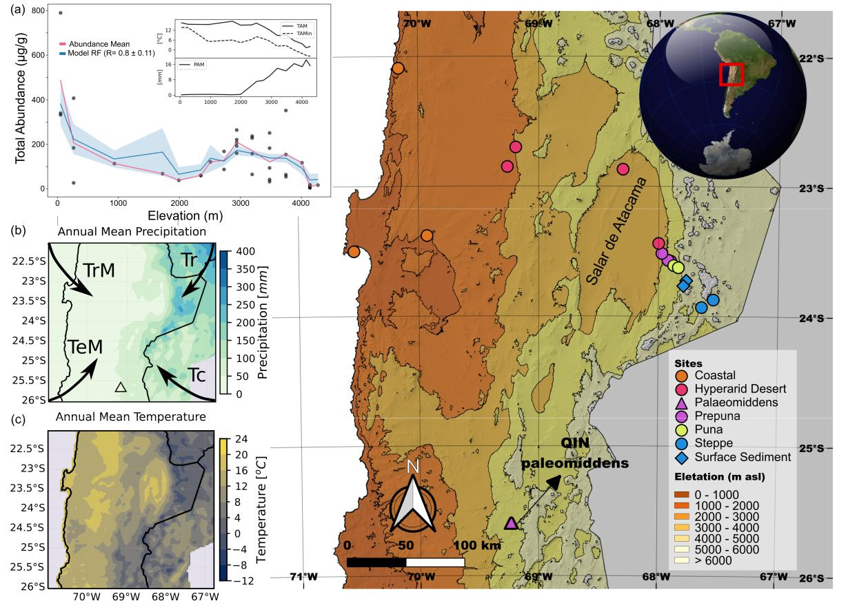

Figure 1: Figure 1: Local and regional context of vegetational and paleomiddens site in the southern Central Andes in the Atacama Desert, Chile. (a) Random forests (RF) correlations between total abundance (µg/g) of *n*-alkyl lipids (*n*-alkanoic acids and *n*-alkanes of plants and lacustrine surface-sediments of Miscanti and Miñique lakes) and climatic features (precipitation and temperature) along an elevation gradient of the Atacama Desert. (b) Mean Annual Precipitation and sources of air masses that contribute moisture to the Atacama Desert and Western Cordillera of the Andes (TrM: tropical maritime source; TeM: temperate maritime source; Tc: temperate continental source and Tr: tropical continental source. Modified from Houston and Latorre, 2022) and (c) Annual Mean Temperature.

6

1. with the plants collected and a reference collection at the Laboratory of Paleoecology and Paleoenvironments
2. of the Pontificia Universidad Católica de Chile. Taxa present in each midden were quantified with a relative
3. abundance index (where 0 is absent and 5 is dominant, Spaulding, 1990). Approximately 100 mg of rodent
4. feces from each of the 31 middens were submitted for 14C dating at the Accelerator mass spectrometry
5. (AMS) laboratory at University of California Irvine (UC Irvine). Radiocarbon ages were calibrated using
6. the SHCal20 calibration curve (Hogg et al., 2020) and reported in ka (thousands of calibrated years before
7. present – defined as year 1950 CE).
8. *2.3. Extraction and quantification of* n*-alkanes and* n*-alkanoic acids*
9. The total lipid extract (TLE) was obtained using a Milestone Ethos Easy Microwave Assisted Extraction
10. (MAE) system by extracting 0.5 g of dry leaf with 20 ml *dichloromethane*:*methanol* (DCM:MeOH) (9:1,
11. v/v). 25 *µL* of an internal standard mixture of known concentration (containing 1000 ng/*µL* of *cis* − 10 −
12. *nonadecenoic acid*, 5*α* − *cholestane* and *nonadecanol*) was added. The MAE was programmed with a ramp
13. to 100 ◦C at 10 ◦C min –1, a hold time at 100 ◦C for 15 min, and a cooling time of 30 min. A blank was
14. included in each sample set, to test for the presence of contaminants prior to sample analysis. The TLE was
15. separated into three fractions using aminopropyl solid phase separation columns, eluting first with DCM:2-
16. propanol (2:1, v/v) (*n*-alkane; neutral fraction), glacial acetic acid (GAA):ether (1:24, v/v) (*n*-alkanoic acid;
17. fatty acid fraction) and MeOH at 100% (phospholipid fraction). The neutral fraction was eluted through
18. activated (at 450 ◦C) silica gel using hexane for *n*-alkanes. The *n*-alkanoic acids were derivatized with
19. methanolic boron trifluoride (BF3:MeOH), forming fatty acid methyl esters (FAMEs). The *n*-alkanoic acids
20. and *n*-alkane waxes were quantified using gas chromatography with flame ionization detection (GC-FID
21. 7890A; Agilent Technologies) and identified via GC–mass spectrometry (GC–MS:QP-5050A-Shimadzu) based
22. on the retention time and spectra of standards for each compound. The temperature program started at 50
23. ◦C for 1 min, increased to 130 ◦C at 10 ◦C/min, then to 325 ◦C at 4 ◦C/min, and then remained isothermal
24. for 15 min. Peak areas from GC-FID chromatograms were manually integrated to quantify the abundances by
25. comparing with the area of a co-injected standard of known concentration (5*α*-Androstane). Total *n*-alkane
26. and *n*-alkanoic acid concentrations in *µ*g/g dry weight (dw) were calculated as the sum of *n*-*C*21 to *n*-*C*33
27. and *n*-*C*22 to *n*-*C*34 (odd as well as even ones), respectively. The *n*-alkanoic acids and *n*-alkanes leaf wax
28. abundance was calculated per unit dry leaf mass (*µ*g/g). The leaf wax distribution was calculated using the
29. ACL and CPI for *n*-alkanoic acids and *n*-alkanes or all samples as shown below:

7

*ACL*(*a*−*b*) = *b i* · *Ci*

*i*=*a* *Ci*

1. where (*a* − *b*) and *Ci* indicate the range and the concentration of odd and even chain lengths for *n*-alkanes
2. (*ACL*(23−33)) and *n*-alkanoic acids *ACL*(24−34), respectively.

|  |  |  |  |  |  |  |  |  |  |  |
| --- | --- | --- | --- | --- | --- | --- | --- | --- | --- | --- |
| *CP I*(*alkanes*) = 0*.*5 · | ( |  | *Ceven* |  | ) + ( |  | *Ceven* |  | ) |  |
|  | *Codd* | |  | *Codd* | |  |
| *CP I*(*F AMEs*) = 0*.*5 · | ( |  | *Codd* | | ) + ( |  | *Codd* | | ) |  |
|  | *Ceven* | |  | *Ceven* | |  |

1. *Ceven* (carbon 24 to 32) and *Codd* (carbon 23 to 33) indicate the carbon-chain length abundance even and
2. odd, respectively.
3. *2.4. Data analysis*
4. To study the relationship between *n*-alkyl lipid total abundances and climate, we use the CR2MET gridded
5. product which contains regional precipitation, average temperature, minimum temperature and maximum
6. temperature values with a resolution of 0.05 degrees (https://www.cr2.cl/datos-productos-grilados/). We
7. calculated 19 bioclimatic layers that were used to evaluate different predictive supervised models of *n*-alkanes
8. from no more than 3 input parameters. The sensitivity was evaluated through the bootsrapping method.
9. Random Forests (RF) correlations were applied using the scipy library in Python3.4. We carried out
10. redundancy analyses (RDA) to quantify the relationship between *n*-alkanes and macrofossil from Rodent
11. middens in the R package ‘vegan’ v4.2.2 using RStudio v12.0 (see ‘Data availability’ section). The *tidy*
12. *data frames* format for data analysis and graphics were performed using the R packages; ‘tidyverse’ v1.3.2,
13. ‘tidypaleo’ v1.3.9,‘rioja’ v1.0-5,‘ggplot2’ v3.4.1 (Wickham et al., 2019; Dunnington et al., 2022; Juggins, 2022;
14. Wickham, 2016).
15. **3. Results**
16. *3.1. Abundance and distribution of long-chain (>C21)* n*-alkyl leaf waxes along an environmental gradient in*
17. *the Atacama Desert.*
18. The vegetational gradient was dominated by twelve species (~80% landscape); *Pappostipa frigida* (Paja
19. brava), *Atriplex imbricata* (Cachiyuyo), *Haplopappus rigidus* (Bailahuén), *Ephedra americana* (Pingo-pingo),

8

1. *Aloysia deserticola* (Rica-rica), *Junellia seriphioides* (Rosa de la cordillera), *Tiquilia atacamensis* (Kauchal),
2. *Cristaria integerrima* (Malvilla), *Nolana aplocaryoides* (Suspiro), *Perityle emoryi* (Manzanillón) and two
3. unidentified species in the coast (see Table 1S and Figure 1S). Figure 1 shows the climatic correlations with
4. individual abundances of each long-chain *n*-alkyl (*n*-alkane and *n*-alkanoic acids) leaf wax. Total leaf wax
5. abundance showed a strong second-degree correlation (*R*2= 0.86 ± 0.11) with altitudinal cline (Figure 1
6. b). Additionally, these results showed positive correlations with annual mean, annual mean maximum, and
7. annual mean minimum temperature, and negative correlations with annual mean precipitation (Figures
8. S3 and S4). The long chains between *n*-*C*26 and *n*-*C*29 showed the highest correlation (between *R*2 = 0.4
9. and *R*2 = 0.6) values in all the variables analyzed (see Figures 2S and 3S). In general, we observe a high
10. variability of total abundances in the chain-length of waxes within and between vegetation belts (Figure 1
11. and Figure 2S). The concentration of *n*-alkyl foliar waxes tends to be higher in the Coastal, Prepuna and
12. Puna zones compared to the Hyperarid and Steppe, which have the most extreme environmental conditions
13. (Figure 1 a and Figure 2S). The highest abundances of *n*-alkyl waxes occur between 50-200 and 2,500 to
14. 3,700 m asl, coincident with zones of the greatest species richness and abundance. The lower individual
15. molecular abundances were observed in the Hyperarid core (~2,000 to 2,300 m asl) and high Andean altitude
16. (4,000 to 4,400 m asl). The odd-over-even and even-over-odd chain-length distributions of *n*-alkanes and
17. *n*-alkanoic acids were more abundant between *n*-*C*25 to *n*-*C*31 and *n*-*C*24 to *n*-*C*30, respectively (Figure 2 a).
18. The leaf wax *n*-alkanes and *n*-alkanoic acids abundance of surface sediment from two brackish lakes in the
19. Atacama Altiplano (Miscanti and Miñiques lakes at 4,200 m asl) showed similar total abundance values to
20. the Steppe but different distribution i.e. CPI and ACL (fig-2 b). The leaf wax *n*-alkanoic acids (n=3) and

|  |  |
| --- | --- |
| 190 | *n*-alkanes (n=6) abundances in these lake sediments were of 375.88 ± 52 *µ*g/gdw (*CP Imedian* = 11 ± 2.6; |
| 191 | *ACLmedian* = 24.25 ± 0.07, Table 1) and 10.45 ± 5 *µ*g/gdw (*CP Imedian* = 9 ± 1.98; *ACLmedian* = 25.92 ± |

1. 0.63, Table 1S), respectively. In sedimentary *n*-alkanoic acids, carbon chain-lengths show higher abundance
2. of medium carbon chain length between *n*-*C*22 and *n*-*C*24. The high and medium molecular weight ranges
3. are the minority (*n*-*C*26 to *n*-*C*32) and represent ca. 20% of the *n*-alkanoic acids in the sediments. For
4. *n*-alkane, carbon chain-lengths distribution is between *n*-*C*23 and *n*-*C*33 with a higher abundance of medium
5. and high molecular weight (*n*-*C*23 and *n*-*C*29), but their relative abundances were lower than *n*-alkanoic
6. acids (Figure 2).
7. *3.2.* n*-Alkanes and plant macrofossils from rodent middens in the Atacama Desert over the last 17,000 years*
8. A total of sixteen different plant taxa were identified covering twelve families; fifteen genera and five species
9. of plant macrofossils (Table 1). Radiocarbon ages from 28 rodent middens reveal a temporal coverage for the

9

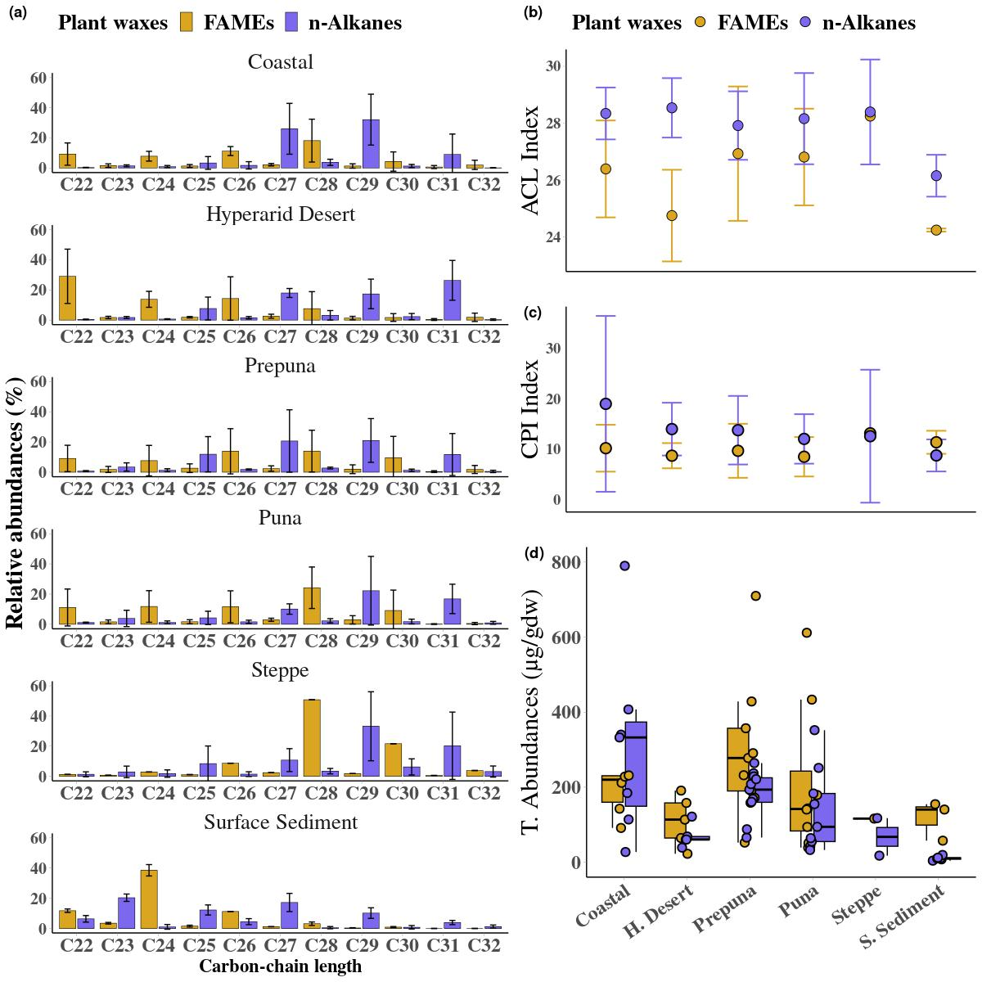

Figure 2: Abundance and distribution of leaf waxes (*n*-alkanoic acids and *n*-alkanes) along an environmental gradient in the Atacama Desert (Coast, Hyperarid Desert, Pre-Puna, Puna, Steppe and superficial lacustrine sediments of two high Andean steppe lakes). (a) average chain length (ACL), (b) carbon preference index (CPI), (c) Total Abundances and (d) percentage distribution of long-chain of leaf waxes from twelve species of Atacama Desert.

10

1. last 17 ka cal BP (Table 2). Fecal-pellets indicate that the middens were either made mainly by the ashy
2. chinchilla rat (*Abrocoma cinerea*) and by leaf-eared mice (*Phyllotis* spp.). In the modern midden 208-B (150
3. ± 90 cal yr BP at 3592 m a.s.l., south slope; Table 2) we find macro-remains of *Haplopappus* sp., *Junellia*
4. *bryoides*, *Gilia* sp., *Cistanthe* sp., *Phacelia cumingii*, *Phacelia pinnatifida*, *Cryptantha* sp. and *Ephedra*
5. *americana* —a composition similar to the species collected in the field (*Haplopappus* sp., *Junellia bryoides*,
6. *Gilia* sp., *Cistanthe* sp., *Phacelia cumingii*, *Phacelia pinnatifida*, *Cryptantha* sp. and *Ephedra americana*
7. besides *Maihueniopsis* sp., *Baccharis tola* and *Pappostipa frígida*). Among taxa identified at the site, we
8. note that some are quite scarce with slope exclusivities, such as *Maihueniopsis* sp and *Baccharis Tola* on the
9. north slope and *Pappostipa frígida* on the south slope.
10. A diagram of the relative abundances of each taxon along with the chronology obtained with AMS 14C
11. dating (Table 2) is shown in Figure 3. The middens were dominated by the local taxa *Junellia bryoides*,
12. *Cistanthe* sp., *Ephedra americana* and *Phacelia cumingii*. At ca. 17 ka cal BP, the record shows the presence
13. of only two local taxa (*Junellia bryoides* and *Phacelia pinnatifida*) and one extra-local taxa (*Adesmia* sp.).
14. Between ca. 15.5 and 10 ka cal BP, the record shows an increase in local plant richness and extra-local
15. species such as *Stipa frígida*, *Adesmia* sp, *Malvaceae*, *Chenopodiaceae*, *Baccharis aff tola* and *Brassicaceae aff*
16. *Atacamanivea*. A large group of middens between ca. 10 and 3 ka cal BP shows a decrease in plant richness
17. with an increase in the annual extra-local Malvaceae family. From 3 to 0.18 ka cal BP, there are increases in
18. the local taxa richness dominated by *Junellia bryoides* and *Cistante* sp. with the appearance of *Haplopappus*
19. sp. and *Cryptantha* sp., among others.
20. The rodent middens contain high wax values spread with a total mean *n*-alkanes abundance of 335.4 ±

221 239 *µ*g/gdw (n=24, *CP Imedian* = 18.46 ± 5.44; *ACLmedian* = 29.12 ± 0.4, Table 1S and Figure 4). The

1. chain-length distribution in middens was between *n*-*C*21 and *n*-*C*35 with a higher abundance of *n*-*C*27 to
2. *n*-*C*31 chain and predominance of carbon chain length *n*-*C*29. Fecal-pellet *δ*13C values show a range from
3. -21.3 to -25.4 ‰ with a median of -23 ‰. The palaeomidden dated to ca. 17 ka cal BP showed a lower
4. abundance in all chain-length distributions. One of the main features of the middens dated to ca. 15.2 ka cal
5. BP and between 14 and 12 ka cal BP was the high *n*-alkanes abundances of longer chains (*n*-*C*25 to *n*-*C*35)
6. compared to the chain-length abundance between ca. 11 and 5 ka cal BP. The abundances of *n*-alkanes for
7. the youngest samples dated between 5 and 0.18 ka cal BP shows an increase in all chain-length distribution,
8. where the midden with higher *n*-alkanes abundance was at ~ 4 ka cal BP (Figure 3). Remarkably, the
9. midden dated at 11.7 ka cal BP has the highest concentration of *n*-alkanes in the record (~1,000 *µ*g/gdw),

11

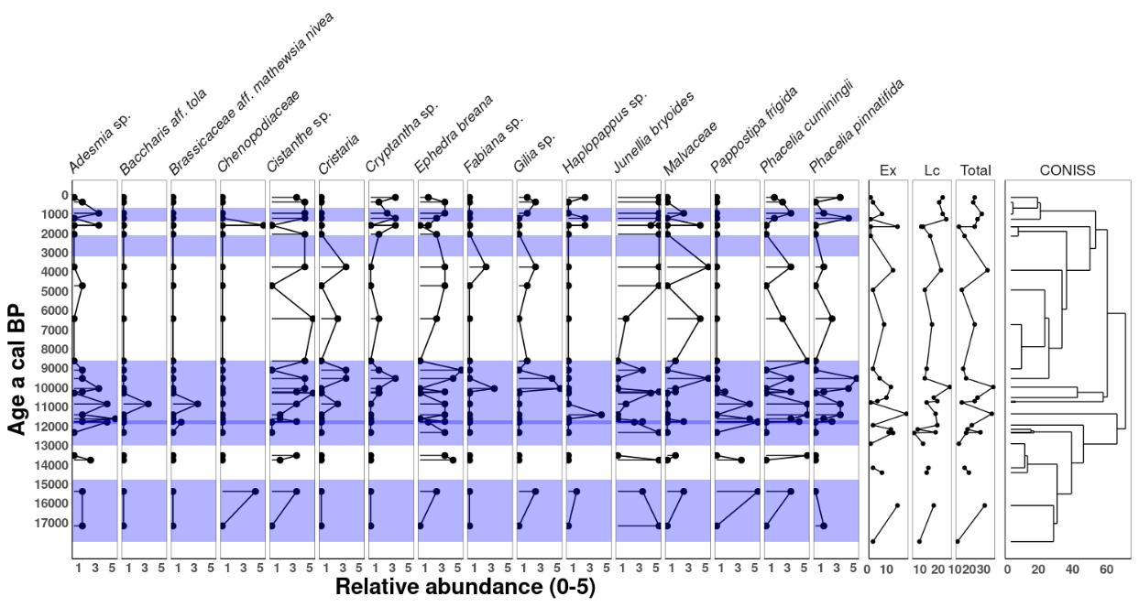

Figure 3: Plant macrofossil diagram from paleomiddens in Quebrada Incahuasi. Relative abundance index runs from 0 (absent)

to 5 (dominant). Modern analogue groups of local and extralocal taxas have been defined. Ex: total number of extra-local

species, Lc: total number of local species and “Total”: represents the total number of species. A CONISS analysis was performed to see the relationships between the samples. The purple bands represent of the pluviometric anomalies CAPE I (ca. 18 to 14.8 ka cal BP), CAPE II (ca. 13.0 to 8.6 and 8.1 to 7.6 ka cal BP), ~2.5 and MCA (ca. 1.2 and 0.8 ka cal BP) described in the Atacama Desert. Note the different magnitudes of the abundances.

12

1. where the carbon length chain *n*-*C*29 dominates. Two grass samples, dated between 970 (QIN237-B) and
2. 11,780 (QIN 214b) a cal BP, extracted from the palaeomiddens matrix showed high *n*-alkane values.

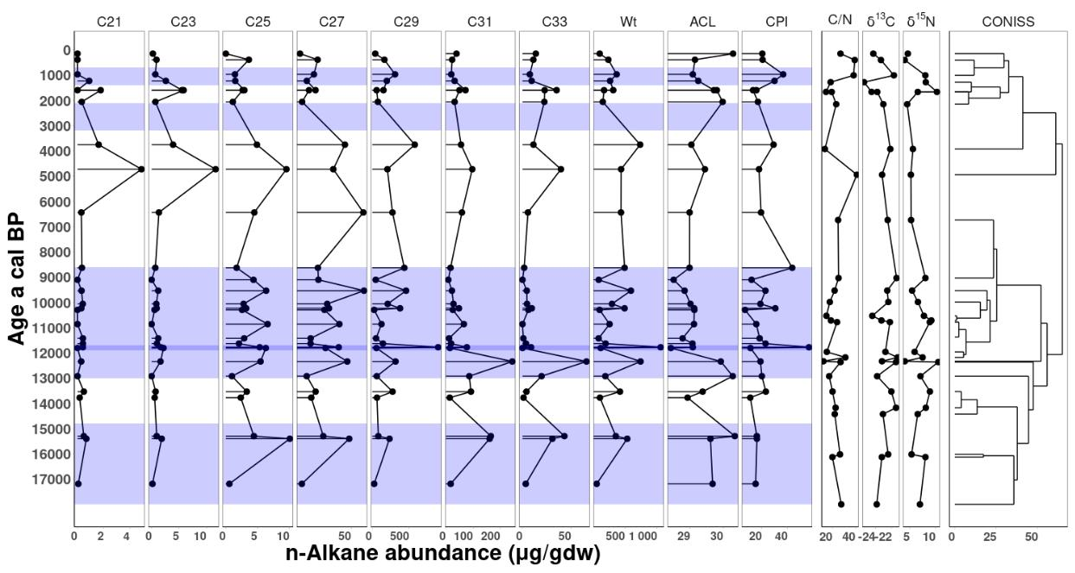

Figure 4: Abundance of *n*-alkanes (*µ*g/gdw) and *δ*13C, *δ*15N and C/N ratio values from fecal-pellet obtained of the palaeomiddens from Quebrada Incahuasi. A constrained cluster analysis by the method of incremental sum of squares (CONISS) was performed to see the relationships between the samples. The purple bands represent of the pluviometric anomalies CAPE I (ca. 18 to 14.8 ka cal BP), CAPE II (ca. 13.0 to 8.6 and 8.1 to 7.6 ka cal BP), ~2.5 and MCA (ca. 1.2 and 0.8 ka cal BP) described in the Atacama Desert. Note the different magnitudes of the abundances.

1. **4. Discussion**
2. *4.1. Distribution of leaf wax* n*-alkanes and* n*-alkanoic acids along an altitudinal transect (50–4200 m a.s.l)*
3. *in the Atacama Desert*
4. The leaf wax *n*-alkanes and *n*-alkanoic acids along the vegetational transect in the Atacama desert show
5. a species-specific and heterogeneous distribution in the chain lengths (Figure 1 and Figure 2). Leaf waxes
6. from Steppe and Puna species have a clear predominance of *n*-*C*29/*n*-*C*28 chain lengths in *n*-alkanes and
7. *n*-alkanoic acids, respectively. On the other hand, the Prepuna showed a higher abundance on *n*-*C*27/*n*-*C*26
8. and *n*-*C*29/*n*-*C*28 chain lengths. At the coast — where advected fog plays an important role as a moisture
9. source — we found equal abundance of *n*-*C*29 and *n*-*C*27, while the plants from the Hyperarid Desert
10. showed two different and antagonistic wax distributions where predominate *n*-alkane *n*-*C*31 and a higher
11. *n*-alkanoic acids abundances of medium chain lengths (Figure 2). Mörchen et al. (2021), found for different
12. plant species of the Atacama Desert that the *n*-alkane abundances showed a predominance of chain lengths

13

1. *n*-*C*27 and *n*-*C*31. These authors related the higher *n*-alkanes production to the influence of the sources
2. of moisture coming either from coastal fog or summer precipitation in the Andes. Contreras et al. (2022)
3. provide a detailed assessment of leaf waxes from *Tillandsia landbeckii* (a CAM specie highly specialized
4. to living only off fog), describing a homogeneous *n*-alkanes distribution that ranges between *n*-*C*23 and
5. *n*-*C*31 where the leaf wax distribution (ACL and CPI index) showed a high inverse correlation with moisture
6. availability. In the northwestern slope of the south-central Andes of Argentina, *n*-alkanes in soil show a
7. higher abundance and unimodal distribution along an altitudinal transect of the chain lengths *n*-*C*27, *n*-*C*33
8. and *n*-*C*29 (Nieto-Moreno et al., 2016). While the tropical forest from Kosñipata valley in Perú, (Feakins
9. et al., 2016) showed a predominance of *n*-*C*29 and *n*-*C*31 chains followed by *n*-*C*27 and a poor relationship
10. between temperature and leaf wax distribution. Wu et al. (2019), in another elevation gradient between
11. the Amazon floodplain and the eastern flank of the Andes in Peru, found a dominance of chain lengths
12. *n*-*C*29 and *n*-*C*31 with a higher *n*-*C*31/*n*-*C*29 ratio at lower elevation sites. And Teunissen van Manen et al.
13. (2020) observe this same relationship in leaves and soil in Ecuador. All these studies above show that the
14. proportions in the chain lengths of *n*-alkanes are highly variable at ecosystem-dependent scale.
15. Biotic and abiotic stresses can induce metabolic and biosynthesis responses in cuticular waxes (Shepherd
16. and Wynne Griffiths, 2006; Lewandowska et al., 2020). In the Atacama Desert, one of the harshest terrestrial
17. environment conditions on earth, *n*-alkanes and *n*-alkanoic acids from leaf-wax show a strong relationship
18. to vegetation belts (Figure 1). We observed a higher total abundance of individual chains of *n*-alkanes
19. and *n*-alkanoic acids in zones where the plants have more moisture available coming from the coast and
20. seasonal summer rains (Arroyo et al., 1988). Atacama vegetation is adapted to prolonged drought conditions,
21. mechanical stress, low nutrient availability, and high levels of radiation, salinity, and metals along the altitude
22. gradient (Díaz et al., 2016; Rondanelli et al., 2015; Eshel et al., 2021). Several studies show significant
23. correlations between *n*-alkane distributions with temperature and precipitation (Hoffmann et al., 2013; Tipple
24. and Pagani, 2013; Feakins et al., 2016; Wang et al., 2018), while others show a weak or null relationship with
25. climatic variables (Carr et al., 2014; Howard et al., 2018). Mörchen et al. (2021) and Contreras et al. (2022),
26. argue that *n*-alkanes from fog-fed plants in the Atacama that receive coastal moisture show a dominance
27. of *n*-*C*31, *n*-*C*29, *n*-*C*33 and *n*-*C*27 chain lengths, whereas plants affected by summer rainfall show a greater
28. abundance of *n*-*C*31 and *n*-*C*29 chain lengths. The *n*-alkane distributions along the Atacama Desert suggests
29. a strong relationship with the available moisture conditions in the vegetation belts, which should be evaluated
30. before using the leaf waxes as an indicator of paleoenvironmental change.

14

1. *4.2. Sources* n*-alkane leaf wax in a 17,000 yr rodent midden record from Atacama Desert*
2. The analysis of *n*-alkanes in rodent coprolites from middens showed a marked distribution range of chain
3. length between *n*-*C*21 and *n*-*C*35 with a greater abundance of *n*-*C*29 followed by *n*-*C*31 (Figure 4). These
4. wax distributions were similar to those found in plants that dominate the Steppe and Puna, where species
5. such as *Pappostipa frigida*, *Haplopappus rigidus* and *Junellia seriphioides* have a greater abundance of *n*-*C*27,
6. *n*-*C*29 and *n*-*C*31. In the Steppe, where *Pappostipa frigida* dominates the landscape, the fingerprint of chain
7. length is the *n*-*C*29. When we compared the *n*-alkanes from grasses inside two rodent middens matrix with
8. the *n*-alkanes obtained from their fecal-pellet (QIN237-B and QIN214-B; ca. 970 and 11,780 a cal BP,
9. respectively), we noted a similar pattern between their distributions (Figure 5S), but with concentrations
10. that are one to two orders of magnitude lower —50/16 *µ*g/gdw in grasses compared to 368/1054 *µ*g/gdw
11. in fecal-pellet (Figure 4). Latorre et al. (2002), studied the relationship between vegetation and dietary
12. behavior by analyzing cuticles in feces from 41 rodent middens during the last 45 ka cal BP of the Prepuna of
13. the Atacama Desert. This comparative study between plant macrofossil, abundance of grasses and leaf wax
14. analysis showed that the diets of different rodent species are closely related to the surrounding vegetation,
15. however, we can not rule out that the dietary preferen-ces and collecting behaviors can introduce bias into
16. midden records (Borrelli and Holmgren, 2016). Our fecal-pellet isotopic analysis shows *δ*13C values close to
17. -23 ‰ that are indicative of an almost pure *C*3 diet (Latorre et al., 2002). This is consistent with our RDA
18. analysis between abundance of plant macrofossil and *n*-alkanes which discriminate between the abundance
19. *n*-*C*29 and plant extralocal of Prepuna taxa together with *n*-*C*31 (Figure 6S). Based on our observations, we
20. predict that a higher abundance of plant species in the landscape will lead to increased variation in chain
21. length distributions in paleomiddens. In addition, we expect to see a pronounced dominance of *n*-*C*29 during
22. periods of increased grass abundance. This observation can be explained by the presence of species-specific
23. chemotaxonomic biomarkers and the generalist dietary behaviour of rodents (Latorre et al., 2002; Borrelli
24. and Holmgren, 2016).
25. *4.3. Leaf wax* n*-alkane in rodent midden record as proxy of palaeoenvironmental changes*
26. Paleomidden records from the central Atacama (15◦ to 27◦S), contain many extra-local species indicative of
27. past pluvials in the south-central Andes during the Quaternary (Betancourt et al., 2000; Rech et al., 2002;
28. Latorre et al., 2006; Díaz et al., 2019). At least six pluviometric anomalies have been linked with vegetation
29. changes in the Atacama; CAPE I (ca. 18 to 14.8 ka cal BP), CAPE II (ca. 13.0 to 8.6 and 8.1 to 7.6 ka
30. cal BP) and four relatively short-period pluvials during ~ 4 to 3.4, ~2.5, MCA (ca. 1.2 and 0.8 ka cal BP)
31. and LIA (ca. 0.5 and 0.1 ka cal BP). Low latitude insolation changes and/or strengthening/weakening of

15

1. the South American Monsoon System and precipitation from the maritime weather system —forced by
2. ocean-atmosphere dynamics of the Pacific and/or Atlantic— are the most common climatic teleconnections
3. proposed tot explain these precipitation anomalies (Betancourt et al., 2000; Rech et al., 2002; Gayo et al.,
4. 2012; González-Pinilla et al., 2021)
5. Can the *n*-alkanes obtained from paleomiddens records reflect niche shifts in the Atacama plant communities
6. during the past? The leaf wax *n*-alkane chain-length distributions of the plants studied show a clear species-
7. specific molecular signature associated with the different vegetational belts (Figure 2S). High Andean Steppes
8. from Atacama are represented mainly by *n*-*C*29 and *n*-*C*31 *n*-alkanes. At the same time, environments in
9. lowlands (Prepuna and Puna) are characterized by a greater diversity of chain lengths between *n*-*C*22 to
10. *n*-*C*33 due to the different species that live there. These molecular relationships could be used to detect wax
11. input due to extra-local species in ancient Atacama ecosystems. In that regard, rodent paleomiddens can be
12. an excellent tool to understand the relationships between wax production and plant species that lived at
13. a given time. Plant macrofossils analysis from modern middens dated around 150 cal a BP (3,592 m asl,
14. Figure 3) from Pre-puna showed a composition similar to the species collected in the field (*Haplopappus*
15. sp, *Junellia bryoides*, *Gilia* sp, *Cistanthe* sp, *Phacelia cumingii*, *Phacelia pinnatifida*, *Cryptantha* sp. and
16. *Ephedra americana*). In the same manner, as observed in the Puna and Pre-puna, the *n*-alkanes chain
17. lengths obtained from fecal-pellets in this modern midden are dominated by *n*-*C*25, *n*-*C*27 and *n*-*C*33 whereas
18. *n*-*C*29 and *n*-*C*31 are co-dominants. Furthermore, when we analyze the *n*-alkane distributions across all
19. paleomiddens over the last 17 ka cal BP, the data show a high variability in n-alkane chain lengths (Figure 4).
20. We propose that these heterogeneous *n*-alkane distributions represent a response to changes in the climate
21. and species composition of the Pre-puna where the paleomiddens are generated. That idea is supported
22. by the redundancy analysis (RDA) where the extra-local species are grouped with *n*-*C*25, *n*-*C*27 and *n*-*C*29
23. *n*-alkanes (Figure 6S) and by the link between the *n*-alkane distributions of grasses and fecal-pellets found in
24. the middens QIN237-B and QIN214-B (Figure 5S). This suggests that the Atacama Desert plants have a
25. sufficiently high molecular plasticity to overrun ecosystems different from the current, as shown by some
26. recent studies in these extreme habitats (Díaz et al., 2019; Eshel et al., 2021; Dussarrat et al., 2022). To
27. test this assumption, we compare our *n*-alkanes paleomidden series with different climate change records
28. associated with food variations in the Atacama Desert (Figure 5).

16

1. During the CAPE I, paleomidden records show an increase of extra-local species, together with *n*-*C*25,
2. *n*-*C*27, *n*-*C*29 and *n*-*C*33 *n*-alkanes (Figure 4 and Figure 5 a-d). According to the current distribution of chain
3. lengths in the Atacama Desert, this increase could represent greater biodiversity of plants from different
4. vegetation belts. González-Pinilla et al. (2021), reconstructs positive mean annual rainfall (MAR) anomalies
5. in the Atacama Desert at 15.9 to 14.8 ka cal BP (MAR = 142 ± 10), 13.0 to 8.6 ka B.P (MAR = 130
6. ± 18) and more variable precipitation during the Late Holocene (Figure 5 f). They associated the MAR
7. anomalies from CAPE I to the Heinrich Event 1 (HE-1) and La Niña-like conditions inferred from El Niño
8. flood activity record in Perú (Rein et al., 2005) that drove an intensification and southward shift of the
9. South American Summer Monsoon (SASM). These moisture changes are coeval with those observed in the
10. *n*-alkanes of the midden series (Figure 5 f). In contrast, in the western Central Andes lake records (Figure 5
11. h-g), there are low lake levels at lakes of Miscanti, Chungará and Junín during this phase, which have been
12. associated with the weakening of the SASM and the hydrological balance of the upper Amazon basin and the
13. Altiplano (Valero-Garcés et al., 1996; Moreno et al., 2007; Rodbell et al., 2022). During the CAPE II, the
14. *n*-alkanes show an initial increase in *n*-*C*31 chain length followed by an abrupt increase in *n*-*C*29 during the
15. end of the YD (at ca. 17.780 ka cal BP) followed by fluctuations of the *n*-*C*27 *n*-alkane (Figure 5). Between
16. the CAPE I and CAPE II phases (ca. 14.8 and 13.1 ka B.P.), the decrease of *n*-alkanes are indicative of
17. dry conditions that coincide with the Bölling/Allerød (BA) warming period and the Meltwater Pulse 1A
18. (MWP-1A) occurred around 14.6 ka (Liu et al., 2009; Obase and Abe-Ouchi, 2019; He and Clark, 2022).
19. These data support the assumption of a very dry period by González-Pinilla et al. (2021) between 14.8 and
20. 13.1 ka B.P. However, high lake levels in the western central Andes (Figure 5 g-f) during this period suggest
21. a seesaw response of the SASM, possibly related to meridional shifts of the Intertropical Convergence Zone
22. (ITCZ) forcing by Atlantic Meridional Overturning Circulation (AMOC) and North Atlantic SST variability
23. during the last deglaciation (Fornace et al., 2014, see Figure 5 j). A weaker AMOC reduces northward energy
24. transport, leading to cooler North Atlantic SSTs. This can cause the ITCZ to shift southward, as it tends to
25. follow the region of maximum SSTs and associated convection. A southward shift of the ITCZ in turn affects
26. the strength and position of the South Atlantic Subtropical Anticyclone and the position of the trade winds
27. in the tropical Atlantic, leading to a redistribution of rainfall within the tropics and subtropics, with less
28. rainfall further north and more rainfall further south(Schneider et al., 2014; Houston and Latorre, 2022).
29. However, the direct impact of the AMOC on the Atacama Desert is likely to be limited. This apparent
30. disagreement could be explained by different sources of oceanic and continental moisture along the Andean
31. Dry Diagonal, where ENSO-like conditions could play a predominant role (see Houston and Latorre, 2022).

17

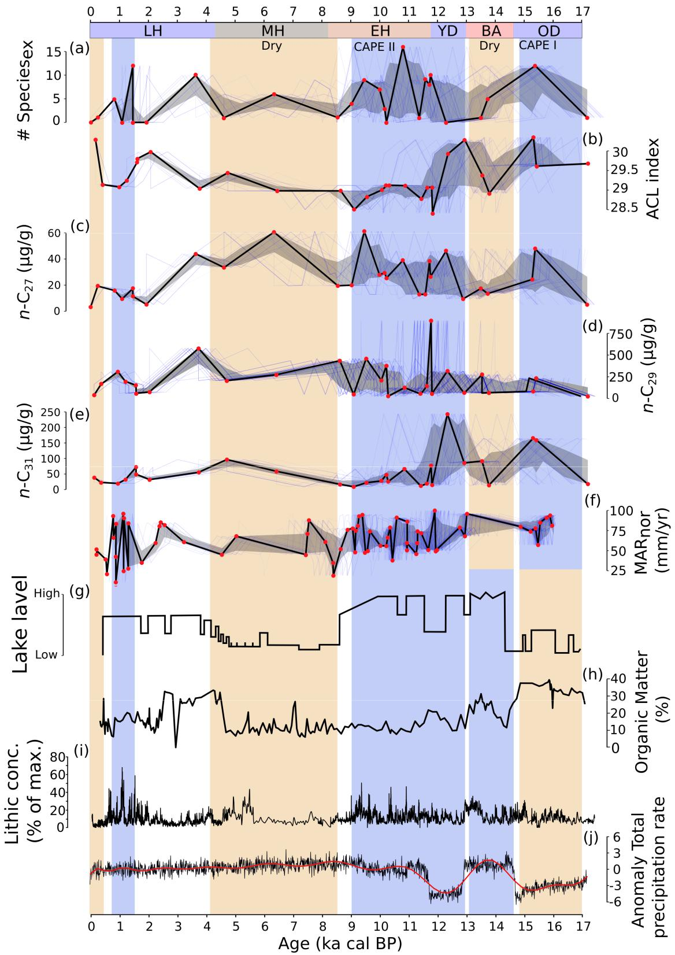

Figure 5: Comparison of selected *n*-alkane abundances and macrofossil18 obtained from paleomiddens records with representative local, regional and global paleoclimate records. (a) total number of extra-local species of macrofossil from paleomiddens in Quebrada Incahuasi. (b) average chain length (ACL) of *n*-alkanes. (c-e) *n*-*C*27, *n*-*C*29 and *n*-*C*31 *n*-alkane abundances (*µ*g/gdw).

1. MAR anomalies in the central Atacama Desert (González-Pinilla et al., 2021). (g) Miscanti ancient lake level (Valero-Garcés et al., 1996; Grosjean et al., 2001, 23º44’S, 67º46’W, 4140 m asl). (h) Amount of organic matter from Junín lake (Rodbell et al.„ 2022, 4080 m asl ).(i) Late Pleistocene-Holocene El Niño-like ENSO-sensitive marine records, from Peruvian shelf (Rein et al., 2005). (j) Transient simulation of precipitation (TraCE 21k-II, (He and Clark, 2022) over the central Atacama (24°S). From (a) to (f), the age-uncertainty median ensemble (estimated with the Banded Age Model in GeochronR package) is shown in black, with the 50% and 95% highest-density probability ranges shown in dark and light gray, respectively. (see Comboul et al., 2014; McKay et al., 2021 for more detail). OD: Oldest Dryas, BA: Bølling-Allerød, YD: Younger Dryas Stadial.

1. Stable deuterium and carbon isotope analysis of individual long-chain *n*-alkanes from paleomiddens could
2. give us clues about the mechanisms at work in the Atacama Desert. In the Middle Holocene, the paloemidden
3. record shows a greater abundance of *n*-*C*29 and *n*-*C*27 chain lengths typical of grasses, while during the Late
4. Holocene the differences in abundances among the *n*-alkanes decrease. Several authors have described arid
5. conditions in the Atacama Desert during the Middle Holocene (Grosjean and Núñez, 1994; Valero-Garcés
6. et al., 1996; Betancourt et al., 2000; Núñez et al., 2002), the timing and lapse of this aridity condition are still
7. under discussion (Grosjean, 2001; Latorre et al., 2002; Rech et al., 2002), where La Niña-like conditions and
8. a spatial complexity of precipitation of SASM system are the main characteristics (Rein et al., 2005; Wong
9. et al., 2021). Finally, during the Late Holocene the *n*-alkanes chain lengths are co-dominant and represent
10. the present-day plant communities, where climatic variability could only partly explain present-day chain
11. length distributions if we consider other factors such as species introduction by human activity.
12. **5. Conclusions**
13. This work demonstrates how the abundance of leaf waxes and records of climate change obtained from
14. paleomiddens are related to vegetation change in the Atacama. The *n*-alkanes and *n*-alkanoic acids from
15. current plant leaf waxes show a high variability through the elevational gradient and a species-specific
16. molecular signature of these vegetational belts. The Steppe is characterized by high abundances of *n*-*C*29
17. chain length followed by *n*-*C*31, *n*-*C*27, respectively. Leaf waxes from the Puna and Pre-puna have a greater
18. abundance and diversity of chain lengths, whereas in the absolute desert the most abundant *n*-alkanes
19. and *n*-alkanoic acids were the *n*-*C*31 and *n*-*C*22 chains. Along the coastal Atacama, the *n*-alkanes that
20. predominated were *n*-*C*27 and *n*-*C*29 in contrast with a decrease of the *n*-alkanoic acids that were dominated
21. by *n*-*C*28 and *n*-*C*26 chains. We observe a decoupling of leaf wax ACL values between *n*-alkanes and
22. *n*-alkanoic acids in the absolute desert. Biochemical differences between *n*-alkanes and *n*-alkanoic acids ACL
23. values could imply different hydric-deficit tolerance strategies in plants under hyper-extreme environmental
24. conditions. In general, our study shows that paleomiddens are an excellent source of leaf wax abundances in
25. the Prepuna of the Atacama and respond to different moisture pulses previously identified in the region. As
26. described in other research, the paleomidden record indicates increased wet conditions during the CAPE
27. phases consistent with lower summer insolation and increased humidity modulated by ENSO and SASM.
28. Furthermore, paleomiddens show a dry period between ca. 13 and 14.8 ka cal BP co-occurring during a
29. strengthened AMOC and abrupt increase in grasses at 11.7 ka cal BP as indicated by increased abundance of
30. *n*-*C*29 chain length. Lower bioproductivity could be interpreted during the Early and Middle Holocene (from

19

1. ca. 11.0 to 6.0 ka cal BP), coincident with a decrease in precipitation described for the Atacama. Multiple
2. interrelations between solar irradiance, climate, nutrient and vegetational changes could be controlling the
3. abundance of waxes in time, and other proxies should be used to confirm this relationship. However, more
4. comprehensive leaf wax analysis of the dominant vegetation and other midden series are required to better
5. understand and quantify the link between climatic variability and *n*-alkyl leaf waxes under extreme arid
6. environmental conditions. These records create an opportunity to complement other paleoclimate proxies
7. with isotopic analysis and genetic information to across a wide spatial range to understand the complex
8. relationships between climate and desert vegetation where other paleoclimate records are scarce.
9. **6. Data Availability**
10. All raw data and code used in this paper are publicly available for reuse via Zenodo (doi:10.5281/zenodo.7768860)
11. and Github (https://github.com/mat1506/atacama.waxes.git)
12. **7. Acknowledgments**
13. We thank Chris Moy, Jean Pierre Francois, Hector Orellana, indigenous community of Socaire and CONAF
14. for help with sample analysis, logistical support in the field.
15. **8. Financial support**
16. This research has been supported by the ANID-FONDECYT (grants 1190398, 1191568, 11220930, 3180368).
17. Additional support was provided by the Millennium Science Initiative Program Nucleus AFOREST
18. (NCS2022_24) and the Millennium Science Initiative Nucleus UPWELL (NCN19-153) of the Ministry of
19. Economy, Development and Tourism (Chile) and IEB (through ANID FB210006).
20. **9. CRediT authorship contribution statemen**
21. The authors declare that they have no conflict of interest

20

1. **10. Tables**
2. **Table 1: Macrofossils identified, including their family, type and phytogeographic affinity.**
3. **Table 2: Site location, radiocarbon dates, calendar year BP (95.4**% **probability ranges; curve**
4. **Shcal20, Oxcal 4.4) and former agent for 28 rodent middens analyzed (see Fig. 1 for midden**
5. **localities). *SD*: standard deviation, *:Unidentified**

21

1. **References**
2. Anjos, L.J.S., de Toledo, P.M., 2018. Measuring resilience and assessing vulnerability of terrestrial ecosystems to climate change
3. in South America. PLOS ONE 13, e0194654. doi:[10.1371/journal.pone.0194654](http://dx.doi.org/10.1371/journal.pone.0194654).
4. Arroyo, M.T.K., Armesto, J.J., Villagran, C., 1981. Plant Phenological Patterns in the High Andean Cordillera of Central Chile.
5. Journal of Ecology 69, 205–223. doi:[10.2307/2259826](http://dx.doi.org/10.2307/2259826).
6. Arroyo, M.T.K., Squeo, F.A., Armesto, J.J., Villagran, C., 1988. Effects of Aridity on Plant Diversity in the Northern Chilean
7. Andes: Results of a Natural Experiment. Annals of the Missouri Botanical Garden 75, 55–78. doi:[10.2307/2399466](http://dx.doi.org/10.2307/2399466).
8. Berdugo, M., Delgado-Baquerizo, M., Soliveres, S., Hernández-Clemente, R., Zhao, Y., Gaitán, J.J., Gross, N., Saiz, H., Maire,
9. V., Lehmann, A., Rillig, M.C., Solé, R.V., Maestre, F.T., 2020. Global ecosystem thresholds driven by aridity. Science 367,
10. 787–790. doi:[10.1126/science.aay5958](http://dx.doi.org/10.1126/science.aay5958).
11. Betancourt, J.L., Latorre, C., Rech, J.A., Quade, J., Rylander, K.A., 2000. A 22,000-Year Record of Monsoonal Precipitation
12. from Northern Chile’s Atacama Desert. Science 289, 1542–1546. doi:[10.1126/science.289.5484.1542](http://dx.doi.org/10.1126/science.289.5484.1542).
13. Betancourt, J.L., Saavedra, B., 2002. Paleomadrigueras de roedores, un nuevo método para el estudio del Cuaternario en zonas
14. áridas de Sudamérica. Revista chilena de historia natural 75, 527–546. doi:[10.4067/S0716-078X2002000300005](http://dx.doi.org/10.4067/S0716-078X2002000300005).
15. Borrelli, M.P., Holmgren, C.A., 2016. Dietary modifications of packrats in response to changing plant communities: Evidence
16. from fossil plant cuticles spanning *>*55,000 years in Sonoran Desert packrat middens. Journal of Arid Environments 135, 1–8.
17. doi:[10.1016/j.jaridenv.2016.08.004](http://dx.doi.org/10.1016/j.jaridenv.2016.08.004).
18. Braun-Blanquet, J., et al., 1932. Plant sociology. the study of plant communities. Plant sociology. The study of plant communities.
19. First ed. doi:[10.1146/annurev-earth-032320-095943](http://dx.doi.org/10.1146/annurev-earth-032320-095943).
20. Bush, R.T., McInerney, F.A., 2013. Leaf wax n-alkane distributions in and across modern plants: Implications for paleoecology
21. and chemotaxonomy. Geochimica et Cosmochimica Acta 117, 161–179. doi:[10.1016/j.gca.2013.04.016](http://dx.doi.org/10.1016/j.gca.2013.04.016).
22. Carr, A.S., Boom, A., Grimes, H.L., Chase, B.M., Meadows, M.E., Harris, A., 2014. Leaf wax n-alkane distributions in arid
23. zone South African flora: Environmental controls, chemotaxonomy and palaeoecological implications. Organic Geochemistry
24. 67, 72–84. doi:[10.1016/j.orggeochem.2013.12.004](http://dx.doi.org/10.1016/j.orggeochem.2013.12.004).
25. Contreras, S., Landahur, M., García, K., Latorre, C., Reyers, M., Rethemeyer, J., Jaeschke, A., 2022. Leaf wax composition and
26. distribution of Tillandsia landbeckii reflects moisture gradient across the hyperarid Atacama Desert. Plant Systematics and
27. Evolution 308, 8. doi:[10.1007/s00606-021-01800-0](http://dx.doi.org/10.1007/s00606-021-01800-0).
28. Díaz, F.P., Frugone, M., Gutiérrez, R.A., Latorre, C., 2016. Nitrogen cycling in an extreme hyperarid environment inferred from
29. d15 N analyses of plants, soils and herbivore diet. Scientific Reports 6, 22226. doi:[10.1038/srep22226](http://dx.doi.org/10.1038/srep22226).
30. Díaz, F.P., Latorre, C., Carrasco-Puga, G., Wood, J.R., Wilmshurst, J.M., Soto, D.C., Cole, T.L., Gutiérrez, R.A., 2019.
31. Multiscale climate change impacts on plant diversity in the Atacama Desert. Global Change Biology 25, 1733–1745.
32. doi:[10.1111/gcb.14583](http://dx.doi.org/10.1111/gcb.14583).
33. Díaz, F.P., Latorre, C., Maldonado, A., Quade, J., Betancourt, J.L., 2012. Rodent middens reveal episodic, long-distance
34. plant colonizations across the hyperarid Atacama Desert over the last 34,000 years. Journal of Biogeography 39, 510–525.
35. doi:[10.1111/j.1365-2699.2011.02617.x](http://dx.doi.org/10.1111/j.1365-2699.2011.02617.x).
36. Didyk, B.M., Simoneit, B.R.T., Brassell, S.C., Eglinton, G., 1978. Organic geochemical indicators of palaeoenvironmental
37. conditions of sedimentation. Nature 272, 216–222. doi:[10.1038/272216a0](http://dx.doi.org/10.1038/272216a0).
38. Dunnington, D.W., Libera, N., Kurek, J., Spooner, I.S., Gagnon, G.A., 2022. tidypaleo: Visualizing paleoenvironmental archives
39. using ggplot2. Journal of Statistical Software 101, 1–20. doi:[10.18637/jss.v101.i07](http://dx.doi.org/10.18637/jss.v101.i07).

22

1. Dussarrat, T., Prigent, S., Latorre, C., Bernillon, S., Flandin, A., Díaz, F.P., Cassan, C., Van Delft, P., Jacob, D., Varala, K.,
2. Joubes, J., Gibon, Y., Rolin, D., Gutiérrez, R.A., Pétriacq, P., 2022. Predictive metabolomics of multiple Atacama plant
3. species unveils a core set of generic metabolites for extreme climate resilience. New Phytologist doi:[10.1111/nph.18095](http://dx.doi.org/10.1111/nph.18095).
4. Eglinton, G., 1973. Chemical fossils: A combined organic geochemical and environmental approach. Pure and Applied Chemistry
5. 34, 611–632.
6. Eshel, G., Araus, V., Undurraga, S., Soto, D.C., Moraga, C., Montecinos, A., Moyano, T., Maldonado, J., Díaz, F.P., Varala, K.,
7. Nelson, C.W., Contreras-López, O., Pal-Gabor, H., Kraiser, T., Carrasco-Puga, G., Nilo-Poyanco, R., Zegar, C.M., Orellana,
8. A., Montecino, M., Maass, A., Allende, M.L., DeSalle, R., Stevenson, D.W., González, M., Latorre, C., Coruzzi, G.M.,
9. Gutiérrez, R.A., 2021. Plant ecological genomics at the limits of life in the Atacama Desert. Proceedings of the National
10. Academy of Sciences 118. doi:[10.1073/pnas.2101177118](http://dx.doi.org/10.1073/pnas.2101177118).
11. Feakins, S.J., Peters, T., Wu, M.S., Shenkin, A., Salinas, N., Girardin, C.A.J., Bentley, L.P., Blonder, B., Enquist, B.J., Martin,
12. R.E., Asner, G.P., Malhi, Y., 2016. Production of leaf wax n-alkanes across a tropical forest elevation transect. Organic
13. Geochemistry 100, 89–100. doi:[10.1016/j.orggeochem.2016.07.004](http://dx.doi.org/10.1016/j.orggeochem.2016.07.004).
14. Fornace, K.L., Hughen, K.A., Shanahan, T.M., Fritz, S.C., Baker, P.A., Sylva, S.P., 2014. A 60,000-year record of hydrologic
15. variability in the Central Andes from the hydrogen isotopic composition of leaf waxes in Lake Titicaca sediments. Earth and
16. Planetary Science Letters 408, 263–271. doi:[10.1016/j.epsl.2014.10.024](http://dx.doi.org/10.1016/j.epsl.2014.10.024).
17. Gayo, E.M., Latorre, C., Jordan, T.E., Nester, P.L., Estay, S.A., Ojeda, K.F., Santoro, C.M., 2012. Late Quaternary hydrological
18. and ecological changes in the hyperarid core of the northern Atacama Desert (~ 21°S). Earth-Science Reviews 113, 120–140.
19. doi:[10.1016/j.earscirev.2012.04.003](http://dx.doi.org/10.1016/j.earscirev.2012.04.003).
20. González-Pinilla, F.J., Latorre, C., Rojas, M., Houston, J., Rocuant, M.I., Maldonado, A., Santoro, C.M., Quade, J., Betancourt,
21. J.L., 2021. High- and low-latitude forcings drive Atacama Desert rainfall variations over the past 16,000 years. Science
22. Advances 7, eabg1333. doi:[10.1126/sciadv.abg1333](http://dx.doi.org/10.1126/sciadv.abg1333).
23. Grosjean, M., 2001. Mid-Holocene Climate in the South-Central Andes: Humid or Dry? Science 292, 2391–2391. doi:[10.1126/](http://dx.doi.org/10.1126/science.292.5526.2391a)
24. [science.292.5526.2391a](http://dx.doi.org/10.1126/science.292.5526.2391a).
25. Grosjean, M., Núñez, A.L., 1994. Lateglacial, early and middle holocene environments, human occupation, and resource use in
26. the Atacama (Northern Chile). Geoarchaeology 9, 271–286. doi:[10.1002/gea.3340090402](http://dx.doi.org/10.1002/gea.3340090402).
27. He, F., Clark, P.U., 2022. Freshwater forcing of the Atlantic Meridional Overturning Circulation revisited. Nature Climate
28. Change 12, 449–454. doi:[10.1038/s41558-022-01328-2](http://dx.doi.org/10.1038/s41558-022-01328-2).
29. Hoffmann, B., Kahmen, A., Cernusak, L.A., Arndt, S.K., Sachse, D., 2013. Abundance and distribution of leaf wax n-alkanes in
30. leaves of Acacia and Eucalyptus trees along a strong humidity gradient in northern Australia. Organic Geochemistry 62,
31. 62–67. doi:[10.1016/j.orggeochem.2013.07.003](http://dx.doi.org/10.1016/j.orggeochem.2013.07.003).
32. Hogg, A.G., Heaton, T.J., Hua, Q., Palmer, J.G., Turney, C.S., Southon, J., Bayliss, A., Blackwell, P.G., Boswijk, G.,
33. Bronk Ramsey, C., et al., 2020. Shcal20 southern hemisphere calibration, 0–55,000 years cal bp. Radiocarbon 62, 759–778.
34. doi:[10.1017/RDC.2020.59](http://dx.doi.org/10.1017/RDC.2020.59).
35. Houston, J., Latorre, C., 2022. The role of the non-stationary Andean Dry Diagonal in paleoclimate reconstructions. Hydrological
36. Processes 36, e14723. doi:[10.1002/hyp.14723](http://dx.doi.org/10.1002/hyp.14723).
37. Howard, S., McInerney, F.A., Caddy-Retalic, S., Hall, P.A., Andrae, J.W., 2018. Modelling leaf wax n-alkane inputs to soils
38. along a latitudinal transect across Australia. Organic Geochemistry 121, 126–137. doi:[10.1016/j.orggeochem.2018.03.013](http://dx.doi.org/10.1016/j.orggeochem.2018.03.013).
39. Inglis, G., Bhattacharya, T., Hemingway, J., Hollingsworth, E., Feakins, S., Tierney, J.E., 2022. Biomarker approaches for

23

1. reconstructing terrestrial environmental change. Annual Review of Earth and Planetary Sciences 50, 369–394. doi:[10.1146/](http://dx.doi.org/10.1146/annurev-earth-032320-095943)
2. [annurev-earth-032320-095943](http://dx.doi.org/10.1146/annurev-earth-032320-095943).
3. Juggins, S., 2022. rioja: Analysis of quaternary science data. Newcastle upon Tyne: University of Newcastle URL: [https:](https://cran.r-project.org/package=rioja)
4. [//cran.r-project.org/package=rioja](https://cran.r-project.org/package=rioja). r package version 1.0-5.
5. Latorre, C., Betancourt, J.L., Arroyo, M.T.K., 2006. Late Quaternary vegetation and climate history of a perennial river canyon
6. in the Río Salado basin (22°S) of Northern Chile. Quaternary Research 65, 450–466. doi:[10.1016/j.yqres.2006.02.002](http://dx.doi.org/10.1016/j.yqres.2006.02.002).
7. Latorre, C., Betancourt, J.L., Rylander, K.A., Quade, J., 2002. Vegetation invasions into absolute desert: A 45.000 yr rodent
8. midden record from the Calama–Salar de Atacama basins, northern Chile (lat 22°–24°S). GSA Bulletin 114, 349–366.
9. doi:[10.1130/0016-7606(2002)114<0349:VIIADA>2.0.CO;2](http://dx.doi.org/10.1130/0016-7606(2002)114<0349:VIIADA>2.0.CO;2).
10. Lewandowska, M., Keyl, A., Feussner, I., 2020. Wax biosynthesis in response to danger: Its regulation upon abiotic and biotic
11. stress. New Phytologist 227, 698–713. doi:[10.1111/nph.16571](http://dx.doi.org/10.1111/nph.16571).
12. Li, R., Fan, J., Xue, J., Meyers, P.A., 2017. Effects of early diagenesis on molecular distributions and carbon isotopic compositions
13. of leaf wax long chain biomarker n-alkanes: Comparison of two one-year-long burial experiments. Organic Geochemistry 104,
14. 8–18. doi:[10.1016/j.orggeochem.2016.11.006](http://dx.doi.org/10.1016/j.orggeochem.2016.11.006).
15. Liu, Z., Otto-Bliesner, B.L., He, F., Brady, E.C., Tomas, R., Clark, P.U., Carlson, A.E., Lynch-Stieglitz, J., Curry, W., Brook,
16. E., Erickson, D., Jacob, R., Kutzbach, J., Cheng, J., 2009. Transient Simulation of Last Deglaciation with a New Mechanism
17. for Bølling-Allerød Warming. Science 325, 310–314. doi:[10.1126/science.1171041](http://dx.doi.org/10.1126/science.1171041).
18. Lüning, S., Gałka, M., Bamonte, F.P., Rodríguez, F.G., Vahrenholt, F., 2019. The Medieval Climate Anomaly in South America.
19. Quaternary International 508, 70–87. doi:[10.1016/j.quaint.2018.10.041](http://dx.doi.org/10.1016/j.quaint.2018.10.041).
20. Martin, L.C.P., Blard, P.H., Lavé, J., Condom, T., Prémaillon, M., Jomelli, V., Brunstein, D., Lupker, M., Charreau, J.,
21. Mariotti, V., Tibari, B., ASTER Team, Davy, E., 2018. Lake Tauca highstand (Heinrich Stadial 1a) driven by a southward
22. shift of the Bolivian High. Science Advances 4, eaar2514. doi:[10.1126/sciadv.aar2514](http://dx.doi.org/10.1126/sciadv.aar2514).
23. Mörchen, R., Amelung, W., Giese, C., Böhnert, T., Ruhm, J., Lehndorff, E., 2021. Fingerprint of plant life in the Atacama
24. Desert – Insights from n-alkane analyses. Organic Geochemistry 151, 104145. doi:[10.1016/j.orggeochem.2020.104145](http://dx.doi.org/10.1016/j.orggeochem.2020.104145).
25. Moreno, A., Giralt, S., Valero-Garcés, B., Sáez, A., Bao, R., Prego, R., Pueyo, J.J., González-Sampériz, P., Taberner, C.,
26. 2007. A 14kyr record of the tropical Andes: The Lago Chungará sequence (18°S, northern Chilean Altiplano). Quaternary
27. International 161, 4–21. doi:[10.1016/j.quaint.2006.10.020](http://dx.doi.org/10.1016/j.quaint.2006.10.020).
28. Mucina, L., 2019. Biome: Evolution of a crucial ecological and biogeographical concept. New Phytologist 222, 97–114.
29. doi:[10.1111/nph.15609](http://dx.doi.org/10.1111/nph.15609).
30. Navarro, J., Powers, J.M., Paul, A., Campbell, D.R., 2022. Phenotypic plasticity and selection on leaf traits in response to
31. snowmelt timing and summer precipitation. New Phytologist 234, 1477–1490. doi:[10.1111/nph.18084](http://dx.doi.org/10.1111/nph.18084).
32. Nester, P.L., Gayó, E., Latorre, C., Jordan, T.E., Blanco, N., 2007. Perennial stream discharge in the hyperarid Atacama
33. Desert of northern Chile during the latest Pleistocene. Proceedings of the National Academy of Sciences 104, 19724–19729.
34. doi:[10.1073/pnas.0705373104](http://dx.doi.org/10.1073/pnas.0705373104).
35. Nieto-Moreno, V., Rohrmann, A., van der Meer, M.T.J., Sinninghe Damsté, J.S., Sachse, D., Tofelde, S., Niedermeyer, E.M.,
36. Strecker, M.R., Mulch, A., 2016. Elevation-dependent changes in n-alkane *δ*D and soil GDGTs across the South Central
37. Andes. Earth and Planetary Science Letters 453, 234–242. doi:[10.1016/j.epsl.2016.07.049](http://dx.doi.org/10.1016/j.epsl.2016.07.049).
38. Núñez, L., Grosjean, M., Cartajena, I., 2002. Human Occupations and Climate Change in the Puna de Atacama, Chile. Science
39. 298, 821–824. doi:[10.1126/science.1076449](http://dx.doi.org/10.1126/science.1076449).

24

1. Obase, T., Abe-Ouchi, A., 2019. Abrupt Bølling-Allerød Warming Simulated under Gradual Forcing of the Last Deglaciation.
2. Geophysical Research Letters 46, 11397–11405. doi:[10.1029/2019GL084675](http://dx.doi.org/10.1029/2019GL084675).
3. Pollard, M., Beisson, F., Li, Y., Ohlrogge, J.B., 2008. Building lipid barriers: Biosynthesis of cutin and suberin. Trends in Plant
4. Science 13, 236–246. doi:[10.1016/j.tplants.2008.03.003](http://dx.doi.org/10.1016/j.tplants.2008.03.003).
5. Quade, J., Rech, J.A., Betancourt, J.L., Latorre, C., Quade, B., Rylander, K.A., Fisher, T., 2008. Paleowetlands and regional
6. climate change in the central Atacama Desert, northern chile. Quaternary Research 69, 343–360. doi:[10.1016/j.yqres.2008.](http://dx.doi.org/10.1016/j.yqres.2008.01.003)
7. [01.003](http://dx.doi.org/10.1016/j.yqres.2008.01.003).
8. Rabatel, A., Francou, B., Jomelli, V., Naveau, P., Grancher, D., 2008. A chronology of the Little Ice Age in the tropical Andes
9. of Bolivia (16°S) and its implications for climate reconstruction. Quaternary Research 70, 198–212. doi:[10.1016/j.yqres.](http://dx.doi.org/10.1016/j.yqres.2008.02.012)
10. [2008.02.012](http://dx.doi.org/10.1016/j.yqres.2008.02.012).
11. Rech, J.A., Quade, J., Betancourt, J.L., 2002. Late Quaternary paleohydrology of the central Atacama Desert (lat 22°–24°S),
12. Chile. GSA Bulletin 114, 334–348. doi:[10.1130/0016-7606(2002)114<0334:LQPOTC>2.0.CO;2](http://dx.doi.org/10.1130/0016-7606(2002)114<0334:LQPOTC>2.0.CO;2).
13. Rein, B., Lückge, A., Reinhardt, L., Sirocko, F., Wolf, A., Dullo, W.C., 2005. El Niño variability off Peru during the last 20,000
14. years. Paleoceanography 20, PA4003. doi:[10.1029/2004PA001099](http://dx.doi.org/10.1029/2004PA001099).
15. Rodbell, D.T., Hatfield, R.G., Abbott, M.B., Chen, C.Y., Woods, A., Stoner, J.S., McGee, D., Tapia, P.M., Bush, M.,
16. Valero-Garcés, B.L., Lehmann, S.B., Mark, S.Z., Weidhaas, N.C., Hillman, A.L., Larsen, D.J., Delgado, G., Katz, S.A., Solada,
17. K.E., Morey, A.E., Finkenbinder, M., Valencia, B., Rozas-Davila, A., Wattrus, N., Colman, S.M., Bustamante, M.G., Kück, J.,
18. Pierdominici, S., 2022. 700,000 years of tropical Andean glaciation. Nature 607, 301–306. doi:[10.1038/s41586-022-04873-0](http://dx.doi.org/10.1038/s41586-022-04873-0).
19. Rondanelli, R., Molina, A., Falvey, M., 2015. The Atacama Surface Solar Maximum. Bulletin of the American Meteorological
20. Society 96, 405–418. doi:[10.1175/BAMS-D-13-00175.1](http://dx.doi.org/10.1175/BAMS-D-13-00175.1).
21. Sachse, D., Radke, J., Gleixner, G., 2006. *δ*D values of individual n-alkanes from terrestrial plants along a climatic gradient –
22. Implications for the sedimentary biomarker record. Organic Geochemistry 37, 469–483. doi:[10.1016/j.orggeochem.2005.12.](http://dx.doi.org/10.1016/j.orggeochem.2005.12.003)
23. [003](http://dx.doi.org/10.1016/j.orggeochem.2005.12.003).
24. Schneider, T., Bischoff, T., Haug, G.H., 2014. Migrations and dynamics of the intertropical convergence zone. Nature 513,
25. 45–53. doi:[10.1038/nature13636](http://dx.doi.org/10.1038/nature13636).
26. Shepherd, T., Wynne Griffiths, D., 2006. The effects of stress on plant cuticular waxes. New Phytologist 171, 469–499.
27. doi:[10.1111/j.1469-8137.2006.01826.x](http://dx.doi.org/10.1111/j.1469-8137.2006.01826.x).
28. Smith, F.A., Freeman, K.H., 2006. Influence of physiology and climate on *δ*D of leaf wax n-alkanes from C3 and C4 grasses.
29. Geochimica et Cosmochimica Acta 70, 1172–1187. doi:[10.1016/j.gca.2005.11.006](http://dx.doi.org/10.1016/j.gca.2005.11.006).
30. Spaulding, W.G., 1990. Vegetational and climatic development of the mojave desert: The last glacial maximum. Packrat
31. middens: the last 40,000 years of biotic change , 166.
32. Stotz, G.C., Salgado-Luarte, C., Escobedo, V.M., Valladares, F., Gianoli, E., 2021. Global trends in phenotypic plasticity of
33. plants. Ecology Letters 24, 2267–2281. doi:[10.1111/ele.13827](http://dx.doi.org/10.1111/ele.13827).
34. Stríkis, N.M., Cruz, F.W., Barreto, E.A.S., Naughton, F., Vuille, M., Cheng, H., Voelker, A.H.L., Zhang, H., Karmann, I.,
35. Edwards, R.L., Auler, A.S., Santos, R.V., Sales, H.R., 2018. South American monsoon response to iceberg discharge in the
36. North Atlantic. Proceedings of the National Academy of Sciences 115, 3788–3793. doi:[10.1073/pnas.1717784115](http://dx.doi.org/10.1073/pnas.1717784115).
37. Teunissen van Manen, M.L., Jansen, B., Cuesta, F., León-Yánez, S., Gosling, W.D., 2020. From leaf to soil: N-alkane signal
38. preservation, despite degradation along an environmental gradient in the tropical Andes. Biogeosciences 17, 5465–5487.
39. doi:[10.5194/bg-17-5465-2020](http://dx.doi.org/10.5194/bg-17-5465-2020).

25

1. Tipple, B.J., Pagani, M., 2013. Environmental control on eastern broadleaf forest species’ leaf wax distributions and D/H ratios.
2. Geochimica et Cosmochimica Acta 111, 64–77. doi:[10.1016/j.gca.2012.10.042](http://dx.doi.org/10.1016/j.gca.2012.10.042).
3. Valero-Garcés, B.L., Grosjean, M., Schwalb, A., Geyh, M., Messerli, B., Kelts, K., 1996. Limnogeology of Laguna Miscanti:
4. Evidence for mid to late Holocene moisture changes in the Atacama Altiplano (Northern Chile). Journal of Paleolimnology
5. 16, 1–21. doi:[10.1007/BF00173268](http://dx.doi.org/10.1007/BF00173268).
6. Villagrán, C., Armesto, J.J., Kalin Arroyo, M.T., 1981. Vegetation in a high Andean transect between Turi and Cerro León in
7. Northern Chile. Vegetatio 48, 3–16. doi:[10.1007/BF00117356](http://dx.doi.org/10.1007/BF00117356).
8. Wang, J., Axia, E., Xu, Y., Wang, G., Zhou, L., Jia, Y., Chen, Z., Li, J., 2018. Temperature effect on abundance and distribution
9. of leaf wax n-alkanes across a temperature gradient along the 400 mm isohyet in China. Organic Geochemistry 120, 31–41.
10. doi:[10.1016/j.orggeochem.2018.03.009](http://dx.doi.org/10.1016/j.orggeochem.2018.03.009).
11. Wickham, H., 2016. ggplot2: Elegant graphics for data analysis. Wiley interdisciplinary reviews: computational statistics URL:
12. <https://ggplot2.tidyverse.org>.
13. Wickham, H., Averick, M., Bryan, J., Chang, W., McGowan, L.D., François, R., Grolemund, G., Hayes, A., Henry, L., Hester,
14. J., Kuhn, M., Pedersen, T.L., Miller, E., Bache, S.M., Müller, K., Ooms, J., Robinson, D., Seidel, D.P., Spinu, V., Takahashi,
15. K., Vaughan, D., Wilke, C., Woo, K., Yutani, H., 2019. Welcome to the tidyverse. Journal of Open Source Software 4, 1686.
16. doi:[10.21105/joss.01686](http://dx.doi.org/10.21105/joss.01686).
17. Wong, M.L., Wang, X., Latrubesse, E.M., He, S., Bayer, M., 2021. Variations in the South Atlantic Convergence Zone
18. over the mid-to-late Holocene inferred from speleothem *δ*18O in central Brazil. Quaternary Science Reviews 270, 107178.
19. doi:[10.1016/j.quascirev.2021.107178](http://dx.doi.org/10.1016/j.quascirev.2021.107178).
20. Workman, T.R., Rech, J.A., Gayó, E.M., Santoro, C.M., Ugalde, P.C., De Pol-Holz, R., Capriles, J.M., Latorre, C., 2020.
21. Landscape evolution and the environmental context of human occupation of the southern pampa del tamarugal, Atacama
22. Desert, Chile. Quaternary Science Reviews 243, 106502. doi:[10.1016/j.quascirev.2020.106502](http://dx.doi.org/10.1016/j.quascirev.2020.106502).
23. Wu, M.S., West, A.J., Feakins, S.J., 2019. Tropical soil profiles reveal the fate of plant wax biomarkers during soil storage.
24. Organic Geochemistry 128, 1–15. doi:[10.1016/j.orggeochem.2018.12.011](http://dx.doi.org/10.1016/j.orggeochem.2018.12.011).

26