CLEARER study: a global survey on cefiderocol use in multidrug-resistant infections
Marco Meroi^{*,1}, Matteo Morra^{*,1,✉}, Juan Antonio del Castillo Polo², Rebecca Scardellato¹, Gaia Maccarrone¹, Renata Da Costa³, Laura Piddock³, Jennifer Cohn³, Alessia Savoldi¹, Evelina Tacconelli¹, Elda Righi¹, and GARDP CLEARER Study Group
* These authors contributed equally to this work.
¹ Division of Infectious Diseases, Department of Diagnostics and Public Health, University of Verona, Verona, Italy
² Servicio de Microbiología, Hospital Universitario Ramón y Cajal and Instituto Ramón y Cajal de Investigación Sanitaria (IRYCIS), Madrid, Spain
³ Global Antibiotic Research and Development Partnership (GARDP), Geneva, Switzerland
✉ Correspondence: Matteo Morra <matteo.morra@univr.it>

Abstract
A 106 survey was conducted in 2023 to assess cefiderocol availability, use, and perceived efficacy. Responses from 54 experts across 28 countries showed that cefiderocol was available in only a minority of countries, mainly in Europe, and generally reserved for severe multidrug-resistant infections. It was considered highly effective against Carbapenem-resistant (CR) Enterobacterales and CR Pseudomonas, with uncertain efficacy for CR Acinetobacter baumannii, and was more frequently selected in case vignettes than in theoretical considerations, indicating a tendency toward broader practical use compared with theoretical positioning.

Introduction
Antimicrobial resistance (AMR) is a major public health challenge, with carbapenem-resistant Gram-negative bacteria (CR-GNB) responsible for significant morbidity and mortality [1] . Cefiderocol, a siderophore cephalosporin with enhanced membrane penetration, shows potent in vitro activity against Enterobacterales, Pseudomonas aeruginosa, Acinetobacter baumannii, and Stenotrophomonas maltophilia, including metallo-β-lactamase (MBL) producers [2,3]. Clinical trials have demonstrated cefiderocol non-inferiority for complicated urinary tract infections (cUTIs) and hospital/ventilator-associated pneumonia (HAP-VAP) [4,5], but these studies were not focused on infections sustained by CR-GNB. The CREDIBLE-CR trial was the only study to specifically evaluate these infections and its results suggested a potential association between cefiderocol use and higher mortality in the subgroup of CRAB patients [6]. Several uncertainties remain regarding the clinical application of cefiderocol including how best to use it in real-world settings, variability in microbiological methods for cefiderocol susceptibility testing, and restrictions on prescribing frameworks. There is limited consensus on the most effective clinical indications for cefiderocol, as well as the role of combination therapies to maximize its efficacy. Current guidelines recommend cefiderocol as a last-resort or targeted option for MBL producers [7,8], however, real-world evidence remains limited. The CLEARER survey was designed to assess global availability, restrictions, patterns of use, and perceptions of cefiderocol, including simulated clinical scenarios.

Methods
A cross-sectional, web-based survey designed using RedCap was disseminated via GARDP, ESCMID working groups, and academic collaborations between. The questionnaire covered seven domains: (1) respondent demographics, (2) guidelines and stewardship access, (3) local multidrug-resistant (MDR) bacteria epidemiology, (4) microbiology tools, (5) cefiderocol availability and prescribing restrictions, (6) perceptions of efficacy by pathogen and site of infection, and (7) decision-making in clinical vignettes. Snowball sampling was employed to expand respondent recruitment. Data were summarized using descriptive statistics, and all analyses were conducted in R (version 4.5.2). Ethical approval was not required as participation was voluntary, anonymous, and involved no collection of identifiable data.

Results
The survey was launched in May 2023 and was kept online until October 2023. A total of 54 respondents completed the survey, accounting for 28 countries (43% from Europe); Figure 1. Regarding the experts’ background, most were Infectious Diseases (ID) specialists (32/54 ; 59%) or clinical microbiologists (12/54 ; 22%), with the majority having more than six years of experience in their field and based in large teaching hospitals with over 500 beds. The full demographic and professional characteristics of the respondents are presented in Table 1.
Cefiderocol availability was reported in 11 countries (Italy, United States, France, Netherlands, Cyprus, Germany, Israel, Switzerland, United Arab Emirates, Ireland and Sweden).
Focusing on countries reporting cefiderocol availability, in most sites (21/23 ; 91%) cefiderocol use was restricted by the pharmacy and required approval from an ID physician. The number of cefiderocol prescriptions were low, usually fewer than two per month, however some clinicians had prior access through compassionate use during the COVID-19 pandemic (15/26 ; 58%) or via clinical trials (3/27 ; 11%). Two thirds (21/27 ; 78%) of the users reported cefiderocol use in accordance with clinical guideline, with the majority referring to local (2/27 ; 7%) or national guidelines (12/27 ; 44%), while international guidelines were less commonly used. An Antimicrobial stewardship (AMS) team was available for consultation in 93% ( 25/27 ) of cases.
Surveillance data on MDR-GNB were routinely collected in 89% ( 24/27 ) of hospitals. KPC was the most frequent carbapenemase detected, followed by OXA-48 and NDM. Half of respondents reported access to cefiderocol susceptibility testing, most commonly evaluated by disc diffusion method performed when MBL production was detected or upon specialist’s request.
Molecular methods for carbapenemase detection were available for 67% of respondents, while use of phenotypic methods were reported by 43% of them.
Perceived efficacy varied by pathogen as reported in Figure 2. For CR Enterobacterales, 96% ( 23/24 ) considered cefiderocol highly or moderately effective, especially for non-MBL strains. For MBL-producing CRE, most respondents supported its use, often as second-line after ceftazidime-avibactam plus aztreonam. However, for CR Pseudomonas aeruginosa, only 38% ( 10/26 ) would use cefiderocol, increasing to 100% ( 10/10 ) for MBL-producing isolates, though often as second choice. For CR Acinetobacter baumannii, 62% ( 16/26 ) of prescribers considered cefiderocol as an option, but efficacy was mostly rated as moderate (56% ( 14/25 ) ) or low (20% ( 5/25 ) ). Across infection sites, the overall perception of efficacy was highest for cUTIs, moderate for bloodstream infections (BSI) and pneumonia, and lowest for central nervous system (CNS) infections.
Combination therapy was frequently considered: 56% ( 9/16 ) reported using cefiderocol with other antibiotics, particularly polymyxins or aminoglycosides, mainly to prevent the emergence of resistance or in case of septic shock.
Clinical scenarios highlighted that, in practice, cefiderocol was often used empirically for suspected CRAB infections or targeted in confirmed infections, sometimes beyond what guidelines recommend. For MBL-producing Enterobacterales, ceftazidime-avibactam plus aztreonam was usually preferred. In real-world clinical scenarios, compared to theoretical questions, cefiderocol was used more frequently for CRAB and MBL-producing pathogens, often in combination with older antibiotics. Notably, 14% (4/29) of the respondents reported that they would consider cefiderocol monotherapy for CRAB infections, despite current guidelines advising against monotherapy in this setting [7,8].

Discussion and conclusions
This study contributes to understanding how cefiderocol is used and perceived globally, especially in the treatment of MDR-GNB. While widely regarded as effective against CRE and CRPA, some concerns persist regarding its efficacy against CRAB and MBL-producing pathogens. Cefiderocol use is predominantly guided by AMS principles, reserving its primary role in severe, difficult-to-treat infections. Cefiderocol is mainly employed as a second-line agent for MBL-producing CRE and CRPA, often following ceftazidime-avibactam plus aztreonam. The high perceived efficacy for CRE and CRPA suggests clinicians’ confidence in cefiderocol’s activity against these pathogens, while the uncertainty surrounding its role in CRAB infections highlights ongoing doubts despite limited treatment options. The tendency to consider cefiderocol for CRAB cases likely reflects both the lack of effective alternatives and the influence of emerging real-world evidence showing outcomes more favorable than those reported in CREDIBLE-CR [6,9] . Notably, many of the real world studies compared cefiderocol in monotherapy or combination therapy against heterogeneous regimens, including different drugs usually in combination [10–12]. This lack of real world evidence may have led to further uncertainties regarding the best treatment strategies for CRAB, with less consensus and more heterogeneity in the questionnaire responses.
Cefiderocol use in real-world simulated settings is highly context-dependent, influenced by pathogen type, infection severity, and available treatment options. Combination therapy is frequently employed, particularly for CRAB and septic shock, to optimize outcomes and mitigate resistance, though in clinical scenarios 14% of respondents would use cefiderocol monotherapy for CRAB. Treatment decisions in clinical vignettes further underscored the divergence between theoretical recommendations and real-world practice, with cefiderocol being used more often for CRAB and MBL-producing bacteria than guideline-based approaches might suggest. These findings highlight the need for further research to define cefiderocol optimal role, particularly in the treatment of CRAB infections and in comparison to newer BL/BLI combinations for the treatment of CRE and CRPA infections. Main points and open issues are reported in Table 2.
It is important to note that our study has some limitations, including a small sample size and potential geographic bias, as Europe was the most represented continent. However, the validity of the results is supported by the high level of expertise among respondents and the depth of the questionnaire that effectively captures diverse and complex clinical contexts, as well as patterns of cefiderocol use. Although cefiderocol is a valuable option for MBL-producing pathogens, debate remains over its positioning as a first- or second-line agent, reflecting divergent guideline recommendations [7,8]. Concerns regarding the use of cefiderocol monotherapy in the setting of MBL-producing pathogens have been also highlighted in the recent GAME CHANGER trial where higher absolute all-cause mortality was observed in patients treated with cefiderocol compared to standard-of-care, both at 14 and 30 days [13]. Limited availability in regions with high resistance rates further underscores the need for collaboration among scientific communities, policymakers, and pharmaceutical companies to enhance access and optimize treatment strategies.
In conclusion, cefiderocol represents a critical tool in the management of MDR-GNB infections, but its role is contingent on clinical context, emerging evidence, and evolving treatment protocols. Further observational studies and randomized controlled trials are necessary to find its position in the treatment of CRAB and to refine its use, particularly relative to BL/BLI agents. Strengthening AMS programs and ensuring equitable access are essential to maximize cefiderocol impact in combating antimicrobial resistance.

Acknowledgments
The following individuals are members of the GARDP CLEARER Study Group: Seif Al Abri, Aleksandra Barac, Michele Bartoletti, Sanjay Bhattacharya, Adrian Brink, Eirini Christaki, Wichmann Dominic, Amany El-Sharif, Muhammad Faroque, Emmanuel Fru Nsutebu, Sumath Gandra, Gabriel Gutkind, Baptiste Hoellinger, Romaric Larcher, Gabriel Levy Hara, Ignacio Martin Loeches, Marc Mendelson, Jameela Mohammad Al-Salman, Nico Mutters, Nehad Nabeel Al Shirawi, Angelo Pan, Garyphallia Poulakou, Jens Thomsen, Sarah Tschudin Sutter, Thomas Tängdén, Sabrina Van Ierssel, Silvio Vega, Heiman Wertheim, Erlannga Yusuf.
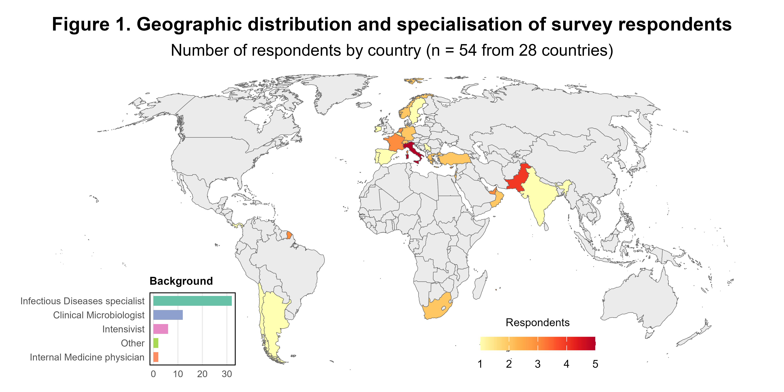
Characteristic | N = 54
World region, n (%)
Europe | 25 (46%)
Asia | 19 (35%)
Americas | 7 (13%)
Africa | 3 (5.6%)
Specialization, n (%)
Infectious Diseases specialist | 32 (59%)
Clinical Microbiologist | 12 (22%)
Intensivist | 6 (11%)
Internal Medicine physician | 2 (3.7%)
Other | 2 (3.7%)
Years of experience, n (%)
21 or above | 23 (43%)
11-15 | 12 (22%)
6-10 | 11 (20%)
16-20 | 5 (9.3%)
1-5 | 3 (5.6%)
Teaching hospital, n (%) | 48 (89%)
Number of beds, n (%)
>500 | 39 (72%)
301-500 | 9 (17%)
100-300 | 6 (11%)
avail_cefid, n (%) | 27 (51%)
Surveillance of carbapenem-resistant organisms, n (%)
Yes | 46 (85%)
No | 7 (13%)
I dont have this information | 1 (1.9%)
cUTI management, n (%)
Only if there are no alternative therapeutic regimens | 30 (64%)
Never | 9 (19%)
Whenever a metallo-betalactamase producing bacteria is isolated | 6 (13%)
Also in empirical therapy | 1 (2.1%)
Whenever a carbapenem-resistant gram negative bacteria is isolated | 1 (2.1%)
BSI management, n (%)
Only if there are no alternative therapeutic regimens | 33 (69%)
Whenever a metallo-betalactamase producing bacteria is isolated | 11 (23%)
Never | 3 (6.3%)
Also in empirical therapy | 1 (2.1%)
HAP/VAP management, n (%)
Only if there are no alternative therapeutic regimens | 33 (70%)
Whenever a metallo-betalactamase producing bacteria is isolated | 9 (19%)
Never | 3 (6.4%)
Also in empirical therapy | 1 (2.1%)
Whenever a carbapenem-resistant gram negative bacteria is isolated | 1 (2.1%)
CNS management, n (%)
Only if there are no alternative therapeutic regimens | 30 (64%)
Whenever a metallo-betalactamase producing bacteria is isolated | 9 (19%)
Never | 7 (15%)
Also in empirical therapy | 1 (2.1%)
cIAI management, n (%)
Only if there are no alternative therapeutic regimens | 34 (72%)
Whenever a metallo-betalactamase producing bacteria is isolated | 7 (15%)
Never | 4 (8.5%)
Also in empirical therapy | 1 (2.1%)
Whenever a carbapenem-resistant gram negative bacteria is isolated | 1 (2.1%)
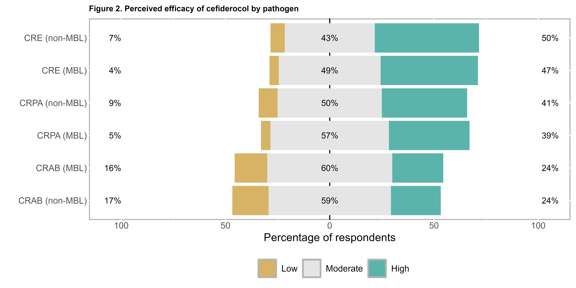
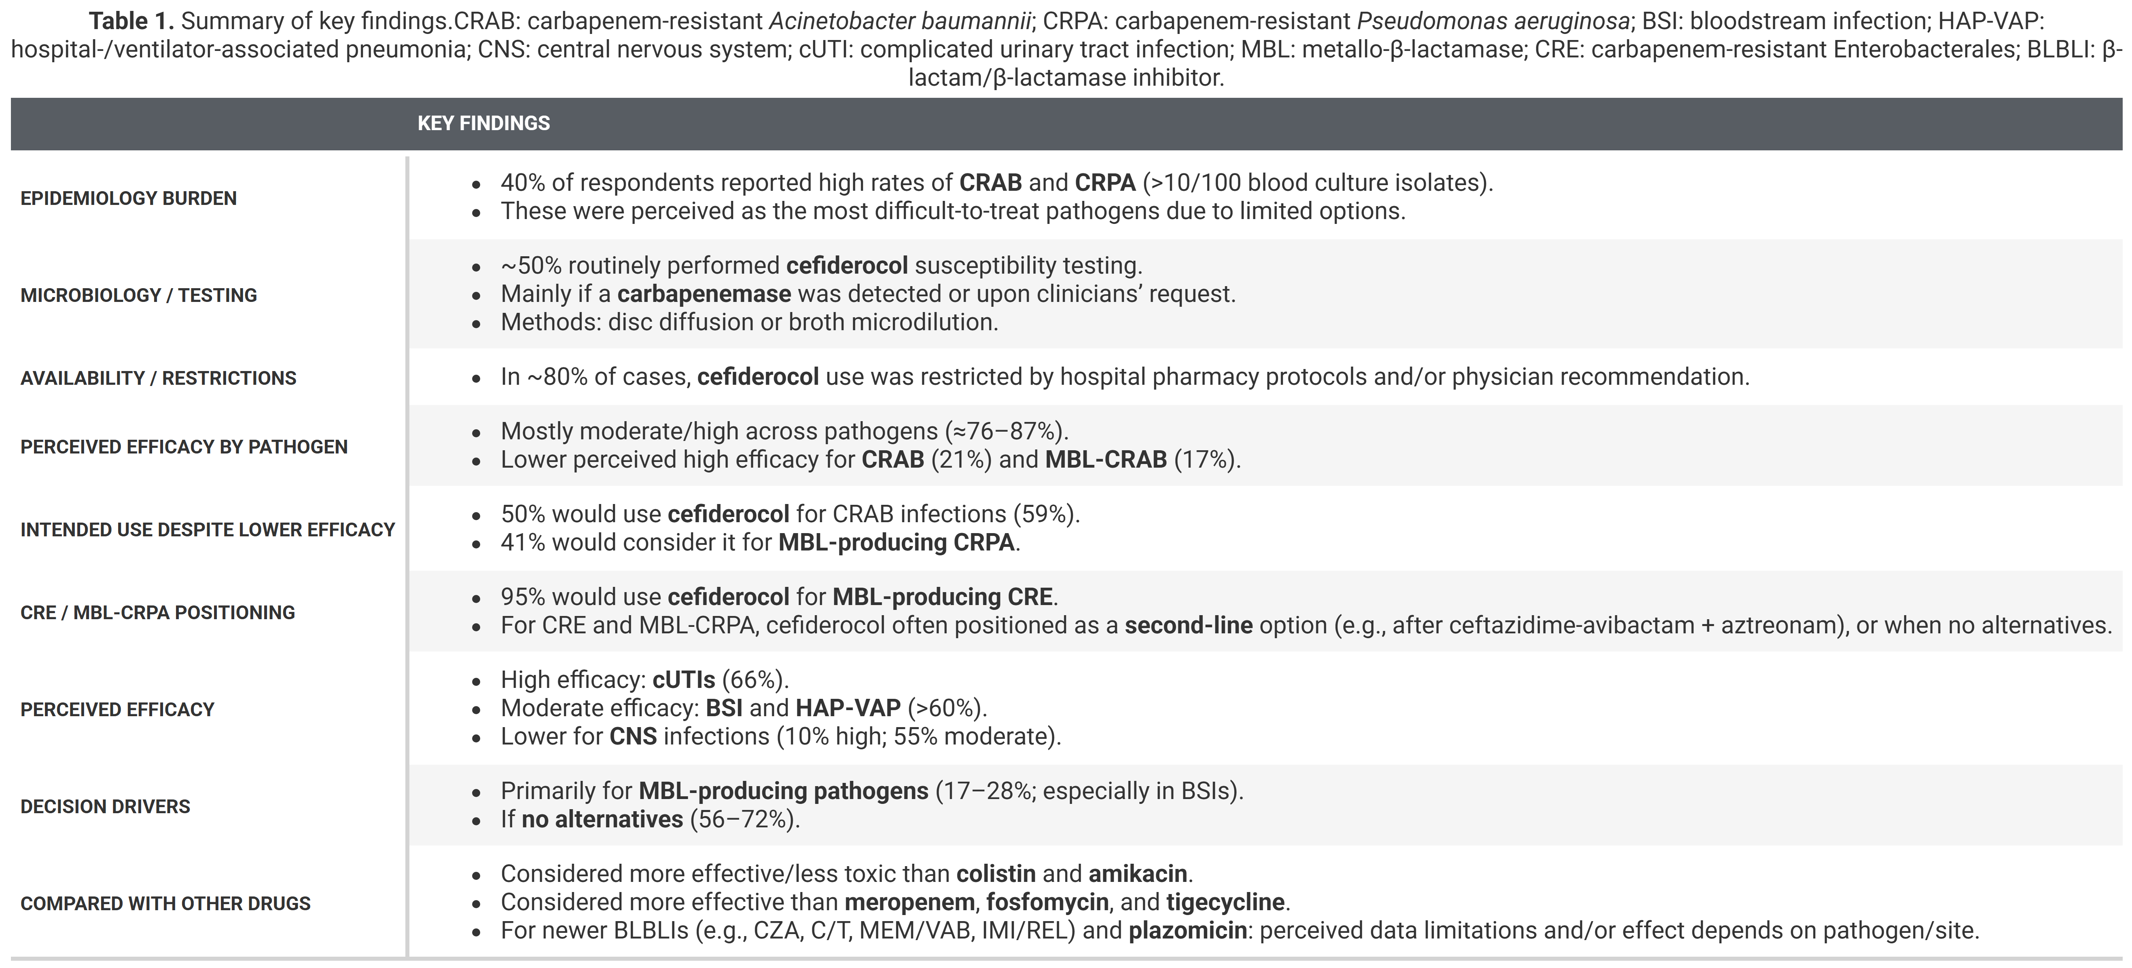

References
[1] Naghavi M, Vollset SE, Ikuta KS, Swetschinski LR, Gray AP, Wool EE, et al. Global burden of bacterial antimicrobial resistance 19902021: a systematic analysis with forecasts to 2050. The Lancet 2024;404:1199–226. https://doi.org/10.1016/S0140-6736(24)01867-1.
[2] Ito A, Nishikawa T, Ishii R, Kuroiwa M, Ishioka Y, Kurihara N, et al. 696. Mechanism of Cefiderocol high MIC mutants obtained in non-clinical FoR studies. Open Forum Infectious Diseases 2018;5:S251–1. https://doi.org/10.1093/ofid/ofy210.703.
[3] Karlowsky JA, Hackel MA, Takemura M, Yamano Y, Echols R, Sahm DF. In Vitro Susceptibility of Gram-Negative Pathogens to Cefiderocol in Five Consecutive Annual Multinational SIDERO-WT Surveillance Studies, 2014 to 2019. Antimicrobial Agents and Chemotherapy 2022;66. https://doi.org/10.1128/aac.01990-21.
[4] Portsmouth S, Veenhuyzen D van, Echols R, Machida M, Ferreira JCA, Ariyasu M, et al. Cefiderocol versus imipenem-cilastatin for the treatment of complicated urinary tract infections caused by Gram-negative uropathogens: a phase 2, randomised, double-blind, non-inferiority trial. The Lancet Infectious Diseases 2018;18:1319–28. https://doi.org/10.1016/s1473-3099(18)30554-1.
[5] Wunderink RG, Matsunaga Y, Ariyasu M, Clevenbergh P, Echols R, Kaye KS, et al. Cefiderocol versus high-dose, extended-infusion meropenem for the treatment of Gram-negative nosocomial pneumonia (APEKS-NP): a randomised, double-blind, phase 3, non-inferiority trial. The Lancet Infectious Diseases 2021;21:213–25. https://doi.org/10.1016/s1473-3099(20)30731-3.
[6] Bassetti M, Echols R, Matsunaga Y, Ariyasu M, Doi Y, Ferrer R, et al. Efficacy and safety of cefiderocol or best available therapy for the treatment of serious infections caused by carbapenem-resistant Gram-negative bacteria (CREDIBLE-CR): a randomised, open-label, multicentre, pathogen-focused, descriptive, phase 3 trial. The Lancet Infectious Diseases 2021;21:226–40. https://doi.org/10.1016/S1473-3099(20)30796-9.
[7] Paul M, Carrara E, Retamar P, Tängdén T, Bitterman R, Bonomo RA, et al. European Society of Clinical Microbiology and Infectious Diseases (ESCMID) guidelines for the treatment of infections caused by multidrug-resistant Gram-negative bacilli (endorsed by European society of intensive care medicine). Clinical Microbiology and Infection: The Official Publication of the European Society of Clinical Microbiology and Infectious Diseases 2022;28:521–47. https://doi.org/10.1016/j.cmi.2021.11.025.
[8] Tamma PD, Heil EL, Justo JA, Mathers AJ, Satlin MJ, Bonomo RA. Infectious diseases society of america 2024 guidance on the treatment of antimicrobial-resistant gram-negative infections. Clinical Infectious Diseases 2024:ciae403. https://doi.org/10.1093/cid/ciae403.
[9] Gatti M, Cosentino F, Giannella M, Viale P, Pea F. Clinical efficacy of cefiderocol-based regimens in patients with carbapenem-resistant Acinetobacter baumannii infections: A systematic review with meta-analysis. International Journal of Antimicrobial Agents 2024;63:107047. https://doi.org/10.1016/j.ijantimicag.2023.107047.
[10] Falcone M, Tiseo G, Leonildi A, Della Sala L, Vecchione A, Barnini S, et al. Cefiderocol- compared to colistin-based regimens for the treatment of severe infections caused by carbapenem-resistant acinetobacter baumannii. Antimicrobial Agents and Chemotherapy 2022;66:e02142–21. https://doi.org/10.1128/aac.02142-21.
[11] Russo A, Bruni A, Gullì S, Borrazzo C, Quirino A, Lionello R, et al. Efficacy of cefiderocol- vs colistin-containing regimen for treatment of bacteraemic ventilator-associated pneumonia caused by carbapenem-resistant acinetobacter baumannii in patients with COVID-19. International Journal of Antimicrobial Agents 2023;62:106825. https://doi.org/10.1016/j.ijantimicag.2023.106825.
[12] Rando E, Cutuli SL, Sangiorgi F, Tanzarella ES, Giovannenze F, De Angelis G, et al. Cefiderocol-containing regimens for the treatment of carbapenem-resistant A. baumannii ventilator-associated pneumonia: a propensity-weighted cohort study. JAC-Antimicrobial Resistance 2023;5:dlad085. https://doi.org/10.1093/jacamr/dlad085.
[13] Paterson DL, Sulaiman H, Liu P-Y, Chatfield MD, Yilmaz M, Salmuna ZN, et al. Cefiderocol versus standard therapy for hospital-acquired and health-care-associated Gram-negative bacterial bloodstream infection (the GAME CHANGER trial): an open-label, parallel-group, randomised trial. The Lancet Infectious Diseases 2025. https://doi.org/10.1016/s1473-3099(25)00469-4.

