Toward model informed precision dosing for Dalbavancin
M. Morra, Jason A Roberts, C. Leven, E. Tacconelli, M. Gregoire
Background
Dalbavancin is an attractive therapeutic option owing to its exceptionally long terminal half-life of approximately 14 days and its potent in vitro activity against Staphylococcus aureus, including methicillin-resistant strains. Its clinical use has expanded beyond approved indications to include complex infections such as bone and joint infections and infective endocarditis. However, optimal dosing strategies for these off label uses remain poorly defined. To address this gap, we developed a model-informed precision dosing tool to support individualized dalbavancin therapy.
Methods
A systematic search of the literature was performed to identify published dalbavancin population pharmacokinetic models. A Shiny application was developed using the R packages rxode2 and posologyr to enable a posteriori dosing optimisation.
Model averaging was implemented using a log–likelihood–based weighting approach. For each candidate model $i$, the likelihood was computed as $L_{i}=exp⁡(-0.5×OFV_{i})$, and the corresponding model weight ($w_{i}$) was calculated as:
$$w_{i}=\frac{L_{i}}{\sum_{j=1}^{n}{L_{J}}}$$
where $L_{i}$is the likelihood of model $i$, and $n$ is the total number of candidate models. The predicted concentrations from the best-fitting model were compared with observed concentrations by calculating relative bias (rBias) and relative root mean squared error (rRMSE) as follows:
$$rBias=\frac{1}{N} \sum_{1}^{i}{\frac{{predicted}_{i}-{observed}_{i}}{({predicted}_{i}+{observed}_{i})/2}}*100$$

$$rRMSE=\sqrt{\frac{1}{N} \sum_{1}^{i}{\frac{({{predicted}_{i}-{observed}_{i})}^{2}}{{(({predicted}_{i}+{observed}_{i})/2)}^{2}}}}*100$$

Results
In total, seven (1-7) published and one unpublished model were included. Both model averaging and best-model selection were implemented within the Shiny app. For the selected best-fitting model, Sampling-Importance Resampling was performed to estimate parameter uncertainty and generate credible intervals for each predicted concentration–time point (Figure 1).
The app enables customisation of PK/PD targets, free fraction, and MIC values (Figure 2-3). Dosing individualisation is performed through maximum a posteriori estimation and model-averaged a posteriori predictions. All diagnostic plots, model comparison outputs, and credible interval visualisations are integrated within the app. The tool can be freely accessed at: https://1k96vt-matteo-morra.shinyapps.io/Dalbavincin/
Conclusion
A comprehensive model-averaged framework was developed to inform dalbavancin dose optimisation across off-label indications. While prospective clinical validation is required, the Shiny application already offers an accessible and externally informed support tool to guide personalized dalbavancin therapy.

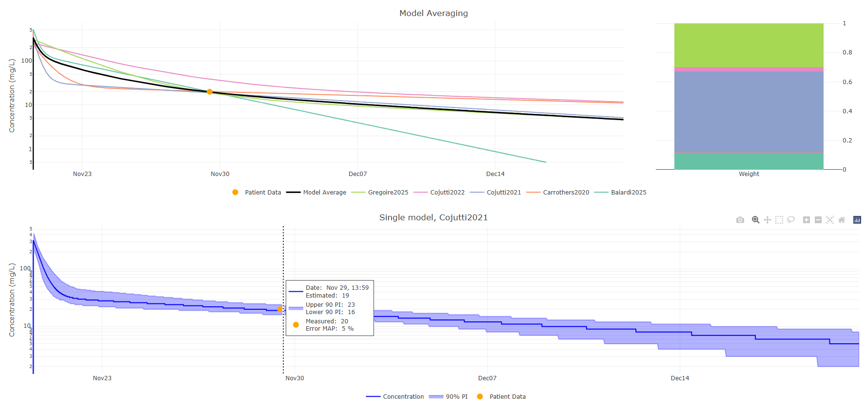
Figure 1: Visualisation of model averaging and single-model predictions. The upper left panel displays model-averaged concentration–time predictions alongside individual candidate model curves, with observed patient data overlaid. The upper right panel shows the corresponding model weights contributing to the averaged prediction. The lower panel illustrates the prediction from the selected best-fitting model including the 90% prediction interval generated via Sampling–Importance Resampling (SIR) and the patient’s measured concentration used for MAP estimation.
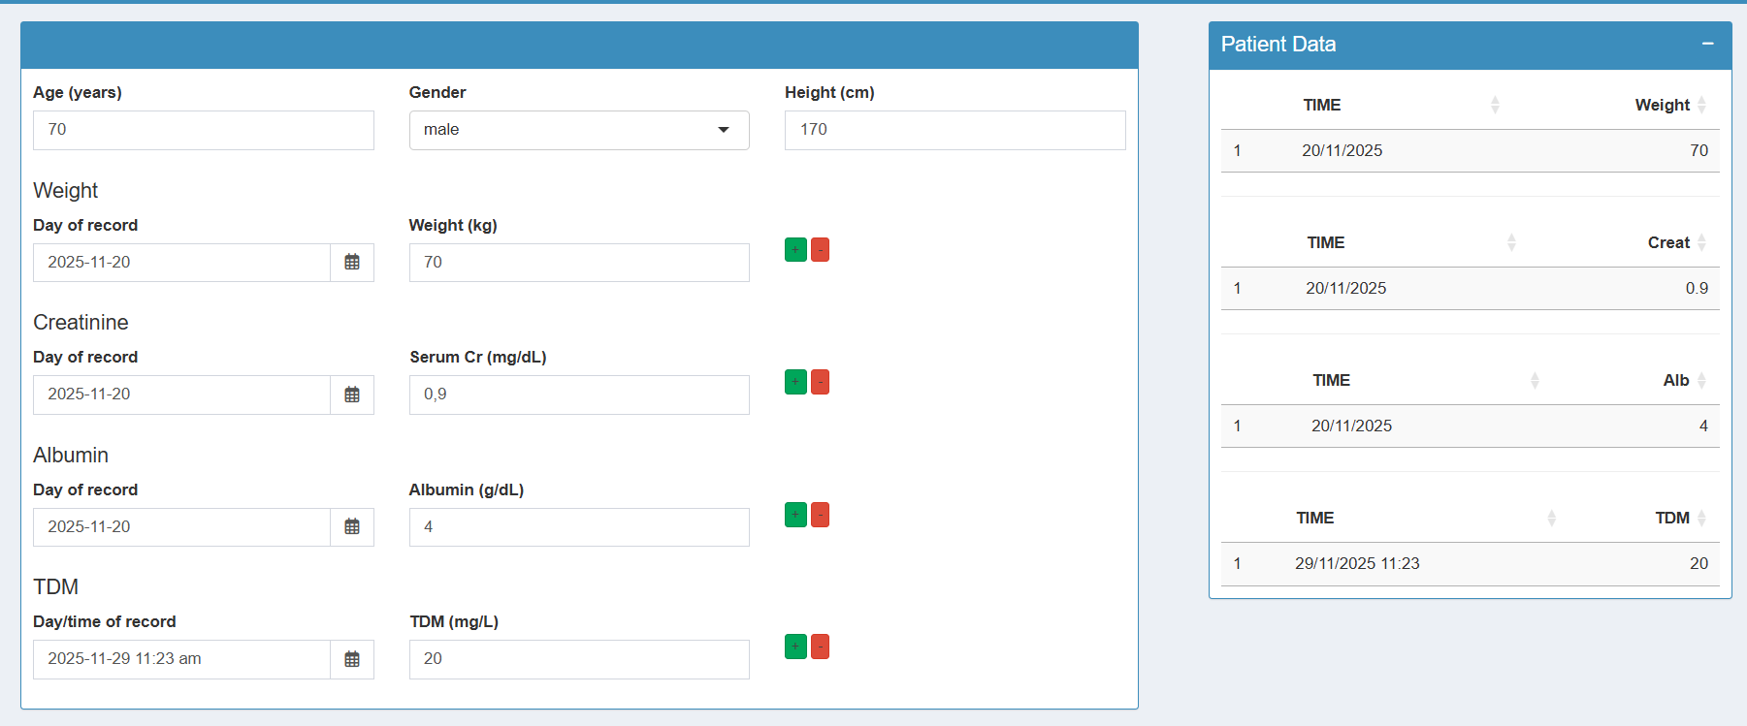
Figure 2: Patient data input interface of Shiny application. Demographic information, laboratory values (creatinine, albumin), and TDM measurements can be entered or updated on the left panel, while the right panel displays the structured patient dataset that will be used for model estimation and dose optimisation.

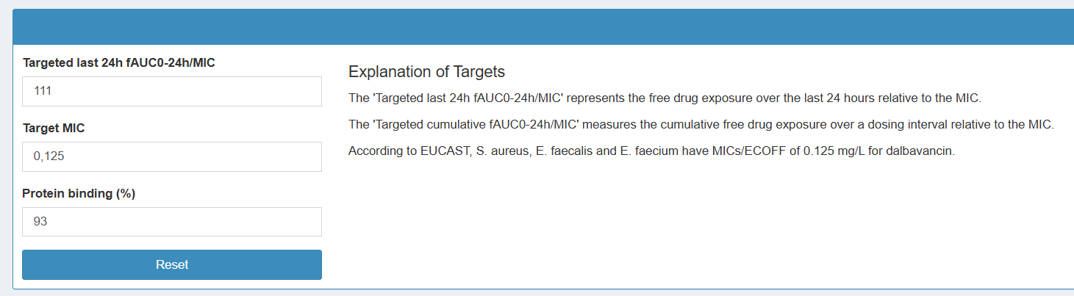
Figure 3: Pharmacodynamic target selection panel. Users can specify the desired PK/PD target (e.g., last-24h fAUC₀–₂₄h/MIC), the MIC value, and the protein binding percentage
References
1, Baiardi G, Cameran Caviglia M, Boni S, Di Paolo A, Marini V, Cangemi G, Cafaro A, Pontali E, Mattioli F. Multidose Dalbavancin Population Pharmacokinetic Analysis for Prolonged Target Attainment in Patients Requiring Long-Term Treatment. Antibiotics (Basel). 2025 Feb 13;14(2):190. doi: 10.3390/antibiotics14020190. PMID: 40001433; PMCID: PMC11852064.
2, Buckwalter M, Dowell JA. Population pharmacokinetic analysis of dalbavancin, a novel lipoglycopeptide. J Clin Pharmacol. 2005 Nov;45(11):1279-87. doi: 10.1177/0091270005280378. PMID: 16239361.
3, Carrothers TJ, Chittenden JT, Critchley I. Dalbavancin Population Pharmacokinetic Modeling and Target Attainment Analysis. Clin Pharmacol Drug Dev. 2020 Jan;9(1):21-31. doi: 10.1002/cpdd.695. Epub 2019 May 14. PMID: 31087630; PMCID: PMC7003773.
4, Cojutti PG, Tedeschi S, Zamparini E, Viale P, Pea F. Population Pharmacokinetics and Pharmacodynamics of Dalbavancin and C-Reactive Protein in Patients with Staphylococcal Osteoarticular Infections. Clin Pharmacokinet. 2024 Sep;63(9):1271-1282. doi: 10.1007/s40262-024-01410-2. Epub 2024 Aug 22. PMID: 39172334; PMCID: PMC11449996.
5, Cojutti PG, Tedeschi S, Gatti M, Zamparini E, Meschiari M, Siega PD, Mazzitelli M, Soavi L, Binazzi R, Erne EM, Rizzi M, Cattelan AM, Tascini C, Mussini C, Viale P, Pea F. Population Pharmacokinetic and Pharmacodynamic Analysis of Dalbavancin for Long-Term Treatment of Subacute and/or Chronic Infectious Diseases: The Major Role of Therapeutic Drug Monitoring. Antibiotics (Basel). 2022 Jul 24;11(8):996. doi: 10.3390/antibiotics11080996. PMID: 35892386; PMCID: PMC9331863.
6, Benavent E, Lora-Tamayo J, Ulldemolins M, Pons-Oltra P, Gregoire M, Mancheño-Losa M, Hernández-Jiménez P, Meléndez-Carmona MÁ, Casals V, Roberts JA, Rigo-Bonnin R, Murillo O. Efficacy, safety, and population pharmacokinetics of a single 1500mg dose of dalbavancin for short-term therapy in patients with chronic prosthetic joint infections. Antimicrob Agents Chemother. 2025 Oct 17:e0077325. doi: 10.1128/aac.00773-25. Epub ahead of print. PMID: 41105523.
7, Chiriac U, Liebchen U, Frey OR, Lanzinger H, Klein S, Hoppe-Tichy T, Karck M, Meyer A, Morath B. Model-Based Dose Identification of Dalbavancin for Long-Term Suppressive Outpatient Treatment of Ventricular Assist Device Infections. Antibiotics (Basel). 2024 Nov 20;13(11):1103. doi: 10.3390/antibiotics13111103. PMID: 39596796; PMCID: PMC11591545.

