Maiken Winterberg Inbox 2 HTML
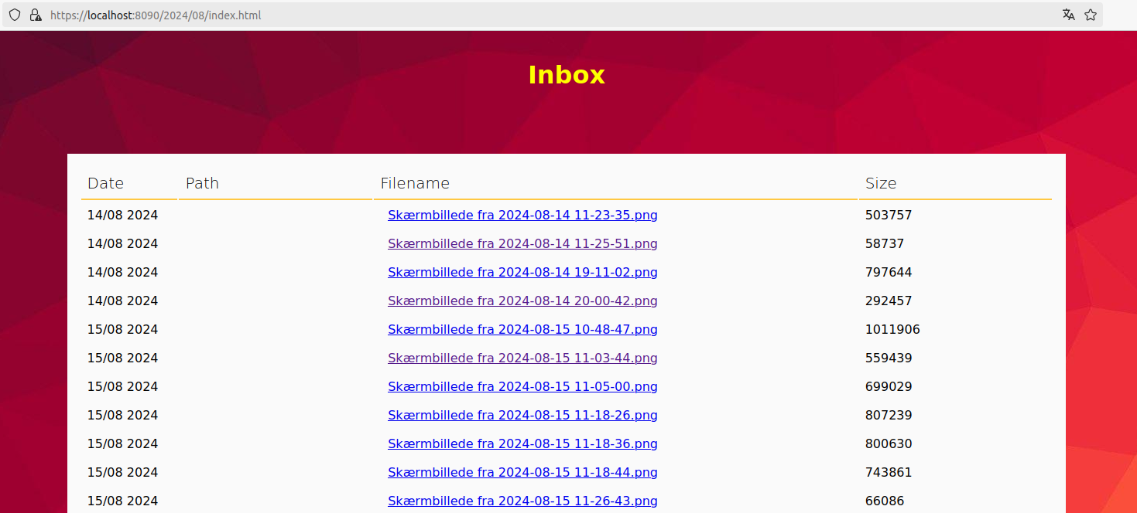
This is a tool that will generate HTML based on a folder. It will create a unique link for each file in the tree. This link acts as a userid and password. Everyone that has the link can open the file. If you want to browse the generated html tree, the ip-address of your browser location will be validated and checked with the receiverdomainnames of the configuration. You can have many receiverdomainnames. If so you must seperate them with semicolon. By default its using https with an autogenerated key. This key is not automaticly approved by your browser. You must either generate your own key with approvable certifications or manually accept the key into your browser.

Installation
Easy installation in 5 steps:
1) Install java on your maschine
linux: sudo apt-get install openjdk-21-jdk
windows/macos: https://www.oracle.com/java/technologies/downloads/
2) Update config/inbox2HTMLConfig/inbox2HTML.properties
A) Replace localhost with your domainname of your externalip
B) Update the startingdir with the location of the folder that you want to access online.
3) on linux execute the file linux_service/installInboxServer.sh and on windows install windows_service/AlwaysUp.exe and add the application: bin/startInboxServer.bat
4) Open for port 8090
5) Test by opening page https://localhost:8090

Security
The key with ssl certificates are located in config/inbox2HTMLConfig/KeyStore.jks. The default password of the KeyStore.jks is 123456. You can read in the following article about how to generate your own ssl certificate at: https://stackoverflow.com/questions/11308077/generate-key-and-certificate-using-keytool
When you browse the generated HTML you must come from the right ip address. If you want to allow everyone to access the generated HTML files you must set the domaincheck to false.

Plugins
If you have java programming resources available you can extend the tool. You can implement plugins fo:
Link2filelogger: Creates links and associates them with files.
DocumentIterator: Traverse documents from the filesystem or a database (if implemented)
HTMLGererator: Creates HTML

Templates
You can change the HTML by modify the templates. In the config folder there are templates for index, inbox and e-mail. The attributes of the templates will be replaced with html from the HTMLGenerator. An attribute start with ’${’ and ends with: ’}’. You can add or modifify the attributes by changing the HTMLGenerator of the configuration.

Email
As an option you can turn on emails. However, that requeres som extra admin skils. You need information about your mailserver. You must modify the mail.smtp configuration settings and set the sendEmail config value to true. By default no emails are sent. When turned on an email are sent when the weektimePattern or timePattern are matched with current time.

WWW
The Inbox2Html service comes with a https server. You find the www folder in MaikenWintebergInbox2HTML/bin/www directory. If you want to create a subscription homepage you can create a directory in the www folder called with a name of your choice. In the new folder you can create an index.html file. If you want a closed www page you must set the receiverdomainnames with the domainnames of your subscribers (sepereated by semecolon). If you want everyone to access the page you must set the domaincheck parameter to false. You can install multiple Inbox2Html services. But then you must change the port – each service must have a different port number.

