Sorting Recyclables with a Pre-Trained DINOv3 Model: An Industry Recommendation
Jesse Mazariegos and Mataeo Anderson
November 10, 2026
Business Problem
Our hypothetical client is a regional recycling operator that runs a single-stream materials recovery facility. Mixed recyclables arrive on a conveyor, and workers on the line pull out the trash and separate the rest into cardboard, glass, metal, paper, and plastic. The sorted material is baled and sold. The problem the client wants solved is contamination. When trash or the wrong material ends up in a bale, the buyer can downgrade or reject the load, and the facility pays to haul away material it expected to sell. Right now, the only protection against that is people. Manual sorting is slow, hard to staff, and gets less consistent over a long shift.
Without AI, the client's options are to add sorters, slow the line down, or accept more contamination. An image classifier would be useful if it could look at each item and say what material it is, so that the sorters can spend their attention on the items the model marks as trash or is unsure about. The two kinds of mistakes do not cost the same. If the model calls a piece of trash recyclable, that item can contaminate a bale. If it calls a recyclable item trash, the facility loses the value of that one item. Missing trash is the more serious error for this client, so we cared more about catching trash than about raw accuracy.
Model and Dataset
We selected the DINOv3 ConvNeXt-Tiny model [3, 4] as our pre-trained backbone. DINOv3 is trained with self-supervision on a very large image collection, so its features are general and not tied to one set of labels. The Tiny version has about 27.8 million parameters, which is small enough to run many experiments on Kaggle's free GPUs. It was also the backbone from our Unit 3 project, so we already had a tested pipeline and a reference result to compare against. Another reasonable option would have been an ImageNet-supervised network from Keras Applications, such as EfficientNetV2. That would have been easier to load, but we would have lost the direct comparison to our earlier results.
The dataset is TrashNet [1], a public dataset of 2,527 photos in six classes: 403 cardboard, 501 glass, 410 metal, 594 paper, 482 plastic, and 137 trash. Each photo has exactly one label. We used the resized copy hosted on Kaggle [2], where every image is 384 × 512 pixels. The main limitation for this client is that TrashNet was photographed one object at a time on a plain background. A real conveyor has overlapping, dirty, and crushed items, motion blur, and different lighting. The trash class is also small, and it is a catch-all category, so 137 images cannot cover everything that could show up as trash at a facility. Not only that, but trash is also the most important class to have high recall for, making the class imbalance a problem paramount to address.
We adapted the model in two ways. In most runs the backbone stayed frozen, and we trained a small classifier head on its output features. In the last experiment we unfroze the final layers of the backbone and trained them together with the head to test if that could improve performance. All modeling and training were done in TensorFlow and Keras.
Success Criteria
Our primary model metric is macro F1 on the validation set. Macro F1 averages the F1 score of each class equally, so the 21 trash images in the validation split count as much as the 89 paper images. Accuracy by itself would mostly reward getting the large classes right. Our business criterion is trash recall. The goal we aim to achieve is a model with at least 90% recall for trash items, because a missed trash item is the expensive error for this client. We also tracked how many recyclable items get labeled as trash, since that was the price of pushing trash recall higher from our previous experiments. Our operational constraint is that the system should be able to run on ordinary edge hardware, such as an NVIDIA Jetson, though we have only timed it on Kaggle GPUs. The facility should be able to run the model on a single GPU workstation making it a low barrier to entry and feasible to implement; hence selecting the tiny CNN model instead of a ViT or one of the larger models from the DINOv3 pre-trained family.
Data Pipeline and Pre-Processing
We kept the same stratified 70/15/15 split from Unit 3 with random seed 42, which gives 1,768 training, 379 validation, and 380 test images. The notebook checks the per-class counts against the Unit 3 run, so every result in this report uses the same images in the same splits. Images stay at their native 384 × 512 resolution with no resizing, cropping, or padding. The only pre-processing is scaling the RGB values and applying ImageNet normalization. The frozen backbone turns each image into a 12 × 16 × 768 feature map. We area-resize that map to a 2 × 2 grid and flatten it into a 3,072-value vector, which was the best representation in Unit 3. Because the backbone is frozen, the features are extracted once and reused by every head. We also published the extracted features as a public Kaggle dataset so that either of us could train heads without rerunning the backbone, which sped up the model training.
Baseline and Controlled Experiments
The simple benchmark is a majority-class predictor that always answers paper. It gets 23.48% validation accuracy and a macro F1 of 0.0635. Our baseline run uses the frozen backbone, the 2 × 2 spatial features, and a head with two hidden layers of 40 and 24 GELU units with dropout of 0.1, trained with cross entropy and Adam. Every head trains for 100 epochs at a batch size of 256 with a warmup, stable, and decay learning-rate schedule that peaks at 0.002. We did not use early stopping, because in Unit 3 it always ended training before the decay phase started. Each run saves the epoch with the lowest validation loss and the last epoch, and we report whichever of the two had the higher validation macro F1.
Each experiment changes one major thing relative to the baseline, and Table 1 is our experiment log. Experiment 2 is the one place where we bundled changes. The logit-adjusted loss [6] came together with label smoothing of 0.1 and AdamW weight decay of 0.05, following the long-tail literature [7], so its result belongs to the whole recipe and not to the loss alone.
Run | Change made | Reason for change | Model result (validation) | Practical trade-off
Baseline | Frozen backbone, 2 × 2 spatial features, cross-entropy head | Establish reference | Macro F1 0.9125; 18 of 21 trash caught | Head trains in about 90 seconds
Experiment 1 | Focal loss (γ = 2) with inverse-frequency class weights | Put more weight on trash and on hard examples | Macro F1 0.9097; 19 of 21 trash caught | No added cost, but no real gain
Experiment 2 | Logit-adjusted loss, with label smoothing and AdamW weight decay | Correct the head's bias toward the large classes | Macro F1 0.9220; 20 of 21 trash caught | No added cost; more recyclables get called trash
Experiment 3 | One mirrored and rotated copy of each training image | Reduce overfitting in the head | Macro F1 0.8997; trash F1 fell to 0.708 | Backbone reruns once on the augmented training images
Experiment 4 | Unfreeze the last 12 backbone layers, learning rate 1e-5 | Let the features adapt to waste images | Macro F1 0.9246; 19 of 21 trash caught | About 8× the training time; 14.4M trainable parameters
Table 1. Experiment log. Results are on the 379-image validation split.
Results
Table 2 compares every run. All of the learned models are far above the majority benchmark, and all five land within about two and a half points of each other on validation macro F1. That closeness is the main result. The validation split has 379 images and only 21 of them are trash, so a single trash image is worth almost five points of trash recall. We also ended up running the baseline configuration three separate times, once in each notebook, and its last-epoch test macro F1 came out as 0.9372, 0.9372, and 0.9288 with no change to the settings. Differences smaller than about a point should be read as noise after seeing this phenomenon.
Run | Val. accuracy | Val. macro F1 | Val. trash recall | Test accuracy | Test macro F1 | Test trash recall
Majority benchmark (always paper) | 23.48% | 0.0635 | 0 of 21 | — | — | —
Baseline: cross entropy | 92.35% | 0.9125 | 18 of 21 | 94.21% | 0.9372 | 18 of 21
Experiment 1: focal loss | 92.61% | 0.9097 | 19 of 21 | 93.68% | 0.9288 | 18 of 21
Experiment 2: logit-adjusted loss | 94.20% | 0.9220 | 20 of 21 | 94.21% | 0.9384 | 20 of 21
Experiment 3: augmentation | 92.35% | 0.8997 | — | 93.16% | 0.9208 | 17 of 21
Experiment 4: partial fine-tuning | 93.93% | 0.9246 | 19 of 21 | Not run | Not run | Not run
Unit 3 reference: logistic regression | 94.20% | 0.9282 | — | 94.47% | 0.9390 | —
Table 2. Validation and test results. Each split contains 21 trash images. The augmentation notebook reported validation trash F1 (0.708) but not recall.
For experiment 1 we expected focal loss to help trash the most, since it gives trash about three times the weight of an average class. It caught one more trash image on validation than the baseline did, but macro F1 did not improve. For experiment 2 we expected the logit adjustment to move the decision boundary toward the small class, and it did. It caught 20 of the 21 trash images on both validation and test, and it had the best validation macro F1 of the frozen-backbone runs. The cost showed up in precision. On validation it labeled 13 recyclable items as trash (6 paper, 6 plastic, and 1 glass) compared with 4 for the baseline. On test the same comparison was 3 against 1.
For experiment 4 we expected the largest gain, because fine-tuning is the only change that lets the backbone itself learn about waste images. It reached the highest validation macro F1 at 0.9246, but that is 0.003 above experiment 2, which is about one image. It also took 677 seconds to train, where a frozen head takes about 90, and it trains 14.4 million parameters where the head alone has 124 thousand. We did not select it, so we did not run it on the test set. It is also worth saying plainly that none of the Unit 4 runs beat the Unit 3 logistic regression head on validation macro F1. The imbalance methods changed which errors the model makes more than they changed how many.
Error Analysis
Figure 1 shows the test confusion matrix for the experiment 2 model. Three error patterns stand out, and they showed up in every model we trained. First, 7 of the 72 plastic images were called glass. Our best explanation is that clear bottles and containers look alike in a photo no matter what they are made of. For the client this puts plastic into the glass stream, which is contamination between two materials that are both sellable. Second, 3 of the 62 metal images were called glass, most likely for a similar reason, since both can be shiny and reflective. Third, 3 of the 61 cardboard images were called paper. That confusion is the least costly of the three because both are fiber.
The errors the client cares about most are in the trash row and column. The model missed 1 of the 21 trash images, calling it plastic, and it labeled 3 recyclable items as trash (2 paper and 1 metal). Given the costs in the business problem, we think that is the right direction to lean. A recyclable item in the trash costs the facility one item, while trash in a bale can cost the load. This is the reason we prefer experiment 2 over the baseline even though their test accuracy is identical.
An Unsuccessful Experiment
Experiment 3, augmentation, was our clearest miss. Every head we trained reached about 99.9% training accuracy while validation stayed in the low 90s, so we believed that showing the head slightly different versions of the training images would close some of that gap. Each training image was mirrored with 50% probability and rotated by up to 10 degrees, then passed through the frozen backbone again. Validation and test images were left alone. Validation macro F1 dropped to 0.8997 from the baseline's 0.9125, and trash F1 fell from 0.837 to 0.708.
Figure 2 shows what happened. Training loss still went to almost zero while validation loss climbed from about 0.25 at epoch 17 to about 0.47 by the end, so the head overfit the augmented features just as easily as the original ones. We think the design of the experiment is the reason. To keep the comparison controlled we made one augmented copy of each image and used it in place of the original. The head saw the same number of examples as before, it never saw the unmodified images that validation uses, and it never saw a fresh variation from one epoch to the next. Rotating also fills the corners of the image with white, which the validation images do not have. What we learned is that augmentation done once, offline, is not the same thing as augmentation during training, and with a frozen backbone the real version costs a backbone pass for every new view. The result did change our recommendation in one way, which is that augmentation is not part of the model we propose. However, with more time, we would like to try training with online train-time augmentation to see if the longer train time but more thorough augmentation could produce the result we’d hoped for.
Moreover, in a way, all the Unit 4 experiments were failed experiments because none of them improved over the best model from the previous experiments done for the Unit 3 project. We were able to improve recall for the trash class, even reaching the 90% recall our hypothetical client requested. But in every case the trade-off was such that the macro F1 never improved over the strongest Unit 3 experimental model.
Practical Constraints and Limitations
Extracting features for all 2,527 images took between 151 and 298 seconds across our runs on two Kaggle T4 GPUs. That works out to roughly 8 to 17 images per second, including the time to decode each image. This is workable for a station where items are photographed one at a time, but it would have to be measured again on the facility's own hardware and belt speed. Each head trains in about 90 seconds, and the notebook with the baseline and first two experiments finished in under 12 minutes. Experiments 1 through 3 only change how the head is trained, so they add nothing to the cost of a prediction.
Along that vein of thought, the images in the dataset are also single images of a piece of trash or recycling, taken in isolation, in a controlled setting. In production in a plant like our hypothetical client’s, the model would need to do multi-object detection more than plain image classification. It would need to be able to identify the different trash and recycling objects when more than one exists in each image on top of the real time constraints. Only identifying a single object, as an image classification task, works as a proof of concept for when items are evenly distributed across a very slow-moving conveyor belt. But the dataset would need to include the more realistic setting and images before a model trained on it could be deployed.
The biggest limitation is still the data. A result of about 94% on TrashNet should not be read as 94% on a real sorting line. Our evaluation splits are also small, which is why we avoid drawing conclusions from one-point differences. Having a larger dataset would not only make the evaluation split results more conclusive, it would also give the deep learning model enough data to generalize from and make it more difficult to overfit the training data, as well as have enough pictures of trash to better display the distribution of different trash items that could be encountered in production. There is also a limitation in our own process. The training notebook printed test scores for the baseline and the first two experiments next to the validation scores. We made our choices from the validation numbers, but the test set was not kept as hidden as it should have been, so we treat the test results as a check and not as proof.
Team Process
Mataeo built the feature extraction and training pipeline and ran the baseline and the two loss experiments. Jesse designed and ran the augmentation and fine-tuning experiments in a copy of the same notebook. We shared code through GitHub and via email, met after class to go over results, and reviewed each other's notebooks so that both of us could explain every run in this report.
Recommendation
We recommend that the hypothetical client proceed with a limited pilot, with conditions. The model for the pilot is the frozen DINOv3 backbone with the logit-adjusted head from experiment 2. The Unit 3 model would be a reasonable fallback, although it missed at least three of the 21 trash images in the test set. We did not select the experiment 2 model for having the highest accuracy. It met our trash recall target on both validation and test, it had the best validation macro F1 of the frozen models, it trains in about 90 seconds, and it predicts at the same cost as the baseline. Fine-tuning scored 0.003 higher on validation, but that is inside the noise we measured, and it costs about eight times the training time. We would hold it back until there are facility images to fine-tune on.
The pilot should be limited in a specific way. The model should run in shadow mode on one line, where it labels items and flags likely trash while the sorters keep making the real decisions. During the pilot the facility collects and labels its own images, especially trash. The decision about anything automated should then be made on those images using the same criteria, which are trash recall of at least 90% and an acceptable number of recyclables sent to trash. Our reason for recommending a pilot over more development is that four different experiments on TrashNet moved validation macro F1 by a little over a point in either direction. We do not think more tuning on studio photos will tell the client much more. These experiments showed us that the modeling done through the Unit 3 and Unit 4 experiments has likely extracted all the information available in the current dataset. Any more significant improvement would likely need to come from improving the data rather than trying to improve the model or training pipeline. The open question is how the model does on a real conveyor, and only a pilot can answer that.
Figures
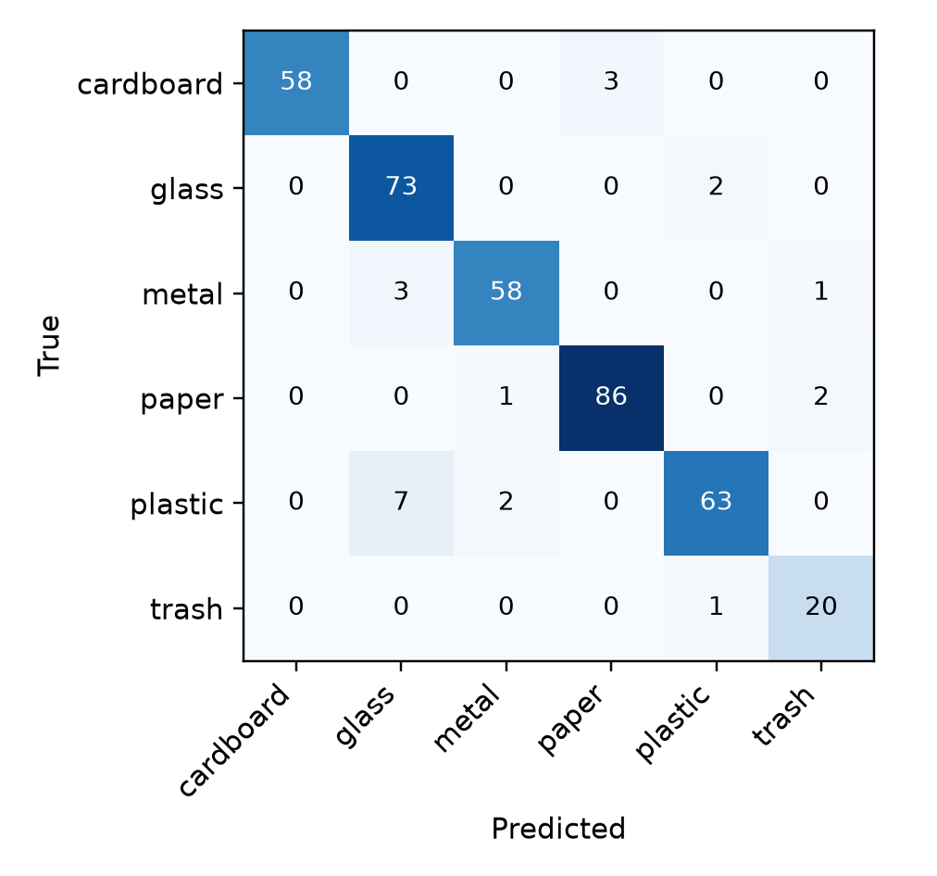
Figure 1. Test confusion matrix for the recommended model (frozen backbone, logit-adjusted head) on the 380-image held-out test set.
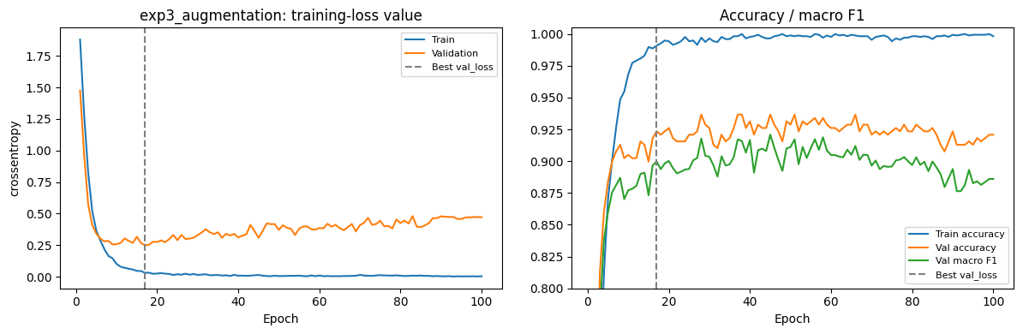
Figure 2. Learning curves for the augmentation experiment. The dashed line marks the epoch with the lowest validation loss.
References
[1] G. Thung and M. Yang, "TrashNet," GitHub repository, https://github.com/garythung/trashnet.
[2] feyzazkefe, "TrashNet / dataset-resized," Kaggle dataset used for all experiments.
[3] O. Siméoni et al., "DINOv3," arXiv:2508.10104, 2025.
[4] Mataeo Anderson, "DINOv3 ConvNeXt," Kaggle model artifact used as the pre-trained backbone, https://www.kaggle.com/models/mataeoanderson/dinov3-convnext.
[5] T.-Y. Lin et al., "Focal Loss for Dense Object Detection," ICCV 2017.
[6] A. K. Menon et al., "Long-Tail Learning via Logit Adjustment," ICLR 2021.
[7] B. Kang et al., "Decoupling Representation and Classifier for Long-Tailed Recognition," ICLR 2020.
[8] Project repository: https://github.com/mataeo-eh/Unit3_Group_Proj.

