Probabilistic Methods in Civil Engineering and Mechanics

EN. 560.618: Term Project – Report

Due: 12/19/16

Matan Grossmann

**1. Project Background**

The task of this Term Project was to investigate the structural stability of an unknown structure subject to ground acceleration forces of an earthquake. The structure was represented only by probability distribution functions of certain structural parameters, (stiffness, mass, damping ratio, and yield strength), and by a “black box” model which amounted to a structural analysis code, whose outputs were the displacements experienced by the structure under the forces of the earthquake. The black box model providing the structure’s response required input files containing values of the indicated structural parameters, and the ground accelerations due to the earthquake over a given period of time. The accelerations and associated forces of the earthquake were represented only by its power spectral density function.

Structural stability was indicated through likelihood of sustaining distinct levels of damage or failure. These levels of damage or collapse were defined by ranges of values of displacement experienced by the structure. To provide an assessment of structural stability, it was necessary to determine the likelihood of falling into these damage-defining regions. Thus, the ultimate task, of assessing structural stability, could only be accomplished through employing probabilistic methods and analysis.

This report will present the methodology and approach to taking on such a project, the results of the investigations (i.e. the probability of sustaining certain levels of damage under the aforementioned stimuli), computational cost, as well as alternate approaches and best attempts at reducing computational cost.

**2. Approach**

The term project was broken down into three cases. The first case assumed that the accelerations of the earthquake was known, but the structural parameters were unknown. The second case assumed that the accelerations of the earthquake were unknown, but the values of the structural parameters were known. Lastly, case three assumed that both the accelerations due to the earthquake and the structural parameters were unknown.

To assess the adequacy of the structure, the necessary input values (i.e. the magnitudes of ground accelerations from the earthquake, and the values of the structural parameters) had to be generated and then provided to the structural analysis code, so that the resulting displacements from said inputs could be assessed. Below, distribution of the ground accelerations due to the earthquake is provided along with

The approach applied to this problem was to treat each case separately. Creating three different scripts in python to generate the necessary inputs required by each case. For each case, the baseline method to be employed was a Monte Carlo Simulation. In order to assess the structural stability, the “black box” model needed to be provided with its inputs and run numerous times in order to identify statistically relevant trends in the structures response to the excitations. Given the nature of Monte Carlo Simulations, and the significance of the associated computational costs of employing this method, as soon as statistically pronounced behaviors were identified, reduction techniques could be applied.

The approach can thus be broken down into the following steps. Program the basic-version files to generate the necessary inputs in the most direct way possible. Employ the brute strength, Monte Carlo Simulations for each case with varying numbers of simulations to gage the behavior of the structure. Then employ variance reduction techniques to achieve these same results but while expending significantly lower computational effort.

**3. Monte Carlo Simulations**

As was mentioned earlier, the Monte Carlo Simulations are computationally intensive, and require careful programming to minimize efforts as well as patience for the thousands of simulations to run. The following chart depicts the number of simulations run for each case, the computational cost, in seconds, and the probability breakdown of falling into the prescribed damage thresholds: No Damage, Mild Damage, Moderate Damage, Major Damage, and Collapse.



As can be seen, in the above depiction, the computational expense is significantly higher in cases where the ground accelerations, due to the earthquake, needed to be generated. This is due to the nature of the Power Spectral Density Function and the Spectral Representation function. Both are high dimensional, and when thousands of representations must be generated, computational cost increases substantially. This is an aspect that should be noted, as in future simulations, which incorporated variance reduction techniques, this was a challenging aspect to overcome.

Below are figures representing the distribution of maximum displacements experienced by our structure of interest.

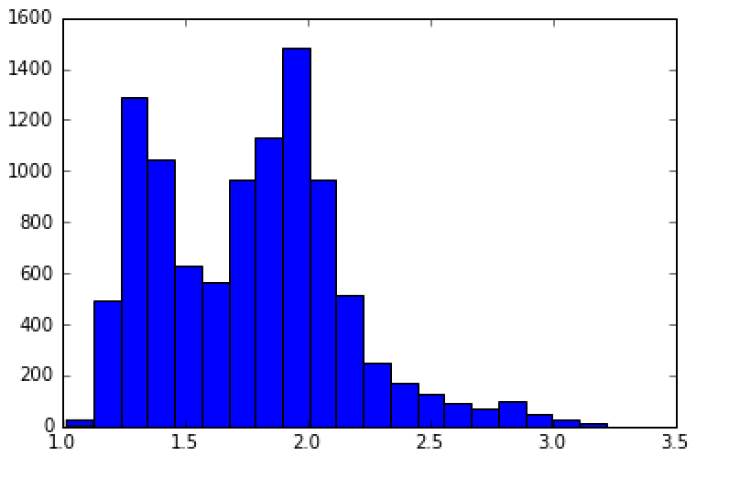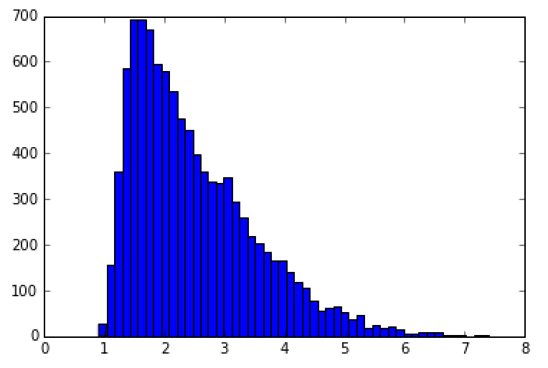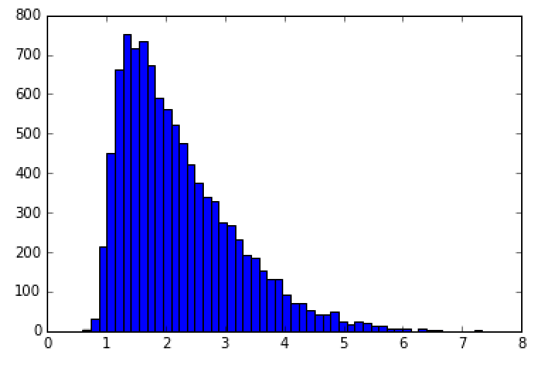

***Left to Right****: Case 1: 10000 simulations, Case 2: 10000 simulations, Case 3: 10000 simulations*

*Y- axis is number of occurrences, and X-axis represents the maximum displacement in inches.*

Furthermore, what is arguably most notable about the above table is that the probability of collapse in cases 2 and 3 are substantially higher than that of case 1. This can be explained by the fact that in case 2 there is heavy reliance on the one set of structural parameters that are sampled. If it just so happens that for a simulation of 10000 runs samples a particularly weak structure, then the results will reflect high percentages of damage and failure. Secondly, the nature of the damage thresholds is such that the range of values between the No Damage level and the Collapse level is incredible small, such that the region of all those spaces combined is not even a quarter of the size of the collapse domain. Thus, with any wide spread distribution, it is likely that the greatest probabilities will fall into the No Damage level and the Collapse level.

**4. Variance Reduction Techniques**

As can be seen in the column indicated ‘comp_time’ in the above table, and the corresponding column ‘simulations,’ no case was run more than 10,000 times. This is because the 10,000-simulation scenario required more than an hour for it to run. This puts us at arguably a minimum range for there to be enough comfort in the law of large numbers to hold for these results.

Given that the structural analysis, “black box”, code is not very computationally demanding, these high simulation Monte Carlos were doable. However, had there been more than one input parameter that was high dimensional, like the functions that describe the ground accelerations due to the earthquake, or if the structural analysis code was a bit more computationally intensive, the incentive to reduce variance and ultimately reduce computational expense would become more apparent/evident. Even in this case it is clear that variance reduction is necessary, but in real world applications of this type of analysis, variance reduction techniques become even more necessary.

In this project, there were three attempts at variance reduction: through control variates, antithetic variate, and through stratified sampling.

Control Variates were used in the post processing stage. To use control variates, it is necessary that the code or program generates an additional output to the output of interest: in our case, maximum displacement. Secondly, this method requires that the additional output be positively correlated with the output of interest to ensure variance reduction. Luckily, displacement time history was also an output from the structural analysis code, from which average displacement was easily calculated. Having a hunch that the two were positively correlated, I used this control variate, and the associated formula to reduce variance in our statistical estimator from. This yielded an increased confidence interval, allowing me to achieve results providing comfort with 60 simulations compared to 10,000 simulations previously employed when using the baseline Monte Carlo.

The second variance reduction technique that was implemented was through the use of Antithetic Variates. This method is particularly useful when dealing with many independent and identically distributed random variables, especially when those random variables are uniformly distributed between 0 and 1. In this situation, variance reduction is guaranteed when the random variables are the independent variables of a function which is monotonic. This method in a nutshell allows you to reduce variance and computational expense by generating half of the required variables, and using each generated value to determine two random variables. This method could have been potentially implemented in many aspects of this project, but I found that it would be most useful in reducing the computational expense, and associated variance, of generating of the random phase angles in the spectral representation function.

The final variance reduction technique to be employed was stratified sampling. This one was a bit tricky, but ultimately is a very appealing variance reduction technique because it almost always guarantees variance reduction. Stratified sampling allows the person employing the method to break up a sample space into a number of smaller sample spaces of varying size and associated probability. I found that it would be useful to use stratified sampling in sampling the stiffness structural parameter. The variance of the normally distributed k was 251, i.e. quite large, thus it seemed an appropriate parameter to improve sampling. This was also the case because the structural parameters have a significant impact on the overarching model by the nature of which they are weighted. Thus, when attempting to minimize computational expense and run under 100 simulations, it is likely that certain values in the distributions of the structural parameters will be missed. Thus, by prescribing the “correct” probability to the subspaces, it can be assured, even when the model is run 10 times that certain regions will be sampled accordingly.

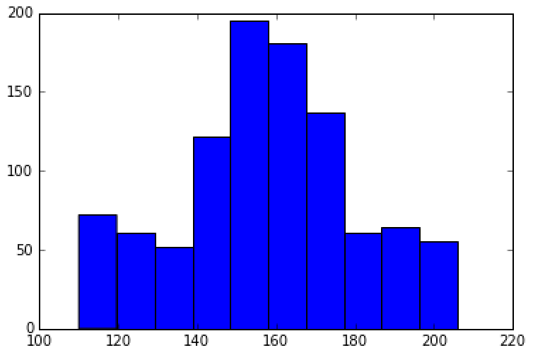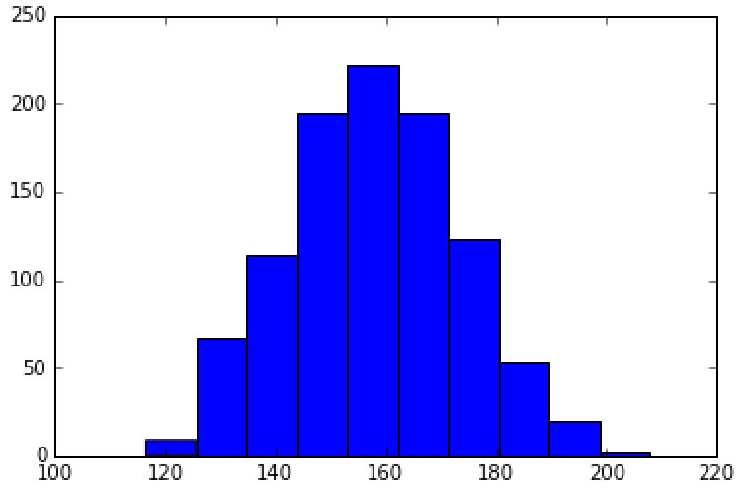

***Left to Right:*** *Stratified K showing greater sampling from the tails, Normally Distributed K, Stiffness*

**5. Conclusions and Takeaways**

Below are depicted the full case results exemplifying the efficacy of the variance reduction techniques. First, is case 1 with the stratified K value for the structural parameter, stiffness. The simulation was run 60 times, which is a significant reduction of computational cost, and as can be seen the distribution is not far off from the results recorded from the 10000 simulation Monte Carlo. Recording probability of no damage, slight damage, moderate damage, major damage, and collapse at 63.3%, 3.3%, 6.7%, 10 %, and 16%, respectively, and a variance of 0.27.

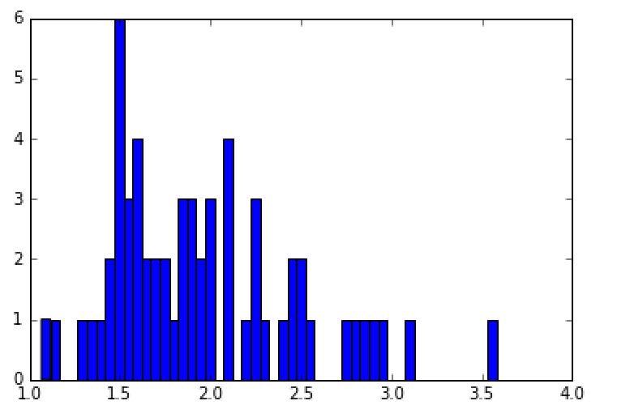

Below is provided an example of case 2 run 60 times, which is again a significant reduction in computational expense. This result uses the antithetic variance technique to reduce computational effort and reduce variance. The likelihood of structural response for no damage, slight damage, moderate damage, major damage, and collapse are: 56.6%, 1.67%, 8.3%,6.67%, and 26.6%, respectively.

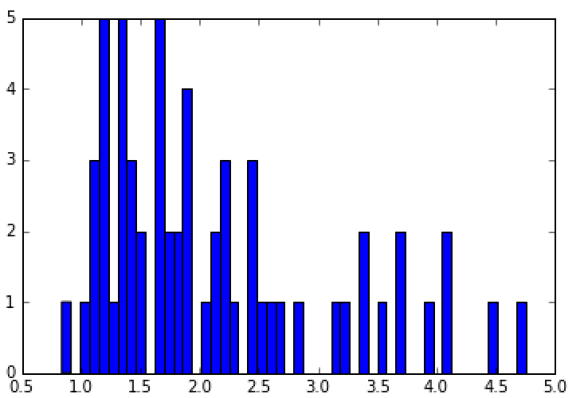

Lastly, the case 3 result used all three variance reduction techniques for the same case, also run for 60 simulations. Use of stratified sampling, antithetic variance and control variance in the same case provided the result of Probability of No Damage to be 38.3%, Slight Damage at 13.3%, Moderate Damage at 21.6%, Major Damage at18.3%, and Probability of Collapse

8.3%.

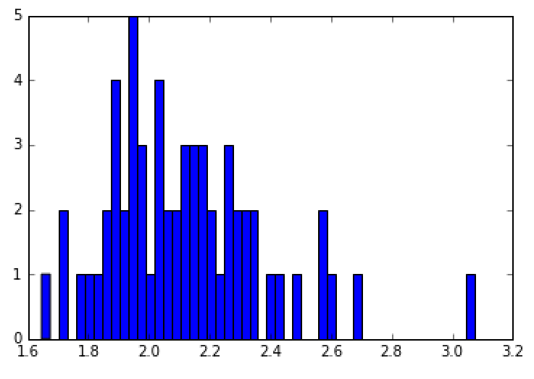

These results indicate the necessity of incorporating variance reduction techniques in probabilistic models. Reduction of computational cost and reduction of variance is incredibly necessary when dealing with complex models and simple models. Furthermore, there are numerous methods that can be employed in order to achieve variance reduction; from assisting in sampling a distribution that is difficult to define, to sampling a well-known distribution that frequently leaves out its tails, to post processing after all the data has been collected. The variety of implementation methods allows and encourages the use of variance reduction.