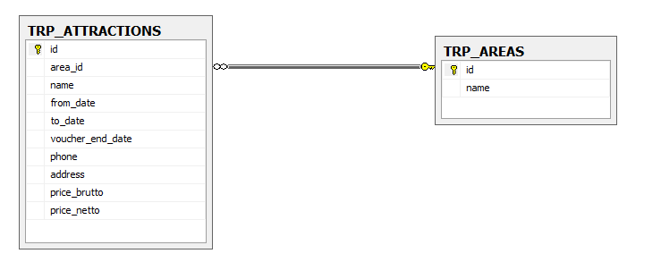TRP_ATTRACTIONS

** Id is incremental int (1, 1)

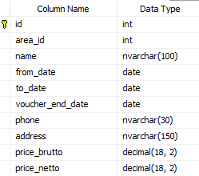

TRP_AREAS



Queries

* Get all the attractions which contains the char 'a'.

SELECT * FROM TRP_ATTRACTIONS WHERE name LIKE '%a%';

* Get all the attractions that from date in year 2019.

SELECT * FROM TRP_ATTRACTIONS WHERE YEAR(from_date) = 2019;

* Get all the attractions in area Eilat. (The area name is in table TRP_AREAS)

SELECT *

FROM TRP_ATTRACTIONS

WHERE area_id = (

SELECT id

FROM TRP_AREAS

WHERE name = 'Eilat'

);

* Get all **areas IDs** (area_id) which has more than 1 attraction in. (at least 2 attraction in area_id)

SELECT area_id FROM TRP_ATTRACTIONS GROUP BY area_id HAVING COUNT(id) > 1;

* Get all areas Names which has more than 1 attraction in. (at least 2 attraction in area_id)

SELECT A.name AS area_name

FROM TRP_AREAS A

JOIN TRP_ATTRACTIONS T ON A.id = T.area_id

GROUP BY A.name

HAVING COUNT(T.id) >= 2;

* Get all the attractions that the address in not in the area.   
  (Example: Kayaks is connected to Tel-Aviv area_id and the address contains 'Eilat')

SELECT T.name AS attraction_name, T.address, A.name AS area_name

FROM TRP_ATTRACTIONS T

JOIN TRP_AREAS A ON T.area_id = A.id

WHERE T.address NOT LIKE '%' + A.name + '%';

* Get the most profitable attraction. (brutto minus netto = profit)

SELECT TOP 1 *, (price_brutto - price_netto) AS profit FROM TRP_ATTRACTIONS ORDER BY profit DESC;