# SFL_DIAGNOSER

Spectrum-based Fault Localization package written in python 2.7.

## Package install

Git clone https://github.com/amir9979/SFL-diagnoser.git

Cd SFL-diagnoser  
python setup.py install

## Usage Example

The following example do the following:

Read an input file named "temp_matrix.txt" that describe the sfl matrix. The diagnose it.  
Later, use the Diagnosis_Results class to evaluate it.

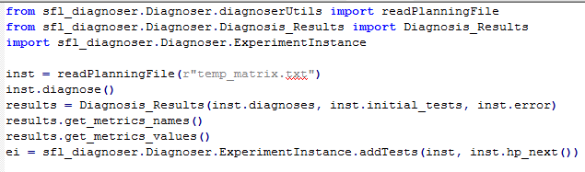

## Input File

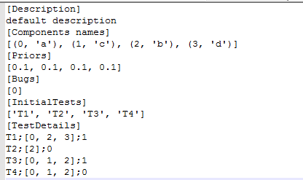

Description – general description about the experiment instance

Component names- list of tuples of component index and component name

Priors – prior probabilities for each component

Bugs – list of the real diagnosis

InitialTests – list of the test in the initial matrix

TestDetails – Description of the tests of this instance (initials and non-initials), each test description is list of test name, list of test components, test result. The test description list separated by semicolon.