Q1:
$$∂/∂bL\left(w,b\right)=∂/∂b\left(1/mΣ\left(i=1 to m\right){\left(w^{T}·x_{i}+b-y_{i}\right)}^{2}\right)=\left(1/m\right)Σ\left(i=1 to m\right)2·\left(w^{T}·x_{i}+b-y_{i}\right)=2b+\left(2/m\right)Σ\left(i=1 to m\right)\left(w^{T}·x_{i}-y_{i}\right)$$
Q2:
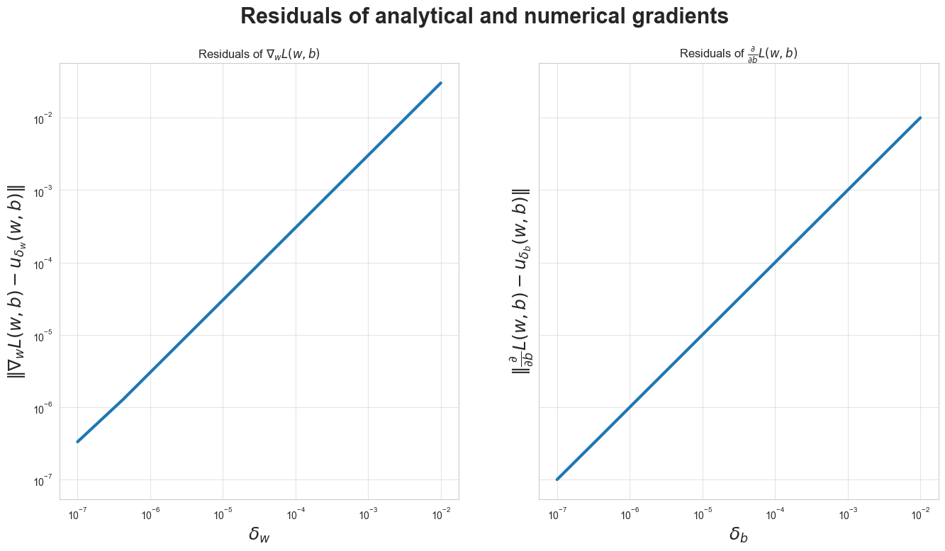
Q3:
Lr bigger we reach faster lr smaller we cant reach with this num of iterations
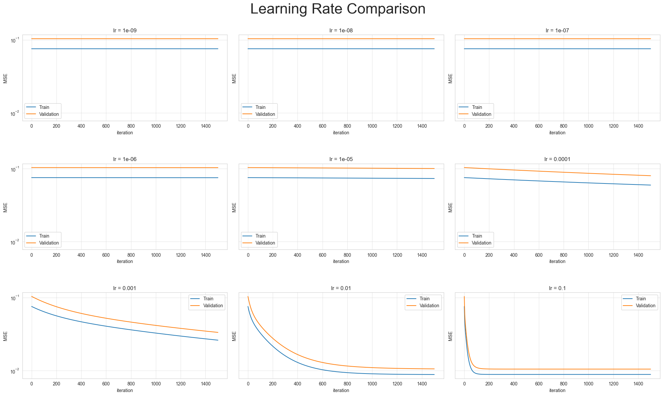

Q4:

model | section | Train MSE | Valid MSE
 |  | Cross Validation
dummy | 2 | 0.07020197010965457 | 0.07041185933040296
train loss mean:
0.07020197010965457
valid loss mean:
0.07041185933040296

Q:5

model | section | Train MSE | Valid MSE
 |  | Cross Validation
dummy | 2 | 0.07020197010965457 | 0.07041185933040296
Linear | 2 | 0.009049982022477634 | 0.009637031428234372

optimal Valid Error:
0.009637031428234372
optimal Train Error:
0.009049982022477634
optimal LR:
0.021544346900318832

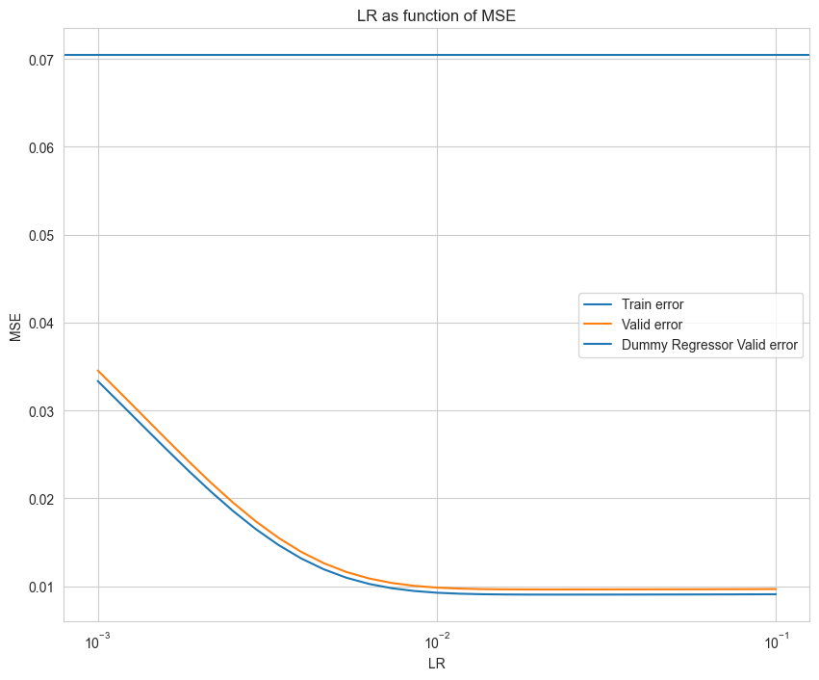

Q6:
Dummy regressor
It does not learn from the input features , it calculates the mean of the contamination levels and predict using it , so it is not affected by the using of normalized or nor normalized features.
Linear regressor:
No, the linear model is not affected by the scales if the input, The linear regression model is typically expressed as:
y^ =w0 +w1 x1 +w2 x2 +⋯+wp xp
Where if the scales of the features are different then the wi’s could adjust accordingly,
Since there is no regularization the scales woun't affect the process of choosing the best Wi's

Q7:
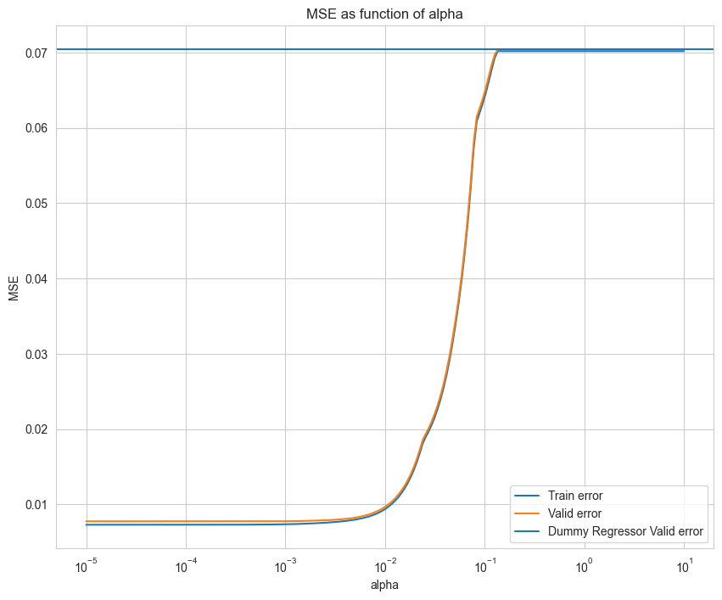

Q8:

model | section | Train MSE | Valid MSE
 |  | Cross Validation
dummy | 2 | 0.07020197010965457 | 0.07041185933040296
Linear | 2 | 0.009049982022477634 | 0.009637031428234372
Lasso Linear | 3 | 0.007319608597012884 | 0.007755303598110869

Lasso Optimal Alpha - Valid Error:
0.007755303598110869
Lasso Optimal Alpha - Train Error:
0.007319608597012884
Optimal Alpha:
0.0003962688638701478

Q9:
The following are the five biggest coefficents:
PCR_04 with a coeff of: 0.463496941205235
PCR_02 with a coeff of: 0.2527901149279534
sugar_levels with a coeff of: 0.13514775112520705
PCR_06 with a coeff of: 0.050162463221740054
PCR_09 with a coeff of: 0.016407406852982007

Q10:
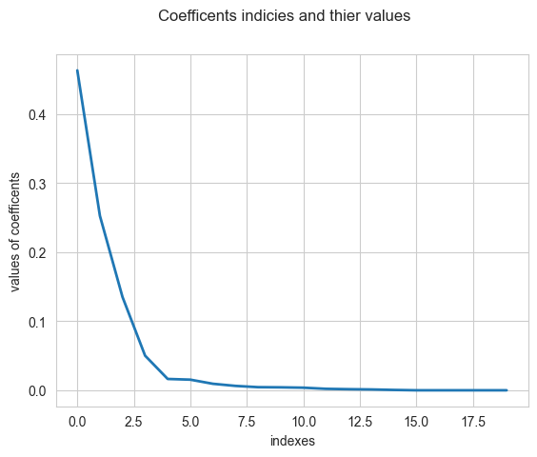
Q11:
the magnitude of the coefficients helps in interpreting the model by giving us how strongly each feature affects the targeted variable which in our case is the contamination_level, and it helps to automatically select a subset of important features.

Q12:
The lasso model is sensitive to the scale of features , it uses regularization which not only controls the overfitting by shrinking coefficients but also performs automatic feature selection by driving some coefficients to zero. it select the features depending on how important it is ,
Without normalization, this would lead the lasso model to shrink coefficients of smaller-scale features too much or even to zero, regardless of their actual importance, cause features with larger scales would dominate the regularization penalty

Q13:
Ridge regression usually leads to a model where all features have some influence, with most coefficients being small and not zero.
Lasso regression, on the other hand, often results in a model where some features have no influence at all, with their coefficients set to zero, effectively removing them from the model.
If we switch to Ridge regression, we expect the coefficients to be more evenly spread across the features, with fewer zeros and generally smaller values. This means that all features will play a role in the prediction, but with a more balanced impact.

Part 4:
Task:
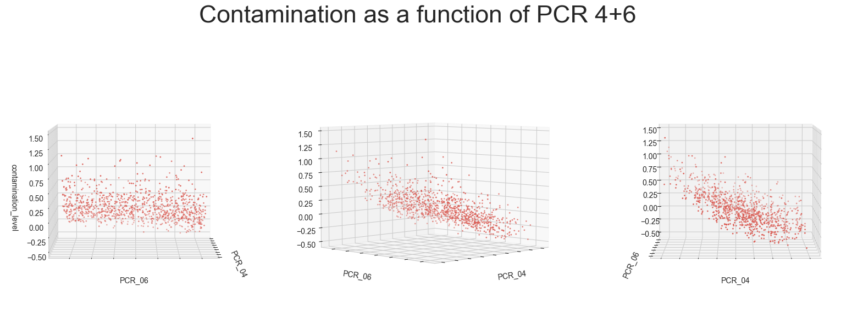
Q14:
In lasso we have regularization that is affected by the normalization and the scale of feature, when we do polynomial feature mapping , we create new features that are powers of the original features. As the degree of the polynomial increases, the magnitude of the features can become very large. normalization ensures that all features, including polynomial features, are on a comparable scale, so it is indeed important to normalize them.

Q15:

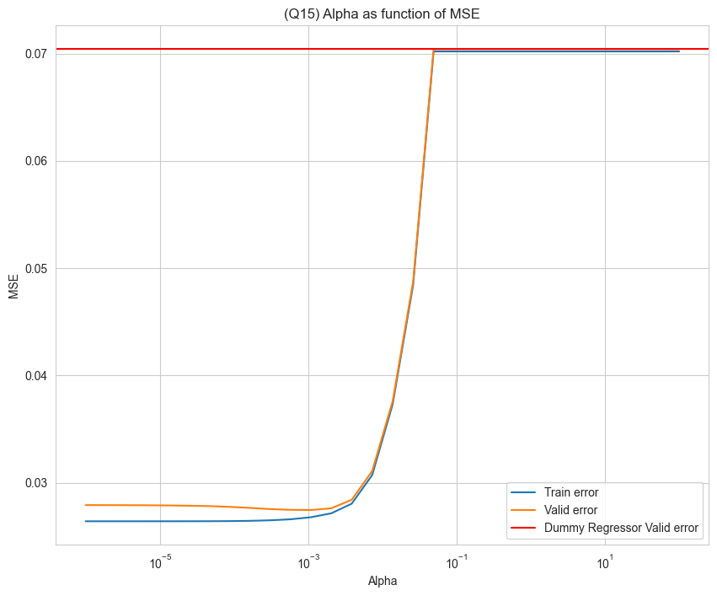
Dummy Valid Loss mean:
0.07041185933040296
(Q15) Lasso Optimal Alpha - Valid Error:
0.027468432604160088
Lasso Optimal Alpha - Train Error:
0.027468432604160088
Optimal Alpha:
2.146141197858406e-05

Q16:

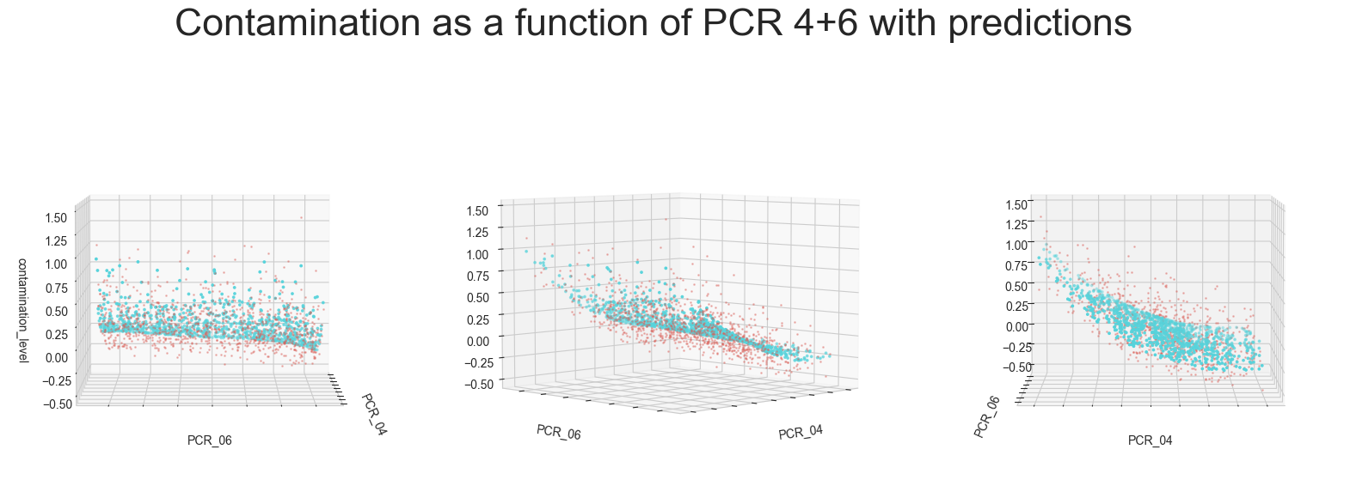
Q17:

model | section | Train MSE | Valid MSE
 |  | Cross Validation
dummy | 2 | 0.07020197010965457 | 0.07041185933040296
Linear | 2 | 0.009049982022477634 | 0.009637031428234372
Lasso Linear | 3 | 0.007319608597012884 | 0.007755303598110869
Polynomial Lasso | 4 | 0.027468432604160088 | 0.027468432604160088

Lasso Optimal Alpha - Valid Error:
0.027468432604160088
Lasso Optimal Alpha - Train Error:
0.027468432604160088
Optimal Alpha:
2.146141197858406e-05

Part 5:
Q18:
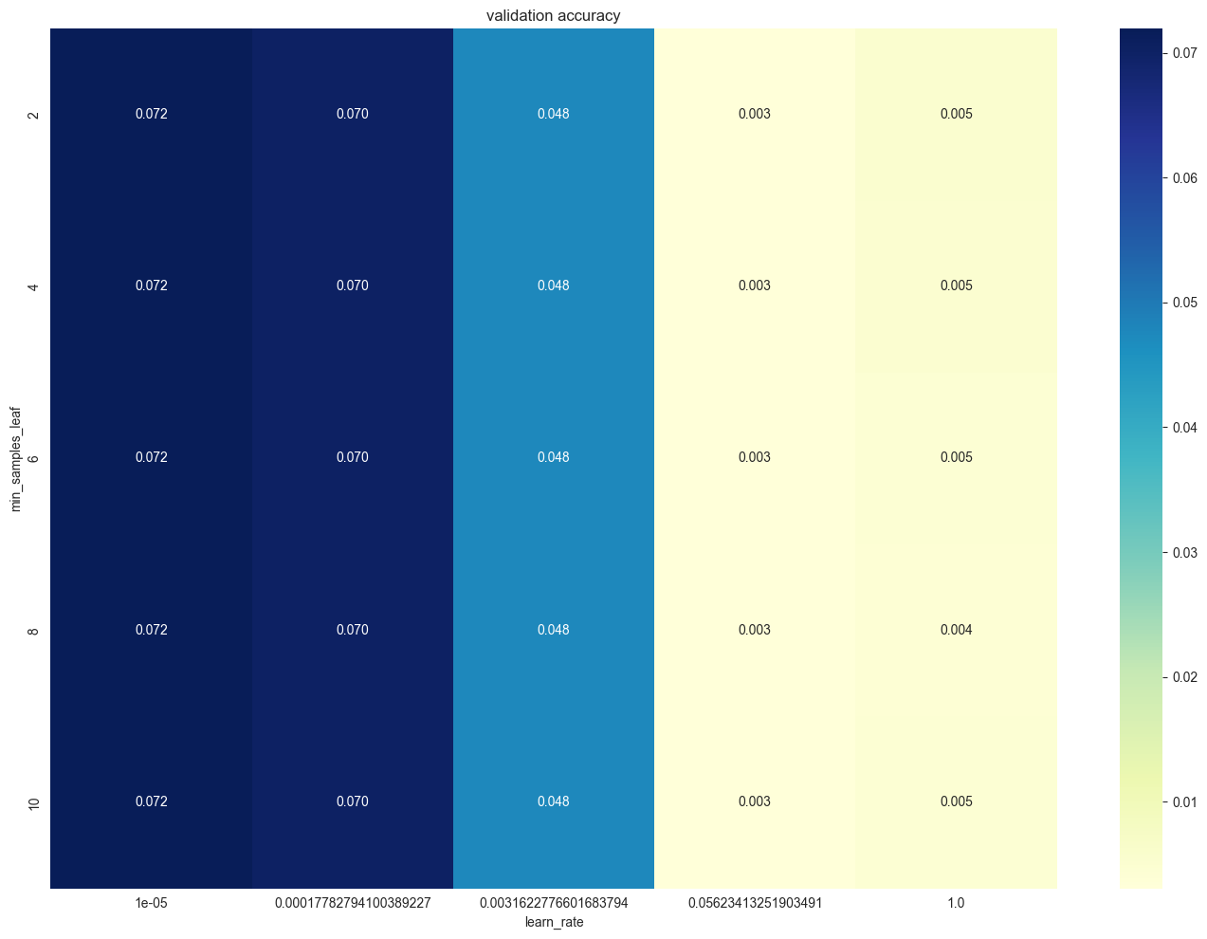
Gradient Boost Best Training Error
0.0030703755291724114
Gradient Boost Best Validation Error
0.0016542936425426866
Gradient Boost Best Hyper Paremeters
{'learning_rate': 0.05623413251903491, 'min_samples_leaf': 10}

Q19:
TO FILL INTO TABLE:
model | section | Train MSE | Valid MSE
 |  | Cross Validation
dummy | 2 | 0.07020197010965457 | 0.07041185933040296
Linear | 2 | 0.009049982022477634 | 0.009637031428234372
Lasso Linear | 3 | 0.007319608597012884 | 0.007755303598110869
Polynomial Lasso | 4 | 0.027468432604160088 | 0.027468432604160088
GBM Regressor | 5 | 0.0030703755291724114 | 0.0016542936425426866

Section 6:
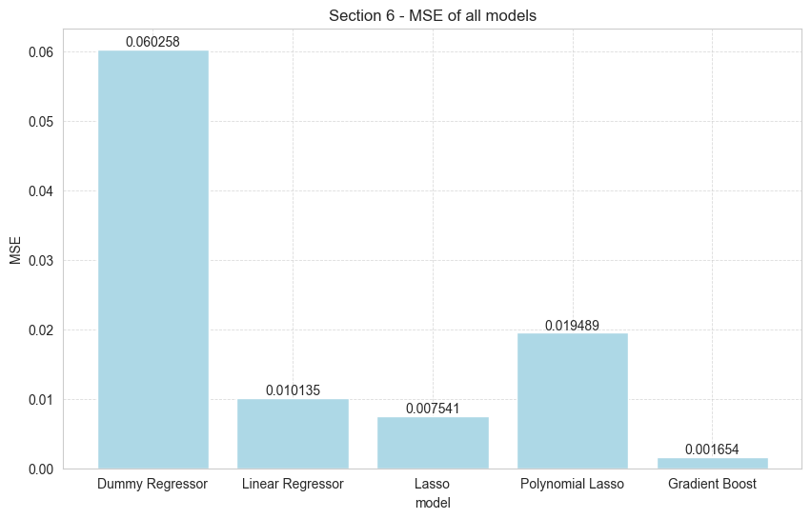
TO ADD explanation:
model | section | Train MSE | Valid MSE | Test MSE
 |  | Cross Validation | Cross Validation | Retrained
dummy | 2 | 0.07020197010965457 | 0.07041185933040296 | 0.060258
Linear | 2 | 0.009049982022477634 | 0.009637031428234372 | 0.010135
Lasso Linear | 3 | 0.007319608597012884 | 0.007755303598110869 | 0.007541
Polynomial Lasso | 4 | 0.027468432604160088 | 0.027468432604160088 | 0.019489
GBM Regressor | 5 | 0.0030703755291724114 | 0.0016542936425426866 | 0.001654

Best Performing Model on the Test Set
The GBM Regressor model performed the best on the test set, with the lowest Test MSE of 0.001654.
Discussion of Results
- Dummy Model:
  - The Dummy model has the highest MSE across all metrics. This is expected since it is a baseline model that makes predictions based on simple strategies, like predicting the mean of the target variable.
2. Linear Model:
The Linear model is better then the Dummy model, with a Test MSE of 0.010135. but, it still has higher MSE compared to more complex models like the Lasso and GBM models.
This means that the linear model is able to capture some relationships in the data, but it might be underfitting since it's not complex enough to model more complex patterns.it is a simple model.
3.
Lasso Linear Model:
The Lasso model is better than the Linear model, with a lower Test MSE of 0.007541.
Lasso uses regularization, which likely helps prevent overfitting compared to the simple Linear model. This indicates that some features are irrelevant and their coefficients have been shrunk to zero, leading to a more complex and flixiable model

4.
Polynomial Lasso Model:
The Polynomial Lasso model has a higher Test MSE (0.019489) compared to the Linear and Lasso models. This means it might be overfitting. Even though it uses Lasso regularization, adding more complex features (like polynomial features) makes it harder for the model to work well with new, unseen data.
GBM Regressor:

The GBM model has the lowest Test MSE (0.001654), meaning it works best on the test set.
The GBM model is probably finding complex patterns in the data without overfitting, as shown by the low error. This suggests that GBM, which uses multiple models together to improve accuracy, can be very powerful.

•

