Q1:
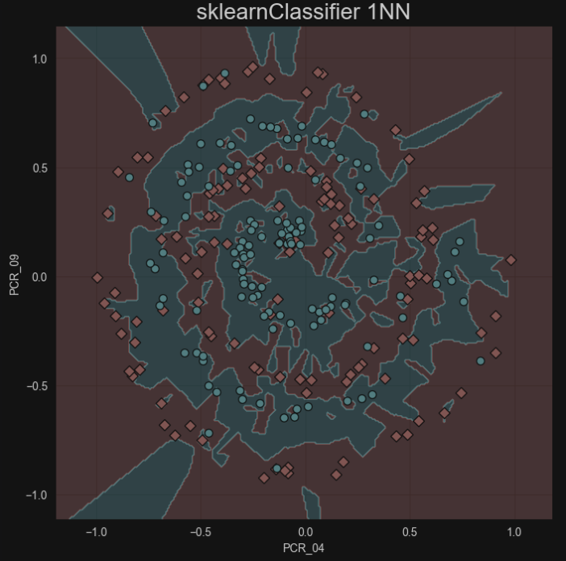
Testing score is: 75.6%

Q2:
The best K is: K=9, at this K we get the best validation accuracy ( the highest point of the validation accuracy plot) : 0.833
Average train accuracy score: 0.7019183673469389
Average test accuracy score: 0.6792857142857144
K values that cause overfitting: K = 1 , at this k we have a gap between the training accuracy and the validation accuracy, such that the training accuracy is a lot bigger.
K values that cause underfitting: this happens when both the training accuracy and the validation accuracy is at its lowest, which is at big orders of K ( K = 670).

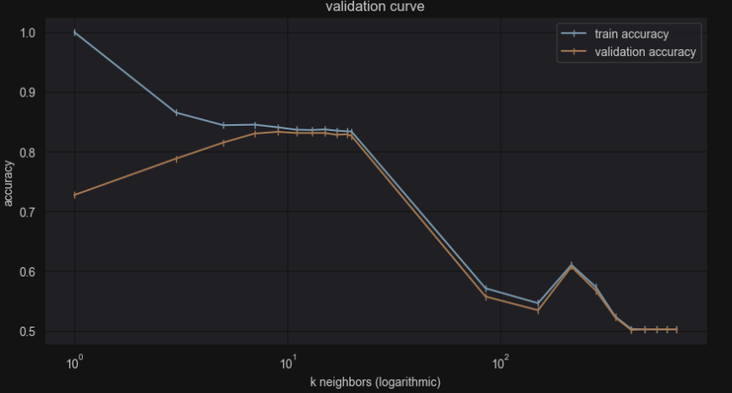

Q3:
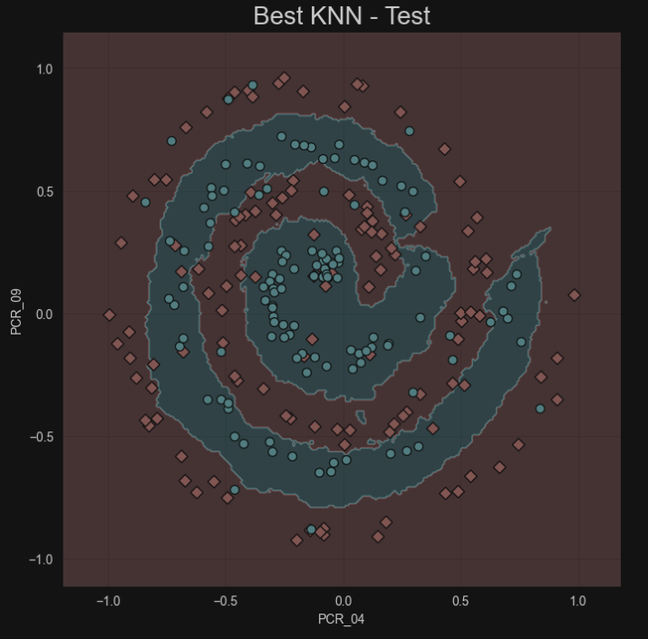

Testing score is: 86.0% (calculated using sklearn.metrics.accuracy_score)

Q4:
When we set K to 9 in our k-NN classifier, the decision boundaries that separate different classes become smoother.
By considering more neighbors, the classifier captures the overall distribution of the data better, leading to smoother decision boundaries. This helps the classifier make more accurate predictions on new data points that it hasn't seen before.
As we see the test accuracy for k= 9 is 0.86, outperforming the accuracy of 0.756 when k=1

Q5:
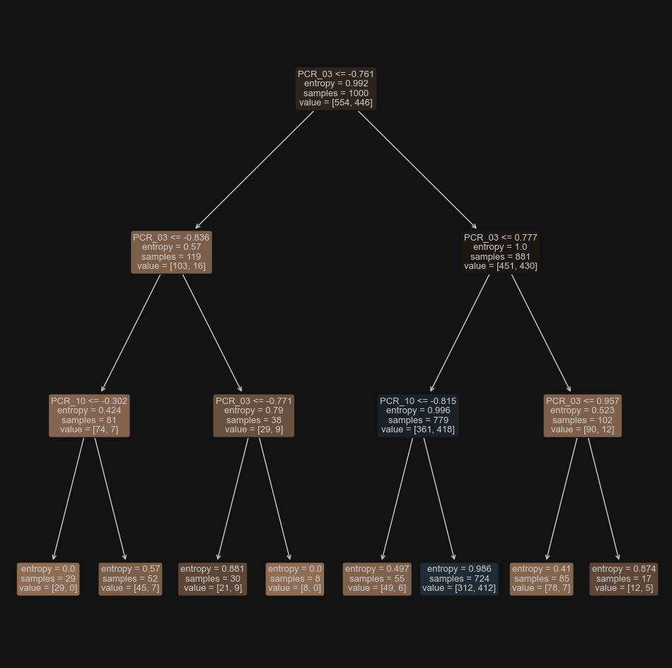

Training score is: 65.4% (calculated using sklearn.metrics.accuracy_score)

Q6:
Optimal hyperparameter combination:
Max depth: 13
Min sample Leafs: 11
Validation accuracy: 0.712
A hyperparameter-combination that causes underfitting:
Max depth: 1
Min sample Leafs: 19
training accuracy: 0.554
With this hyperparameter combination the decision tree is at max depth of 1 (can only make one split) thus can’t capture the patterns of the data, and with a min sample tree of 19 the decisions are too generalized such that the model can’t reach a high training accuracy of learning from the training data .
A hyperparameter-combination that causes overfitting:
Max depth: 19
Min sample Leafs: 1
training accuracy: 0.997
With this hyperparameter combination the decision tree is at max depth of 19 it creates a very deep and specific splits, closely fitting the training data, and with a min sample leafs 1 the model will learn the training data too closely such that it will adapt to outliers and noise.

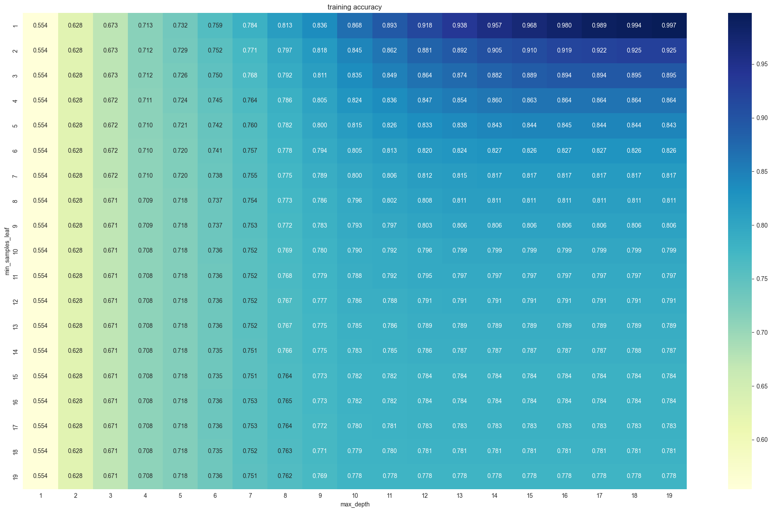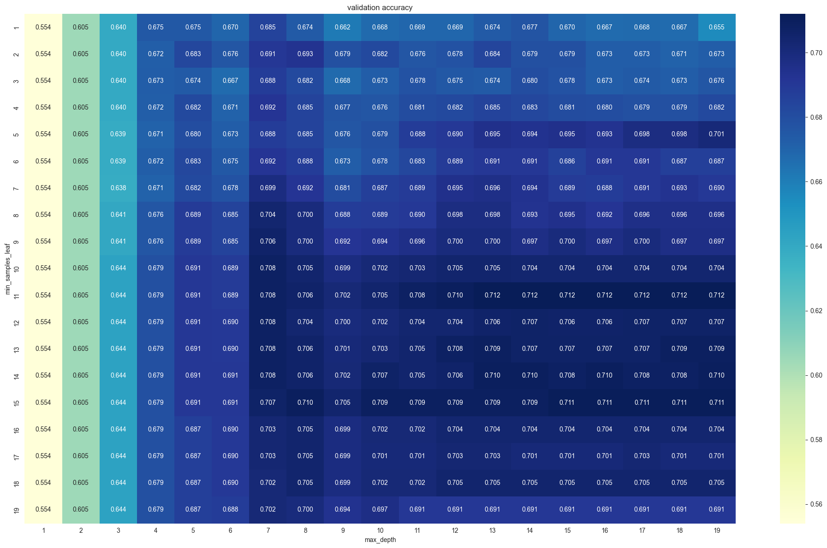

Q7:
In our grid search we evaluated 19*19=361 hyperparameter combinations, for each parameter we tried 19 different values, if we were to add another hyperparameter it would increase the number of possible combinations to evaluate. By a multiple of n3 (n3 being the size of the range of the 3rd hyper parameter)
If n_i is the num of different values that we evaluated on one hyperparameter then the num of different combinations on 3 hyperparameters would be n1 x n2 x n3

Q8:
Testing score is: 74.0%
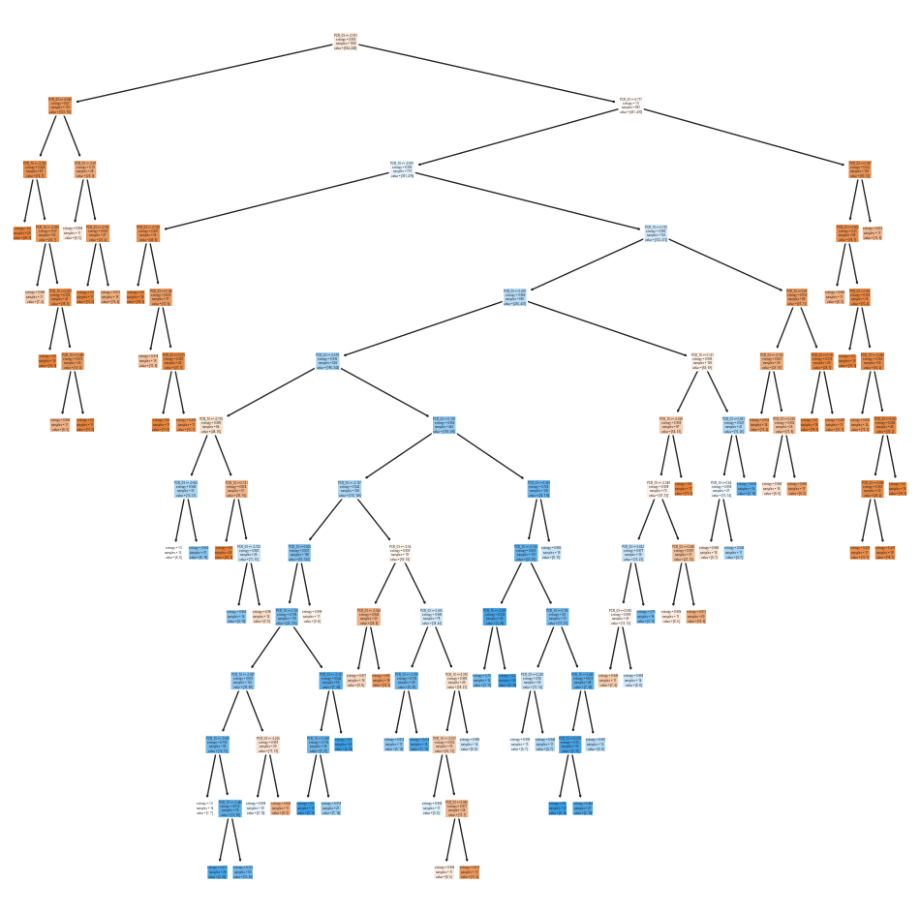
Q9

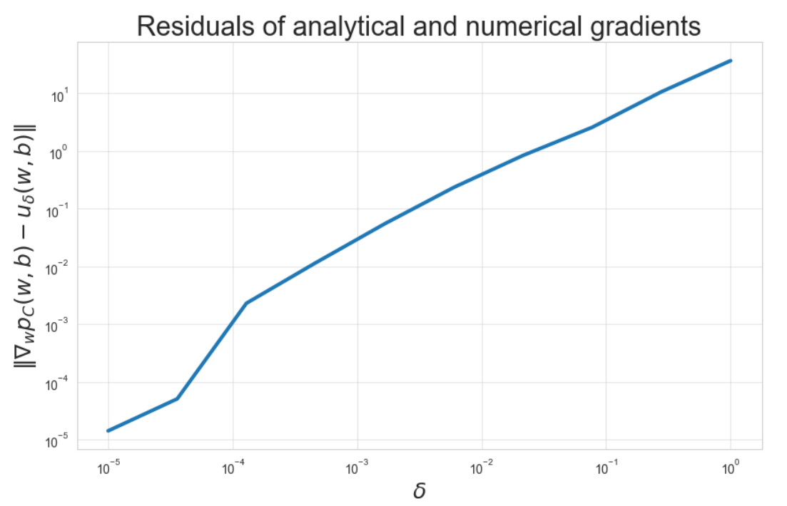
larger step sizes delta cause a greater difference between numerical and analytical gradients, as expected according to calculus.
smaller δ provides a more accurate match, making the gradients nearly the same.

Q10:

LOSS
The loss starts very high ~1.2 x 10^14 and rapidly drops to ~10^14 in O(100) steps | loss continues to decrease but much more slowly and in a very stable way
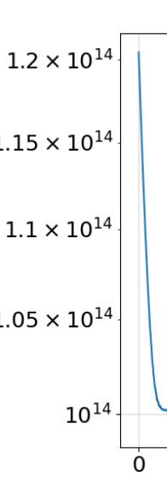 | 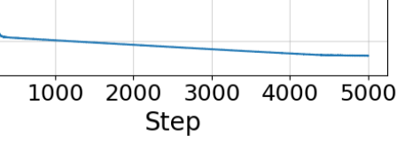

TRAIN ACCURACY
starts around 0.46, with rapid increase to about 0.50 in O(100) steps | significant drop to about 0.42 around step 2000 | rapid increase to a max of ~0.53 around step 3500 | slight decrease to around 0.49
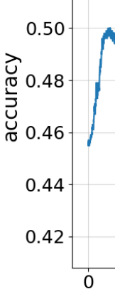 | 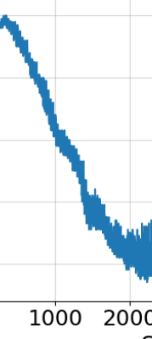 | 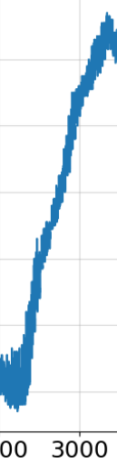 | 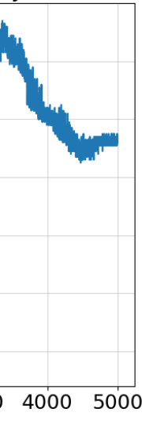

loss-accuracy interactions:

 | Phase 1 | Phase 2 | Phase 3 | Phase 4
Interaction | loss rapidly decreases, and accuracy quickly improves. | loss continues to decrease but more slowly now, but the accuracy drops from 0.5 to 0.42 | accuracy improves a lot, loss continues to decreas slowly. | loss continues to decreas slowly, the accuracy starts to stabilize at around 0.49
Explanation | This is expected behavior, the model is learning quickly initially. | This is not expected, it could suggest certain overfitting to certain data outliers. | the model was able to find a better way to fit to the data in a more general way. | the model
Overall, we expected the initial very quick improvement in accuracy and loss, we also expect the model to have a general trend of the loss decreasing while the accuracy increase.
But, we did not expect the drop in accuracy while the loss continued to decrease, and for the accuracy to pick up thereafter.
One way to interpret this unexpected behavior is because of the complex shape of the decision bouandaries, which can be seen in the given plot where the bouandaries between the two classes is non-linear
Hyperparameter interactions:
The very high C value leads the models to give a very high penalty to missclassifications, which probably lead to the fluctuations in the accuracy curve.
the very small learning step size likely contributed to the very gradual decrease in loss, after the initial rapid decrease. And also to the very slow learning rate of about 5000 steps.

Q11?:
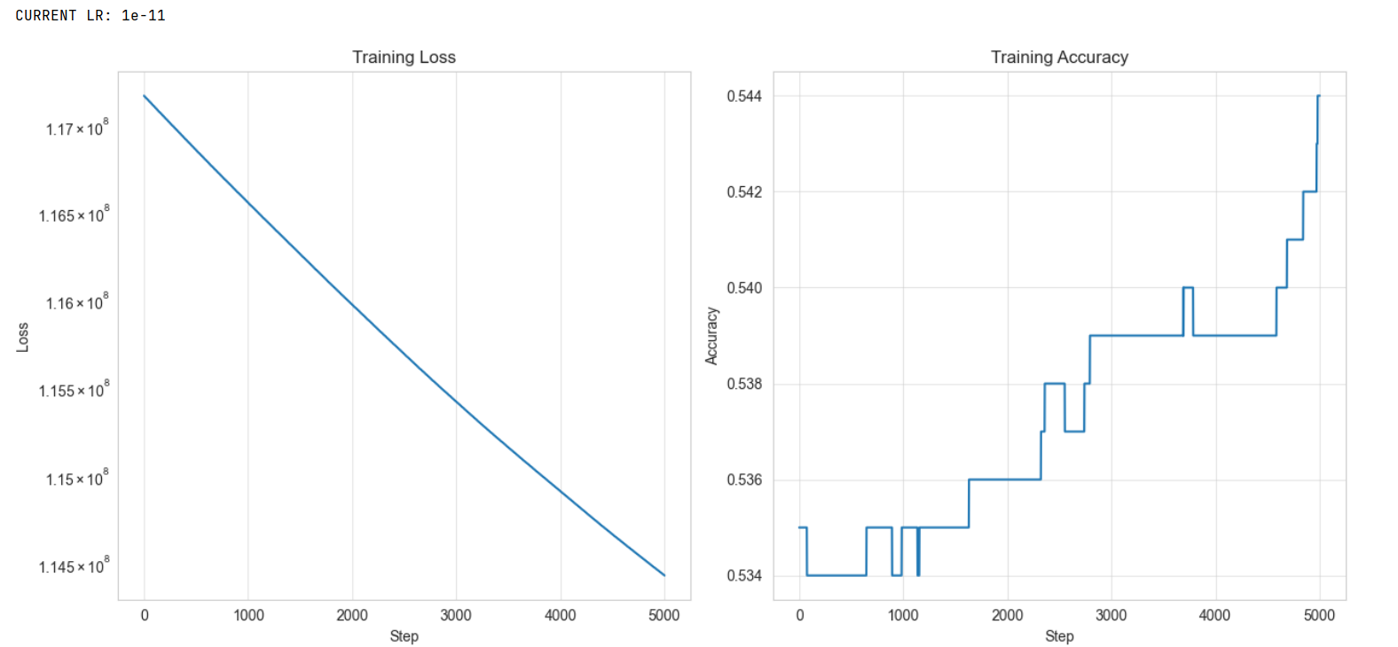
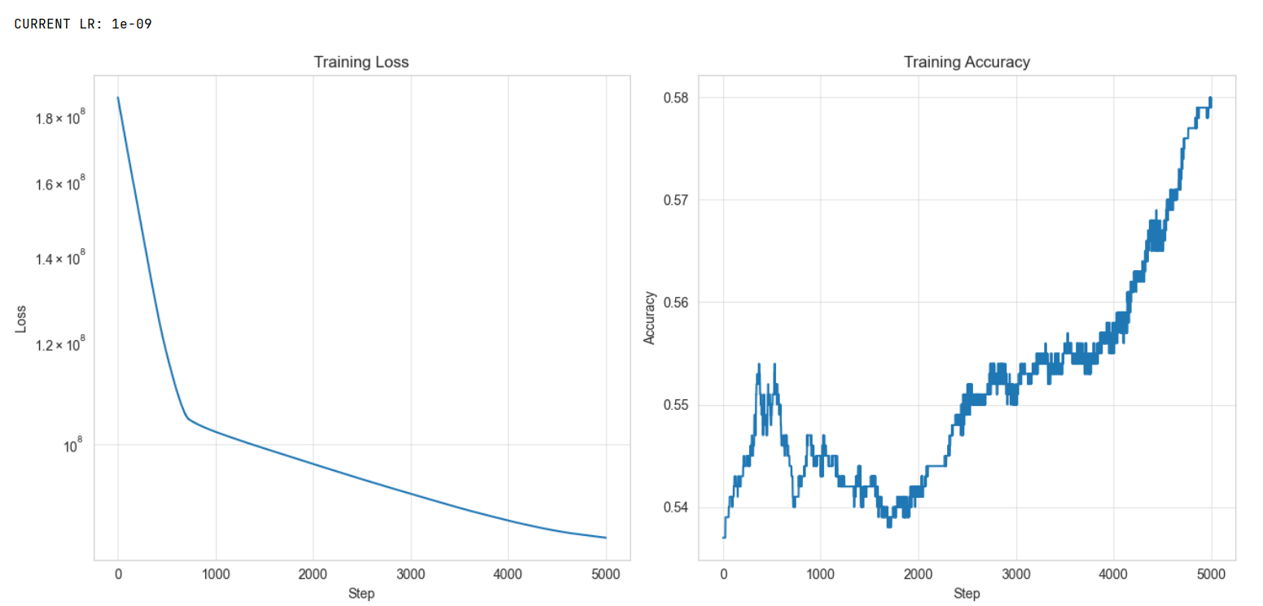
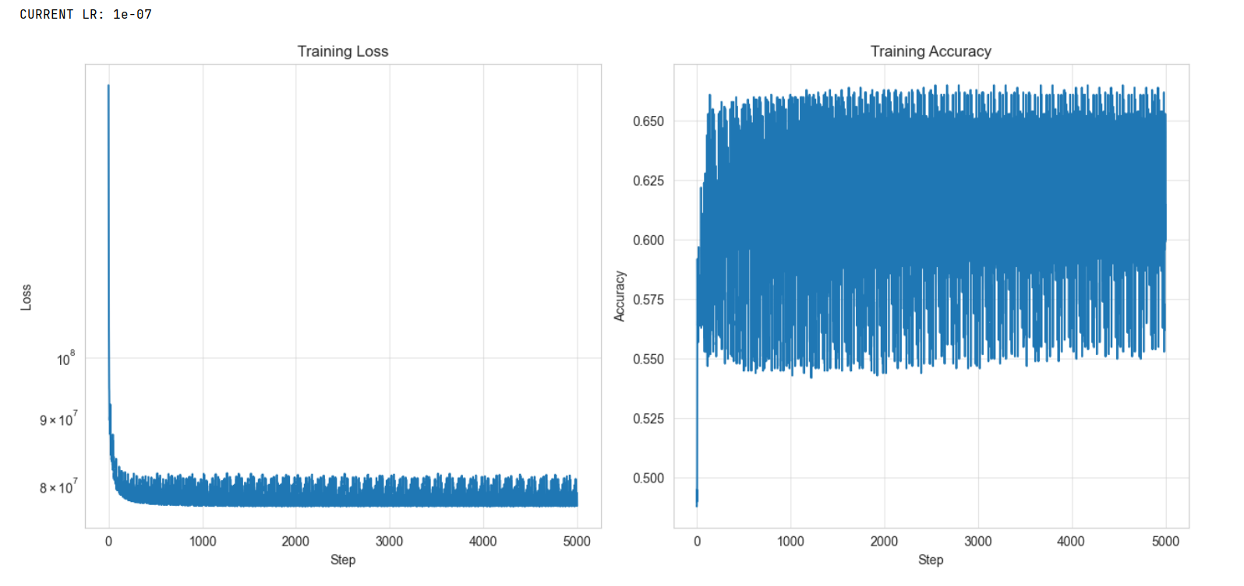
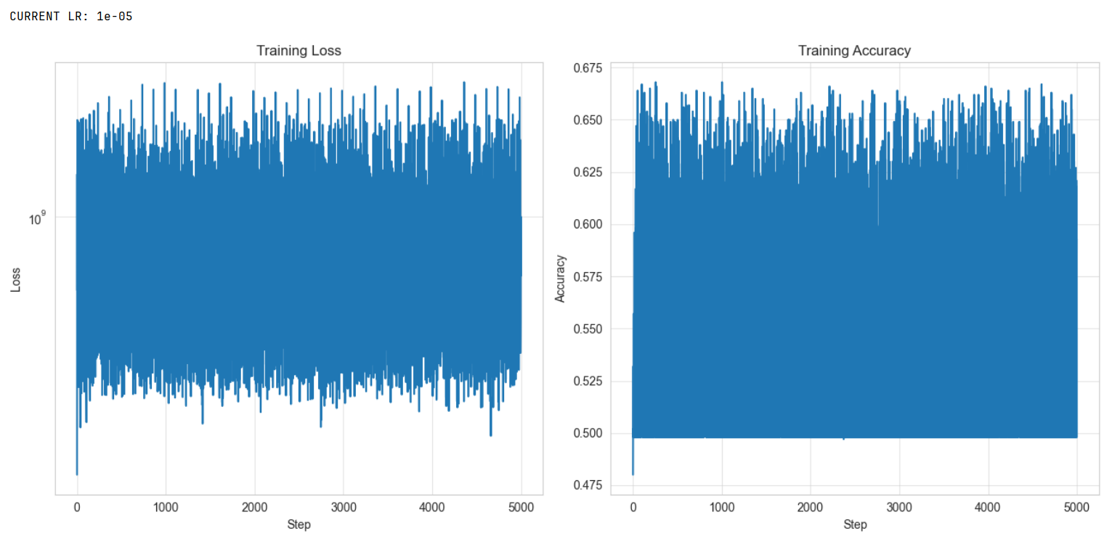
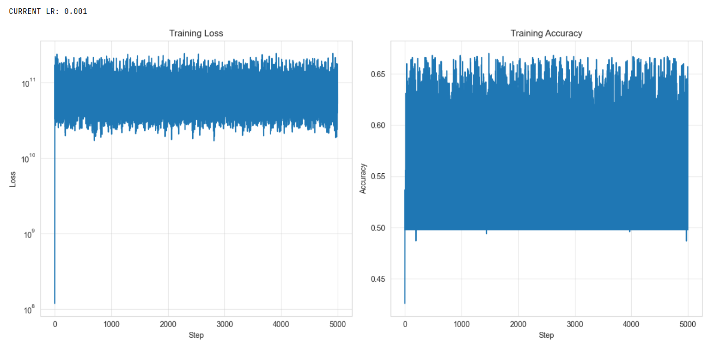
From observing the data, we could see that the best lr step size out of the bunch would be 1e-09, that is because it reaches the lowest loss while staying stable, and the highest training accuracy of 0.58 while staying stable, meaning without the rapid fluctuations that other models with bigger step sizes have, that is because they keep “stepping over” literally over the minimum so they always skip the minimum and never reach it
The model with the smaller step size of 1e-11 could have probably reached a steady state with a good, low loss, and a high accuracy, but it would take more steps, so at 5000 steps, 1e-09 is better)
Q12:
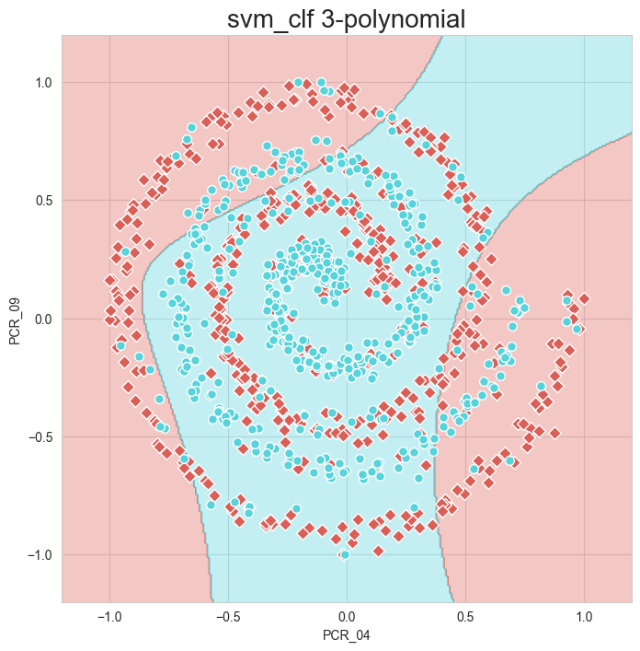
Testing score is: 86.0%
Training score is: 56.8%

Q13:

