Asymmetries in the mental representation of presence and absence
Matan Mazor¹, Rani Moran², & Stephen M. Fleming^{1,2,3}
¹ Wellcome Centre for Human Neuroimaging, UCL
² Max Planck UCL Centre for Computational Psychiatry and Ageing Research
³ Department of Experimental Psychology, UCL

Author note
Correspondence concerning this article should be addressed to Matan Mazor, 12 Queen Square, London WC1N 3BG. E-mail: mtnmzor@gmail.com

Abstract
People generally find it more difficult to infer, represent, and attend to the absence of a stimulus or object than its presence. Such asymmetries in the representation of absence are thought to arise from basic constraints on information processing – at any given moment, there are many more things that could be there (absences) than are there (presences), such that positively coding for the latter is more efficient. However, at what stage in the processing hierarchy such asymmetries in the representation of absences arise remains unknown. For instance, in visual search, the presence/absence asymmetry has been demonstrated not only for the presence or absence of entire objects, but also of specific stimulus features and expectation violations. In addition, presence/absence asymmetries are found not only for first-order tasks such as visual search, but also in metacognitive evaluation (with more accurate metacognition for decisions about presences than absences). Here we measure presence/absence asymmetries both across tasks (visual search and confidence judgments) and stimulus features, to ask whether asymmetries in the representation of absence arise from one or many sources.

Keywords: metacognition, visual search, attention
Word count: 4162

Asymmetries in the mental representation of presence and absence

Introduction
At any given moment, there are many more things that are not there than things that are there. As a result, and in order to efficiently represent the environment, perceptual and cognitive systems have evolved to represent presences, and the absence is implicitly represented as a default state (Oaksford, 2002; Oaksford & Chater, 2001). One corollary of this is that presence can be inferred from bottom-up sensory signals, but absence is never explicitly represented in sensory channels and must instead by inferred based on top-down expectations about the likelihood of detecting a hypothetical signal, had it been present. Experiments on human subjects accordingly suggest that representing the absence of things is more cognitively demanding than representing their presence, even in simple perceptual tasks. This is evident in slower reactions to stimulus absence than stimulus presence in near-threshold visual detection (Mazor, Friston, & Fleming, 2020), in a general difficulty to form associations with absence (Newman, Wolff, & Hearst, 1980), and in the late acquisition of the explicit representation of absence in development (e.g., Sainsbury, 1971; Coldren & Haaf, 2000; for a review on the representation of nothing see Hearst, 1991).
This overarching difficulty in representing absence may reflect the metacognitive nature of absence representations; to represent something as absent, one must assume that they would have detected it had it been present. In philosophical writings, this form of higher-order, metacognitive inference-about-absence is known as argument from epistemic closure, or argument from self knowledge (If it was true, I would have known it; Walton, 1992; De Cornulier, 1988). Strikingly, metacognitive insight is consistently found to be lower for decisions about absence than for decisions about presence. When asked to rate their subjective confidence following near-threshold detection decisions, subjective confidence ratings following ‘target absent’ judgments are commonly lower, and less aligned with objective accuracy, than following ‘target present’ judgments (Fig. 1, upper panel; Kanai, Walsh, & Tseng, 2010; Kellij, Fahrenfort, Lau, Peters, & Odegaard, 2018; Mazor et al., 2020; Meuwese, Loon, Lamme, & Fahrenfort, 2014).
What counts as absence for visual metacognition? In visual perception, previous empirical demonstrations of metacognitive presence/absence asymmetries have been limited to judgments about the presence or absence of concrete physical objects and stimuli. However, evidence from the neighboring field of meta-memory suggest that the presence/absence asymmetry may operate at more abstract levels up the cognitive hierarchy as well. In recognition memory, subjects typically show poor metacognitive sensitivity for judgements about the absence of memories (such as when judging that they haven’t seen a study item before; Higham, 2012). The absence of a memory is not localized in space and does not correspond with a specific representation of ‘nothing’. Instead, an asymmetry emerges because the presence of memories is actively represented, and the absence of memories is assumed as default unless evidence is available for the contrary. Even within visual perception, not only entire objects can be present or absent, but also object parts (the tail of a dog) and object features (a spot pattern on a dog). Furthermore, some visual dimensions that do not fall under the presence/absence dichotomy are still likely to be coded in a default manner – assuming one state unless evidence is available for the contrary (a dog is standing on the ground and not floating in space). However, the extent to which these different levels of absence representations are grounded in a shared cognitive asymmetry between presence and absence, and the level of this asymmetry in the cognitive hierarchy (from perception at the bottom to metacognition at the top) remain unknown. Here we set out to test the structure of absence representations by comparing asymmetries in metacognition and spatial attention, for presences and absences at different representation levels.
Our choice of stimuli relies on findings from visual search – a field where asymmetries are observed for a variety of stimulus types and features. In visual search, participants typically take longer to detect the absence of a target item than to detect its presence. Moreover, searchers take longer to detect a target that is marked by the presence of a distinguishing feature relative to distractors, as compared to detecting a target that is marked by the absence of a feature relative to distractors. Importantly, such search asymmetries have been reported for presence and absence at different representation levels, from local features (finding a Q among Os is easier than the inverse search; Treisman & Souther, 1985), through global features (finding a curved line among straight lines is easier than the inverse search; Treisman & Gormican, 1988), and all the way to expectation violations (searching for an upward-tilted cube among downward-tilted cubes is easier than the inverse searches, in line with a general expectation to see objects on the ground rather than floating in space; Wang, Cavanagh, & Green, 1994). In expectation violation asymmetries, presence and absence are not of a spatial stimulus feature, but pertain to a more abstract deviation from the expected default state, which can be based on experience and contextual expectations.
Here we compare participants’ asymmetries in search time and metacognitive sensitivity across six stimulus pairs that induce search asymmetries at the local, global, and expectation-violation levels (hereafter representation levels). Leveraging variability in the direction and strength of these asymmetries across stimuli and subjects, we will test the extent to which presence/absence asymmetries are task-general (such that similar asymmetries are observed for both tasks across stimuli and subjects). We will further test the extent to which they originate from a common mechanism across representation levels (such that participants’ asymmetries for the three representation levels correlate). Our results may indicate a shared origin for presence/absence asymmetries across representation levels and tasks, a set of cognitively distinct asymmetries for different tasks and representation levels, or intermediate patterns such as generality across tasks but not levels of representation, or vice versa. Of particular interest are the expectation-violation asymmetries, and their relation with the more typical asymmetries induced by the presence or absence of local and global features. A correlation between these different types of asymmetries would support a default-reasoning interpretation of the presence/absence asymmetry, where absence is only but one feature of the expected default state.

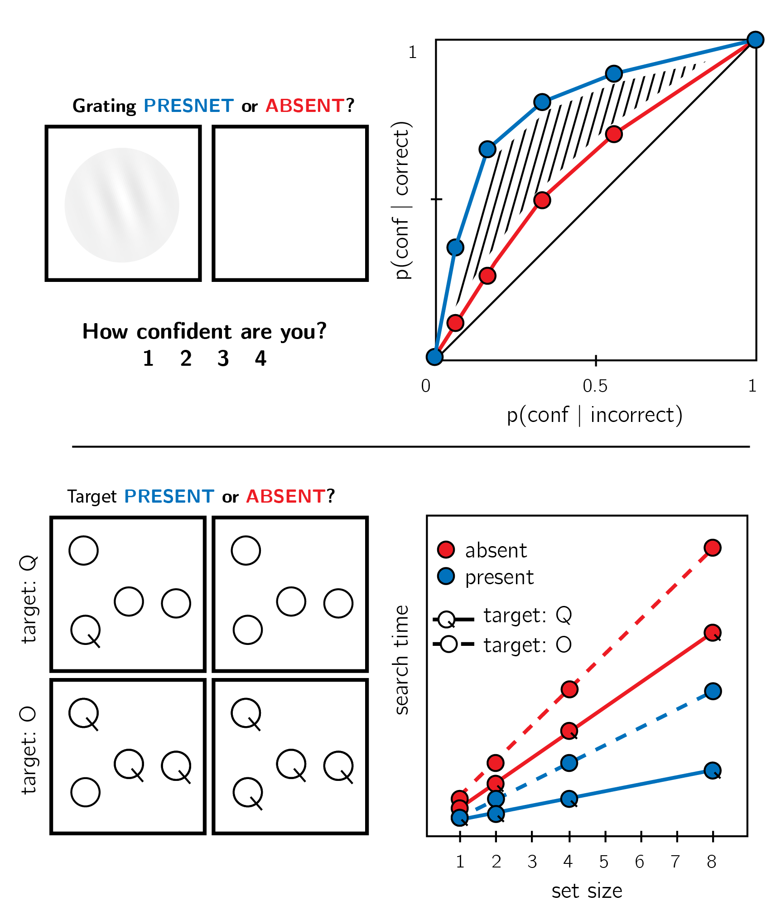
Figure 1:. Top panel: in visual detection, subjective confidence ratings following judgments about target absence are typically lower, and less correlated with objective accuracy than following judgments about target presence. This metacognitive asymmetry manifests as lower area under the response-conditional ROC curve (see methods) for ‘yes’ responses (blue) compared with ‘no’ responses (red). Lower panel: in visual search, search times are typically slower (and search time/set size slopes shallower) for target absent trials, compared with target present trials. Search time is also slower when searching for a target that is marked by the absence, rather than presence, of a distinguishing feature (for example, searching for an O among Q’s)

Different patterns of results would lead to different interpretations of the structure of absence representations. At one end of the spectrum, a complete alignment of metacognitive and search asymmetries across all six stimulus pairs and across participants (measured as a correlation across participants and stimulus types) would indicate an expansive default-reasoning interpretation of the presence/absence asymmetry. At the other end of the spectrum, metacognitive asymmetries may be restricted to object-level presence and absence, with a symmetric pattern of metacognitive sensitivity for all of our stimulus pairs. This would suggest a qualitative difference between the presence or absence of things, as opposed to more abstract features and violations of expectations. Intermediate patterns may extend the search asymmetry to the metacognitive domain only for local stimulus features, suggesting that the metacognitive asymmetry is specific to objects and object parts, which are spatially defined. Finally, search and metacognitive asymmetries may align only for spatial features, but not for default-compliance. This would indicate that the asymmetry in the representations of presence and absence, as manifested in subjective confidence ratings, cannot be reduced to default reasoning.

Methods
We report how we determined our sample size, all data exclusions (if any), all manipulations, and all measures in the study.

Participants
The research complies with all relevant ethical regulations, and was approved by the Research Ethics Committee of University College London (study ID number 1260/003). Participants will be recruited via Prolific (prolific.co), and will give informed consent prior to their participation. They will be selected based on their acceptance rate (>95%) and for being native English speakers. For each of the six experiments, we will collect data until we reach 320 included participants (after applying our pre-registered exclusion criteria). The entire experiment will take 15 minutes to complete (median completion time in our pilot data: 13.5 minutes). Participants will be paid £2 for their participation, equivalent to an hourly wage of £8.

Procedure
Experiments will be identical, except for the identity of the target and distractor stimuli. In what follows we will describe the procedure for the stimulus pair ‘Q’ and ‘O’. Experiments were programmed using the jsPsych and P5 JavaScript packages (De Leeuw, 2015; McCarthy, 2015), and hosted on a JATOS server (Lange, Kühn, & Filevich, 2015). The full Experiment as delivered to participants is available here: http://167.99.93.4/publix/13/start?batchId=45&generalMultiple.
The Experiment will comprise three parts (“challenges”) presented in pseudorandomized order.
- The first part will comprise 32 visual search trials. In these trials participants will search for one ‘Q’ in an array of 1, 2, 4 or 8 ‘O’ distractors. The target stimulus will be present in half of the trials, and absent in the other half. Participants will be instructed to use their keyboard to indicate whether the target was present (press J) or absent (press F) as quickly and accurately as possible. Each trial will start with an instruction screen, indicating the search target (500-1000 ms), followed by the presentation of the search array. The search array will remain visible until a response is recorded. Feedback about accuracy will be delivered. To motivate accurate responses, the feedback screen will remain for 1000 ms following correct responses and for 4000 ms following incorrect responses. The visual search block will start with four practice trials of distractor set-size 4 that will not be included in the final analysis. The actual block of 32 trials (4 trials of each set size, presented in random order) will start once all four practice trials are answered correctly, otherwise additional practice trials will be delivered.
- The second part will be identical to the first part, except for the identity of the target stimulus. Here ‘O’ will server as target and ‘Q’ as distractor.
- In the third part, participants will make discrimination judgments between masked Q and O stimuli, and rate their subjective decision confidence on a continuous scale. After a fixation cross (500 ms), the target stimulus will be presented in the center of the screen for 50 ms, followed by a mask (100 ms). Stimulus onset asynchrony will be calibrated online in a 1-up-2-down procedure (Levitt, 1971), with a multiplicative step factor of 0.9, and starting from 30 milliseconds. Participants will then use their keyboard to make a discrimination judgment. Following their response, subjective confidence ratings will be given on an analog scale by controlling the size of a colored circle with the computer mouse. High confidence will be mapped to a big, blue circle, and low confidence to a small, red circle. The confidence rating phase will terminate once participants click their mouse, but not before 2000 ms. No feedback will be delivered about accuracy.
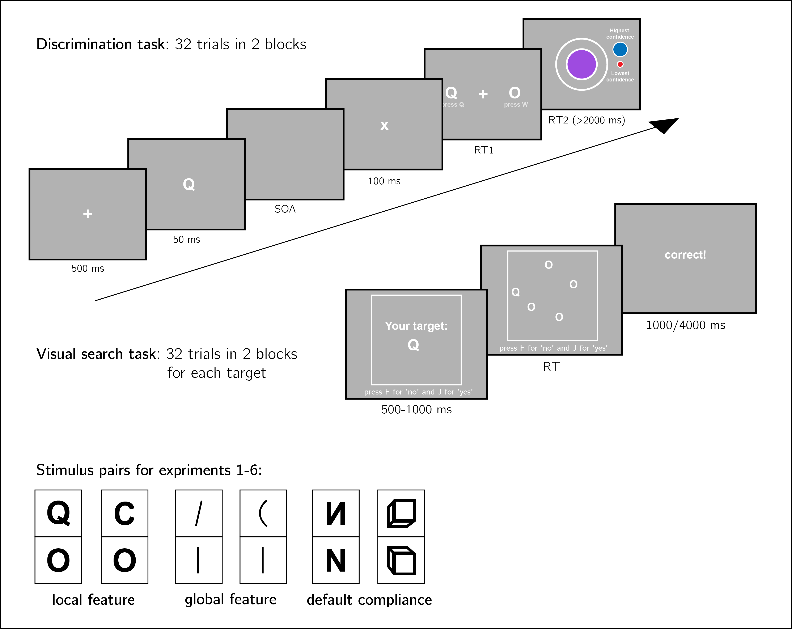
Figure 3:. Experiment structure. Three experimental parts will be delivered in pseudorandomized order: a discrimination task with subjective confidence ratings, and two visual search tasks with different distractor/target assignments. Asymmetry effects will be tested for six stimulus features in six separate experiments.
We will test the following stimulus features in separate experiments with different participants (Fig. 3):
- Local feature: Addition of a stimulus part. Q and O will be used as stimuli (Treisman & Souther, 1985).
- Local feature: Open ends. C and O will be used as stimuli (Takeda & Yagi, 2000; Treisman & Gormican, 1988; Treisman & Souther, 1985).
- Global feature: Curvature. Straight and curved lines will be used as stimuli (Treisman & Gormican, 1988).
- Global feature: Orientation. Vertical and tilted lines will be used as stimuli (Treisman & Gormican, 1988).
- Default compliance: Letter inversion. Reversed and normal N will be used as stimuli (Frith, 1974; Wang et al., 1994).
- Default compliance: Viewing angle. Upward and Downward tilted cubes will be used as stimuli (Von Grünau & Dubé, 1994).

Randomization.
The order and timing of experimental events will be determined pseudo-randomly by the Mersenne Twister pseudorandom number generator, initialized in a way that ensures registration time-locking (Mazor, Mazor, & Mukamel, 2019).

Data analysis
We will use R (Version 3.6.0; R Core Team, 2019) and the R-packages BayesFactor (Version 0.9.12.4.2; Morey & Rouder, 2018), brms (Version 2.13.0; Bürkner, 2018), broom (Version 0.5.6; Robinson & Hayes, 2020), cowplot (Version 1.0.0; Wilke, 2019), dplyr (Version 1.0.0; Wickham et al., 2020), ggplot2 (Version 3.3.1; Wickham, 2016), papaja (Version 0.1.0.9942; Aust & Barth, 2020), and tidyr (Version 1.1.0; Wickham & Henry, 2020) for all our analyses.
We will test the following hypotheses:
- Hypothesis 1 (REPLICATION): For our selected stimulus pairs, visual search is more efficient in one direction compared with the other.
This hypothesis will be tested for the following stimulus features for which search asymmetry has been demonstrated: addition of a stimulus part (visual search is more efficient for Q-in-O than for O-in-Q search), open ends (more efficient for C-in-O than for O-in-C search), orientation (more efficient for tilted-in-vertical than for vertical-in-tilted search), curvature (more efficient for curved-in-straight than for straight-in-curved search), letter inversion (more efficient for inverted-in-canonical than for canonical-in-inverted search), and viewing angle (more efficient for upward-in-downward tilted than for downward-in-upward-tilted search). We will test Hypothesis 1 separately for each stimulus feature, by replicating the original search asymmetry.
- Hypothesis 2 (TASK-GENERALITY): Conditioned on the results of our testing of Hypothesis 1. Metacognitive asymmetry, measured as the area between the two response conditional ROC curves in a discrimination task (see methods section below), follows the same direction as search asymmetry.
For each of the six stimulus pairs, we will test the null hypothesis that metacognitive sensitivity (measured as the area under the response conditional ROC curve) for the efficient target (e.g., Q) is equal to or lower than metacognitive sensitivity for the inefficient target (e.g., for the case of Q/O, $H_{o}=auROC_{Q}≤auROC_{O}$).
- Hypothesis 3 (TASK-CORRELATION): Individual differences in the direction and magnitude of search asymmetry positively covary with individual differences in the direction and magnitude of metacognitive asymmetry.
This hypothesis will be tested separately for each stimulus pair by measuring the Pearson correlation between search asymmetry and metacognitive asymmetry across participants. We will also measure the overall correlation between search and metacognitive asymmetries across participants, pooled from all 6 experiments.
- Hypothesis 4 (SEARCH-CORRELATION): Individual differences in the direction and magnitude of search asymmetry positively covary with individual differences in the additional time cost for reporting target absence in visual search.
This hypothesis will be tested separately for each stimulus pair by measuring the Pearson correlation between search asymmetry and the time cost of reporting target absence, across participants. We will also measure the overall correlation between these two measures across participants, pooled from all 6 experiments.
For each stimulus pair, Hypothesis 2 (TASK-GENERALITY) will test the extent to which the asymmetry is unique to visual search, or otherwise generalizes to an independent measure of presence/absence asymmetry from metacognitive evaluations. Hypothesis 3 (TASK-CORRELATION) will build on and strengthen findings favouring a shared mechanism, by testing for shared variance between the two independent measures across participants. Finally, Hypothesis 4 (SEARCH-CORRELATION) will test whether, for each of our stimulus pairs, feature-level asymmetries are correlated with object-level asymmetries between ‘present’ and ‘absent’ responses. This will serve to test the more general idea that feature-level asymmetries are related to explicit decisions about the presence or absence of objects.

Rejection criteria.
Participants will be excluded for performing below 70% accuracy in one or two of the search tasks, for performing below 60% accuracy in the discrimination task, for having extremely fast or slow reaction times in one or more of the tasks (below 250 milliseconds or above 5 seconds in more than 25% of the trials), and for failing the comprehension check. For the response-conditional ROC analysis, only participants that committed at least one error of each error type (for example, mistaking a Q of O and mistaking an O for Q), will be included.
Trials with response time below 250 milliseconds or above 5 seconds will be excluded.
Only correct visual search trials will be analyzed.

Dependent variables and analysis plan.
The following measures will be extracted for each participant:
- The difference between the area under the response-conditional type-2 ROC curves for the two responses [e.g., ‘Q’ and ‘O’]: $Δ_{m}$.
Response conditional ROC curves will be extracted, by plotting the empirical cumulative distribution of confidence ratings for correct responses against the same cumulative distribution for incorrect responses. This will be done separately for the two responses, resulting in two curves. The area under the response-conditional ROC curve is a measure of metacognitive sensitivity. The area between the two curves is a measure of metacognitive asymmetry (Meuwese et al., 2014). This difference will be used to test Hypothesis 2 (TASK-GENERALITY).
- The difference between search slopes for the two visual search tasks: $Δ_{s}$.
For each visual search task, the slope will be extracted for target present and target absent trials separately (correct trials only), and the average value will be taken. The difference between these average slopes is a measure of search asymmetry. This difference will be used to test Hypotheses 1 (REPLICATION) and 2 (TASK-GENERALITY).
- The relative difference between the area under the response-conditional type-2 ROC curves for the two responses ($Δ_{m}^{rel}$) will be defined as the area between the two curves, divided by the sum of the areas under the two curves.
This relative difference will be used to test Hypothesis 3 (TASK-CORRELATION).
- The relative difference between search slopes for the two visual search tasks ($Δ_{s}^{rel}$) will be defined as the difference between the two search slopes, divided by the sum of their absolute values.
This relative difference will be used to test Hypotheses 3 (TASK-CORRELATION) and 4 (SEARCH-CORRELATION).
- The relative difference between search slopes for the two visual search responses: $Δ_{r}^{rel}$.
For each visual search response (‘present’ and ‘absent’; correct trials only), the slope will be extracted for the two stimulus assignments separately, and the average value will be taken. The relative difference between search slopes for the two visual search responses ($Δ_{r}^{rel}$) will be defined as the difference between the two search slopes, divided by the sum of their absolute values.
This relative difference will be used to test Hypothesis 4 (SEARCH-CORREALTION).
For each of the six experiments, Hypothesis 1 (REPLICATION) will be tested using a two tailed t-test at the group level with $α=0.05$.
Conditioned on that search asymmetry will be replicated, for each of the six experiments, Hypothesis 2 (TASK-GENERALITY) will be tested using a one tailed t-test at the group level with $α=0.05$.
Hypothesis 3 (TASK-CORRELATION) will be tested for each experiment by testing the Pearson correlation between $Δ_{m}^{rel}$ and $Δ_{s}^{rel}$, across participants. We will also test the Pearson correlation between $Δ_{m}^{rel}$ and $Δ_{s}^{rel}$ pooled across participants from all 6 experiments, and controlling for experiment-specific intercept effects (by mean-centering both variables at the experiment level prior to computing a correlation).
Hypothesis 4 (RESPONSE-GENERAL) will be tested for each experiment by testing the Pearson correlation between $Δ_{s}^{rel}$ and $Δ_{r}^{rel}$, across participants. We will also test the Pearson correlation between $Δ_{s}^{rel}$ and $Δ_{r}^{rel}$ pooled across participants from all 6 experiments, and controlling for experiment-specific intercept effects.
For hypotheses 1 (REPLICATION) and 2 (TASK-GENREAL), in case of a null result, a Bayes factor will be computed using the BayesFactor R package (Morey, Rouder, Jamil, & Morey, 2015) and using a Jeffrey-Zellner-Siow Prior with a medium rscale parameter of $\sqrt{2}/2$. For hypotheses 3 (TASK-CORREALTION) and 4 (SEARCH-CORRELATION), in case of a null result, the BayesFactor package will be used to compute a Bayes factor using a shifted, scaled beta(3,3) prior distribution for the correlation.

Statistical power.
Statistical power calculations were performed using the R-pwr package (Champely, 2020).
- Hypothesis 1 (REPLICATION): With 320 participants, we will have a statistical power of 95% to detect effects of size 0.20, which is less than a fifth of the standardized effect size we observed for search slopes in our pilot sample.
- Hypothesis 2 (TASK-GENERALITY): With 320 participants, we will have a statistical power of 95% to detect effects of size 0.18, which is less than a half of the standardized effect size we observed for metacognitive asymmetry in our pilot sample.
- Hypothesis 3 (TASK-CORRELATION): For each stimulus pair, will have a statistical power of 95% to detect a Pearson correlation of 0.20 between search and metacognitive asymmetries. Across all six stimulus pairs, we will have a statistical power of 95% to detect a Pearson correlation of 0.08.
- Hypothesis 4 (SEARCH-CORRELATION): For each stimulus pair, will have a statistical power of 95% to detect a Pearson correlation of 0.20 between search type and search response asymmetries. Across all six stimulus pairs, we will have a statistical power of 95% to detect a Pearson correlation of 0.08.

Data availability
All raw data will be made fully available on OSF and on the study’s GitHub respository: https://github.com/matanmazor/asymmetry. Pilot data is available at: https://github.com/matanmazor/asymmetry/blob/master/Experiments/Q_in_O/results/pilot/jatos_results_batch3.csv

Code availability
All analysis code will be openly shared on the study’s GitHub repository: https://github.com/matanmazor/asymmetry. For complete reproducibility, the RMarkdown file used to generate the final version of the manuscript, including the generation of all figures and extraction of all test statistics, will be available on our GitHub repository.

Acknowledgements

Author contributions

Competing interests
The authors declare no competing interests.

Table 1: Design Table
Question | Hypothesis | Sampling Plan | Analysis Plan | Interpretation given to different outcomes
Replication: search asymmetry | Visual search is more efficient when searching for the presence rather than the absence of a feature, or when searching for a non-default target among default distractors rather than vice versa. | 320 included participants in each experiment $×$ 6 experiments. We will have 95% power to detect an effect size of 0.2. | T test on $Δ_{m}$ against 0. If p>0.05, compute Bayes factor with JZS prior (rsacle=0.707).
Does metacognitive asymmetry extend to sub-stimulus features? | Metacognitive asymmetry, measured as the area between the two response conditional ROC curves, follows the same direction as search asymmetry. | 320 included participants in each experiment $×$ 6 experiments. We will have 95% power to detect an effect size of 0.2. | Conditioned on a significant effect for H1: T test on $Δ_{m}$ against 0. If p>0.05, compute Bayes factor with JZS prior (rscale=0.707). | For each experiment separately, a significant result in the expected direction would be interpreted as metacognitive asymmetry for the specific stimulus feature. Across all experiments, a series of significant results in the expected direction would be interpreted as supporting a common underlying mechanism for search and metacognitive asymmetries. $BF_{0,1}≥10$ would be interpreted as indicating indistinguishable metacognitive sensitivity for the two stimulus types.
Is there a common source to metacognitive and search asymmetries? | Individual differences in the direction and magnitude of search asymmetry positively covary with individual differences in the direction and magnitude of metacognitive asymmetry. | 320 included participants in each experiment $×$ 6 experiments. We will have 95% power to detect a correlation of 0.2 at the single experiment level, and a correlation of 0.08 pooled across all six experiments. | Pearson correlation between $Δ_{m}^{rel}$ and $Δ_{s}^{rel}$ at the single experiment level, and pooled across all six experiments after regressing out the effect of experiment on both measures. IF p>0.05, a compute Bayes factor with a shifted, scaled beta distribution (a=3, b=3). | For each experiment separately, a significant correlation would be interpreted as a common cause for the two asymmetries for the particular stimulus pair. Pooled across all six experiments, a significant correlation would be interpreted as reflecting a common cause for search and metacognitive asymmetries generally. $BF_{0,1}≥10$ would be interpreted as evidence against a common mechanism underlying the two asymmetries.
Is there a common source to search asymmetries at the feature and stimulus levels? | Individual differences in the direction and magnitude of search asymmetry for the two stimulus assignments positively covary with individual differences in the direction and magnitude of the relative difference in search slope for ‘target absent’ and ‘target absent’ responses. | 320 included participants in each experiment $×$ 6 experiments. We will have 95% power to detect a correlation of 0.2 at the single experiment level, and a correlation of 0.08 pooled across all six experiments. | Pearson correlation between $Δ_{m}^{rel}$ and $Δ_{s}^{rel}$ at the single experiment level, and pooled across all six experiments after regressing out the effect of experiment on both measures. IF p>0.05, a compute Bayes factor with a shifted, scaled beta distribution (a=3, b=3). | For each experiment separately, a significant correlation would be interpreted as a common cause for the two asymmetries for the particular stimulus pair. Pooled across all six experiments, a significant correlation would be interpreted as reflecting a common cause for feature-level and stimulus-level search asymmetries generally. $BF_{0,1}≥10$ would be interpreted as evidence against a common mechanism underlying the two asymmetries.

References
Aust, F., & Barth, M. (2020). papaja: Create APA manuscripts with R Markdown. Retrieved from https://github.com/crsh/papaja
Bürkner, P.-C. (2018). Advanced Bayesian multilevel modeling with the R package brms. The R Journal, 10(1), 395–411. https://doi.org/10.32614/RJ-2018-017
Champely, S. (2020). Pwr: Basic functions for power analysis. Retrieved from https://CRAN.R-project.org/package=pwr
Coldren, J. T., & Haaf, R. A. (2000). Asymmetries in infants’ attention to the presence or absence of features. The Journal of Genetic Psychology, 161(4), 420–434.
De Cornulier, B. (1988). Knowing whether, knowing who, and epistemic closure. Questions and Questioning, 182–192.
De Leeuw, J. R. (2015). JsPsych: A javascript library for creating behavioral experiments in a web browser. Behavior Research Methods, 47(1), 1–12.
Frith, U. (1974). Acurious effect with reversed letters explained by a theory of schema. Perception & Psychophysics, 16(1), 113–116.
Hearst, E. (1991). Psychology and nothing. American Scientist, 79(5), 432–443.
Kanai, R., Walsh, V., & Tseng, C.-h. (2010). Subjective discriminability of invisibility: A framework for distinguishing perceptual and attentional failures of awareness. Consciousness and Cognition, 19(4), 1045–1057.
Kellij, S., Fahrenfort, J., Lau, H., Peters, M. A., & Odegaard, B. (2018). The foundations of introspective access: How the relative precision of target encoding influences metacognitive performance.
Lange, K., Kühn, S., & Filevich, E. (2015). " Just another tool for online studies”(JATOS): An easy solution for setup and management of web servers supporting online studies. PloS One, 10(6), e0130834.
Levitt, H. (1971). Transformed up-down methods in psychoacoustics. The Journal of the Acoustical Society of America, 49(2B), 467–477.
Mazor, M., Friston, K. J., & Fleming, S. M. (2020). Distinct neural contributions to metacognition for detecting, but not discriminating visual stimuli. Elife, 9, e53900.
Mazor, M., Mazor, N., & Mukamel, R. (2019). A novel tool for time-locking study plans to results. European Journal of Neuroscience, 49(9), 1149–1156.
McCarthy, L. (2015). P5. Js. URL: Https://P5js. Org, 3.
Meuwese, J. D., Loon, A. M. van, Lamme, V. A., & Fahrenfort, J. J. (2014). The subjective experience of object recognition: Comparing metacognition for object detection and object categorization. Attention, Perception, & Psychophysics, 76(4), 1057–1068.
Morey, R. D., & Rouder, J. N. (2018). BayesFactor: Computation of bayes factors for common designs. Retrieved from https://CRAN.R-project.org/package=BayesFactor
Morey, R. D., Rouder, J. N., Jamil, T., & Morey, M. R. D. (2015). Package “bayesfactor”. URLh Http://Cran/R-Projectorg/Web/Packages/BayesFactor/BayesFactor Pdf I (Accessed 1006 15).
Newman, J. P., Wolff, W. T., & Hearst, E. (1980). The feature-positive effect in adult human subjects. Journal of Experimental Psychology: Human Learning and Memory, 6(5), 630.
Oaksford, M. (2002). Contrast classes and matching bias as explanations of the effects of negation on conditional reasoning. Thinking & Reasoning, 8(2), 135–151.
Oaksford, M., & Chater, N. (2001). The probabilistic approach to human reasoning. Trends in Cognitive Sciences, 5(8), 349–357.
R Core Team. (2019). R: A language and environment for statistical computing. Vienna, Austria: R Foundation for Statistical Computing. Retrieved from https://www.R-project.org/
Reiter, R. (1980). A logic for default reasoning. Artificial Intelligence, 13(1-2), 81–132.
Robinson, D., & Hayes, A. (2020). Broom: Convert statistical analysis objects into tidy tibbles. Retrieved from https://CRAN.R-project.org/package=broom
Sainsbury, R. (1971). The “feature positive effect” and simultaneous discrimination learning. Journal of Experimental Child Psychology, 11(3), 347–356.
Takeda, Y., & Yagi, A. (2000). Inhibitory tagging in visual search can be found if search stimuli remain visible. Perception & Psychophysics, 62(5), 927–934.
Treisman, A., & Gormican, S. (1988). Feature analysis in early vision: Evidence from search asymmetries. Psychological Review, 95(1), 15.
Treisman, A., & Souther, J. (1985). Search asymmetry: A diagnostic for preattentive processing of separable features. Journal of Experimental Psychology: General, 114(3), 285.
Vincent, B. T. (2011). Search asymmetries: Parallel processing of uncertain sensory information. Vision Research, 51(15), 1741–1750.
Von Grünau, M., & Dubé, S. (1994). Visual search asymmetry for viewing direction. Perception & Psychophysics, 56(2), 211–220.
Walton, D. (1992). Nonfallacious arguments from ignorance. American Philosophical Quarterly, 29(4), 381–387.
Wang, Q., Cavanagh, P., & Green, M. (1994). Familiarity and pop-out in visual search. Perception & Psychophysics, 56(5), 495–500.
Wickham, H. (2016). Ggplot2: Elegant graphics for data analysis. Springer-Verlag New York. Retrieved from https://ggplot2.tidyverse.org
Wickham, H., François, R., Henry, L., & Müller, K. (2020). Dplyr: A grammar of data manipulation. Retrieved from https://CRAN.R-project.org/package=dplyr
Wickham, H., & Henry, L. (2020). Tidyr: Tidy messy data. Retrieved from https://CRAN.R-project.org/package=tidyr
Wilke, C. O. (2019). Cowplot: Streamlined plot theme and plot annotations for ’ggplot2’. Retrieved from https://CRAN.R-project.org/package=cowplot

Supplementary information

Pilot data and analysis

Pilot Experiment
30 participants were recruited from Prolific for our pilot experiment. We followed the procedure described in the Methods section, using Q and O as our stimuli. The experiment took about 10 minutes to complete. Subjects were paid £1.25 for their participation.
Mean accuracy was 0.80 in the discrimination task, 0.96 in the Q-in-O search task, and 0.95 in the O-in-Q search task. We excluded participants for performing below 70% accuracy in one or two of the search tasks, for performing below 60% accuracy in the discrimination task, for having extremely fast or slow reaction times in one or more of the tasks (below 250 milliseconds or above 5 seconds in more than 25% of the trials), and for failing the comprehension check. Overall we excluded 0 participants, leaving 30 participants for the main analysis.

Visual search task: search asymmetry
Search time analysis was performed on correct trials with reaction time between 250 and 5000 milliseconds. Search slopes for the response time/set size function were extracted for each participant, task and response, and then subjected to a two-way analysis of variance. As expected, we observed significant effects for target identity (mean search slope for Q-in-O search: 18.93 ms/item; mean search slope for O-in-Q search: 54.89 ms/item; $F(1,116)=44.39$, $MSE=873.80$, $p<.001$) and response (mean search slope for target absent responses: 48.04; mean search slope for target present responses: 25.78; $F(1,116)=17.01$, $MSE=873.80$, $p<.001$; see Figure ). An interaction effect was also significant ($F(1,116)=8.91$, $MSE=873.80$, $p=.003$). These results match previous reports of steeper search slopes for searching a circle among circles crossed by a line than for the inverse search (e.g., Treisman & Souther, 1985).
(#tab:search_analysis)
**
Effect | $$F$$ | $${df}_{1}$$ | $${df}_{2}$$ | $$MSE$$ | $$p$$ | $${\hat{η}}_{G}^{2}$$
Target | 44.39 | 1 | 116 | 873.80 | < .001 | .277
Response | 17.01 | 1 | 116 | 873.80 | < .001 | .128
Target $×$ Response | 8.91 | 1 | 116 | 873.80 | .003 | .071
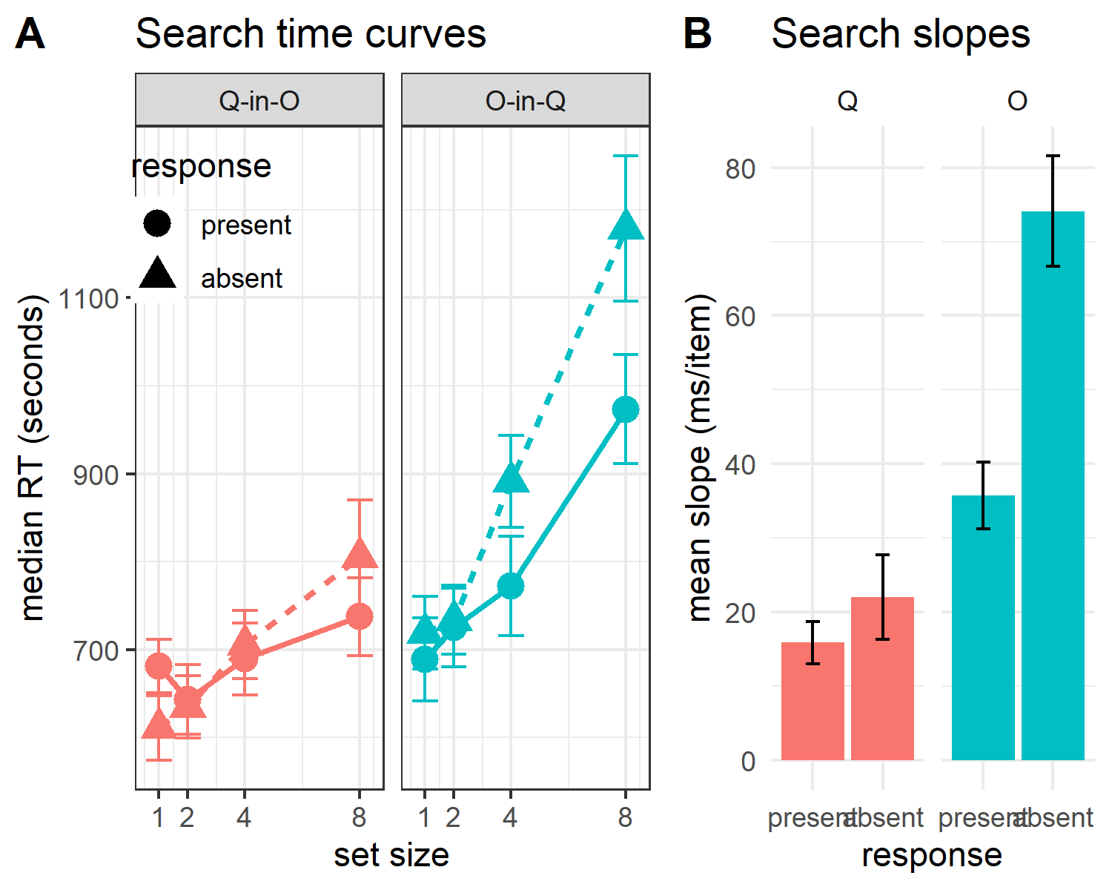
Figure 4:. A: Median search time by distractor set size for the two search tasks and two responses. Correct responses only. Error bars represent the standard error of the median. B: mean search slope per target (Q or O) and response (present or absent). Error bars represent the standard error of the mean.

Discrimination task: metacognitive asymmetry
Mean accuracy in the discrimination task was 0.81 ($M=0.81$, 95% CI $[0.77$, $0.84]$). Participants showed no consistent bias in their responses ($M=0.53$, 95% CI $[0.48$, $0.57]$). On a scale of 0 to 1, mean confidence level was 0.56 ($M=0.56$, 95% CI $[0.47$, $0.64]$). Confidence was higher for correct than for incorrect responses ($M_{d}=0.15$, 95% CI $[0.09$, $0.21]$, $t(29)=5.24$, $p<.001$).
Q responses were similar to detection ‘stimulus presence’ responses in several ways. First, response times were faster for Q than for O responses ($M_{d}=-149.38$, 95% CI $[-241.39$, $-57.38]$, $t(29)=-3.32$, $p=.002$). Second, confidence was generally higher for Q responses ($M_{d}=0.10$, 95% CI $[0.05$, $0.16]$, $t(29)=3.63$, $p=.001$). Lastly, in order to measure metacognitive asymmetry, we extracted the response-conditional type-2 ROC (rc-ROC) curves for the two responses (Q and O) in the discrimination task. This was done by plotting the cumulative distribution of confidence ratings (high to low) for correct responses against the same distribution for incorrect responses. The area under the rc-ROC curve (auROC) was then taken as a measure of metacognitive sensitivity (Kanai et al., 2010; Meuwese et al., 2014). This analysis was available only for those participats that had at least one of each error type (Q miskaen for O and vice versa). Indeed, auAUC for Q responses ($M=0.67$, 95% CI $[0.61$, $0.74]$) was significantly higher than for O responses ($M=0.59$, 95% CI $[0.53$, $0.65]$; $t(20)=2.15$, $p=.044$; Cohen’s d = 0.47; see Figure .), mirroring the metacognitive asymmetry for detection judgments.
Similar to Vincent (2011), we observed shallow standardized ROC (zROC) curves ($M=$ 0.69 $t(29)=-6.70$, $p<.001$ for a t test on the log slopes). Shallow zROC curves are typical of situations where the signal distribution for one category is broader than for the other (Kellij et al., 2018; Vincent, 2011).
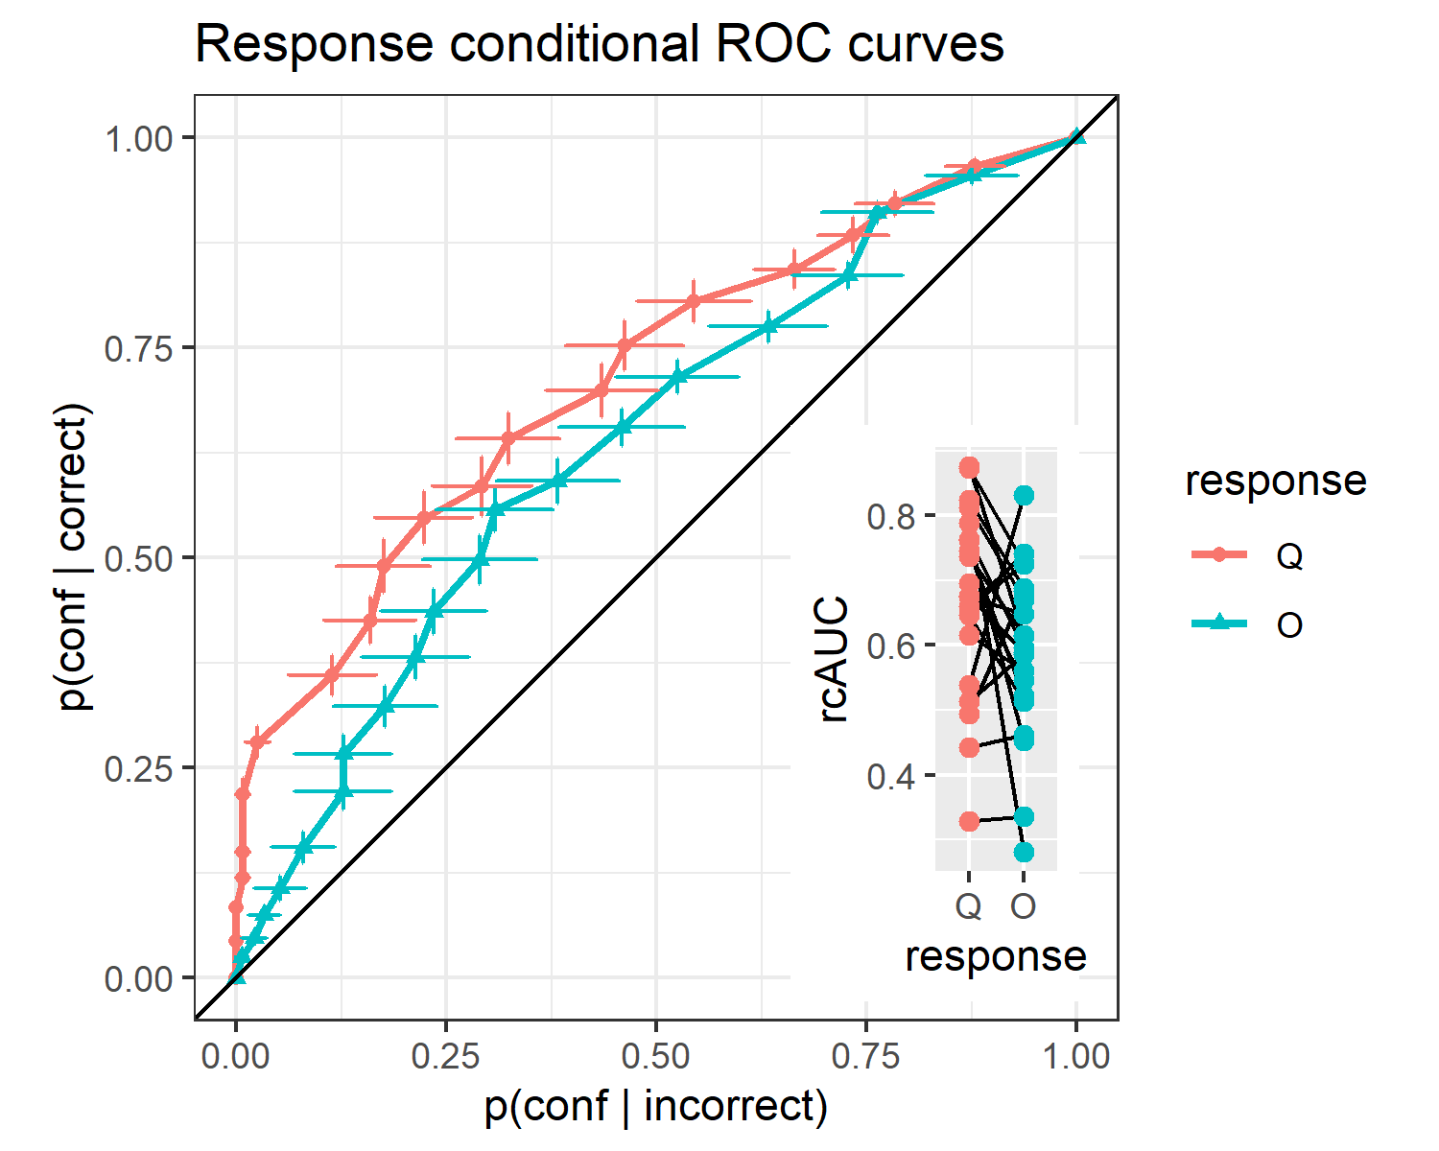
Figure 5:. response conditional ROC curves for the two discrimination responses. The area under the curve is a measure of metacognitive sensitivity. Bottom right inset: distributions of the area under the curve for the two responses, across participants. Overall, participants had lower metacognitive insight into the accuracy of their ‘O’ responses.

