Exp. 4

Matan Mazor

2023-03-13

252 participants completed the task. Mean accuracy in the main block experiment was 0.78 (SD=0.04). The mean median response time was 2.39 seconds (SD=0.55). No participants were excluded based on our pre-registered accuracy lower bound of 50%, and based on our pre-registered criterion for making hasty responses (RT<100 ms in more than 25% of the trials). 45 participants were excluding for having resposne times longer than 5 seconds in more than 25% of the trials, leaving 207 for the main analysis.

*Hypothesis 1 (PRESENCE/ABSENCE RESPONSE TIME)*: As expected, response times were significantly shorter in decisions about presence compared to absence (2.18 vs 2.54 seconds; $t\left(206\right)=−11.32$, $p<.001$).

*Hypothesis 2 (OCCLUSION RT EFFECT IN PRESENCE)*: Target-present decisions were significantly slower when more of the target was occluded behind black rows (2.15 vs 2.05 seconds; $t\left(206\right)=−3.44$, $p=.001$).

*Hypothesis 3 (OCCLUSION RT EFFECT IN ABSENCE)*: Target-absent decision times were unaffected by the occlusion manipulation (2.37 vs 2.39 seconds for the 2 and 6 rows conditions, respectively; $t\left(206\right)=0.87$, $p=.387$).

*Hypothesis 4 (OCCLUSION RESPONSE INTERACTION ON RT)*: The effect of occlusion on response time was stronger in decisions about target presence, compared to decisions about target absence (, ).

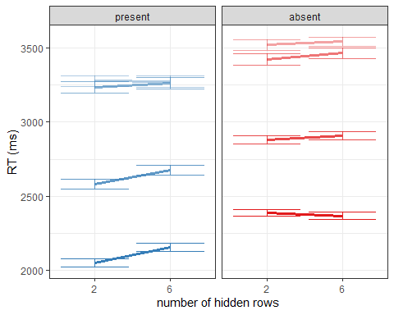

Response time quantiles 50, 75, 90 and 95 for correct decisions about presence and absence when 2 or 6 rows are occluded.

*Hypothesis 5 (SENSITIVITY)*: Signal detection sensitivity was significantly impacted by pixel occlusion ($t\left(206\right)=7.81$, $p<.001$), with d’=2.51 (SD=0.96) when two rows were occluded, and d’=1.79 (SD=0.80) when six rows were occluded. This effect was driven by a decrease in hit rate ($t\left(206\right)=9.87$, $p<.001$), and a smaller decrease in the false-positive rate ($t\left(206\right)=−2.59$, $p=.010$) when six rows were occluded.

*Hypothesis 6 (CRITERION)*: Signal detection criterion was conservative overall, and more conservative when more of the display was occluded ($t\left(206\right)=−2.60$, $p=.010$), with c=0.42 (SD=0.68) when two rows were occluded, and 0.55 (SD=0.56) when six rows were occluded.

*Hypothesis 7 (PRESENCE/ABSENCE CONFIDENCE)*: Confidence was descriptively, but not significantly higher in decisions about presence compared to absence (0.70 vs 0.68 on a 0-1 scale; $t\left(206\right)=1.53$, $p=.127$).

*Hypothesis 8 (OCCLUSION CONFIDENCE EFFECT IN PRESENCE)*: Confidence in decisions about absence was lower when more of the display was occluded (0.67 vs. 0.74; $t\left(206\right)=8.18$, $p<.001$).

*Hypothesis 9 (OCCLUSION CONFIDENCE EFFECT IN ABSENCE)*: Confidence in decisions about presence was also lower when more of the display was occluded (0.65 vs. 0.73; $t\left(206\right)=9.65$, $p<.001$).

*Hypothesis 10 (OCCLUSION RESPONSE INTERACTION ON CONFIDENCE)*: The effect of occlusion on confidence was not significantly different in decisions about target presence and absence ($t\left(206\right)=−0.46$, $p=.646$).

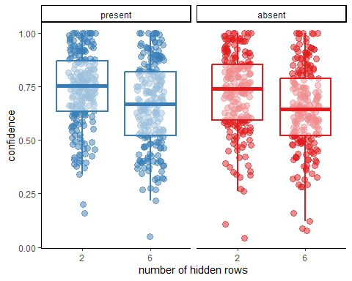

Mean confidence in correct decisions about presence and absence when 2 or 6 rows are occluded.

## Exploratory analysis: first part only.

In the first part of the experiment participants haven’t yet been exposed to confidence ratings, so we can see whether RT effects appear in the absence of confidence ratings.

*Hypothesis 1p1 (PRESENCE/ABSENCE RESPONSE TIME)*: As expected, response times were significantly shorter in decisions about presence compared to absence (2.03 vs 2.41 seconds; $t\left(206\right)=−11.53$, $p<.001$).

*Hypothesis 2p1 (OCCLUSION RT EFFECT IN PRESENCE)*: Target-present decisions were significantly slower when more of the target was occluded behind black rows (2.05 vs 1.95 seconds; $t\left(206\right)=−2.70$, $p=.008$).

*Hypothesis 3p1 (OCCLUSION RT EFFECT IN ABSENCE)*: Target-absent decision times were unaffected by the occlusion manipulation (2.30 vs 2.31 seconds for the 2 and 6 rows conditions, respectively; $t\left(206\right)=0.37$, $p=.714$).

*Hypothesis 4 (OCCLUSION RESPONSE INTERACTION ON RT)*: The effect of occlusion on response time was stronger in decisions about target presence, compared to decisions about target absence (, ).

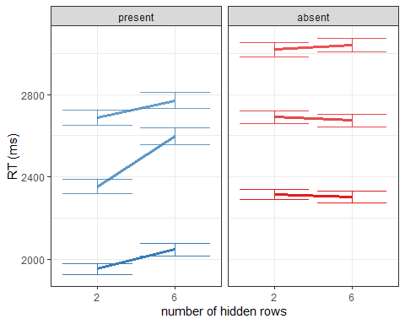

Response time quantiles 50, 75, 90 and 95 for correct decisions about presence and absence when 2 or 6 rows are occluded.