Exp. 3a

Matan Mazor

2023-06-08

10 participants completed the task. Mean accuracy in the main block experiment was 0.86 (SD=0.07). The mean median response time was 2.02 seconds (SD=0.95). 0 participants were excluded based on our pre-registered accuracy lower bound of 50%, 0 were excluded based on our pre-registered criterion for making hasty responses (RT<100 ms in more than 25% of the trials), and 0 participants were excluding for having response times longer than 7 seconds in more than 25% of the trials, leaving 10 for the main analysis.

*Hypothesis 1 (PRESENCE/ABSENCE RESPONSE TIME)*: As expected, response times were significantly shorter in decisions about presence compared to absence (1.66 vs 2.30 seconds; $t\left(9\right)=−1.72$, $p=.120$).

*Hypothesis 2 (OCCLUSION RT EFFECT IN PRESENCE)*: Target-present decisions were significantly slower when more of the target was occluded behind black rows (1.66 vs 1.57 seconds; $t\left(9\right)=−3.31$, $p=.009$).

*Hypothesis 3 (OCCLUSION RT EFFECT IN ABSENCE)*: Target-absent decision times were unaffected by the occlusion manipulation (2.08 vs 2.07 seconds for the 2 and 6 rows conditions, respectively; $t\left(9\right)=−0.10$, $p=.922$).

*Hypothesis 4 (OCCLUSION RESPONSE INTERACTION ON RT)*: The effect of occlusion on response time was stronger in decisions about target presence, compared to decisions about target absence ($t\left(9\right)=−1.75$, $p=.113$).

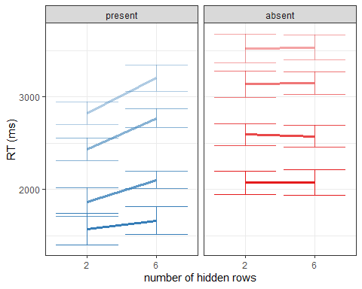

Response time quantiles 50, 75, 90 and 95 for correct decisions about presence and absence when 2 or 6 rows are occluded.

*Hypothesis 5 (SENSITIVITY)*: Signal detection sensitivity was significantly impacted by pixel occlusion ($t\left(9\right)=5.44$, $p<.001$), with d’=2.76 (SD=0.81) when two rows were occluded, and d’=2.03 (SD=0.72) when six rows were occluded. This effect was driven by a decrease in hit rate ($t\left(9\right)=5.66$, $p<.001$), and a smaller decrease in the false-positive rate ($t\left(9\right)=−2.16$, $p=.059$) when six rows were occluded.

*Hypothesis 6 (CRITERION)*: Signal detection criterion was conservative overall, and more conservative when more of the display was occluded ($t\left(9\right)=−1.26$, $p=.239$), with c=0.07 (SD=0.26) when two rows were occluded, and 0.17 (SD=0.26) when six rows were occluded.

## [1] "Generating null distribution"  
## ================================================================================

## [1] "Generating null distribution"  
## ================================================================================

## [1] "Generating null distribution"  
## ================================================================================

## [1] "Generating null distribution"  
## ================================================================================

## [1] "Generating null distribution"  
## ================================================================================

## [1] "Generating null distribution"  
## ================================================================================

## [1] "Generating null distribution"  
## ================================================================================

## [1] "Generating null distribution"  
## ================================================================================

## x y  
## 1 0.998 0.472  
## 2 0.948 0.472  
## 3 0.992 0.472  
## 4 0.930 0.472  
## 5 1.000 0.472  
## 6 0.936 0.472  
## 7 0.878 0.472  
## 8 0.976 0.472  
## 9 0.582 0.472  
## 10 0.422 0.472

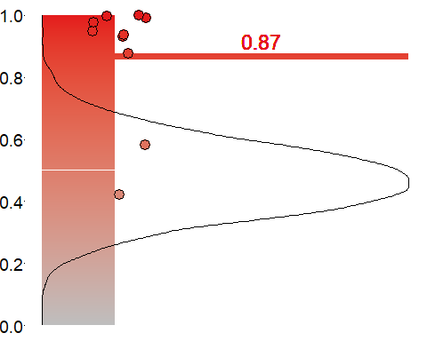

## x y  
## 1 0.402 0.472  
## 2 0.530 0.472  
## 3 0.992 0.472  
## 4 0.496 0.472  
## 5 0.708 0.472  
## 6 1.000 0.472  
## 7 0.994 0.472  
## 8 0.800 0.472  
## 9 0.716 0.472  
## 10 1.000 0.472

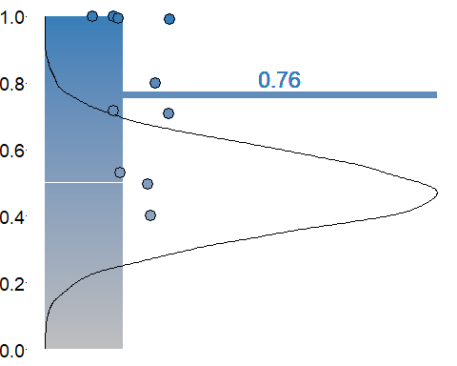

## x y  
## 1 0.680 0.472  
## 2 0.846 0.472  
## 3 1.000 0.472  
## 4 1.000 0.472  
## 5 0.320 0.472  
## 6 0.996 0.472  
## 7 1.000 0.472  
## 8 0.998 0.472  
## 9 0.996 0.472  
## 10 1.000 0.472

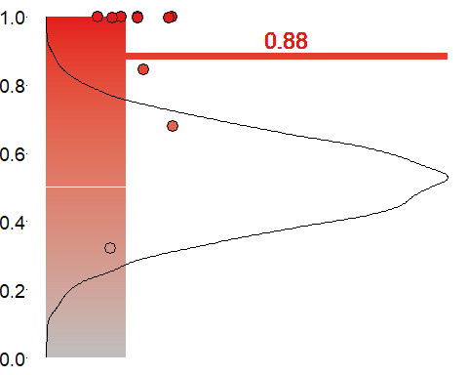

## x y  
## 1 1.000 0.472  
## 2 0.470 0.472  
## 3 0.688 0.472  
## 4 0.420 0.472  
## 5 0.998 0.472  
## 6 0.426 0.472  
## 7 1.000 0.472  
## 8 0.958 0.472  
## 9 0.372 0.472  
## 10 0.278 0.472

