Pretending not to know: pretense behavior reveals a capacity for counterfactual self-simulation

Generally, what we do depends on what we know. But sometimes we try to appear not to know something that we really do know. Such pretense behavior relies on counterfactual self-simulation — an understanding of how we would behave if our knowledge were different — and so provides an opportunity to investigate how well people can emulate a hypothetical knowledge state. Surprisingly, despite its immediate relevance to metacognition and theory of mind, little research has focused on quantifying pretense accuracy, relative to non-pretense behaviour. In a large-scale, pre-registered online experiment, we examine the ability to both produce and detect pretense behaviour using the game “Battleships.” We show that relative to standard ‘non-pretend’ games, pretend games demonstrate similar, but exaggerated, patterns of cell selections and response latencies. Furthermore, pretend games are less aligned than non-pretend games with the simualted games of a near-optimal Bayesian player, but are still significantly more rational than expected by chance alone. However, despite these striking differences, independent “judge” participants were completely unable to discriminate the games of pretenders from non-pretenders. We conclude by discussing the implications of our findings for simulation accounts of theory of mind and metacognition.

# Introduction

The ability to intentionally deceive others relies on a capacity to reason about mental states (Frith & Frith, 2005). This is evident in a similar developmental trajectory for the acquisition of theory of mind and the ability to deceive and detect deception (Shultz & Cloghesy, 1981; Sodian, Taylor, Harris, & Perner, 1991; Wimmer & Perner, 1983), and a similar distribution of deception and theory of mind in the animal kingdom (e.g., Emery & Clayton, 2004; Hall & Brosnan, 2017). This link makes conceptual sense: to deceive others, one needs to understand that others can have different knowledge and beliefs than one’s own.

Moreover, deception often involves pretense behaviour, which in turn relies on an ability to simulate and mimic one’s own behaviour under a hypothetical belief state. For example, in order to successfully deceive your friends into thinking that you were surprised by the birthday party they threw for you, it is not sufficient that you are able to reason about their mental states (“I know that they are planning a surprise party, but they don’t know that I know that.”) — you also need to convincingly simulate and mimic your hypothetical behaviour had you not known about the party (“Where would I look first? What would I say? How long would it take me to recover from the surprise?”). This reliance of pretense behaviour on self-simulation makes it an ideal opportunity to examine metacognitive knowledge about one’s own mental states, and the potential reliance of this knowledge on a self-simulation. By comparing non-pretend and pretend behaviour, we can ask which aspects of their cognitive processes subjects can simulate, and which aspects are not represented in their mental models of their own cognition.

To this end, here we examine pretense in a game setting. Using an online version of the game “Battleships,” participants played a non-pretend (normal) version of the game, as well as a pretend version where they were given secret information about the location of hidden ships, but tried to behave as if they didn’t have this information.

# Methods

We report how we determined our sample size, all data exclusions (if any), all manipulations, and all measures in the study. A detailed pre-registration can be accessed at [osf.io/v9zsb](https://osf.io/v9zsb).

## Participants

The research complied with all relevant ethical regulations and was approved by the Research Ethics Committee of Johns Hopkins University. 500 Participants were recruited via Prolific (prolific.co) and game their informed consent prior to their participation. They were selected based on their acceptance rate (>95%) and for being native English speakers. The entire experiment took 20 minutes to complete (median completion time: 19 minutes). Participants were paid 3.15 USD for their participation, equivalent to an hourly wage of 9.50 USD, in addition to a bonus payment (0.2 - 2 USD, mean = 0.90).

## Procedure

Participants were first instructed that the experiment, based on the game Battleships, has three parts, and that the points they will accumulate will translate to a monetary bonus payment. They were then presented with a leaderboard of previous players. Then, the rules of the game were presented:

“In the game Battleships, your task is to sink all ships located in a grid with as few clicks as possible. What makes the game difficult is that you can’t see the ships; all you can see is a grid of squares, and you have to guess where the ships are. To sink a ship, you need to click on all of the squares it is located in. If you hit part of a ship, the square will turn red. If there is no ship in the square, it will turn blue.”

We further explained that in this version of the game, ships can touch corners, but their sides can’t touch. This explanation was accompanied by a visual presentation of legal and illegal ship configurations.

After completing a comprehension question and a practice round, participants completed one pretend and one non-pretend block, each comprising five full games and one half game (see below for details). The order of pretend and non-pretend blocks was counterbalanced between participants. The allocation of boards (spatial configurations of ships) to conditions was randomized between participants such that exactly one board was played in both pretend and non-pretend conditions, and this common board was different for different participants. The order of boards within a block was fully randomized, with the exception that half-games were always played last.

### Non-pretend games

In non-pretend games (Fig. 1B), participants sunk two 2-square patrol boats and one 3-square submarine with as few clicks as possible. An online counter of the number of clicks was displayed on the screen. After each game, feedback was given about the number of clicks and resulting number of points obtained.

### Pretend games

Participants were given the following instructions:

“In the next part of the experiment, you’ll play 5 games where you sink one 3-square submarine and two 2-square patrol boats. However, this time your goal is different. In this round, we’re going to tell you where the ships are, but **we want you to act like you don’t know this information**. We’ve marked the ships’ locations with a cross, so you’ll know where they are the whole time; but your job is to play the game as if these hints aren’t there. To see how good you are at this, we’re going to compare your games to the games of people who actually had no hints, and see how similar they are. We will measure where and when you clicked; if your clicks look similar to people who played like normal (trying to reveal all ships with as few clicks as possible, but without any hints), you’ll get bonus points. But if your games look different, you won’t get these bonus points. Your number of clicks in this part will not affect your bonus. Only your ability to play like you had no hints.”

After one practice round and one comprehension question, participants played six pretend games (Fig. 1C). Each game was followed by a short message, reminding them that a game that looks similar to the game of participants who had no hints will be awarded with 10 bonus points.

### Half games

In order to directly compare participants’ pretend and non-pretend games for identical belief states (true or pretended knowledge about where the ships are hidden), participants completed one pretend and one non-pretend game given a partly finished board with the content of 7 cells already revealed (see Fig. 1D). We designed our half games to produce a strong expectation to find a ship in specific cells, but not in others. The assignment of half-completed boards to pretend and non-pretend conditions was randomized between participants.

### Judge trials

In the final part of the experiment, participants observed the games of previous players and determined who had hints and who didn’t. On each trial, two empty grids were presented side by side, with a smaller grid on top, displaying the hidden positions of ships on the grid (Fig. 1F). The two grids corresponded to the true games of two previous players who played a version of the top grid either as pretenders or as non-pretenders. Only games shorter than one minute were chosen for presentation in this part. For non-pretend games, only games from the group of participants that pretended in the second block (and played normally in the first block) were chosen for presentation in this part. Judge participants observed a real time replay of the two grids, mimicking not only where participants clicked, but also when. After making a decision, participants were informed whether they will receive the 10 points, or alternatively, whether the pretender will receive them in case the pretender managed to trick them.

A more detailed description of the study procedure is provided in the study [pre-registration document](https://osf.io/v9zsb). Readers are also invited to try a [demo of the experiment](https://jatos.mindprobe.eu/publix/NervzpM0Y0z).

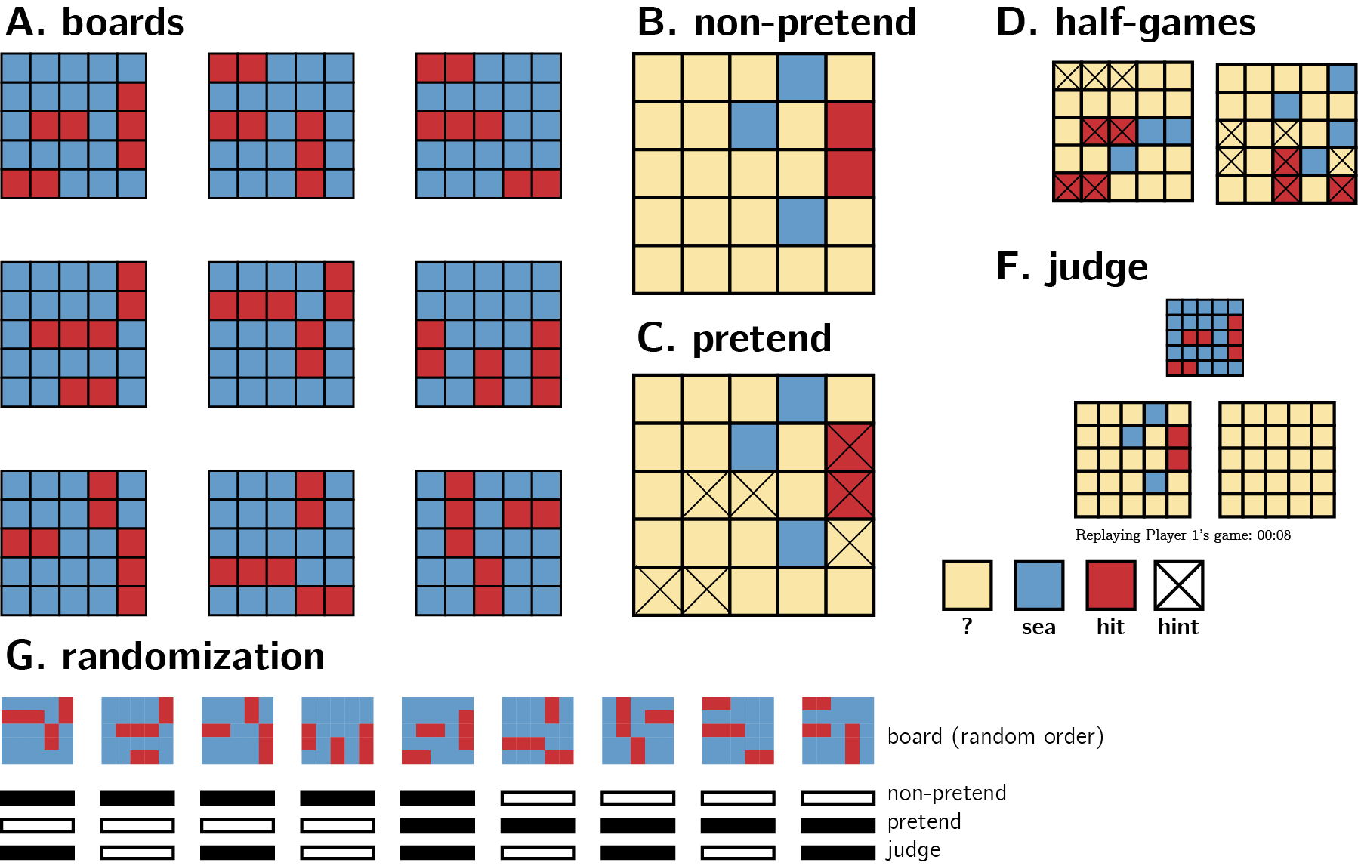

Experimental Design. See Methods for details.

# Results

We designed our analyses to explore subjects’ capacity for self-simulation under a counterfactual knowledge state, and the limits of this capacity. We focused on where subjects clicked and when, and asked whether this differed between pretend and non-pretend games. All analyses were pre-registered unless otherwise specified. In our pre-registered document, we committed to separately analyzing participants according to whether they pretended before or after completing a non-pretend block. Due to space limitations, and since the results of the two groups mostly agreed, we report here the pooled results from both groups of participants, and mention whenever we found different results depending on block order. When directly comparing pretend and non-pretend blocks, we perform a between-subjects comparison using data from the first block only, i.e., pretend games from participants that pretended in the first block and non-pretend games from participants that played normally in the first block. We do so to ensure any successful pretending is not due to memory of one’s own behaviour in a previous block, and that non-pretend games are not biased by experience with the pretend block.

## Total number of clicks

To sink all ships, players had to click on at least 7 and at most 25 squares. A simulated player that clicks randomly had a median number of clicks of 23, and a near-optimal greedy player that consistently selected the square with the highest objective probability of containing a ship had a median total click number of 14. Among our players, the median number of clicks was 16 in both pretend and non-pretend games (see Fig. 2A).

We observed no significant difference in the number of clicks between the two conditions ($t(440.10)=0.41$, $p=.682$). However, a significant interaction with block order suggested that participants made less clicks in the second block compared to the first, regardless of which block was the pretend one ($F(1,996)=10.59$, $MSE=6.55$, $p=.001$).

On 62 pretend games from 20 players, games were completed after 7 clicks only, without ever missing a ship. This never happened in non-pretend games. we assumed these participants did not follow task instructions, and excluded them from all following analyses.

## Game optimality

Pretend games were similar to non pretend games in the total number of clicks, but were they also similar in *where* participants clicked? More specifically, did cell selections in pretend games make sense given the information that participants pretended to have? To ask this, we approximated optimal behaviour by calculating the probability that a ship is hidden in each cell, given available information $p(ship(x_{i}))$ and the posterior probability that one should click on a square, assuming a uniform prior over cells $P(x_{i})=\frac{p(Ship(x_{i}))}{\sum_{j=1}^{k}{p}(Ship(x_{j}))}$. Critically, in modelling pretend games we did not treat hints as part of this available information for extracting $p(ship(x_{i}))$, because an optimal player should ignore hints in choosing where to click next. Given this posterior map, a rational player should choose cells where $P(x_{i})$ is high [this behaviour is not strictly optimal, but approximates optimal behaviour in most cases; Audinot, Bonnet, & Viennot (2014), Section 3.3]. To quantify optimality, before each cell selection we computed the posterior probability map for all ‘unknown’ cells. Then, we ranked cells from high to low according to their posterior probability and recorded the rank of the chosen cell: a lower rank indicating more optimal behaviour.

The mean posterior rank of non-pretend cell selections was 6.44 and significantly lower (more optimal) than that of a simulated random agent (see Fig. 2B; 9.17, $t(479)=−48.80$, $p<.001$). Pretend games were significantly less optimal than non-pretend games (6.93; $t(474.06)=−6.07$, $p<.001$), but still more optimal than those of a random agent ($t(479)=−37.72$, $p<.001$). Critically, the same pattern was observed when restricting analysis to cell selections that resulted in a miss (non-pretend - pretend: $t(469.71)=−6.30$, $p<.001$; pretend - random: $t(479)=−10.25$, $p<.001$). In other words, the optimality of pretend games relative to random cell selection was not merely due to the fact that pretenders clicked on ships more than expected by chance. Even when missing a ship, their cell selections made sense given the limited information they pretended to have.

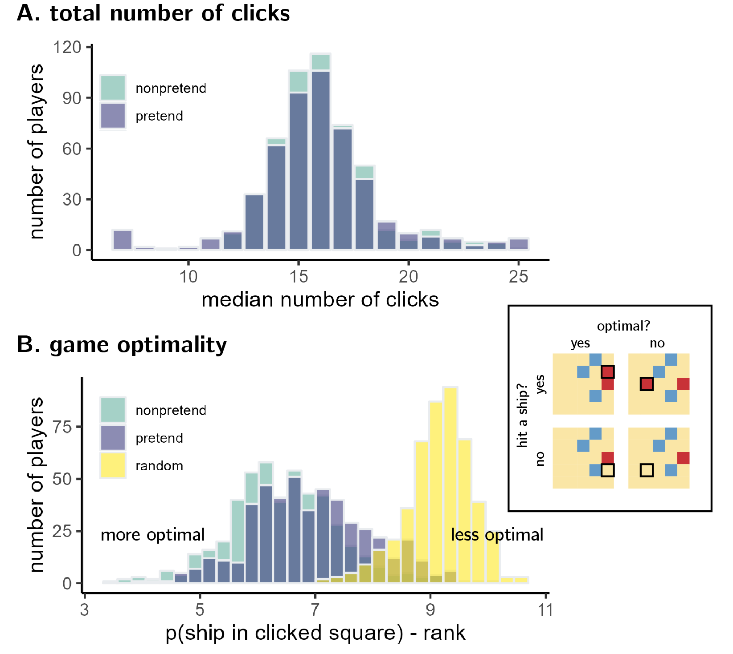

A: The total number of clicks in pretend and non-pretend games was highly similar. B: Non-pretend games were significantly more optimal than pretend games, but both were more optimal than what is expected by random chance. Box: An illustration of the difference between success and optimality. A given click (highlighted with a black border) can reveal a ship (upper row) or not (lower row) regardless of whether a click made sense given available information (left column) or not (right column).

## Reaction time analysis

In general, participants were slower in pretending compared to when non-pretending. Despite the similar number of clicks per game, the median game duration was 22.31 seconds in the non-pretend condition and 29.23 second, and significantly longer, in the pretend condition ($t(479)=12.68$, $p<.001$). This difference showed a significant interaction with the order of conditions, such that completing games in the first block took longer ($F(1,956)=21.24$, $MSE=243.45$, $p<.001$, ${\hat{η}}_{G}^{2}=.022$).

In our instructions to pretenders, we asked them to pretend not knowing where the ships were not only in *where* they choose to click, but also in *when* they click. In the following set of analyses, we identified patterns in click latency in non-pretend games, and asked whether the same patterns are also observed in pretend games. We focused on the effects of hitting versus missing a ship, decision uncertainty, and ship completion.

### Effects of hitting versus missing a ship

In non-pretend games, players were faster by 109 ms when hitting compared to missing a ship (see Fig. 3A; $t(479)=−12.37$, $p<.001$). The same effect was observed in pretend games: players were faster by 293 ms in hits compared to misses ($t(233)=−11.83$, $p<.001$; pretend first: $t(479)=−16.23$, $p<.001$). The difference between hits and misses was significantly more pronounced in pretend games ($t(314.67)=−7.45$, $p<.001$).

The opposite effect was observed for a hit on the previous click: players were slower by 182 ms after hitting a ship ($t(479)=13.39$, $p<.001$). Again, this effect was also observed in pretend games, where players were slower by 236 ms following a hit on the previous click ($t(479)=12.02$, $p<.001$). This effect of hit on previous click was again exaggerated in the pretend condition ($t(377.12)=2.75$, $p=.006$).

### Effects of decision uncertainty

When playing the game Battleships, it is sometimes clear what the next cell selection should be, and sometimes it is more difficult to decide where to click next. To capture this notion of decision uncertainty, we extracted the entropy of the posterior distribution over cell selections $H(P)=−\sum_{i=1}^{k}{P}(x_{i})\text{log}P(x_{i})$, where $P(x_{i})=\frac{p(Ship(x_{i}))}{\sum_{j=1}^{k}{p}(Ship(x_{j}))}$, and asked how this measure relates to decision latency, or the time taken to click on the next cell. $H(P)$ is high when players need to decide between multiple cells with a similar probability of hiding a ship, and low when there are a few candidates with a high probability of hiding a ship. For every player and condition separately, we fitted a multiple linear regression to predict decision latency based on $H(P)$ and $H(P)^{2}$. The resulting coefficients were then subjected to a group-level inference. The first cell selection of each game was excluded from this analysis, because entropy was constant for the first click.

In non-pretend games, we found no evidence for a linear relation between decision entropy and decision latency ($t(479)=−1.67$, $p=.096$). We did however observe a block order effect, with a significantly negative linear modulation only in the group that pretended in the first ($t(233)=−10.24$, $p<.001$), but in the second block ($t(245)=−0.06$, $p=.950$). In pretend games this negative relation between $H(P)$ and click latency was significant in both groups, and overall ($t(479)=−7.42$, $p<.001$).

A negative linear modulation of $H(P)$ on decision latency is surprising, as it suggests that participants were quicker to decide when uncertainty was high. However, visual inspection of the RT/entropy curves (Fig. 3B) reveals a pronounced quadratic modulation, such that in both pretend and non-pretend games slower decision times are observed for intermediate $H(P)$ values of around 2. Similar to the linear effect of $H(P)$ on decision latency, here too a quadratic modulation in non-pretend games was observed only in the group that pretended in the first ($t(233)=−13.26$, $p<.001$), but not in the second block ($t(245)=−1.33$, $p=.184$). Again, in pretend games this negative quadratic relation was significant in both groups, and overall ($t(479)=−15.65$, $p<.001$). A between-subjects comparison focusing on games from the first block revealed that this negative quadratic effect was stronger in pretend, compared to non-pretend games ($t(363.42)=3.46$, $p=.001$).

## Effects of ship completion

The previous analyses reveal robust associations between game state and decision latency, that are highly similar, and even exaggerated, in pretend compared to non-pretend games. To get at more subtle dynamics in a more direct way, in a follow-up exporatory analysis we focused on decision latencies following a hit. We categorized hits into four types: first hit in a ship, second hit in a ship when the size-three submarine hasn’t been sunk yet, second hit in a ship when the size-three submarine has already been sunk, and third hit in a submarine (see Fig. 3C). In the first case, players know the ship must continue in one of the neighboring cells. In the second case, there is a good chance there ship continues (if this ship turns out to be a submarine). In the third and fourth cases, it is clear that the ship is fully sunk.

In non-pretend games, participants were significantly slower to select the next cell when they knew they just completed a ship (categories 1 and 2) compared to when they just hit a ship, but were not sure if they completely sunk it (categories 3 and 4; $t(404)=−16.82$, $p<.001$). Specifically, comparing the second and third classes, we find that participants were slower by 728 to make the next cell selection after hitting the second cell in a ship if the size-3 submarine has already been sunk ($t(404)=13.45$, $p<.001$).

Strikingly, we found the exact same pattern in pretend games. Players were faster to make the next cell selection when they pretended to think that the current ship may not be fully sunk ($t(369)=−14.47$, $p<.001$). This was not merely a difference between the first, second and third hits: when focusing on second hits only (second and third classes), participants were slower by 754 ms to make the next cell selection after hitting the second cell in a ship if they size-3 submarine has already been sunk ($t(404)=13.45$, $p<.001$). Further control analysis confirmed that this effect remained significant when controlling for click number ($t(404)=11.28$, $p<.001$), and when restricting analysis to the second hit of a ship that is in fact of size-two ($t(366)=3.91$, $p<.001$). To reiterate: in both classes two and three, pretenders *knew* that they had just sunk a size-two ship, but in the second case they *pretended not to know* this fact, and this affected their response latency in the same way it affected response latencies in non-pretend games.

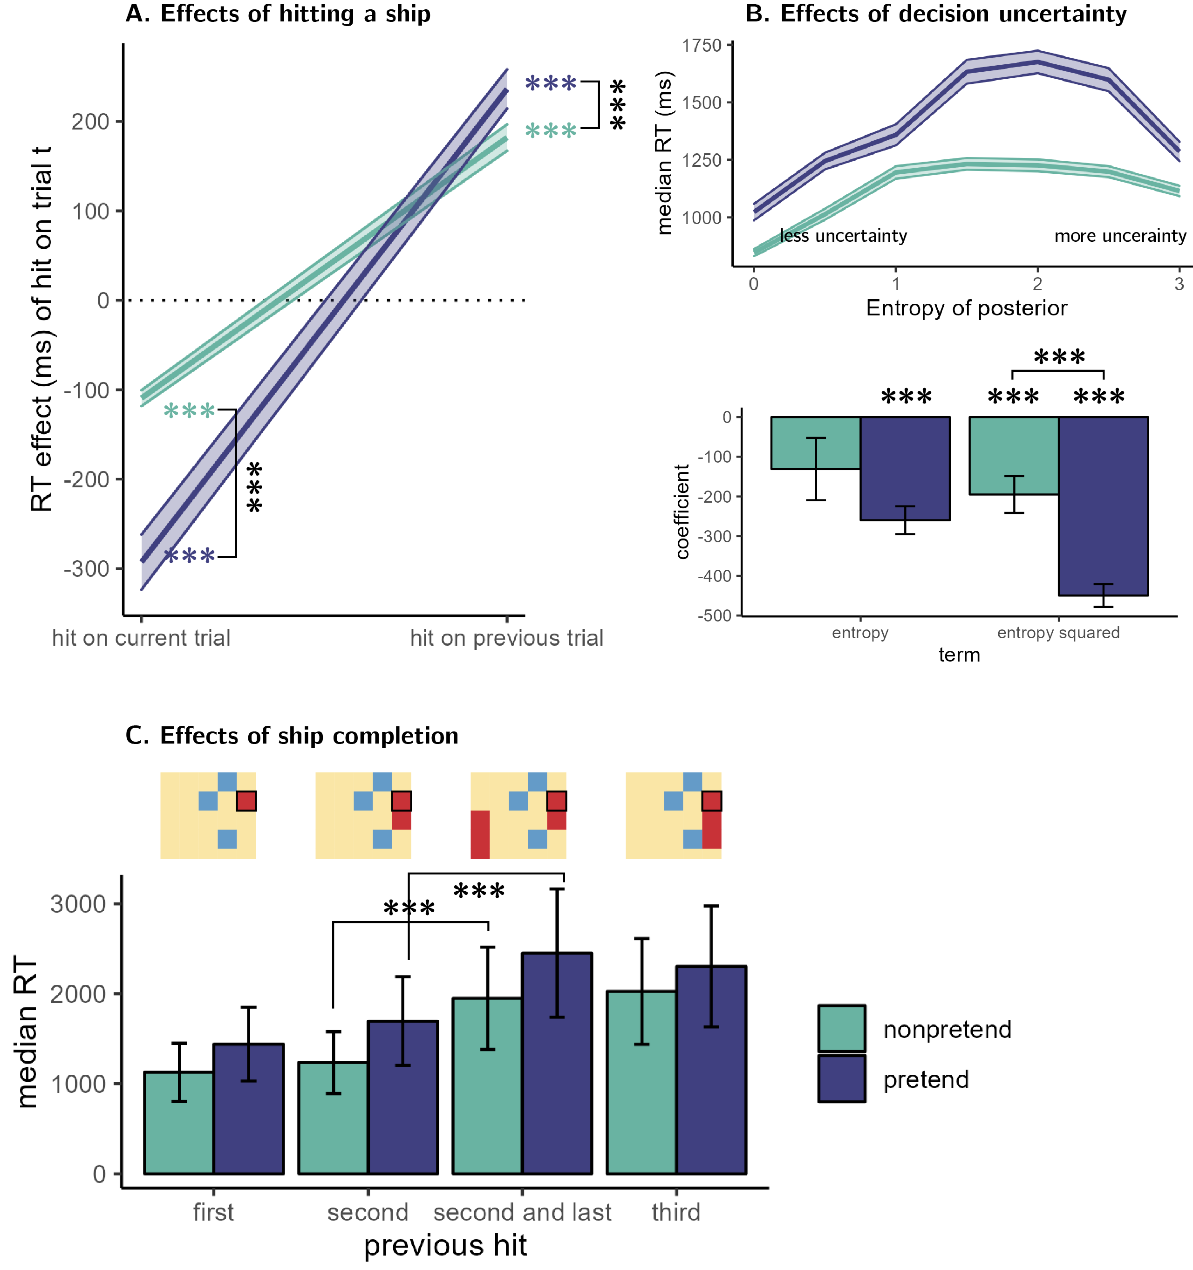

A: A subtraction of decision latencies in misses versus hits in the current and previous cell selections, in pretend and non-pretend games. B. Upper panel: Effect of the entropy of the posterior distribution over cell selections (a measure of decision uncertainty) on decision latency in pretend and non-pretend games. Lower panel: mean beta coefficients for a multiple regression model, predicting decision latency from entropy and entropy squared. C: Decision latency after a hit, as a function of hit number.

## Half-games

Our optimality analysis showed that pretenders’ click selections resemble those of non-pretenders, at least in that they are not random, and somehow guided by where a ship might be. But due to the high number of possible board configurations, data from full games provides little opportunity to compare cell selections for specific game states. In addition to asking “what guides cell selections in pretend and non-pretend games,” we also wanted to ask “where exactly would pretenders and non-pretenders click, given a specific board configuration?”

To achieve this, the sixth game in each block started not with an empty grid, but with the contents of some cells already revealed by a previous player. As before, pretenders also knew where the remaining ships were hidden, but tried to play as if they only knew what was known to this previous player. Having cell selections from 250 players for each board configuration and condition allowed us to plot and compare the distribution of clicks under a true, or pretend, knowledge state.

For example, have a look at Board A in Fig. 4 (upper left corner). Imagine that you need to select your next move, knowing that exactly two size-two patrol boats and one size-three submarine are hiding in the water. Where would you click next? Perhaps one of the two revealed ships is the submarine. In that case you want to click on the first cell in the third row, or on the third cell in the fifth row. Or maybe these are the two patrol boats. This would mean the submarine is hiding in some other place, and for it not to touch sides with the boats this must be in the first row. The hit probability map in the second column visualizes this reasoning, by plotting the normalized probability that different a ship is hidden in different cells. Indeed the highest probabilities are to the sides of the revealed ships, and in the first row.

In the third column we plot the distribution of clicks for non-pretend players. This distribution is in agreement with the hit probability map (board A: $r=.81$, 95% CI $[.55$, $.93]$, $t(16)=5.48$, $p<.001$; board B: $r=.87$, 95% CI $[.68$, $.95]$, $t(16)=7.01$, $p<.001$). Finally, in the fourth column we plot the distribution of cell selections for pretend players. Although noisier, this distribution was also in agreement with the hit probability map (board A: $r=.49$, 95% CI $[.03$, $.78]$, $t(16)=2.27$, $p=.037$; board B: $r=.73$, 95% CI $[.40$, $.89]$, $t(16)=4.28$, $p=.001$), and more importantly, with the hit distribution of non-pretenders for the same board configuration (board A: $r=.63$, 95% CI $[.31$, $.82]$, $t(23)=3.89$, $p=.001$, board B: $r=.87$, 95% CI $[.73$, $.94]$, $t(23)=8.60$, $p<.001$).

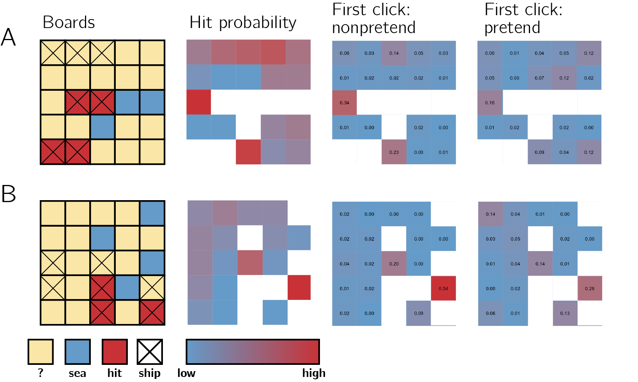

Half games. First column: the two boards, as they appeared to pretenders. Second column: objective hit probability, given game state. Third and fourth columns: empirical click probabilities in non-pretend and games, respectively.

## Judge trials

Despite the fact that pretenders were overall successful in mimicking patterns of cell selection and decision latency, they also left many clues for an independent observer to pick on: they were slower, displayed exaggerated effects of decision uncertainty and hit success on reaction time, and were less optimal than a non-pretending in choosing where to click next. To illustrate, a support vector machine (SVM) algorithm reached an accuracy level of 72% in linearly classifying condition (pretend / non-pretend) based on three basic summary features (median decision latency, game optimality score, and number of irrational clicks per game).

Despite this, participants were never significantly above chance in judging which of the two presented game came from a pretender (mean number of successes out of 5: 2.57; t test against 2.5: $t(499)=1.45$, $p=.147$).

For a subset of 288 players, one of the five boards presented in the judging block was already presented both in the pretend and in the non-pretend blocks. Still, even this subset of participants who had just experienced a board both as pretenders and as non-pretenders were only slightly, but not significantly above chance in telling which of two other players had hints for this same board ($p=.141$).

## Are good pretenders also better judges?

The abilities to pretend and to detect pretense in others both rely on some form of theory of mind: reasoning about counterfactual knowledge states of oneself in the first case, and of others in the second. For example, in scrub jays, individual birds that pilfered another bird’s caches were also more careful in hiding their own food, suggestive of an ability to project from their own experience of stealing to the behaviour of others (Emery & Clayton, 2001). We therefore reasoned that those participants whose pretend games better resembled the games of genuine players will also be more accurate in detecting pretense in others. To our surprise, this was not at all the case ($r=−.03$, 95% CI $[−.13$, $.07]$, $t(352)=−0.56$, $p=.573$). Furthermore, we find no significant correlation between participants’ accuracy in detecting the pretender and their decision optimality in pretend games (measured as the mean rank posterior probability of their cell selections; $r=.01$, 95% CI $[−.08$, $.10]$, $t(478)=0.18$, $p=.854$), nor with the cost to optimality realtive to non-pretend games ($r=.02$, 95% CI $[−.07$, $.11]$, $t(478)=0.47$, $p=.641$).

Despite our considerable sample size of 500 participants, we are cautious in making strong claims based on the absence of a correlation between pretense and pretense detection abilities in our sample. We note however that previous developmental research has identified weaker correlations with theory of mind measures for a tendency to intentionally deceive another player in a game setting, compared to an ability to detect and understand deception, potentially indicating partly different mechanisms (Shultz & Cloghesy, 1981).

# Dicussion

In writing the Results Section we faced a challenge. We, as the scientists who had carried out the study and analyses, knew exactly what each plot and sentence mean. But we were also aware that some of the analyses are complex and counter-intuitive, such that a naïve reader (meaning, any reader that hasn’t taken part in writing this paper) may struggle to follow what we are trying to say. To write a paper that is comprehensible to people who are not ourselves, we had to read the paper in the eyes of someone who don’t know what we do in fact know. This is just an example of a more general fact - the ability to simulate counterfactual knowledge states is necessary for efficient and flexible communication. To do this, we need to have an internal self-model that can generate thoughts and behaviour for hypothetical beliefs, desires, and perceptions.

Recent research on Bayesian Theory of Mind provides some support for the existence of such a model by measuring subjects’ ability to infer beliefs and desires from observed behaviour, either explicitly (Baker, Jara-Ettinger, Saxe, & Tenenbaum, 2017; Baker, Saxe, & Tenenbaum, 2009), or implicitly (Liu, Ullman, Tenenbaum, & Spelke, 2017; Onishi & Baillargeon, 2005). The complementary approach we put forward here is to ask participants to generate behaviour based on a counterfactual mental state - in our case, a counterfactual knowledge state in which some known information is unavailable to them. Instead of relying on model inversion (e.g., “which belief states would give rise to this behaviour?”), here we ask participants to run the model forward, taking beliefs and desires as input and produce behaviour as output. Due to the unconstrained space of possible behaviours in our task (cell selections x decision latencies), successfully pretending not to know demands a rich model of cognition, and is much more difficult to achieve based a semi-scientific theory of mental states (Gopnik & Wellman, 1994).

Our subjects rose to the challenge. Their pretense behaviour, although not perfect, resembled that of non-pretenders not only in gross measures such as total number of clicks, but also in more subtle patterns of cell selection and decision latency. Our preferred interpretation of this finding is that participants are able to engage in rich and relatively accurate counterfactual self-simulation: “what would I have done if I didn’t have this piece of knowledge?”

But there is an alternative interpretation: instead of simulating a counterfactual knowledge state, participants may have actively suppressed, or ignored, unwanted knowledge, such that their entire cognitive machinery was available to play the game. This does not require any self-modelling or self-simulation, beyond the knowledge that suppressing knowledge can be beneficial for pretending not to know something. Similarly, in writing our Results Section, instead of simulating a counterfactual knowledge state we may have been able to actively suppress our prior knowledge about the details of the experimental design and analysis. While we cannot fully rule out this interpretation, we think this is unlikely to be the driver behind participants’ pretense ability in our data, for two indirect reasons. First, suppressing thoughts on demand is notoriously difficult (Wegner, Schneider, Carter, & White, 1987), and our first-person experience of performing the task is that suppressing knowledge of ship locations is hardly possible. And second, when asked how they had performed the task in a debrief question, the responses of most participants were aligned with a self-simulation account. However, more work is needed to provide direct support for self-simulation.

# References

Audinot, M., Bonnet, F., & Viennot, S. (2014). Optimal strategies against a random opponent in battleship. *The 19th Game Programming Workshop*.

Baker, C. L., Jara-Ettinger, J., Saxe, R., & Tenenbaum, J. B. (2017). Rational quantitative attribution of beliefs, desires and percepts in human mentalizing. *Nature Human Behaviour*, *1*(4), 1–10.

Baker, C. L., Saxe, R., & Tenenbaum, J. B. (2009). Action understanding as inverse planning. *Cognition*, *113*(3), 329–349.

Emery, N. J., & Clayton, N. S. (2001). Effects of experience and social context on prospective caching strategies by scrub jays. *Nature*, *414*(6862), 443–446.

Emery, N. J., & Clayton, N. S. (2004). The mentality of crows: Convergent evolution of intelligence in corvids and apes. *Science*, *306*(5703), 1903–1907.

Frith, C., & Frith, U. (2005). Theory of mind. *Current Biology*, *15*(17), R644–R645.

Gopnik, A., & Wellman, H. M. (1994). The theory theory. In *An earlier version of this chapter was presented at the society for research in child development meeting, 1991.* Cambridge University Press.

Hall, K., & Brosnan, S. F. (2017). Cooperation and deception in primates. *Infant Behavior and Development*, *48*, 38–44.

Liu, S., Ullman, T. D., Tenenbaum, J. B., & Spelke, E. S. (2017). Ten-month-old infants infer the value of goals from the costs of actions. *Science*, *358*(6366), 1038–1041.

Onishi, K. H., & Baillargeon, R. (2005). Do 15-month-old infants understand false beliefs? *Science*, *308*(5719), 255–258.

Shultz, T. R., & Cloghesy, K. (1981). Development of recursive awareness of intention. *Developmental Psychology*, *17*(4), 465.

Sodian, B., Taylor, C., Harris, P. L., & Perner, J. (1991). Early deception and the child’s theory of mind: False trails and genuine markers. *Child Development*, *62*(3), 468–483.

Wegner, D. M., Schneider, D. J., Carter, S. R., & White, T. L. (1987). Paradoxical effects of thought suppression. *Journal of Personality and Social Psychology*, *53*(1), 5.

Wimmer, H., & Perner, J. (1983). Beliefs about beliefs: Representation and constraining function of wrong beliefs in young children’s understanding of deception. *Cognition*, *13*(1), 103–128.