Motivated seeing and unseeing - Exp. 8 pre-registration document

Matan Mazor1,2, Itay Goetz3, & Clare Press1,2

1 Birkbeck, University of London

2 Wellcome Centre for Human Neuroimaging, UCL

3 University of Bamberg

Author note

Correspondence concerning this article should be addressed to Matan Mazor, Malet Street, London WC1E 7HX. E-mail: [mtnmzor@gmail.com](mailto:mtnmzor@gmail.com)

Abstract

*Keywords:* keywords

*Word count:* X

Motivated seeing and unseeing - Exp. 8 pre-registration document

# Motivation

In a series online experiments, we replicated previously observed effects of motivation on perceptual decisions (Balcetis, Dunning, & Granot, 2012; Leong, Dziembaj, & D’Esposito, 2021; Leong, Hughes, Wang, & Zaki, 2019). Specifically, we found that subjects were less likely to report seeing stimuli that were associated with point loss in a perceptual discrimination task, even when incentivized to report accurately. In contrast, we observed no effects of point gain on perceptual decision making.

Here we attempt to shed further light on the mechanism behind these effects. Specifically, by including trials in which participants guess the identity of an occluded target, we will be able to directly contrast the biasing effects of motivation on decisions with and without useful perceptual input.

# Methods

We report how we determined our sample size, all data exclusions (if any), all manipulations, and all measures in the study.

## Participants

The study was approved by the Research Ethics Committee of Birkbeck, University of London (study ID number 2122050). No adverse effects for participants from participation in the study are expected. Participants will give consent for taking part in the study which can be withdrawn at any time.

One hundred participants will be recruited from the Prolific database. The criteria for recruitment will be a Prolific approval rate of 95%, English as their first language, and an age between 18 and 60. The study will take participants about 15 minutes of their time. Participants will be paid 7.5 pounds per hour. The top-performing 30% of participants will get an additional bonus payment of £1.

## Procedure

Figure 1 illustrates the experimental design. In a near-threshold categorisation task, participants will report whether they saw an image of a bird or a fish. At the beginning of the experiment, participants will be given instructions and their understanding will be checked by a multiple-choice question. Then, participants will be presented with a practice block, which will be repeated until accuracy on the task reaches 75%. The practice round will then be followed by the main part of the experiment, comprising six blocks of 28 trials. At the beginning of each trial a fixation cross will appear on the screen for 500-1000 milliseconds, followed by three grayscale images: a forward mask (presented for 50 ms), the target image (presentation time calibrated to achieve 70% accuracy), and a backward mask (presented until a decision is made). All images are from the noisy animals stimulus set curated, processed, and kindly shared by, Meuwese, Loon, Lamme, and Fahrenfort (2014). Participants’ task will be to judge whether the second image was of a bird or a fish. They will be asked to indicate their decision using the J and F keys on the keyboard, counterbalanced across participants. The next trial will not begin until participants press one of these keys to indicate their decision. Critically, on a random 50% of the trials, the images will be occluded by a black square. On these trials, subjects will be instructed to guess the category of the hidden stimulus.

In addition to a base payment, participants will be told that they can accumulate points in the task, and that these points will determine whether or not they get a bonus payment. Specifically, that a bonus payment of £1 will be given to the top 30% of highest performing participants.

In all blocks, participants will be told that correct responses award them with 10 points. In addition, on different experimental blocks, either fish or bird images will be associated with a loss of 12 points. These losses will be incurred regardless of whether the images will be occluded or not, and regardless of subjects’ responses in the discrimination task. The order of the six blocks will be randomized, with the constraint that the three blocks of each condition are always be presented consequently.

Two multiple-choice questions will be used to make sure participants understand these instructions (for example, “To get many points I need to…” correct answer: “press F when the second image contained a bird and J when it contained a fish”, and not “press F as many times as possible”; “In addition to getting 10 points for accurate responses, in this block whenever a bird image is presented…” correct answer: “I automatically lose 12 points”, and not “I lose 12 points only if I pressed F”).

Task difficulty will be calibrated by adjusting the target presentation time, starting at 60 ms and following a one-up-two-down procedure with a multiplicative step size of 0.9, which will move closer to 1 following each change in the direction of the calibration process. The calibration will run in the background throughout the entire task. Trials in which the stimulus was occluded will be ignored in the calibration procedure.

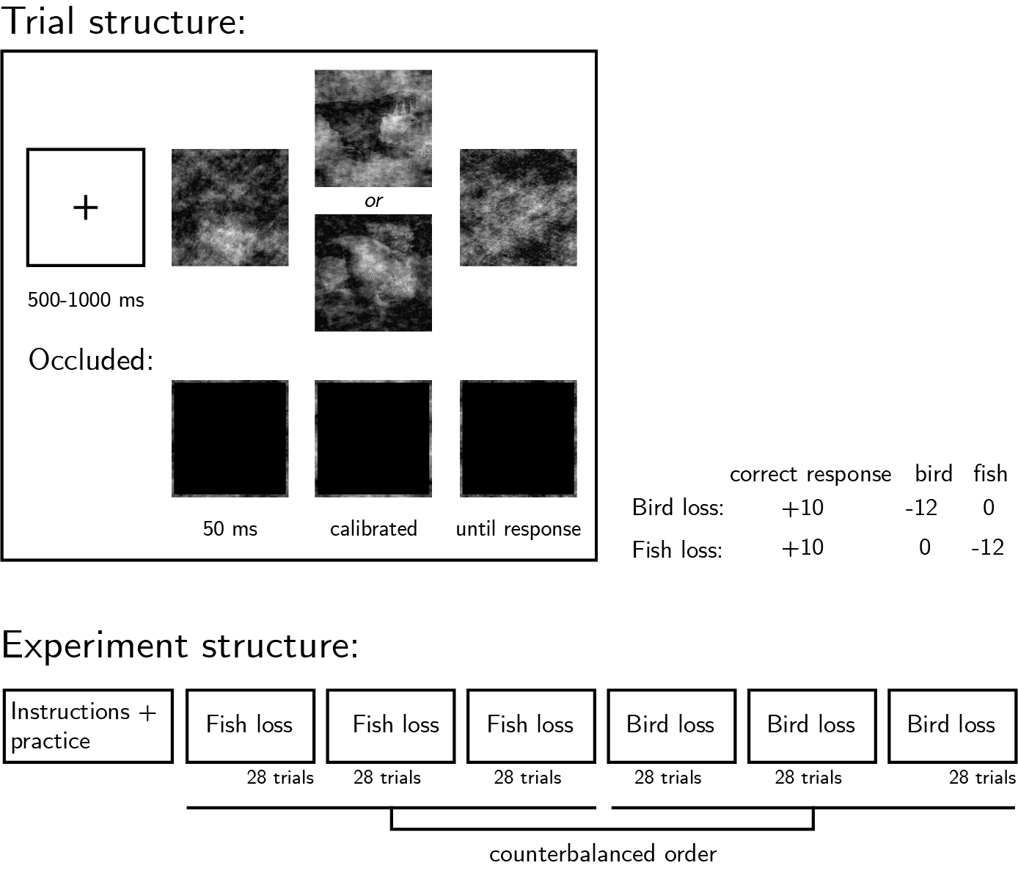

*Figure* *1.*  Experimental design. Top left: Trial structure. Presentation time will be calibrated to achieve 70% accuracy. On occluded trials, a black square will occlude the images. Right: incentive structure on different experimental blocks. Bottom: Overall experiment structure.

### Randomization.

The order and timing of experimental events will be determined pseudo-randomly by the Mersenne Twister pseudorandom number generator, initialized in a way that ensures registration time-locking (Mazor, Mazor, & Mukamel, 2019).

## Rejection criteria

Participants will be excluded if their accuracy falls below 50% in the non-occluded trials of one or more experimental conditions (bird-loss and fish loss). We will also exclude participants for having extremely fast or slow reaction times in one or more of the tasks (below 100 milliseconds or above 5 seconds in more than 25% of the trials). Trials with response time below 100 milliseconds or above 5 seconds will be excluded from the response-time analysis.

## Data analysis

This study is designed to test several hypotheses regarding the effect of motivation on perception, with a focus on perceptual decisions and response time. Specifically, we plan to test the following hypotheses:

*Hypothesis 1 (MOTIVATED SEEING)*: We will test the null hypothesis that the proportion of reports of seeing a bird is similar on bird-loss and fish-loss non-occluded trials, using a two-tailed repeated measures t-test.

*Hypothesis 2 (MOTIVATED GUESSING)*: We will test the null hypothesis that the proportion of reports of seeing a bird is similar on bird-loss and fish-loss occluded trials, using a two-tailed repeated measures t-test.

*Hypothesis 3 (INTERACTION: BIAS)*: We will test the null hypothesis that motivated seeing and motivated guessing effects are similar in magnitude, using a two-tailed repeated measures t-test.

*Hypothesis 4 (LOSS EFFECT ON DECISION TIME: PERCEPTION TRIALS)*: We will test the null hypothesis that response times for images that are associated with a loss are similar to response times for neutral images. This will be tested using a paired t-test on the median individual level-response times (correct trials only).

*Hypothesis 5 (LOSS EFFECT ON DECISION TIME: GUESSING TRIALS)*: We will test the null hypothesis that response times for guessing that the occluded image was associated with a loss are similar to response times for guessing that the occluded image was not associated with a loss. This will be tested using a paired t-test on the median individual level-response times.

*Hypothesis 6 (INTERACTION: RESPONSE TIME)*: We will test the null hypothesis that decision time differences between loss and neutral stimuli are similar in magnitude in occluded and non-occluded trials, using a two-tailed repeated measures t-test.

# References

Balcetis, E., Dunning, D., & Granot, Y. (2012). Subjective value determines initial dominance in binocular rivalry. *Journal of Experimental Social Psychology*, *48*(1), 122–129.

Leong, Y. C., Dziembaj, R., & D’Esposito, M. (2021). Pupil-linked arousal biases evidence accumulation toward desirable percepts during perceptual decision-making. *Psychological Science*, *32*(9), 1494–1509.

Leong, Y. C., Hughes, B. L., Wang, Y., & Zaki, J. (2019). Neurocomputational mechanisms underlying motivated seeing. *Nature Human Behaviour*, *3*(9), 962–973.

Mazor, M., Mazor, N., & Mukamel, R. (2019). A novel tool for time-locking study plans to results. *European Journal of Neuroscience*, *49*(9), 1149–1156.

Meuwese, J. D., Loon, A. M. van, Lamme, V. A., & Fahrenfort, J. J. (2014). The subjective experience of object recognition: Comparing metacognition for object detection and object categorization. *Attention, Perception, & Psychophysics*, *76*(4), 1057–1068.