**שאלה 1:**

DELIMITER $$

CREATE procedure myPrecuder (IN CID varchar(5))

BEGIN

SELECT cus.orderID,

CASE WHEN sum(ap.avargeProudct*od.Quantity)-sum(od.unitPrice*od.Quantity)<0 then 'Loss'

WHEN sum(ap.avargeProudct*od.Quantity)-sum(od.unitPrice*od.Quantity)>0 then 'Profit'

else 'Equal' END as 'Profit/Loss',

abs(sum(ap.avargeProudct*od.Quantity)-sum(od.unitPrice*od.Quantity)) Amount

FROM

(SELECT orderID

FROM orders

WHERE customerID like CID) cus

JOIN

`order details` od on cus.OrderID=od.OrderID

JOIN

(SELECT ProductID, orderID, Avg(unitprice) avargeProudct

FROM `order details`

GROUP BY ProductID) ap

on od.ProductID=ap.ProductID

GROUP BY cus.orderID

ORDER BY orderID desc;

END $$

DELIMITER ;

import java.sql.*;  
import java.util.Scanner;  
  
public class Question1 *{* public static void main(String[] args) *{* System.*out*.println("Please insert CustomerID:");  
 Scanner s= new Scanner(System.*in*);  
 String CID= s.nextLine();  
 try *{* Class.*forName*("com.mysql.jdbc.Driver");  
 try (Connection con = DriverManager.*getConnection*("jdbc:mysql://localhost/northwind", "root", "123456")) *{* Statement stmt = con.createStatement();  
 ResultSet rs = stmt.executeQuery("call myPrecuder('"+CID+"')");  
 int numOfColumns = rs.getMetaData().getColumnCount();  
 while (rs.next()) *{* for (int col = 1; col <= numOfColumns; col++) *{* System.*out*.print(rs.getString(col) + " ");  
 *}* System.*out*.println();  
 *}  
 }  
 }* catch (Exception ex) *{* ex.printStackTrace();  
 *}  
 }*}

**שאלה 2:**

DELIMITER $$

CREATE TRIGGER remove_order

BEFORE DELETE on orders

FOR EACH ROW

BEGIN

DROP TEMPORARY TABLE IF EXISTS units;

CREATE TEMPORARY TABLE units as

SELECT t.productId as pid, SUM(t.unitsinstock + t.quantity) as sum

FROM (

SELECT O.orderID, O.ProductID, P.unitsinstock, Quantity

FROM `order details` as O JOIN Products as P on O.ProductID=P.ProductID ) as t

WHERE t.orderID = old.orderID

GROUP BY t.orderID,t.ProductID;

UPDATE products JOIN units on units.pid=products.productID

SET products.unitsInStock = units.sum;

DELETE FROM `order details` WHERE old.orderID= `order details`.orderID;

END $$

DELIMITER ;

**שאלה 3:**



SELECT OrderID, RequiredDate

FROM orders

WHERE ShippedDate is NULL and RequiredDate<NOW()

ב. נשלוף את כל ההזמנות אשר היו אמורות להשלח בתאריך קודם להיום ולא נשלחו עוד.

**שאלה 4:**

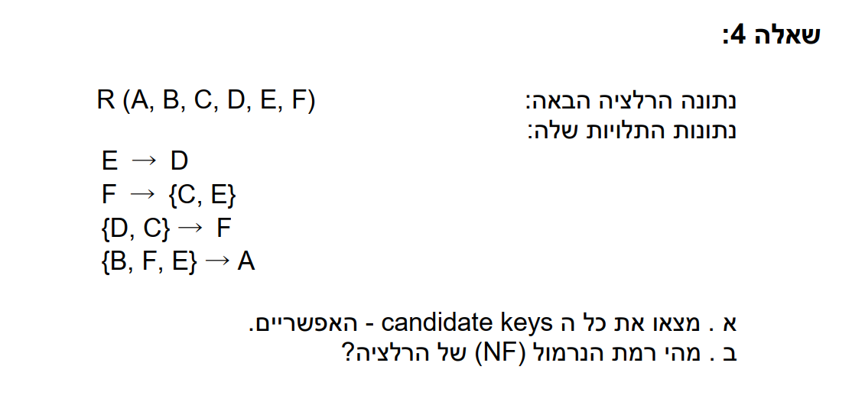

Candidate key: BF, BCD, BCE

Non-Prime- A

Normal-Form- 3NF

* 1NF- מניחים.
* 2NF- (none prime) A לא תלוי בתת קבוצה של Candidate key.
* 3NF- (none prime) A תלוי **רק** ב super key (BFE).
* 3.5NF- אינו מתקיים. כי יש לנו איברים בצד שמאל שאינם super key. למשל E.