* Correct normalization
* We prefer downsampling with stepsize rather than pooling in small imgs.

Cifar 1.2.1

Low acc tried increasing capacity of the model. Didn’t help much

* Trained with l1 instead of mse. Results:

50.38

Cifar 1.2.2

Had high overfitting , tried adding droput

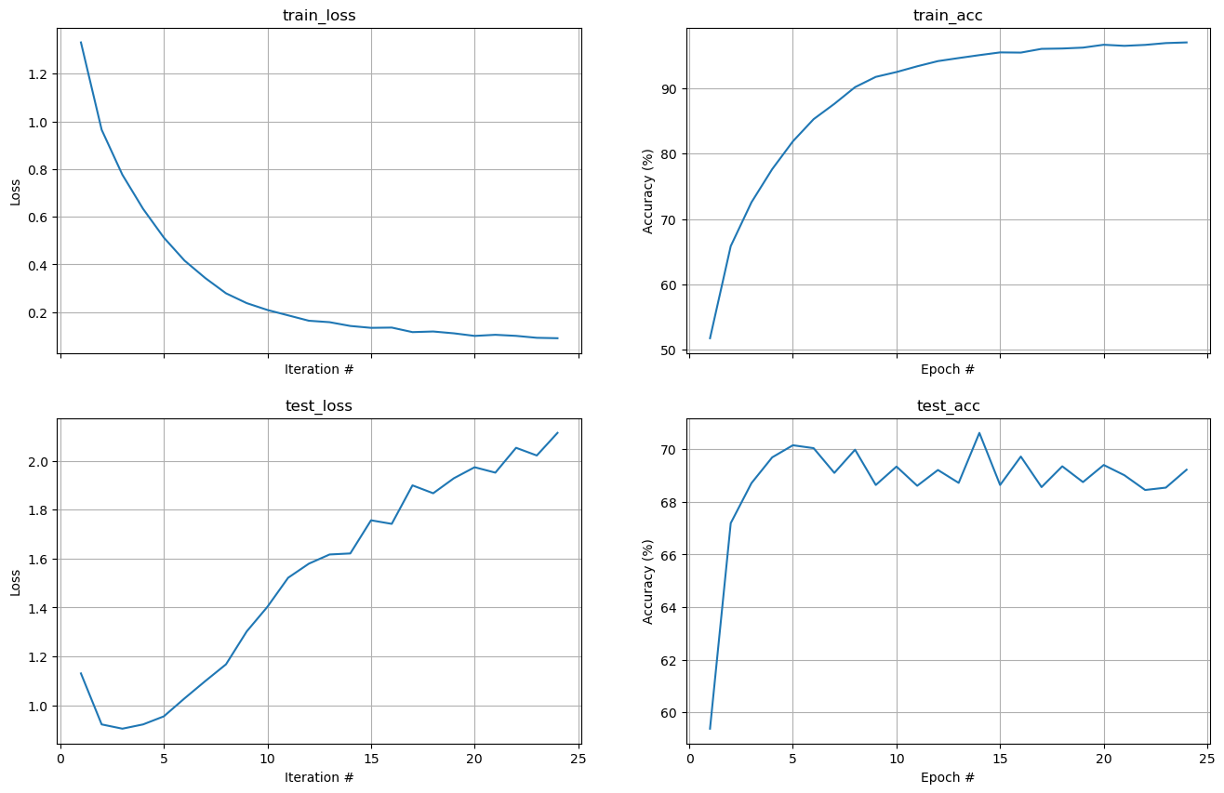

Worked –

