I used xampp for the database

1. After extracting the zip file go to xampp folder and put the commission folder in the htdocs

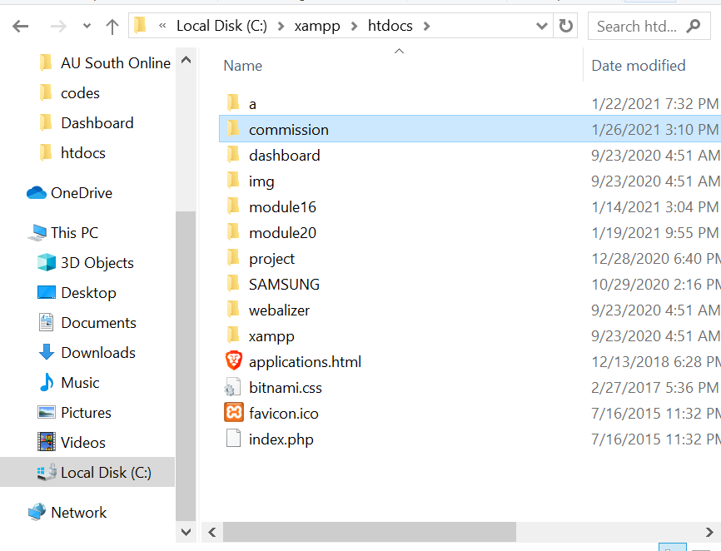

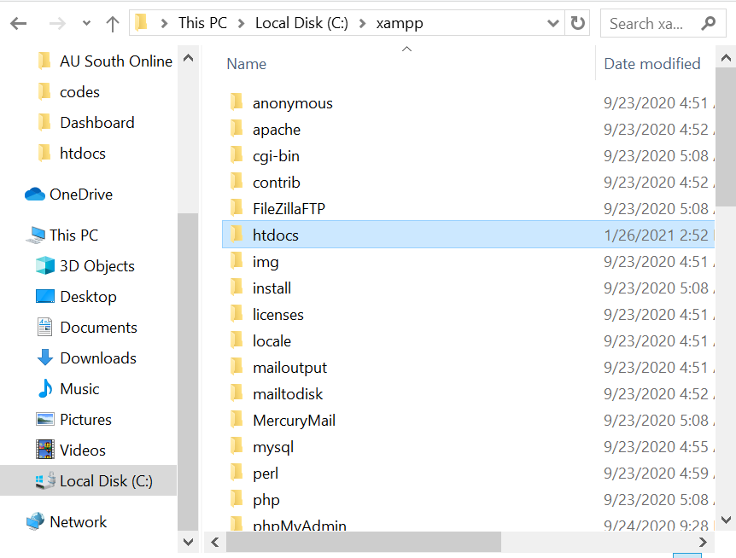

1. Now open your xampp control panel (start apache and mysql) and click admin

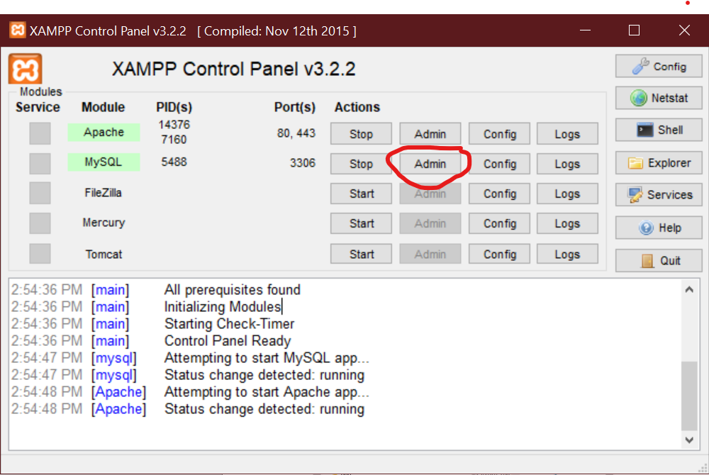

1. Go to databases and create database named “management_db” then click create

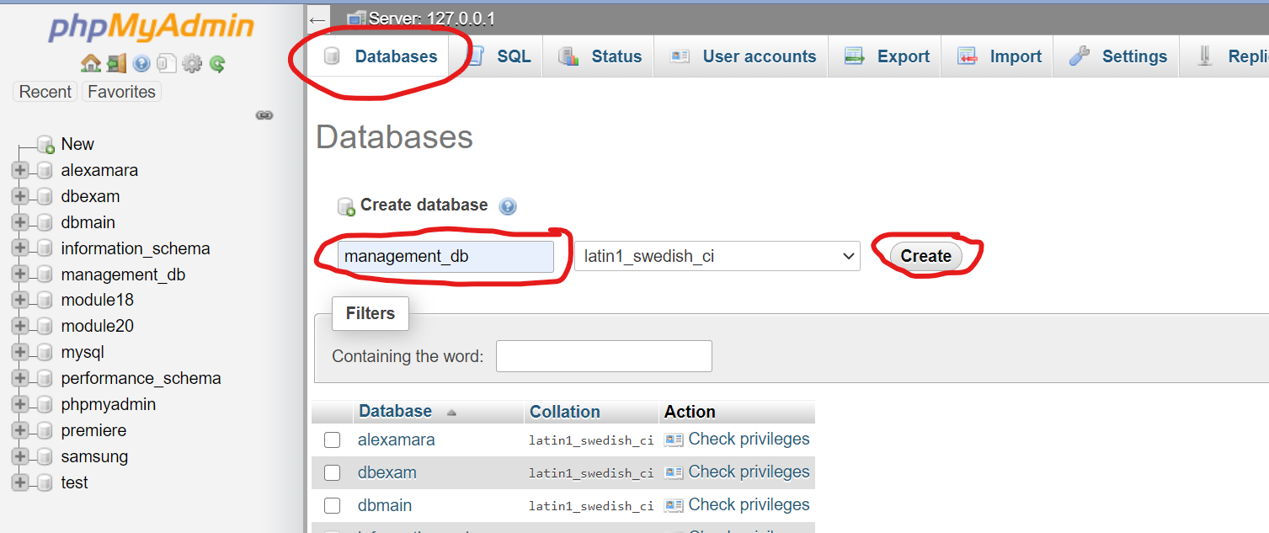

1. After creating the database go to import and choose file

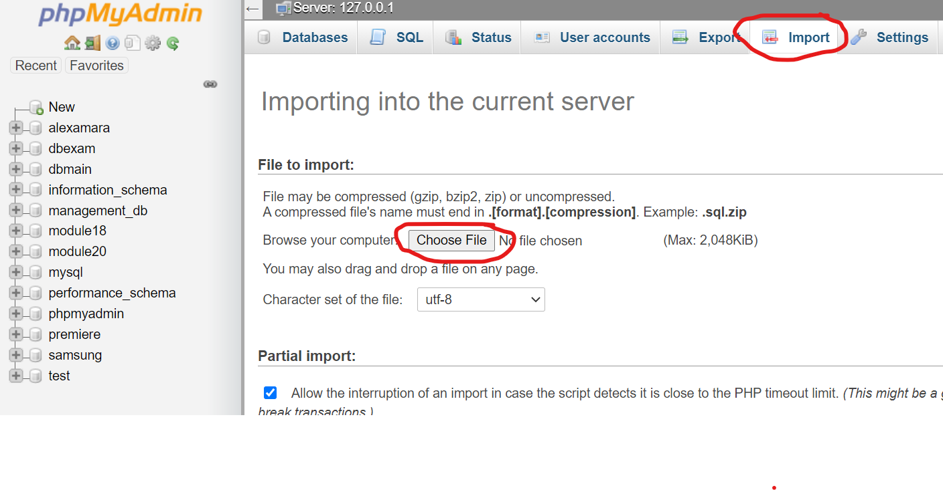

1. 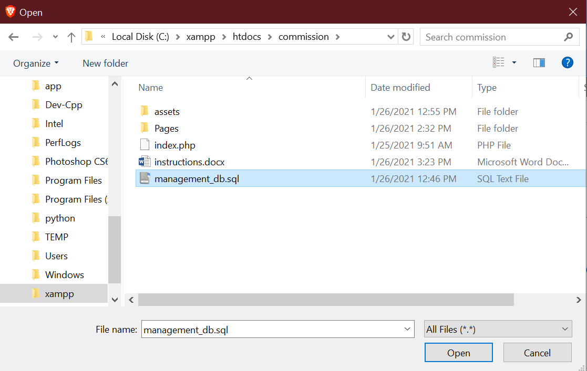The file is In the commission folder select management_db.sql and click open
2. Scroll down and click go

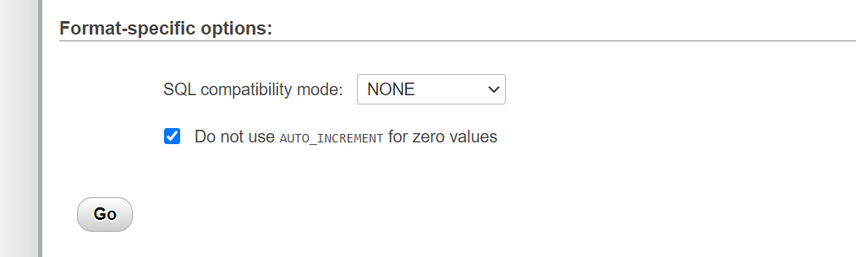

1. Now you can finally open the project just go to <http://localhost/commission/>

