Replacement of the cam (532550) that drives from the center of the machine the support and testing stations in machine 222

Registrar: Tzvika Ivgi and Fadi Sleiman. 12.12.2024

Operating technical team: Austin Ashmoz, Gassan Maron.

Background: In the past year, the cam was replaced twice (before 11/2024), and the spring piston was also replaced once (for added safety). Each time, after almost two months, the cam wore out again.

* On 12.11.2024, in work order 581433, lot 242668277-03, bag number 291, the machine was re-inspected and the following findings were made:
* The cam and cam follower are worn out - replaced with new ones

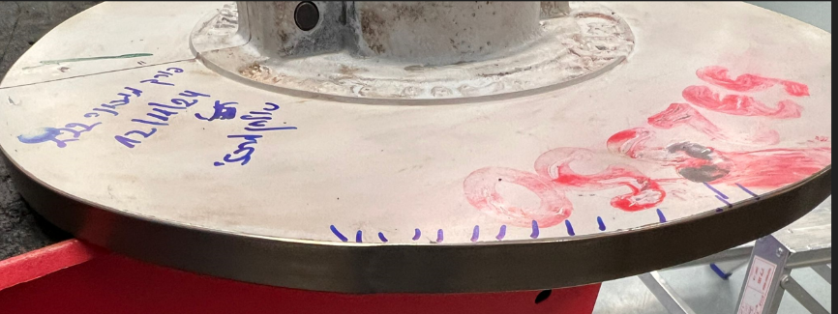

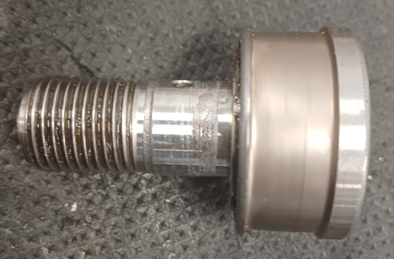

* Station 24 - when the station goes all the way down, it stops on the block, meaning there was no gap between the fixed block and the dynamic block, but in this situation, the cam follower was checked and it appears it does not rotate, meaning the station is functioning properly and the cam has not separated from the cam follower. In all this, it is necessary to adjust so that there will be a safety gap - at least a few millimeters.

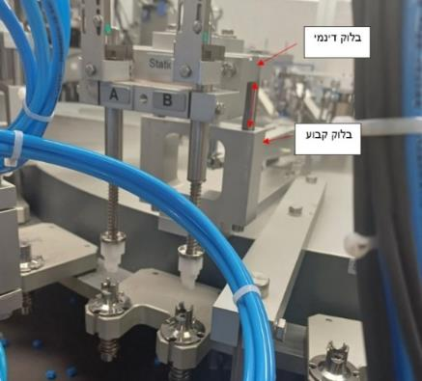

* Screw station - body support during screw insertion
* When the station is in locking mode, the screw (the mechanical stopper) touches the block holding it - the block was sharpened.
* The top screw holding the entire assembly of the mechanical stopper broke - replaced with a new one.
* When the station is in idle mode (during the table rotation), the stopper screw head hit the base plate, which could have caused mechanical pressure on the cam in the damaged area - fixed so that there is a large clearance between the screw and the plate.
* When the body's support was in the most forward position, the joint was not straight – as if it were supposed to be straight.

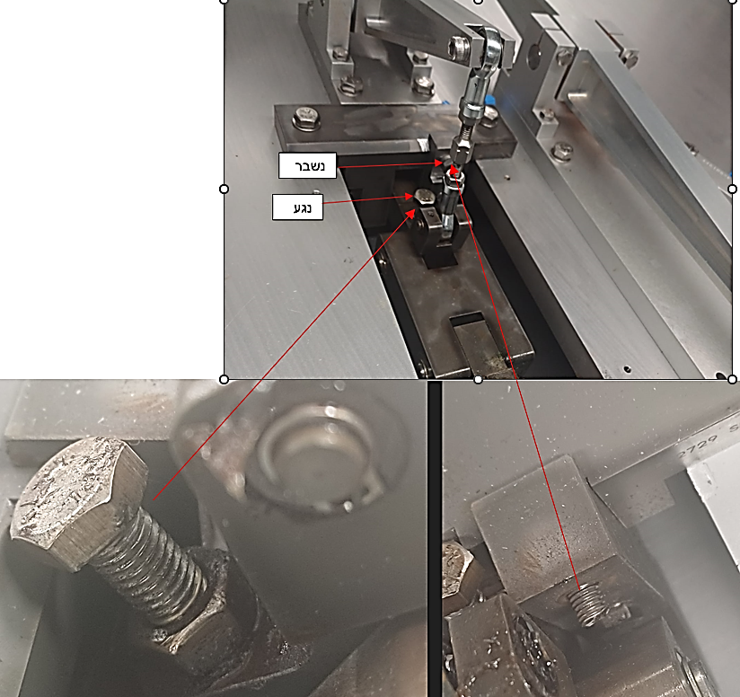

The slot at the body support bushing location in the rotational plane was enlarged by approximately 2 mm, and 1 mm was also milled from its rear part.

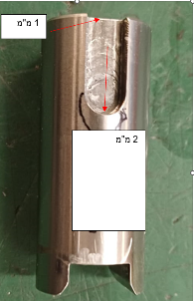

The machine was operated after the adjustments and checked after a week. It was inspected by a technician and no vibrations were observed.

* On 24/11/24 during a re-inspection, vibrations were again observed on the test stations table.
* Upon inspection, it appeared that the cam follower was stuck and not indexed – it was replaced.
* After disassembly, signs of wear were visible on it and no new grease was seen.
* On the new cam, signs of wear were observed on the cam edge; it was decided to replace it during the next operation.
* Grease pipe disassembled, upon inspection it appeared empty of grease, we were unable to insert grease into it using a manual grease gun – the valve connected to the grease manifold was replaced, and grease was injected into the pipe.
* After reassembly on the arm with a cam follower, grease is expected to be expelled from the bearing during manual greasing.
* Additionally, a check of the central axis for freedom of movement was performed after disconnecting all the stations connected to it - found to be in good condition.
* The lower part of the lower vertical motion bearing was inspected - it was found that the holder of
* The lower centering bearing may touch the bearing screws – there is a gap of only 0.4 mm.
* On the block above the screws, contact marks from the screw were found.
* It was decided to increase the distance during the continuation operation.
* On 12/2/24 we performed a follow-up action.
* Replacing a new cam, checking grease output at the cam follower, and peripheral greasing
* Increasing the gap between the vertical bearing and the upper block by approximately 5 mm

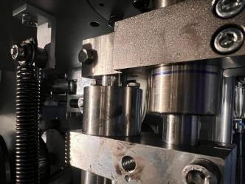

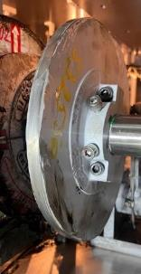

* We increased the automatic firmware update frequency in the machine from once every 40,000 to once every 30,000.
* On 12/8/24 we performed a reinspection of the cam clearance.
* During the inspection, we found that there is a lot of play in the axis on which the arm is mounted.
* We replaced the bearings in this arm, and in the second arm that sits on the shaft (the clamp rotator).
* We saw that the amount of grease coming out of the cam cube is small.
* We installed a new valve on the grease tube, but no grease came out when we connected to the splitter.
* As a result, we connected a grease tube from another arm (adjacent and more accessible) to this cam follower, and to the arm from which we disconnected, we connected a grease tube with a Y-connector from another grease tube.
* Nir will look for valves with a built-in 4-pipe connection.
* In the test on machine 221, we saw that a flush is set every 10,000 cycles.
* We changed the setting to 10,000 also on machine 222.
* In every grease pulse, a small drop of grease exits at the cam follower.
* Follow-up activities to be carried out in the coming weeks:
* Follow-up cam grinding inspection in one week, and then every two weeks until the next three-month treatment.
* Tracking for the absence of vibrations on the test station table once a week during the upcoming month, after which the inspection frequency can be spaced out.
* Ordering new connection valves for the grease tube, with a 4 mm connection.
* On 07/01/24, light vibrations were detected at the testing stations.
* During inspection, it was found that the cam follower began to wear again. It was also noticed that the cam follower was heating up unreasonably.
* We checked the entire assembly again.
* It was also found that the lower pin of the connecting rod to the arm is worn.
* It was decided to replace the quick release valves on the piston, as well as to weaken the end-of-stroke dampers on the piston.
* In addition, the manufacturing engineering team (Lior, Dubi, Rotem) recommended increasing the pressure inside the piston, based on the assumption that the cam follower disconnects from the arm during the arm's downward movement, and upon reattachment, a small impact occurs between the cam follower and the cam.
* We increased the pressure from 4 bar to 5 bar.
* We conducted an experiment where we reduced the pressure in the piston to 2 bar, and then observed that vibrations developed in the test stations both during the increase and decrease.
* The piston stroke was checked in the two extreme positions of the cam:
* When the piston is fully open facing the arm - there is a clearance of 15 mm up to the end of the piston stroke.
* When the piston is fully closed against the arm - there is a clearance of 50 mm up to the end of the piston's stroke.
* Checked grease – intact. The cam follower contains grease inside.
* The cam – there is a slight impact at the point where the arm is in the lower position, currently causing very slight vibrations.

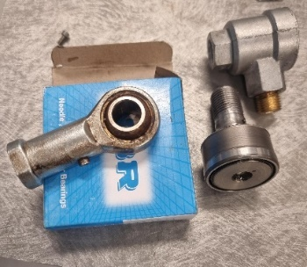

* On 20/01/20, we inspected the arm of the test stations in machine 223 at Deltone.
* Spring piston pressure – Bar 4

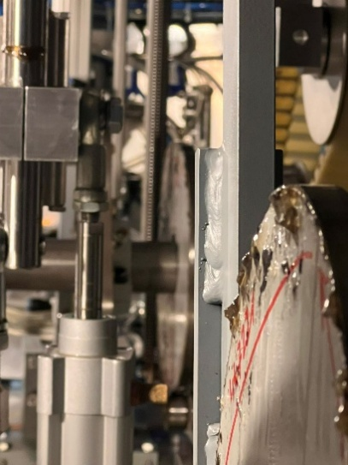

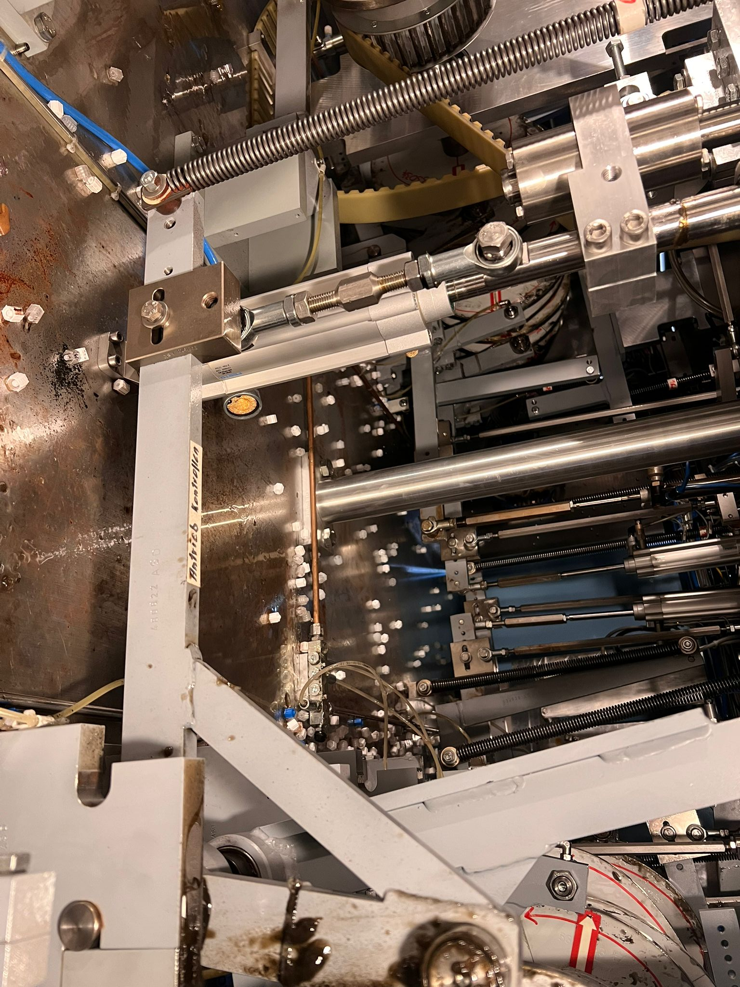

* On 25/01/29 vibrations appeared at the station.
* The cam follower is well machined but shows signs of wear.
* On 2/3/25, the following actions were performed:
* Replacement of the lower apple bearing with a rod (there was a missing disk between it and the stroke block)
* Replacement of cam and cam follower (with an additional ring between it and the arm)
* Checking clearances in the arm shaft bearings – normal
* Checking the freedom of movement of the table up and down, and repeat check against the nut support - OK
* Free grease passage inspection between the hose connector and the cam follower – OK (images 2+3)
* Increasing the piston pressure to 5.5 bar
* Verification of automatic lubrication setting – every 10,000 cycles
* Alignment of the two parallel blocks that guide the rod raising and lowering the small table (Picture 1)

Important – in the area opposite stations 7-8, the table vibrates slightly despite the reinforcements, and these vibrations are visible in the leg station supports! These are not vibrations coming from the cam at this stage when everything below is normal.

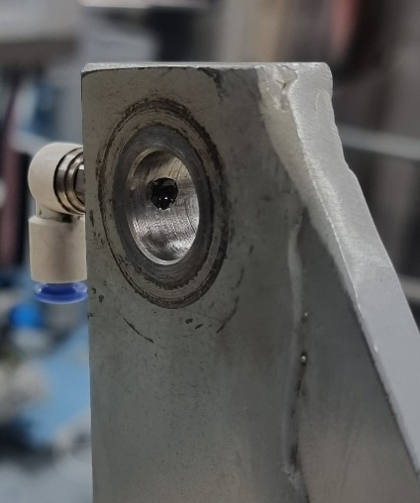

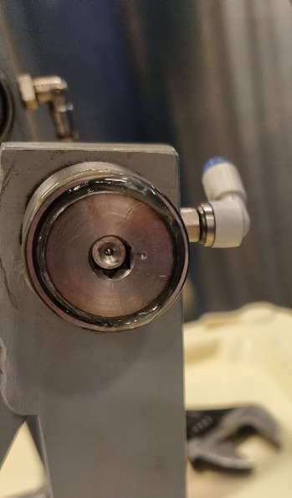

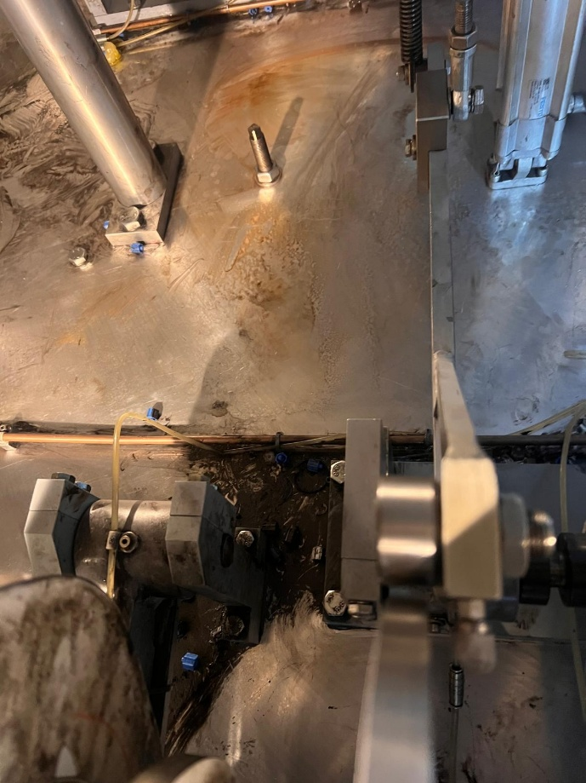

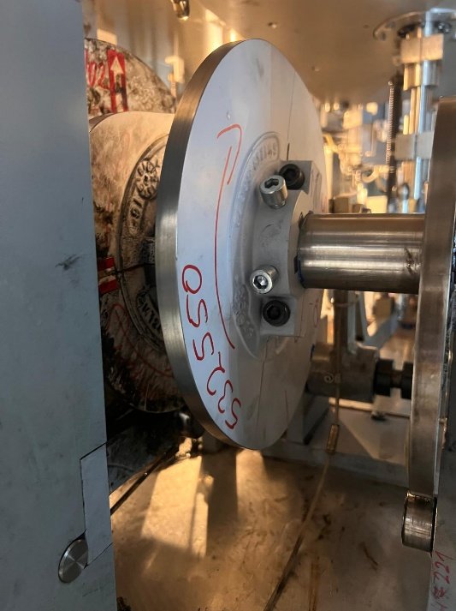

In the last three cams, the damage was at the same point - in the idle state, during the rotation of the table.  
We examined the cam area while in motion. We did not find any possible causes for the damage occurring at the cam location.

* Follow-up activities to be carried out in the coming weeks
* Checking the cam follower wear in a week, and then every two weeks until the next quarterly treatment.
* Tracking the absence of vibrations on the test station table once a week during the upcoming month, after which the inspection frequency can be spaced out.
* Transferring findings for consultation with Sortimat - Nir Lustig + Production Engineering
* On 2/6/25, an inspection was conducted in collaboration with Yair Kapri.
* We tested vibrations at 5 bar pressure in the piston – no vibrations were felt in the cam and the test station table.
* We tested vibrations at 3 bar pressure in the piston – no vibrations were felt in the cam and the test station table.
* Slow-motion imaging was performed in both of the above cases. It does not appear that the cam follower separates from the cam in either of the two pressures.
* We checked the rear support at the ohm station – intact, without looseness or collisions
* We checked the central rod – there is no play – the movement of the rod in the bearing is freely up and down
* Review dated 11/2/25
* Normal

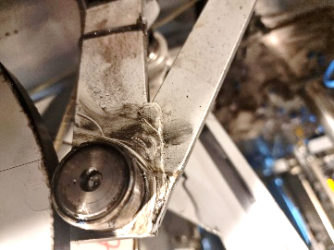

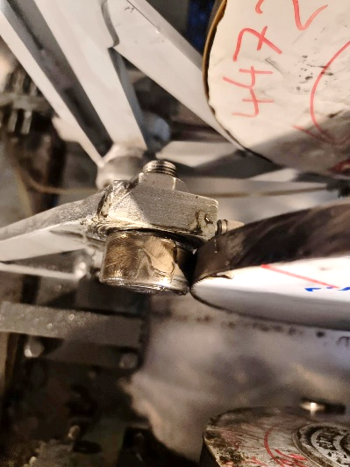

* Review dated 3/3/25
* There are slight wear marks on the cam follower; it was replaced with a new cam follower supplied by Sortimat.
* The old cam follower is disassembled while rotating freely and properly lubricated.

