**Deep Learning - 236606 - HW1**

Ido Glanz - 302568936 Matan Weksler - 302955372

1. **Distance of point to hyperplane**
   1. Given a hyperplane $H_{w,b}$ and a point $x_{0}$;

We will write the constrained optimization problem whose solution is the distance from to

* 1. We will use the Lagrange multipliers method to solve the optimization problem:

$$F\left(x,λ\right)={\left(f\left(x,x_{0},w,b\right)\right)}^{2}+λg\left(x,x_{0},w,b\right)=$$

$$={\left(x_{0}-x\right)}^{T}\left(x_{0}-x\right)+λ\left(w^{T}x+b\right)$$

We than derivate the equation w.r.t x and $λ$ and equate to zero:

$$\frac{∂F}{∂x}=0=2{\left(x-x_{0}\right)}^{T}+λw^{T}=$$

$$\left(1\right) x=x_{0}-\frac{λ}{2}w$$

$$\left(2\right) \frac{∂F}{∂λ }=0= w^{T}x+b$$

Substituting (1) in to (2):

$$w^{T}\left(x_{0}-\frac{λ}{2}w\right)+b=0$$

$$λ=\frac{2\left(w^{T}x_{0}+b\right)}{w^{T}w}$$

Substituting $λ$ back:

$$λ=\frac{2\left(w^{T}x_{0}+b\right)}{w^{T}w}$$

$$x=x_{0}-\frac{\left(w^{T}x_{0}+b\right)}{w^{T}w}w$$

We now have the $argmax_{x}f^{2}=argmax_{x}f$ (due to f being monotone). Calculating the distance between the point we found and $x_{0}$ we obtain:

$$d=\left\|x_{0}-\frac{\left(w^{T}x_{0}+b\right)}{w^{T}w}w-x_{0}\right\|=\left\|-\frac{\left(w^{T}x_{0}+b\right)}{w^{T}w}w\right\|=\left\|\frac{\left(w^{T}x_{0}+b\right)}{‖w‖}\right\|$$

And we got the formula obtained in class

1. **Perceptron**
   1. Prove $h_{\hat{w} }(\hat{x})=h_{w}(x)$ where:

Proof:

* 1. We now prove that if a linear separator with margin $γ$ exsits for S, then the margin perceptron algorithm, will make at most $\frac{12}{γ^{2}}$ mistakes on S.

We will first show $\left\|w_{t+1} \right\|≤\left\|w_{t} \right\|+\frac{1}{2\left\|w_{t} \right\|}+\frac{γ}{2}$:

Notice;

$${\left\|w_{t+1} \right\|}^{2}={\left\|w_{t}+xy\right\|}^{2}={\left\|w_{t} \right\|}^{2}+2{yxw}_{t}+{\left\|x \right\|}^{2}={\left\|w_{t} \right\|}^{2}\left(1+\frac{2{yxw}_{t}}{{\left\|w_{t} \right\|}^{2}}+\frac{{\left\|x \right\|}^{2}}{{\left\|w_{t} \right\|}^{2}}\right)$$

We saw in class that: ${\left\|x\right\|}^{2}≤1$ due to x being on the unit sphere, and $\frac{yw_{t}x}{\left\|w_{t} \right\|}≤\frac{γ}{2}$ on x. Hence taking the root of the above we obtain:

$$\left\|w_{t+1} \right\|≤\left\|w_{t} \right\|{\left(1+\frac{γ}{\left\|w_{t} \right\|}+\frac{1}{{\left\|w_{t} \right\|}^{2}}\right)}^{\frac{1}{2}}$$

Using Taylor expansion, we can substitute $\sqrt{1+a} ≈1+\frac{a}{2}$:

$$\left\|w_{t+1} \right\|≤\left\|w_{t} \right\|+\frac{γ}{2}+\frac{1}{2\left\|w_{t} \right\|}$$

We will now see what happens when $\left\|w_{t} \right\|≥\frac{2}{γ}$:

$$\left\|w_{t+1} \right\|≤\left\|w_{t} \right\|+\frac{3γ}{4}$$

We saw in class $\left\|w_{t+1} \right\|≤\left\|w_{t} \right\|+1$, now after M iteration we obtain (similar to what was done in the lecture):

$$\left\|w_{M+1} \right\|≤1+\frac{2}{γ}+\frac{3Mγ}{4}$$

and for $Mγ≤\left\|w_{M+1} \right\|$:

$$Mγ≤1+\frac{2}{γ}+\frac{3Mγ}{4} →\boxed{M≤\frac{12}{γ^{2}}}$$

1. **Ridge Regression**

Given the ERM training strategy:

$$L\left(w,b\right)=\frac{1}{2m}{\left\|Xw+b1-y\right\|}_{2}^{2}+λ{\left\|w\right\|}_{2}^{2}$$

$$= \frac{1}{2m}{\left(Xw+b1-y\right)}^{T}\left(Xw+b1-y\right)+λ{\left(w\right)}^{T}\left(w\right)$$

we will first rearrange the equation above:

$$\frac{1}{2m}{\left(Xw+b1-y\right)}^{T}\left(Xw+b1-y\right)+λ{\left(w\right)}^{T}\left(w\right)=\frac{1}{2m}\left(w^{T}X^{T}+b1^{T}-y^{T}\right)\left(Xw+b1-y\right)+λ{\left(w\right)}^{T}\left(w\right)=\frac{1}{2m}\left(w^{T}X^{T}Xw+w^{T}X^{T}b1+w^{T}X^{T}y+b1^{T}Xw+b1^{T}b1+b1^{T}y+y^{T}Xw+y^{T}b1+y^{T}y\right)+λw^{T}w$$

we denote: $b1^{T}b1=b^{2}m$ as b is a scalar, and $w^{T}X^{T}b1=b1^{T}Xw=0$ as the samples are centered hence it’s average times b = 0.

We now have:

* 1. We will now compute $– \frac{∂L}{∂b}$:
 $$\frac{∂L}{∂b}=\frac{1}{2m}\left(2mb+1y+y^{T}1\right)= b-\frac{1}{m}\sum_{i=1}^{m}{y_{i}}$$

 2. And for the derivative w.r.t w we get:
 $$\frac{∂L}{∂w}=\frac{1}{m}{(wX}^{T}X-y^{T}X)+2λw^{T}$$

 3. Assuming $λ>0$, infer the solution obtained by equating the derivatives from 3(A) and 3(B) to 0:

$$\left(1\right) b=\frac{1}{m}\sum_{i=1}^{m}{y_{i}} \left(2\right) \frac{1}{m}{(wX}^{T}X-y^{T}X)+2λw^{T}=0$$

$${wX}^{T}X+2mλw^{T}=y^{T}X→transposing both sides we get:$$

$$\left(X^{T}X+2mλI\right)w=X^{T}y→w={\left(X^{T}X+2mλI\right)}^{-1}X^{T}y$$

In the next section, we will show why $X^{T}X+2mλI$ is positive definite and hence invertible. Also, being positive definite there is a single solution and it is the global minimum of the function.

* 1. In the last section we obtained $M=X^{T}X+2mλI$. Assuming $λ>0$, we will prove M is invertible due to being positive definite:

$X^{T}X$ is a gram matrix and is hence positive semidefinite (meaning is it $≥0$), $2mλI$, as $λ$ is greater than 0 and so M is positive-definite.

* 1. The advantages of the Ridge Regression method is as we’ve seen above, as long as $λ>=0$, M is positive-definite and hence invertible, leading to a single and global minimum for our problem.

1. **Binary Classification using Ridge Regression:**

Training Set:

------------- Lambda = 1e-05-------------

Analytic: 0/1 Loss = 0.10506000000000001, Square loss = 0.3848223593949477

Gradient Decent: 0/1 Loss = 0.15026, Square loss = 0.4770427522576504

Validation Set:

------------- Lambda = 1e-05-------------

Analytic: 0/1 Loss = 0.09620000000000001, Square loss = 0.3681495912984633

Gradient Decent: 0/1 Loss = 0.138, Square loss = 0.455714139091732

Training Set:

------------- Lambda = 0.0001-------------

Analytic: 0/1 Loss = 0.10534, Square loss = 0.3852902716901684

Gradient Decent: 0/1 Loss = 0.15026, Square loss = 0.4770489997987863

Validation Set:

------------- Lambda = 0.0001-------------

Analytic: 0/1 Loss = 0.09670000000000001, Square loss = 0.3680395483842602

Gradient Decent: 0/1 Loss = 0.138, Square loss = 0.45572133256623004

Training Set:

------------- Lambda = 0.001-------------

Analytic: 0/1 Loss = 0.10674000000000002, Square loss = 0.38702297617025144

Gradient Decent: 0/1 Loss = 0.15026, Square loss = 0.47711155190041343

Validation Set:

------------- Lambda = 0.001-------------

Analytic: 0/1 Loss = 0.09680000000000001, Square loss = 0.3673293410755911

Gradient Decent: 0/1 Loss = 0.13820000000000002, Square loss = 0.4557933419050195

Training Set:

------------- Lambda = 0.01-------------

Analytic: 0/1 Loss = 0.11402000000000001, Square loss = 0.3984509927523093

Gradient Decent: 0/1 Loss = 0.15038, Square loss = 0.4777446490293447

Validation Set:

------------- Lambda = 0.01-------------

Analytic: 0/1 Loss = 0.1037, Square loss = 0.3742663699065845

Gradient Decent: 0/1 Loss = 0.1383, Square loss = 0.4565208008240802

Training Set:

------------- Lambda = 0.1-------------

Analytic: 0/1 Loss = 0.13224000000000002, Square loss = 0.4384801661382786

Gradient Decent: 0/1 Loss = 0.15152000000000002, Square loss = 0.48474661759407917

Validation Set:

------------- Lambda = 0.1-------------

Analytic: 0/1 Loss = 0.1188, Square loss = 0.4144005145227963

Gradient Decent: 0/1 Loss = 0.1398, Square loss = 0.4644445220180887

Training Set:

------------- Lambda = 1-------------

Analytic: 0/1 Loss = 0.16038000000000002, Square loss = 0.5705970170330118

Gradient Decent: 0/1 Loss = 0.1615, Square loss = 0.5746047505802111

Validation Set:

------------- Lambda = 1-------------

Analytic: 0/1 Loss = 0.1516, Square loss = 0.5570021917188126

Gradient Decent: 0/1 Loss = 0.1526, Square loss = 0.5612373901061849

Training Set:

------------- Lambda = 10-------------

Analytic: 0/1 Loss = 0.19602000000000003, Square loss = 0.8678484668338203

Gradient Decent: 0/1 Loss = 0.19282000000000002, Square loss = 0.8678568706896871

Validation Set:

------------- Lambda = 10-------------

Analytic: 0/1 Loss = 0.19240000000000002, Square loss = 0.8656610325813602

Gradient Decent: 0/1 Loss = 0.1889, Square loss = 0.8656336480669078

Training Set:

------------- Lambda = 100-------------

Analytic: 0/1 Loss = 0.39388, Square loss = 0.9831052092037058

Gradient Decent: 0/1 Loss = 0.67034, Square loss = 4.608377068721547

Validation Set:

------------- Lambda = 100-------------

Analytic: 0/1 Loss = 0.3956, Square loss = 0.9830812896333874

Gradient Decent: 0/1 Loss = 0.6659, Square loss = 4.485072791010506

**Best Lambda for analytic: 1e-05**

**Best Lambda for GD: 1e-05**

**Test Set:**

**------------- For the best Lambda found (different for each scheme) -------------**

**Analytic: Lambda = 1e-05, 0/1 Loss = 0.10590000000000001, Square loss = 0.3884744552245516**

**Gradient Decent: Lambda = 1e-05, 0/1 Loss = 0.1491, Square loss = 0.470738027690171**

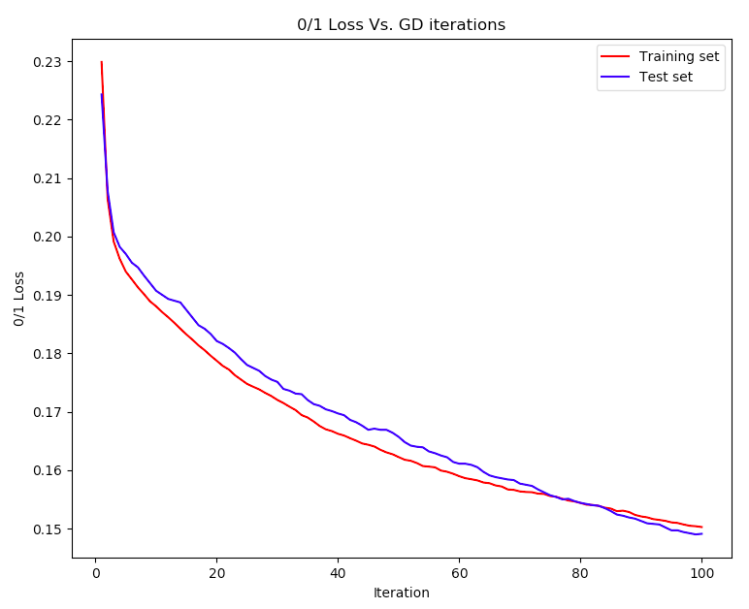

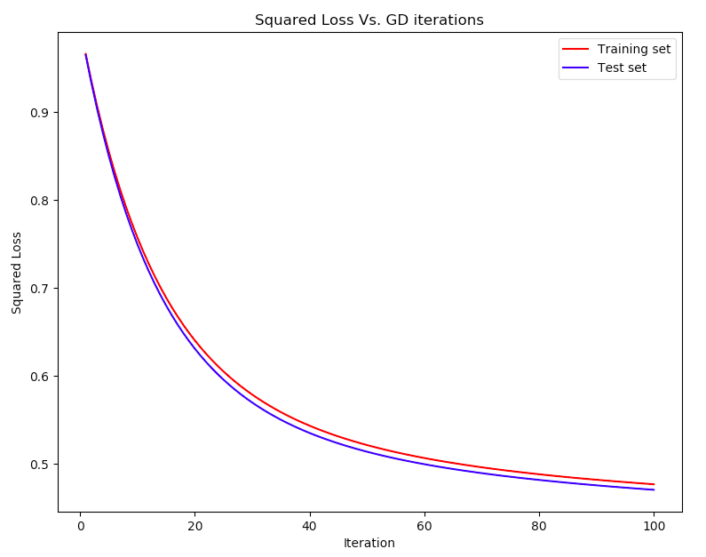

A simple case where the linear regression is a bad idea would be in the XOR example as we saw in class. As this function is not linearly separable, it could not output a good classifier. Another simple example would be any problem not linearly separable and hence not suitable for this kind of classification.