A Quick SPIM Tutorial

SPIM is a MIPS architecture simulator. It allows you to run a program written in MIPS assembly language on a fake microprocessor. You can control the execution by single-stepping the program or setting breakpoints, and observe the effect of each instruction on registers and memory.

In order to run SPIM, you must have access to:

- A Windows machine on which you have installed pcspim, OR
- A Linux machine on which you have installed xspim, OR
- An ITLABS machine, which already has xspim installed.

Running a simple program under SPIM on Linux:

- Download the sample programs from (WHERE?). You should have three programs, named simple2.s, simple3.s, and simple4.s
- Run SPIM using the following command-line: xspim -notrap simple2.s
- The xspim window should appear. It will look like this:
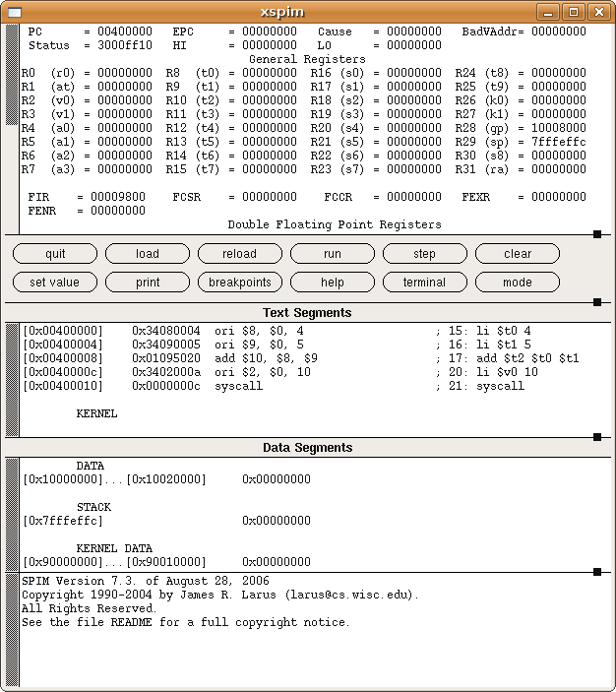
- There are four panels in the xspim window:
  - The top panel shows the state of the microprocessor, including the contents of the 32 general purpose registers, along with the PC and several other specialized registers that we won't need to worry about.
  - The second panel (below the buttons) shows what is called the "Text Segment", which contains the instructions of our program. Yes, the name "Text" is confusing: in the context of looking at the assembly code of a program, this always means code.
  - Below that is the "Data Segment", which doesn't contain anything interesting for this program because we don't store anything in memory.
  - The last panel is for messages from SPIM about the operation of our program.
- Now we will run our program. Take a look in the top panel at the registers R8, R9, and R10. In our program we use the standard aliases $t0, $t1, and $t2. All of them should have the value 00000000 (hex).
- Click the "run" button and press "ok". You might not notice anything, but the program has been executed. If you look again at $t0, $t1, and $t2, you will see that they now have the values 4, 5, and 9. This is what you'd expect if you look at the main body of the program we loaded.
- If you want to see the program run one instruction at a time, reset the machine by pressing the "reload" button and choosing "assembly file". Then press the "step" button, which brings up a small window. Press the "step" button in this new window several times and you can see the program execute one instruction at a time. The only interesting thing to watch in this program is the loading of values into registers $t0 and $t1, and then the add instruction produces a result in $2. You can also watch the PC move forward with each instruction executed.

Running a simple program under SPIM on Windows:

- Download the sample programs from (WHERE?). You should have three programs, named simple2.s, simple3.s, and simple4.s
- Run SPIM by double-clicking on the “pcspim.exe” icon. Two windows will open, the main PCSpim window and one called “console” that you can ignore.
- If the text is too big for your display, change the font using Simulator->Set Font. Try Courier New, size 8.
- The first time you run pcspim, you need to open Simulator->Settings, and un-check the box labeled “Load exception file.”
- Use File->Open and load the file “simple2.s”. Your window should now look like this:
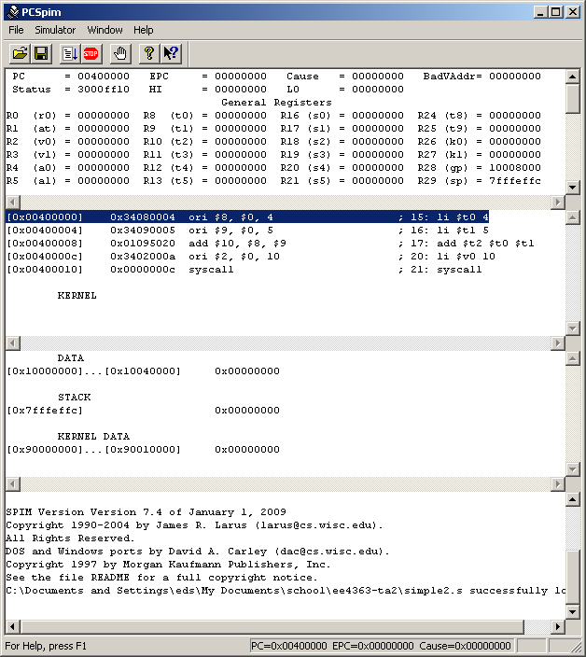

- There are four panels in the pcspim window:
  - The top panel shows the state of the microprocessor, including the contents of the 32 general purpose registers, along with the PC and several other specialized registers that we won't need to worry about.
  - The second panel shows what is called the "Text Segment", which contains the instructions of our program. Yes, the name "Text" is confusing: in the context of looking at the assembly code of a program, this always means code.
  - Below that is the "Data Segment", which doesn't contain anything interesting for this program because we don't store anything in memory.
  - The last panel is for messages from SPIM about the operation of our program.
- Now we will run our program. Take a look in the top panel at the registers R8, R9, and R10. In our program we use the standard aliases $t0, $t1, and $t2. All of them should have the value 00000000 (hex).
- Click the “go” button (third from left) (or, press F5 or use menu Simulator->Go). You might not notice anything, but the program has been executed. If you look again at $t0, $t1, and $t2, you will see that they now have the values 4, 5, and 9. This is what you'd expect if you look at the main body of the program we loaded.
- If you want to see the program run one instruction at a time, reset the machine by selecting Simulator->Reload. Then press F10 (or Simulator->Single Step) several times and you can see the program execute one instruction at a time. The only interesting thing to watch in this program is the loading of values into registers $t0 and $t1, and then the add instruction produces a result in $2. You can also watch the PC move forward with each instruction executed.

Exercises in SPIM:

1. The first line of code in the program “simple4.s” is li $t0, 0x55555555. li is a pseudo-instruction; what real instructions are produced in its place? Explain how the two instructions produce the desired result of the pseudo-instruction.

2. In the file “simple4.s”, replace the constant 0x55555555 with a new value of 0x000000BB. What is the output of the program (the value in $t1 when it finishes)? How many times is the beq instruction executed?

3. What instruction in “simple3.s” loads a character from memory? What are the values in $t0-$t4 immediately after the program “simple3.s” loads the character ‘7’ from memory? Hint: you might want to look up the ASCII value of the character ‘7’.

