CPE 301 EMBEDDED SYSTEM DESIGN May 15, 2015

TITLE: Temperature Monitor

GOAL:

* Use the MPU6050 to measure room temperature
* Read in values for the 3-axis accelerometer and 3-axis gyroscope
* Send the accelerometer and gyroscope raw values to the ic2 cloud using the ESP8266 module

DELIVERABLES:

To send raw data from the MPU 6050 sensor, including the temperature measurement, to ThingSpeak. Connect ESP8266 to the internet using puTTY.

LITE RATU RE SURVEY:

Technology is becoming a bigger part of today’s society, and is essential to the medical field. The MPU 6050 sensor can measure room temperature and inform the user when a change in temperature has occurred. The user could be informed directly to their phone or a website by using the ESP8266 module. A possible application could be essential to a laboratory where specimen such as blood or body tissue are stored and the room temperature must be kept at a specific temperature to produce correct test results based on the specimen of the patients.

COMPONENTS:

MPU 6050 – Accelerometer with four selectable scales: 2G, 4G, 8G, and 16G

* Gyroscope with four selectable scales: 250, 500, 1000, and 2000 degrees
* Temperature Sensor with 1 degree Celsius accuracy
* Digital Motion Processing

ESP8266 - Full WIFI front-end and TCP/IP stack

* 3.3V output is used, which could be a limitation if a higher voltage is needed

ATmega328p - 8 bit AVR RISC based microcontroller

* USART and serial programming
* 3 timers and 32 general purpose registers
* Limited to only a 3.3V input due to the MPU 6050 and ESP8266

Name: Michelle Mata Page 1/3

SCHEMATICS: (exception - include image)

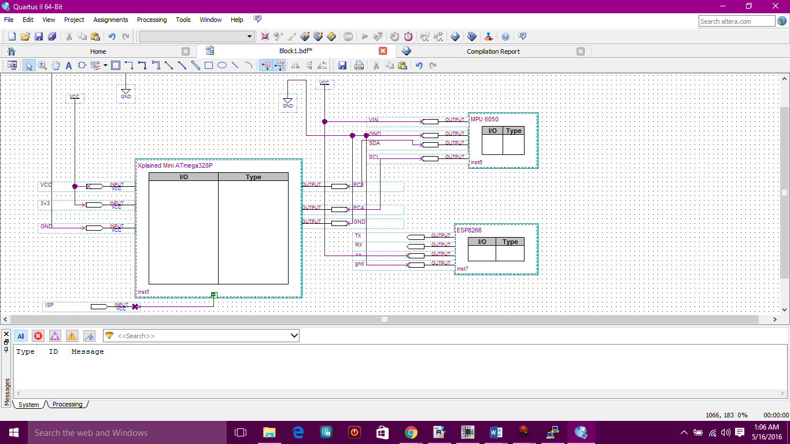

INITIAL PCB*: (exception - include image)

IIMPLEMENTATION:

* Set up NODEMCU Firmware
* Set up ESPlorer
* Set up puTTY
* Set up the MPU6050, ATmega328p and ESP8266 on the breadboard with a 9V battery voltage source
* Write code
* Write code inside puTTY and connect to internet

SNAPSHOTS/SCREENSHOTS*: (only links - do not embed images or videos in the document) https://github.com/matareye/MataReyesCPE301s16/blob/master/ScreenShots.docx

CODE: (with comments) [*final code]

#include <avr/io.h>

#include <util/delay.h>

#include <avr/interrupt.h>

#include <string.h>

#include "i2cmaster.h"

#define SSID belkin.452 //My home network

#define PASS 2e968269 //Home network password

#define IP "184.106.153.149" // ThingSpeak IP Address: 184.106.153.149

//string GET = "GET /update?key=[ThingSpeak_(Write)API_KEY]";

unsigned char ret;

int16_t accelerometer[3];

int16_t gyro[3];

double AcX, AcY, AcZ;

double GyX, GyY, GyZ;

#define MPU6050 0xD0 //MPU address

Name: Michelle Mata Page 2/3

int main(void)

{

i2c_init(); //init I2C interface

_delay_ms(500); //Delay of 500 ms

while(1)

{

ret=i2c_start(MPU6050+I2C_WRITE); //set device and write mode

if(ret){

i2c_stop();

}

else{

i2c_write(0x6B); // go to register 107

i2c_write(0x00); // set value to 0x00 and wake up sensor

i2c_stop(); // set stop conditon = release bus

i2c_start_wait(MPU6050+I2C_WRITE); // set device address and write mode

i2c_write(0x3B); // accel_xout

i2c_rep_start(MPU6050+I2C_READ); // set device address and read mode

ret = i2c_readNak(); // read one byte

ret = (ret <<8) | i2c_readNak(); // read last byte

i2c_stop();

}

}

}

REFERENCE:

<http://www.avrfreaks.net/forum/mpu6050-and-atmega328p-peter-fleury-implementation-problem>

<https://learn.adafruit.com/adafruit-huzzah-esp8266-breakout/using-nodemcu-lua>

ESPlorer sample code:

<http://www.esp8266.com/viewtopic.php?f=6&t=1713&start=8>

<https://learn.adafruit.com/adafruit-huzzah-esp8266-breakout/overview>

<https://www.adafruit.com/product/2471>

<http://stm32f4-discovery.net/2014/10/library-43-mpu-6050-6-axes-gyro-accelerometer-stm32f4/>

<http://playground.arduino.cc/Main/MPU-6050>

<http://www.esp8266-projects.com/2015/12/mailbag-mpu6050-module-i2c-driver-init.html>

<http://www.esp8266-projects.com/2015/11/new-esp8266-devboard-cbdb-next-evo.html>

<http://www.atmel.com/devices/atmega328.aspx>

http://www.avrfreaks.net/forum/issue-translating-arduino-code-avr-c

Name: Michelle Mata Page 3/3