Michelle Mata

CPE301 – SPRING 2016

Design Assignment 1

**DO NOT REMOVE THIS PAGE DURING SUBMISSION:**

The student understands that all required components should be submitted in complete for grading of this assignment.

|  |  |  |  |
| --- | --- | --- | --- |
| **NO** | **SUBMISSION ITEM** | **COMPLETED (Y/N)** | **MARKS**  **(/MAX)** |
| 0. | COMPONENTS LIST AND CONNECTION BLOCK DIAGRAM w/ PINS |  |  |
| 1. | INITIAL CODE OF TASK 1/A |  |  |
| 2. | INCREMENTAL / DIFFERENTIAL CODE OF TASK 2/B |  |  |
| 3. | INCREMENTAL / DIFFERENTIAL CODE OF TASK 3/C |  |  |
| 4. | INCREMENTAL / DIFFERENTIAL CODE OF TASK 4/D |  |  |
| 5. | INCREMENTAL / DIFFERENTIAL CODE OF TASK 5/E |  |  |
| 6. | SCHEMATICS |  |  |
| 7. | SCREENSHOTS OF EACH TASK OUTPUT |  |  |
| 8. | SCREENSHOT OF EACH DEMO |  |  |
| 9. | VIDEO LINKS OF EACH DEMO |  |  |
| 10. | GOOGLECODE LINK OF THE DA |  |  |
|  |  |  |  |
|  |  |  |  |

|  |  |  |  |
| --- | --- | --- | --- |
| 0. | COMPONENTS LIST AND CONNECTION BLOCK DIAGRAM w/ PINS |  |  |

|  |  |  |  |
| --- | --- | --- | --- |
| 1. | INITIAL CODE OF TASK 1/A |  |  |

LDI R16, low(RAMEND/2) ;Load Low byte of RAMEND/2 into R16

OUT SPL, R16 ;Load R16 into SPL

LDI R16, high(RAMEND/2) ;Load High byte of RAMEND/2 into R16

OUT SPH, R16 ;Load R16 into SPH

LDI ZL, SPL

LDI R17, 1 ;Set R17=1

L1: LPM R20, Z ;load z into R20, update R20

INC ZL ;Increment ZL

INC R17 ;R17=R17+1

CPI R17, 24 ;Compare if R17=24

BREQ END ;Jump to END if R17=24

BRNE L1

END: RJMP END

|  |  |  |  |
| --- | --- | --- | --- |
| 6. | SCHEMATICS |  |  |

|  |  |  |  |
| --- | --- | --- | --- |
| 7. | SCREENSHOTS OF EACH TASK OUTPUT |  |  |

TASK 1/A:

Build:

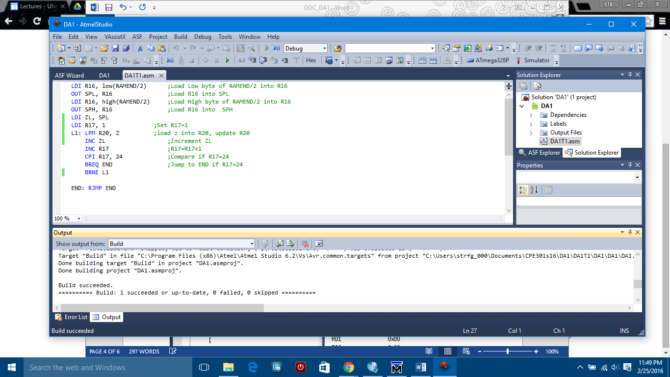

Debug:

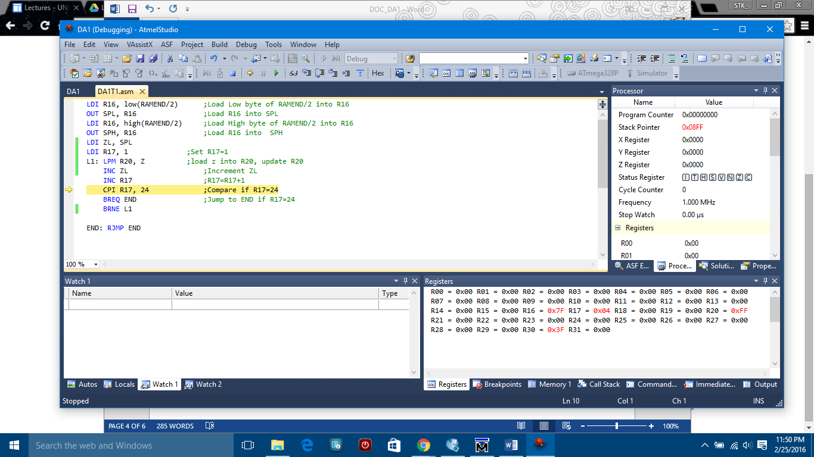

|  |  |  |  |
| --- | --- | --- | --- |
| 8. | SCREENSHOT OF EACH DEMO |  |  |

|  |  |  |  |
| --- | --- | --- | --- |
| 9. | VIDEO LINKS OF EACH DEMO |  |  |
| http:// @youtube | | | |
| 10. | GOOGLECODE LINK OF THE DA |  |  |
| https://github.com/matareye/MataReyesCPE301s16/blob/master/DA1T1 | | | |

**Student Academic Misconduct Policy**

<http://studentconduct.unlv.edu/misconduct/policy.html>

“This assignment submission is my own, original work”.

Michelle Mata