Michelle Mata

CPE301 – SPRING 2016

Design Assignment 2

**DO NOT REMOVE THIS PAGE DURING SUBMISSION:**

The student understands that all required components should be submitted in complete for grading of this assignment.

|  |  |  |  |
| --- | --- | --- | --- |
| **NO** | **SUBMISSION ITEM** | **COMPLETED (Y/N)** | **MARKS**  **(/MAX)** |
| 0. | COMPONENTS LIST AND CONNECTION BLOCK DIAGRAM w/ PINS |  |  |
| 1. | INITIAL CODE OF TASK 1/A |  |  |
| 2. | INCREMENTAL / DIFFERENTIAL CODE OF TASK 2/B |  |  |
| 3. | INCREMENTAL / DIFFERENTIAL CODE OF TASK 3/C |  |  |
| 4. | INCREMENTAL / DIFFERENTIAL CODE OF TASK 4/D |  |  |
| 5. | INCREMENTAL / DIFFERENTIAL CODE OF TASK 5/E |  |  |
| 6. | SCHEMATICS |  |  |
| 7. | SCREENSHOTS OF EACH TASK OUTPUT |  |  |
| 8. | SCREENSHOT OF EACH DEMO |  |  |
| 9. | VIDEO LINKS OF EACH DEMO |  |  |
| 10. | GOOGLECODE LINK OF THE DA |  |  |
|  |  |  |  |
|  |  |  |  |

|  |  |  |  |
| --- | --- | --- | --- |
| 0. | COMPONENTS LIST AND CONNECTION BLOCK DIAGRAM w/ PINS |  |  |

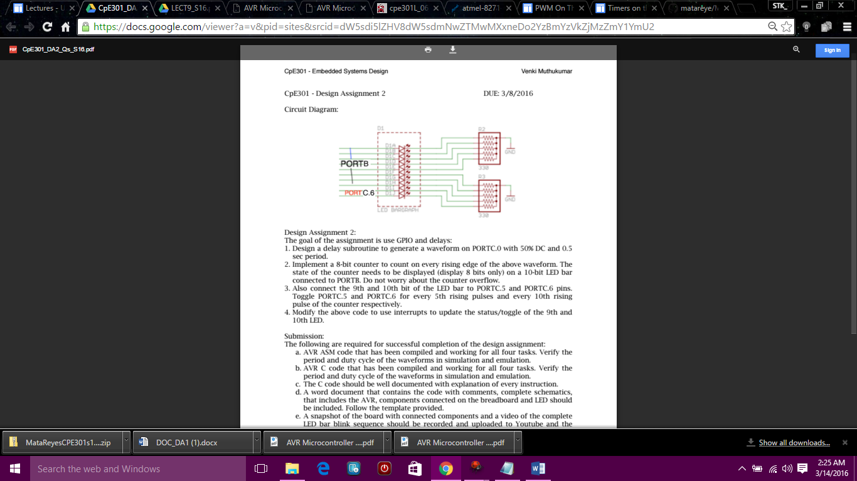

ATmega328P Xplained mini

USB Pololu AVR programmer

10-bit LED Bargraph

|  |  |  |  |  |
| --- | --- | --- | --- | --- |
| 1. | INITIAL CODE OF TASK 1/A |  |  |  |

;Design a delay subroutine to generate a waveform on PORTC.0 with 50%DC and 0.5sec period

LDI R16, HIGH(RAMEND)

OUT SPH, R16

LDI R16, LOW (RAMEND)

OUT SPL, R16 ;initialize stack pointer

SBI DDRC, 0 ;PortC.0 as output

BEGIN: SBI PORTC, 0 ;set to High PCO

RCALL DELAY ;call delay subroutine

CBI PORTC, 0 ;PortC.0=0

RCALL DELAY ;Call Delay

RJMP BEGIN

DELAY: LDI R20, HIGH(62500-1)

STS TCNT1H, R20 ;0xF4

LDI R20, LOW(62500-1)

STS TCNT1L, R20 ;0x23 , TCNT1=0xF423

LDI R20, HIGH(31250-1)

STS OCR1BH, R20 ;OCR1BH=7A

LDI R20, LOW(31250-1)

STS OCR1BL, R20 ;OCR1BL=11, OCR1B=0x7A11

LDI R20, 0x0

STS TCCR1A, R20 ;WGM11:10=00

LDI R20, 0x0A

STS TCCR1B, R20 ;8 prescaler, WGM 13:12 01, CTC

AGAIN: IN R20, TIFR1 ;Read TIFR1

SBRS R20, OCF1A ;if OCF1A is set skip next instruction

RJMP AGAIN

LDI R20, 0x00

STS TCCR1B, R20 ;Stop timer1

LDI R20, (1<<OCF1A)

STS TIFR1, R20 ;Clear TIFR1 by writing 1 to OCF1A

RET

|  |  |  |  |  |
| --- | --- | --- | --- | --- |
| 1. | INITIAL CODE OF TASK 1/B |  |  |  |

------------------------------------------------------------------ C code -------------------------------------------------------------

#define F_CPU 1000000UL //XTAL=1MHZ

#include <avr/io.h>

#include<util/delay.h>

int main()

{

void delay_ms(int d)

{

_delay_ms(d);

}

unsigned char i;

DDRC=0x01; //PortC.0 is an output

i=127;

OCR1A=127; //duty cycle=50%

while(i!=0)

{

OCR1A=i;

_delay_ms(500);

TCNT1H=0xF4;

_delay_ms(500);

TCNT1L=0X23; //TCNT1=0xF423 for prescaler 8 CTC

_delay_ms(500);

OCR1BH=0x7A;

-delay_ms(500);

OCR1BL=0x11; //OCR1B=0x7A11, prescaler 8

_delay_ms(500);

TCCR1B=0x0A; //8 prescaler, WGM13:12 01, where WGM is 0100 for CTC

_delay_ms(500);

while((TIFR1&0x01) == 0); //Read TIFR1

TCCR1B=0; //Stop Timer1

TIFR1 |= 1<<OCF1A; //Clear TIFR1 by writing 1 to OCF1A

i++;

}

return 0;

}

|  |  |  |  |  |
| --- | --- | --- | --- | --- |
| 2. | INITIAL CODE OF TASK 2/A |  |  |  |

LDI R16, HIGH(RAMEND)

OUT SPH, R16

LDI R16, LOW (RAMEND)

OUT SPL, R16 ;initialize stack pointer

CBI DDRB, 1 ;PB1 T1 is input

SBI DDRC, 0 ;PortC.0 as output

BEGIN: SBI PORTC, 0 ;set to High PCO

RCALL DELAY ;call delay subroutine

CBI PORTC, 0 ;PortC.0=0

RCALL DELAY ;Call Delay

RJMP BEGIN

DELAY: LDI R20, HIGH(62500-1)

STS TCNT1H, R20 ;0xF4

LDI R20, LOW(62500-1)

STS TCNT1L, R20 ;0x23 , TCNT1=0xF423

LDI R20, HIGH(31250-1)

STS OCR1BH, R20 ;OCR1BH=7A

LDI R20, LOW(31250-1)

STS OCR1BL, R20 ;OCR1BL=11, OCR1B=0x7A11

LDI R20, 0x0

STS TCCR1A, R20 ;WGM11:10=00

LDI R20, 0x0F

STS TCCR1B, R20 ;8 prescaler, CTC, RISING EDGE  
AGAIN: LDI R20, 0

STS OCR1AH, R20

LDI R20, 2

STS OCR1AL, R20

L1: IN R20, TIFR1 ;Read TIFR1

SBRS R20, OCF1A ;if OCF1A is set skip next instruction

RJMP L1

LDI R20, 0x00

STS TCCR1B, R20 ;Stop timer1

LDI R20, (1<<OCF1A)

STS TIFR1, R20 ;Clear TIFR1 by writing 1 to OCF1A

SBI PORTC, 0 ;PCO=1

CBI PORTC, O ;PC0=0

RJMP AGAIN

RET

|  |  |  |  |  |
| --- | --- | --- | --- | --- |
| 2. | INITIAL CODE OF TASK 2/B |  |  |  |

#define F_CPU 1000000UL //XTAL=1MHZ

#include <avr/io.h>

#include<util/delay.h>

int main()

{

void delay_ms(int d)

{

_delay_ms(d);

}

unsigned char i;

DDRB=0x00;

DDRC=0x01; //PortC.0 is an output

i=127;

OCR1A=127; //duty cycle=50%

while(i!=0)

{

OCR1A=i;

_delay_ms(500);

TCNT1H=0xF4;

_delay_ms(500);

TCNT1L=0X23; //TCNT1=0xF423 for prescaler 8 CTC

_delay_ms(500);

OCR1BH=0x7A;

-delay_ms(500);

OCR1BL=0x11; //OCR1B=0x7A11, prescaler 8

_delay_ms(500);

TCCR1B=0x0A; //8 prescaler, WGM13:12 01, where WGM is 0100 for CTC

_delay_ms(500);

OCR1AH=0x0;

_delay_ms(500);

OCR1AL=0x02;

_delay_ms(500);

while((TIFR1&0x01) == 0); //Read TIFR1

TCCR1B=0; //Stop Timer1

TIFR1 |= 1<<OCF1A; //Clear TIFR1 by writing 1 to OCF1A

i++;

}

DDRC=0x0;

return 0;

}

|  |  |  |  |
| --- | --- | --- | --- |
| 6. | SCHEMATICS |  |  |

|  |  |  |  |
| --- | --- | --- | --- |
| 7. | SCREENSHOTS OF EACH TASK OUTPUT |  |  |

TASK 1/A:

Design a delay subroutine to generate a waveform on PORTC.0 with 50%DC and 0.5sec period

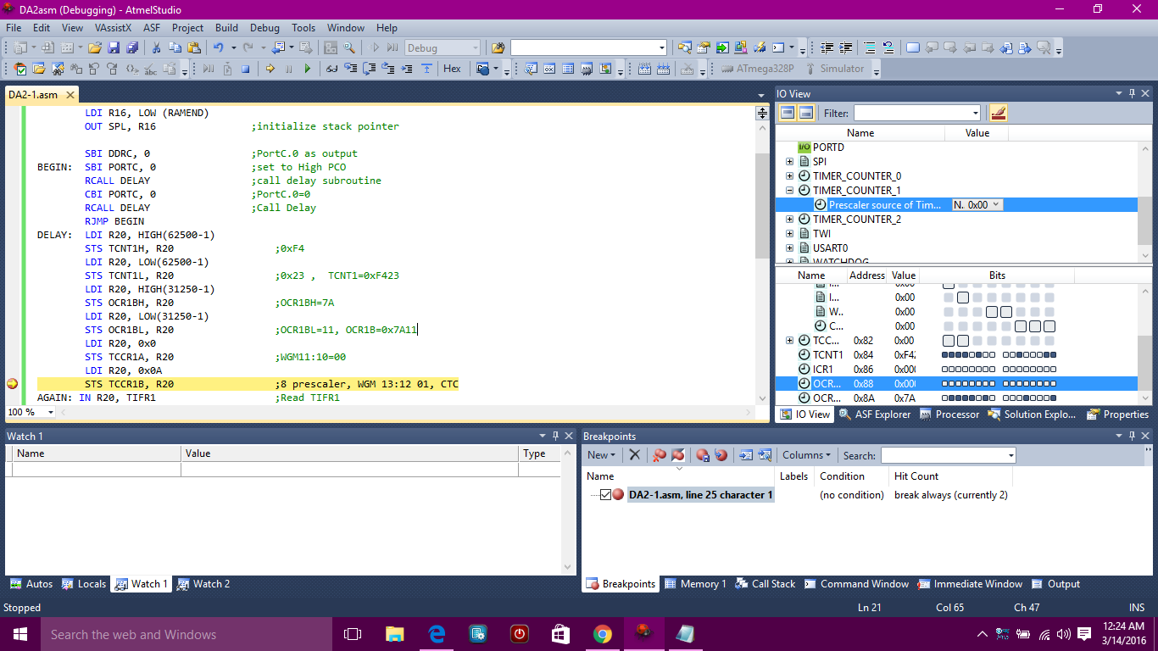

TASK 1/B:

**C:**

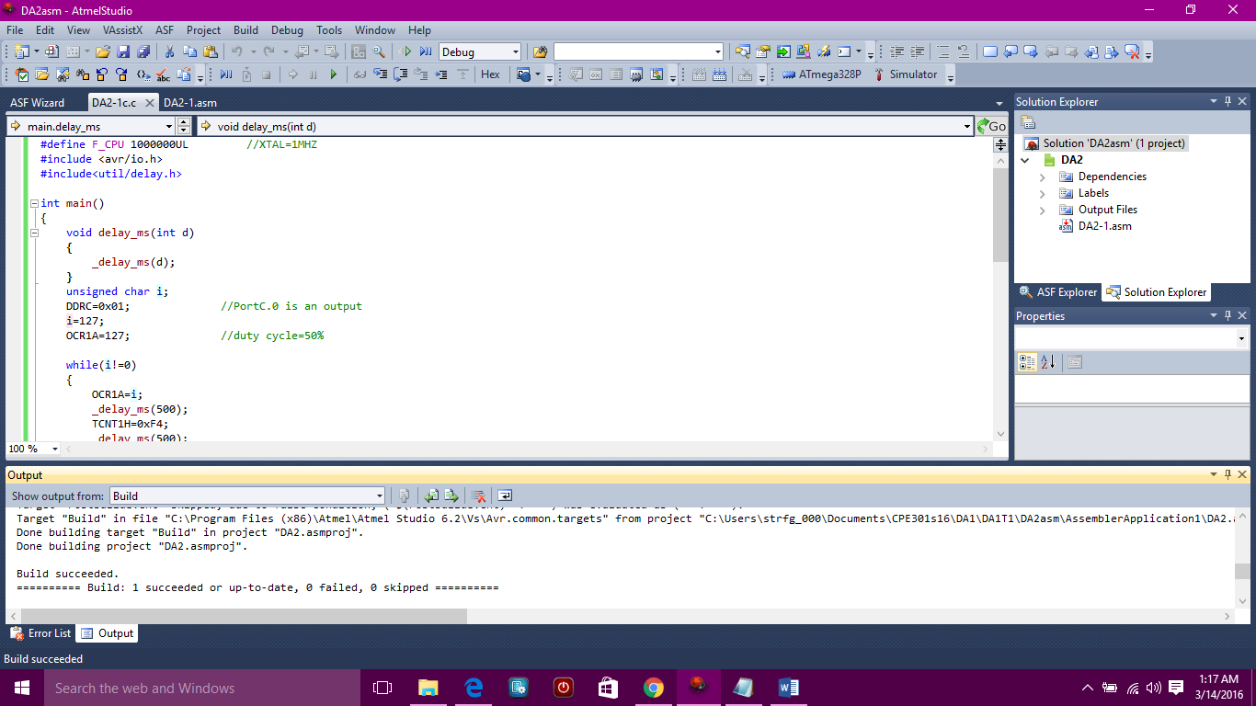

TASK 2/A:

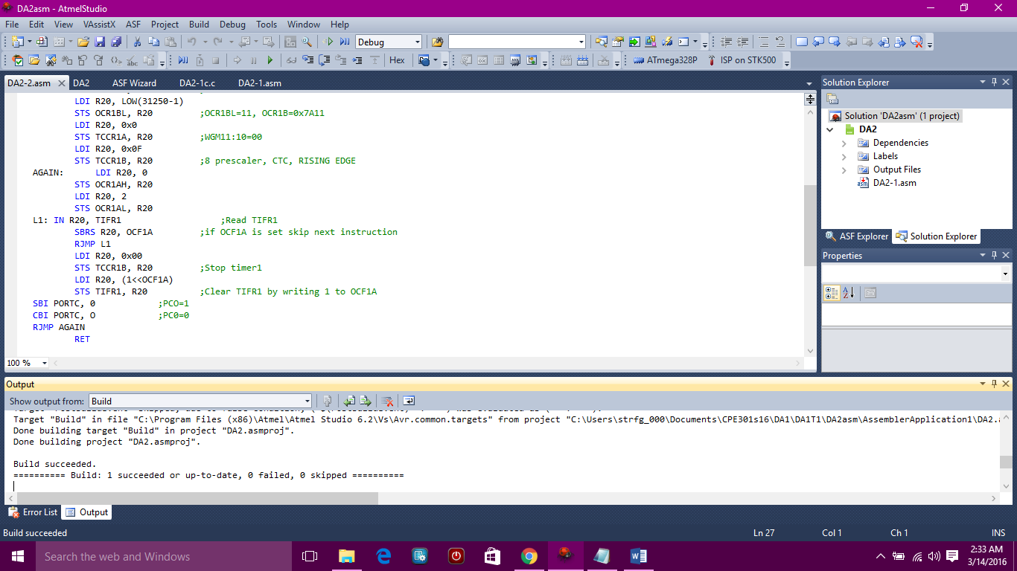

TASK 2/B:

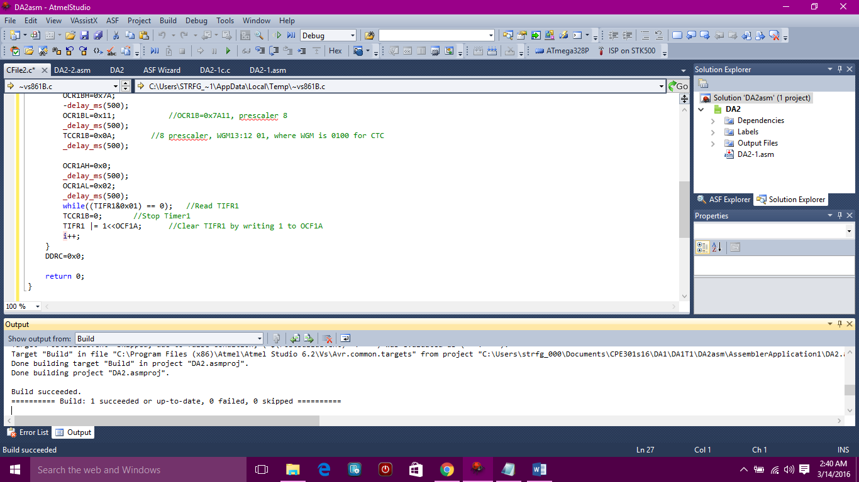

|  |  |  |  |
| --- | --- | --- | --- |
| 8. | SCREENSHOT OF EACH DEMO |  |  |

|  |  |  |  |
| --- | --- | --- | --- |
| 9. | VIDEO LINKS OF EACH DEMO |  |  |
| http:// @youtube | | | |
| 10. | GOOGLECODE LINK OF THE DA |  |  |
| https://github.com/matareye/MataReyesCPE301s16 | | | |

**Student Academic Misconduct Policy**

<http://studentconduct.unlv.edu/misconduct/policy.html>

“This assignment submission is my own, original work”.

Michelle Mata