Michelle Mata

CPE301 – SPRING 2016

Design Assignment 4

**DO NOT REMOVE THIS PAGE DURING SUBMISSION:**

The student understands that all required components should be submitted in complete for grading of this assignment.

|  |  |  |  |
| --- | --- | --- | --- |
| **NO** | **SUBMISSION ITEM** | **COMPLETED (Y/N)** | **MARKS**  **(/MAX)** |
| 0. | COMPONENTS LIST AND CONNECTION BLOCK DIAGRAM w/ PINS |  |  |
| 1. | INITIAL CODE OF TASK 1/A |  |  |
| 2. | INCREMENTAL / DIFFERENTIAL CODE OF TASK 2/B |  |  |
| 3. | INCREMENTAL / DIFFERENTIAL CODE OF TASK 3/C |  |  |
| 4. | INCREMENTAL / DIFFERENTIAL CODE OF TASK 4/D |  |  |
| 5. | INCREMENTAL / DIFFERENTIAL CODE OF TASK 5/E |  |  |
| 6. | SCHEMATICS |  |  |
| 7. | SCREENSHOTS OF EACH TASK OUTPUT |  |  |
| 8. | SCREENSHOT OF EACH DEMO |  |  |
| 9. | VIDEO LINKS OF EACH DEMO |  |  |
| 10. | GOOGLECODE LINK OF THE DA |  |  |
|  |  |  |  |
|  |  |  |  |

|  |  |  |  |
| --- | --- | --- | --- |
| 0. | COMPONENTS LIST AND CONNECTION BLOCK DIAGRAM w/ PINS |  |  |

Atmega328p

RGB LED

|  |  |  |  |
| --- | --- | --- | --- |
| 1. | INITIAL CODE OF TASK 1/A |  |  |

#include <avr/io.h

#include <avr/io.h>

#define F_CPU 1000000UL //XTAL 1=MHz

int main(){

unsigned char i;

DDRB = 0x08; //PB3 as output

DDRD=0xff; //Set all PortD as output

PORTB=0x00; //Set output high- turn all LEDs off

i=25;

OCROA=25; //duty cycle = 10% for one PWM signal

OCR1A=25; //duty cycle = 10% for the second PWM signal

OCR2A=25; //duty cycle = 10% for the third PWM signal

TCCR0A = 0xC1; //Phase correct PWM for the 1st PWM signal

TCCR0B = 0x03; //N=64

TCCR1A = 0xC1; //Phase correct PWM for the 2nd PWM signal

TCCR1B = 0x03; //N=64

TCCR2A = 0xC1; //Phase correct PWM for the 3rd PWM signal

TCCR2B = 0x03; //N=64

for (;;){

/* dimm LED on */

for (i=0; i<255; i++)

{

OCR0AL=i;

OCR1AL = i; //Note OCR1AL NOT OCR1A

OCR2AL=i;

PORTB=i;

_delay_ms(30);

}

/* dimm LED off */

for( i=255; i>0; i--)

{

OCR0AL=i;

OCR1AL = i; //Note OCR1AL NOT OCR1A

OCR2AL=i;

PORTB=i;

_delay_ms(30);

}

}

return 0;

}

|  |  |  |  |
| --- | --- | --- | --- |
| 6. | SCHEMATICS |  |  |

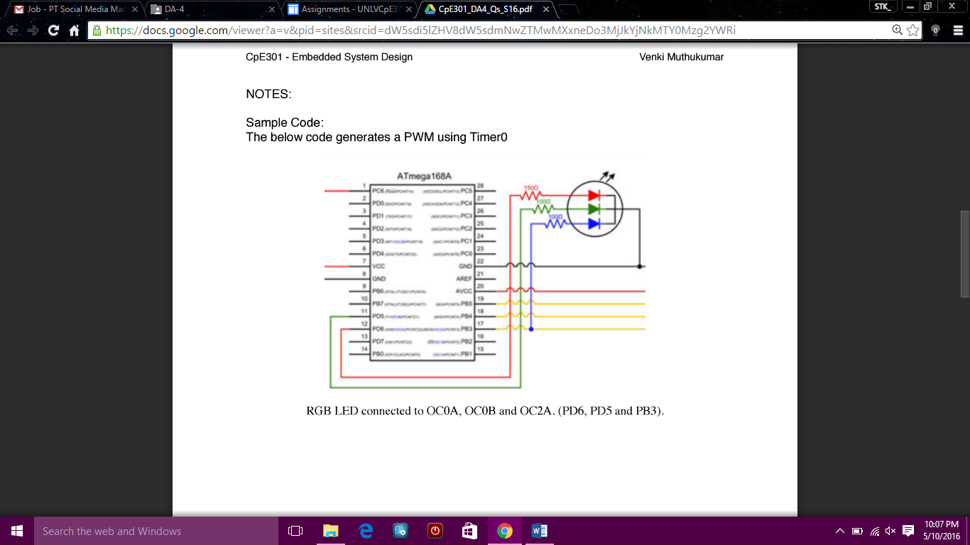

|  |  |  |  |
| --- | --- | --- | --- |
| 7. | SCREENSHOTS OF EACH TASK OUTPUT |  |  |

TASK 1/A:

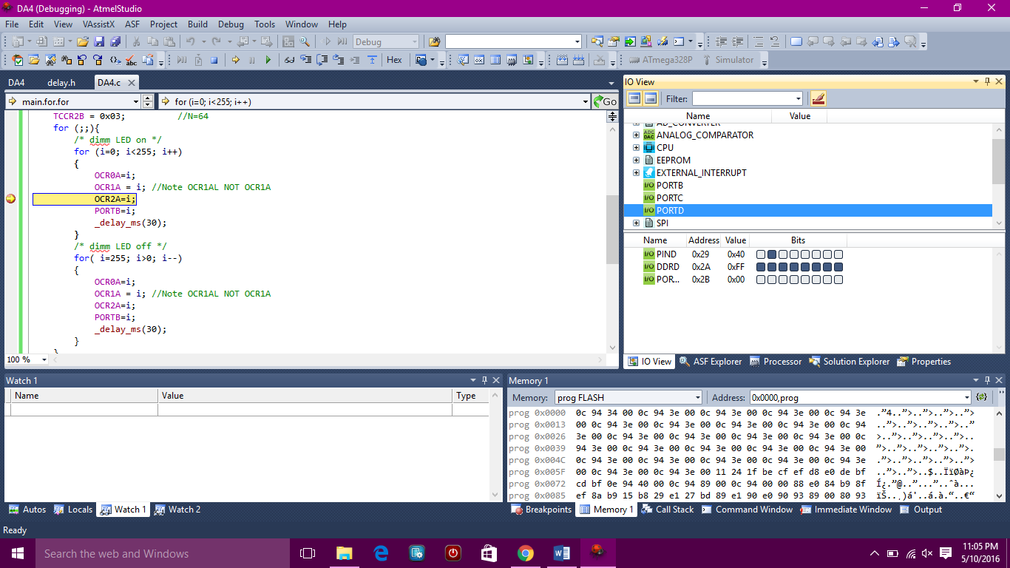

|  |  |  |  |
| --- | --- | --- | --- |
| 8. | SCREENSHOT OF EACH DEMO |  |  |

|  |  |  |  |
| --- | --- | --- | --- |
| 9. | VIDEO LINKS OF EACH DEMO |  |  |
| http:// @youtube | | | |
| 10. | GOOGLECODE LINK OF THE DA |  |  |
| https://github.com/matareye/MataReyesCPE301s16/blob/master/DA4 | | | |

**Student Academic Misconduct Policy**

<http://studentconduct.unlv.edu/misconduct/policy.html>

“This assignment submission is my own, original work”.

Michelle Mata