Supplementary Information

1 Datasets 2
1.1 SIR database 3
1.2 SLO dataset 5
1.3 NOV dataset 5
1.4 KAT dataset 5
1.5 SHA dataset (containing ISI) 5
1.6 SAE dataset 6
1.7 PHI dataset 6
1.8 AMG (GOLDEN) dataset 6
1.9 Histogram of the final datasets 7
2 Features 8
2.1 Compositional 8
2.2 Motifs 8
2.3 Thermodynamic 9
2.4 Structural 10
2.5 List of features employed in our study 12
3 Measuring prediction accuracy 16
4 Sequence-specific study of the impact of the motifs ‘UCU’ and ‘ACGA’ 18
5 Thermodynamic parameters for the stability of the dinucleotide bonds 20
6 Model convergence 21
6.1 Log-likelihood fluctuation 21
6.2 Model size variation 21
7 Features included most often in the models employed in our study 22
8 Predictive performances of the models employed in this study 23
9 References 25

Datasets
There are two fundamental issues in meta- analysis from disparate datasets. Firstly, the siRNA sequences might be stated differently: either the anti-sense (AS) or the sense (S) sequence might be given. To compare siRNA sequence information from two datasets which do not state siRNA sequences in the same form, one set of sequences has to be inverse-complemented. However, this assumes sequence complementary siRNAs, which might not necessary be the case (Leuschner2006) and therefore might introduce errors.
Secondly, siRNA potency might be stated in different and often conflictive ways. The Novartis and Isis datasets (Matveeva2007) have siRNA potencies measured by means of the percentage of gene product remaining after siRNA activity. Jagla et al. on the other hand (Jagla2005) pre-grouped siRNAs according to their mRNA target. They then assigned one and zero to the siRNA sequences, which caused the highest and lowest level of target inhibition, respectively. All other siRNA sequences were assigned potencies proportional to their level of target inhibition compared to the level of the most potent siRNA sequence for that target – a relative, not an absolute reporting scheme, as seen in the Sloan-Kettering dataset. Katoh et al. (Katoh2007) used the rate of fluorescence reduction after siRNA activity as a measure of potency. A potency of one meant full reduction of fluorescence, indicating a potent siRNA sequence, whereas no reduction in fluorescence indicated a non-potent siRNA sequence.
Even though all authors stated a continuous number in the range of [0,1] as a measure for siRNA potency, each dataset was subject to different measurement errors and a combination of their results was not straightforward. Furthermore, two of the datasets included in our study did not state continuous numbers, but classes for siRNA potency. The siRecords database (Ren2006) stated one of four potency classes (very high, high, medium, low) for each of its entries. The comparison becomes even more challenging when different cell types (Hela, fibroblasts), test methods (Western Blotting, real-time PCR) or siRNA delivery methods (vectors method, synthetic oligos method) have been employed. As at least one of the aforementioned parameters was missing in most of the obtained datasets, we neglected these factors for our study. However, we acknowledge that, should information on these become available for all datasets, one could get a better, less error-prone picture of the actual features that affect siRNA potency and further resolve inconsistencies found between different studies.

To tackle the aforementioned problems, we reformatted the data contained in all ten datasets, so that the siRNAs were stated as 5’-3’ anti-sense (guide strand) sequences. also, we presented all product level data as continuous values, representing product level remaining after siRNA activity (as in the Novartis and Isis datasets). Therefore, product levels of zero and one refer to completely potent and non-potent siRNA sequences. The class representation given in siRecords dataset was translated according to the following convention: “very high”, “high”, “medium” and “low” correspond to product levels of 0.05, 0.2, 0.41 and 0.78, respectively. These values were obtained by comparing the product levels of entries that were contained both in cardinal format in the siRecords dataset, as well as in continuous format in one of the other datasets. Next, the identified continuous product levels were separated into four classes (very high, high, medium, low) depending on the respective cardinal value of the sequence in the siRecords dataset. Histograms for each class can be found in the supplementary information. The central value of each histogram was chosen to reflect the product level that best corresponded to the respective class.

A leave-one-out scheme was employed for our potency prediction algorithm, using only four of the SLO, NOV, KAT, SAE and SIR datasets for the training of our algorithm, and subsequently testing on the fifth dataset. This was considered necessary, in order to alleviate dataset-specific effects, such as over-representation of a particular feature because of siRNA sample selection. To be able to compare the predictive powers of all generated models against each other on a common ground, we set one dataset aside, to act as reference. For that purpose, we selected the AMG datasets to form an independent test set (GOLDEN) containing 239 siRNA sequences, which was never employed as a training set.

SIR database
The siRecords database (Ren2006, http://sirecords.umn.edu/siRecords) was set up and still is maintained by the Department of Neuroscience at the University of Minnesota, Minneapolis, USA. It represents an effort to systematically browse through all PUBMED publications referring to siRNAs and to extract the sequence and efficacy information contained. The gathered results are compiled into an online database which then can be queried for free by users. As a result of this method, the datasets contains entries from a very wide range of sources with sequences originally being given in either sense or anti-sense format and results being stated in a number of different ways. In an attempt to address the arising problems, the authors of siRecords stated only sense strand sequences and reported the respective efficacy as one of four classes: very high, high, medium and low, with very high and low referring to a very low level and a very high level of target product remaining after siRNA activity, respectively. Therefore the efficacy data stated in the siRecords database is cardinal instead of continuous. To assign an efficacy value to each class for computational means and also for comparison, entries of the siRecords dataset were checked against the entries of the Shabalina dataset (Shabalina2006) with 556 sequence matching, for which we assumed that they represent reports of the same experiment. Next, identical sequences were classified according to their siRecords efficacy entry and histograms of the efficacies reported in the Shabalina dataset were calculated for each class. Results are displayed in Figure 3. The reported mean values for efficacies lying within the boundaries of each class were taken as a measure for the efficacy constant that is representing the respective class. These values are 0.05, 0.2, 0.41 and 0.78 for the classes very high, high, medium and low, respectively.

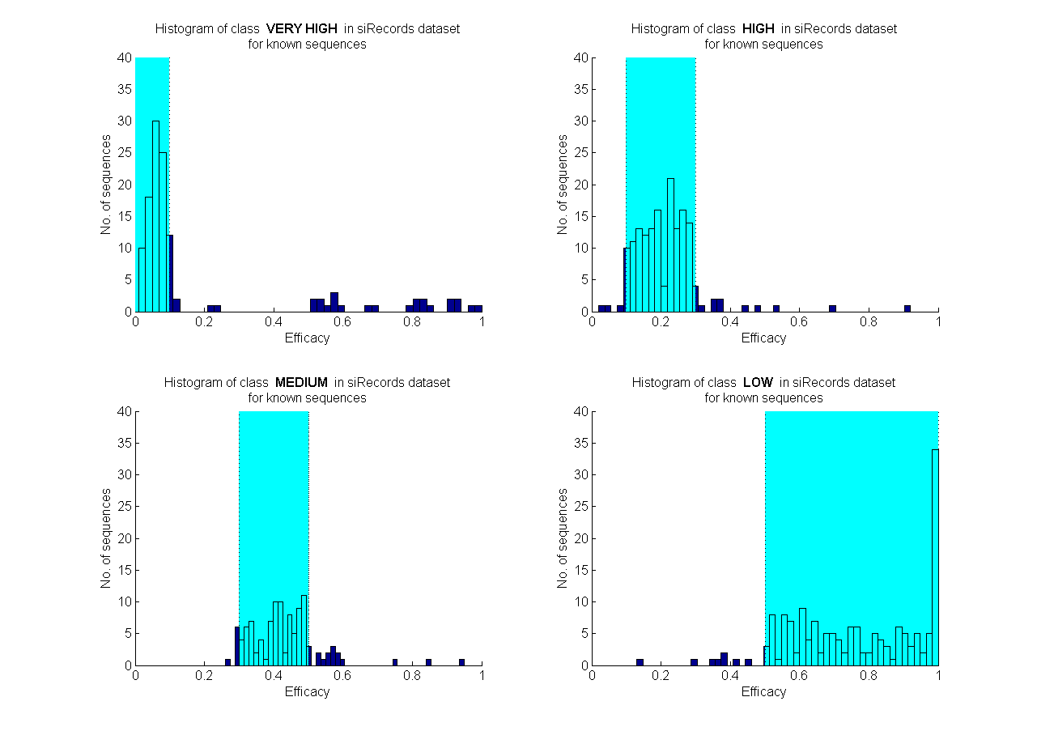
Figure 1: Histogram of the four classes of the siRecords dataset

An interesting fact is that the SIR dataset contains twice as many potent as non-potent entries – the largest ratio for all datasets. This can be explained by the fact that the data contained in SIR stemmed from hundreds of independent biological experiments and there is obviously a tendency to report only sequences that showed a strong potency while neglecting those that didn’t work well. This is different to purpose-built experiments, where all possible siRNA sequences for one mRNA target are examined (Katoh2007) and all resulting sequences are reported.
Recently, Ren et al. (Ren2009) extended the fraction of the siRecords database that is publicly available (to 14,282 samples) half of which would be useful to our study (19 nt length and siRNA efficacy reported) and could be included in a follow-up study.

SLO dataset
SLO (Sloan-Kettering) dataset was originally published by Jagla et al. (Jagla2005). The version used for the present study, containing 601 entries, is the same as that used by Matveeva et al. in their 2007 study (Matveeva2007). As mentioned above, the original authors grouped all samples according to their mRNA target. They then assigned one and zero to the siRNAs which caused the highest and lowest level of target inhibition, respectively. All other siRNA sequences were assigned potencies proportional to their level of target inhibition compared to that of the most potent siRNA sequence for that target.

NOV dataset
Novartis dataset was originally published by Huesken et al. (Huesken2005). The version of the data used for the present study, totaling 2431 entries, is the one used by Matveeva et al. (Matveeva2007), which should contain the correct siRNA efficacy for each entry, as it agrees with the supplementary information currently (as of 29/03/2009) available on the Nature Methods website.

KAT dataset
The Katoh dataset (Katoh2007) contains a set of 702 siRNAs, all targeting the 720 nucleotide long coding region of enhanced green fluorescent protein (EGFP) mRNA in human cells. The siRNAs were chosen in a way that all possible sequence positions of this coding region had been targeted. The fact that all siRNAs have the same target and that the whole coding region of the target has been covered, makes this dataset very useful, as it eliminates a number of errors, which would occur when data from different sources would be combined. On the other hand, the dataset does not leave space for inter mRNA variations, which might lead to an over fitted model.
Katoh et al state sense sequence information and as a measure of efficacy the rate of EGRP fluorescence reduction is given. An efficacy of one means full reduction of EGRP fluorescence after siRNA activity (within the limits of accuracy of the employed test method) and therefore indicates a potent siRNA sequence. For an efficacy of zero the EGRP fluorescence is not reduced at all and therefore it indicates a non-potent siRNA sequence.

SHA dataset (containing ISI)
The Shabalina et al (Shabalina2006) dataset represents a heterogeneous set of 653 experimentally evaluated siRNAs, which target 52 mRNAs. It consists of three subsets of siRNA produced by Dharmacon (Khvorova2003), Amgen Inc (Reynolds2004, 298 entries), Isis Pharmaceuticals (Vickers2003, 67 entries), and data from other sources (355 entries from Aza-Blanc2003, Harboth2003, Holen2002, Kumar2003, Hsieh2004, Ui-Tei2004, Jackson2003, Giddings2000 and Kawasaki2003). All the siRNA sequences are stated in anti-sense format.
As measure of efficacy, they report averages of duplicate measurements at a constant oligonucleotide dose expressed as percent of untreated control. Therefore a reported efficacy of one means no down-regulation of the gene product (within the limits of accuracy of the employed test method) and therefore indicates a non-potent siRNA sequence. For an efficacy of zero the siRNA down-regulated the gene product completely and therefore it indicates a very potent siRNA sequence.

SAE dataset
To assemble their dataset, Saetrom et al (Saetrom2004) collected experimentally verified data from papers published between 2000 and 2003 (Vickers et al., 2003; Kawasaki et al., 2003; Harborth et al., 2003; Holen et al., 2002; Khvorova et al., 2003; Giddings et al., 2000).
They state siRNAs in anti-sense format and efficacy is based on the reported protein knockdown levels (percentage of gene product remaining after siRNA activity). Therefore a reported efficacy of one means no down-regulation of the gene product (within the limits of accuracy of the employed test method) and indicates a non-potent siRNA sequence. For an efficacy of zero the siRNA down-regulated the gene product completely and therefore it indicates a very potent siRNA sequence. Whenever the protein knockdown level was not reported, Saetrom et al assigned an efficacy of 0.05 and 0.75 to potent and non-potent siRNAs, respectively.

PHI dataset
Phipps et al (Phipps2004) created a dataset of 26 experimentally evaluated siRNAs, which target different sections of the human rhinovirus-16 (HRV-16) genome. All their stated siRNA sequences are in sense format.
As measure of efficacy, they report siRNA-mediated inhibition of HRV replication. Therefore a reported efficacy of zero means no down-regulation of the gene product (within the limits of accuracy of the test method employed) and indicates a non-potent siRNA sequence. For an efficacy of one the siRNA down-regulated the gene product completely and therefore it indicates a very potent siRNA sequence.

AMG (GOLDEN) dataset
The golden dataset provides a reference to compare the predictive power of all generated models against each other on a common test bed. For that purpose, we selected the Amgen-Dharmacon dataset, as contained in (Matveeva2007), to form an independent test set containing 239 siRNA sequences.

Histogram of the final datasets
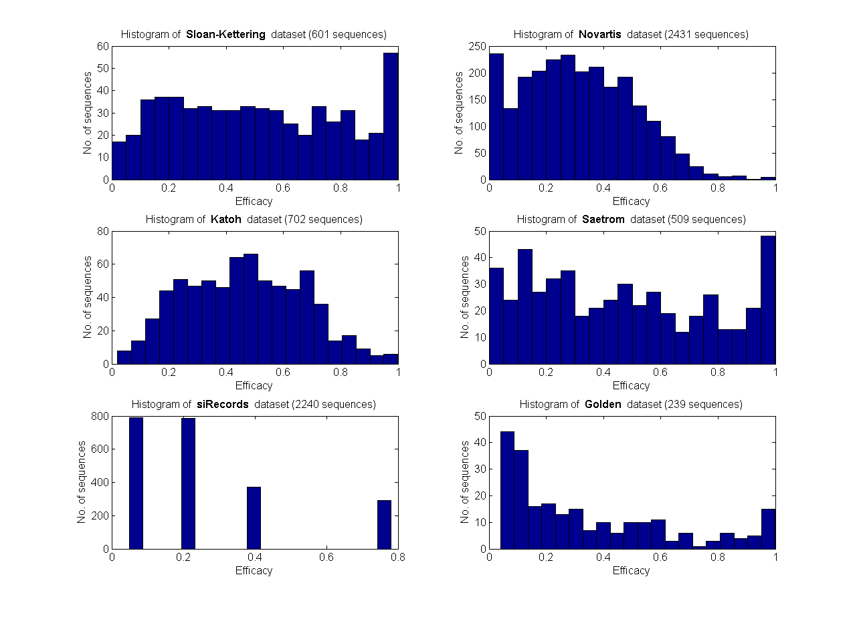
Figure 2: Histogram of the datasets with 0.05 wide bins for the product level

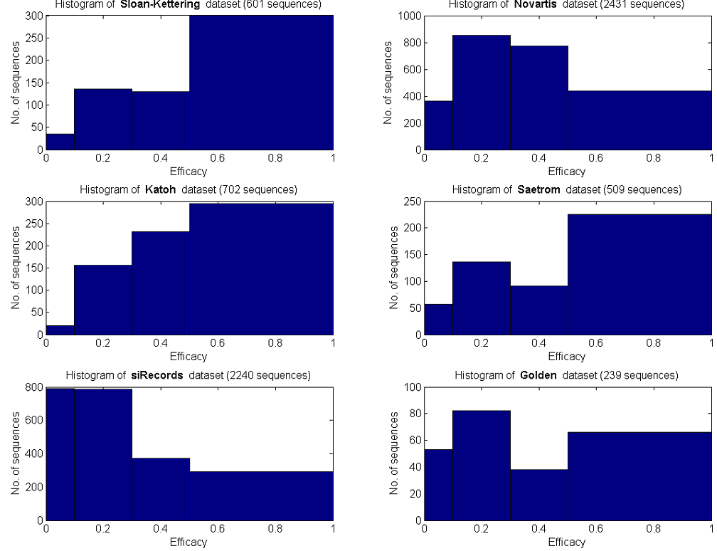
Figure 3: Histogram of the datasets, where the bins are designed to represent the four efficacy classes: very high [0,0.1], high [0.1,0.3], medium [0.3,0.5] and low [0.5,1].

Features

Compositional
Position-dependent nucleotide preference features, such as a U7, A10, A1/U1, G1/C1 and A19 respectively, were reported by multiple studies (Shabalina2006, Katoh2007, Matveeva2007) as being positively or negatively correlated with siRNA potency. Having built a bigger dataset than those studies, our objective was to confirm or reject previously reported correlations with added confidence, as well as to potentially identify novel ones. 76 (4x19) binary explanatory variables were added to our feature set, 19 for the presence of each nucleotide (A, C, G or U) at each position of the siRNA sequence, with a one indicating the presence of the respective nucleotide at the stated position.
A connection between GC content (percentage of Guanine and Cytosine bases in the siRNA sequence) and siRNA potency was previously reported by a variety of studies (Holen2002, Reynolds2004, Matveeva2007, Pei2006, Gong2006). It appeared as if siRNA sequences with certain GC contents are more potent than the remaining siRNA sequences. However, the exact percentage varied significantly between studies. For instance, Shao et al. (Shao2006) treated sequences with GC contents between 40 and 65% as more potent, while Matveeva et al. (Matveeva2007) identified a GC content of 20 - 53% as more favourable for siRNA design. Another group employed a multiple classification scheme (Root2006). To study the impact of GC content on siRNA efficacy in greater detail, we have included 18 binary features, representative of GC content thresholds. Lower thresholds were set between 5-45 %, at windows of 5% : >5%, >10%, >15%, >20%, >25%, >30%, >35%, >40%, >45%.
Upper thresholds were set between 95-55 %, at windows of 5%: <95%, <90%, <85%, <80%, <75%, <70%, <65%, <60% and <55%. For instance, an siRNA with GC content of 36.8% would have 1,1,1,1,1,1,1,0,0, (lower thresholds) and 1,1,1,1,1,1,1,1,1 (upper thresholds) in the respective columns.

Motifs
Most recent publications omitted the analysis of correlation between sequence motifs and siRNA potency. Two notable exceptions include the studies by Teramoto et al. (Teramoto2005) and Vert et al.(Vert2007). Teramoto focused on 1-mer, 2-mer and 3-mer motifs (consecutive siRNA sub-sequences of one, two and three nucleotides length, respectively), but worked on a small dataset consisting of just 94 siRNA sequences. Using a Support Vector Machine approach, he published a ranked list of 20 siRNA sub-sequences which he found to be favourable for siRNA potency prediction. Three of the reported motifs were 2-mers (‘UG’, ‘GA’, ‘GU’). Out of his top five ranked motifs (‘CAC’, ‘GGA’, ‘AUA’, ‘UGC’, ‘CAA’) two were symmetric, contradicting Vert’s et al. claim that potent siRNAs contain asymmetric motifs in their sequence. Vert et al., working on a much bigger dataset of 2182 entries, reported motifs ‘AAC’, ‘UC’, ‘UG’, ‘AAG’ and ‘AGC’ as those correlated with increased siRNA potency, and motifs ‘CUU’, ‘CUA’, ‘GUU’, ‘GU’ and ‘GAU’ as those correlated with decreased potency. The almost complete lack of agreement between the two studies illustrates the need for a follow-up study on correlation between motifs and siRNA efficiency. Consequently, we included the presence of 2-mer (16 features), 3-mer (64 features) and 4-mer motifs (256 features) in the respective siRNA as binary explanatory variables in our feature set, with a one indicating the presence of the respective motif within the analysed siRNA sequence.
In addition, we included the presence of consecutive GC stretches of length seven or more, that of A/U stretches at nucleotides 7-10 of the siRNA anti-sense strand, as well as of stretches of 3 or more consecutive Guanine nucleotides, all as binary features (where 0 signals absence, 1 signals presence in the respective siRNA sequence). all of these have been previously reported to correlate with siRNA potency (Pei2006, Gong2006, Root2006, Chalk2004, Ding2006).
Pei et al. reported that stable duplexes, devoid of palindromes, appeared to be attributed to more potent siRNA (Pei2006). The reason behind this could be the correlation of palindrome-containing sequences with formation of secondary structures. As such, it is part of the broader idea that sequences with no secondary structure are more likely to induce RNA interference (Patzel2005). As a result, the occurrence of palindromes of length three or more, with a gap between the two legs to allow for the forming of a hairpin-like structure, was also included as a binary feature in our feature set.
The last type of motifs we are checking for are those reported to stimulate an innate immune response like UGUGU or GUCCUUCAA (Hornung2005, Judge2005) and those that have been reported as cell toxic like UGGC (Fedorov2006).

Thermodynamic
The thermodynamics of duplex formation depend on the backbone of the nucleotide sequence. Hence, in theory the stability of siRNA duplexes, as well as of siRNA secondary structure, can be predicted from the sequence. In addition, thermodynamic parameters can be well approximated by nearest neighbour methods under the assumption that only Watson-Crick base-pairs are formed (only complementary bases bind to each other) (Kierzek2006). The critical role of the thermodynamic properties of siRNA in duplex unwinding and strand retention by the complex has been highlighted by Khvorova et al. (Khvorova2003) and Reynolds et al. (Reynolds2004). A strong correlation between siRNA potency and thermodynamic stability of dinucleotides (dG) has been confirmed for the first (dG₁₋₂) and the last (dG₁₈-₁₉) dinucleotides of the siRNA anti-sense strand by subsequent studies (Shabalina2006, Matveeva2007, Lu2008). Other dinucleotide stabilities, such as dG₇₋₈ and dG₁₃₋₁₄, also appeared to be correlated with siRNA potency (Matveeva2007). Furthermore, the difference of free energy in the siRNA strand ends, dG₁₋₂-dG₁₈₋₁₉ was previously found to be correlated with silencing efficiency (Shabalina2006).
Consequently, the change in free energy (stability) of all 18 dinucleotides (dG) of the siRNA anti-sense strand was calculated and included into our feature set. In addition, the total free energy (sum of all dG values) was also included. Finally, and in an attempt to assess whether the stability of longer stretches of neighbouring nucleotides could have an impact on siRNA potency, stabilities of tetranucleotides (d4G) were calculated and included as features as well.
We found in initial simulations (results not shown) that not the difference between the first and last dinucleotide, but instead between the first and last tetranucleotide was revealed as a more important feature. To get a more detailed picture, we extended our feature set by all four possible combinations of end strand stability terms (dG₁₋₂-dG₁₈₋₁₉, dG₁₋₂-d4G_{16-19,} d4G₁₋₄-dG_{18-19,} d4G₁₋₄-d4G₁₆₋₁₉).
The thermodynamic parameters used to calculate all stabilities were taken from Xia et al. (Xia1998), even though other sets would have been equally plausible (Freier1986) and the thermodynamic parameters employed in this study are presented in the Supplementary Information.

Structural
A series of features regarding the presence of secondary siRNA structure, which was already discussed as a potency-shaping feature (Patzel2005, Pei2006), were also added to our feature set. The RNAfold algorithm from the Vienna package (Hofacker1994, http://rna.tbi.univie.ac.at/cgi-bin/RNAfold.cgi) was used to provide a secondary structure prediction for each siRNA candidate sequence, based on energy minimisation. The resulting free energy was used as a measure of self-folding of the siRNA sequence and included as a feature in our set. A second question to be answered was whether intra-molecular bonds between nucleotides at specific positions were more important than others. To answer this, a position-dependent set of structural features was defined. Borrowing the idea from Peek (Peek2007), and again employing RNAfold, each nucleotide of a siRNA sequence was assigned a value of one, if it formed a bond with another nucleotide in the sequence, or a zero otherwise. That way, 19 binary structural features were created for each siRNA entry. An example of how these features would look like for the siRNA sequence ‘GAAGCUGAACUACUCGGUU’ is illustrated in Figure 4.
It should also be noted that we look only at siRNA secondary structure, neglecting the mRNA target structure so far as, to the knowledge of the authors, no reliable method for secondary structure prediction of larger polynucleotide chains is available yet. It did not escape the attention of the authors that, would such a method be available, siRNA potency prediction would enter a whole new realm as, for the first time, mRNA target structure and therewith accessibility could be taken into account for siRNA candidate design. By looking at the secondary structure formed by siRNA candidate sequences though, at least a first take on the impact of molecule structure on siRNA potency can be made.

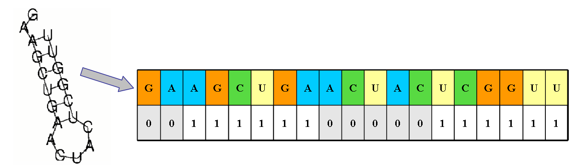

Figure 4: Binary structural features which indicate nucleotide-specific participation in bond formation for the siRNA sequence ‘GAAGCUGAACUACUCGGUU’, linking the folded structure (left) to its binary bond-formation features array (right). Each nucleotide of the studied siRNA candidate sequence is assigned a one when it forms a bond with another nucleotide of the same sequence (highlighted in white) or a zero (highlighted in grey) otherwise.

List of features employed in our study

Feat.  No | Feat description | Feat.  No | Feat description | Feat.  No |  | Feat description
1 | 'GC content in NT[1..19]' | 167 | 'AAUG in NT[1..19]' | 333 |  | 'UUCC in NT[1..19]'
2 | 'A @ NT1' | 168 | 'AAUU in NT[1..19]' | 334 |  | 'UCAA in NT[1..19]'
3 | 'A @ NT2' | 169 | 'AAUC in NT[1..19]' | 335 |  | 'UCAG in NT[1..19]'
4 | 'A @ NT3' | 170 | 'AACA in NT[1..19]' | 336 |  | 'UCAU in NT[1..19]'
5 | 'A @ NT4' | 171 | 'AACG in NT[1..19]' | 337 |  | 'UCAC in NT[1..19]'
6 | 'A @ NT5' | 172 | 'AACU in NT[1..19]' | 338 |  | 'UCGA in NT[1..19]'
7 | 'A @ NT6' | 173 | 'AACC in NT[1..19]' | 339 |  | 'UCGG in NT[1..19]'
8 | 'A @ NT7' | 174 | 'AGAA in NT[1..19]' | 340 |  | 'UCGU in NT[1..19]'
9 | 'A @ NT8' | 175 | 'AGAG in NT[1..19]' | 341 |  | 'UCGC in NT[1..19]'
10 | 'A @ NT9' | 176 | 'AGAU in NT[1..19]' | 342 |  | 'UCUA in NT[1..19]'
11 | 'A @ NT10' | 177 | 'AGAC in NT[1..19]' | 343 |  | 'UCUG in NT[1..19]'
12 | 'A @ NT11' | 178 | 'AGGA in NT[1..19]' | 344 |  | 'UCUU in NT[1..19]'
13 | 'A @ NT12' | 179 | 'AGGG in NT[1..19]' | 345 |  | 'UCUC in NT[1..19]'
14 | 'A @ NT13' | 180 | 'AGGU in NT[1..19]' | 346 |  | 'UCCA in NT[1..19]'
15 | 'A @ NT14' | 181 | 'AGGC in NT[1..19]' | 347 |  | 'UCCG in NT[1..19]'
16 | 'A @ NT15' | 182 | 'AGUA in NT[1..19]' | 348 |  | 'UCCU in NT[1..19]'
17 | 'A @ NT16' | 183 | 'AGUG in NT[1..19]' | 349 |  | 'UCCC in NT[1..19]'
18 | 'A @ NT17' | 184 | 'AGUU in NT[1..19]' | 350 |  | 'CAAA in NT[1..19]'
19 | 'A @ NT18' | 185 | 'AGUC in NT[1..19]' | 351 |  | 'CAAG in NT[1..19]'
20 | 'A @ NT19' | 186 | 'AGCA in NT[1..19]' | 352 |  | 'CAAU in NT[1..19]'
21 | 'G @ NT1' | 187 | 'AGCG in NT[1..19]' | 353 |  | 'CAAC in NT[1..19]'
22 | 'G @ NT2' | 188 | 'AGCU in NT[1..19]' | 354 |  | 'CAGA in NT[1..19]'
23 | 'G @ NT3' | 189 | 'AGCC in NT[1..19]' | 355 |  | 'CAGG in NT[1..19]'
24 | 'G @ NT4' | 190 | 'AUAA in NT[1..19]' | 356 |  | 'CAGU in NT[1..19]'
25 | 'G @ NT5' | 191 | 'AUAG in NT[1..19]' | 357 |  | 'CAGC in NT[1..19]'
26 | 'G @ NT6' | 192 | 'AUAU in NT[1..19]' | 358 |  | 'CAUA in NT[1..19]'
27 | 'G @ NT7' | 193 | 'AUAC in NT[1..19]' | 359 |  | 'CAUG in NT[1..19]'
28 | 'G @ NT8' | 194 | 'AUGA in NT[1..19]' | 360 |  | 'CAUU in NT[1..19]'
29 | 'G @ NT9' | 195 | 'AUGG in NT[1..19]' | 361 |  | 'CAUC in NT[1..19]'
30 | 'G @ NT10' | 196 | 'AUGU in NT[1..19]' | 362 |  | 'CACA in NT[1..19]'
31 | 'G @ NT11' | 197 | 'AUGC in NT[1..19]' | 363 |  | 'CACG in NT[1..19]'
32 | 'G @ NT12' | 198 | 'AUUA in NT[1..19]' | 364 |  | 'CACU in NT[1..19]'
33 | 'G @ NT13' | 199 | 'AUUG in NT[1..19]' | 365 |  | 'CACC in NT[1..19]'
34 | 'G @ NT14' | 200 | 'AUUU in NT[1..19]' | 366 |  | 'CGAA in NT[1..19]'
35 | 'G @ NT15' | 201 | 'AUUC in NT[1..19]' | 367 |  | 'CGAG in NT[1..19]'
36 | 'G @ NT16' | 202 | 'AUCA in NT[1..19]' | 368 |  | 'CGAU in NT[1..19]'
37 | 'G @ NT17' | 203 | 'AUCG in NT[1..19]' | 369 |  | 'CGAC in NT[1..19]'
38 | 'G @ NT18' | 204 | 'AUCU in NT[1..19]' | 370 |  | 'CGGA in NT[1..19]'
39 | 'G @ NT19' | 205 | 'AUCC in NT[1..19]' | 371 |  | 'CGGG in NT[1..19]'
40 | 'U @ NT1' | 206 | 'ACAA in NT[1..19]' | 372 |  | 'CGGU in NT[1..19]'
41 | 'U @ NT2' | 207 | 'ACAG in NT[1..19]' | 373 |  | 'CGGC in NT[1..19]'
42 | 'U @ NT3' | 208 | 'ACAU in NT[1..19]' | 374 |  | 'CGUA in NT[1..19]'
43 | 'U @ NT4' | 209 | 'ACAC in NT[1..19]' | 375 |  | 'CGUG in NT[1..19]'
44 | 'U @ NT5' | 210 | 'ACGA in NT[1..19]' | 376 |  | 'CGUU in NT[1..19]'
45 | 'U @ NT6' | 211 | 'ACGG in NT[1..19]' | 377 |  | 'CGUC in NT[1..19]'
46 | 'U @ NT7' | 212 | 'ACGU in NT[1..19]' | 378 |  | 'CGCA in NT[1..19]'
47 | 'U @ NT8' | 213 | 'ACGC in NT[1..19]' | 379 |  | 'CGCG in NT[1..19]'
48 | 'U @ NT9' | 214 | 'ACUA in NT[1..19]' | 380 |  | 'CGCU in NT[1..19]'
49 | 'U @ NT10' | 215 | 'ACUG in NT[1..19]' | 381 |  | 'CGCC in NT[1..19]'
50 | 'U @ NT11' | 216 | 'ACUU in NT[1..19]' | 382 |  | 'CUAA in NT[1..19]'
51 | 'U @ NT12' | 217 | 'ACUC in NT[1..19]' | 383 |  | 'CUAG in NT[1..19]'
52 | 'U @ NT13' | 218 | 'ACCA in NT[1..19]' | 384 |  | 'CUAU in NT[1..19]'
53 | 'U @ NT14' | 219 | 'ACCG in NT[1..19]' | 385 |  | 'CUAC in NT[1..19]'
54 | 'U @ NT15' | 220 | 'ACCU in NT[1..19]' | 386 |  | 'CUGA in NT[1..19]'
55 | 'U @ NT16' | 221 | 'ACCC in NT[1..19]' | 387 |  | 'CUGG in NT[1..19]'
56 | 'U @ NT17' | 222 | 'GAAA in NT[1..19]' | 388 |  | 'CUGU in NT[1..19]'
57 | 'U @ NT18' | 223 | 'GAAG in NT[1..19]' | 389 |  | 'CUGC in NT[1..19]'
58 | 'U @ NT19' | 224 | 'GAAU in NT[1..19]' | 390 |  | 'CUUA in NT[1..19]'
59 | 'C @ NT1' | 225 | 'GAAC in NT[1..19]' | 391 |  | 'CUUG in NT[1..19]'
60 | 'C @ NT2' | 226 | 'GAGA in NT[1..19]' | 392 |  | 'CUUU in NT[1..19]'
61 | 'C @ NT3' | 227 | 'GAGG in NT[1..19]' | 393 |  | 'CUUC in NT[1..19]'
62 | 'C @ NT4' | 228 | 'GAGU in NT[1..19]' | 394 |  | 'CUCA in NT[1..19]'
63 | 'C @ NT5' | 229 | 'GAGC in NT[1..19]' | 395 |  | 'CUCG in NT[1..19]'
64 | 'C @ NT6' | 230 | 'GAUA in NT[1..19]' | 396 |  | 'CUCU in NT[1..19]'
65 | 'C @ NT7' | 231 | 'GAUG in NT[1..19]' | 397 |  | 'CUCC in NT[1..19]'
66 | 'C @ NT8' | 232 | 'GAUU in NT[1..19]' | 398 |  | 'CCAA in NT[1..19]'
67 | 'C @ NT9' | 233 | 'GAUC in NT[1..19]' | 399 |  | 'CCAG in NT[1..19]'
68 | 'C @ NT10' | 234 | 'GACA in NT[1..19]' | 400 |  | 'CCAU in NT[1..19]'
69 | 'C @ NT11' | 235 | 'GACG in NT[1..19]' | 401 |  | 'CCAC in NT[1..19]'
70 | 'C @ NT12' | 236 | 'GACU in NT[1..19]' | 402 |  | 'CCGA in NT[1..19]'
71 | 'C @ NT13' | 237 | 'GACC in NT[1..19]' | 403 |  | 'CCGG in NT[1..19]'
72 | 'C @ NT14' | 238 | 'GGAA in NT[1..19]' | 404 |  | 'CCGU in NT[1..19]'
73 | 'C @ NT15' | 239 | 'GGAG in NT[1..19]' | 405 |  | 'CCGC in NT[1..19]'
74 | 'C @ NT16' | 240 | 'GGAU in NT[1..19]' | 406 |  | 'CCUA in NT[1..19]'
75 | 'C @ NT17' | 241 | 'GGAC in NT[1..19]' | 407 |  | 'CCUG in NT[1..19]'
76 | 'C @ NT18' | 242 | 'GGGA in NT[1..19]' | 408 |  | 'CCUU in NT[1..19]'
77 | 'C @ NT19' | 243 | 'GGGG in NT[1..19]' | 409 |  | 'CCUC in NT[1..19]'
78 | 'AA in NT[1..19]' | 244 | 'GGGU in NT[1..19]' | 410 |  | 'CCCA in NT[1..19]'
79 | 'AG in NT[1..19]' | 245 | 'GGGC in NT[1..19]' | 411 |  | 'CCCG in NT[1..19]'
80 | 'AU in NT[1..19]' | 246 | 'GGUA in NT[1..19]' | 412 |  | 'CCCU in NT[1..19]'
81 | 'AC in NT[1..19]' | 247 | 'GGUG in NT[1..19]' | 413 |  | 'CCCC in NT[1..19]'
82 | 'GA in NT[1..19]' | 248 | 'GGUU in NT[1..19]' | 414 |  | 'dG in NT[1,2]'
83 | 'GG in NT[1..19]' | 249 | 'GGUC in NT[1..19]' | 415 |  | 'dG in NT[2,3]'
84 | 'GU in NT[1..19]' | 250 | 'GGCA in NT[1..19]' | 416 |  | 'dG in NT[3,4]'
85 | 'GC in NT[1..19]' | 251 | 'GGCG in NT[1..19]' | 417 |  | 'dG in NT[4,5]'
86 | 'UA in NT[1..19]' | 252 | 'GGCU in NT[1..19]' | 418 |  | 'dG in NT[5,6]'
87 | 'UG in NT[1..19]' | 253 | 'GGCC in NT[1..19]' | 419 |  | 'dG in NT[6,7]'
88 | 'UU in NT[1..19]' | 254 | 'GUAA in NT[1..19]' | 420 |  | 'dG in NT[7,8]'
89 | 'UC in NT[1..19]' | 255 | 'GUAG in NT[1..19]' | 421 |  | 'dG in NT[8,9]'
90 | 'CA in NT[1..19]' | 256 | 'GUAU in NT[1..19]' | 422 |  | 'dG in NT[9,10]'
91 | 'CG in NT[1..19]' | 257 | 'GUAC in NT[1..19]' | 423 |  | 'dG in NT[10,11]'
92 | 'CU in NT[1..19]' | 258 | 'GUGA in NT[1..19]' | 424 |  | 'dG in NT[11,12]'
93 | 'CC in NT[1..19]' | 259 | 'GUGG in NT[1..19]' | 425 |  | 'dG in NT[12,13]'
94 | 'AAA in NT[1..19]' | 260 | 'GUGU in NT[1..19]' | 426 |  | 'dG in NT[13,14]'
95 | 'AAG in NT[1..19]' | 261 | 'GUGC in NT[1..19]' | 427 |  | 'dG in NT[14,15]'
96 | 'AAU in NT[1..19]' | 262 | 'GUUA in NT[1..19]' | 428 |  | 'dG in NT[15,16]'
97 | 'AAC in NT[1..19]' | 263 | 'GUUG in NT[1..19]' | 429 |  | 'dG in NT[16,17]'
98 | 'AGA in NT[1..19]' | 264 | 'GUUU in NT[1..19]' | 430 |  | 'dG in NT[17,18]'
99 | 'AGG in NT[1..19]' | 265 | 'GUUC in NT[1..19]' | 431 |  | 'dG in NT[18,19]'
100 | 'AGU in NT[1..19]' | 266 | 'GUCA in NT[1..19]' | 432 |  | 'SUM of dG'
101 | 'AGC in NT[1..19]' | 267 | 'GUCG in NT[1..19]' | 433 |  | 'dG in NT[1..4]'
102 | 'AUA in NT[1..19]' | 268 | 'GUCU in NT[1..19]' | 434 |  | 'dG in NT[2..5]'
103 | 'AUG in NT[1..19]' | 269 | 'GUCC in NT[1..19]' | 435 |  | 'dG in NT[3..6]'
104 | 'AUU in NT[1..19]' | 270 | 'GCAA in NT[1..19]' | 436 |  | 'dG in NT[4..7]'
105 | 'AUC in NT[1..19]' | 271 | 'GCAG in NT[1..19]' | 437 |  | 'dG in NT[5..8]'
106 | 'ACA in NT[1..19]' | 272 | 'GCAU in NT[1..19]' | 438 |  | 'dG in NT[6..9]'
107 | 'ACG in NT[1..19]' | 273 | 'GCAC in NT[1..19]' | 439 |  | 'dG in NT[7..10]'
108 | 'ACU in NT[1..19]' | 274 | 'GCGA in NT[1..19]' | 440 |  | 'dG in NT[8..11]'
109 | 'ACC in NT[1..19]' | 275 | 'GCGG in NT[1..19]' | 441 |  | 'dG in NT[9..12]'
110 | 'GAA in NT[1..19]' | 276 | 'GCGU in NT[1..19]' | 442 |  | 'dG in NT[10..13]'
111 | 'GAG in NT[1..19]' | 277 | 'GCGC in NT[1..19]' | 443 |  | 'dG in NT[11..14]'
112 | 'GAU in NT[1..19]' | 278 | 'GCUA in NT[1..19]' | 444 |  | 'dG in NT[12..15]'
113 | 'GAC in NT[1..19]' | 279 | 'GCUG in NT[1..19]' | 445 |  | 'dG in NT[13..16]'
114 | 'GGA in NT[1..19]' | 280 | 'GCUU in NT[1..19]' | 446 |  | 'dG in NT[14..17]'
115 | 'GGG in NT[1..19]' | 281 | 'GCUC in NT[1..19]' | 447 |  | 'dG in NT[15..18]'
116 | 'GGU in NT[1..19]' | 282 | 'GCCA in NT[1..19]' | 448 |  | 'dG in NT[16..19]'
117 | 'GGC in NT[1..19]' | 283 | 'GCCG in NT[1..19]' | 449 |  | 'SUM of dG4'
118 | 'GUA in NT[1..19]' | 284 | 'GCCU in NT[1..19]' | 450 |  | 'Folding in NT[1..19]'
119 | 'GUG in NT[1..19]' | 285 | 'GCCC in NT[1..19]' | 451 |  | 'NT1 forms bond'
120 | 'GUU in NT[1..19]' | 286 | 'UAAA in NT[1..19]' | 452 |  | 'NT2 forms bond'
121 | 'GUC in NT[1..19]' | 287 | 'UAAG in NT[1..19]' | 453 |  | 'NT3 forms bond'
122 | 'GCA in NT[1..19]' | 288 | 'UAAU in NT[1..19]' | 454 |  | 'NT4 forms bond'
123 | 'GCG in NT[1..19]' | 289 | 'UAAC in NT[1..19]' | 455 |  | 'NT5 forms bond'
124 | 'GCU in NT[1..19]' | 290 | 'UAGA in NT[1..19]' | 456 |  | 'NT6 forms bond'
125 | 'GCC in NT[1..19]' | 291 | 'UAGG in NT[1..19]' | 457 |  | 'NT7 forms bond'
126 | 'UAA in NT[1..19]' | 292 | 'UAGU in NT[1..19]' | 458 |  | 'NT8 forms bond'
127 | 'UAG in NT[1..19]' | 293 | 'UAGC in NT[1..19]' | 459 |  | 'NT9 forms bond'
128 | 'UAU in NT[1..19]' | 294 | 'UAUA in NT[1..19]' | 460 |  | 'NT10 forms bond'
129 | 'UAC in NT[1..19]' | 295 | 'UAUG in NT[1..19]' | 461 |  | 'NT11 forms bond'
130 | 'UGA in NT[1..19]' | 296 | 'UAUU in NT[1..19]' | 462 |  | 'NT12 forms bond'
131 | 'UGG in NT[1..19]' | 297 | 'UAUC in NT[1..19]' | 463 |  | 'NT13 forms bond'
132 | 'UGU in NT[1..19]' | 298 | 'UACA in NT[1..19]' | 464 |  | 'NT14 forms bond'
133 | 'UGC in NT[1..19]' | 299 | 'UACG in NT[1..19]' | 465 |  | 'NT15 forms bond'
134 | 'UUA in NT[1..19]' | 300 | 'UACU in NT[1..19]' | 466 |  | 'NT16 forms bond'
135 | 'UUG in NT[1..19]' | 301 | 'UACC in NT[1..19]' | 467 |  | 'NT17 forms bond'
136 | 'UUU in NT[1..19]' | 302 | 'UGAA in NT[1..19]' | 468 |  | 'NT18 forms bond'
137 | 'UUC in NT[1..19]' | 303 | 'UGAG in NT[1..19]' | 469 |  | 'NT19 forms bond'
138 | 'UCA in NT[1..19]' | 304 | 'UGAU in NT[1..19]' | 470 |  | 'GC stretch of length >=4'
139 | 'UCG in NT[1..19]' | 305 | 'UGAC in NT[1..19]' | 471 |  | 'G stretch of length >=3'
140 | 'UCU in NT[1..19]' | 306 | 'UGGA in NT[1..19]' | 472 |  | 'AU stretch of length >=7'
141 | 'UCC in NT[1..19]' | 307 | 'UGGG in NT[1..19]' | 473 |  | 'No. palindromes in NT[1..19]'
142 | 'CAA in NT[1..19]' | 308 | 'UGGU in NT[1..19]' | 474 |  | 'Palindromes in NT[1..19]'
143 | 'CAG in NT[1..19]' | 309 | 'UGGC in NT[1..19]' | 475 |  | Presence of repeats in NT[1..19]'
144 | 'CAU in NT[1..19]' | 310 | 'UGUA in NT[1..19]' | 476 |  | dG(NT[1,2]) - dG(NT[18,19])'
145 | 'CAC in NT[1..19]' | 311 | 'UGUG in NT[1..19]' | 477 |  | ‘GC content > 0.05’
146 | 'CGA in NT[1..19]' | 312 | 'UGUU in NT[1..19]' | 478 |  | ‘GC content > 0.1’
147 | 'CGG in NT[1..19]' | 313 | 'UGUC in NT[1..19]' | 479 |  | ‘GC content > 0.15’
148 | 'CGU in NT[1..19]' | 314 | 'UGCA in NT[1..19]' | 480 |  | ‘GC content > 0.2’
149 | 'CGC in NT[1..19]' | 315 | 'UGCG in NT[1..19]' | 481 |  | ‘GC content > 0.25’
150 | 'CUA in NT[1..19]' | 316 | 'UGCU in NT[1..19]' | 482 |  | ‘GC content > 0.3’
151 | 'CUG in NT[1..19]' | 317 | 'UGCC in NT[1..19]' | 483 |  | ‘GC content > 0.35’
152 | 'CUU in NT[1..19]' | 318 | 'UUAA in NT[1..19]' | 484 |  | ‘GC content > 0.4’
153 | 'CUC in NT[1..19]' | 319 | 'UUAG in NT[1..19]' | 485 |  | ‘GC content > 0.45’
154 | 'CCA in NT[1..19]' | 320 | 'UUAU in NT[1..19]' | 486 |  | ‘GC content < 0.95’
155 | 'CCG in NT[1..19]' | 321 | 'UUAC in NT[1..19]' | 487 |  | ‘GC content < 0.90’
156 | 'CCU in NT[1..19]' | 322 | 'UUGA in NT[1..19]' | 488 |  | ‘GC content < 0.85’
157 | 'CCC in NT[1..19]' | 323 | 'UUGG in NT[1..19]' | 489 |  | ‘GC content < 0.8’
158 | 'AAAA in NT[1..19]' | 324 | 'UUGU in NT[1..19]' | 490 |  | ‘GC content < 0.75’
159 | 'AAAG in NT[1..19]' | 325 | 'UUGC in NT[1..19]' | 491 |  | ‘GC content < 0.7’
160 | 'AAAU in NT[1..19]' | 326 | 'UUUA in NT[1..19]' | 492 |  | ‘GC content < 0.65’
161 | 'AAAC in NT[1..19]' | 327 | 'UUUG in NT[1..19]' | 493 |  | ‘GC content < 0.6’
162 | 'AAGA in NT[1..19]' | 328 | 'UUUU in NT[1..19]' | 494 |  | ‘GC content < 0.55’
163 | 'AAGG in NT[1..19]' | 329 | 'UUUC in NT[1..19]' | 495 |  | dG4(NT[1,2,3,4]) – dG4(NT[16,17,18,19])'
164 | 'AAGU in NT[1..19]' | 330 | 'UUCA in NT[1..19]' | 496 |  | dG4(NT[1,2,3,4]) – dG(NT[18,19])'
165 | 'AAGC in NT[1..19]' | 331 | 'UUCG in NT[1..19]' | 497 | dG(NT[1,2]) – dG4(NT[16,17,18,19])'
166 | 'AAUA in NT[1..19]' | 332 | 'UUCU in NT[1..19]' | 497

Table 1: Overview of compositional, thermodynamic, motif and structural features studied

Measuring prediction accuracy
Consider a model M, which predicts the efficacy of any given siRNA. If used on a dataset with known siRNA remaining product levels for each of its entries, and by applying a single threshold to split entries into potent and non-potent ones, we can define the following four distinct classes:

- True positives (TP): potent entries that are correctly predicted as potent
- True negatives (TN): non-potent entries that are correctly predicted as non-potent
- False positives (FP): non-potent entries that are falsely predicted as potent (also known as type II error)
- False Negatives (FN): potent entries that are falsely predicted as non-potent (also known as type I error)

Based on these classifications we can now define two comparable measures, namely specificity and sensitivity, to compare the predictive power of different models M₁ and M₂.

Specificity = TN/(FP+TN)
Sensitivity = TP/(TP+FN)

A fully potent siRNA would ideally leave no remaining product at all, if applied. In practice, however, this is not the case. Therefore, the choice of the threshold to be used, in order to transform continuous product levels into binary (potent/non-potent) data, is subjective. Shao (Shao2007) regards as potent any siRNA that silences more than 50% of its target product, (Matveeva2007) siRNAs that silences more than 70% and (Teramoto2005) siRNAs that silence at least 90%. Moreover, some studies, e.g. (Ui-Tei2004) and (Teramoto2005), use two different thresholds, one for potent and one for non-potent entries, effectively splitting data into three groups (potent, non-potent, undefined). It should be clear from the above that one cannot compare results between different models directly, as these heavily depend on their choice of threshold.
Fixing the threshold to a non-zero value, and then transforming the data into binary using the chosen threshold is considered unsatisfactory, as the models having used the chosen threshold to make their predictions would likely gain an unfair advantage over the rest.
To overcome this problem, it was decided to fix specificity, rather than the threshold, and to subsequently compare models on the basis of sensitivity. By this it is meant that, although the internal thresholds of the models were kept intact, the continuous prediction output returned by each was not transformed to binary by using the threshold value each model used internally, but by changing it to the value which leads to a specificity of 95% for its predictions.
This approach of fixing specificity allows us to shift the focus from the challenge of quantitatively defining potent siRNAs, to the easier one of defining what a successful prediction algorithm should do. Even one siRNA of high potency can be enough to successfully degenerate the respective mRNA. Hence, it is crucial that all algorithms are specific. By changing the prediction measure, instead of addressing how well does an algorithm assign siRNA samples to a potent or non-potent group, based on an arbitrary threshold, we rather assess how sensitive can an algorithm be if it is specific enough to be of practical use. More importantly, this is a scheme that makes no assumptions and allows for direct comparison of different models, irrespectively of the threshold used by each internally. The approach of varying the threshold has been previously used to assess a model’s performance (Fedorov2006).

Sequence-specific study of the impact of the motifs ‘UCU’ and ‘ACGA’
Starting nucleotide of motif | 1 | 2 | 3 | 4 | 5 | 6 | 7 | 8 | 9 | 10 | 11 | 12 | 13 | 14 | 15 | 16 | 17
SLO | 6 | 7 | 7 | 7 | 11 | 9 | 7 | 11 | 8 | 5 | 5 | 13 | 6 | 6 | 9 | 9 | 9
NOV | 67 | 71 | 55 | 62 | 57 | 59 | 55 | 64 | 61 | 63 | 61 | 53 | 70 | 57 | 49 | 55 | 52
KAT | 7 | 7 | 7 | 7 | 7 | 7 | 7 | 7 | 7 | 7 | 7 | 7 | 7 | 7 | 7 | 7 | 7
SAE | 12 | 21 | 11 | 15 | 18 | 8 | 17 | 18 | 9 | 19 | 16 | 17 | 16 | 11 | 17 | 12 | 6
SIR | 64 | 62 | 66 | 64 | 70 | 79 | 50 | 60 | 53 | 42 | 77 | 88 | 55 | 56 | 69 | 54 | 43
TOTAL | 156 | 168 | 146 | 155 | 163 | 162 | 136 | 160 | 138 | 136 | 166 | 178 | 154 | 137 | 151 | 137 | 117
TOTAL (excl. SIR) | 92 | 106 | 80 | 91 | 93 | 83 | 86 | 100 | 85 | 94 | 89 | 90 | 99 | 81 | 82 | 73 | 74
Table 2: Sequence-specific study of the impact of the motifs ‘UCU’. Analysed are all entries of the respective dataset. Stated are the total numbers of sequences in each database that contain the motif at the nucleotide position indicated.

Starting nucleotide  of motif | 1 | 2 | 3 | 4 | 5 | 6 | 7 | 8 | 9 | 10 | 11 | 12 | 13 | 14 | 15 | 16 | 17
SLO | 3 | 2 | 3 | 3 | 5 | 2 | 3 | 4 | 2 | 0 | 1 | 7 | 3 | 2 | 3 | 4 | 4
NOV | 50 | 47 | 33 | 33 | 37 | 29 | 37 | 40 | 37 | 30 | 28 | 37 | 38 | 29 | 32 | 31 | 32
KAT | 3 | 6 | 3 | 4 | 4 | 2 | 3 | 4 | 4 | 4 | 5 | 4 | 5 | 5 | 1 | 2 | 4
SAE | 1 | 3 | 1 | 2 | 2 | 1 | 2 | 2 | 2 | 0 | 2 | 1 | 2 | 1 | 0 | 2 | 2
SIR | 51 | 47 | 46 | 49 | 55 | 59 | 37 | 47 | 32 | 31 | 57 | 66 | 45 | 44 | 55 | 48 | 29
TOTAL | 108 | 105 | 86 | 91 | 103 | 93 | 82 | 97 | 77 | 65 | 93 | 115 | 93 | 81 | 91 | 87 | 71
TOTAL (excl. SIR) | 57 | 58 | 40 | 42 | 48 | 34 | 46 | 50 | 45 | 34 | 36 | 49 | 48 | 37 | 36 | 39 | 42
% of total | 69 | 63 | 59 | 59 | 63 | 57 | 60 | 61 | 56 | 48 | 56 | 65 | 60 | 59 | 60 | 64 | 61
% of Total (excl. SIR) | 62 | 55 | 50 | 46 | 52 | 41 | 54 | 50 | 53 | 36 | 40 | 54 | 48 | 46 | 44 | 53 | 57
Table 3: Sequence-specific study of the impact of the motifs ‘UCU’. Analysed are only potent entries of the respective dataset. Stated are the total numbers of sequences in each database that contain the motif at the nucleotide position indicated.

Starting nucleotide  of motif | 1 | 2 | 3 | 4 | 5 | 6 | 7 | 8 | 9 | 10 | 11 | 12 | 13 | 14 | 15 | 16
SLO | 5 | 5 | 4 | 4 | 5 | 4 | 4 | 4 | 5 | 6 | 4 | 6 | 8 | 5 | 5 | 5
NOV | 2 | 2 | 4 | 1 | 1 | 1 | 5 | 2 | 1 | 1 | 3 | 2 | 3 | 0 | 1 | 4
KAT | 2 | 2 | 2 | 2 | 2 | 2 | 2 | 2 | 2 | 2 | 2 | 2 | 2 | 2 | 2 | 2
SAE | 0 | 0 | 0 | 1 | 1 | 1 | 2 | 1 | 0 | 3 | 2 | 0 | 1 | 0 | 1 | 0
SIR | 3 | 5 | 2 | 6 | 4 | 4 | 3 | 7 | 2 | 4 | 6 | 4 | 2 | 3 | 2 | 5
TOTAL | 12 | 14 | 12 | 14 | 13 | 12 | 16 | 16 | 10 | 16 | 17 | 14 | 16 | 10 | 11 | 16
TOTAL (excl. SIR) | 9 | 9 | 10 | 8 | 9 | 8 | 13 | 9 | 8 | 12 | 11 | 10 | 14 | 7 | 9 | 11
Table 4: Sequence-specific study of the impact of the motifs ‘ACGA’. Analysed are all entries of the respective dataset. Stated are the total number of sequences in each database that contain the motif at the nucleotide position indicated.

Starting nucleotide  of motif | 1 | 2 | 3 | 4 | 5 | 6 | 7 | 8 | 9 | 10 | 11 | 12 | 13 | 14 | 15 | 16
SLO | 2 | 1 | 1 | 3 | 1 | 0 | 0 | 1 | 1 | 2 | 1 | 0 | 2 | 1 | 0 | 0
NOV | 2 | 1 | 2 | 0 | 0 | 1 | 1 | 1 | 0 | 0 | 0 | 0 | 2 | 0 | 0 | 2
KAT | 1 | 1 | 0 | 1 | 0 | 2 | 0 | 0 | 0 | 0 | 0 | 0 | 0 | 0 | 0 | 0
SAE | 0 | 0 | 0 | 1 | 0 | 1 | 2 | 0 | 0 | 0 | 0 | 0 | 0 | 0 | 1 | 0
SIR | 0 | 4 | 1 | 6 | 2 | 2 | 2 | 7 | 2 | 2 | 4 | 2 | 2 | 0 | 2 | 4
TOTAL | 5 | 7 | 4 | 11 | 3 | 6 | 5 | 9 | 3 | 4 | 5 | 2 | 6 | 1 | 3 | 6
TOTAL (excl. SIR) | 5 | 3 | 3 | 5 | 1 | 4 | 3 | 2 | 1 | 2 | 1 | 0 | 4 | 1 | 1 | 2
% of total | 42 | 50 | 33 | 79 | 23 | 50 | 31 | 56 | 30 | 25 | 29 | 14 | 38 | 10 | 27 | 38
% of total (excl. SIR) | 56 | 33 | 30 | 63 | 11 | 50 | 23 | 22 | 13 | 17 | 9 | 0 | 27 | 14 | 11 | 18

Table 5:Sequence-specific study of the impact of the motifs ‘ACGA’. Analysed are only potent entries of the respective dataset. Stated are the total number of sequences in each database that contain the motif at the nucleotide position indicated.

Thermodynamic parameters for the stability of the dinucleotide bonds
 | A | G | U | C
A | 0.93 | 2.08 | 1.1 | 2.24
G | 2.35 | 3.26 | 2.24 | 3.42
U | 1.33 | 2.11 | 0.93 | 2.35
C | 2.11 | 2.36 | 2.08 | 3.26
Table 6: Thermodynamic parameters for the stability of the bonds formed between any two nucleotides, taken from [Matveeva2007, Freier1986]. Values are stated in Kcal/mol. First nucleotides of the duplex appear in rows and second in columns. As an example, the inner energy of a GA dinucleotide is 2.35 Kcal/mol.

Model convergence

Log-likelihood fluctuation
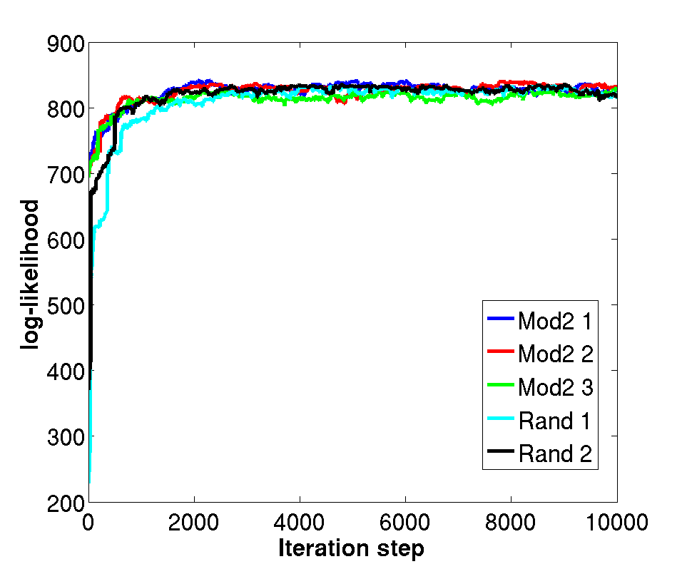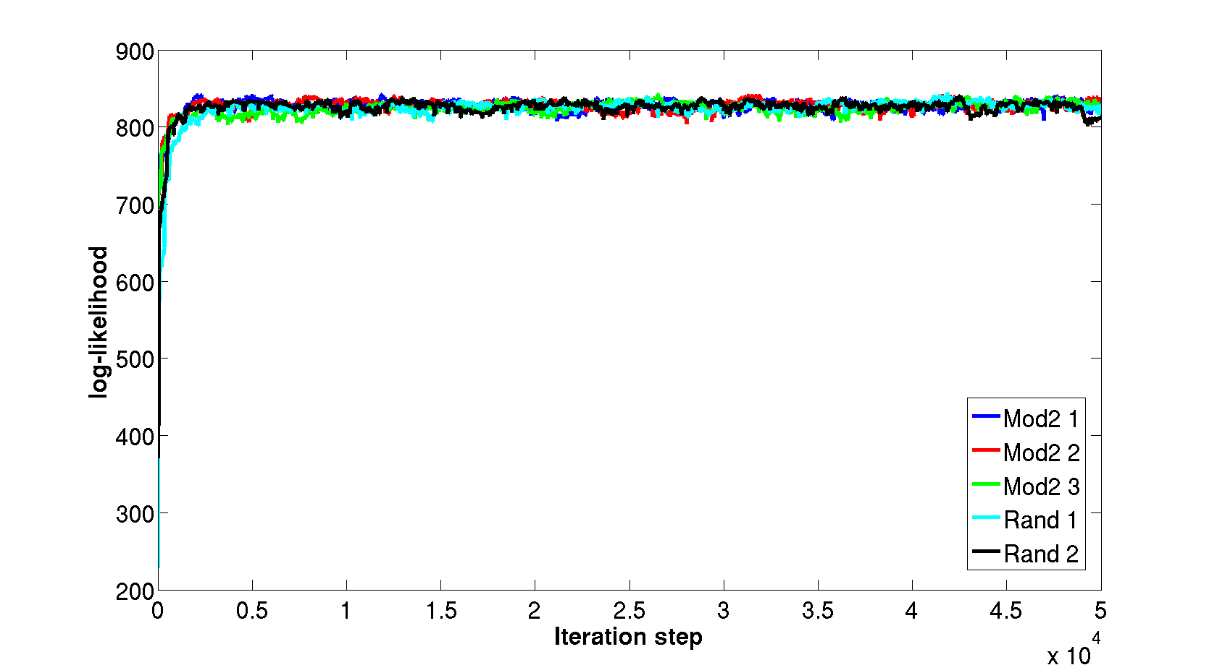
Figure 5: Penalized log - likelihood after 10k (left) and 50k (right) runs of the algorithm. The chosen burn in phase of 100K is conservative. The fact that the average log- likelihood changes only slightly between different runs is an indictor that the algorithm converges to a similar state.

Model size variation
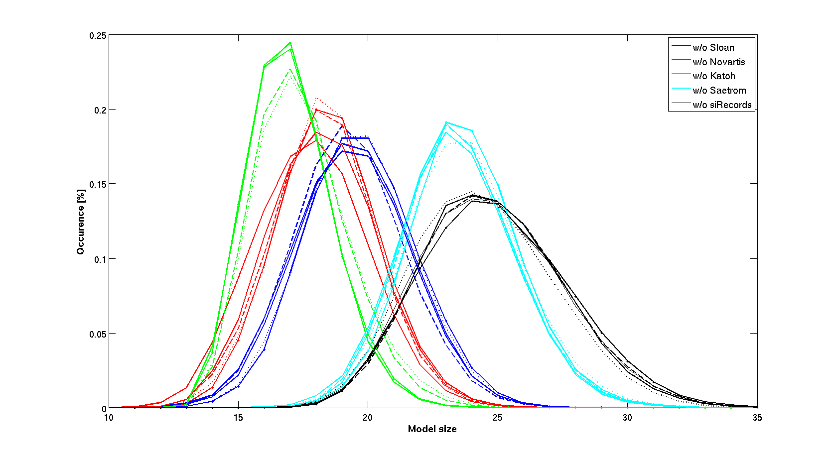
Figure 6: Distribution of sizes of selected models between different repeats of the algorithm (as indicated by different line style), starting from different initial feature sets. The distributions are coloured according to which training/test pair has been employed. The small changes in model sizes indicate that the algorithm converges to similar states for every repeat.

Features included most often in the models employed in our study
Simulation | Features
MODEL2 | 20 21 40 414 431 59 420 426 11 17 19 61 65 66 34 37 38 45 1
RUN1 | 433 140 20 11 483 437 210 40 431 426 38 34 2 492 491 450 432 259 125 58 1
RUN2 | 433 140 11 437 426 210 40 20 483 431 38 34 2 491 450 347 259 155 58 53 15
RUN3 | 140 11 210 40 20 483 437 38 34 491 476 450 433 431 426 347 259 155 58 2 1
RAND1 | 433 140 20 11 437 210 40 38 483 431 34 2 491 450 426 347 259 155 53 15
RAND2 | 433 140 40 20 11 483 437 431 210 38 2 34 492 491 450 426 259 155
FINAL_19 | 11 140 20 40 433 210 437 38 34 483 426 431 2 491 125 450 492 259 347
Table 7: Individual features (for reference see Table 6) found more than 50% of all runs for each simulation

Predictive performances of the models employed in this study
In a recent comparative study (Matveeva2007), the authors designed two novel models, based on linear regression, which (and in particular the more elaborate one, Model2) predicted siRNA silencing efficiency as well as the best-ranked up-to-date algorithms. Given that the present work is oriented mainly towards the identification of features significant for siRNA potency prediction and not towards comparing prediction strategies, it was decided to compare our results only with those from Matveeva’s et al. models, which were considered representatives of the latest siRNA potency prediction techniques. In order to compare the predictive power of their models with the model developed by us, their results had to be reproduced employing the specificity/sensitivity/threshold scheme described before. Two more things should be highlighted regarding the reproductions of their results. Originally, Matveeva trained their models on the NOV dataset only and then tested them on a number of different datasets. In addition to that, we also trained their models on all but one of our five datasets (SLO, NOV, KAT, SAE, SIR) in turn, and then tested it on the remaining dataset, in a leave-one-out fashion. We also tested them on the independent GOLDEN dataset (results not shown). Three of the features of the two Matveeva models were considering characteristics of the 2 nt 3’ siRNA overhangs. In our study, these features have been excluded from the feature set defining the Matveeva models, as all entries are sequences of length of 19 nt. As a consequence, our versions of Matveeva’s models include only 6 of the original 9 (MODEL1) and only 19 of the original 22 (MODEL2) features, respectively. This reduction in model complexity didn’t alter the predictive power incorporated in the models, as even in the original paper the models were tested only on datasets containing siRNAs of length of 19 nt. Consequently, the models used here to reproduce Matveeva’s et al. findings are considered identical to those used in the original paper.

Simulation | SLO | NOV | KAT | SAE | SIR
MODEL2 | 0.1789 | 0.3479 | 0.2576 | 0.2333 | 0.0646
RUN1 | 0.1685 | 0.2685 | 0.3333 | 0.2368 | 0.0671
RUN2 | 0.1573 | 0.2726 | 0.3269 | 0.2389 | 0.0696
RUN3 | 0.10843 | 0.26978 | 0.32298 | 0.23894 | 0.068354
Average (RUN1-3) | 0.1447 | 0.2703 | 0.3277 | 0.2382 | 0.0684
RAND1 | 0.16867 | 0.26496 | 0.33333 | 0.23894 | 0.068354
RAND2 | 0.1573 | 0.26686 | 0.33333 | 0.23894 | 0.06962
FINAL_19 | 0.1461 | 0.2955 | 0.3869 | 0.2667 | 0.0734

Table 8: Predictive performances of the models employed in this study. The models tested were an adopted version of Matveeva’s et al. MODEL2 (17) as well as a set of models generated by three repeats of our Bayesian Markov chain Monte Carlo feature selection method with MODEL2 as initial model (RUN1-3) and two repeats of our Bayesian Markov chain Monte Carlo feature selection method with a random initial model (RAND1-2). Each model was trained on a combination of four of the five datasets, with the one stated in the respective column being excluded from the training set and then tested on the dataset stated in the respective column. The final row, labelled FINAL_19, contains the results of the model that was composed of all 19 features contained identified by our algorithm. Each of the above mentioned runs was independent and consisted of 1,000,000 iterations, including a 100,000 burn-in period. Stated for each run is the resulting sensitivity for 95% specificity.

Simulation | SLO out | NOV out | KAT out | SAE out | SIR out
MODEL2  (trained in all but one dataset) | 0.265 | 0.295 | 0.310 | 0.238 | 0.255
MODEL2  (trained on NOV) | 0.183 | 0.183 | 0.183 | 0.183 | 0.183
RUN1 | 0.2762 | 0.2521 | 0.2358 | 0.3596 | 0.3774
RUN2 | 0.2667 | 0.2155 | 0.3333 | 0.3596 | 0.3551
RUN3 | 0.3113 | 0.2193 | 0.3333 | 0.3246 | 0.3585
Average (RUN1-3) | 0.2847 | 0.2290 | 0.3008 | 0.3479 | 0.3637
RAND_1 | 0.2875 | 0.2039 | 0.2359 | 0.3597 | 0.3774
RAND_2 | 0.2762 | 0.2203 | 0.2359 | 0.3597 | 0.3679
FINAL_19

Table 9: Predictive performances of the models employed in this study, when tested on the AMG “GOLDEN” set. The models tested were two adopted version of Matveeva’s et al. MODEL2 (Matveeva2007), as well as a set of models generated by three repeats of our Bayesian MCMC feature selection method with MODEL2 features as initial model (RUN1-3) and two repeats of our Bayesian Markov chain Monte Carlo feature selection method with a random initial model (RAND1-2). The first of Matveeva’s et al. models was trained on Novartis only, as was the case in the original paper (and tested only on AMG, which explains why only one value appears in this row of the matrix), whereas all the others were trained on a combination of four of the five datasets, with the one stated in the respective column being excluded from the training set, and then tested on the AMG dataset. The final row, labelled FINAL_19, contains the results of the model that was composed of all 19 features contained identified by our algorithm. Each of the above mentioned runs was independent and consisted of 1,000,000 iterations, including a 100,000 burn-in period. Stated for each run is the resulting sensitivity for 95% specificity.

References

Chalk2004 Chalk, A.M., Wahlested, C., Sonnhammer, E.L.L. (2004) Improved and automated prediction of effective siRNA. Biochem. Biophys. Res. Comm., 319, 264-274
Ding2006 Ding, Y., Zhang, Y.Z., Furuyama, K., Ogawa, K., Igarashi, K., Shibahara, S. (2006) Down-regulation of heme oxygenase-2 is associated with the increased expression of heme oxygenase-1 in human cell lines. FEBS J., 273, 5333-46
Fedorov2006 Fedorov Y., Anderson E., M., Birmingham, A., Reynolds, A., Karpilow, J., Robinson, K., Leake, D., Marshall, W., S. and Khvorova, A. (2006) Off-target effects by siRNA can induce toxic phenotype, RNA 12(7), 1188–1196.
Freier1986 Freier, S.M., Kierzek, R., Jaeger, J.A., Sugimoto, N., Caruthers, M.H., Neilson, T., Turner, D.H. (1986) Improved free-energy parameters for predictions of RNA duplex stability. Proc. Natl. Acad. Sci., 83, 9373–9377
Freier1986 Freier, S.M., Kierzek, R., Jaeger, J.A., Sugimoto, N., Caruthers, M.H., Neilson, T., Turner, D.H. (1986) Improved free-energy parameters for predictions of RNA duplex stability. Proc. Natl. Acad. Sci., 83, 9373–9377
Gong2006 Gong, W., Ren, Y., Xu, Q., Wang, Y., Lin, D., Zhou, H., Li, T. (2006) Integrated siRNA design based on surveying of features associated with high RNAi effectiveness. BMC Bioinformatics, 7, 516
Hofacker1994 Hofacker, I.L., Fontana, W., Stadler, P.F., Bonhoeffer, S., Tacker, M., Schuster, P. (1994) Fast Folding and Comparison of RNA Secondary Structures. Monatshefte f. Chemie, 125, 167-188
Holen2002 Holen, T., Amarzguioui, M., Wiiger, M.T., Babaie, E., Prydz, H. (2002) Positional effects of short interfering RNAs targeting the human coagulation trigger Tissue Factor. Nucleic Acids Res., 30, 1757-66
Hornung2005 Hornung V, et al. (2005) Sequence-specific potent induction of IFN-alpha by short interfering RNA in plasmacytoid dendritic cells through TLR7. Nat. Med, 11, 263–270
Jagla2005 Jagla, B., Aulner, N., Kelly, P.D., Song, D., Volchuk, A., Zatorski, A., Shum, D., Mayer, T., De Angelis, D.A., Ouerfelli, O., Rutishauser, U., Rothman, J.E. (2005) Sequence characteristics of functional siRNAs. RNA, 6, 864-72
Judge2005 Judge AD, et al. (2005) Sequence-dependent stimulation of the mammalian innate immune response by synthetic siRNA. Nat. Biotechnol., 23, 457–462
Katoh2007 Katoh, T., Suzuki, T. (2007) Specific residues at every third position of siRNA shape its efficient RNAi activity. Nucleic Acids Res., 35, e27
Kierzek2006 Kierzek, E., Mathews, D.H., Ciesielska, A., Turner, D.H., Kierzek, R. (2006) Nearest neighbor parameters for Watson–Crick complementary heteroduplexes formed between 2′-O-methyl RNA and RNA oligonucleotides. Nucleic Acids Res., 34, 3609-3614.
Leuschner2006 Leuschner, P.J.F., Ameres, S.L., Kueng, S., Martinez, J. (2006) Cleavage of the siRNA passenger strand during RISC assembly in human cells. EMBO Rep., 7, 314–320
Lu2008 Lu, Z. J., and Mathews D. H. (2008) Efficient siRNA selection using hybridization thermodynamics. Nucleic Acids Res. 36(2), 640–647.
Matveeva2007 Matveeva, O., Nechipurenko, Y., Rossi, L., Moore, B., Saetrom, P., Ogurtsov, A.Y., Atkins, J.F., Shabalina, S.A. (2007) Comparison of approaches for rational siRNA design leading to a new efficient and transparent method. Nucleic Acids Res., 35, e63
Patzel2005 Patzel, V., Rutz, S., Dietrich, I., Koberle, C., Scheffold, A., Kaufmann, S.H.E. (2005) Design of siRNAs producing unstructured guide-RNAs results in improved RNA interference efficiency. Nature Biotech., 23, 1440–1444.
Peek2007 Peek, A.S. (2007) Improving model predictions for RNA interference activities that use support vector machine regression by combining and filtering features. BMC Bioinformatics, 8, 182-201
Pei2006 Pei, Y., Tuschl, T. (2006) On the art of identifying effective and specific siRNAs. Nature Meth., 3, 670-6
Phipps2004 Phipps, K.A., Martinez, A., Lu, J., Heinz, B.A., Zhao, G. (2004) Small interfering RNA molecules as potential anti-human rhinovirus agents: in vitro potency, specificity, and mechanism. Antiviral Res., 61, 49–55
Ren2006 Ren, Y., Gong, W., Xu, Q., Zheng, X., Lin, D., Wang, Y., Li, T. (2006) siRecords: an extensive database of mammalian siRNAs with efficacy ratings. Bioinformatics, 22, 1027-8
Ren2009 Ren, Y. et al. (2009) siRecords: a database of mammalian RNAi experiments and efficacies, Nucleic Acids Research, 37, D146-D149
Reynolds2004 Reynolds, A., Leake, D., Boese, Q., Scaringe, S., Marshall, W.S., Khvorova, A. (2004) Rational siRNA design for RNA interference. Nat. Biotech., 22, 326-330
Root2006 Root, D.E., Hacohen, N., Hahn, W.C., Lander, E.S., Sabatini, D.M. (2006) Genome-scale loss-of-function screening with a lentiviral RNAi library. Nature Meth., 3, 715-719
Saetrom2004 Saetrom, P. (2004) Predicting the efficacy of short oligonucleotides in antisense and RNAi experiments with boosted genetic programming. Bioinformatics, 20, 3055-63
Shabalina2006 Shabalina, S.A., Spiridonov, A.N., Ogurtsov, A.Y. (2006) Computational models with thermodynamic and composition features improve siRNA design. BMC Bioinformatics, 7, 65
Shao2006 Shao, Y., Wu, Y., Chan, C.Y., McDonough, K., Ding, Y. (2006) Rational design and rapid screening of antisense oligonucleotides for prokaryotic gene modulation. Nucleic Acids Res., 34, 5660-5669
Shao2007 Shao, Y., Chan, C.Y., Maliyekkel, A., Lawrence, C.E., Roninson, I.B., Ding, Y. (2007) Effect of target secondary structure on RNAi efficiency. RNA, 13, 1631-40
Teramoto2005 Teramoto, R., Aoki, M., Kimura, T., Kanaoka, M. (2005) Prediction of siRNA functionality using generalized string kernel and support vector machine. FEBS Lett., 579, 2878-82
Ui-Tei2004 Ui-Tei, K., Naito, Y., Takahashi, F., Haraguchi, T., Ohki-Hamazaki, H., Juni, A., Ueda, R., Saigo, K. (2004) Guidelines for the selection of highly effective siRNA sequences for mammalian and chick RNA intereference. Nucl. Acids Res., 32, 936-948
Vert2007 Vert, J.P., Foveau, N., Lajaunie, C., Vandenbrouck, Y. (2007) An accurate and interpretable model for siRNA efficacy prediction. BMC Bioinformatics, 7, 520
Xia1998 Xia, T., SantaLucia, J., Burkard, M.E., Kierzek, R., Schroeder, S.J., Jiao, X., Cox, C., Turner, D.H. (1998) Thermodynamic parameters for an expanded nearest-neighbour model for formation of RNA duplexes with Watson-Crick base pairs. Biochemistry, 37, 14719–14735.

