Software Design & Quality Lab 7 – Radar System

Introduction
The aim of the lab is to design a radar system that will monitor the Dublin airport airspace. The document will develop a conceptual and full design model for how a radar system with the specified problem statement below might be implemented.

Problem Statement
A radar system is required to monitor the airspace of Dublin airport. The radar system will use a pair of transmitter and receiver to propagate radio waves to detect objects in airspace. The radar system will be composed of two radio systems: primary and secondary. Each radio system will contain a transmitter and receiver pair. The primary system will be used to detect aerial objects by measuring the response wave reflected from the aerial object. The primary system will provide positional data in terms of angle and distance from radar (polar co-ordinates). The secondary system will target aerial objects that contain a transponder which will provide identification data such as name and altitude. Aerial objects such as UFO’s (Unidentified Flying Objects) and military objects will not contain transponders, in the case such object is detected a warning signal is generated for the operative of the radar system. The combination of primary and secondary radar data will be referred as a track. Each track instance will be managed by a central processing unit that will also enable an operative to view the track data on a display with the ability to pull detailed data by the interaction with a button. The radar system should provide a warning signal in the case either radar system is down or unavailable.

Software Analysis

Use Case Analysis

Fully dressed Use Case Model

Fully dressed Use Case description

Conceptual model

UML Class Conceptual Model

Modelling Assumptions

Behaviour Analysis
In this section the systems behaviour will be analysed for are specific/ chosen use-case.

High Level Sequence Diagram\
The image below shows the high level sequence diagram for an unknown object detected scenario.
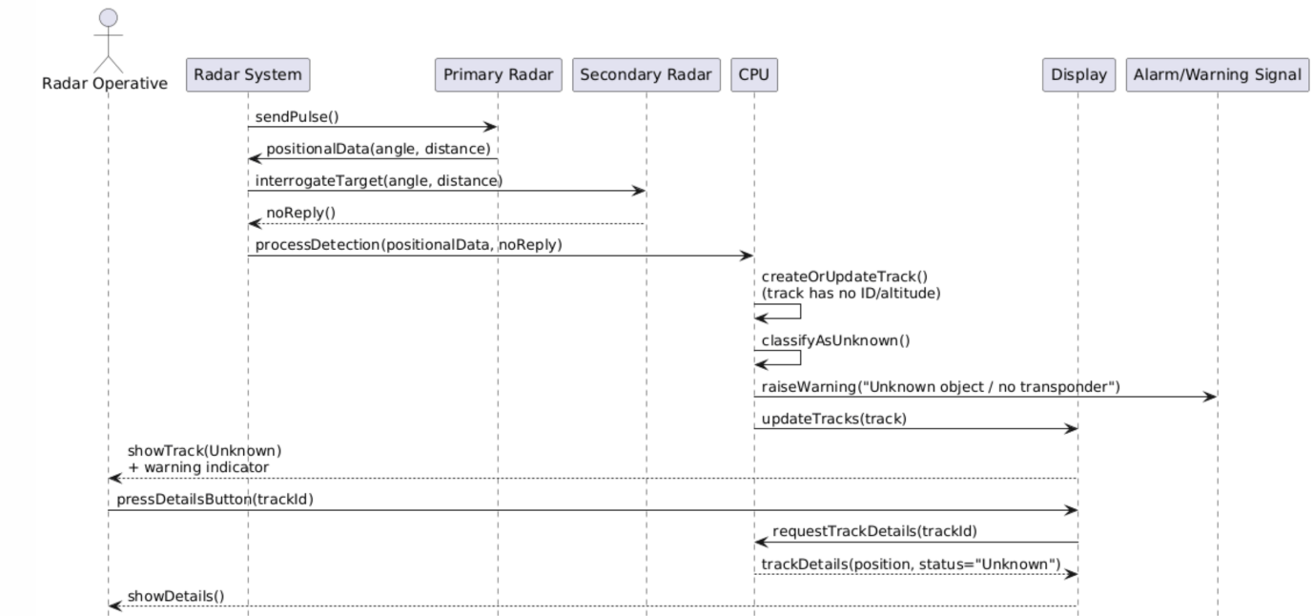
Figure 1

High Level Activity Diagram
The image below shows the high level activity diagram for unknown object detected use-case
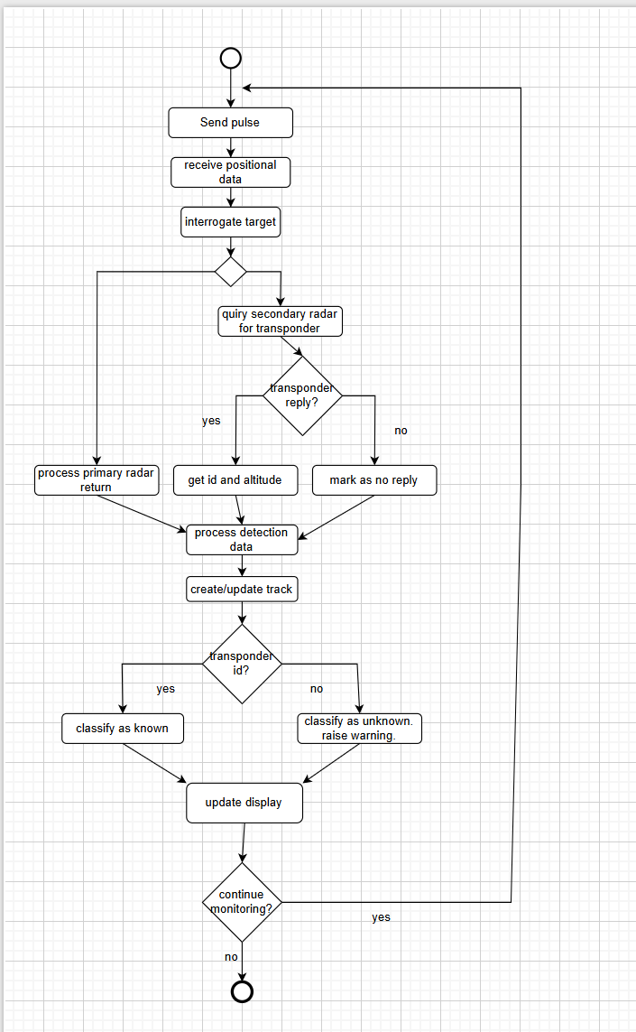
Figure 2

High Level State Diagram
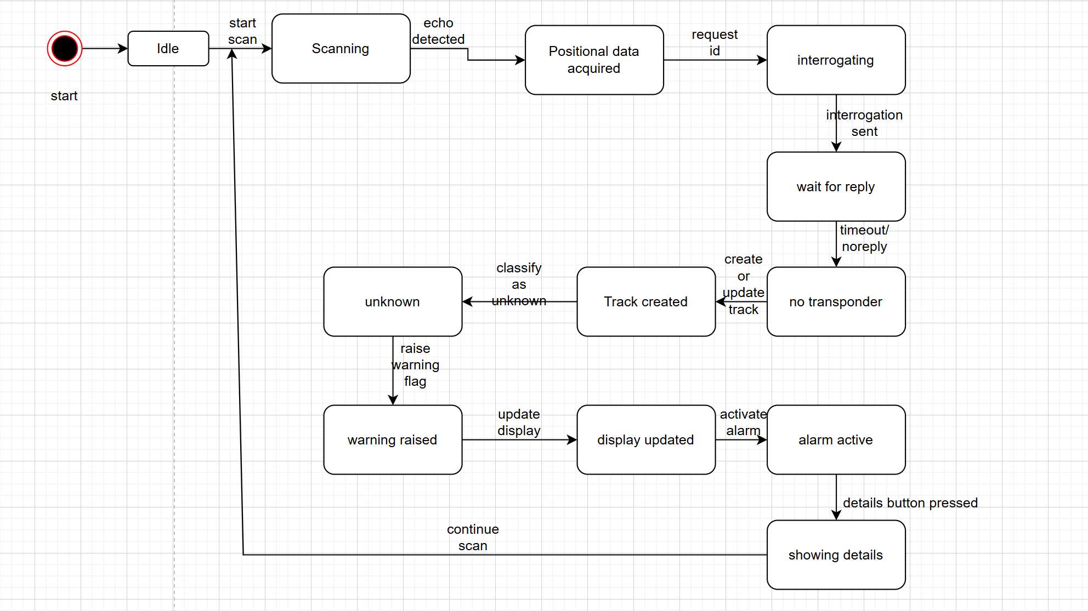
Figure 3

System Design Observations and recommendations
The radar system is designed as a reactive, state-based system where behaviour changes in response to events such as echo detection, identification requests, and operator input. The state diagram shows a clear progression from idle operation through scanning, target detection, and identification using both primary and secondary radar. When no transponder response is received, the system correctly creates a track, classifies the object as unknown, and raises a warning that updates the display and activates an alarm. The inclusion of a loop back to the scanning state reflects continuous radar operation, while the separation of states improves clarity, fault handling, and maintainability of the system design.

Software Design

Interaction Analysis

Detailed Sequence Diagrams

Sequence 1…n

Refined Class Diagram

Discussion: Implementation recommendations and notes

Conclusion

