Lab 1 – Version Control Introduction

Matas Noreika, B00163844

Department of Engineering
School of Informatics & Engineering
Institute of Technology, Blanchardstown
Dublin 15.

ELEC H3013
16/11/2025

Part 1

Step 1:
The following figure showcases a screencast of a directory called lab1part1/ being created with git initialised.
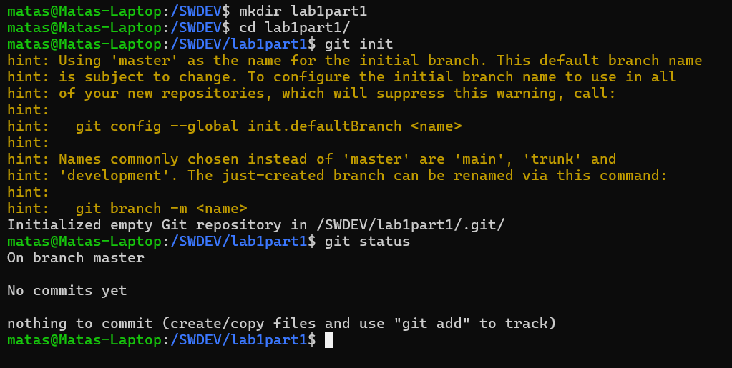
Figure 1 shell output from step 1 process

Step 2:
The following showcases a file being created and added to the repository.
Figure 2 shell output from step 2 process

Step 3:
The following showcases a remote repository from GitHub being cloned to local machine.
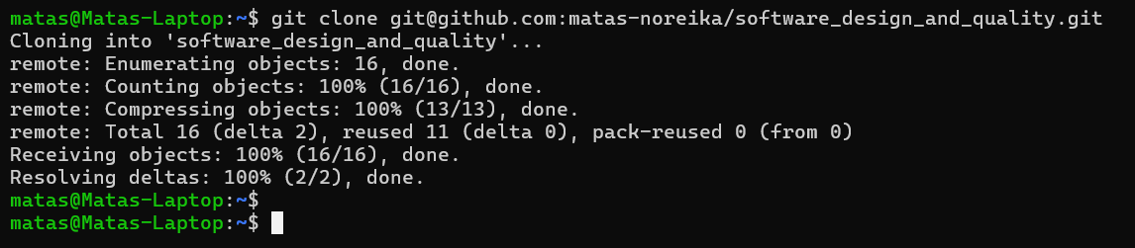
Figure 3 shell output from step 3 process

Step 4 & 5:
The following figure shows a README markdown file being created, staged and committed on local git repository. The file is then pushed upstream to remote repository.

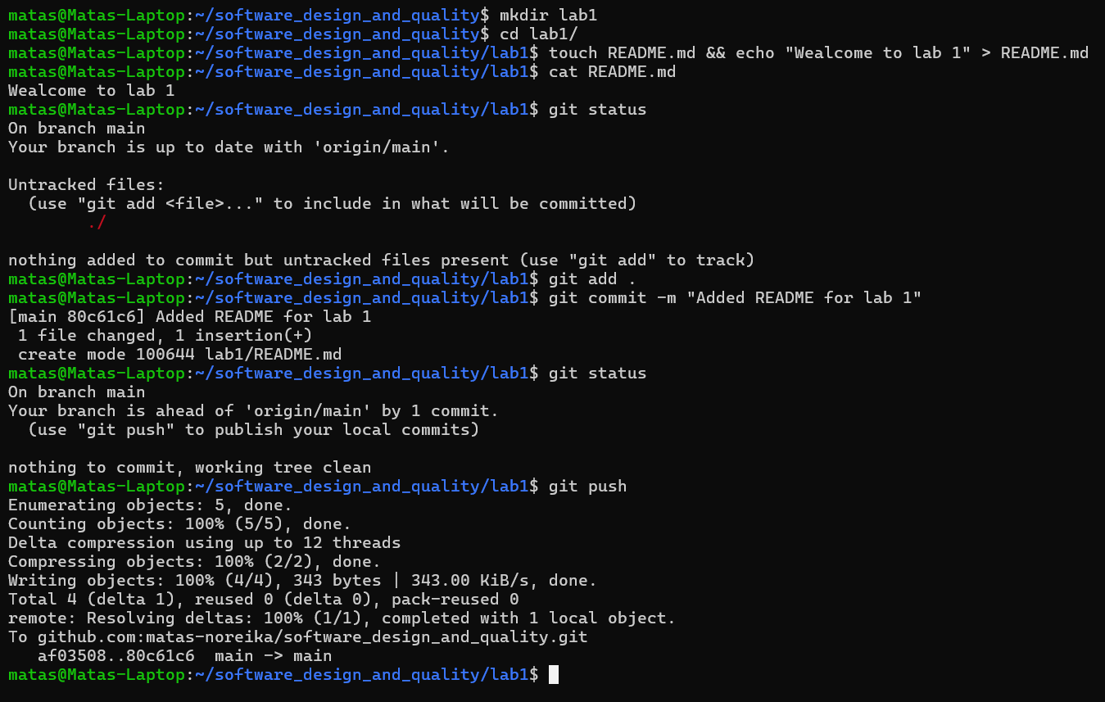
Figure 4 shell output from steps 4 & 5 process

Part 2
Remote repository called software_design_and_quality/ was create on GitHub to hold all module related content with sub directory lab1 containing the relevant content related to this lab exercise. It can be viewed here:
https://github.com/matas-noreika/software_design_and_quality

