CA03:
Analysis & Design Document



Dovydas Klisys, Matas Noreika
B00165094, B00163844

Department of Engineering
School of Informatics & Engineering
Technological University Dublin, Blanchardstown
Dublin 15.

Software design and Quality
27th November 2025

Contents
Introduction: 3
Project statement: 3
Software Analysis: 4
Use case analysis 4
Conceptual Model: 6
Modelling Assumptions: 6
Behaviour Analysis: 7
High-level sequence diagram: 7
High-level activity diagram: 8
High-level state diagram: 9
System Design Observations and Recommendations: 9
Software Design: 10

Figure 1: User/Display/system use case diagram: 4
Figure 2: Collect and transmit data use case diagram: 5
Figure 3: conceptual model 6
Figure 4: state diagram 9

Introduction:
This document presents the software requirements analysis for a simple weather station system. The purpose of this analysis is to model the system’s operations and structure using object-oriented techniques. The weather system collects a variety of data on the weather and displays real-time data to users. It also saves historical data which can be reviewed at any time. The data is transported to an information system via a satellite link
The document includes a use case diagram to illustrate the interaction between actors and the system. The use cases describe different events that can happen between the actors and system. This document also contains a conceptual model to represent different parts of the system and how the parts link together.

Project statement:
You have been tasked with designing the software system for a simple weather-station. A weather station records local weather information and periodically transfers this to a weather information system using a satellite link. Currently the system keeps track of temperature, wind speed (Anemometer) and pressure (barometer) but must be flexible enough to be expanded at a later stage.
The system is composed of a basic Microcontroller, a single temperature sensor, a display, memory bank and user buttons.
The system displays temperature readings in real time on the display. It also keeps track of historical information on an hourly and daily basis. This historical data can be pulled up on the display at the request of the user by pressing the appropriate button.

Software Analysis:

Use case analysis
Figure 1: User/Display/system use case diagram:
Primary Actor: User
Goal in Context: Viewing the data displayed
Level: User-level
Stakeholders and Interests:
- User: Wants to view accurate weather data easily.
- System: Must respond promptly to button presses and display correct data.
Preconditions:
- Data was collected by the system and is ready to be displayed.
- Buttons are functioning.
Minimum Guarantee:
- User changes displayed data by pressing the corresponding button.
Success Guarantee:
- User can see displayed data on the display.
- Buttons allow switching between historical, real-time, or hourly data.
Trigger:
- User presses a button.
Main Success Scenario:
- User is near the system.
- Display shows data collected by the system.
- User presses a button.
- Display changes the type of data projected (real-time, historical, hourly).
- User views the updated data.
Extensions:
- If a sensor fails, the display shows an error message.
- If a button press is invalid, the system ignores the input.

Description:
User interacts with the system through observing the screen and controlling the display through button presses. Each button will contribute to changing the displayed data (from real-time to historical data). The user must understand what each button does to use the system efficiently.

Figure 2: Collect and transmit data use case diagram:
Primary Actor: Microcontroller
Goal in Context: Collecting real data and sending it out
Level: System-level
Stakeholders and Interests:
- Microcontroller: Wants to read and store data from sensors for transmission.
- Weather Information System: Wants accurate weather data for analysis.
Preconditions:
- Sensors are ready to collect data.
- Satellite is prepared to send data from the system to the weather information system.
Minimum Guarantee:
- Microcontroller collects data that can be sent out.
Success Guarantee:
- Sensors collect reliable weather data.
- Microcontroller saves data to the memory bank.
- Microcontroller sends all saved data to the weather information system.
Trigger:
- Scheduled interval or event triggers data collection.
Main Success Scenario:
- Sensor detects weather data and collects it.
- Microcontroller reads sensor data.
- Data is stored in the memory bank.
- Microcontroller initializes satellite connection.
- Full data set is transmitted to the weather information system.
Extensions:
- If sensors fail, the microcontroller produces an error message.
- Microcontroller verifies a reliable satellite connection before sending data.

Description:
The microcontroller is the weather station system’s brain. It performs the sensor data collecting, saving data and sending out data processes.

Conceptual Model:
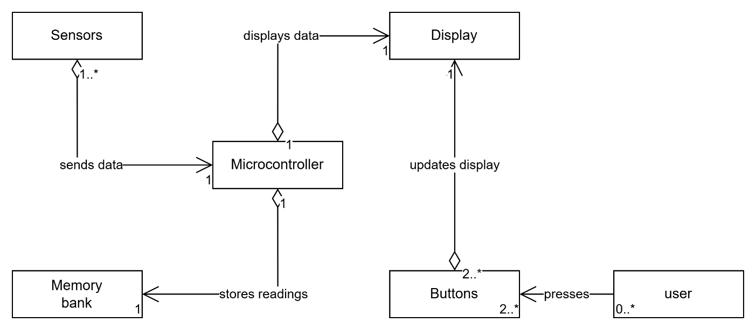
Figure 3: conceptual model

Modelling Assumptions:
This conceptual model depicts the most likely components of the system and the most likely links to each component.
The system’s functions have to be controlled by a microcontroller to perform smart processing. Only need one microcontroller.
Sensors represent the physical device that collects raw weather data that gets collected by the microcontroller. There can be one sensor or different sensors that collect specific data.
There has to be a way to store data and not loose readings or else the user can’t view anything. A memory bank can store the system’s data and there only has to be one memory bank.
The user can interact with the system by pressing a button which performs a certain operation. There doesn’t have to be any user to interact with the system but there must be 2 or more buttons in case someone wants to switch between different data readings.
The buttons control what the display projects. There will be one display to show all readings. The display shows what the microcontroller has processed.

Behaviour Analysis:

High-level sequence diagram:

High-level activity diagram:

High-level state diagram:
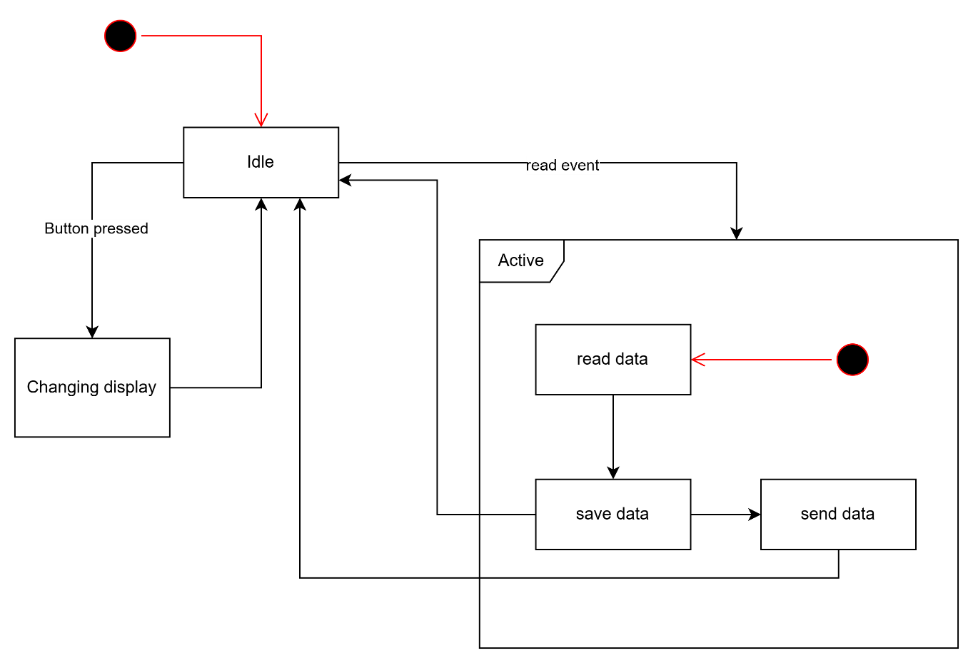
Figure 4: state diagram

System Design Observations and Recommendations:
- The system design supports flexibility by allowing additional sensors to be added in the future to collect different types of weather data.
- The design follows a straightforward process of sending the weather readings. (collect data, process data, save data, send via satellite, display for user).
- However, the system design lacks specification of communication protocols (such as HTTP, MQTT, UART). No sensor protocols given (I2C, SPI). Additionally, there isn’t information on the storage capacity requirements. It is important to know how much the system can collect and save to be transmitted.

Software Design:

