CA02:
User-case and conceptual modeling


Dovydas, Klisys
B00165094

Department of Engineering
School of Informatics & Engineering
Technological University Dublin, Blanchardstown
Dublin 15.

Software design and Quality
24th September 2025

Use-case 1: satellite to weather information system communication
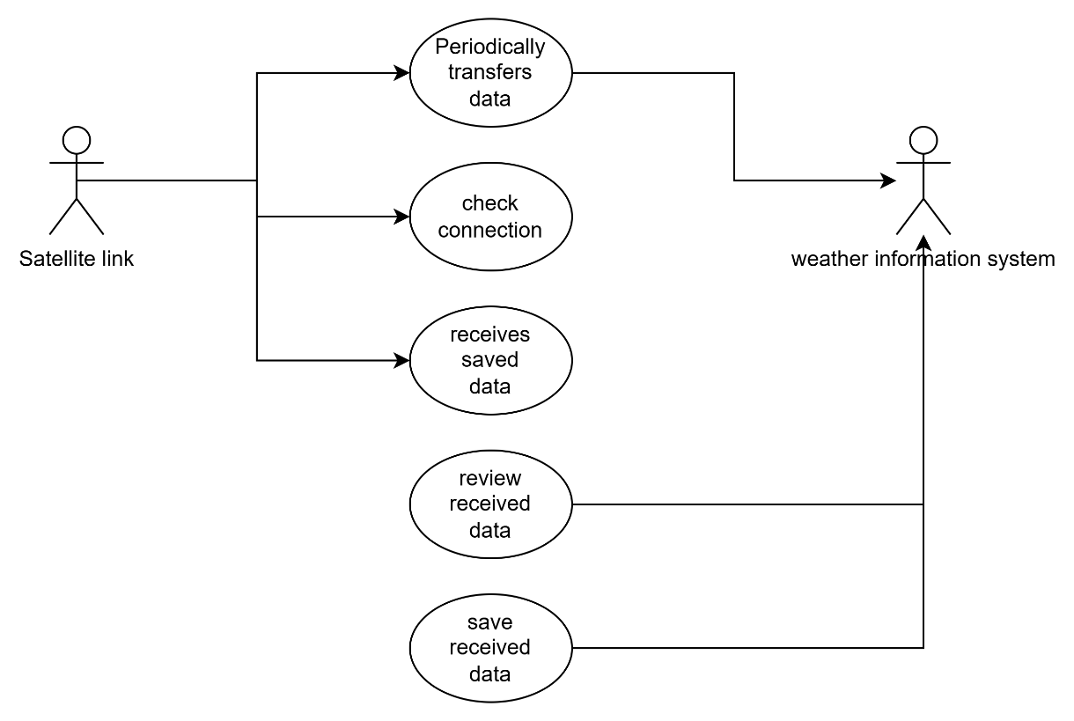
- In this case the satellite takes data from the system, checks the info (if its valid) then transfers data to the information system.
- The information system reviews the received data and saves it.

Use-case 2: user to microcontroller communication
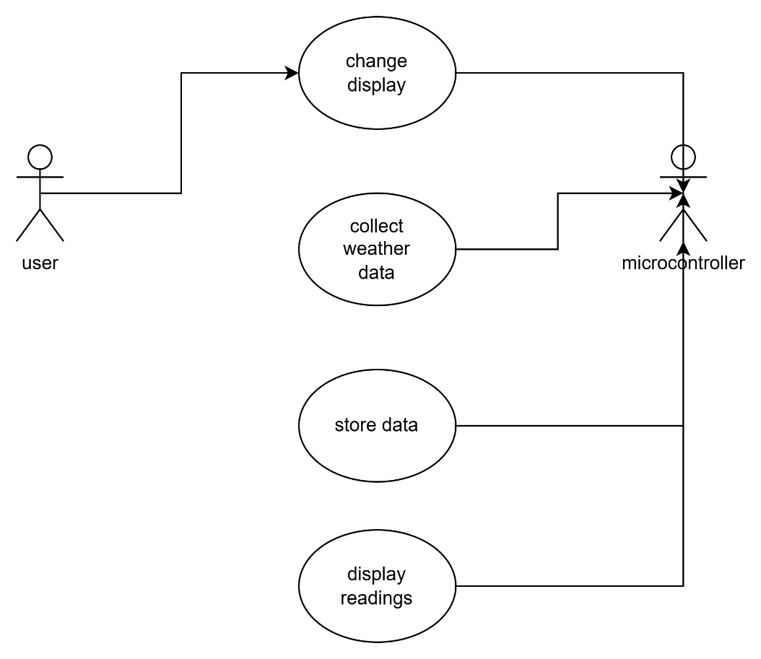
- The user has some control over the system by being able to change the display view (real-time or historical data view).
- The microcontroller is the main part of the system. It collects weather data, stores it in a memory bank and displays the readings.

Use-case 3: microcontroller to satellite communication
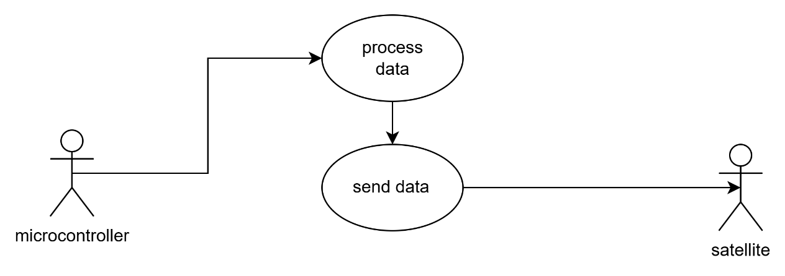
- The microcontroller communication with the satellite may be something like this:
- The microcontroller would process the data received from sensors and then it would send to the satellite to be ready to transport to the information system.

Main use-case:
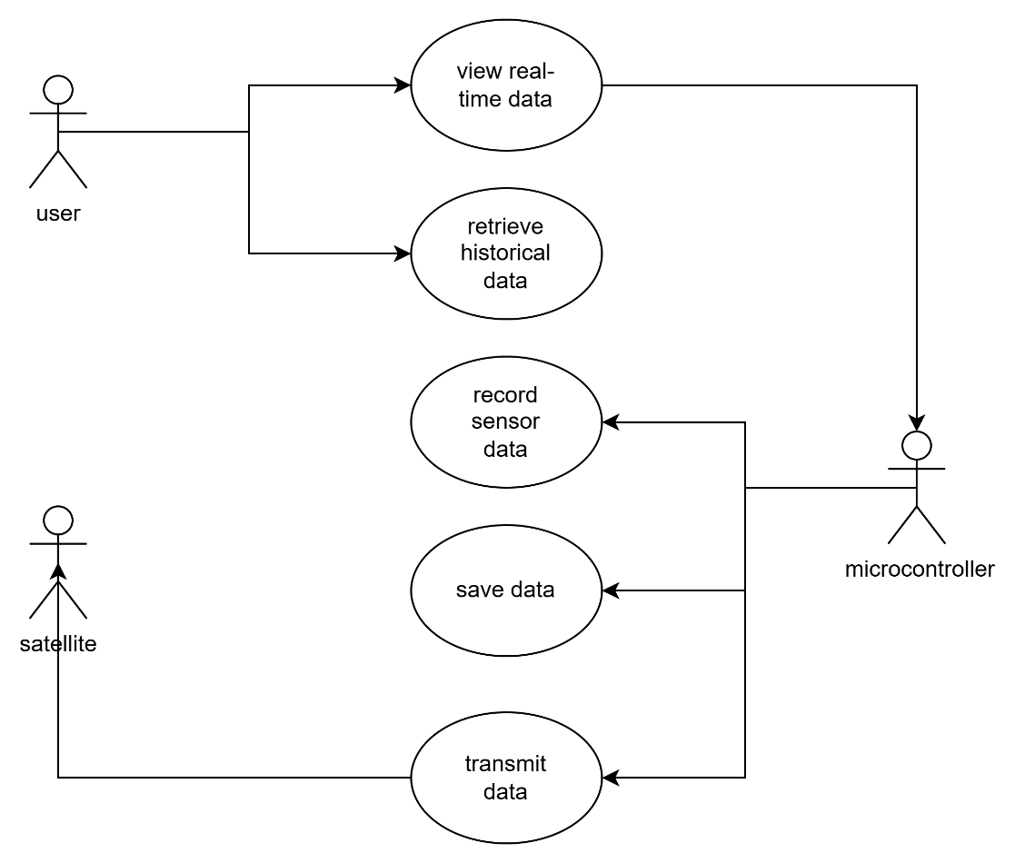
- The main system would consist of the following sections.
- User changes display.
- Microcontroller records, saves and transmits data to satellite.
- The satellite is there to communicate with other systems to transport the main systems data.

Conceptual Model:
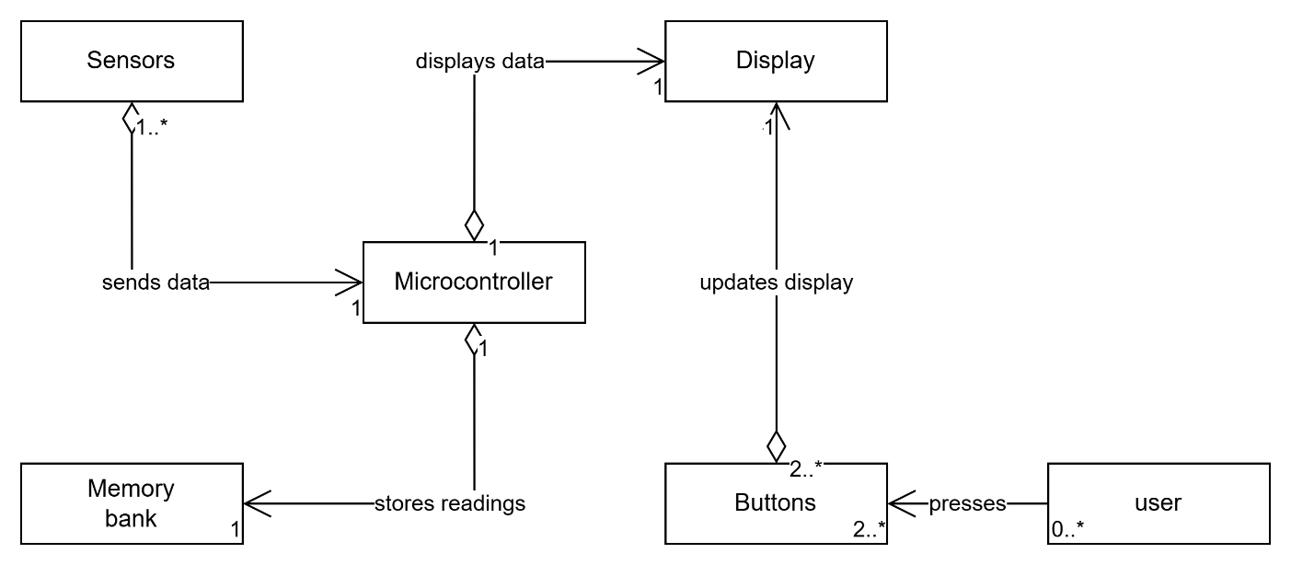
How the conceptual model works:
- There can be none users or many that can press a certain button.
- The buttons are there to change the display. Must be two to change between real-time or historical but can be extra buttons for other controls.
- The buttons change the one display.
- The microcontroller can take data from one or many sensors then send it to the display.
- The memory bank stores the microcontroller’s processing.

