CA02:
Software Requirements Specification



Dovydas Klisys, Matas Noreika
B00165094, B00163844

Department of Engineering
School of Informatics & Engineering
Technological University Dublin, Blanchardstown
Dublin 15.

Software design and Quality
20th November 2025

Introduction:
This document presents the software requirements analysis for a simple weather station system. The purpose of this analysis is to model the system’s operations and structure using object-oriented techniques. The weather system collects a variety of data on the weather and displays real-time data to users. It also saves historical data which can be reviewed at any time. The data is transported to an information system via a satellite link
The document includes a use case diagram to illustrate the interaction between actors and the system. The use cases describe different events that can happen between the actors and system. This document also contains a conceptual model to represent different parts of the system and how the parts link together.

Project statement:
You have been tasked with designing the software system for a simple weather-station. A weather station records local weather information and periodically transfers this to a weather information system using a satellite link. Currently the system keeps track of temperature, wind speed (Anemometer) and pressure (barometer) but must be flexible enough to be expanded at a later stage.
The system is composed of a basic Microcontroller, a single temperature sensor, a display, memory bank and user buttons.
The system displays temperature readings in real time on the display. It also keeps track of historical information on an hourly and daily basis. This historical data can be pulled up on the display at the request of the user by pressing the appropriate button.

Use-case Analysis:

Use case diagram:
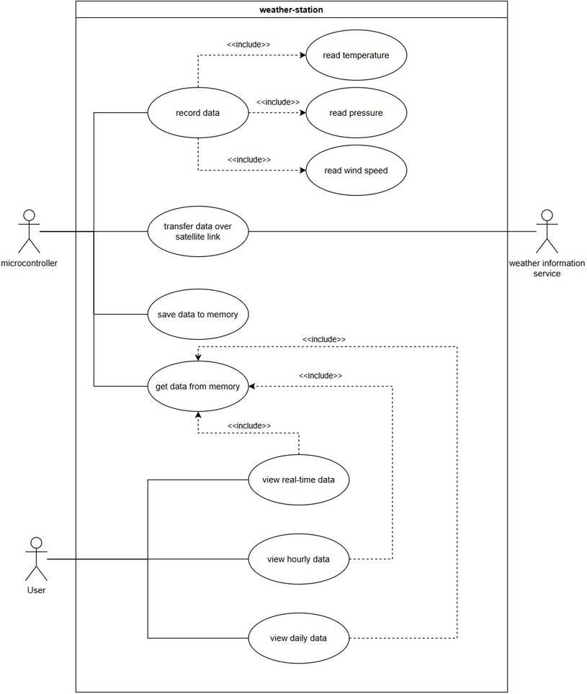
Figure 1: use case diagram

Description:
Actors:
The system has three actors which may interact with the system:
- Actor1: user – views the system’s data
Use-cases: can view real-time, historical or hourly data. Can switch between which data to display by pressing the corresponding buttons.
- Actor2: Microcontroller – provides the brains of the system
Use cases: records the data by interacting with the sensors, saves the data to memory, displays the data on a display for the user to view, transfers the data to the weather information system via satellite link.
- Actor3: Weather information service – this service allows the user to view the data that was collected.
Use-case: collect the systems data and analyse the data.

Conceptual Model:
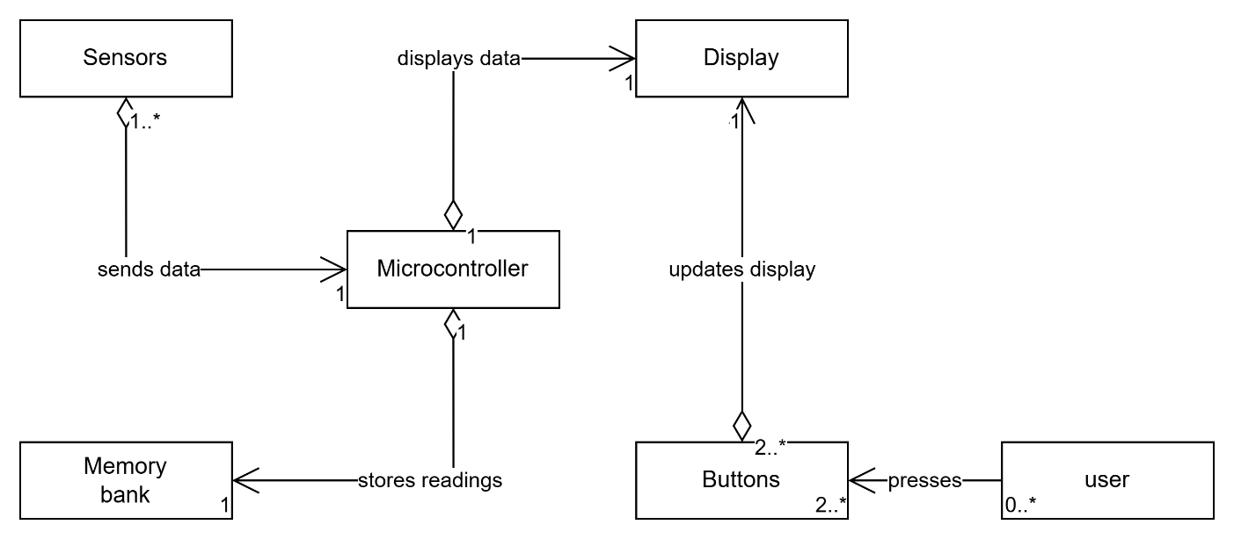
Figure 2: conceptual model

Modelling Assumptions:
This conceptual model depicts the most likely components of the system and the most likely links to each component.
The system’s functions have to be controlled by a microcontroller to perform smart processing. Only need one microcontroller.
Sensors represent the physical device that collects raw weather data that gets collected by the microcontroller. There can be one sensor or different sensors that collect specific data.
There has to be a way to store data and not loose readings or else the user can’t view anything. A memory bank can store the system’s data and there only has to be one memory bank.I
The user can interact with the system by pressing a button which performs a certain operation. There doesn’t have to be any user to interact with the system but there must be 2 or more buttons in case someone wants to switch between different data readings.
The buttons control what the display projects. There will be one display to show all readings. The display shows what the microcontroller has processed.

System Design Observations and Recommendations:
- The system design supports flexibility by allowing additional sensors to be added in the future to collect different types of weather data.
- The design follows a straightforward process of sending the weather readings. (collect data, process data, save data, send via satellite, display for user).
- However, the system design lacks specification of communication protocols (such as HTTP, MQTT, UART). No sensor protocols given (I2C, SPI). Additionally, there isn’t information on the storage capacity requirements. It is important to know how much the system can collect and save to be transmitted.

