LAB 2 – Object Oriented conceptual modelling

Matas Noreika, B00163844

Department of Engineering
School of Informatics & Engineering
Institute of Technology, Blanchardstown
Dublin 15.

ELTC H3013
16/11/2025

Introduction

Problem statement
You have been tasked with designing the software system for a simple weather-station. A
weather station records local weather information and periodically transfers this to a
weather information system using a satellite link. Currently the system keeps track of
temperature, wind speed (Anemometer) and pressure (barometer) but must be flexible
enough to be expanded at a later stage.
The system is composed of a basic Micro-controller, a single temperature sensor, a display,
memory bank and user buttons.
The system displays temperature readings in real time on the display. It also keeps track of
historical information on an hourly and daily basis. This historical data can be pulled up on
the display at the request of the user by pressing the appropriate button.

Use case analysis

Use case model
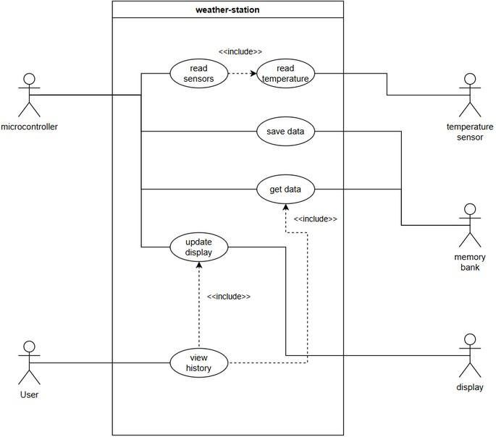
Figure 1 use case diagram of weather-station

Description
- Microcontroller periodically reads sensor data
- Data is saved to persistent memory (memory bank)
- Data is displayed on display
- User interacts with button (view history)
- Data from memory is retrieved (get data) and displayed on display

Conceptual model

UML Class Conceptual model
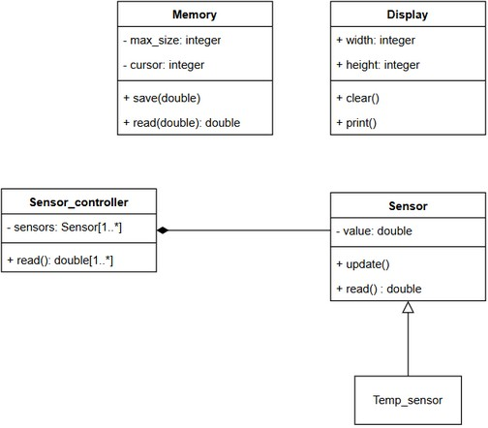
Figure 2 Object model of weather station system

Modelling Assumptions
The design above assumes the sensors will only provide double value outputs with no metadata. The design assumes additional sensors will inherit from Sensor base class to enable flexibility of future changes and take advantage of polymorphism features.

System design observations and recommendations
The design above is flexible to allow for additional sensor types to be added although the sensor controller may require an additional method for adding sensors to its private attribute. The design could be improved by designing a container class such as Weather_station which would contain methods to allow for cross communication between sperate weather_station objects.

